In our need to make a secure networking environment we required several things prior to even being given a separate set of rules. 1. We understood that each networking environment is different, but all expect a high level of use & flexibility, 2. There's a high amount of sensitive information in regard to payroll, 3. There are a large set of computers, approximately 30 from the sales department, that need to be mobile and flexible, which presents a larger vulnerability in our network. Our rules were laid out for us, figure 1 shows the regulations required of a healthy computing environment.

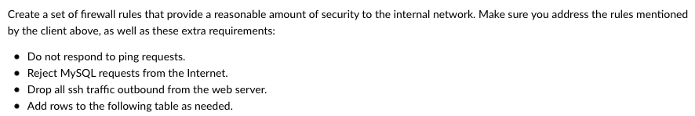

We also chose to logically place a DMZ for our VPN and Public servers, although we were asked that special permissions be given to several of our clients which does pose for a security risk

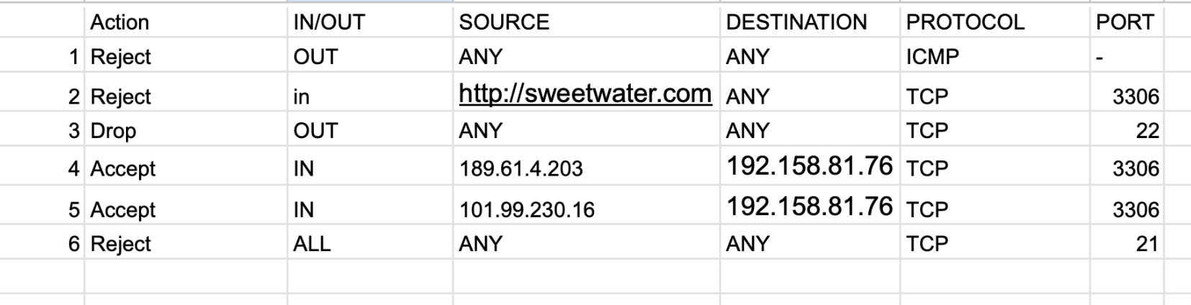

Our table, figure 2, shows precisely how we decided to organize the requests. No ICMP pings, rejection of MySQL, rejection for the connection of FTP transfers rather than both ports, and most importantly dropping all outbound ssh traffic. The IP addresses of our special clients are shown above and highlight some of the main exceptions within our firewall.