|  |
| --- |
| ENGINEERING MANAGEMENT |
| THE BLINDSPOTTER |
| Safe Roads, Save Lives |
|  |

**Group 7:**

Sherwin Lau (1000481)

Ong Jing Jie (1000722)

Chow Wong Chong (1000509)

Lee Joo Chuen (1000519)

Evelyn Ng (1000574)

Spring 2016

**TABLE OF CONTENTS**

|  |  |  |
| --- | --- | --- |
|  | **Executive Summary…………………………………………………...………....** | **2** |
| **1.** | **Introduction to the Business ……………………………………………………..** | **3** |
|  | Business Opportunity …………………………….………………...…………...... | 3 |
|  | Customer Profiles ……………………………....………………………………... | 3 |
|  | Revenue and Profit Model………………………………………………………... | 3 |
|  | Initial Capital ……………………………………………………………………. | 4 |
| **2.** | **Overview of Market ……………………………………………………………...** | **5** |
|  | Market Opportunity ...……………………………….………………………….... | 5 |
|  | Testbed - Singapore …………………………………………………………….... | 8 |
|  | Customer Analysis …………………..……….…………………………………... | 9 |
|  | Competitive Analysis ………..………………………….………………………... | 11 |
|  | Compelling Attributes …….…………………………..…………………………. | 12 |
|  | Value Proposition ………………………………………………………………... | 13 |
| **3.** | **Overview of Sales and Marketing Plans ………………………………………….** | **14** |
|  | Target Market ………………………………………………………………….... | 14 |
|  | Sales Strategy ………………………………………………………………….... | 16 |
|  | Marketing Strategy …………………………………………………………….... | 17 |
|  | Pricing Strategy………………………………………………………………….. | 19 |
|  | Revenue Forecast …………….………………………………………………….. | 19 |
|  | Risk Management ……………………………………………………………….. | 20 |
| **4.** | **Overview of Products and Roadmaps ……………………………………………** | **22** |
|  | Team Expertise ………………………………………………………………….. | 22 |
|  | Current Status ………………………………….………………………………... | 22 |
|  | Expansion Plans …………………………………………………………………. | 23 |
|  | Product Roadmap ………………………………………………..……………… | 24 |
|  | Proprietary Status of Technology …………………………………....…………..... | 24 |
| **5.** | **Summary of Manufacturing and Operations ………………..……........................** | **25** |
|  | Manufacturing Strategy …………………………………………………………. | 25 |
|  | Core Competencies………………………………………………………………. | 25 |
|  | Manufacturing Costs …………………………………………………………….. | 25 |
|  | Inventory Planning ………………………………...…………………………….. | 26 |
|  | Distribution Strategies………………………………………………………….... | 26 |
| **6.** | **Financials ………………………………………………………………………..** | **27** |
|  | Balance Sheet ……………………………………………………....…………… | 27 |
|  | Cash Flow Statement ……………………………………………………………. | 28 |
|  | Income Statement ………………………………………………………………. | 29 |
|  | Underlying Business Assumptions ….…………………………………………… | 30 |
|  | Exit Strategies ……....………………………………………………………….... | 31 |
| **7.** | **Management Team Biography …………………………………………………..** | **32** |

**EXECUTIVE SUMMARY**

The BlindSpotter is a plug-and-use product that helps drivers to check their blindspots. The BlindSpotter is affordable yet infuses technology to perform this function. Similar products have yet to be found in the market that offer the same function and price which places the Blindspotter at a competitive edge. There is also not a better time to penetrate the market when the automobile accessories, car sharing economy and global car sales is booming. A rough market estimates show that our total addressable market is at $725 million USD with plenty of growth in the future to come. Customer analysis have shown that vehicle users and car sharing companies form our customer base where a series of detailed strategies have already been developed to tap on these markets. In fact, a three-pronged strategy will be used to target businesses, consumers and licensing to huge manufacturers which provides us with 3 sources of income. The team comprises of an experienced and talented team covering critical areas to ensure that success ensues. Sherwin and Joo Chuen, who have 10 years of experience in the engineering field, makes sure that research and innovation are in good hands. Evelyn and Jing Jie, who have countless accolades under their name, are capable of running and steering the company in the right direction. Finally, Wong Chong who have won countless design awards will be heading the product design for the company. The company would need $100,000 funding from investors so that the plans described above can actually be carried out.

**INTRODUCTION OF THE BUSINESS**

**Business Opportunity**

With the growing affluence of cities, automobiles are becoming increasingly accessible to the masses. The automobile market is a growing one. Presented with the prospects of increasing car sales, the rise of sharing economy and the booming car accessories market, there has not been a better opportunity for the entrance of the BlindSpotter.

The BlindSpotter is a device which can be purchased off-the-shelves and placed onto any vehicle. It is a useful device which is timely for the market now. Currently, only modern and premium vehicles come with an in-built blind spot detection system. Those who want to equip their cars with such capabilities need to spend up to 5 times the cost of the BlindSpotter and even send their vehicles back to the workshop to retro-fit the blind spot detection system onto their car. On the other hand, installation of the BlindSpotter takes less than 5 minutes.

Current solutions are either prohibitively expensive or dated and the entrance of the BlindSpotter is timely one to improve safety on today’s roads.

**Customer Profiles**

Users of vehicles such as cars, vans and trucks are people who are most interested in our product because it can help them to detect their blind spots better. This group of customers can be split into 2 groups which are businesses and individual customers. The businesses include companies like Uber, Taxi Companies and Car rental companies because they have an interest in protecting their fleet and the BlindSpotter helps them achieve this goal. Similarly, individuals purchase the BlindSpotter to protect their car and save lives.

**Revenue and Profit Model**

The company has identified 3 main types of revenue sources. The first category are businesses while the second are individual consumers. The third category of revenue will be generated from licensing.

The first category of revenue comes from businesses which include companies from Taxi companies and car sharing companies which account for an approximate $283 million USD. The second category of revenue comes from individual consumers and has a potential of $725 million USD market which we can tap into. The third category will come from licensing which we project to be about $30 million USD.

The product is also priced based on its value, which we have estimated to be about $40. This places our profit at nearly 3 times our cost price. The price will be continuously reviewed to have a better pricing.

**Initial Capital**

The company started with a total of USD$50,000 invested by the 5 co-founders, each investing USD$10,000.

|  |  |
| --- | --- |
| **Sources of Initial Capital** | **Amount (USD$ in thousands)** |
| Initial Investment by Co-founders | 50 |
| Grant from SPRING Singapore | 50 |
| Crowdfunding on Kickstarter | 30 |
| Funds from Angel Investors | 100 |
| Total | 230 |

Through the crowdfunding platform Kickstarter, we managed to gain traction in the market in order to sell our product. This has several benefits: first, it garnered media attention and increased brand awareness; and secondly, it has helped to shape the company’s business by allowing the company to better gauge the customer base.

Spurred on by the success of our campaign, we are seeking venture capitalists to invest in our company to obtain a larger capital.

**OVERVIEW OF THE MARKET**

**Market Opportunity**

The automobile industry is a growing one today - driven by 3 trends:

1. Booming accessories market
2. Rise of the sharing economy
3. Growing car sales

*Booming Accessories Market*

The auto accessories market is a booming market. Estimations suggest that this market is worth $32 billion dollars and surveys carried out show that 92% will buy an accessory for their vehicle[1]. This is possibly due to the fact that consumers worldwide are keeping their vehicles longer and that disposable incomes are increasing rapidly. That also serves as good reasons to purchase auto accessories because it is a prudent investment to protect or to enhance their cars.

*Rise of the Sharing Economy*

The car sharing economy has also seen an evolution in recent years. Traditional renting companies such as Hertz and Enterprise have seen new innovative competition from Uber, Zipcar, RelayRides, Car2Go and Lyft. In the traditional car-renting scene, Hertz and Enterprise account for about 1.6 million cars worldwide and accounts for about $24 billion in revenue. These are highly profitable potential companies for collaboration. Similarly, new companies in the sharing industry are also a promising target with an estimated of 8 million cars sharing users worldwide.

|  |  |
| --- | --- |
| **Types of Car-Sharing Companies** | **Size of Fleet (‘000 000)** |
| Traditional (e.g. Hertz and Enterprise) | 1.6 |
| New (e.g. Uber, Zipcar, Lyft) | 8 |
| Total | 9.6 |

This puts our total addressable market (TAM) for the sharing economy at $283 million USD. The BlindSpotter serves to protect their vehicles better and may serve to another potential market for our company.

*Growing Car Sales*

The nature of the blind-spot detection device targets the vehicle users which include cars, buses and trucks as our target market audience. This market is not only huge but is still growing. A look at just the car sales shows that an increasing number of people purchase cars globally since the 1990s as shown in Graph 1 below. Car sales is projected to hit 100 million units by 2020. These statistics tell us that our market is huge and is projected to grow.

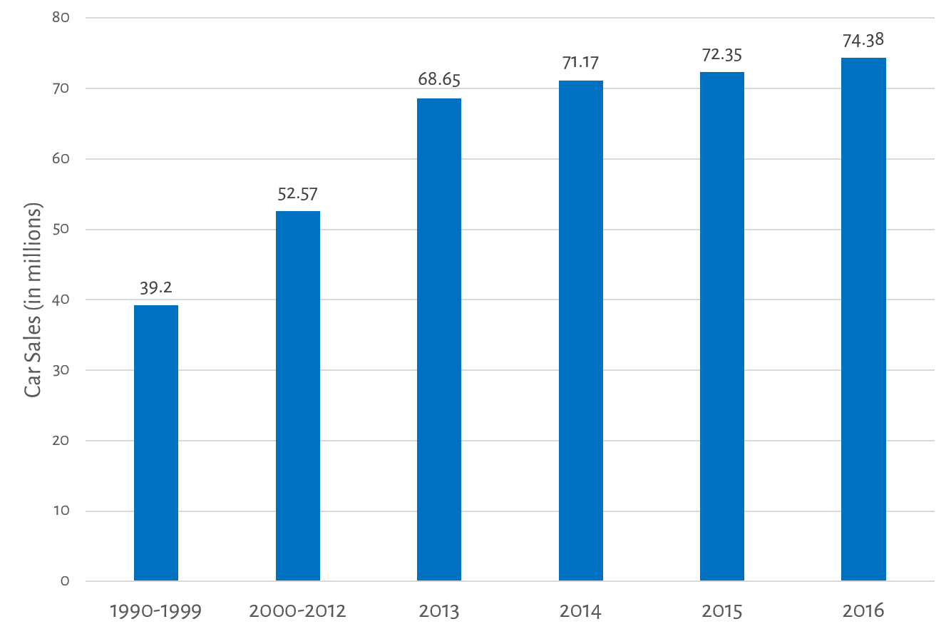

Graph 1: Global Car Sales

A quick look at the major cities[2] shown in Graph 2, which we are most likely to expand to due to the similar demographics we have here in Singapore, reflect the potential of our market which totals at 25.6 million cars. The total addressable market (TAM) is estimated to be $725 million USD. However, we note that this figure is only true if we target all the major cities.

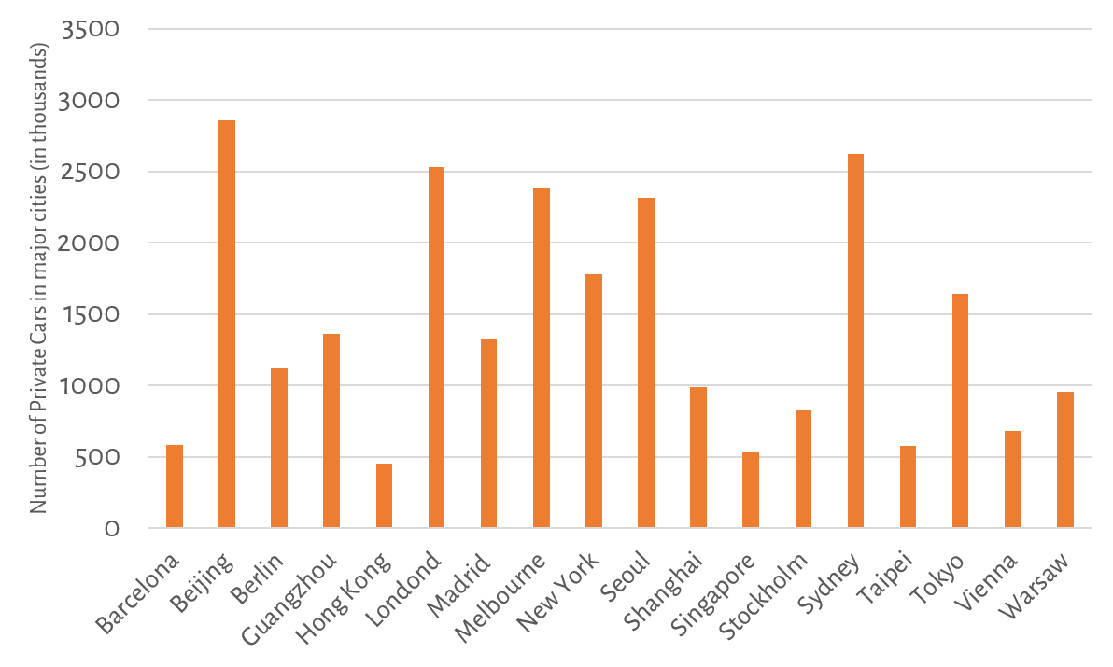

Graph 2: Number of Private Cars in Major Cities around the World

**Testbed - Singapore**

For a start, only the Singaporean market will be targeted as a testbed for the BlindSpotter. This is a reasonable location for the launch of BlindSpotter given that the BlindSpotter is developed in Singapore.

Furthermore, in light of the scarcity of available resources, we will not be able to target all the major markets right from the start despite the high total addressable market. Our estimates reflect that the total addressable market (TAM) for Singapore is $15 million USD.

*Customer Interviews*

In particular, from the interview the team conducted in Singapore, it was found that 78.6% of the respondents found it inconvenient to check their blind spots but accept it as a fact-of-life. They also raised concerns on how the checking of blind spots can cause one to *“almost bang [knock into] the car in front while checking blind spot.”*

Furthermore, it was found that a starking 34.8% of the people do not check their blind spots regularly, and 87.5% of those who did has made a change in lane only to find a vehicle in their blind spot.

All motorbike riders interviewed also mentioned that they have had at least one close call due to drivers not noticing them in the car's blind spot, with one of them even going as far as to say that it happens “*very often*”.

This reinforces the point that there is still a large room for improvement in solving the problematic blind spot of vehicles, which our product is designed to fix.

When faced with the possibility of improving the current scenario with the introduction of the BlindSpotter, 61% of the respondents said that they will be willing to purchase the product.

**Customer Analysis**

Continuing from the interviews carried out, we also seeked to understand the needs of the customers. As mentioned above, the BlindSpotter primarily targets at drivers (of cars, buses and other heavy vehicles), hence a list of customer needs were extracted. We found that the customers wanted the BlindSpotter to be:

1. Easy-to-install
2. Simple & Pleasant to use
3. Reliable
4. Durable

To summarize from the Customer Interview above, it was also found that

* While many of the potential customers interviewed found that the checking of blind spots inconvenient, they accept it as a fact-of-life which would go away as checking of blind spots become habitual.
* While checking the blind spots, drivers had to take their eyes off the road in front which has raised instances of near-miss scenarios
* Drivers were particularly concerned with how their own negligence could potentially cause accidents

In particular, drivers of heavy vehicles are typically very receptive to the idea of a blind spot detector where it proves to be difficult to have to keep tabs on every single blind spot of the vehicle’s exterior while the vehicle is in motion.

At location of launch - Singapore, the exorbitant price to pay for a vehicle in light of the bidding of the Certificate of Entitlement (COE) to own the vehicle is also another reason for vehicle users to purchase the BlindSpotter. From Graph 3 below, it is apparent that the increasing prices of COE[3] is in our favour for it was cited from the interviews conducted that *“the small price paid for purchasing the blind-spot detection device [the BlindSpotter] is worth it to protect the high cost of the car that I [the driver] paid for”* and indicates the willingness of customers to purchase the BlindSpotter.

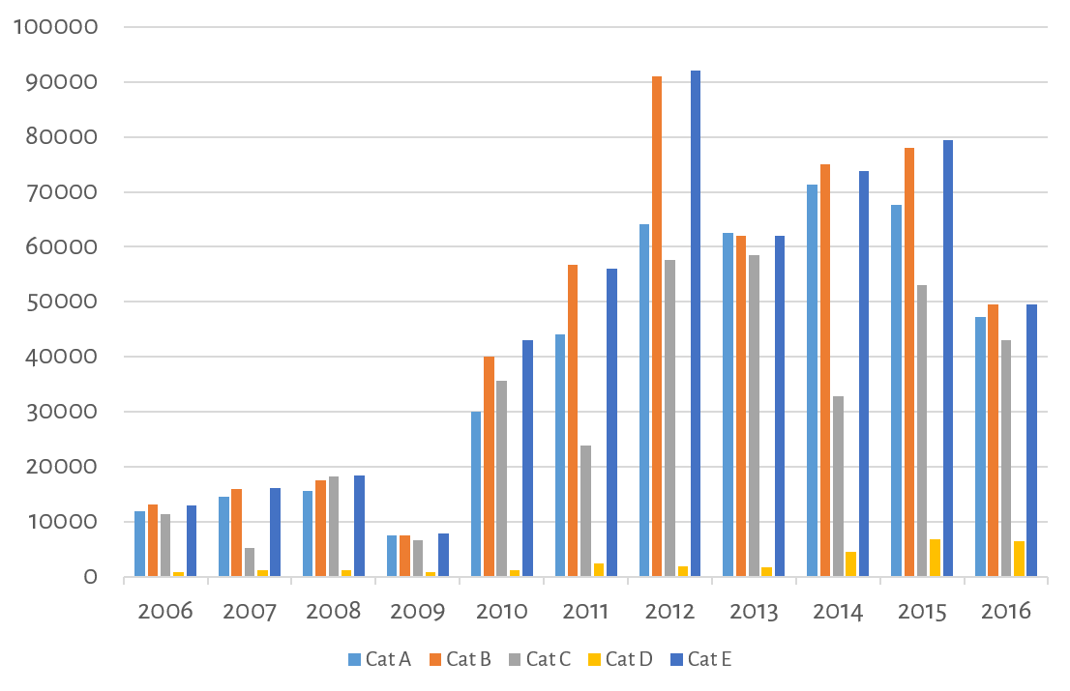

Graph 3: Certificate of Entitlement (COE) Prices

Generally, it was noted that users who did not like the idea mistrusted the reliability of technology. This is particularly so for bikers when the cost associated with technological glitches is far too high for them to trust any form of technology.

However, the market surveys on vehicle users shows that many of them recognise the importance of being able to be notified of their blind spots. This is important because their own safety and that of others are at stake. An overwhelming 76.8% of the responses showed that both riders and drivers found it inconvenient to check their blindspots.

**Competitive Analysis**

It is noted that there are existing products in the market today that would pose as competition to our product, namely the traditional blind spot mirror, retro-fitted blind spot sensors and the modern in-built blind spot monitoring system.

|  |  |  |  |
| --- | --- | --- | --- |
|  | **Traditional Blind-Spot Mirror** | **Retro-fitted Blind Spot Sensor** | **In-built Monitoring System** |
|  |  |  |  |
| Cost | 2 - 8 USD$ | 119 USD$ | 77,500 USD$ |
| (+) | 1. Non-intrusive of vehicle during installation | 1. Seamlessly integrated into vehicle 2. High-Tech 3. Theft Prevention | 1. Seamlessly integrated into vehicle 2. High-Tech 3. Theft Prevention |
| (-) | 1. Takes up space on the side mirror 2. Low resolution 3. Mostly useless at night | 1. Intrusive during installation 2. Requires sending car back to workshop | 1. Only available to newer branded cars |

Therefore, the BlindSpotter offers an affordable solution for users who wants a blind-spot detection solution but finds the retro-fitted blind spot sensors too intrusive and expensive, and the in-built Blind Spot Monitoring System too cost-prohibitive. It also offers a more functional, reliable and advanced blind-spot detection device for those who find the blind spot mirror too rudimentary for use.

**Compelling Attributes**

Below shows the Pugh Chart Analysis of the the BlindSpotter against its competitors to highlight its compelling attributes:

|  |  |  |  |  |
| --- | --- | --- | --- | --- |
|  | DATUM | 1 | 2 | 3 |
|  | BlindSpotter | Traditional Blind Spot Mirror | Retro-fitted Blind Spot Sensor | In-built Monitoring System |
| Cost | 0 | 1 | -1 | -1 |
| Intrusiveness | 0 | 0 | -1 | -1 |
| Ease of Installation | 0 | 0 | -1 | 0 |
| Reliability | 0 | -1 | 1 | 1 |
| Durability | 0 | -1 | 1 | 1 |
| Universality | 0 | 0 | -1 | -1 |
| S+ | 0 | 1 | 2 | 2 |
| S- | 0 | 2 | 4 | 3 |
| S | 0 | -1 | -2 | -1 |

Apart from the advantages stated above that the BlindSpotter has over its competitors, the sublime part of the device is that it is a binary device that gives positive or negative indication of presence of obstructions in the blind spot. The benefits of this feature are explained below:

* Binary nature of the device allows for quick confirmation by the user while allowing the driver to focus on the road in front
* Non-intrusive and easily mountable
* Compatible with all forms of vehicles
* Affordable

**Value Proposition**

The BlindSpotter provides an affordable and reliable solution for vehicle users who wish to be safer on the roads. If it had not been for this device, users would either have to purchase new cars for a comprehensive in-built blindspot monitoring system. Furthermore, only certain models have these systems in-built, the user might prefer a model that does not come with any in-built monitoring systems. In this case, our product is perfect for offering them an affordable and non-intrusive system. In addition, the affordability and ease of installation allows current vehicle users of older cars to achieve the same functionality as that found in modern and better cars. Regardless of the age or model of their cars, users can just purchase and stick on our affordable BlindSpotter and achieve the same function found in premium and modern cars.

In summary, the clear differentiating customer value that the BlindSpotter provides are:

1. Affordability
2. Reliability
3. Ease of Installation
4. Non-intrusiveness
5. Universality

**OVERVIEW OF SALES AND MARKETING PLANS**

**Target market**

The target market for the company to generate revenue flow will be through these sources:

1. Business-to-Consumer (B2C)
2. Business-to-Business (B2B)
3. Licensing and Intellectual Property

*Business-to-Consumer (B2C)*

Our ideal customers are car owners that have problems and issues with checking their blind spot. From the survey conducted, many of them are concerned with how their potential negligence can cause accidents.

The BlindSpotter can be easily installed on the cars of these individuals who do not have any retro-fit or in-built blind spot monitoring system available. It is the aim of ours to improve safety on the road with the installation of the BlindSpotter on every car on the road.

The BlindSpotter will be sold directly under the following channels:

1. Petrol Stations
2. Supermarkets
3. Online store

The BlindSpotter will also be distributed at car workshops because car owners frequent these places and are good avenues to increase our product presence. Furthermore, deals will be made with some of the well-known chained retail stores which might lead to enormous exposure and increase in sales.

We can tap on car mechanics to help display the BlindSpotter in-house and promoting the product directly to customers. Through the word of mouth, we would be able to gain accreditation by the car mechanics which would immensely boost the credibility of the BlindSpotter. Furthermore, car mechanics are the best people who could greatly reduce the inconveniences the customers might face when installing the BlindSpotter for them during the periodic car maintenance cycle.

Through these channels, we can build recognition and trust for our product and increase sales.

*Business-to-Business (B2B)*

The BlindSpotter will also be sold in bulk to car rental, taxi companies, and companies that uses large vehicles. We are in the midst of negotiation with the following companies:

1. Uber
2. ComfortDelgro
3. SBS Transit
4. SMRT
5. Rental car companies (e.g. Hertz)

Acknowledging that these companies have large fleets of vehicles that they would like to protect, we would be able to tap on this market. As the nature of their business is heavily reliant on their fleets, safeguarding them is important. Getting into any major accidents will be detrimental to their business and brand image. Thus, there would be potential market for the BlindSpotter to keep accident rates low, and these companies will purchase a large amount of the product to fit onto their vehicles at any time.

We will also be working with regulatory bodies (e.g. Land Transport Authority of Singapore) to mandate the installation of the BlindSpotter on every vehicle so as to keep the roads safer and reduce the instances of accidents due to the presence of blind spots which the BlindSpotter can eradicate.

*Licensing & Intellectual Property*

With the emergence of newer cars with in-built blind spot monitoring systems, we will license the BlindSpotter, a cheaper alternative to in-built monitoring systems, to automobile manufacturers after obtaining our patent for this technology.

**Sales Strategy**

It is apparent now that the team will be engaging in a 4-pronged approach for our sales strategy which can be summarised as below:

1. Direct Sales
2. Distributorships
3. Licensing
4. Subscription

*Direct Sales and Distributorships*

As described, the company will be distributing the BlindSpotter to customer directly by selling them at petrol stations, supermarkets and online store. Customers would only need to pay for the BlindSpotter when they check-out the product and will be able to install the product by themselves.

In addition, customers would also be able to purchase the BlindSpotter from the car workshops (our distributors) while performing periodic maintenance on their cars at these workshops

*Licensing*

By using our intellectual property, the licensee will first pay an up-front fee of $1 million, followed by rolling royalties of 20 cents per car. We will target automobile manufacturers, such as Honda and Nissan, who have yet to implement any form of blind spot detection in their vehicles.[4]

*Subscription*

For car rental and taxi companies, we will be using a subscription-based approach for our sales strategy in recognition that there is a high chance that these customers would be coming back to us frequently for the replacement of the BlindSpotter on their fleets.

We will be collecting annual recurring fees from them which would provide us with a steady source of revenue and will complement the erratic nature of our Business-to-Customer (B2C) model. We plan to roll out a subscription-based contract with such companies which will last for 2 years and will cover maintenance or replacement of our product.

**Marketing Strategy**

Our company will use a combination of both inbound and outbound marketing for our product in a bid to increase both knowledge and presence of the BlindSpotter in the market.

*Inbound Marketing*

Our company will start marketing our product using inbound marketing for the first few years. Inbound marketing is significantly cheaper than outbound marketing[5], and our company will lack the resources to invest heavily in the traditional marketing during its infancy.

We plan to reach out to early adopters through Kickstarter, and form our first customer base from there. Launching our product from Kickstarter will help to generate large interest from media. Popular technology websites such as Gizmodo, TechRadar, and newspapers such as The Straits Times will feature and publicise our product, thereby increasing brand awareness of our company following the success of crowdfunding.

In addition, we will release a viral video featuring the BlindSpotter which will show a car accident that nearly took place on the highway, but was mitigated due to our product. We plan to partner with the producers of “Singapore Reckless Drivers” to better engage the audience. The video will trend on Facebook and YouTube, and it will familiarise our product to potential customers. This marketing strategy is expected to cost us $1000.

*Outbound Marketing*

After earning $500,000, our company will start utilizing outbound marketing in tandem with inbound marketing. 10% of our revenue will be spent on advertising to grow and gain market share.

Outbound marketing will be employed in the form of advertisement on buses as they are prominent and common on the roads which is a good advertising platform the team can tap into. The advertisement would be designed so as to create the implicit link between road safety and the BlindSpotter, and is expected to cost us $50,000.

We feature a potential advertisement from BlindSpotter below :

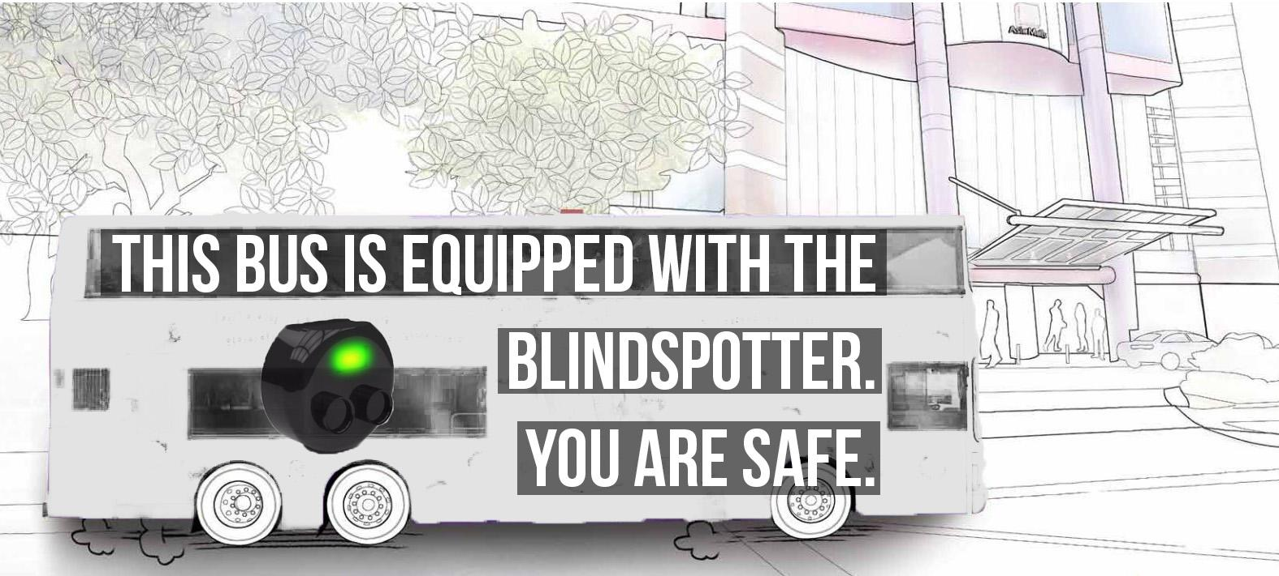

**Pricing Strategy**

*Value-based pricing strategy*

The goal of value-based pricing is to find out how our customers value our product. The most common way is for them to compare with an existing and similar product and determine if the difference in price makes sense for them to purchase.

*Framework*

|  |  |
| --- | --- |
| Aim: | Find out the value of our product to our customer |
| Method: | Compare our product with a close competitor and let our customers choose which to buy |
| Analysis: | From this survey, we can find out how much our customers value our product and also the reason why he/she values the other products more |
| Recalibrate: | This process is iterative and we would have to tweak our price up or down based on our experience and judgement |

*Cost-based pricing strategy*

Cost-based pricing strategy can be separated into full cost pricing and direct-cost pricing. For full cost pricing, it takes into consideration both variable, fixed costs and a percentage markup. As for direct-cost pricing, it considers variable costs plus a percentage markup.

*Final Pricing Strategy*

We are not implementing a cost-based pricing strategy because it restricts the amount of upside potential revenue that we can achieve through value-based pricing. Value-based pricing strategy is more appropriate because it is more accurate but more difficult to implement because it requires more market research to be done. However, our strategy should also take into account the fact that our pricing should be higher than our costs. Thus, our strategy involves finding out the customers’ perception of our product and then pricing it with the costs in mind.

**Revenue Forecast**

We have decided to go ahead with the bottom-up approach because it is more practical to calculate our revenue based on real values of average sales figures instead of a zoom-in estimation of the potential market we can capture. Top-down approach is not reliable as we do not want to fall into the trap of being too optimistic with our forecasting. However, using a bottom-up approach will mean that projections are kept minimal and so we have to look into other areas of the market to grow our numbers and increase our exposure to the market.

**Risk Management**

It is acknowledged that the company might be faced with these potential challenges:

1. Influx of New Cars with in-built monitoring system
2. The rise of very similar products
3. Poor Sales

*Influx of New Cars with in-built monitoring system (Event A)*

It is noted that if the in-built Blind Spot Monitoring System is fully rolled out to all car models, the demand for the BlindSpotter would be at risk of being phased out. We note that this is however unlikely to occur in reality due to the cost-prohibitive nature of the blind spot monitoring system which not only adds complexity but also additional costs for the driver. Also, since the in-built Blind Spot Monitoring System is a relatively new feature in cars, it will take a substantial amount of time before it becomes common technology in roads worldwide.

*The rise of very similar products (Event B)*

The rise of products from the company’s competitors would be one that the team will have to be very wary of. This particular challenge emphasises the need to constantly innovate to adapt to the changing needs of the market. As such, constant R&D to include differentiated features, accessories or augmented features will be conducted so as to provide the company with the competitive advantage over the rest of the market. As part of risk prevention strategy, the team will be filing for patents prior to the launch of the BlindSpotter to prevent technology theft.

*Poor Sales due to Commoditization (Event C)*

As part of a product’s life cycle in the maturity or decline phase, the BlindSpotter might be faced with the blight of commoditization where the company will be competing on price against other market players. In order to mitigate such risks, there is thereby the need to constantly innovate and improve the BlindSpotter. As the company has already filed for patents to protect the intellectual property of our trade, the likelihood of the occurrence of this risk is low right at the moment. Furthermore, the team can explore expansion to different markets and potentially exit strategies.

In light of this, the Failure Mode Effects Analysis (FMEA) for the business is plotted as shown:

*Likelihood*

|  |  |  |  |  |  |  |
| --- | --- | --- | --- | --- | --- | --- |
| 5 |  |  |  |  |  |  |
| 4 |  |  | **B** |  |  |  |
| 3 |  |  |  |  | **C** |  |
| 2 |  |  |  |  |  |  |
| 1 |  |  |  | **A** |  |  |
|  | 1 | 2 | 3 | 4 | 5 | *Impact* |

The Risk Response Matrix for the business is as shown:

|  |  |  |  |
| --- | --- | --- | --- |
| **Risk Event** | **Response** | **Contingency Plan** | **Trigger** |
| Influx of New Cars with in-built monitoring system | Continuous R&D | Exit Strategies | Introduction of new line of cars |
| The rise of very similar products | Continuous R&D | Price war to price out the entrant | New entrants into the market |
| Poor Sales due to Commoditization | Expansion Plans | Exit Strategies | End of Patent Period |

**OVERVIEW OF PRODUCTS AND ROADMAPS**

**Team Expertise**

The company has a strong R&D team with the technical expertise to conduct rapid prototyping and quick CAD sketches so as to test out design concepts. This is made possible by Sherwin’s experience in the nano-electronics industry for 10 years with countless patents to his name. This expertise will allow us to shrink and combine technologies into useful and miniaturized sizes. This capability allows us to innovate continuously to provide good products. Furthermore, Joo Chuen’s experience and expertise of 10 years in mass-manufacturing allows the company to reduce costs by designing products that are ready for manufacturing. Finally, Wong Chong’s expertise in aesthetics also means that we can continue to cut costs by designing the aesthetics in house. Altogether, these expertises enable the company to cut costs by undertaking the innovation, manufacturing design and the design of the product before it is sent for mass-production.

**Current Status**



At the current stage of Research & Development (R&D), the team has incorporated these elements into the BlindSpotter:

1. Binary indication of presence of obstructions in the blind spots
2. Solar-charging technology

**Expansion Plans**

In light of the similarity in demographics to the Singaporean market, and the close proximity to the location of the company’s warehouse in Shenzhen, China, we plan to expand the business to these locations: Guangzhou, Seoul and Tokyo within the next 5 years.

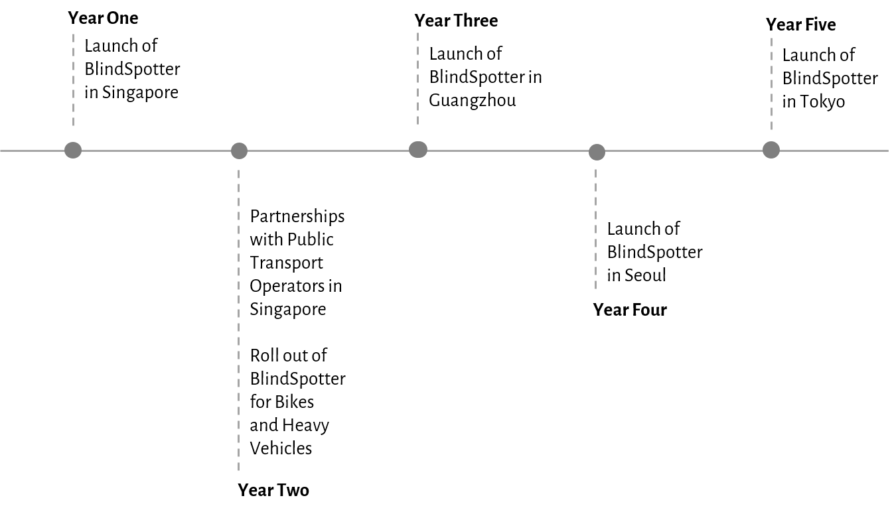

The decision to launch the BlindSpotter in Singapore is the result of the acknowledgement that the context of the product was first based on the Singaporean market as per the customer interviews performed. The BlindSpotter during the first year of its launch will be targeting the market for private cars in recognition of the more receptive response from private car owners in Singapore. During this time, the company will also be applying for considerations with the Land Transport Authority of Singapore to implement the installation of the BlindSpotter on all vehicles in a bid to improve road safety in Singapore.

In Year 2, the company will be partnering with public transport operators (SBS Transit and SMRT) in Singapore to roll out the installation of the BlindSpotter on their fleets of buses with the use of a subscription-based strategy. In the same year, the BlindSpotter would have already been upgraded to include functionalities and specifications for use by heavy vehicles and motorcycles.

In the third year since its inception, the BlindSpotter penetrates the China market from Guangzhou in Year 3, Korea from Seoul in Year 4 and Japan from Tokyo in Year 5. Given the similarity between the demographics between these countries and that of Singapore’s, we would be better able to predict demand which minimises uncertainty in our business by penetrating these markets. Furthermore, their proximities to our warehouse in Shenzhen is also vital as from an operational point-of-view, there would be significant reduction in freight and distribution costs for our business if these Asian countries were first penetrated.

Plans for further expansion towards the West would not be considered during the infancy of the business due to the high risks and operational costs involved.

**Product Roadmap**

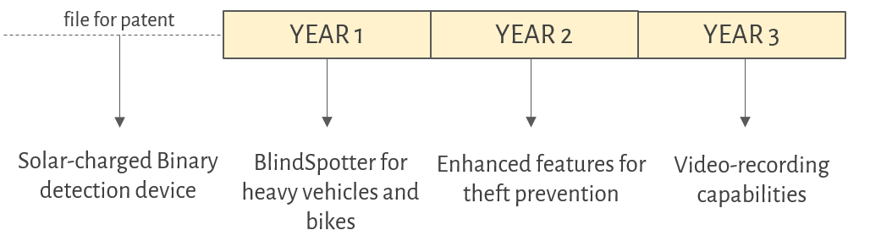

As part of R&D, we will be developing an adaptation of the BlindSpotter for heavy vehicles and bikes in Year 1 for roll out in Year 2. Prior to the expansion in the business outreach to Guangzhou in Year 3, there will be R&D to develop enhanced features for theft prevention. Furthermore, video-recording capabilities will be developed in Year 3 so as to keep to the changing needs of the market.

The Product Roadmap drafted at the current moment is a 3-year projection of the design direction of the company. Future design directions will be updated as the business grows to cater to the changing needs of the market.

**Proprietary Status of Technology**

The company has filed for a patent with the Intellectual Property Office of Singapore, and is currently awaiting the approval of the patent application which is estimated to come in prior to the launch.

We will begin processing the documents for patent applications for the upgraded version of the BlindSpotter in the second year for Singapore, Japan and Korea.

**SUMMARY OF MANUFACTURING AND OPERATIONS**

**Manufacturing Strategy**

The company has complete access to a prototyping facility based in Singapore, to tap on the research and development expertise available in the country. Furthermore, having a research facility based in Singapore allows research and testing of new products to be done in-house.

However, the company does not own any mass-manufacturing equipments and will not acquire any because it will be too risky for a start-up company to acquire huge amounts of long-term assets during its infancy. Instead, the company will be outsourcing the manufacturing of her products to contract manufacturers who will be required to adhere to the Six Sigma Statistical Process Control standard which will keep the defect rate below 0.00034%. This meant that the company is expecting a defect rate goal of 3.4 defects per million products, which will greatly reduce the cost of defect for the company.

Depending on the complexity and novelty of the technology, key components will be manufactured in-house so as to maintain quality and prevent technology theft.

**Core Competencies**

The company has expertise in miniaturizing existing technology, as well as designing components that can be manufactured at the best price. This allows the company to churn out designs that are proprietary and difficult to counterfeit. This sets us apart from our competitors and also gives us an edge for our product.

**Manufacturing Costs**

One blind-spot detector consists of the following parts (with approximate raw price for each component):

1. LED - USD$0.05
2. Ultrasonic sensors - USD$0.80
3. 3V Lithium-ion Battery - USD$5.00
4. Solar-panel - USD$5.00
5. Plastic Housing - USD$0.20

In establishing a long term relationship with the contract manufacturers, the company plan to negotiate a sustainable pricing for both parties at $12.83 after taking into account workmanship costs and profitability for the contract manufacturers.

**Inventory Planning**

Presently, the company is employing the use of the Base-Stock model for our build-to-order policy during the infancy stage of her operations as this model takes into account the replenishing of inventory once a BlindSpotter is sold. The company would also be carrying some stock of the BlindSpotter in order to meet demand promptly.

We would be batch-ordering when the business is expected to pick up in future. Taking into account inventory costs and the cost of setting up the production line for each batch of production, the company will engage contract manufacturers to produce the products in big batches.

The Wagner-Whitin Model will be one that will be used by the company that allows for batch-ordering while balancing setup and inventory costs.

**Distribution Strategies**

For future expansion considerations, the company is negotiating the renting of a warehouse based in Shenzhen to tap on the existing distribution network that China already has, to hold onto the inventory before sale.

**FINANCIALS**

**Balance Sheet**

|  |  |  |  |  |  |
| --- | --- | --- | --- | --- | --- |
| **(In thousands) (in USD)** | **Year 1** | **Year 2** | **Year 3** | **Year 4** | **Year 5** |
| **Assets** |  |  |  |  |  |
| Cash | 372.30 | 792.14 | 1984.09 | 4203.80 | 10204.76 |
| Accounts Receivables | 200.00 | 400.00 | 430.00 | 300.00 | 230.00 |
| Net Inventory | 200.00 | 600.00 | 1300.00 | 2400.00 | 5000.00 |
| Total Current Assets | 772.30 | 1792.14 | 3714.09 | 6903.80 | 15434.76 |
|  |  |  |  |  |  |
| Total Property, Plant & Equipment | 430.00 | 1000.00 | 2540.00 | 9450.00 | 11234.00 |
| Other Long Term Assets | 0.00 | 0.00 | 0.00 | 0.00 | 0.00 |
| Total Assets | 1202.30 | 2792.14 | 6254.09 | 16353.80 | 26668.76 |
|  |  |  |  |  |  |
| **Liabilities and Stockholders Equity** |  |  |  |  |  |
| Accounts Payable | 100.00 | 300.00 | 400.00 | 400.00 | 200.00 |
| Accrued Expenses | 100.00 | 300.00 | 350.00 | 400.00 | 100.00 |
| Taxes Payable | 0.00 | 0.00 | 0.00 | 0.00 | 0.00 |
| Short-Term portion of Long-Term Debt | 0.00 | 0.00 | 0.00 | 0.00 | 0.00 |
| Total Current Liabilities | 200.00 | 600.00 | 750.00 | 800.00 | 300.00 |
|  |  |  |  |  |  |
| Warranty Reserve | 0.71 | 2.32 | 5.78 | 12.39 | 21.12 |
| Long-Term Debt | 0.00 | 0.00 | 0.00 | 0.00 | 0.00 |
| Total Liabilities | 200.71 | 602.32 | 755.78 | 812.39 | 321.12 |
|  |  |  |  |  |  |
| **Stockholder's Equity** |  |  |  |  |  |
| Preferred Stock | 0.00 | 0.00 | 0.00 | 0.00 | 0.00 |
| Common Stock | 0.00 | 0.00 | 0.00 | 0.00 | 0.00 |
| Additional Paid-in Capital | 100.00 | 100.00 | 100.00 | 100.00 | 100.00 |
| Owners Equity | 130.00 | 130.00 | 130.00 | 130.00 | 130.00 |
| Retained Earnings | 771.59 | 1959.83 | 5268.31 | 15311.40 | 26117.64 |
| Total Stockholders' Equity | 1001.59 | 2189.83 | 5498.31 | 15541.40 | 26347.64 |
|  |  |  |  |  |  |
| Total Liabilities and Stockholders Equity. | 1202.30 | 2792.14 | 6254.09 | 16353.80 | 26668.76 |

**Cash Flow Statement**

|  |  |  |  |  |  |
| --- | --- | --- | --- | --- | --- |
| **(In thousands) (in USD)** | **Year 1** | **Year 2** | **Year 3** | **Year 4** | **Year 5** |
|  |  |  |  |  |  |
| **Cash Flows from Operating Activities** |  |  |  |  |  |
| Net Income | 771.59 | 1188.24 | 3308.49 | 10043.09 | 10806.23 |
| Depreciation Expense | 0.00 | 0.00 | 0.00 | 0.00 | 0.00 |
|  |  |  |  |  |  |
| **Changes in working capital accounts** |  |  |  |  |  |
| Changes in Accounts Receivables | -200.00 | -200.00 | -30.00 | 130.00 | 70.00 |
| Changes in Net Inventory | -200.00 | -400.00 | -700.00 | -1100.00 | -2600.00 |
| Changes in Accounts Payable | 100.00 | 200.00 | 100.00 | 0.00 | -200.00 |
| Changes in Accrued Expenses | 100.00 | 200.00 | 50.00 | 50.00 | -300.00 |
| Changes in Taxes Payable | 0.00 | 0.00 | 0.00 | 0.00 | 0.00 |
| Changes in Warranty Reserve | 0.71 | 1.61 | 3.46 | 6.62 | 8.73 |
| **Changes in working capital** | -199.29 | -198.39 | -576.54 | -913.38 | -3021.27 |
| **Total adjustments to net income** | -199.29 | -198.39 | -576.54 | -913.38 | -3021.27 |
| Total Cash Flows from Operations | 572.30 | 989.85 | 2731.94 | 9129.71 | 7784.96 |
|  |  |  |  |  |  |
| **Cash Flows from Investing Activities** |  |  |  |  |  |
| Changes in Total Property, Plant & Equipment | -430.00 | -570.00 | -1540.00 | -6910.00 | -1784.00 |
| Total Cash Flows from Investing Activities | -430.00 | -570.00 | -1540.00 | -6910.00 | -1784.00 |
|  |  |  |  |  |  |
| **Cash Flows from Financing Activities** |  |  |  |  |  |
| Additional Paid-in Capital | 100.00 | 0.00 | 0.00 | 0.00 | 0.00 |
| Owners Equity | 130.00 | 0.00 | 0.00 | 0.00 | 0.00 |
| Total Cash Flows from Financing Activities | 230.00 | 0.00 | 0.00 | 0.00 | 0.00 |
|  |  |  |  |  |  |
| Net change In Cash | 372.30 | 419.85 | 1191.94 | 2219.71 | 6000.96 |
|  |  |  |  |  |  |
| Cash Beginning of year | 0.00 | 372.30 | 792.14 | 1984.09 | 4203.80 |
| Cash, End of year | 372.30 | 792.14 | 1984.09 | 4203.80 | 10204.76 |

**Income Statement**

|  |  |  |  |  |  |
| --- | --- | --- | --- | --- | --- |
| **(In thousands) (in USD)** | **Year 1** | **Year 2** | **Year 3** | **Year 4** | **Year 5** |
| Product Sales | 2619.98 | 5968.40 | 12800.40 | 24512.40 | 32320.40 |
| Service Revenue | 0.00 | 0.00 | 0.00 | 3934.81 | 1934.81 |
| Total Revenue | 2619.98 | 5968.40 | 12800.40 | 28447.21 | 34255.21 |
|  |  |  |  |  |  |
| **Cost of Sales** |  |  |  |  |  |
| Product Cost | 840.36 | 1914.36 | 4105.73 | 7862.35 | 10366.77 |
| Service Cost | 200.00 | 455.61 | 977.14 | 1871.19 | 2467.22 |
| Total Cost of Sales | 1040.36 | 2369.97 | 5082.86 | 9733.54 | 12833.99 |
| Gross Margin | 1579.62 | 3598.43 | 7717.53 | 18713.67 | 21421.22 |
|  |  |  |  |  |  |
| **Operating Expenses** |  |  |  |  |  |
| Research and Development | 50.00 | 800.00 | 800.00 | 1000.00 | 1000.00 |
| Sales, General & Administrative | 600.00 | 1366.82 | 2931.41 | 5613.56 | 7401.66 |
| Total Operating Expense | 650.00 | 2166.82 | 3731.41 | 6613.56 | 8401.66 |
|  |  |  |  |  |  |
| Income Before Interest and Taxes | 929.62 | 1431.61 | 3986.13 | 12100.11 | 13019.56 |
| Tax Expense | 158.04 | 243.37 | 677.64 | 2057.02 | 2213.33 |
|  |  |  |  |  |  |
| Net Income | 771.59 | 1188.24 | 3308.49 | 10043.09 | 10806.23 |

**Underlying Business Assumptions**

In calculating the financials of the company, the following assumptions were made:

1. *61% of car users will purchase our product in 5 years.*

This means that the total amount of units sold in one country will be equivalent to 12.2% of the vehicle population in one year. This is a valid assumption based on the customer interview, which found that 61% of car users will buy our product at $40.

1. *Licensing fee for the product is at $1,000,000 upfront fee, followed by 20 cents for every car sold*

The company will start licensing the product for large car companies such as Honda and Nissan in the 4th year of operation.

1. *Product will be made mandatory for all Buses and Taxis in Singapore.*

The company will sell the product to all Bus and Taxi companies in the 2nd year of operation, hence getting a source of recurring income from such companies.

1. *Product suited for all vehicles will be developed after the launch of the first one.*

The company will sell the product to Motorbikes and Heavy Vehicles in the 2nd year of operation, with the same assumption that 12.2% of the vehicles will purchase the product every year.

1. *Expansion to different countries will be carried out from 3rd year onwards.*

The company will expand to Guangzhou in the 3rd year, Seoul in the 4th and Tokyo in the 5th, with the same assumption that 12.2% of the vehicles in that country will purchase the product every year.

|  |  |  |  |  |  |
| --- | --- | --- | --- | --- | --- |
|  | **Year 1** | **Year 2** | **Year 3** | **Year 4** | **Year 5** |
| **Number of units sold** | 65500 | 149210 | 320010 | 612810 | 808010 |
| **Tax Rate** | 0.17 | 0.17 | 0.17 | 0.17 | 0.17 |
| **Price per unit(USD)** | 40.00 | 40.00 | 40.00 | 40.00 | 40.00 |
| **Cost per unit(USD)** | 12.83 | 12.83 | 12.83 | 12.83 | 12.83 |
| **Number of Cars in Singapore** | 536882 | 536882 | 536882 | 536882 | 536882 |
| **Number of Buses and Taxis** | 46290 | 46290 | 46290 | 46290 | 46290 |
| **Number of Heavy vehicles and Motorbikes** | 306724 | 306724 | 306724 | 306724 | 306724 |
| **Number of cars in Guangzhou** | 1400000 | 1400000 | 1400000 | 1400000 | 1400000 |
| **Number of cars in Seoul** | 2400000 | 2400000 | 2400000 | 2400000 | 2400000 |
| **Number of cars in Tokyo** | 1600000 | 1600000 | 1600000 | 1600000 | 1600000 |

**Exit Strategies**

When there is the need for exit strategies, the company will be considering:

1. *Merger & Acquisition*

When there is opportunity of M&A with automobile manufacturer companies such as Nissan and Honda, we consider it as a win-win situation where we would leverage on the pre-existing infrastructure of such companies to minimise the cost by taking advantage of the economies of scale derived from the M&A.

1. *Liquidation & Close*

We can also consider liquidating the assets of the company in the event that there is no longer any market for this business or when it is simply not profitable to continue the business.

The shutdown point will occur when the marginal revenue of the company is below the the average variable cost.

**MANAGEMENT TEAM BIOGRAPHY**

The management team is made up of individuals with diverse skills and talents.



**Wong Chong** has an acute sense of design and has had many years of experience in product design. He value-adds by making sure that our product is aesthetically pleasing and differentiating. In addition to that, he has also had countless start-up companies under his name. His experience and expertise is crucial in bringing the company out the start-up’s infancy.

**Sherwin** is an electronic engineer by training but is no less skilled on the mechanical aspects. His wide knowledge on electrical and mechanical engineering is something that he uses to create innovative products such as the BlindSpotter. His expertise in product innovation is the core driving force in the company.



**Joo Chuen** is a mechanical engineer and has experience in the manufacturing field. His mechanical background complements with Sherwin’s electronic background to produce a technically sound product. His vast experience in the manufacturing field also ensures that his products are practical designs that can be mass-manufactured.



**Jing Jie** has spent many years in Corporate Finance, especially in M&A and developing innovative strategies for the company. He has successfully set-up a few startups that has a global presence and is currently helping to groom the next generation of technology leaders. His expertise and experience is extremely valuable in expanding the company.



**Evelyn** is a quant who specialises in Operations Management and with her many years spent in several Fortune Global 500 companies, her input will be highly regarded. She will be handling the operations of the company and also coming up with complex mathematical models for sales and revenue. She has been known in the industry to run businesses very efficiently and productively.

1. "The auto accessories market at a glance - Insignia Group." 2015. 21 Apr. 2016 <<http://www.insigniagroup.com/blog/a-quick-overview-of-the-auto-accessories-market>>
2. Area, M. "Key Transport Statistics of World Cities - Land Transport ..." 2014. <<http://www.lta.gov.sg/ltaacademy/doc/13Sep105-Pan_KeyTransportStatistics.pdf>>
3. "COE Prices (1990 to Present) - tralvex.com." 2010. 21 Apr. 2016 <<http://tralvex.com/coe/>>
4. "Cars with Blind Spot Monitoring (standard) - AxleGeeks." 2015. 22 Apr. 2016 <<http://cars.axlegeeks.com/d/s/Blind-Spot-Monitoring>>
5. "Inbound Leads Cost 61% Less Than Outbound [New Data]." 2012. 22 Apr. 2016 <<http://blog.hubspot.com/blog/tabid/6307/bid/31555/Inbound-Leads-Cost-61-Less-Than-Outbound-New-Data.aspx>>