**2.5 I can change the file formats of documents appropriately for content**

During the course of website design, developers and designers alike are going to employing a number of different types of software, open-source and proprietary software (closed-source).

Common to designing ands web development are tools such as Inskscape, Gimp, Microsoft Paint amongst many others. Each of these tools will often save files in different formats, as discussed in unit 1.7

For uniformity and consistency its always prudent and efficient to save common occurring files such as images into a singular format, with.png being the de facto. Below is an example of saving an image file into a png files of which I can easily use in Visual Studio 2019 when writing my HTML code.

PNG- Portable Network Graphic files enable the user to save images and graphics. They enable the user to save high quality images.

**Inkscape**



Open Inkscape and proceed to draw an image. In this example of have utilised Inkscape to draw my navigation buttons as shown below.



With many operations users will attempt to save the image or file using the ‘save as function;

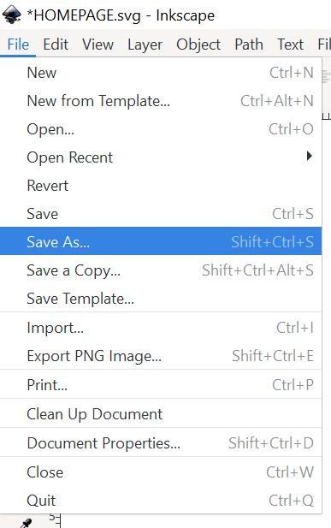

However there are limitations on the basis that this option does not allow the user to save the file in the desired format (png).

**Export Files to png**

Firstly to begin to export to the file tool bar and select ‘Export PNG Image

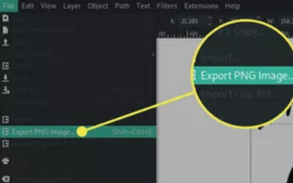

In the Export area you can select the elements of the image. The options include;

Drawing, Page (export the page area), Custom (select specifics by specifying coordinates from corner to corner.

Inscape also enables the user to export size and resolution of the file such as pixel rates.

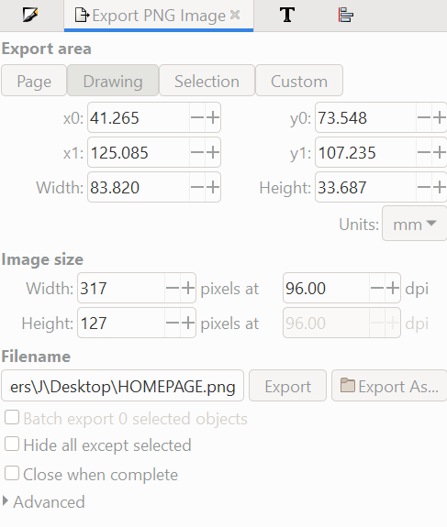

Finally the user will be able to chose location of where to save the file and name the file according to the project they are working on.

To complete the export select the .Export button, and this completes the process.