**Home Page**

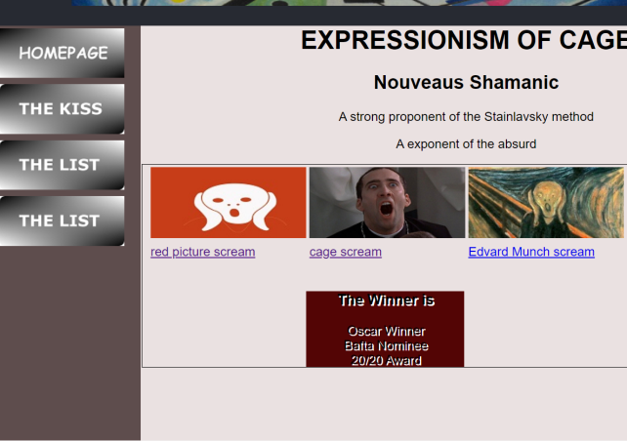

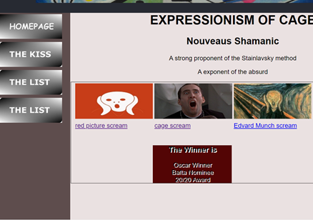

**Top: Chrome**

**Bottom: Edge**

**Home Page Test**

|  |  |  |  |  |
| --- | --- | --- | --- | --- |
| Test Number | Item being tested | Expected result | Actual result | Action |
| 1 | Page open | Page to open | Opens |  |
| 2 | Page close | Page to close | Closes |  |
| 3 | Navigation button home page | Go-to home page | Links |  |
| 4 | Navigation button page two-the kiss | Go-to page to one  The Kiss | Links |  |
| 5 | Navigation button page – the list | Goes to page | Links |  |
| 6 | Navigation-the list | Goes to page | Links |  |
| 7 |  |  |  |  |
| 8 | Click on thumbnail image | Larger image to appear | Only small appears | Missing thumbnail.png *-x3 |
| 9 | Header include banner | Top of page/position | Exactly where it should be |  |
| 10 | Footer | Botton of page | Where is should be | Change width to make it slimmer |

**Contact Page**

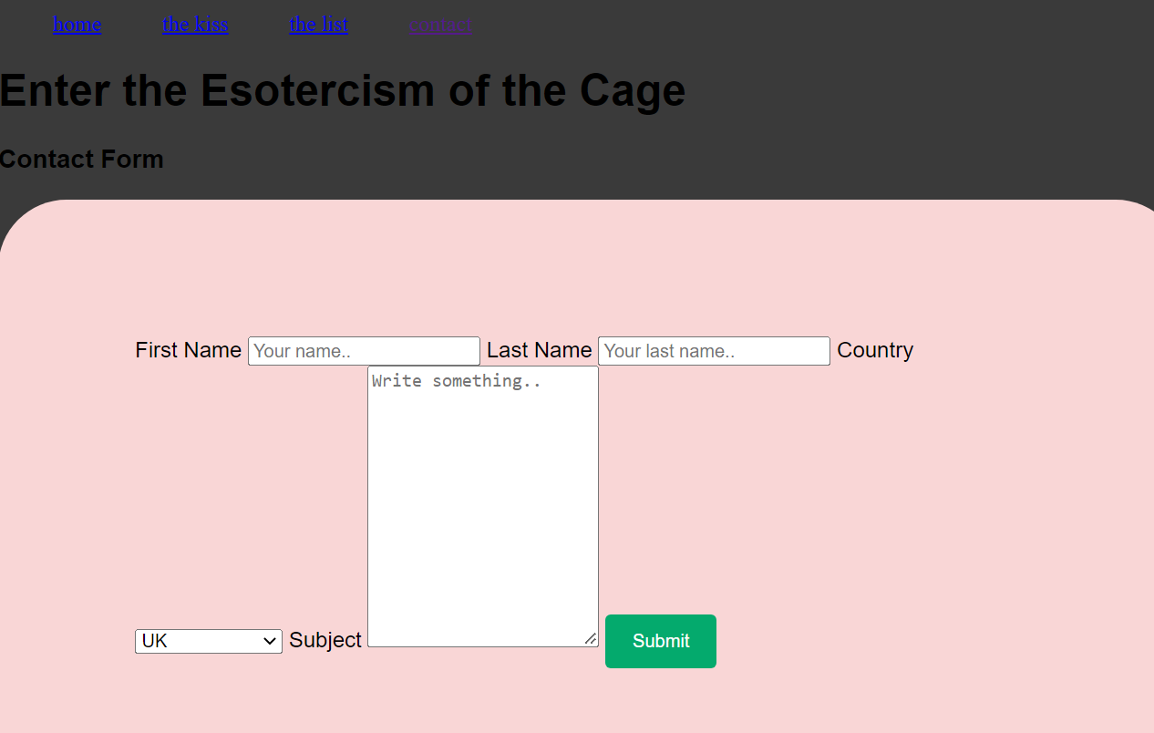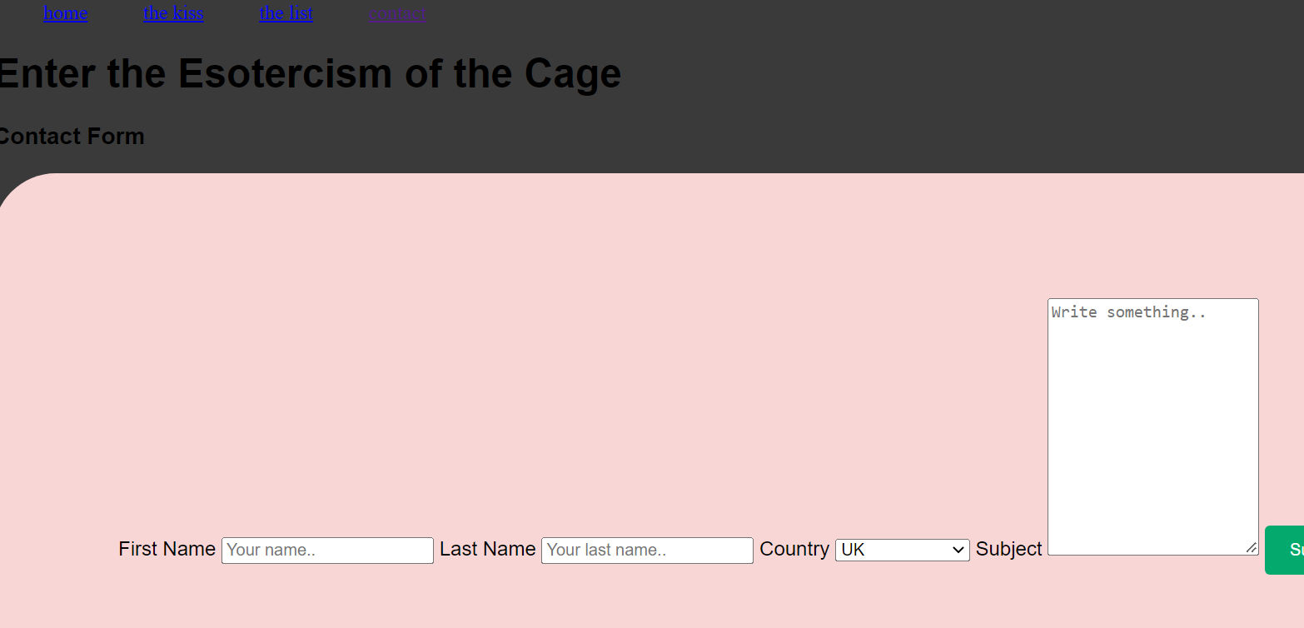

|  |  |  |  |  |
| --- | --- | --- | --- | --- |
| Test Number | Item being tested | Expected result | Actual result | Action |
| 1 | Page open | Page to open | Opens-Chrome. Edge |  |
| 2 | Page close | Page to close | Closes- chrome. Edge |  |
| 3 | Navigation button home page | Goes to page | Links | Requires buttons |
| 4 | Navigation button page 1 | Goes to page | Links | Requires buttons |
| 5 | Navigation Button page 2 | Goes to page | Links | Requires buttons |
| 6 | Navigation button page 3 | Goes to page | Links | Requires buttons |
| 7 | Header |  |  | Requires CC |
| 8 | Footer | Bottom of page | None | Insert Footer |
| 9 | Contacts Table | Correct size and colour | Too big, colouring poor, country list ltd | CSS, including content size. Add counties |
|  |  |  |  |  |