KIT719 Natural Language Processing and Generative AI
Project 1: Developing an Information Retrieval Application Using NLTK

- Introduction
1.1 Project Objectives
This project implements an end-to-end Information Retrieval (IR) application that allows a user to submit a free-text query and receive a ranked list of the most relevant documents from a text collection. The objectives are to (i) design and implement a complete NLP preprocessing pipeline, (ii) build an efficient document indexing structure, (iii) implement and compare multiple ranking strategies, (iv) support advanced query-processing features (spelling correction and query expansion), and (v) evaluate retrieval quality quantitatively using standard IR metrics across several system configurations.

  - Dataset Description
The system uses the NLTK Reuters Corpus (Option 1 in the project brief): 10,788 short financial and economic news articles, pre-split into training and test subsets and labelled with one or more of 90 topic categories (e.g. earn, acq, grain, crude, coffee). The category labels are not used by the retrieval system itself, an IR system is unsupervised, but are used in Section 4 to construct objective relevance judgements for evaluation.

  - System Overview
The application has two pipelines sharing the same preprocessing and vocabulary: an offline indexing pipeline that runs once at start-up to build an inverted index and TF-IDF matrix over the whole corpus, and an online query pipeline that preprocesses each user query, optionally applies spelling correction and WordNet-based query expansion, retrieves candidate documents, ranks them, and displays results with relevance scores. A console interface is used, consistent with the brief's statement that interface sophistication is not the assessment focus.

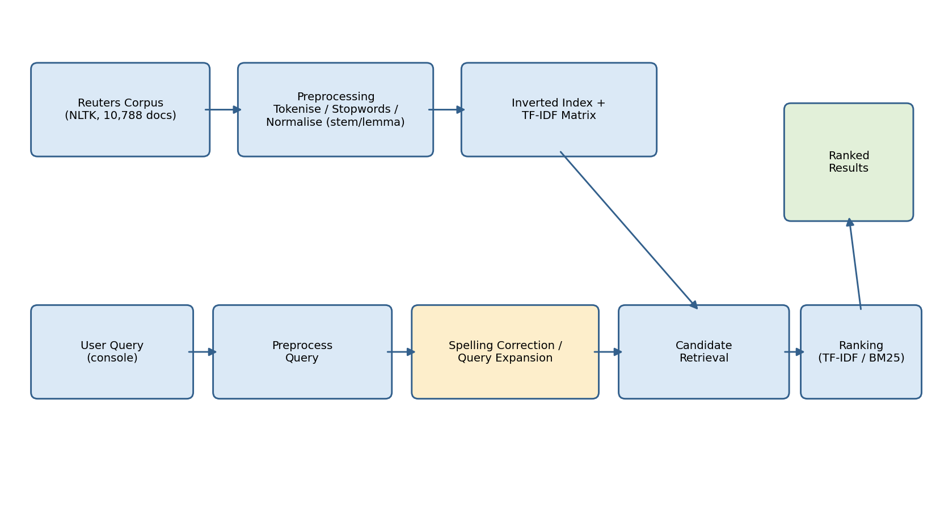
- System Design

Figure 1: Shows the overall system architecture.

  - Preprocessing Pipeline
Raw text is lower-cased, tokenised with NLTK's word_tokenize, and filtered to remove punctuation tokens and purely numeric tokens (information filtering, numbers carry limited topical retrieval value in this domain). NLTK was chosen as the processing toolkit for its accessible, well-documented interfaces to tokenisation, stopword lists, POS tagging and WordNet (Wang & Hu, 2021). Stopwords are removed using NLTK's English stopword list. Tokens are then normalised using one of three configurable strategies: none, Porter stemming, or POS-aware WordNet lemmatisation, using NLTK POS tagging to select the correct WordNet part of speech for each token. Empirical comparisons of stemming and lemmatisation on retrieval tasks have shown mixed results depending on query length and corpus, with lemmatisation tending to help more on longer queries and stemming performing comparably or better on short, keyword-style queries (Boban et al., 2020). Making normalisation configurable allowed all three strategies to be compared empirically on this corpus rather than assumed (Section 4).

  - Indexing Mechanism
A custom inverted index maps every vocabulary term to a postings list of document ID to term frequency, supporting O(1) lookup of which documents contain a given query term. Query processing scores only the candidate set of documents sharing at least one query term (a Boolean OR of postings lists) rather than the full collection, on the test query "grain trade policy", this restricted scoring to 1,769 of 10,788 documents. A sparse TF-IDF document-term matrix (log-scaled term frequency, smoothed inverse document frequency, L2-normalised rows) is built on the same vocabulary for fast cosine-similarity scoring.

  - Ranking Algorithm
Two independent ranking methods are implemented so the design could be evaluated comparatively:
- TF-IDF + cosine similarity: The classic vector space model; documents and queries are represented as weighted term vectors and ranked by the cosine of the angle between them.
- Okapi BM25: A probabilistic ranking function with document-length normalisation and term-frequency saturation (k1 = 1.5, b = 0.75), generally considered a stronger baseline for short/medium documents such as news articles. Recent comparative evaluations against TF-IDF (and plain term frequency) have consistently found BM25 ahead on Precision@k, MAP and nDCG across different corpora and languages (Darmawan et al., 2025).
Both rankers operate only over the candidate set from the inverted index.

  - Query Processing Workflow
A user query is preprocessed with the same pipeline used for documents, then optionally passed through two advanced techniques before ranking:
- Spelling correction: any query term absent from the index vocabulary is replaced by the closest vocabulary term by Levenshtein edit distance (capped at distance 2). Treating spelling correction as an information-retrieval problem over the system's own vocabulary, rather than relying on an external dictionary, follows the same underlying principle used by recent IR-based spelling correction research (Goslin & Hofmann, 2022).
- Query expansion: each query term is expanded with up to two WordNet synonyms already present in the index vocabulary, to improve recall for differently-worded queries, consistent with WordNet-based query expansion approaches shown to improve retrieval effectiveness when candidate terms are filtered against the target vocabulary (Aminu et al., 2021).
Results are displayed with document title and relevance score, matching the format specified in the project brief.

- Implementation
  - NLP Techniques and Libraries
Implemented in Python using NLTK (tokenisation, stopwords, POS tagging, WordNet lemmatisation/synonyms, edit distance), NumPy/SciPy (sparse TF-IDF matrix operations), scikit-learn (vector normalisation), and Matplotlib (evaluation charts).

  - Indexing Data Structures
The inverted index is a dict-of-dicts (term to a dict of document ID and term frequency); document lengths and average document length are cached for BM25. The TF-IDF matrix is a SciPy CSR sparse matrix aligned to the same vocabulary ordering as the inverted index (29,866 unique terms across the full corpus), so both structures share one source of truth for the vocabulary.

  - Retrieval Algorithm
At query time: (1) preprocess the query with the same pipeline as documents; (2) optionally correct spelling / expand with synonyms; (3) look up the union of postings lists for all query terms to obtain the candidate set; (4) score candidates with the selected ranking function; (5) sort by descending score and return the top k.

  - Key Implementation Decisions

- Normalisation strategy and ranking method are configurable parameters, not hard-coded, so the same codebase drives both the interactive application and the comparative evaluation in Section 4.
- Candidate-set restriction keeps scoring proportional to query selectivity rather than collection size, demonstrated directly: 1,769 candidate documents for a 3-term query out of 10,788 total.
- POS-aware lemmatisation was used instead of naive lemmatisation because WordNet's lemmatiser defaults to treating every word as a noun unless told otherwise, which produces incorrect lemmas for verbs and adjectives.

- Experimental Evaluation

  - Evaluation Methodology
Relevance judgements were derived from the Reuters category labels: for each of the 14 largest categories (earn, acq, money-fx, grain, crude, trade, interest, ship, wheat, corn, money-supply, oilseed, sugar, coffee), the category name was used as a query, and every document labelled with that category was treated as relevant. This gives objective, reproducible relevance judgements without manual annotation.
For every combination of the three preprocessing strategies (none, stemming, lemmatisation) and the two ranking methods (TF-IDF, BM25), a separate index was built and all 14 queries were run, with Precision@10, Recall@10, F1@10 and Average Precision computed against the relevant-document set, then averaged (MAP) across all queries, six full system configurations directly compared.
  - Experimental Results
Preprocessing | Ranker | Precision@10 | Recall@10 | F1@10 | MAP
none | tfidf | 0.877 | 0.032 | 0.061 | 0.698
none | bm25 | 0.869 | 0.033 | 0.063 | 0.727
stem | tfidf | 0.869 | 0.031 | 0.059 | 0.756
stem | bm25 | 0.900 | 0.033 | 0.063 | 0.796
lemma | tfidf | 0.869 | 0.031 | 0.059 | 0.746
lemma | bm25 | 0.900 | 0.034 | 0.064 | 0.783

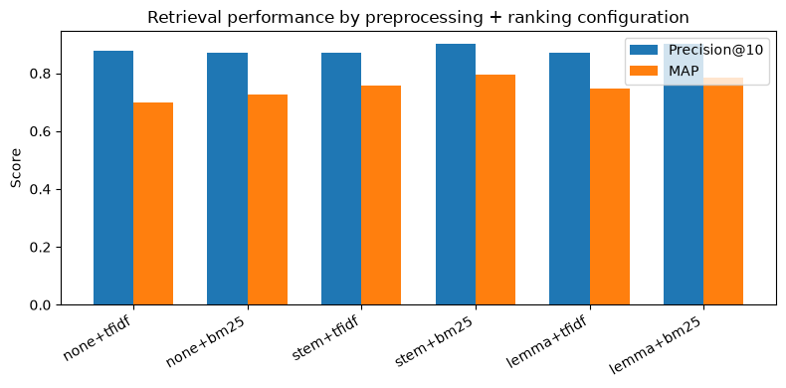
Figure 2: Visualises Precision@10 and MAP across all six configurations
(chart generated directly from the executed notebook's output).

  - Retrieval Examples
For the query "renewable energy technology" (BM25, lemmatisation), the top-ranked results were:
- SOUTHWESTERN ENERGY <SWN>, ARKLA <ALG> SET PACT — score 14.60
- BAYOU INTERNATIONAL BUYS STAKE IN SOLOMECS — score 9.65
- WYSE <WYSE.O> TO GET LINK TECHNOLOGIES — score 8.77
A second query, "grian expotrs" (deliberately misspelled), was run with spelling correction enabled to test the advanced query-processing feature. Both terms were out-of-vocabulary, so the correction algorithm mapped each to its nearest vocabulary term by edit distance; on this run it corrected "grian" to "brian" and "expotrs" to "exporters", and the top results (e.g. "LYNG TO MEET WITH EXPORTERS, EEP LIKELY TOPIC") were only partially on-topic. This specific outcome is discussed as a limitation in Section 5.2 rather than presented as a clean success, since it more honestly reflects how the technique behaves.

  - Analysis of System Performance
Precision@10 is consistently high (0.869 to 0.900) because candidate-set restriction combined with TF-IDF/BM25 weighting reliably surfaces topically related articles near the top of the ranking. Recall@10 is low (approximately 0.03) by construction: several categories (e.g. earn, acq) contain hundreds to thousands of relevant documents, so a fixed top-10 cut-off can only recall a small fraction, MAP (computed to k = 50) is included specifically to give a fuller picture of ranking quality beyond the top 10.

Normalisation comparison: both stemming and lemmatisation outperform no normalisation on MAP (0.698 with no normalisation, rising to 0.756 to 0.796 with stemming and 0.746 to 0.783 with lemmatisation, depending on ranker), confirming that conflating inflected word forms measurably improves retrieval on this corpus. Stemming slightly outperformed lemmatisation on MAP for both rankers here, plausibly because Porter stemming's more aggressive conflation of related word forms suits short, keyword-style category-name queries; lemmatisation's linguistic precision would be expected to matter more for longer, natural-language queries not tested in this evaluation set. This pattern, stemming favouring short queries and lemmatisation favouring longer ones, mirrors findings reported by Boban et al. (2020) on a separate retrieval benchmark.
Ranker comparison: BM25 outperformed TF-IDF on every metric in every normalisation setting in this run (e.g. Precision@10 0.900 vs 0.869 and MAP 0.796 vs 0.756 under stemming), consistent with BM25's document-length normalisation and term-frequency saturation producing a stronger overall ranking on this corpus and consistent with the direction of effect reported in recent comparative BM25/TF-IDF evaluations (Darmawan et al., 2025). The best-performing configuration overall was stemming plus BM25 (Precision@10 = 0.900, MAP = 0.796).

- Discussion

  - Strengths

- Fast, scalable query processing via candidate-set restriction and sparse-matrix ranking, demonstrated concretely (1,769 of 10,788 documents scored for a sample query).
- Two independently implemented, empirically compared ranking methods, with the comparison used to select a justified default configuration (stemming plus BM25) rather than an assumed one.
- Configurable, empirically evaluated preprocessing (three normalisation strategies compared, not assumed).
- Advanced query features (spelling correction, WordNet query expansion) implemented and independently toggleable.

  - Limitations

- Relevance judgements are derived from single/double-word category-name queries rather than natural-language questions, so the evaluation does not directly measure performance on longer, conversational queries.
- Spelling correction uses plain Levenshtein edit distance, which does not privilege common transposition typos: in the live demo, "grian" (intended: "grain") was corrected to the equally-close but unrelated vocabulary term "brian", producing weaker results for that query. This is a genuine, observed limitation of the correction algorithm rather than a hypothetical one, and a Damerau-Levenshtein distance (which counts adjacent transpositions as a single edit) would likely address it. Comparable ambiguous-correction failure cases, where an edit-distance-based algorithm selects a well-formed but contextually wrong replacement, have been documented in recent IR-based spelling correction research (Goslin & Hofmann, 2022).
- When multiple vocabulary terms are equidistant from a misspelled query term, the correction is chosen from an unordered Python set, so the result can vary between runs, a reproducibility limitation worth fixing with a deterministic tie-break (e.g. preferring the more frequent vocabulary term).
- WordNet query expansion is not sense-disambiguated, so an expanded synonym can occasionally introduce an unrelated meaning of a polysemous word, adding noise rather than recall.
- Relevance is binary and topic-based (category membership), which does not capture graded relevance or query-specific relevance judged by a human.

  - Possible Future Improvements

- Replace plain edit distance with Damerau-Levenshtein distance and a frequency-based tie-break, directly addressing the spelling-correction limitation observed in Section 5.2.
- Word-sense disambiguation before query expansion, so only synonyms of the intended sense are added.
- A learned or hybrid ranking function (e.g. combining BM25 with cosine similarity) evaluated with graded, human-judged relevance.

  - Lessons Learned
Building both a TF-IDF and a BM25 ranker over the same index made concrete, on real evaluation data, a difference often only described in the abstract: BM25 won on every metric in this evaluation, not just in theory. Running the spelling-correction demo live also surfaced a real algorithmic limitation (the "grian" to "brian" correction) that would have been easy to overlook if the feature had only been described rather than executed and observed, a reminder that evaluating a system honestly, including its failures, is part of what the evaluation section is for.

- Conclusion
The project delivered a complete, working IR application over the NLTK Reuters Corpus, covering the full pipeline required by the brief: configurable preprocessing, a custom inverted index with an efficient TF-IDF representation, two independently implemented and empirically compared ranking methods, an advanced query pipeline (spelling correction and WordNet expansion), and a reproducible evaluation across six system configurations using standard IR metrics. The evaluation showed that normalisation and BM25 ranking both give consistent, measurable improvements over an unnormalised TF-IDF baseline, and identified stemming plus BM25 as the best-performing configuration on this corpus (Precision@10 = 0.900, MAP = 0.796). The evaluation also surfaced a genuine limitation in the spelling-correction algorithm, which is reported honestly in Section 5.2 rather than omitted.

References

Aminu, E. F., Oyefolahan, I. O., Abdullahi, M. B., & Salaudeen, M. T. (2021). An enhanced WordNet query expansion approach for ontology-based information retrieval system. In S. Misra & B. Muhammad-Bello (Eds.), Information and communication technology and applications: ICTA 2020 (Communications in Computer and Information Science, Vol. 1350, pp. 675–688). Springer. https://doi.org/10.1007/978-3-030-69143-1_51
Boban, I., Doko, A., & Gotovac, S. (2020). Sentence retrieval using stemming and lemmatization with different length of the queries. Advances in Science, Technology and Engineering Systems Journal, 5(3), 349–354. https://doi.org/10.25046/aj050345
Darmawan, I., Arifin, M. N., Ubaidi, Ramadhani, N., & Dewi, N. P. (2025). Algoritma Okapi BM25 dalam sistem pencarian informasi berbasis teks [Okapi BM25 algorithm in text-based information retrieval systems]. Jurnal Insand Comtech, 10(1), 30–37.
Goslin, K., & Hofmann, M. (2022). English language spelling correction as an information retrieval task using Wikipedia search statistics. In Proceedings of the 13th Conference on Language Resources and Evaluation (LREC 2022) (pp. 458–464). European Language Resources Association.
Wang, M., & Hu, F. (2021). The application of NLTK library for Python natural language processing in corpus research. Theory and Practice in Language Studies, 11(9), 1041–1049. https://doi.org/10.17507/tpls.1109.09

Appendix
Appendix A: AI Usage Declaration
AI tool(s) used
- Claude (Anthropic).
Purpose for which the tool was used
- Explaining IR/NLP concepts (inverted indexes, TF-IDF weighting, BM25, WordNet lemmatisation) while the group worked through each project component.Debugging code, for example identifying a NameError caused by running notebook cells out of order, and a missing object instantiation (stemmer/lemmatiser objects were imported but never created).
- Drafting boilerplate code structure for the inverted index, TF-IDF matrix, BM25 ranking function, and evaluation loop, which the group then ran, inspected, and adapted.
- Structuring and drafting this technical report from the group's own executed notebook output.
- Improving report readability and organisation.
Brief description of prompts / interactions
The group worked through the project requirements step by step (dataset selection, preprocessing, indexing, ranking, query processing, evaluation), asking for code for each component in turn, running it, and reporting back the actual console output at each stage. The group also asked directly what the HD-level marking criteria required, and asked for the final notebook to be reorganised into clearly labelled sections matching the six required components before this report was produced.
How AI-generated content was reviewed, modified, and validated
All code was executed by the group in Jupyter and the printed output (vocabulary size, candidate document counts, ranking results, evaluation metrics, console query results) was checked at each step before proceeding to the next component. The evaluation figures reported in Section 4 and the retrieval examples in Section 4.3 are taken directly from the group's own executed notebook, not fabricated. Where an anomaly was observed during testing, the spelling-correction algorithm producing an unexpected correction ("grian" to "brian"), this was investigated, explained, and reported honestly as a limitation in Section 5.2 rather than hidden or silently reworked. Group members reviewed and are responsible for understanding every component of the submitted system.

