**Description about Dropbox 5 Test Scenario’s:-**

The 5 Test Scenarios created includes the 3 mandatory scenarios for this task.

**Pre-Requisites:-**You should have Selenium Webdriver, TestNG, Maven installed in your PC/Laptop.

The Scenarios/programs are copied in the notepad and listed as below. you can see the scenarios/programs in notepad++. However, creating a **Maven project** in selenium webdriver is better option.

1. **SignupWithGoogleTest** – Login to the application using Google sign in.
2. **LoginandLogOutTest** (Login-Logout Functionality) – Ensure for the first time it may ask for captcha before login so you have to manually pass through the captcha and next run you can run your automation test case successfully once captcha is passed through.
3. **UploadFileTest** (Upload File Functionality)
4. **CreateFolderTest** (Create Folder Functionality)
5. **DropboxBusinessTabsTest** (Navigation of Dropbox Tabs) – In this scenario I have navigated through Dropbox tabs and drop downs and checked page up and down scroll.
6. **Testing.xml** – I have created “testing.xml” file under Maven projects under “SRC/test/resources” in Maven. Ensure to remove the “<!-- -->” comments to run the test cases in the ‘class’ tags of the file
7. **POM.xml** – Pom xml file created under the project “MavenResults” is update with required dependencies and with ‘estng.xml file path to execute the test cases.

Test Scenario’s numbered **2,3,4** are the Mandatory Test Scenarios covered. You can see the notepad sent to you with same **naming conventions.**

The pom.xml and testing.xml files can be viewed for complete parameterisation done for all the above Test scenarios and ran successfully.

**Run in Selenium Webdriver: -**

1. Create a Maven Project with name “MavenResults”

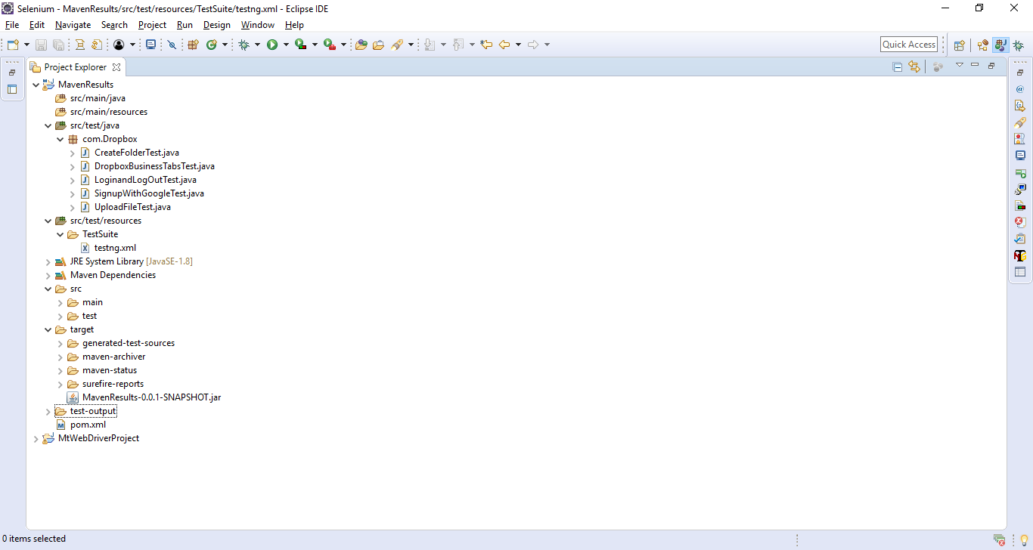

1. Under “MavenResults” Project which is the ArtifactID, Under the folder ‘src/test/java and under the package ‘com.Dropbox’ the five Test Scenarios are created as individual classes:-CreateFolderTest, DropboxBusinessTabsTest, LoginandLogOutTest, SignupWithGoogleTest, UploadFileTest

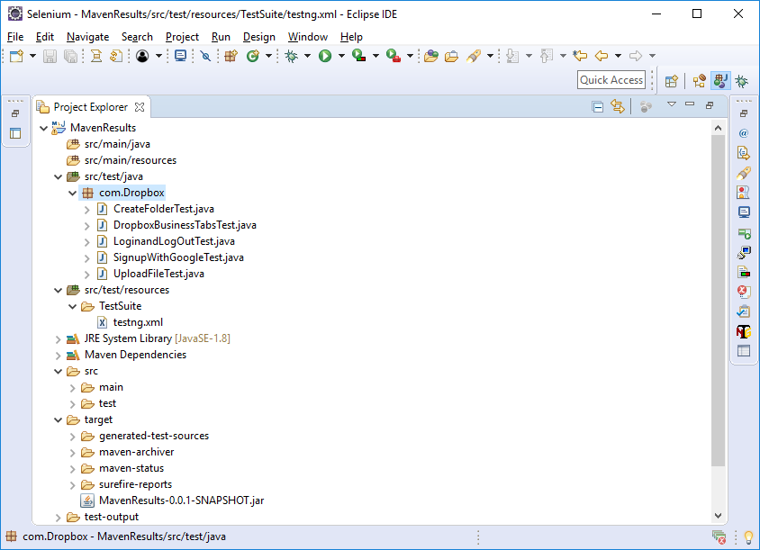

1. Testing.xml file is created under ‘src/test/resources folder also see the xml file in the right-hand side expanded.

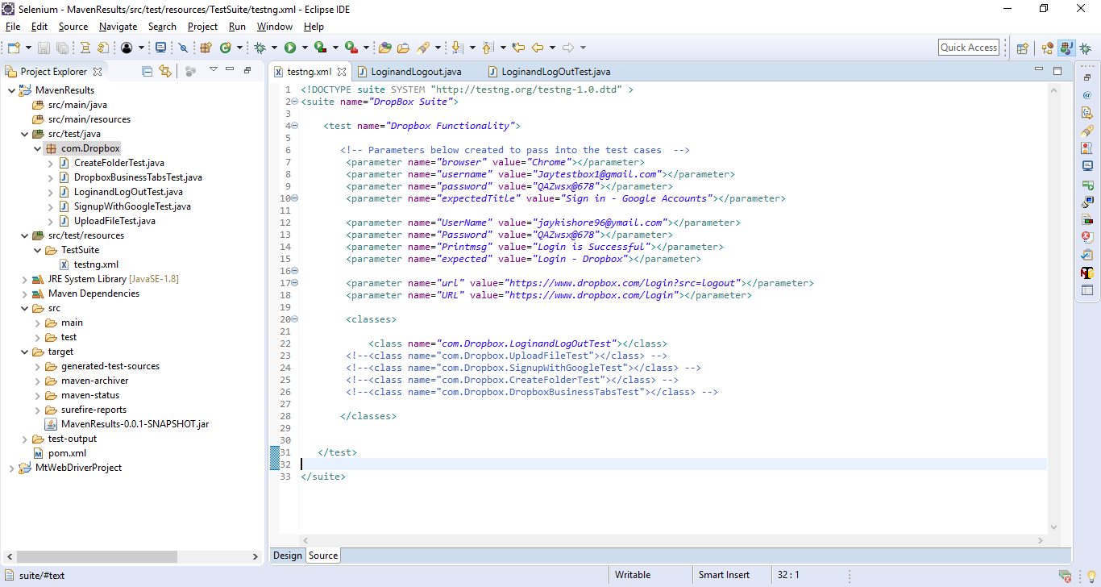

3.pom.xml file, Ensure the path/Location of the testing.xml file is given which is highlighted in blue colour in below screenshot to execute the test cases.

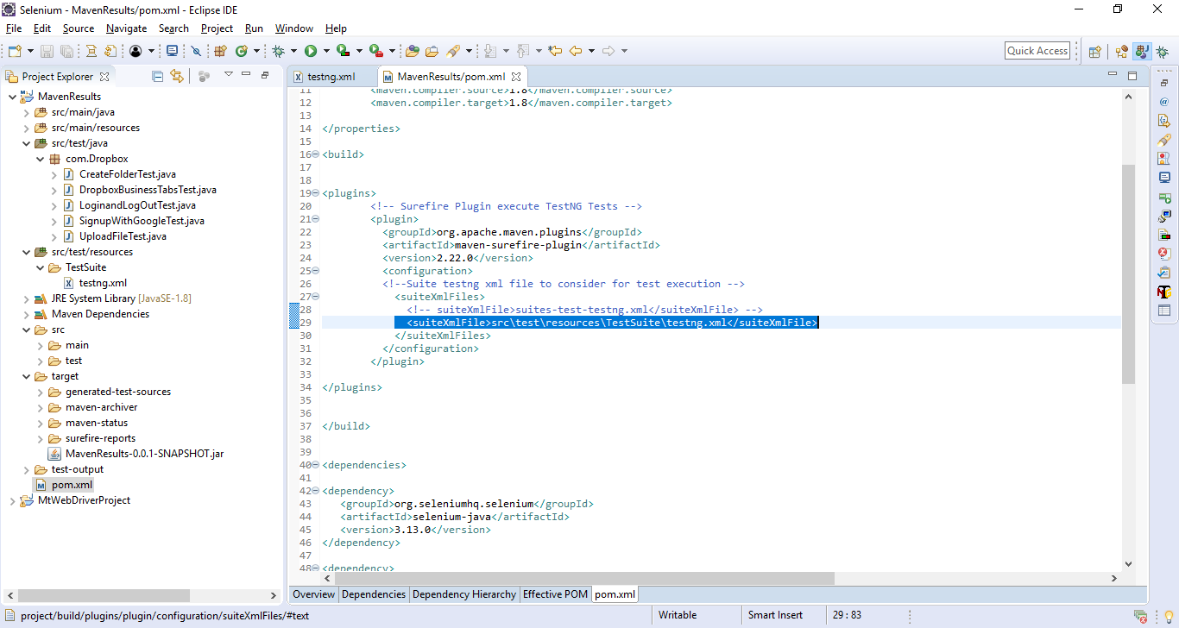

1. Select Project “MavenResults” Right click🡪Run As🡪Maven Test 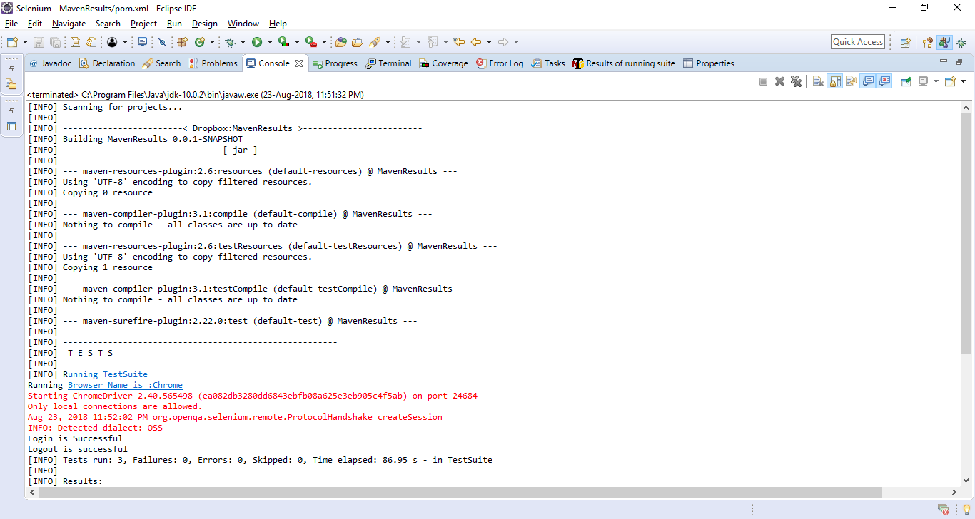

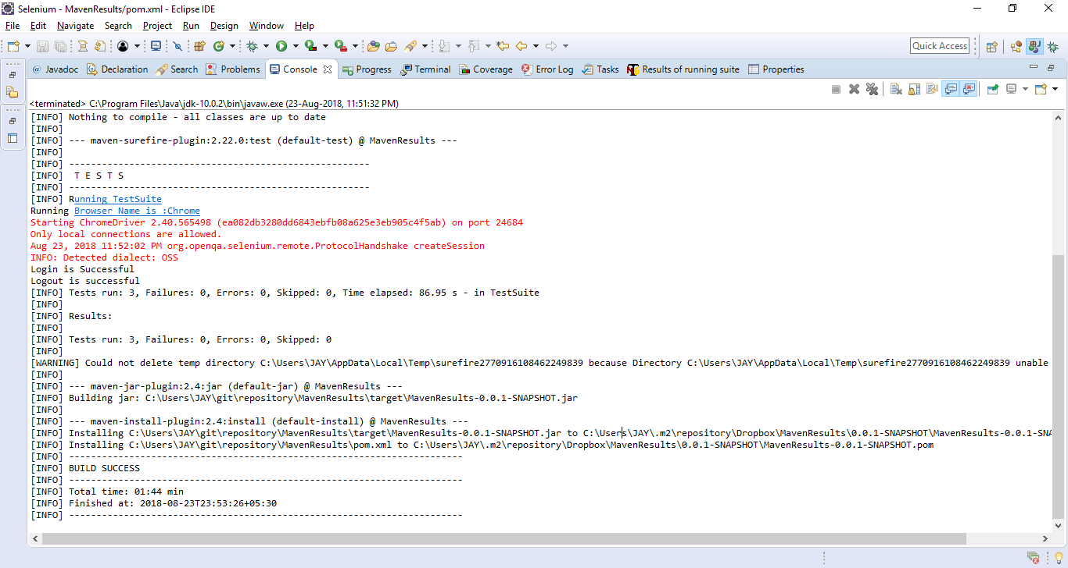

The Maven command ‘Run as Maven test’ is executed to run the test cases and the message output is displayed above.