## Assignment

Q=1:-Are the HTML tags and elements the same thing?

Ans:-HTML Tags are building blocks of HTML Page. They tell the browser how it should display content to the user. A tag starts with a < bracket and ends with a > bracket. Most tags exist in pairs in HTML. Tags have an opening and closing part. They are similar, except the closing part has a / sign after the opening bracket.

Ex:- Ex:

<p><p>,<i></i>, etc are tags while,

<p>This is p tag</p>, <i>This is i tag</i> are elements

(notice that we included some content inside elements).

Q=2:-What are tags aznd attributes in HTML?

Ans:-HTML tags are used to hold the HTML element. HTML element holds the content. HTML attributes are used to describe the characteristic of an HTML element in detail.

Q=3:-What are void elements in HTML? With Example

Ans:-There is a special group of elements that only have start tags and does not contain any content within it, these elements are called void elements. Void elements doesn’t have ending tags and can only have attributes but do not contain any kind of content. These elements can have backslash before ending of start tag but that is completely optional.  Example of such elements are <br>, [<hr>](https://www.geeksforgeeks.org/html-hr-tag/), [<img>](https://www.geeksforgeeks.org/html-img-tag/), [<input>](https://www.geeksforgeeks.org/html-input-tag/), [<link>](https://www.geeksforgeeks.org/html-link-tag/), etc.

Q=4:- What are HTML Entities? With Example

Ans:- An **HTML entity** is used to display invisible characters and reserved characters that would otherwise be interpreted as HTML code. It is a piece of text, or string, that begins with an ampersand (&) and ends with a semicolon (;).

Examples:-

<body>

    <div class="container">

        <h3>Different entity symbol representation</h3>

        <ul style="list-style-type:none;">

            <li>

                <h4>Indian currency: ₹</h4>

            </li>

            <li>

                <h4>Euro: €</h4>

            </li>

            <li>

                <h4>Pound: £</h4>

            </li>

            <li>

                <h4>Yen: ¥</h4>

            </li>

            <li>

                <h4>Dollar: $</h4>

            </li>

        <li>

                <h4>The copyright sign: &copy;</h4>

            </li>

        </ul>

    </div>

</body>

## Output:-

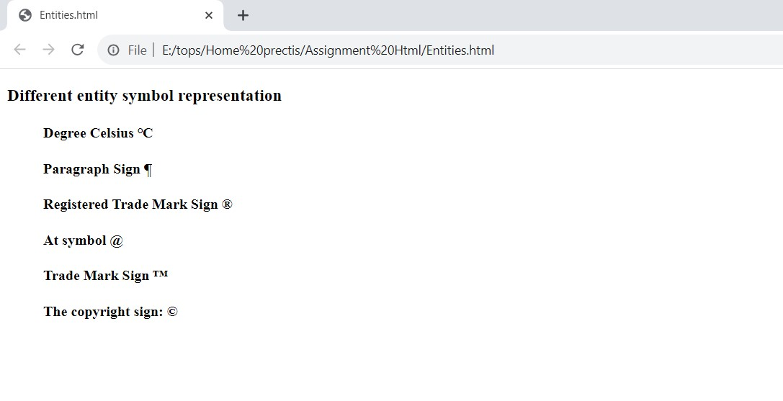

Q=5:- What are different types of lists in HTML? With Example.

Ans:- We can use three types of lists to represent different types of data in HTML:

1.Unordered List<ul>

2.Ordered List<ol>

3. Description List<dl>

1.Uordered List:- The unordered list is used to represent data in a list for which the order of items does not matter.

In HTML, we use the <ul> tag to create unordered lists. Each item of the list must be a <li> tag which represents list items. For example,

Example:-

<!DOCTYPE html>

<html>

<head>

    <title>HTML Entities</title>

</head>

<body>

<ul>

    <li>Apple</li>

    <li>Orange</li>

    <li>Mango</li>

  </ul>

  </body>

</html>

Output:-

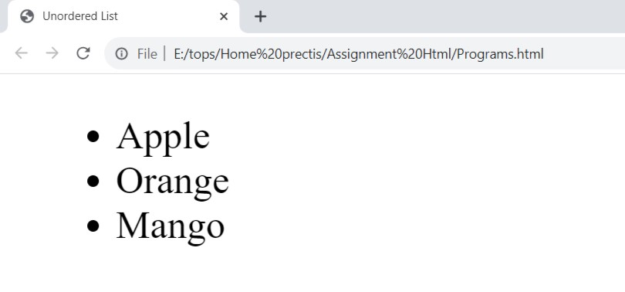

2.Order-List:- Ordered lists, as the name suggests, are useful when you want to present items in a specific sequence or order. They are displayed with numbers or letters by default, but you can customize the numbering style using CSS. An example might be a ranked list of your favorite movies.

To create an ordered list, use the <ol> (ordered list) element and nest list items within <li> elements:

Example:-

<body>

    <ol>

        <li>First item</li>

        <li>Second item</li>

        <li>Third item</li>

      </ol>

</body>

Output:-

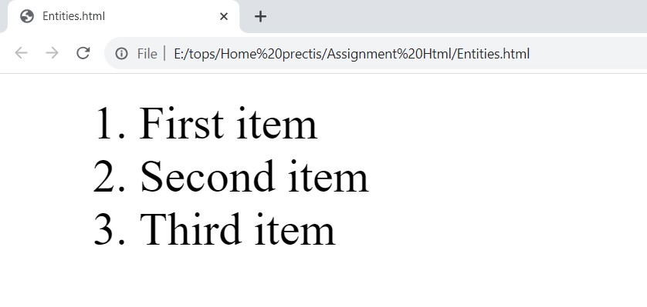

3.Defination-List:- Definition lists are designed to present terms and their corresponding definitions. They consist of a list of terms enclosed in <dt> (definition term) elements and their associated definitions enclosed in <dd> (definition description) elements. Here's an example:

Example:-

<body>

    <dl>

  <dt>HTML</dt>

  <dd>HyperText Markup Language, used for structuring content on the web.</dd>

  <dt>CSS</dt>

  <dd>Cascading Style Sheets, used for styling web documents.</dd>

  <dt>JavaScript</dt>

  <dd>A programming language used for adding interactivity to web pages.</dd>

</dl>

</body>

Output:-

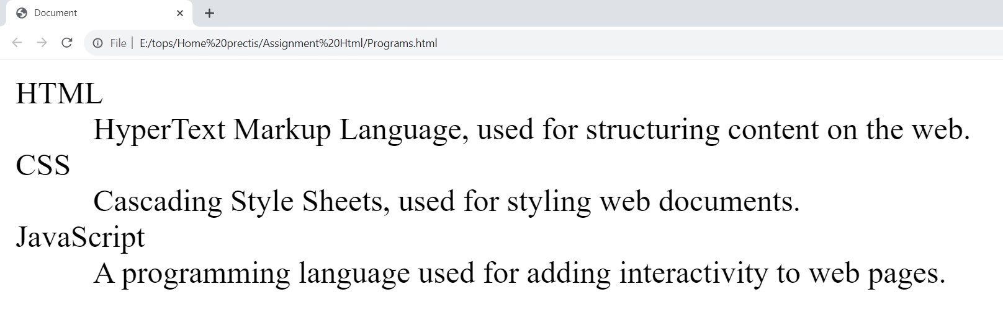

Q=6What is the ‘class’ attribute in HTML? With Example.

Ans:-The class attribute specifies one or more class names for an element. The class attribute is mostly used to point to a class in a style sheet.

Example:-

<html>

    <head>

    <style>

    h1.intro {

        color: blue;

    }

    p.important {

        color: green;

    }

    </style>

    </head>

    <body>

    <h1 class="intro">Header 1</h1>

    <p>A paragraph.</p>

    <p class="important">Note that this is an important paragraph. :</p>

    </body>

    </html>

Output:-

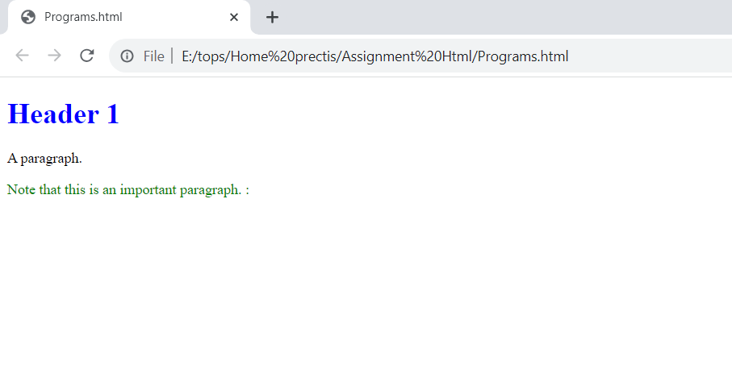

Q=7 What is the difference between the ‘id’ attribute and the ‘class’ attribute of HTML elements? With Example.

Ans:- A class name can be used by multiple HTML elements, while an id name must only be used by one HTML element within the page:

Example:-

<html>

<head>

<style>

/* Style the element with the id "myHeader" */

#myHeader {

  background-color: lightblue;

  color: black;

  padding: 40px;

  text-align: center;

}

/* Style all elements with the class name "city" */

.city {

  background-color: tomato;

  color: white;

  padding: 30px;

}

</style>

</head>

<body>

<!-- An element with a unique id -->

<h1 id="myHeader">My Cities</h1>

<!-- Multiple elements with same class -->

<h2 class="city">London</h2>

<p>London is the capital of England.</p>

<h2 class="city">Paris</h2>

<p>Paris is the capital of France.</p>

</body>

</html>

Output:-

# My Cities

## London

London is the capital of England.

## Paris

Paris is the capital of France.

Q=8:- What are the various formatting tags in HTML?

Ans:- Text formatting in HTML refers to the way text is displayed on a web page. It is the process of applying various styles, colors, fonts, sizes, and other visual enhancements to text content within an HTML document. HTML offers a range of tags that can be used to format text, including:

1.<b> - Bold text

2.<strong> - Important text

3.<i> - Italic text

4.<em> - Emphasized text

5.<mark> - Marked text

6.<small> - Smaller text

7.<del> - Deleted text

8.<ins> - Inserted text

9.<sub> - Subscript text

10.<sup> - Superscript text

Q=9 How is Cell Padding different from Cell Spacing? With Example.

Ans:- Cell padding defines the space that is added between the content within a cell and the cell’s border, while, Cell spacing is an HTML attribute which means how much space is between the table cells. It is used for defining the space between the adjacent cells in a table.

Example:-

 <head>

   <meta charset="UTF-8" />

   <meta http-equiv="X-UA-Compatible" content="IE=edge" />

   <meta name="viewport" content="width=device-width, initial-scale=1.0" />

   <title>Document</title>

   <style>

     * {

       font-family: cursive;

     }

     span{

         text-decoration-style: solid;

         width: 20px;

         font-size: x-large;

         color: purple;

       }

     .table {

       background-color: antiquewhite;

       border-style: solid;

       border-width: 4px;

     }

   </style>

 </head>

 <body>

   <table

     border="2"

     cellpadding="25"

     cellspacing="30"

     class="table"

     border="solid"

   >

     <thead>

       <td><span>Name</span></td>

       <td><span>Position</span></td>

     </thead>

     <tbody<tr>

         <td>Jay</td>

         <td>Job</td>

       </tr>

       <tr>

         <td>Jayesh</td>

         <td>Job</td>

       </tr>

     </tbody>

   </table>

 </body>

Output:-

| Name | Position |
| --- | --- |
| Jay | Job |
| Jayesh | Job |

Q=10 How can we club two or more rows or columns into a single row or column in an HTML table? With Example.

Ans:- The rowspan and colspan are the attributes of [<td> tag](https://www.tutorialspoint.com/html/html_td_tag.htm). These are used to specify the number of rows or columns a cell should merge. The rowspan attribute is for merging rows and the colspan attribute is for merging columns of the [table in HTML](https://www.tutorialspoint.com/html/html_tables.htm).

Example:-

<body>

    <table border="1">

        <tr>

            <th>Device</th>

            <th>Brand</th>

            <th colspan="2">Specification</th>

        </tr>

        <tr>

            <td rowspan="3">Smartphone</td>

            <td rowspan="3">Apple</td>

            <th>Model</th>

            <th>Storage</th>

        </tr>

        <tr>

            <td>iphone 12 pro</td>

            <td>256GB</td>

        </tr>

        <tr>

            <td>iphone SE</th>

            <td>128GB</td>

        </tr>

        <tr>

            <td>Laptop</td>

            <td>HIP</td>

            <td colspan="2">15.6"Display</td>

        </tr>

        <tr>

            <td>Tablet</td>

            <td>Samsumg</td>

            <td colspan="2">10.5"Display</td>

        </tr>

    </table>

</body>

Output:-

|  |  |  |  |
| --- | --- | --- | --- |
| **Device** | **Brand** | **Specification** | |
| Smartphone | Apple | **Model** | **Storage** |
| iphone 12 pro | 256GB |
| iphone SE | 128GB |
| Laptop | HIP | 15.6"Display | |
| Tablet | Samsumg | 10.5"Display | |

Q=11 What is the difference between a block-level element and an inline element?

Ans:- A block-level element always starts on a new line, and the browsers automatically add some space (a margin) before and after the element.A block-level element always takes up the full width available Two commonly used block elements are: <p> and <div>.When An inline element does not start on a new line. An inline element only takes up as much width as necessary.This is a <span> element inside a paragraph.

Example:-

<body>

    <p  style="border: 1px solid black">How are yoy</p>

    <div style="border: 1px solid black">How are you</div>

    <p>This is an inline span <span style="border: 1px solid black">Hello World</span> element inside a paragraph.</p>

</body>

Output:-

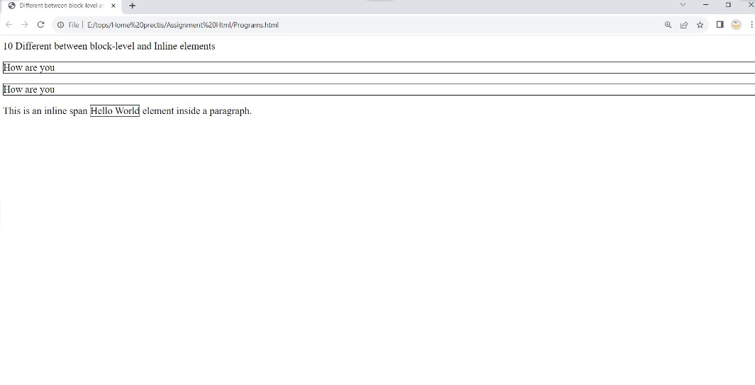

Q=12 How to create a Hyperlink in HTML? With Example.

Ans:- A hyperlink, often called a link, is a reference linking one resource to another. It includes a clickable element like a word, phrase, image, or icon. And when you use them correctly for internal links—links from one page on your site to another page on your site.

Example:-

<html>

<body>

<h1>HTML Links</h1>

<p><a href="https://www.google.com/">Visit google.com!</a></p>

</body>

</html>

Output:-

# HTML Links

[Visit google.com](https://www.google.com/)

Q=13 What is the use of an iframe tag? With Example.

Ans:-The <iframe> tag specifies an inline frame. An inline frame is used to embed another document within the current HTML document.

Example:-

<body>

  <h1>The iframe element</h1>

  <iframe width="900" height="350" src="https://www.youtube.com/embed/Y9pgsPW-KIE?si=ltPLapyYjUXumIfM"

    title="YouTube video player" frameborder="0"

    allow="accelerometer; autoplay; clipboard-write; encrypted-media; gyroscope; picture-in-picture; web-share"

    allowfullscreen></iframe>

</body>

Output:-



Q=14 What is the use of a span tag? Explain with example?

Ans:- In HTML, the span tag is a generic inline container element. You use this element to add attributes to a section of text without creating a new line of content.

Example:-

<body>

  <h1>The span element</h1>

  <p>My Favirote color is <span style="color:blue;font-weight:bold">blue</span> and my Favirote color is<span

      style="color:deeppink;font-weight:bold"> Pink. </span></p>

</body>

Output:-

# The span element

My Favirote color is **blue** and my Favirote color is**Pink.**

Q=15: How to insert a picture into a background image of a web page? With Example.

Ans:- We can use the [background attribute](https://www.tutorialspoint.com/html/html_backgrounds.htm) in the [body tag](https://www.tutorialspoint.com/html/html_body_tag.htm) to set an image as the background of the webpage. We will need to specify the URL or the location of the image which we want to set to the background attribute of the body tag.

<style>

    body {

      width: 75%;

      background-image: url(Bird_Image.jpg);

      background-color: green;

      background-repeat: no-repeat;

      background-size: 50%;

      font-size: 100px;

      color: white;

    }

  </style>

</head>

<body>

  <h1>Background Image<br>

    This is Parrot Picture

  </h1>

</body>

Output:

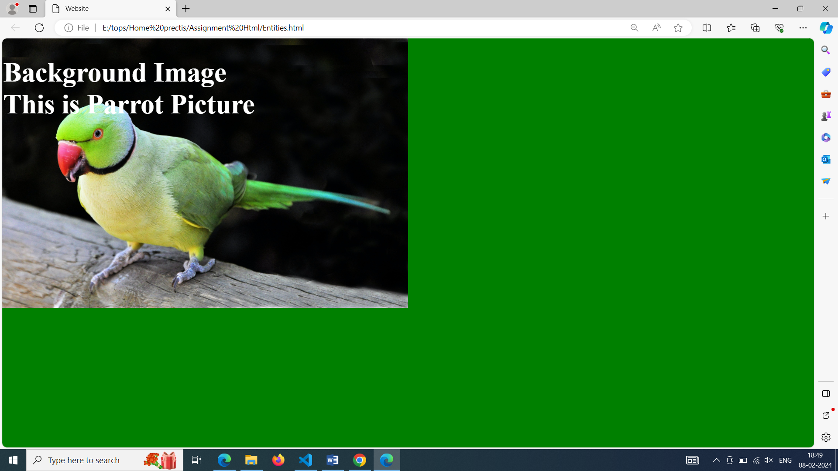

Q=16: How are active links different from normal links?

Ans: The default color for normal and active links is blue. Some browsers recognize an active link when the mouse cursor is placed over that link. Whereas, others recognize active links when the link has the focus. Those that don’t have a mouse cursor over that link is considered a normal link.

Q=17: What are the different tags to separate sections of text?

Ans: The **<br>** tag is one way to separate the lines of text. There are other tags like the **<p>** tag and **<blockquote>** tag that are also used to separate sections of text.

Q=18: What is SVG?

Ans:SVG stands for Scalable Vector Graphics SVG is used to defines vector-based graphics in XML format. The HTML <SVG> element is a container for SVG graphics. SVG has several methods for drawing paths, boxes, circles, text, and graphic images.

Q=19: What is difference between HTML and XHTML?

Ans: HTML (HypertextMarkup Language) and XHTML (ExtensibleHypertext Markup Language) are both markup languages used for creating and displaying web pages. The main difference between them is the syntax and structure; HTML is more lenient in its syntax, while XHTML has a more strict syntax and follows XML rules.

Q=20: What are logical and physical tags in HTML?

Ans:

Logical Tags  :  
Logical Tags are used in HTML to display the text according to the logical styles. Following are the Logical tags commonly used in HTML.

Example:-

<pre> - Defines preformatted text

<abbr> - Defines an abbrivation

<dfn> - Defines an defination term

Physical Tags :-

Physical Tags are used in HTML to provide actual physical formatting to the text. Following are the Physical tags commonly used in HTML.

Example:-

<b> - Defines bold text

<i> - Defines italic text

<small> - Defines small text

Q=21: Create below example using HTML tags only without CSS

Ans:-

<!DOCTYPE html>

<html lang="en">

<head>

    <meta charset="UTF-8">

    <meta name="viewport" content="width=device-width, initial-scale=1.0">

    <title>Document</title>

    <style>

        img{

            margin-left: 45px;

        }

    </style>

</head>

<body>

    <table border=1 align="center" cellspacing="0" style="width: 95%;" border-collapse:collapse;></style>>

         <tr>

            <td rowspan="2" align="center"><a href="homet.html">Home</a></td>

            <td rowspan="2" align="center"><a href="contact.html">contact</a></td>

            <td rowspan="2" align="center"><a href="help.html">help</a></td>

            <td rowspan="2" align="center"><a href="store.html">store</a></td>

            <td align="center" style="background-color: red;"><a href="download.html">download</a></td>

            </td>

        </tr>

        <tr>

            <td align="center" style="background-color: red;">app</td>

        </tr>

        </table>

        <img src="../Assignment Html/Image.png" height="400px" width="95%" align="center">

        <table border=1 cellspacing="0" style="width:90%;" align="center"  border-collapse:collapse;>

            <tr bgcolor="lightblue" align="center">

                <td>

                    <label for="fname">First-name</label>

                    <input type="text" name="fname" placeholder="Enter Your Name" >

                </td>

                <td>

                    <label for="lname">Last-name</label>

                    <input type="text" name="lname" placeholder="Enter Your Name" >

                </td>

            </tr>

            <tr bgcolor="lightblue" align="center">

                 <td>

                    <label for="email">Emai-id</label>

                    <input type="text" name="lname" placeholder="enter email id" >

                </td>

                <td>

                    <label for="pnumber">Phone No.</label>

                    <input type="text" name="lname" placeholder="enter your phone number" >

                </td>

            </tr>

            <tr bgcolor="lightblue" align="center">

                 <td>

                        <label for="cty">City</label>

                        <select name="city" id="">

                            <option value="">Rajkot</option>

                            <option value="Amd" selected>Ahmedabad</option>

                            <option value="" disabled>Surat</option>

                            <option value="brd">Baroda</option>

                            <option value="rms">Rameshwaram</option>

                          </select>

               </td>

                <td>

                    <label for="zender">Zender</label>

                    <label for="male">Male</label>

                    <input type="radio" name="male" id="" />

                    <label for="fmale">Female</label>

                    <input type="radio" name="fmale" id="" />

                    <label for="other">Other</label>

                    <input type="radio" name="other" id="" />

                </td>

                </tr>

                <tr>

                    <td >

                        <iframe src="https://www.google.com/maps/embed?pb=!1m18!1m12!1m3!1d59061.6589354641!2d70.81677598511695!3d22.302459834786323!2m3!1f0!2f0!3f0!3m2!1i1024!2i768!4f13.1!3m3!1m2!1s0x3959ca248c77c099%3A0xdf5ac10af64ac8ee!2sTOPS%20Technologies!5e0!3m2!1sen!2sin!4v1707234025303!5m2!1sen!2sin"

                        width="900" height="350" style="border:0;" allowfullscreen="" loading="lazy" referrerpolicy="no-referrer-when-downgrade">

                        </iframe>

                    </td>

                    <td>

                        <iframe width="900" height="350" src="https://www.youtube.com/embed/Y9pgsPW-KIE?si=ltPLapyYjUXumIfM" title="YouTube video player" frameborder="0" allow="accelerometer; autoplay; clipboard-write; encrypted-media; gyroscope; picture-in-picture; web-share"

                         allowfullscreen></iframe>

                    </td>

                </tr>

        </table>

</body>

</html>

Output:-

