**Assignment :- CSS and CSS 3**

Q=1 What are the benefits of using CSS?

Ans:-

**1. Consistency and Global Styling:-**

CSS ensures a consistent visual identity throughout a website or multiple web pages. By employing a single external CSS file, it becomes possible to maintain a cohesive style, minimizing duplication and simplifying global styling updates.

**2. Easier to Maintain and Efficient Updates:-**

The separation of content and style in the CSS simplifies the process of maintaining web pages and implementing updates. By modifying a few lines of code in the central CSS file, you can quickly adjust fonts, colors, and layouts without the need to edit each HTML element. This results in a more efficient and hassle-free maintenance process.

**3. Time-Saving and Faster Loading Times:-**

Utilizing external CSS files allows web browsers to cache the styling information, resulting in more efficient and faster page load times. This optimization greatly enhances the overall user experience, especially for returning visitors.

**4. SEO-Friendly:-**

Employing clean and structured CSS code can enhance your website’s search engine optimization. By making your code more readable for search engine crawlers CSS can potentially boost your site’s search rankings, leading to increased visibility and traffic.

Q=2 What are the disadvantages of CSS?

Ans:-

**1.Security Issues :-** In today's technologically and data-driven society, security is crucial. CSS has a restricted level of security, which is one of its main drawbacks.

**2.Cross-Browser Issues :-** We can observe that the functionality of different browsers varies. In order to ensure that modifications made to the website using CSS codes are properly displayed across all browsers, need to be checked.

**3.Confusion due to many CSS levels :-** This problem is particularly effects for beginners. Since CSS has numerous levels, including CSS2, CSS3, and others, they could become confused while choosing to study it.

Q=3 What is the difference between CSS2 and CSS3?

Ans:-

|  |  |
| --- | --- |
| CSS2 | CSS3 |
| * CSS2 was released in 1998 with added styles for other media types   So that it can be used for page layout  designing. | * CSS3 was released in 1999 and presentation-style properties were added in it that allows you to build a presentation from documents. |
| * Unlike CSS2,which was comprised of a single document. | * CCS3 has its specifications divided intomany individual modules , which makes CSS3 a whole lot easier to handle. |
| * CSS and CSS2 designers could only use “web-safe fonts” for being 100% sure to use fonts that would that always display the same on every machine. | * CSS3 the designers can now use special fonts like those available in google fonts Typecast. |
| * CSS and CSS2 had simple selector. | * CSS3 calls the components as a sequence of simple selectors. |
| * CSS2 the developers had difficulty because tha standard was not equipped with automatically breaking the text so that it fits within a box. | * CSS3 has the capability to split text sections into multiple columns so that it can be read like a newspaper. |

Q=4Name a few CSS style components

Ans:-

1. Selector: class name, id name or element's start tag name etc.

2.CSS properties: Name of the property we want to style. example border, color,background etc.

3.Value of Property: value which will be given to property.

Q=5 What do you understand by CSS opacity?

Ans:-CSS opacity is a property that allows you to control the transparency of an element.It can be used to make an element more or less transparent .The opacity property is set using value between ) and 1,where 0 is completely transparent and 1 is completely opaque.

Example:-

<!DOCTYPE html>

<html lang="en">

  <head>

    <meta charset="UTF-8" />

    <meta name="viewport" content="width=device-width, initial-scale=1.0" />

    <title>Document</title>

    <style>

      body {

        margin-left: 30%;

        align-items: center;

        align-content: center;

      }

      img {

        opacity: 0.5;

        height: 500px;

        width: 500px;

      }

    </style>

  </head>

  <body>

    <h1>Opacity</h1>

    <img src="Background_Image.jpg" alt="Forest"/>

  </body>

</html>

Output:-

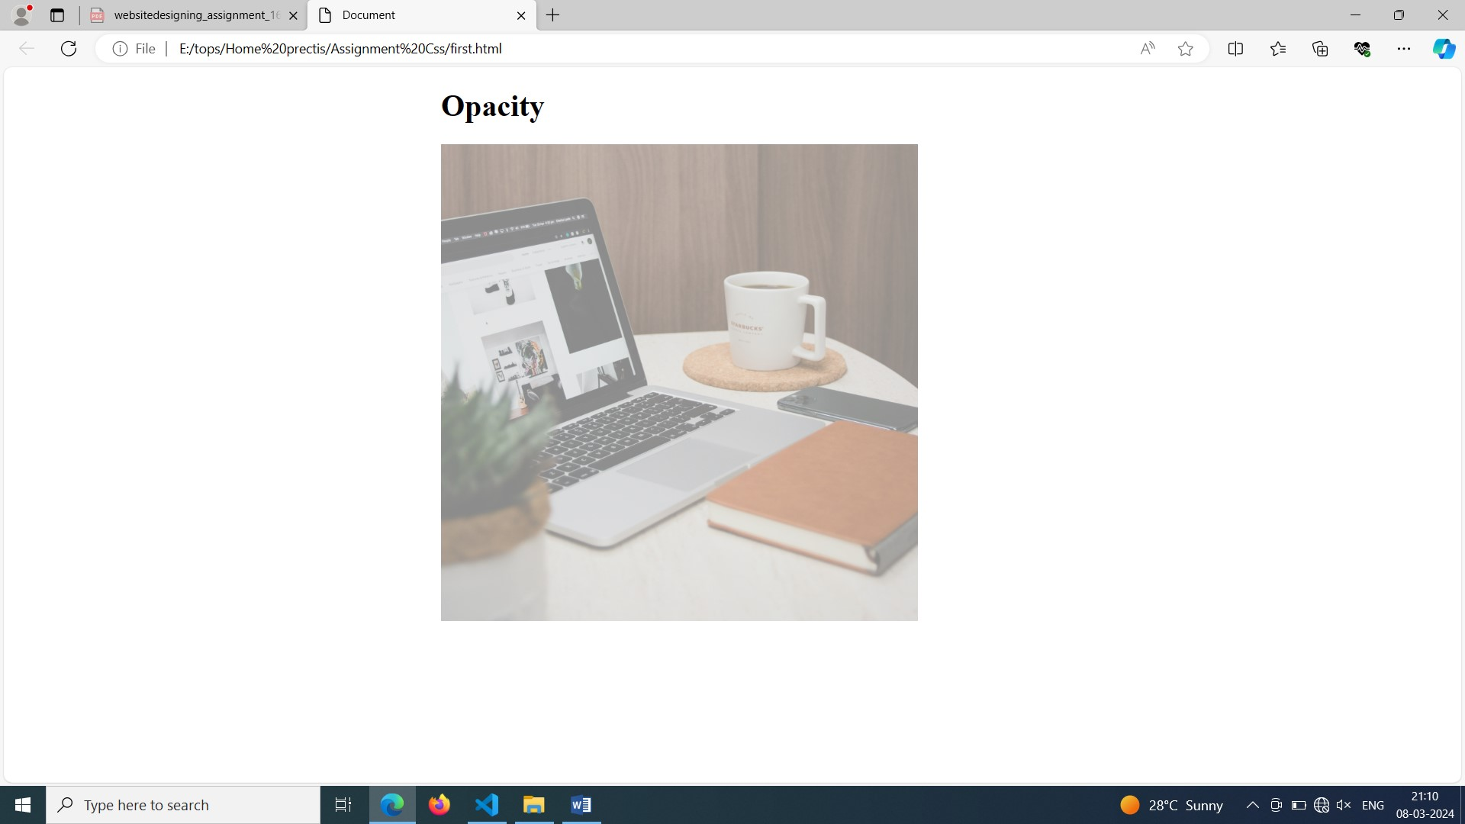

Q=6 How can the background color of an element be changed?

Ans:-  We can set background color by selecting the element by its class name of id name and then apply the background-color property on it to set the background color.

**Syntax:**

background-color: color_name;

Example:-

<!DOCTYPE html>

<html lang="en">

  <head>

    <style>

      * {

        margin: 50px 50px;

        font-size: 50px;

      }

      .bg1 {

        background-color: green;

      }

      .bg2 {

        background-color: rgb(163, 158, 158);

        color: black;

      }

      .bg3 {

        background-color: rgb(102, 119, 102);

      }

    </style>

  </head>

  <body>

    <div class="bg1">div1</div>

    <div class="bg2">div2</div>

    <p class="bg3" style="margin: 50px 50px; font-size: 50px">div3</p>

  </body>

</html>

Output:-

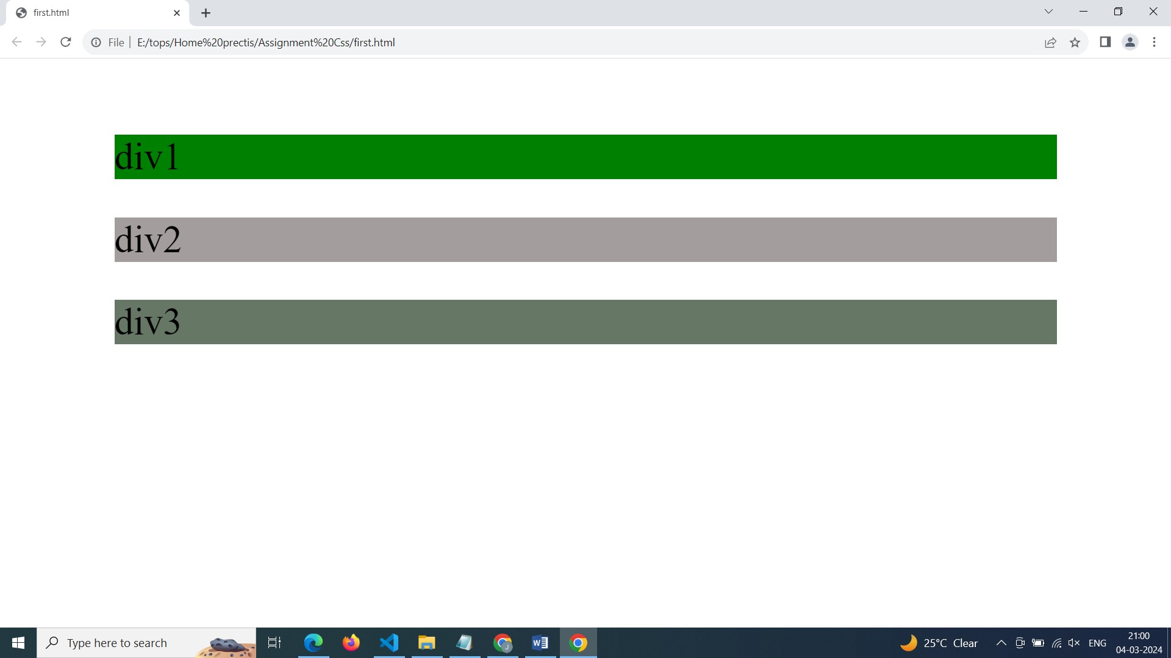

Q=7How can image repetition of the backup be controlled?

The background-repeat property in CSS is used to repeat the background image both horizontally and vertically. It also decides whether the background image will be repeated or not.

**Syntax:**

background-repeat:repeat | repeat-x | repeat-y | no-repeat | initial | inherit;

Example:-

<!DOCTYPE html>

<html lang="en">

  <head>

    <title>15.Insert background Image</title>

    <style>

      body {

        height: 100%;

        width: 100%;

        background-color: cornflowerblue;

        color: white;

        background-size: 50%;

      }

      .bg {

        height: 900px;

        width: 900px;

        background-image: url(Background_Image.jpg);

        background-repeat: repeat;

        background-size: 50%;

        font-size: 50px;

        margin-top: 10px;

        margin-left: 10px;

      }

      h1 {

        padding-top: 30%;

      }

    </style>

  </head>

<body>

    <div class="bg">

      <h1>Background Image</h1>

    </div>

  </body>

</html>

Q=8What is the use of the background-position property?

Ans:- The background-position property use to set position of a bg-image by use this property we can set our bg-image into left,right,center etc. For this Property we can set different value like "left,right,center ,top,bottom".

Q=9Which property controls the image scroll in the background?

Ans:- The [background-attachment](https://www.geeksforgeeks.org/css-background-attachment-property/) property in CSS is used to specify the kind of attachment of the background image with respect to its container. It can be set to scroll or make it remain fixed. It can be applied to all[HTML](https://www.geeksforgeeks.org/html/)elements.

**Syntax:**

background-attachment: scroll|fixed|local|initial|inherit;

Q=10Why should background and color be used as separate properties?

Ans:-while background and color are often used together for elements,they serve different purposes.colour sets the text colour,while background defines the background colour or image.Seprating them allows for more flexibility in styling as background properties can include images,gradiants, and positioning.

Q=11How to center block elements using CSS1?

Ans:-In CSS1,you can center a block-level element horizontally by using the text-align property on its parent element.

Q=12What are the ways to integrate CSS as a web page?

Ans:-There are three ways to integrate css into a web page

(1)Inline CSS:-

(2)Internal CSS:-

(3)External CSS:-

1.Inline CSS:-You can include CSS Directly within Html element using the style attribute

2.Internal CSS:-You can include CSS within the <style> element in the <head> section of the Html.

3.External CSS:-You can create a separate CSS file and linkit toyour HTML document using the <link> element in the <head> section.

Q=13What are the external style sheets?

Ans:-  An external style sheet is a separate CSS file that can be accessed by creating a link within the head section of the webpage. Multiple webpages can use the same link to access the stylesheet.

The link to an external style sheet is placed within the head section of the page.

Q=14 What are the advantages and disadvantages of using external style sheets?

**The advantages of External Style Sheets are:**  
  
1. Using them, the styles of multiple documents can be controlled from one file.  
2. Classes can be created for use on multiple HTML element types in many documents.  
3. In complex situations, selector and grouping methods can be used to apply styles.  
  
**The disadvantages of External Style Sheets are:**  
  
1. In order to import style information for each document, an extra download is needed.  
2. Until the external style sheet is loaded, it may not be possible to render the document.  
3.For small number of style definitions, it is not viable.

Q=15 What is the meaning of the CSS selector?

Ans:- CSS selectors are used to select the content you want to style. Selectors are the part of CSS rule set. CSS selectors select HTML elements according to its id, class, type, attribute etc.

Q=16 What are the media types allowed by CSS?

Ans:-

->The @media rule, introduced in CSS2, made it possible to define different style rules for different media types.

->Media queries in CSS3 extended the CSS2 media types idea: Instead of looking for a type of device, they look at the capability of the device.

->Media queries can be used to check many things, such as:

1.width and height of the viewport

2.orientation of the viewport (landscape or portrait)

3.resolution

Using media queries are a popular technique for delivering a tailored style sheet to desktops, laptops, tablets, and mobile phones (such as iPhone and Android phones).

Q=17 What is the rule set?

Ans:-In CSS,a rule set consists of a selector and one or more declarations enclosed in curly braces {}.

->The selector specifies which elements in the HTML document the rule applies to.

->Inside the curly braces,declarations are made upof property-value pairs seprated by acolon : .These declarations define the styling attributes for the selected elements.