BONUS BUSINESS SUMMARY By Jay Godlonton
RetailMax Customer Findings
What the data says about customers leaving — and what RetailMax could do about it
What are we trying to answer?  - Which customers are most likely to leave RetailMax?  - Does time since the last purchase give an early warning?  - Does region matter, or is customer behaviour more useful?  - Can missing information itself be a warning sign?  - Can customers be grouped into useful types for different strategies? | What data is this based on?  Business: RetailMax, a fictional e-commerce company.  Customers: 500 customer records.  Ages: 24 to 56 where Age was recorded.  Income: $40,000 to $95,000.  Regions: East 124, North 126, South 125, West 125 — almost perfectly even.  Education: High School, Bachelor, Master and PhD.  Available fields: Age, Income, Days Since Purchase, Education, Region, and whether the customer Stayed or Left.

58.6%  of all 500 customers were marked as Left | 60 vs 130  median days since last purchase: Stayed vs Left (training data) | 32.4% vs 84.8%  West vs North customers who left (training data)

What does “Left” mean here?  In the dataset: Left means the customer has a leaving/churn flag of 1. Stayed means 0.  What we do NOT know: The data does not say the exact date they left or why they left.  Important: A pattern can warn us about risk without proving what caused the customer to leave. | How the analysis was split  Overall rate: 58.6% is based on all 500 customers.  Most charts: use the 400-customer training sample created by the required 80/20 machine-learning split.  Training sample: 234 Left and 166 Stayed.  Why split it: so calculations are learned from training data instead of using every record at once.
What is NOT in the RetailMax data
There is no exact leaving date or reason, no city/province, no urban/rural label, no product category, no order value, and no record of which marketing messages a customer received. Those would be useful next-step data, not facts this report can claim.
Bottom line
The clearest warning sign was how long it had been since a customer last purchased. Region mattered too, but later testing showed that purchase behaviour gave a more useful business story than geography alone.
Prepared by Jay Godlonton | Red Deer Polytechnic | Supplementary business-facing summary from AIDA 2152 Lab Assignment 1

The Clearest Warning Sign
Customers who left had gone much longer without buying.
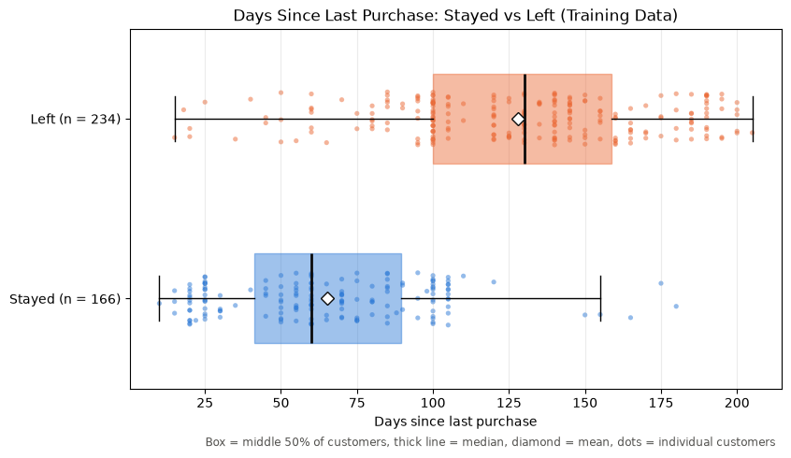
What this chart is showing  Who: 400 RetailMax training customers — 166 Stayed and 234 Left.  Stayed: median 60 days since last purchase.  Left: median 130 days since last purchase.  Plain meaning: the typical customer who left had been inactive for more than twice as long. | What RetailMax could do with it  - Watch the number of days since each customer last purchased.  - Set an early-warning range before customers become heavily inactive.  - Test reminders, offers or re-engagement messages as the gap grows.  - Measure whether those actions actually reduce the percentage who leave.
How to read the chart
Each dot is one customer. The box shows the middle half of customers, the thick line is the median (the middle customer), and the diamond is the average. The important part is that the Left group is shifted much farther to the right.
What this does NOT prove
A long purchase gap is linked to customers leaving in this dataset, but the analysis does not prove that the gap itself caused them to leave. The useful business point is that it can be watched as an early-warning signal.
Confidence check
This same warning signal survived two extra checks. Counting repeated customer profiles only once still left Days Since Purchase as the strongest relationship. Estimating missing values a different way also kept the same top five findings and the same customer groups. In plain language: the result did not disappear when the cleanup assumptions changed.

Location Gives a Clue. Behaviour Gives a Stronger One.
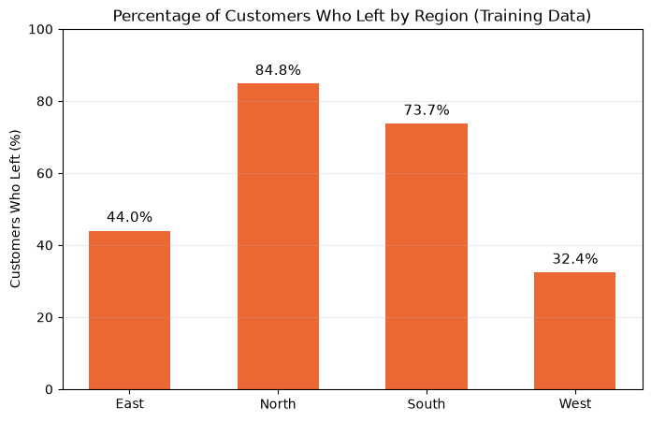 | Which regions? East, North, South and West. The original 500-customer dataset has 124–126 customers in each region, so the groups are almost evenly sized.  Training result: West had the lowest leaving rate at 32.4%. North had the highest at 84.8%. South was 73.7% and East was 44.0%.  What “region” does NOT tell us: There is no city, province/state, urban/rural label, or reason for the difference. Region is only a broad category in this dataset.

The stronger business story: similar customers, very different outcomes.
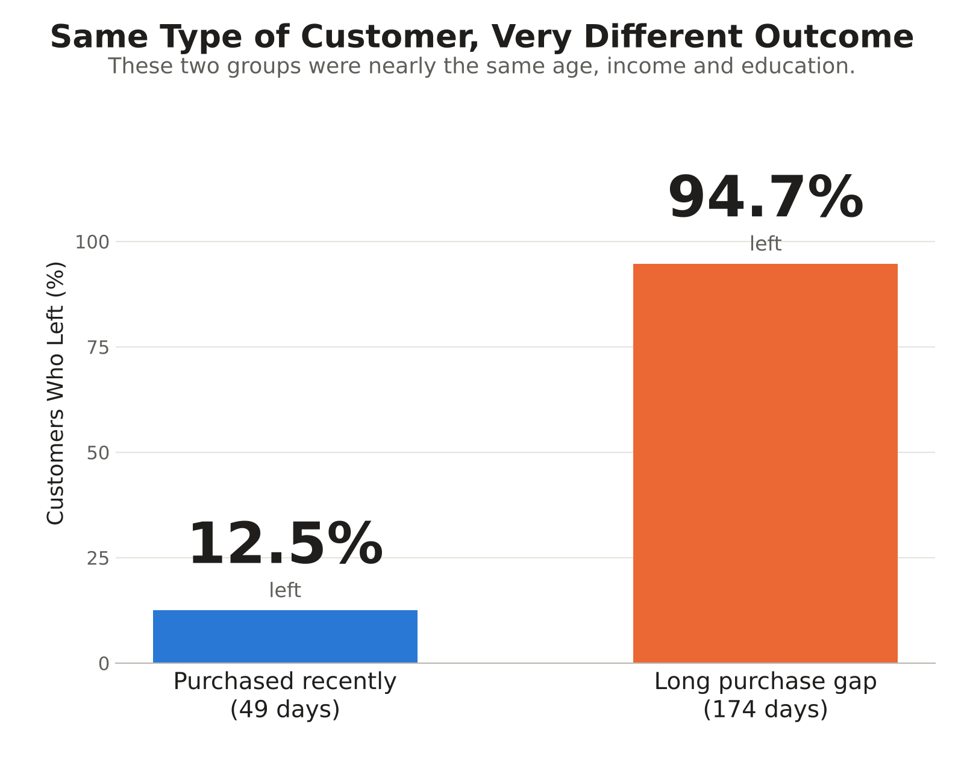
Recent-purchase group  Age ~32 | Income ~$52.5k | Education 1.56 | Purchase gap 49 days | 12.5% left | Long-gap group  Age ~31 | Income ~$50.6k | Education 1.56 | Purchase gap 174 days | 94.7% left
Why this matters
These two groups looked almost the same by age, income and education. The huge difference was purchase timing. That makes purchase behaviour much easier to act on than geography alone.

Missing Information Can Also Be a Warning
A missing purchase-gap value was linked to a much higher leaving rate.
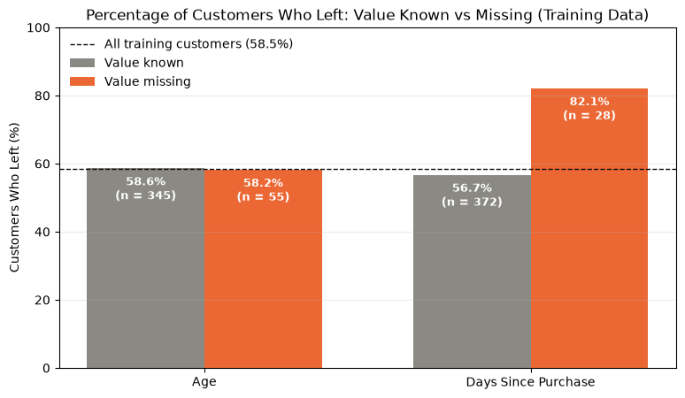
What was actually missing?  Full 500-customer data: 72 Ages were missing and 33 Days Since Purchase values were missing.  Training sample used here: 55 Ages missing and 28 purchase-gap values missing.  Age result: 58.6% left when Age was known vs 58.2% when Age was missing — basically no difference. | The purchase-gap result  Value known: 56.7% left.  Value missing: 82.1% left.  Difference: 25.4 percentage points.  Plain meaning: the fact that purchase timing was missing may itself be useful information.
How this could be used in a future model
Keep two pieces of information: (1) an estimated Days Since Purchase value, and (2) a simple Yes/No flag showing whether the original value was missing. That lets the model use the estimate without throwing away the fact that the record was incomplete.
Do not overread this
Missing data did not “cause” customers to leave. The missing purchase-gap group was also small (28 training customers), so a few customers can move the percentage noticeably. It is a clue worth testing, not a final explanation.
Questions RetailMax should investigate
Why was purchase timing missing in the first place? Was it a tracking/import problem, a process difference, or something about those customers? The dataset does not say. Before using missingness as a business rule, check the data-collection process and confirm the pattern on future records.

A Separate Dataset Shows How Customer Groups Can Be Used
SEPARATE DEMO DATASET — STREAMLYTICS, NOT RETAILMAX
This page is a second fictional dataset used in the assignment to show a different business use: finding natural subscriber types and unusual accounts. It is not part of the RetailMax leaving-rate results on pages 1–4.
What data was used?  Subscribers: 220 streaming-service customer records.  Fields: Age, Monthly Fee, Hours Watched Weekly, and Months Subscribed.  Missing values: none.  No leaving target: this dataset was about grouping subscribers and spotting unusual accounts. | What question was being answered?  - Can the subscribers be separated into clear customer types?  - Can unusual accounts that do not fit a normal group be flagged for review?  - Could the groups support different pricing, engagement or retention strategies?
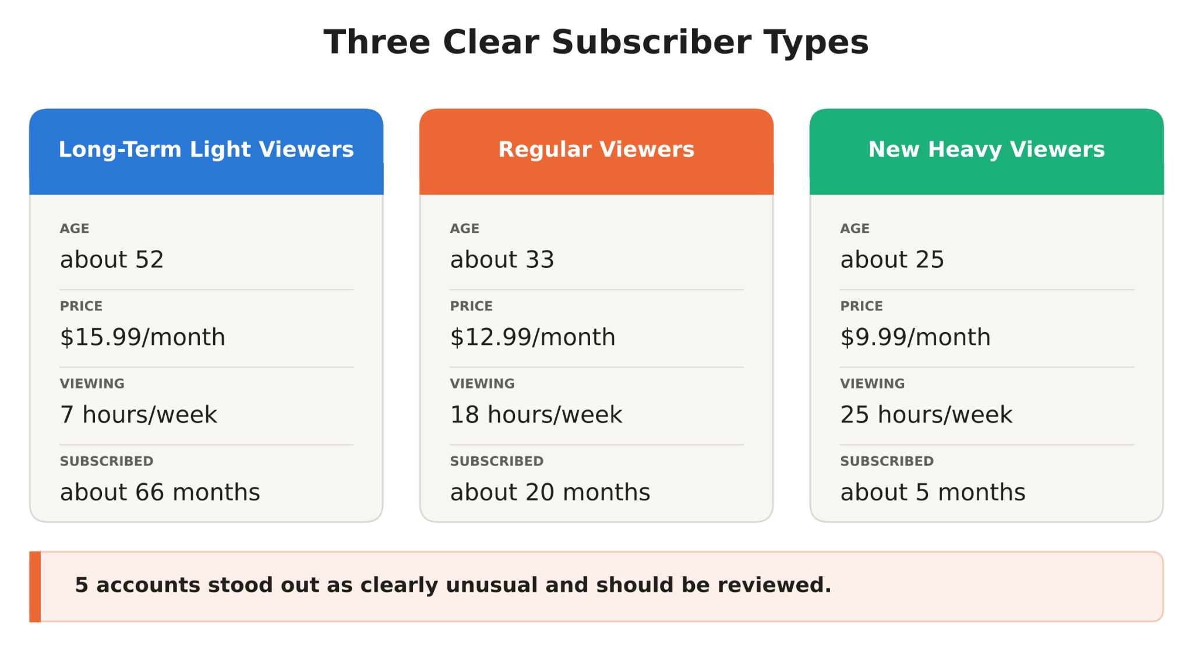
Behind the simple summary
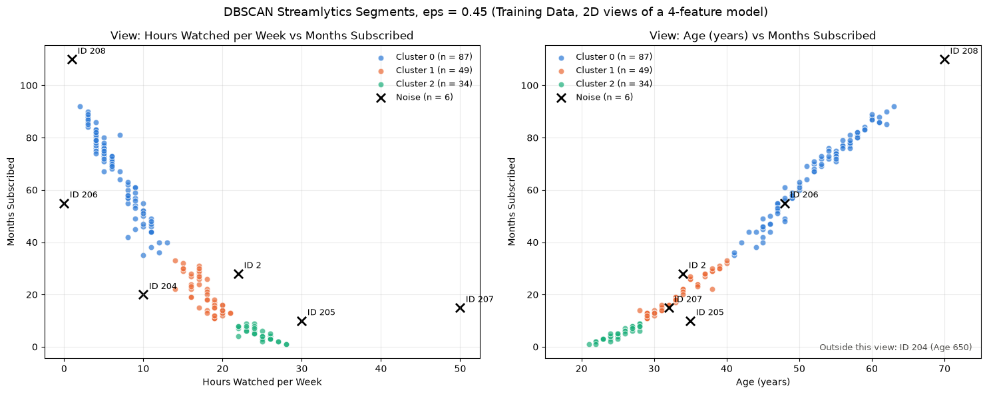
The detailed model found the same three subscriber groups and flagged 6 accounts that did not fit cleanly. Five had clearly unusual values and would be obvious review candidates; one extra account looked ordinary but sat in a sparse part of the data.

What RetailMax Should Do Next
Turn the findings into a small, testable customer-retention plan.
1 | Watch purchase gaps. Long periods without buying were the clearest warning sign. Put “days since last purchase” on a simple customer-risk dashboard.
2 | Act earlier. Test reminders, offers or re-engagement before customers reach the very long-gap range.
3 | Investigate regional differences. North and South had much higher leaving rates, but the dataset does not explain why. Collect better location/context data before making regional decisions.
4 | Keep missing-data flags. If purchase timing is missing, keep that fact as a separate Yes/No field instead of hiding it completely with a fill value.
5 | Treat customer groups differently. Recent buyers, long-inactive buyers and different subscriber types should not all receive the same message or offer.

What would make this analysis stronger?  - Exact city or urban/rural location instead of only East/North/South/West.  - Purchase frequency, order value and product category.  - Customer tenure and previous marketing contact/response.  - A recorded reason for leaving or cancelling.  - Future customer outcomes so any warning system can be tested on new data. | What we still do NOT know  - Why any individual customer left.  - Whether a reminder or discount would have changed the outcome.  - Whether Region itself matters, or whether it is standing in for something else.  - The exact true values that were missing from the original data.  - Whether these same patterns will hold for future customers until they are tested.
Recommended next step
Run a small early-warning pilot: flag customers with growing purchase gaps, contact a test group, keep a similar group untreated for comparison, and measure whether fewer customers leave. That turns the analysis from “interesting pattern” into a business decision that can be proven or rejected.
How to measure whether the plan works
Track the percentage who leave after outreach versus a similar group that did not receive outreach. Also track response rate and the cost per customer retained. The analysis becomes valuable only if the business action improves a real outcome.
Important
These results show patterns in the available data. They do not prove what causes a customer to leave.
Business summary prepared from the completed AIDA 2152 Lab Assignment 1 analysis.

