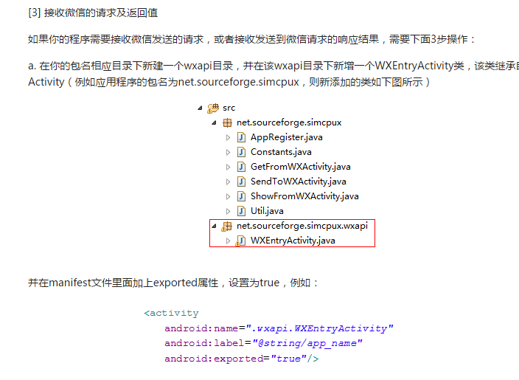

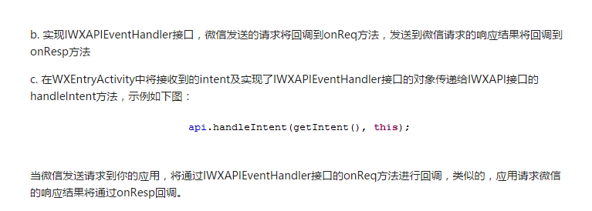

微信登陆的一个大坑可能就是申请的时候的签名与包名就确定下来了，那个应用只能用那一个。

**public class WXEntryActivity extends Activity implements** IWXAPIEventHandler {  
  
  
 **private static final String *TAG*** = **"WXEntryActivity"**;  
  
 **public static void** start(**Context** context) {  
 *start*(context, **false**);  
 }  
  
 **public static void** start(**Context** context, **boolean** kickOut) {  
 **Intent** intent = **new** Intent(context, **WXEntryActivity**.**class**);  
 intent.addFlags(**Intent**.***FLAG_ACTIVITY_CLEAR_TOP*** | **Intent**.***FLAG_ACTIVITY_SINGLE_TOP***);  
 intent.putExtra(**"KICK_OUT"**, kickOut); *// kickout 账号在其他设备登陆* context.startActivity(intent); *// 起动微信登陆界面* }  
  
 **private ImageButton imageButton**;  
  
 IWXAPI **api**;  
 @Override  
 **protected void** onCreate(**Bundle** savedInstanceState) {  
 **super**.onCreate(savedInstanceState);  
  
 setContentView(**R.layout**.***activity_wxentry***);  
  
 *//api注册* **api** = **WXAPIFactory**.*createWXAPI*(**this**, **"wxbf4adad4b62dda38"**, **true**);  
 **api**.registerApp(**"wxbf4adad4b62dda38"**);  
  
 **SendAuth.Req** req = **new** SendAuth.Req();  
  
*//授权读取用户信息* req.**scope** = **"snsapi_userinfo"**;  
  
*//自定义信息* req.**state** = **"wechat_sdk_demo_test"**;  
  
*//向微信发送请求* **api**.sendReq(req);  
 *//注册API* **api** = **WXAPIFactory**.*createWXAPI*(**this**, ***APP_ID***);  
 **api**.handleIntent(getIntent(), **this**);  
 **imageButton** = (**ImageButton**) findViewById(**R.id**.***wxlogin***);  
  
 **imageButton**.setOnClickListener(**new View.OnClickListener**() {  
 @Override  
 **public void** onClick(**View** v) {  
 *// 发起微信登陆* sendAuthRequest();  
 }  
 });  
  
  
 }  
  
 *// 第一步，请求CODE* **private void** sendAuthRequest() {  
 */*Toast.makeText(this, "request Code", Toast.LENGTH_LONG).show();  
 // send oauth request  
 SendAuth.Req req = new SendAuth.Req();  
 req.scope = "snsapi_userinfo";  
 req.state = "wechat_sdk_demo_test";  
 api.sendReq(req);*/* }  
  
  
 *// 微信发送请求到第三方应用时，会回调到该方法* @Override  
 **public void** onReq(**BaseReq** req) {  
 **switch** (req.getType()) {  
 **case** ConstantsAPI.***COMMAND_GETMESSAGE_FROM_WX***:  
 *// goToGetMsg();* **break**;  
 **case** ConstantsAPI.***COMMAND_SHOWMESSAGE_FROM_WX***:  
 *// goToShowMsg((ShowMessageFromWX.Req) req);* **break**;  
 **default**:  
 **break**;  
 }  
 }  
  
 *// 第三方应用发送到微信的请求处理后的响应结果，会回调到该方法* @Override  
 **public void** onResp(**BaseResp** resp) {  
 **int** result = 0;  
  
 **switch** (resp.**errCode**) {  
 **case** BaseResp.ErrCode.***ERR_OK***:  
 **SendAuth.Resp** newResp = (**SendAuth.Resp**) resp;  
  
 *// result = R.string.errcode_success;* **Toast**.*makeText*(**this**, **"返回码正确"** + newResp.**code**, **Toast**.***LENGTH_LONG***).show();  
 **Log**.*i*(***TAG***, **"返回码确认"**);  
  
 **break**;  
 **case** BaseResp.ErrCode.***ERR_USER_CANCEL***:  
 *// result = R.string.errcode_cancel;* **break**;  
 **case** BaseResp.ErrCode.***ERR_AUTH_DENIED***:  
 *// result = R.string.errcode_deny;* **break**;  
 **default**:  
 *// result = R.string.errcode_unknown;* **break**;  
 }  
  
  
 **Toast**.*makeText*(**this**, result, **Toast**.***LENGTH_LONG***).show();  
 }  
}