1. **Print the memory map of the system using the C code.**
2. *#include<stdio.h>*

*int globe=88;*

*int main()*

*{*

*static int jay=898;*

*return 0;*

*}*

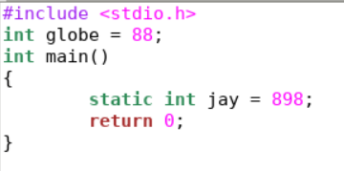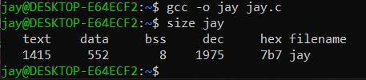

**B**) *#include <stdio.h>*

*int global;*

*int main(void)*

*{*

*return 0;*

*}*

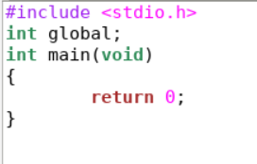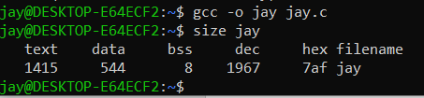

**C***)#include <stdio.h>*

*int global;*

*int main(void)*

*{*

*static int i;*

*return 0;*

*}*

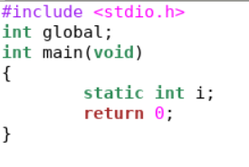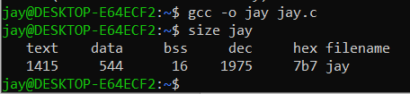

**D***) #include <stdio.h>*

*int global*

*int main(void)*

*{*

*static int i = 100;*

*return 0;*

*}*

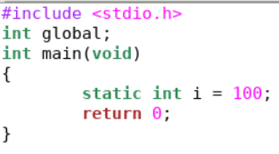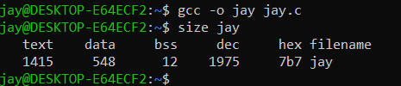

**E**) *#include <stdio.h>*

*int global = 10; /* initialized global variable stored in DS*/*

*int main(void)*

*{*

*static int i = 100; /* Initialized static variable stored in DS*/*

*return 0;*

*}*

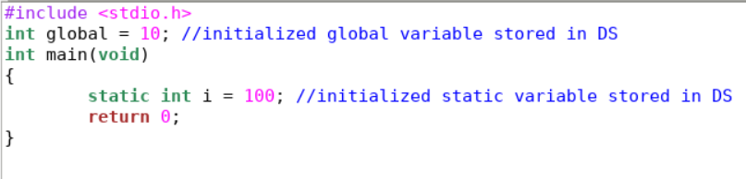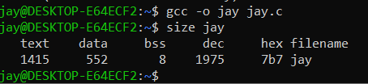

1. **Create a loop which prints a random number after a certain amount of delay. The Value of the delay will be provided by the user. The Delay function gets an interrupt whenever any key press in there.**
2. Code:-

#include <stdio.h>

#include <time.h>

#include <stdlib.h>

#include <conio.h>

*void* delay(*float* *sec*)

{

*int* millis = 1000 * sec;

*clock_t* start_time = clock();

    while (clock() < start_time + millis)

        ;

}

*int* main()

{

*int* i = 0;

*float* delayTime;

    printf("\nEnter the delay (in sec) - ");

    scanf("%f", &delayTime);

    while (!kbhit())

    {

        printf("\nDelay Time - %f", delayTime);

        printf("\nRandom Number Generated - %d", rand());

        delay(delayTime);

        i++;

    }

    main();

    return 0;

}

