Login Page

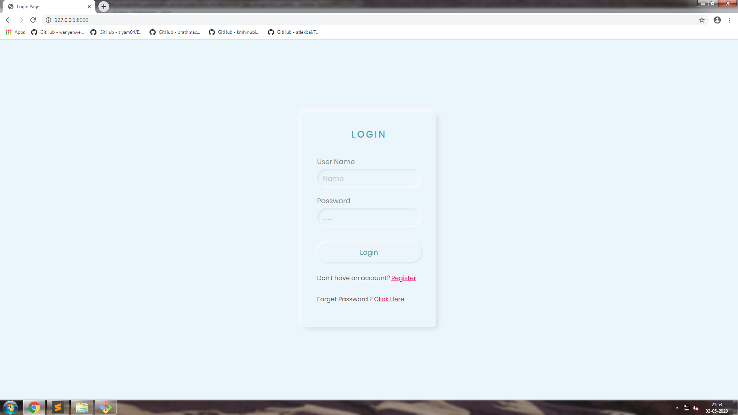

After Login Main Page

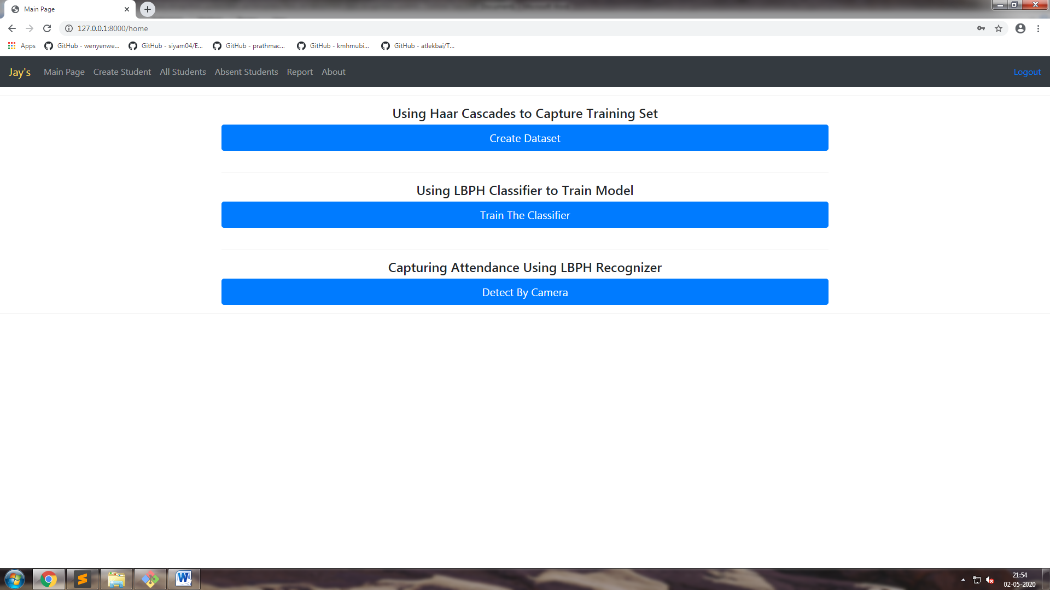

After Clicking Create Dataset

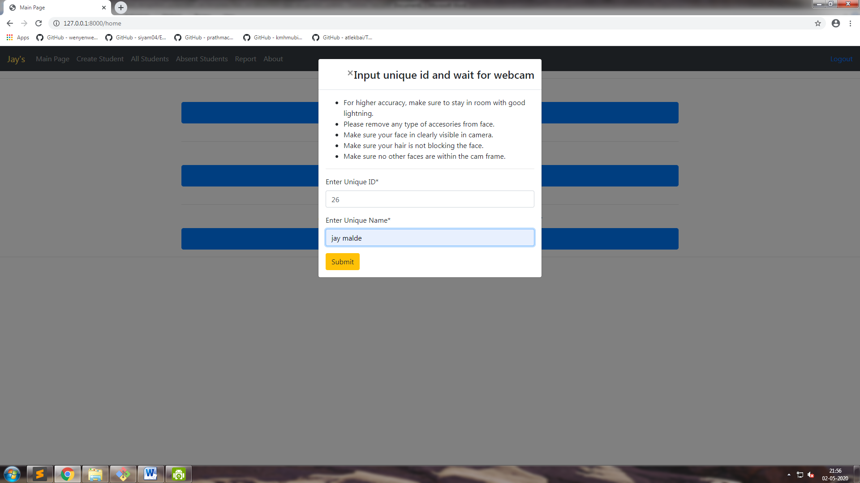

After Submitting A frame will Open And Capture 60 Images Forr Training

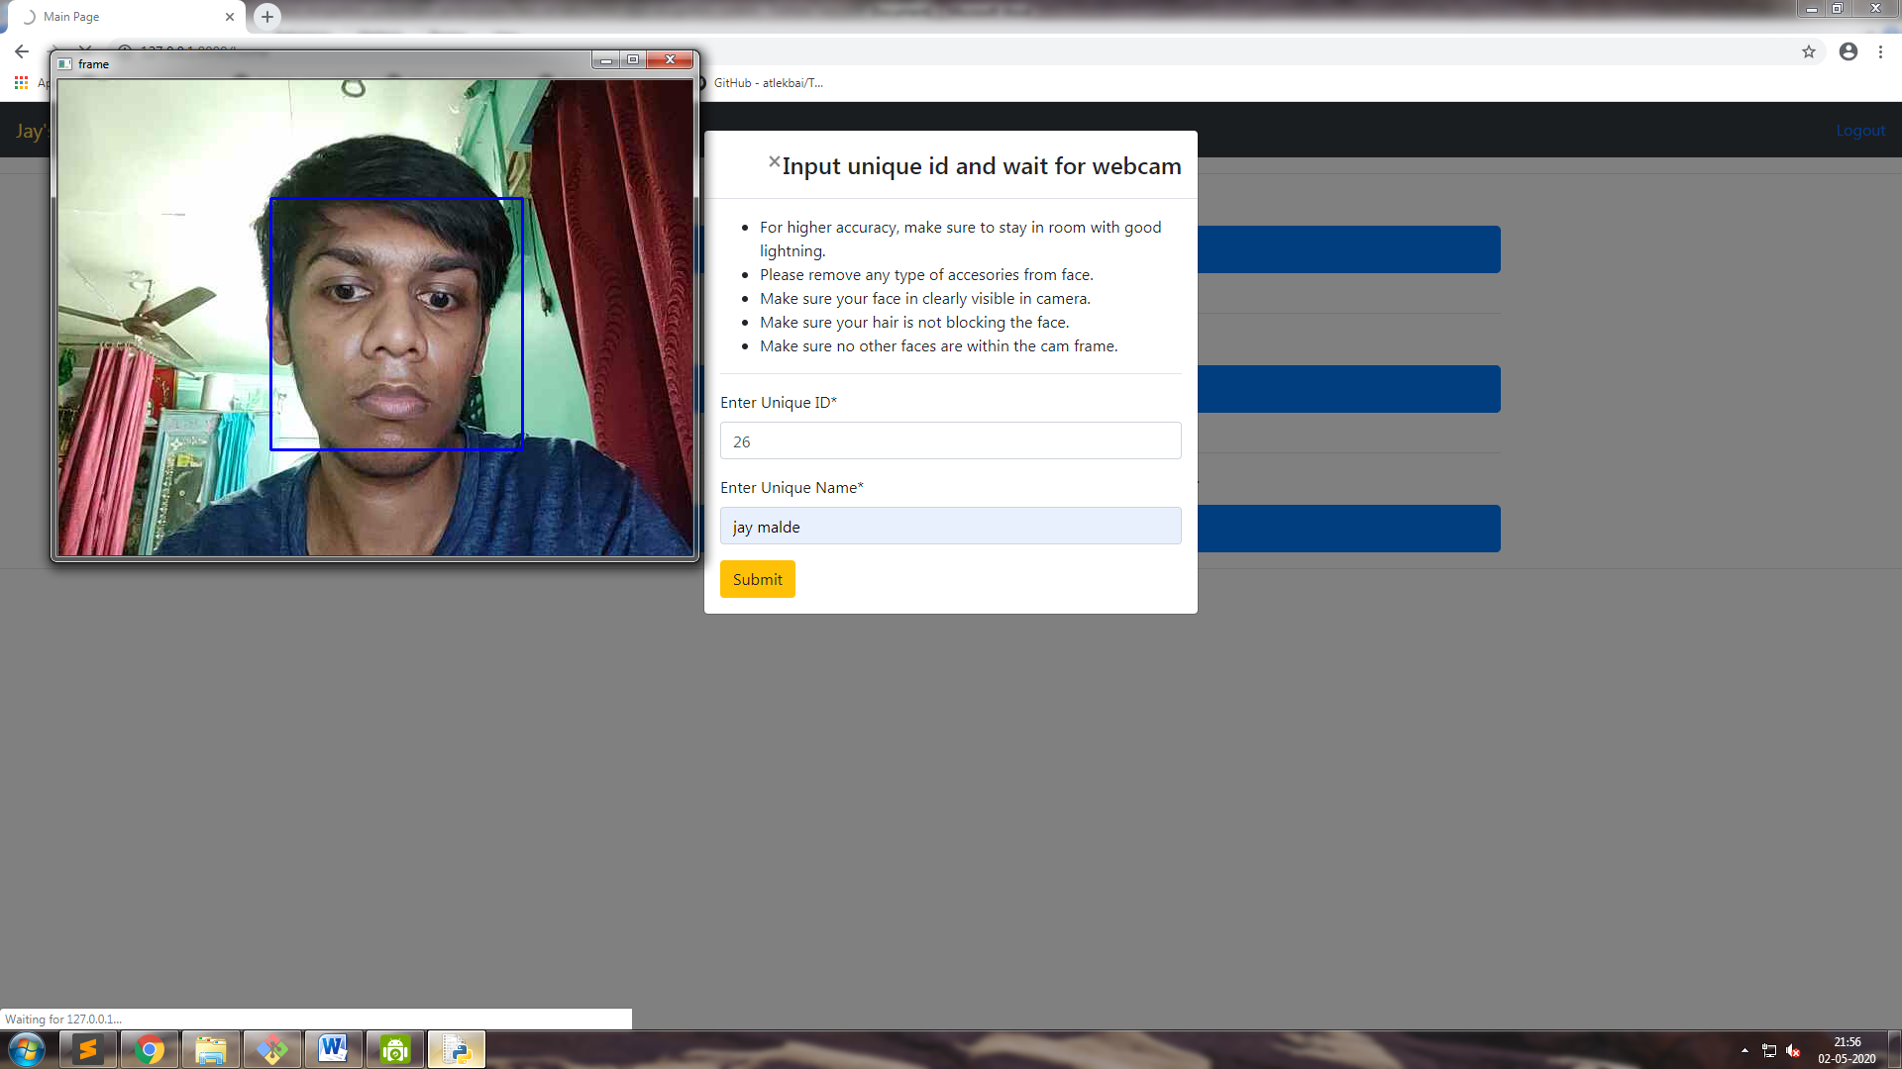

After Capturing Images Click On Train Classifier

A Frame will Show That The Images Are Training

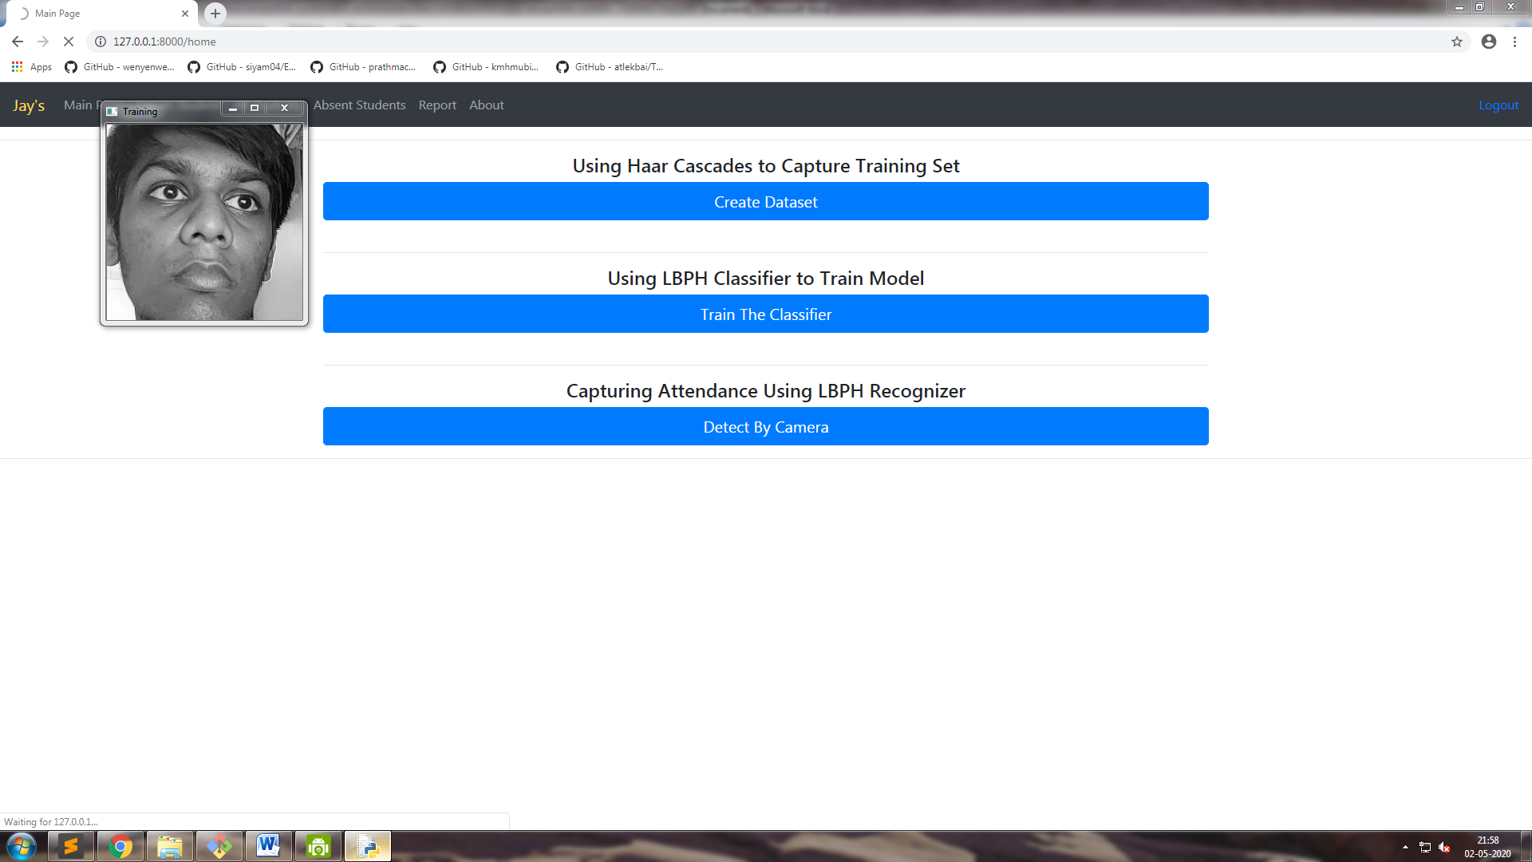

After Clicking Detect By Camera A Frame will Open And Take attendance and Show The Profile Of The Detected User

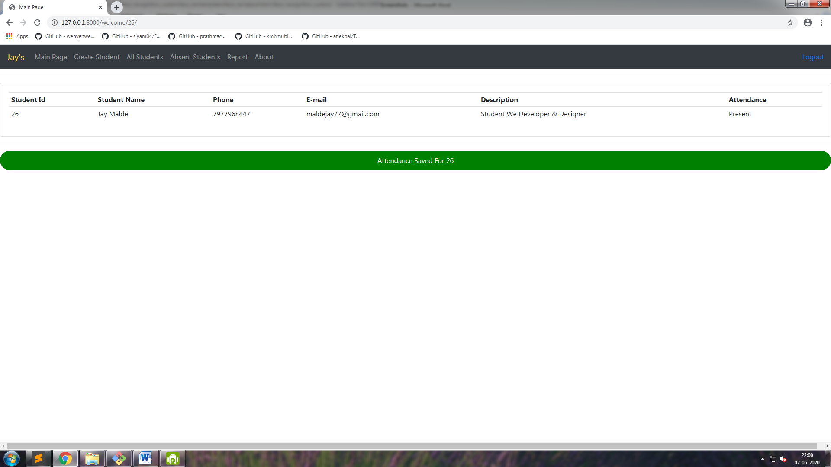

After Clicking All Students We Can see All The Students

With The Count

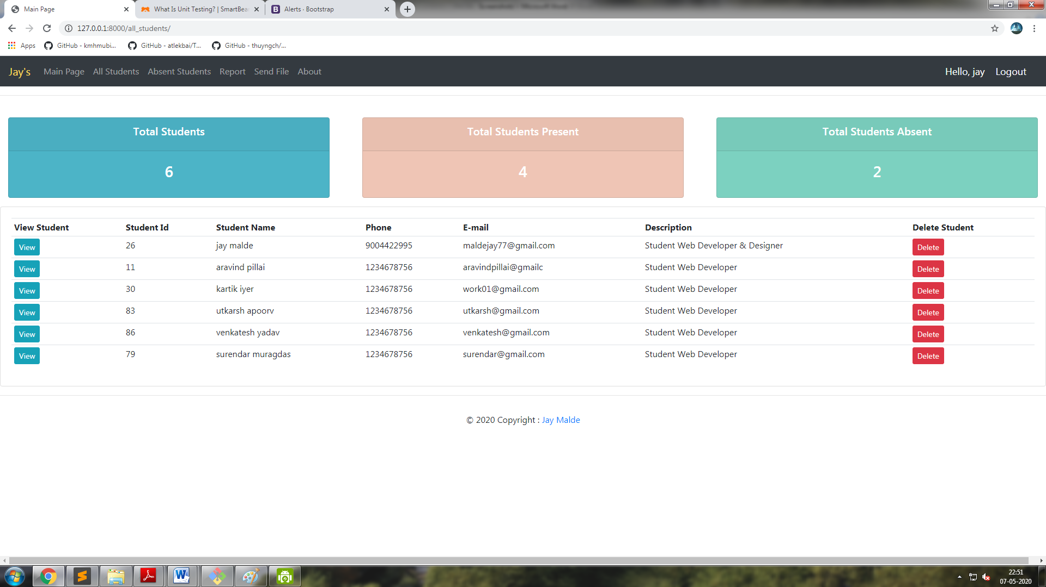

After Clicking Absent It Shows All Those Students Who Were Absent

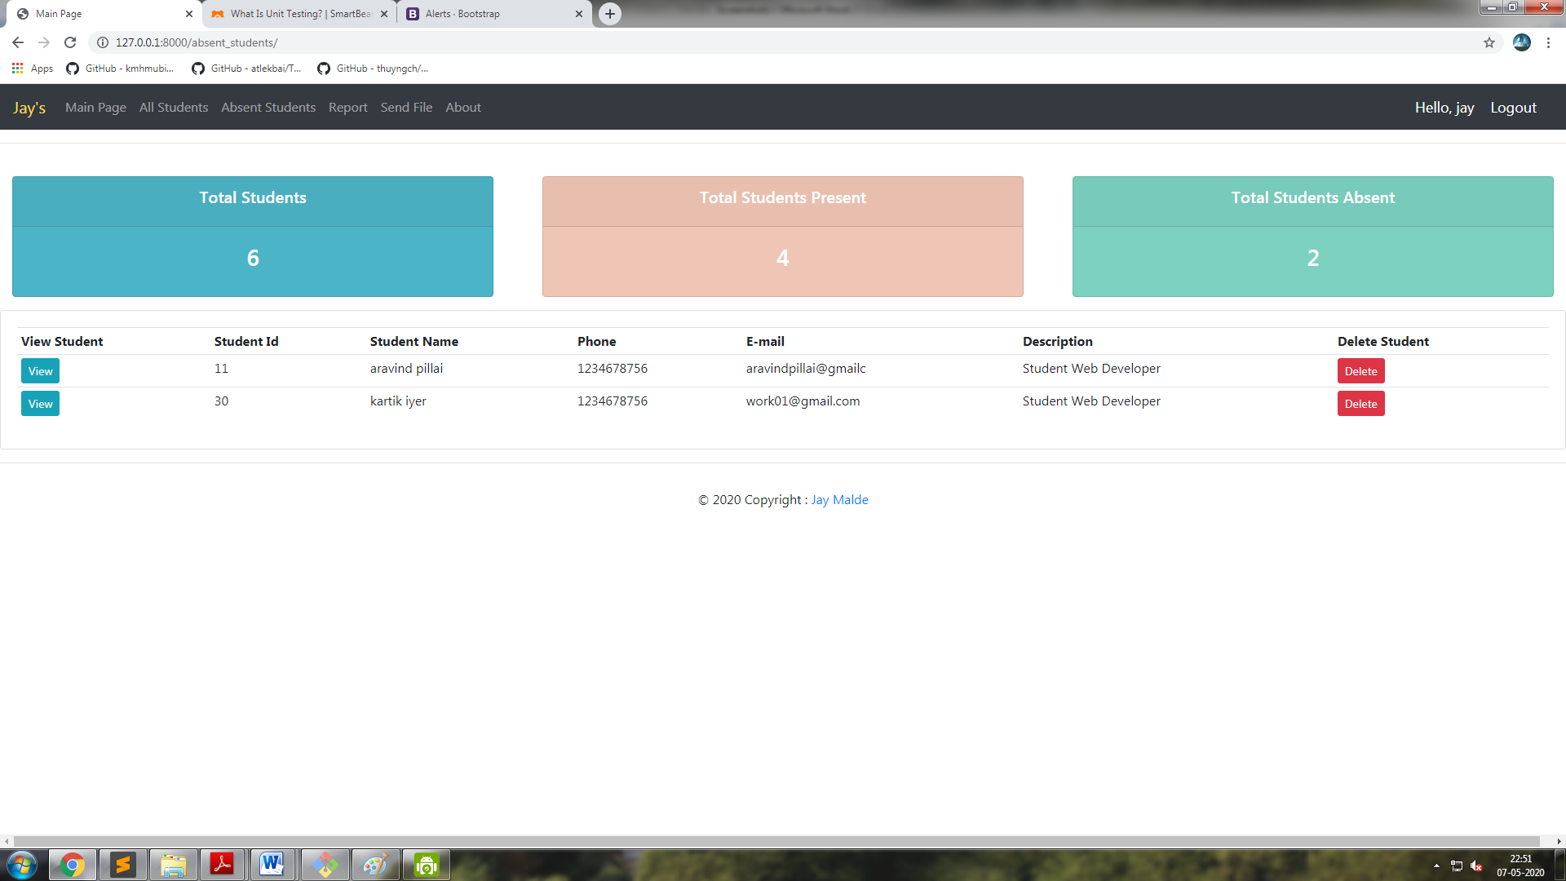

On Clicking The Report Tab It Creates A Real time Report On Students With Time Stamp

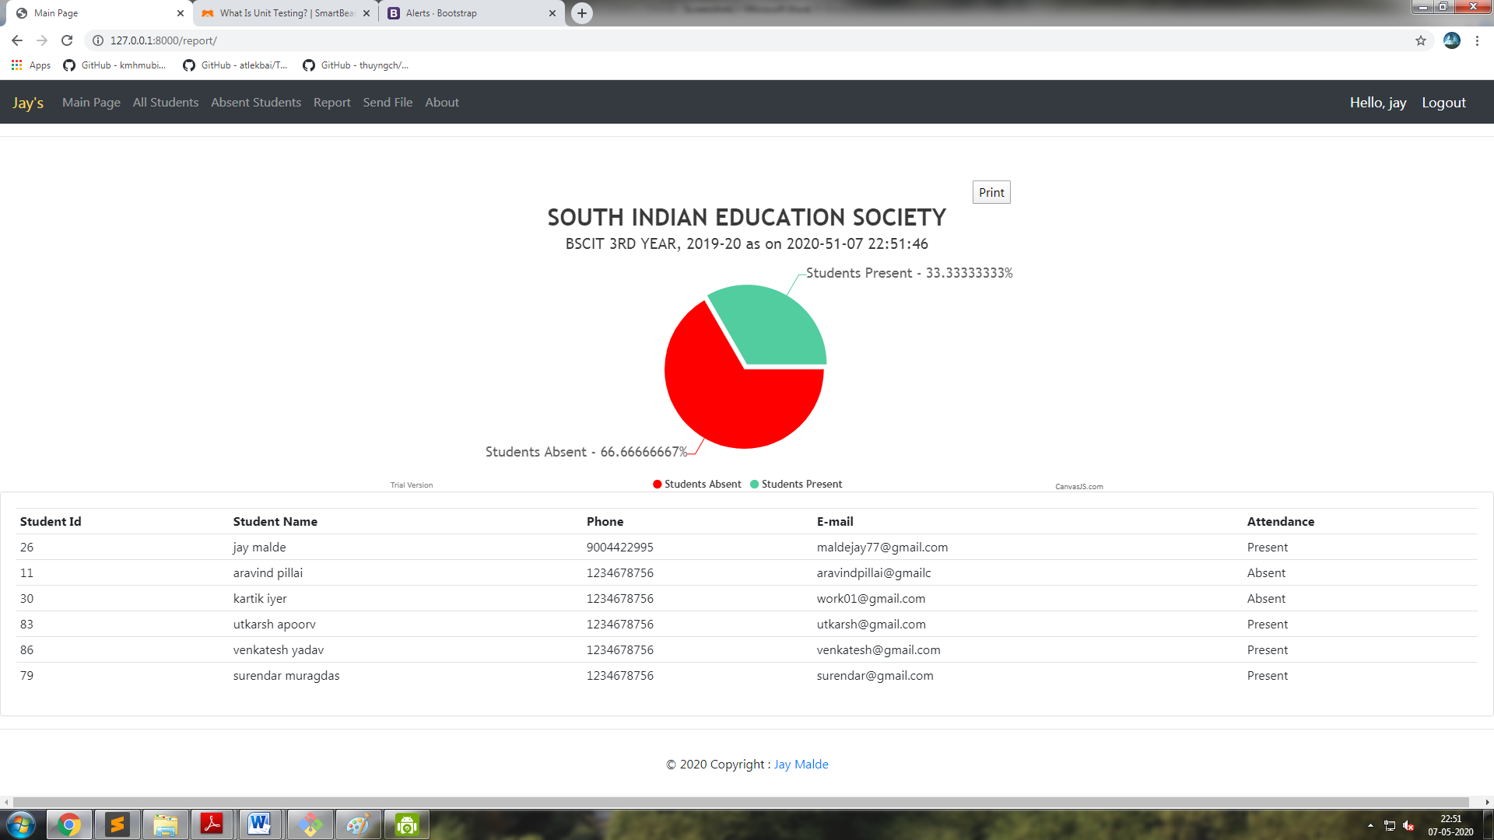

Printable Report PDF 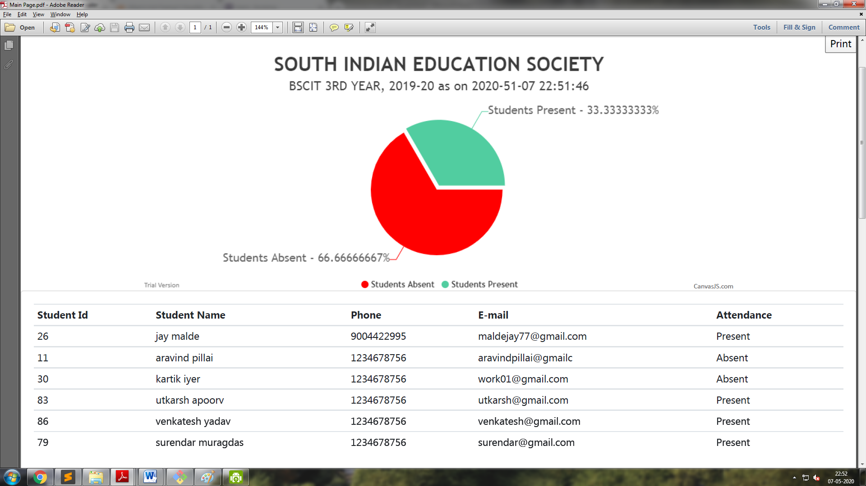

In This Section The User Can Send The Mail 