Cusrow Wadia Institute of Technology, Pune-01

Name of Student: Vedant Jawadwar | Class: TY-IoT
Semester/Year: VI sem 3rd year | Roll No: 235033
Date of Performance: | Date of Submission:
Examined By: | Practical No: 3

Laboratory – (Cloud Security)

AIM : To identify common cloud security risks and apply appropriate security controls to mitigate them.

Theory :

- Introduction

Cloud computing provides on-demand access to shared resources such as servers, storage, applications, and networks. While cloud service providers offer strong infrastructure security, users are still responsible for securing their data and configurations. Many cloud security incidents occur due to weak authentication, misconfiguration, and lack of monitoring. Identifying these risks and applying proper security measures is essential for secure cloud computing.

- Cloud Security Risks
Cloud security risks are threats that can compromise the confidentiality, integrity, and availability of cloud resources. These risks can arise due to human error, cyber-attacks, or weak security practices.

- Common Cloud Security Risks

- Data Breach
A data breach occurs when unauthorized users gain access to sensitive data stored in the cloud. This may happen due to weak passwords, public storage access, or compromised credentials.

- Security Measure
Strong authentication mechanisms such as complex passwords and multi-factor authentication should be used. Sensitive data should also be encrypted.

- Weak Identity and Access Management
Improper access control can allow users to access resources beyond their role. Over-privileged accounts increase the impact of security breaches.

- Security Measure
Role-based access control should be implemented and users should be given only the minimum permissions required to perform their tasks.

- Misconfigured Cloud Storage
Cloud storage services may become publicly accessible if security settings are incorrectly configured, leading to data exposure.

- Security Measure
Public access should be disabled by default and storage permissions should be reviewed
regularly.

- Insecure APIs
Cloud services rely heavily on APIs for communication. If APIs are not secured, attackers can exploit them to access or manipulate data.

- Security Measure
APIs should be protected using authentication, authorization, and secure communication protocols such as HTTPS.

- Malware and Ransomware Attacks
Malicious software can be introduced into cloud systems through infected files or compromised applications, causing data loss or service disruption.

- Security Measure
Antivirus tools, regular patching, and data backups should be used to protect against malware attacks.

- Denial of Service Attacks
In denial of service attacks, attackers flood cloud services with excessive traffic, making them unavailable to legitimate users.

- Security Measure
Traffic monitoring, firewalls, and auto-scaling mechanisms should be implemented to handle traffic spikes.

- Lack of Monitoring and Logging
Without proper monitoring, security incidents may go undetected for long periods.

- Security Measure
Logging and monitoring tools should be enabled to track user activities and detect suspicious behavior.

- Advantages
- Improves data confidentiality and integrity.
- Reduces risk of unauthorized access.
- Enhances availability of cloud services.
- Helps in regulatory compliance.

- Applications
This practical is useful in cloud storage systems, enterprise cloud applications, e-commerce platforms, and government cloud services.

Conclusion
Cloud security risks mainly arise due to weak authentication, misconfiguration, and lack of monitoring. By identifying these risks and applying appropriate security measures such as access control, encryption, and continuous monitoring, cloud environments can be secured effectively.

Code:

#authentication

def authenticate(username,password):
if username==password:
return False
else:
return True

username=input("Enter user name :")
password = input("Enter password :")

if authenticate(username,password):
print("Login succesfuly.")
else:
print("Weak password")

#access grant

roles={
"admin":["read","write","delet"],
"user":["read"]
}

def access(role,action):
if action in roles.get(role,[]):
return True
else:
return False

role=input("Enter user role :")
action= input("Enter action :")

if (access(role,action)):
print("Access Granted")
else:
print("Access Denied")

#Data Encryption

def encrypted_data(data):
encrypted=""
for char in data:
encrypted+=chr(ord(char)+1)
return encrypted

def decrypted_data(data):
decrypted=""
for char in data:
decrypted+=chr(ord(char)-1)
return decrypted

sensitive_data=input("Enter sensitive data: ")

print("Original data: ",sensitive_data)

apply_enc=encrypted_data(sensitive_data)
print("Encrypted Data: ",apply_enc)

apply_dec=decrypted_data(apply_enc)
print("Decrypted data: ",apply_dec)

#LOGGING Activity

def log_activity(user,activity):
file=open("Cloud.txt","a")
file.write("User:"+user+" Activity:"+activity)
file.close()

log_activity("vedant","Login Attempt")
log_activity("Sachin","Changing the format")

print("user activity logged successfully")

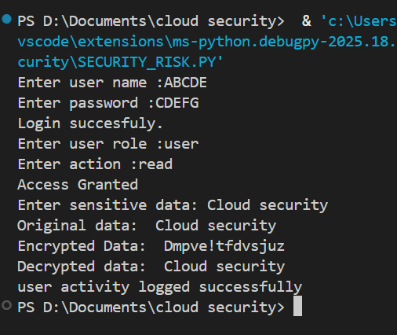
OP:

