# 

**How to Cluster SQL Server Analysis Services**

**Summary:** One approach for meeting your organization’s high availability requirements for Analysis Services is to install it on a Windows Server failover cluster (WSFC). A WSFC is composed of multiple servers that offer redundancy in the event of a hardware failure, system crash, or some other service disruption. A WSFC can offer protection of your mission critical backend servers, including the Analysis Services instances running your BI workloads.

**Writer:** Allan Hirt, Cluster MVP (SQLHA)

**Editor:** Heidi Steen

**Reviewers:** Gert Christen, Jason Howell, Kay Unkroth

**Published:** April 2014

**Applies to:** Analysis Services in SQL Server 2012 or SQL Server 2014, Multidimensional and Tabular modes

Copyright

This document is provided “as-is”. Information and views expressed in this document, including URL and other Internet Web site references, may change without notice. You bear the risk of using it.

Some examples depicted herein are provided for illustration only and are fictitious.  No real association or connection is intended or should be inferred.

This document does not provide you with any legal rights to any intellectual property in any Microsoft product. You may copy and use this document for your internal, reference purposes.

© 2014 Microsoft. All rights reserved.

Contents

Introduction 5

Making Analysis Services Highly Available 5

Differences between WSFC and NLB 5

Differences between FCIs and SSAS Clustered Instances 6

SSAS Cluster Design Considerations 6

Windows Versions and Editions 6

Patch Levels 7

SQL Server Versions and Editions 7

SSAS Server Modes 8

SSAS Service Accounts, Ports, and Types of Instances 8

Names and IP Addresses 9

Associated Active Directory Objects 10

Shared Storage 10

WSFC Quorum 11

Geographically Dispersed Clusters 12

Microsoft Azure and Clustering SSAS 12

Database Engine and Analysis Services in One Cluster Group 12

Number of Nodes and Total Number of Clustered Instances on a WSFC 14

NET Framework 15

Install SSAS in a Clustered Configuration 17

First Instance Install 17

Add Nodes to the Clustered SSAS Instance 43

Add More Instances to the WSFC 47

Verifying the Installation 47

Visual Verification 48

Testing Failover 49

Testing Connectivity 52

Connect to a Clustered SSAS Instance 53

Client Connections and Failover 53

Connection Examples 53

Using SQL Server Management Studio 53

Using SQL Server Data Tools 55

Using Excel 56

Using HTTP 57

Administer a Clustered SSAS Instance 57

Adjust Memory Settings 57

Changing Node Configuration 58

Servicing Clustered Instances of SSAS 58

Stopping and Starting Clustered Instances 58

Changing Service Accounts 58

Renaming a Clustered Instance and Changing the IP Address 59

Adding and Removing Nodes 59

Hands on Learning 60

Conclusion 60

# Introduction

Service continuity in the event of hardware failure, system crash, or even planned maintenance is a critical business requirement that many IT departments solve using some form of server redundancy. For SQL Server, **AlwaysOn failover cluster instances (FCIs)** are one of the more popular approaches for making the relational database engine highly available. Analysis Services (SSAS) can benefit from an equivalent approach for BI workloads that are mission critical to its customers.

Fortunately, there are several methods for making SSAS highly available: a scale-out solution that provides redundancy and increased capacity, or clustering SSAS similar to how an FCI is deployed. This paper shows you how to deploy a clustered instance of Analysis Services with SQL Server 2012.

# Making Analysis Services Highly Available

There are two methods for making SSAS highly available: load balancing or using a Windows Server Failover Cluster (WSFC). While both ways achieve the desired end result, the configurations are very different.

More often than not, load balancing is considered the best approach for SSAS. You can use either the built-in Windows load balancing feature called Network Load Balancing (NLB) or a hardware-based load balancer.

An NLB cluster (or hardware load balancer) is essentially the front end to a number of SSAS instances and distributes incoming requests to those instances. Those SSAS instances are usually read only. Not only does this provide availability through multiple redundant instances, each having the same data, but NLB also provides the ability to scale-out query capacity as more redundant instances are added to the NLB cluster. There is nothing you need to configure in Analysis Services that enables NLB; it is a function of Windows. Install multiple standalone Analysis Services instances, and make it part of an NLB configuration. For more information about SSAS scale-out solutions, see [Scale-Out Querying for Analysis Services with Read-Only Databases](http://download.microsoft.com/download/A/5/7/A575AD7C-4172-42D0-8D58-0698D6802F81/SSASReadOnlyDBs.docx) (http://download.microsoft.com/download/A/5/7/A575AD7C-4172-42D0-8D58-0698D6802F81/SSASReadOnlyDBs.docx). Although the paper is several years old, its guidance is applicable to current versions of SSAS.

Less recommended, yet still widely used and the focus of this paper, is configuring a WSFC and installing SSAS on top of it, similar to deploying an FCI. Because FCIs are common in many environments, many want to cluster SSAS because it leverages existing in-house expertise and processes already in place. To determine the best approach to making Analysis Services available in your environment, you should understand the differences between the different methods.

## Differences between WSFC and NLB

A WSFC’s purpose is availability, not performance, scale, or protecting data. While clustered installations of SQL Server (either the engine or SSAS) should also be architected to perform well, improving performance on WSFC requires the traditional scale up methods developed for standalone systems. This means that there is no load balancing.

With a WSFC, a single server, also known as a node, owns the resources associated with an FCI or SSAS instance. All resources for a single clustered application are grouped together and called a Role in Windows Server 2012. In Windows Server 2008 and 2008 R2, a Role was known as a service or application, and before that, a resource group.

In the event of a problem on the node that owns the Role, the Role and all of its resources will fail over to another node in the WSFC. Should failover occur, the connectivity information of the SSAS instance will remain the same regardless of the node it is running on. Since SSAS goes through a stop on the old node and a start on another – just like shutting down and restarting a standalone server – there will be an impact on the end user.

## Differences between FCIs and SSAS Clustered Instances

There is one fundamental difference between an FCI and a clustered instance of SSAS: an FCI is a formal, cluster-aware application, whereas clustering SSAS is not cluster-aware. This means that an FCI utilizes the full health detection methods of the underlying WSFC which checks not only Windows-related items, but also looks inside SQL Server to ensure that it is in a healthy state, and if it is not, potentially initiates a failover.

With SSAS, no such health check process exists if it is clustered. Setup creates what is known as a Generic Service or Application (for more information, see [Understanding Generic Applications in a Failover Cluster](http://technet.microsoft.com/en-us/library/cc753938.aspx) (http://technet.microsoft.com/en-us/library/cc753938.aspx)). If something is not quite right within the SSAS instance, it would need to be detected by other means and you would need to try a manual failover to see if it resolves the issue. However, SSAS will automatically fail over if there is a problem detected by the WSFC at the node level.

One trait common to both an FCI as well as clustering SSAS is that configuring each can only happen during Setup. That means you cannot convert a standalone instance (database engine or SSAS) into one that is clustered without a full uninstall and reinstall of the product.

**NOTE:** The database engine has a broader range of availability options which also includes AlwaysOn Availability Groups. While the AlwaysOn Availability Groups feature also requires a WSFC, it can only be utilized with the relational engine and cannot be used with Analysis Services databases.

# SSAS Cluster Design Considerations

To ensure that you have successful clustered installations of SSAS, this section will cover the most important aspects that you need to consider during the planning phase. Where applicable, links to additional information will be provided.

## Windows Versions and Editions

Analysis Services in SQL Server 2012 or 2014 is supported on these versions of Windows:

* Windows Server 2008
* Windows Server 2008 R2
* Windows Server 2012
* Windows Server 2012 R2

For full requirements, consult [Hardware and Software Requirements for Installing SQL Server 2014](http://msdn.microsoft.com/en-us/library/ms143506(v=sql.120).aspx) (http://msdn.microsoft.com/en-us/library/ms143506(v=sql.120).aspx). You can use this link to also access the SQL Server 2012 version of this Books Online topic.

**NOTE:** At this point, you should strongly consider deploying your clustered instances of SQL Server using Windows Server 2012 or later, as mainstream support for Windows Server 2008 and 2008 R2 ends on January 13, 2015. See <http://support.microsoft.com/lifecycle> for more information.

For Windows Server 2008 and 2008 R2, WSFC is a feature of only the Enterprise or Datacenter editions of Windows; Standard is not supported for clusters. In Windows Server 2012 and later, all editions have the same feature set. If deploying Windows Server 2012, chances are you will use Windows Server 2012 Standard Edition unless you require the license benefit of Datacenter for unlimited virtualization.

You cannot mix major operating system editions in the same WSFC. For example, if your cluster is Windows Server 2008 R2, you cannot have a Windows Server 2012 node added to it. While it is technically possible to mix editions of the same major operating version in the same WSFC, it is discouraged and not a best practice.

SQL Server Analysis Services is also supported on Windows Server Core, which is a GUI-less variant of Windows. For more information, see [Install SQL Server 2012 on Windows Server Core](http://msdn.microsoft.com/en-us/library/hh231669(v=sql.110).aspx) (http://msdn.microsoft.com/en-us/library/hh231669(v=sql.110).aspx) on MSDN. With Windows Server 2012 and later, you can mix nodes that have the full user interface of Windows and Server Core nodes in the same WSFC.

## Patch Levels

Each node should be configured with the same updates in Windows. For example, if you apply a service pack to one node, apply it to all. This practice helps ensure that all nodes will behave similarly. The validation process for creating a WSFC will note any differences so you can address them.

## SQL Server Versions and Editions

Depending on how you plan on deploying the clustered instance of SSAS, the edition of SQL Server may dictate how many nodes you can configure as part of a given instance.

If deploying only Analysis Services:

* Standard Edition allows only two nodes to be part of the instance regardless of the total number of nodes in the WSFC
* Business Intelligence and Enterprise editions allow up to the maximum number of nodes supported by the underlying WSFC

If deploying both an FCI and Analysis Services at the same time:

* As with just SSAS only, Standard Edition allows only two nodes to be part of the instance regardless of the total number of nodes in the WSFC
* Business Intelligence is tied to the FCI limitation, which like Standard Edition, is up to two nodes only.
* Enterprise edition allows up to the maximum number of nodes supported by the underlying WSFC

## SSAS Server Modes

A clustered instance of SSAS is the full installation of Analysis Services. That means everything that you can do in a standalone instance can be done with the clustered instance regardless of whether the server is installed in Tabular or Multidimensional mode. For example, SSAS databases on a cluster can use any storage mode, including DirectQuery or ROLAP. Similarly, for multidimensional solutions, feature behaviors that reach back to the external data source, such as drillthrough and write-back, are supported in an SSAS cluster.

**NOTE:** Don’t mix tabular and multidimensional server modes in the same clustered instance. SSAS can be installed in either tabular or multidimensional mode, and in a cluster, all nodes must support the same operational context.

Clustering Analysis Services in SharePoint integrated mode (PowerPivot for SharePoint) is not supported, nor is it necessary. Availability and scalability are built into SharePoint, with SharePoint providing load balancing among server applications in the same environment.

SharePoint 2013 farms that utilize external Analysis Services instances (configured for SharePoint integrated mode) do not support clustering the SSAS instance. If you need scale or redundancy for this scenario, install multiple standalone instances of Analysis Services in SharePoint mode and register all of them in Excel Services configuration pages. Excel Services will automatically load balance the requests among all available Analysis Services servers. Conversely, if the PowerPivot workloads are small across multiple SharePoint farms, you can use a single Analysis Services instance for both SharePoint farms.

**NOTE:** Because clustering support is different among the SQL Server features used in a SharePoint farm, planning a SharePoint deployment will take some careful consideration. For example, as the storage engine of the farm, the database engine is often installed as a FCI, but as noted above, SSAS cannot be clustered.

## SSAS Service Accounts, Ports, and Types of Instances

A domain-based service account is required for a clustered SSAS instance. This does not need to be, nor should it be, a domain administrator. You should create a least privileged account based on the information stated in [Configure Service Accounts](http://msdn.microsoft.com/en-us/library/ms143504.aspx) (http://msdn.microsoft.com/en-us/library/ms143504.aspx).

Clustered SSAS instances use TCP port 2383, which must be opened up in your firewall (Windows firewall on each node and/or external). All clustered SSAS instances will use this port regardless of whether it was installed as a default or a named instance. The reason for this is that the SQL Server Browser service, which provides OLAP redirection, is not cluster aware and may contain wrong entries over time, so it is not supported for clustered implementations of SSAS.

For a standalone instance, you might normally edit the server configuration file msmdsrv.ini as described in [Configure Server Properties](http://technet.microsoft.com/en-us/library/ms174556.aspx) (http://technet.microsoft.com/en-us/library/ms174556.aspx).This approach is not supported for clustered SSAS instances. Altering the port number is altered in msmdsrv.ini will have no effect; it is ignored.

SQL Server Setup only allows one default instance per WSFC. Anything else would need to be installed as a named instance. However, unlike an FCI, a clustered install of SSAS that is a named instance acts as if it were a default instance. More information on how this works is in the section “Connect to a Clustered SSAS Instance” later in this paper.

## Names and IP Addresses

Each installation of SSAS in a clustered configuration gets its own set of resources in its own Role. This section explains names and IP addresses as related to instances, and how you would need to plan for them.

**Names for Objects in a WSFC**

Whenever a clustered instance is created, it is associated with a network name resource in the WSFC. This network name resource is different from the name of the WSFC or the underlying nodes, and also unique in the Active Directory domain and cannot be used anywhere else. This name also has two things associated with it: an object in Active Directory (see “[Failover Cluster Step-by-Step Guide: Configuring Accounts in Active Directory](http://technet.microsoft.com/en-us/library/cc731002(v=WS.10).aspx) (http://technet.microsoft.com/en-us/library/cc731002(v=WS.10).aspx)”) and an entry in DNS (more on DNS later in this section). For example, if your nodes were named SSASNODE1 and SSASNODE2 with the WSFC named SSASWSFC, the name of the SSAS instance could not be any of those and would need to be something like SSAS-CLUSINS.

The network name of a clustered instance equates to what would be considered a default instance of SQL Server or SSAS. For a clustered default SQL Server instance, you would connecting using the network name of the cluster instance (SSAS-CLUSINS, in the previous example).

**IP Addresses**

Similar to the naming, each clustered installation will get its own IP address (and sometimes multiple if spanning geographies), and the IP is different than that of the underlying nodes as well as the WSFC itself. For example, if the nodes have IP addresses of 192.168.1.1 and 192.168.1.2, the WSFC an IP Address of 192.168.1.3, the SSAS instance could be 192.168.1.4. If you install SSAS and the database engine into the same WSFC instance, then the same IP address is used for both.

**DNS Entries**

Because a clustered installation of SSAS has both a name and an IP address associated with it, make sure the name and IP address are in your company’s DNS. If you have dynamic DNS, these entries will be added automatically. If DNS does not allow dynamic updates, someone responsible must enter the name and IP address in so applications can access the clustered SSAS instance.

## Associated Active Directory Objects

Windows Server 2008 and later require that both the WSFC and the items created in it (such as an instance of SSAS that is clustered) have objects associated with them in Active Directory (AD). There is one exception to this rule which is described in the next paragraph. The name of the WSFC has an object created called the Cluster Name Object, or CNO. Anything else that gets a network name resource – including SSAS – gets a virtual computer object, or VCO. For more information on these objects and the rights needed to create them, see [Failover Cluster Step-by-Step Guide: Configuring Accounts in Active Directory (http://technet.microsoft.com/en-us/library/cc731002(WS.10).aspx))](file:///C:\Users\munnangj\AppData\Local\Temp\Failover%20Cluster%20Step-by-Step%20Guide:%20Configuring%20Accounts%20in%20Active%20Directory%20(http:\technet.microsoft.com\en-us\library\cc731002(WS.10).aspx))).While this article was written for Windows Server 2008 and 2008 R2, it is applicable to Windows Server 2012 and later as well.

**NOTE:** If your AD deployment is locked down, these objects can be created ahead of time; see [Prestage Cluster Computer Objects in Active Directory Domain Services](http://technet.microsoft.com/en-us/library/dn466519.aspx) (http://technet.microsoft.com/en-us/library/dn466519.aspx) for instructions.

The exception mentioned above is that with Windows Server 2012 R2, you can create what is known as an Active Directory-Detached Cluster. The name is a bit of a misnomer since the nodes themselves are still required to be joined to AD, but there would be no associated CNOs or VCOs. For more information, consult [Deploy an Active Directory-Detached Cluster](http://technet.microsoft.com/en-us/library/dn265970.aspx) (http://technet.microsoft.com/en-us/library/dn265970.aspx).

## Shared Storage

All program files – the binaries associated with Analysis Services – are installed locally on each node. Each node must have the same drive configuration from that standpoint. For example, if one node uses a local C drive, the other node must also use a local C drive.

All data files and backups for SSAS are stored on drives that are presented to and seen by the WSFC, and subsequently, the clustered SSAS instance. This means all data is not stored locally on a node. While all nodes of the WSFC configured may possibly be able to own the storage, you will still need to ensure that at the hardware layer, you make your storage highly available and follow best practices like copying backups off of the storage to ensure that it will not be a single point of failure.

Unlike the database engine which also offers Server Message Block (SMB) 3.0 shares or Cluster Shared Volumes (CSVs) [2014 only] as storage options, Analysis Services supports only two options for shared storage:

* Clustered drives with drive letters
* Clustered drives with drive letters and mount points created underneath them

A mount point is a physical drive presented to Windows but not given a drive letter, and then “attached” to a drive that has a letter. It appears as a folder, but is really a pointer to the disk. You get the benefits of multiple physical drives, but consolidated in a single place.

All storage properly presented to Windows for use in the WSFC is seen as a disk resource. These disk resources can be viewed in the main WSFC administration tool Failover Cluster Manager (FCM) or in PowerShell. Once assigned to a clustered installation of SSAS, a disk resource cannot be shared with another clustered installation of SSAS. The only exception to this rule is if SSAS and an FCI are installed at the same time (see section “First Instance Install” in this paper for more information). Drive letters and mount points – the disk resources – are also owned by the node owning the SSAS resources. Sample unused disks in a WSFC are shown in Figure 1. These disks are configured in a resource group named Available Storage until they are utilized (a step that is handled by SQL Server Setup when you install SSAS to an WSFC instance).

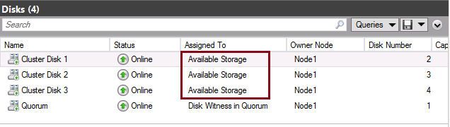**Figure 1.** Disks presented to a WSFC and not in use

It is always recommended that you rename these disks in a WSFC to friendly name, such as SSAS Disk, or the actual name of the drive such as Disk E or Drive E. The reason for this is that SQL Server Setup will use this friendly name and Cluster Disk 1, 2, etc. may not be descriptive enough if the person installing SSAS does not know what drive it maps to.

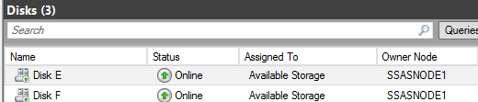

**Figure 2.** Renamed disks

Regardless of the storage configuration type, ensure that what is presented will provide enough IOPS as well as reliability and uptime. This means that multiple paths should be configured to the storage array, and things like RAID used in the configuration of the disks. Also, all disks must be formatted with NTFS. ReFS has limited support for the database engine in SQL Server 2014, and no support for clustered SSAS instances.

## WSFC Quorum

Quorum is a mechanism built into WSFCs that helps ensure that the cluster stays up. By default, each node gets a vote. Depending on the number of nodes, you may or may not need a witness which can be disk-based or a file share. The general rule of thumb is that for an even number of nodes you configure a witness, and for odd you skip it. This is slightly different in Windows Server 2012 R2 where there is the concept of dynamic witness, and Windows will automatically figure out if a witness needs to be used based on various factors.

When shared storage is not being used, a file share witness is recommended, but since SSAS only supports shared disk-based implementations, a disk-based witness should be utilized if necessary. This disk can be small (such as 1 GB in size).

Prior to Windows Server 2012, you would need to monitor your WSFC and if nodes were added or lost, either roll a witness in or out. Windows Server 2012 R2 introduced the concept of dynamic witness where at the creation time of the WSFC, you configure a witness and the WSFC will determine if it needs it. For more information on quorum in a Windows Server 2012 WSFC, see <http://technet.microsoft.com/en-us/library/jj612870.aspx>.

## Geographically Dispersed Clusters

A WSFC can be configured to span nodes that are configured over distance. This is known as a geographically dispersed cluster. This configuration usually covers more than one data center (usually just two). For a WSFC to span data centers, the following must be met:

* All nodes must be part of the same Active Directory domain – not trusted domains in each data center.
* Storage must be replicated between data centers using methods provided by the storage vendor, which is commonly known as hardware storage mirroring.

As a node in another subnet/data center is added to the configuration, an IP address will be configured and will only be online if that node owns the SSAS resources. A VLAN is no longer required for geographically dispersed cluster configurations starting with SQL Server 2012. For more information, see <http://msdn.microsoft.com/en-us/library/ff878716.aspx>.

## Microsoft Azure and Clustering SSAS

A clustered implementation of SSAS can be configured in Microsoft Azure. Such a configuration would need to meet all the requirements stated in this paper including Active Directory and storage. A clustered implementation of SSAS can also span from on premises to Azure (or any qualified cloud) if networking is properly configured so that the nodes on premise and in the cloud can see each other, talk to Active Directory, and access storage.

## Database Engine and Analysis Services in One Cluster Group

Even though it’s a best practice to install SSAS in its own clustered instance, the reality is that SSAS and the database engine are often installed together, stretching the same licensing dollars further than if you install them separately. This means that both the FCI and clustered SSAS are configured in the same Role and share some resources such as the network name and IP address, as well as disks (unless different disks are explicitly used for either the FCI or SSAS).

**NOTE:** That means the fate of the relational database engine and SSAS are tied together. You would need to ensure that the thing you care least about – the relational engine or SSAS – would not cause the one you care most about, to fail. If SSAS is deemed less important, it would be configured as shown in Figure 3.

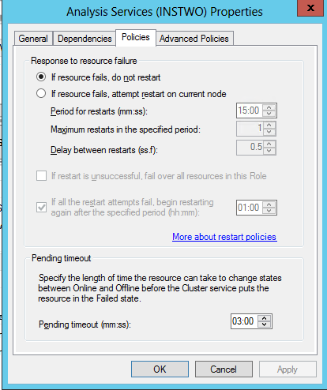

**Figure 3.** Properties of the Analysis Services clustered resource when configured with the database engine

You can also see in Figure 4 that when installed together, both SSAS and the relational engine, unless configured differently, will share the same disk resource(s). Furthermore, because of the combined install, both will always share the same network name and IP address. Note that the dependencies show that SSAS is a Generic Service as noted earlier in this paper.

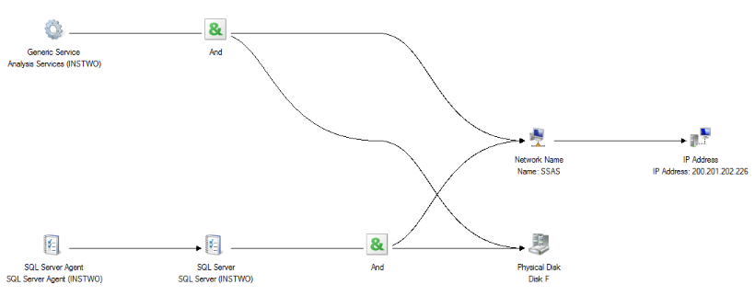

**Figure 4.** Combined SSAS and FCI dependency report

## Number of Nodes and Total Number of Clustered Instances on a WSFC

Outside of any limits imposed by the edition of SQL Server, a WSFC supports up to 64 nodes starting with Windows Server 2012. More nodes brings additional complexity around management, and specifically, patching/update scenarios.

One major factor in choosing how many nodes to include in a single WSFC relates to the total number of clustered instances (SSAS or database engine) configured on that WSFC. The more instances you have, the more nodes you need to allow room for failover.

When deciding on the number of clustered instances, there are four major considerations:

* Performance
* Reserve capacity
* Failover condition
* Maintaining quorum

Performance is going to hinge upon having the right levels of system resources. You need to ensure that the nodes which can host the clustered installation of SSAS have enough resources to run the workload of that instance and possibly others. This might seem straightforward, but this is where both reserve capacity and the failover condition come into play. The failover condition means that in a worst case scenario, all instances may need to be able to run on a single node. If you have not properly planned your WSFC, this may not be possible. Clustered SSAS instances and database engine are based on a traditional scale-up model for performance. If you get down to last man standing (which is possible with the introduction of dynamic quorum in Windows Server 2012), you want to be able to ensure that your workload can run.

Reserve capacity means having enough additional nodes in the event of multiple failovers. It is not uncommon to have deployments with one or two nodes dedicated for failover, standing by in the event of failover. This way there can be more flexibility for moving things around, especially during patching.

One way to control some of this behavior is to set the preferred owners at the resource group level. An example is shown in Figure 5. While this is generally not recommended with two nodes, it is more beneficial with three or more nodes. If a node is not checked but is allowed to own the instance, it can still fail to that node, but the WSFC will try to go to the checked ones in the order selected first.

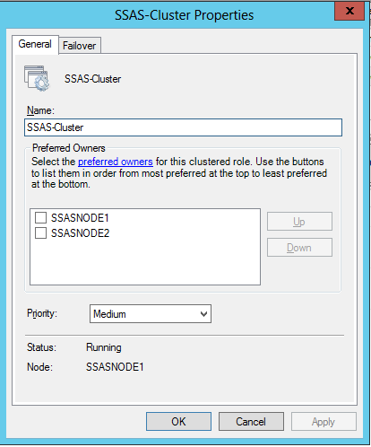

**Figure 5.** Preferred owners settings in the WSFC

Last, but not least, if quorum is not maintained, the WSFC and everything running in it will be down. For example, rebooting too many nodes simultaneously during patching may get you in trouble. This is why having the right number of nodes and keeping track of quorum is important for any clustered deployment of SQL Server.

## NET Framework

Both SQL Server 2012 and 2014 require.NET Framework 3.51 and .NET Framework 4.0 (or higher). With Windows Server 2012 and later, .NET 3.51 it is not included by default with the operating system. You would have to point it to the installation media or be connected to the Internet so it could be downloaded by the operating system. You have three options ways to install .NET Framework 3.51:

* Use Server Manager to enable .NET Framework 3.51. Only enable the feature itself as shown in Figure 6 which was captured from Windows Server 2008 R2. It would be similar in Windows Server 2012 and 2012 R2. Selecting any other option will install other Windows items (such as IIS) that you do not need or want.

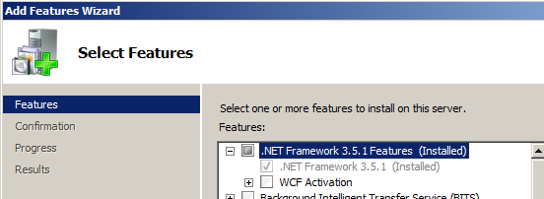

**Figure 6.** .NET Framework 3.51 enabled in Windows Server 2008 R2

* Use DISM <http://www.sqlha.com/2012/03/01/windows-server-8-sql-server-2012-and-net-framework/>
* Use PowerShell <http://www.sqlha.com/2012/06/01/part-2-windows-server-2012-sql-server-2012-and-net-framework-powershell/>

.NET Framework 4.0 is part of the operating system in Windows Server 2012 and 2012 R2, but for Windows Server 2008 and 2008 R2, it will be installed as part of SQL Server Setup. While you can install it on your own (or install a later version, such as 4.5), it is not required to install .NET Framework 4.0 before installing SQL Server on Windows Server 2008 and 2008 R2.

# Install SSAS in a Clustered Configuration

Installation of a clustered instance can be performed using the SQL Server Installation Wizard or command line. This section walks you through the wizard. For command line or script-based installs, consult or [Install SQL Server 2012 from the Command Prompt](http://technet.microsoft.com/en-us/library/df40c888-691c-4962-a420-78a57852364d) (http://technet.microsoft.com/en-us/library/df40c888-691c-4962-a420-78a57852364d) (command line) or [Install SQL Server 2012 Using a Configuration File](http://technet.microsoft.com/en-us/library/a832153a-6775-4bed-83f0-55790766d885) (http://technet.microsoft.com/en-us/library/a832153a-6775-4bed-83f0-55790766d885) (script-based). All of the screen shots in this paper were captured from SQL Server 2012. SQL Server 2014 will be similar, but some dialogs may be slightly different.

**NOTE:** If you want to add SSAS to an existing FCI, the only supported way to achieve this is to uninstall and reinstall the instance.

## First Instance Install

These steps will configure the clustered instance of SSAS on a node where no instances have been installed in the WSFC yet.

1. Run SQL Server Setup on one of the nodes. In the Installation Wizard, choose Installation, then choose **New SQL Server failover cluster installation** as shown in Figure 7.

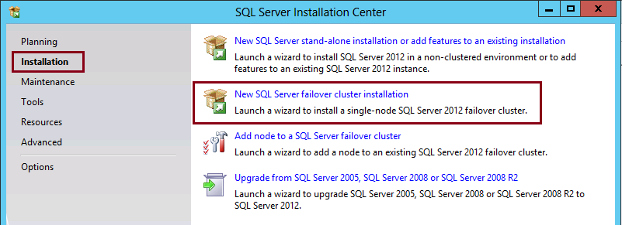

**Figure 7.** Installation options

1. On the Setup Support Rules dialog, it should appear as it does in Figure 8. If not, click **Show Details** and resolve your issues. Click **OK** to continue when everything is fine.

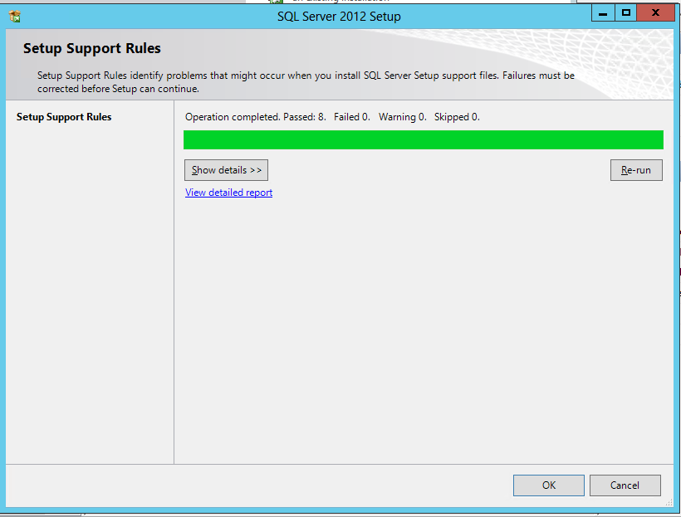

**Figure 8.** Setup Support Rules dialog

1. On the Product Key dialog shown in Figure 9, enter your license key if the install media is not already populated with a PID. Click **Next**.

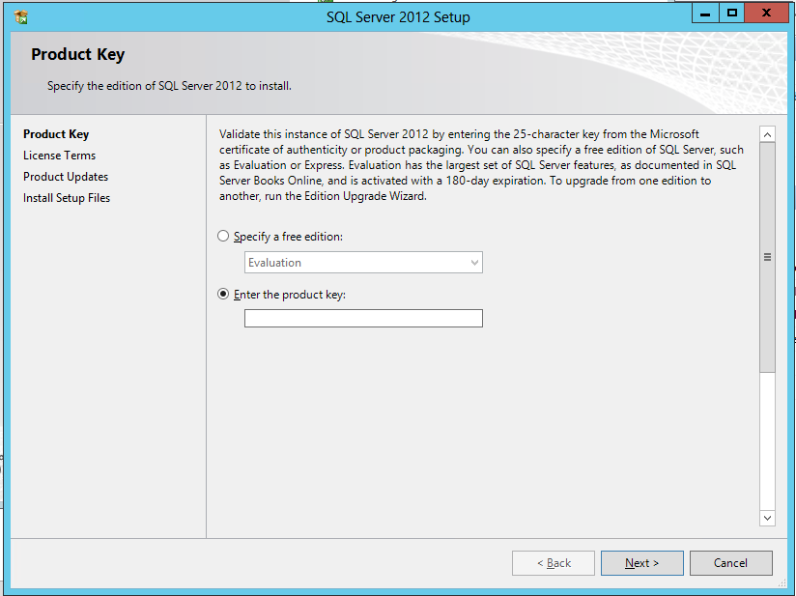

**Figure 9.** Product Key dialog.

1. Accept the licensing terms shown in Figure 10 and if desired, choose to opt in to send usage data to Microsoft. Click **Next**.

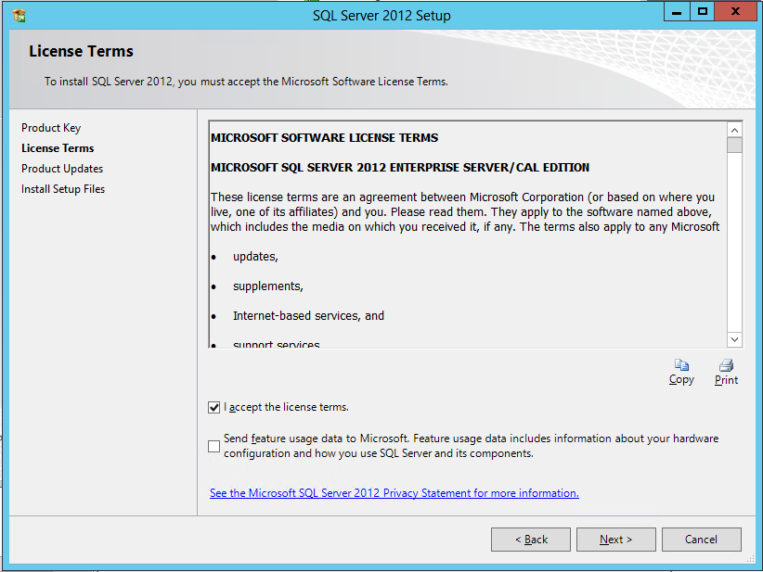

**Figure 10.** License Terms dialog

1. Setup will now check online for updates as shown in Figure 11. If you are not connected to the Internet or do not want to automatically check for updates, clear the update option. Click **Next** and you will see the dialog in Figure 12 installing files. If you allowed Setup to check for updates, it will prompt you if there are updates and you can choose to install them or not. 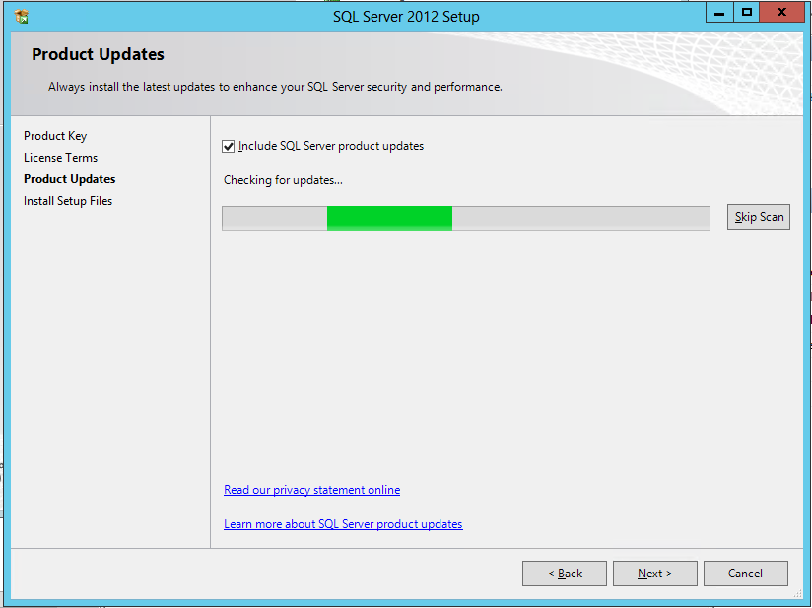

**Figure 11.** Checking for updates

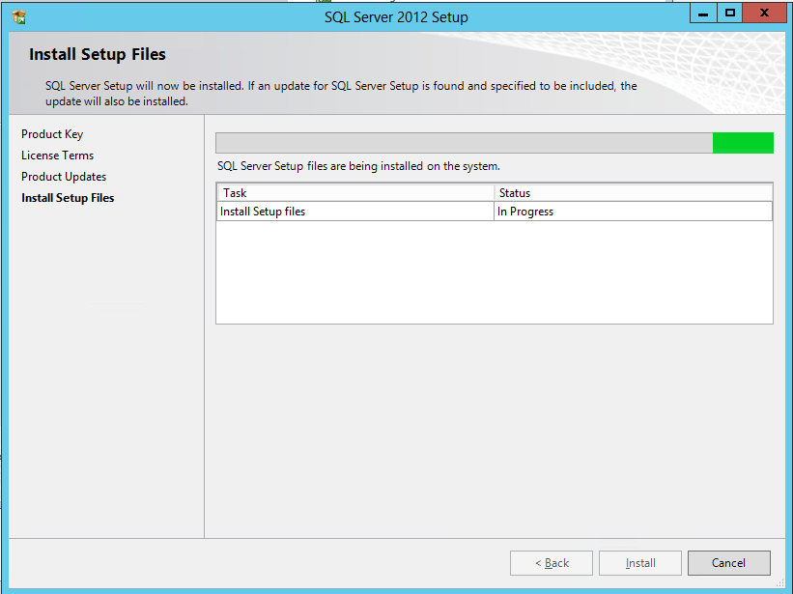

**Figure 12.** Installing Setup files

1. Figure 13 shows the Setup Support Rules dialog. You would want to see all green checks, however seeing the yellow warnings just means that you need to check those items out to ensure that they are not problems (hence the warning). If you see any red circles with a white X in it, Setup will not allow you to proceed. Fix any issues and click **Next**.

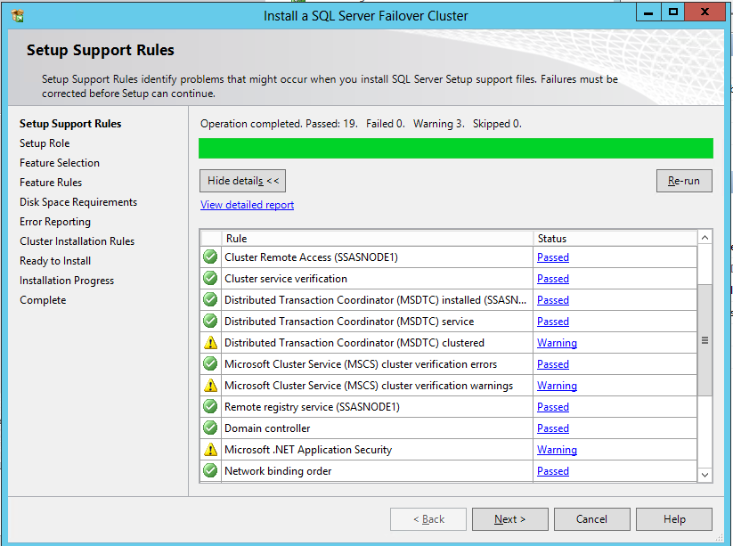

**Figure 13.** Setup Support rules dialog

1. On Setup Role as shown in Figure 14, select SQL Server Installation and click **Next**.

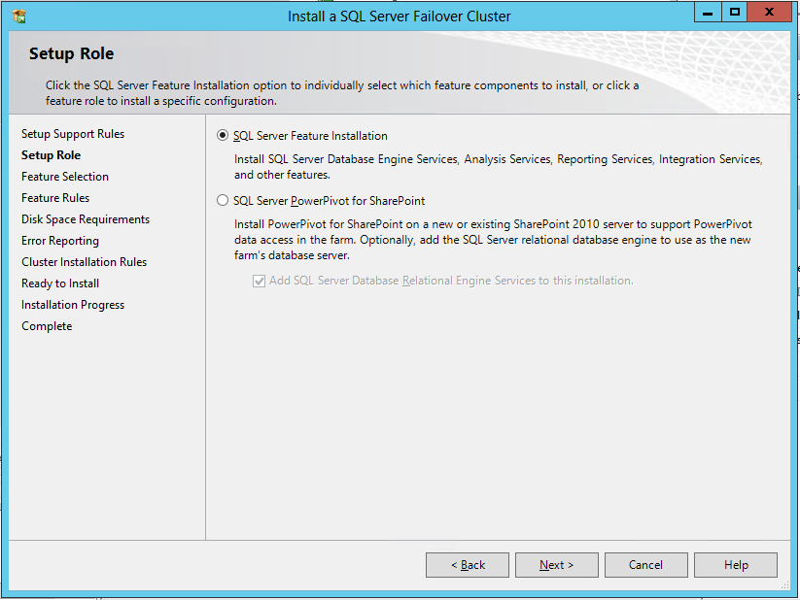

**Figure 14.** Setup Role dialog

1. On Feature Selection, choose the features that you want to install. You can install just SSAS, or both the database engine and SSAS at the same time along with other optional features such as the management tools. Figure 15 shows just a clustered instance of SSAS being installed.

**NOTE:** Choose the options to install carefully. Should you get this step wrong, you may need to completely uninstall and reinstall to get the features you require.

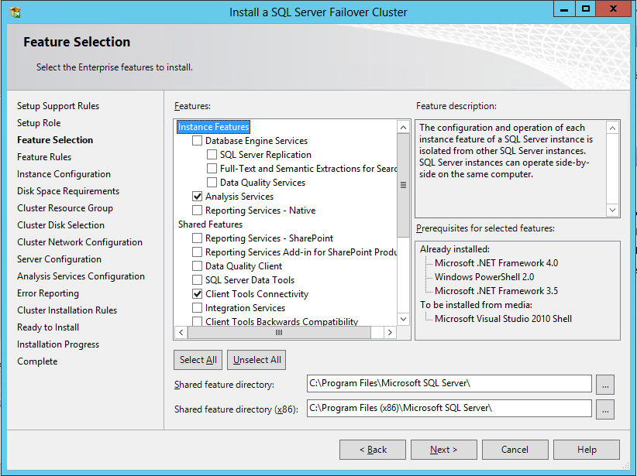

**Figure 15.** Choose which features to install.

1. On Feature Rules as shown in Figure 17, if there are any problems, fix them and click **Next**.

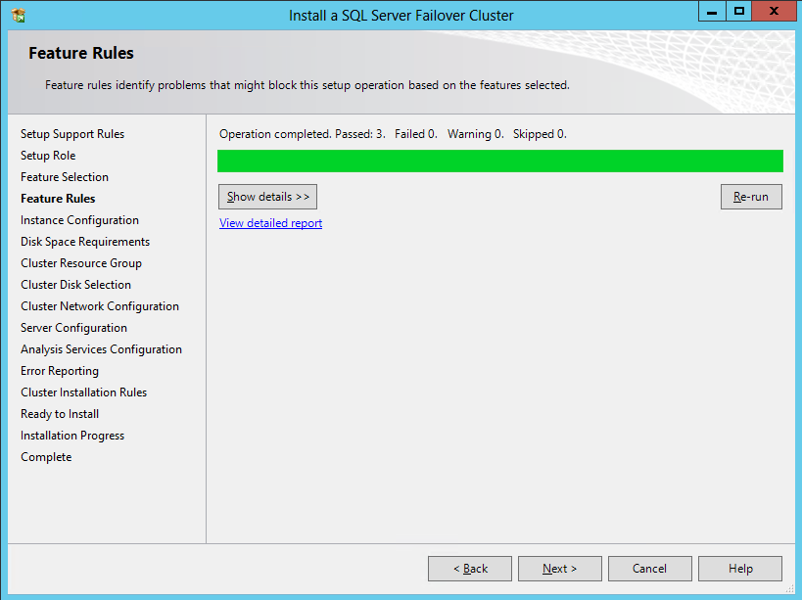

**Figure 17.** Feature Rules dialog

1. The Instance Configuration dialog is one of the important during Setup. If things are entered incorrectly here, it could potentially mean a full uninstall and reinstall of the instance.

For the SQL Server Network Name, this is where you would enter the name associated with SSAS (as well as the database engine, if you install both) that will be created in the WSFC and represented by a network name resource (as well as getting a VCO and DNS entry). This name must be unique within the domain.

Decide whether this instance will be a default or named instance. There can only be one default instance per WSFC. As noted in this paper, a named instance from an SSAS perspective is required by Setup, but not necessarily used when connecting.

Notice the Instance ID. By default, the Instance ID for a default instance will be MSSQLSERVER and for a named instance as shown in Figure 18. Figure 19 shows an example of a named instance. For either default or named instances, is recommended you change this value to be something associated with the clustered instance name. Clustered instances have different names, and when looking at your program files in Explorer, you want to be able to easily distinguish among existing installations. You can see how the instance ID is incorporated into the full path towards the bottom of the dialog. As you can imagine, it’s more useful to see SSAS-Cluster in the path than MSSQLSERVER.

Click **Next** to continue.

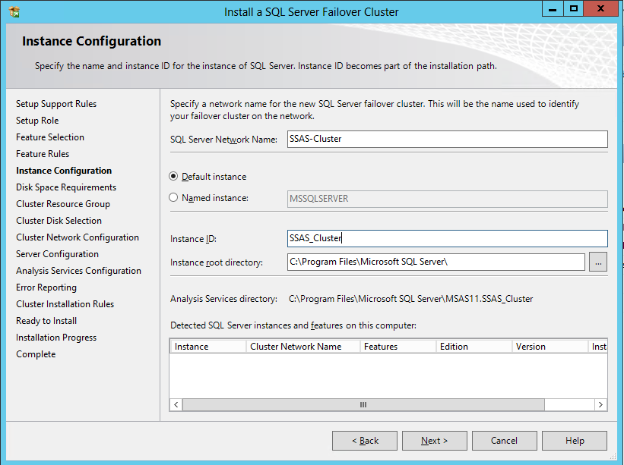

**Figure 18.** Default Instance

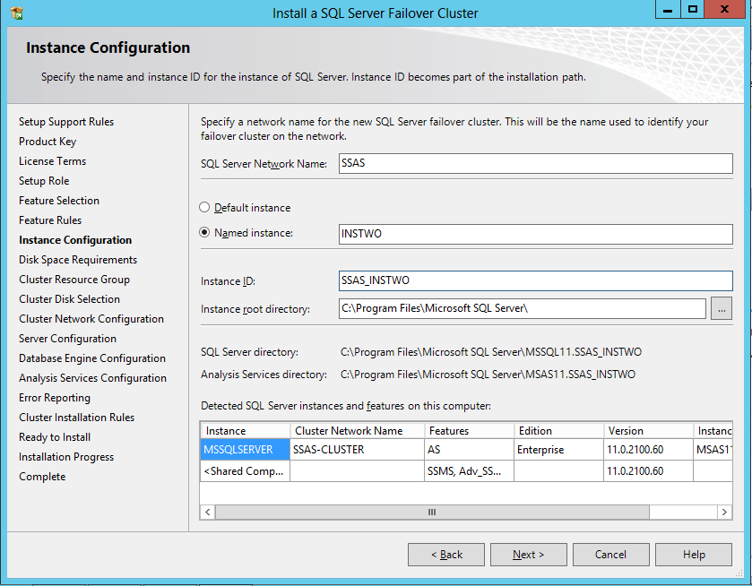

**Figure 19.** Named Instance

1. Click **Next** on the Disk Space Requirements dialog shown in Figure 20.

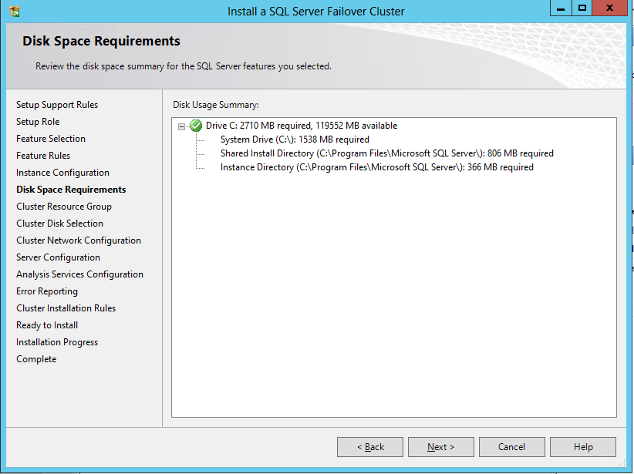

**Figure 20.** Disk Space Requirements dialog

1. On Cluster Resource Group, this is the name of the Role that will be used in the WSFC. The Role contains all of the resources for the clustered instance. If you enter the wrong name, this can be changed post-installation.

As with Instance ID, it is recommended to change this to the name of the actual instance since it is different from the name of any of the other components of the WSFC. Figures 21 and 22 show a default and named instance, and the default values Setup provides. Figures 23 and 24 show proper resource group names.

Click **Next**.

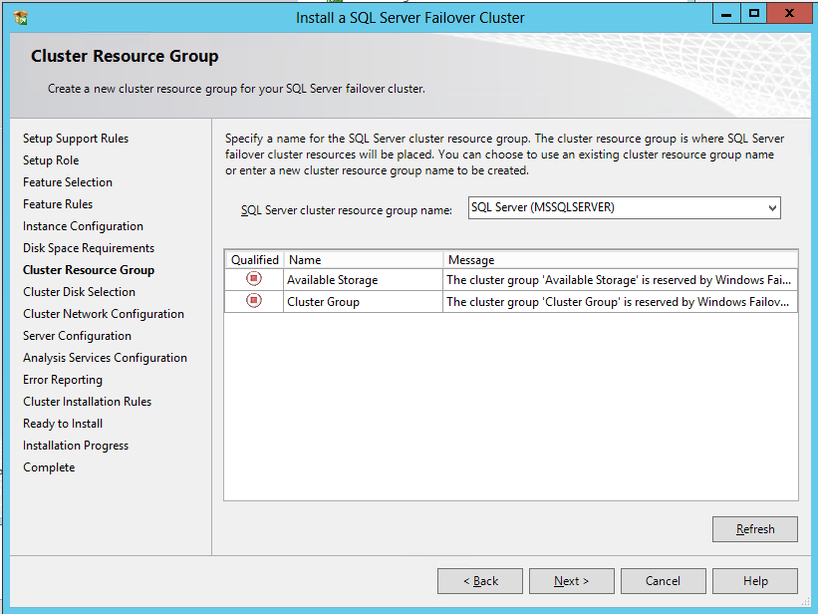

**Figure 21.** Default name for a resource group for a default instance

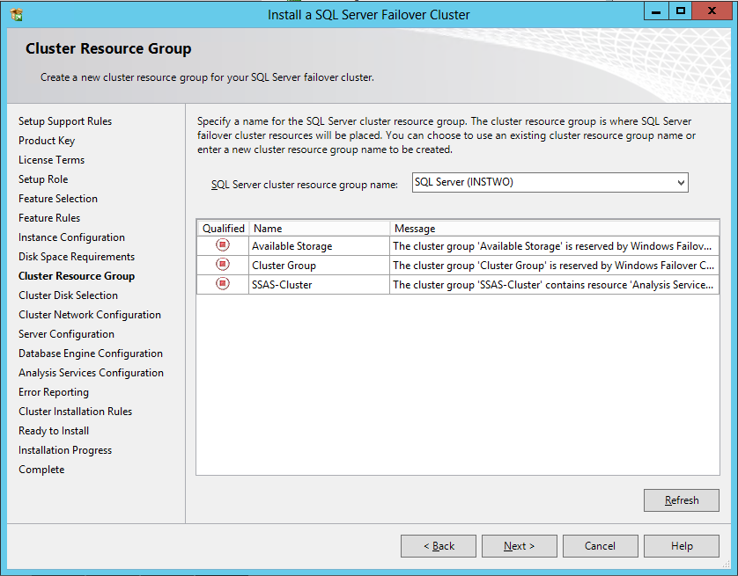

**Figure 22.** Default name for a resource group for a named instance

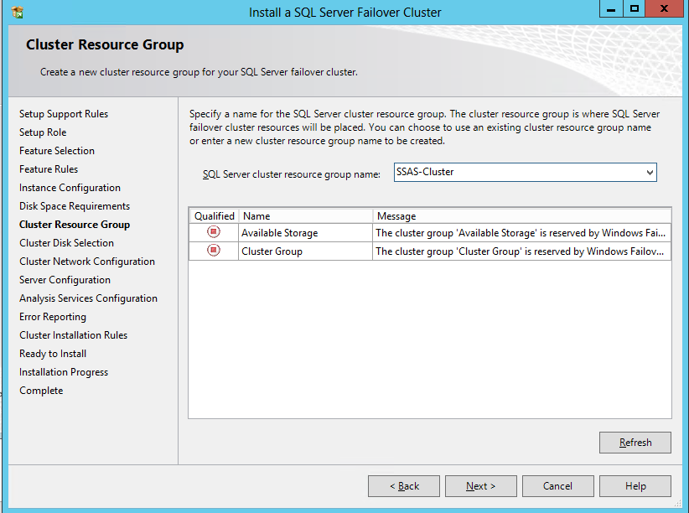

**Figure 23.** Renamed resource group for the default instance

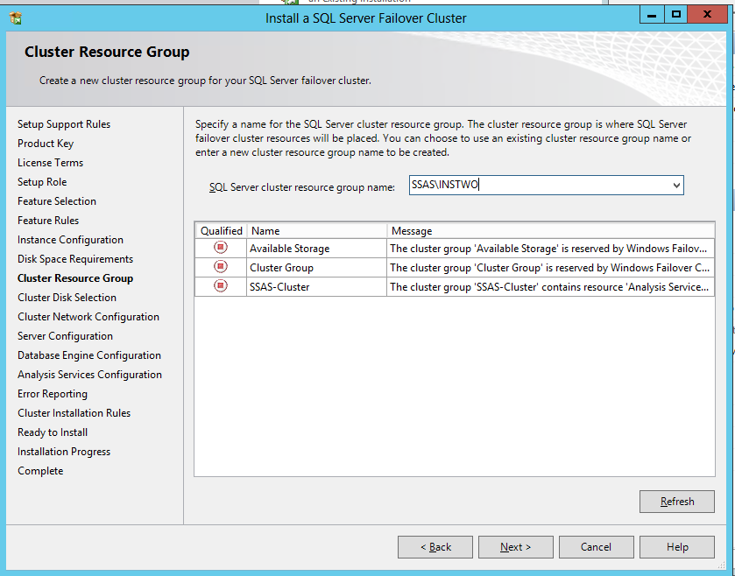

**Figure 24.** Renamed resource group for the named instance

1. Now it is time to select the disk (or disks) that will be used by the clustered instance. More than one disk can be chosen if available. As noted earlier in the paper, you should rename the disks to ensure that they are easy to discern in Setup. Once the disks you want are selected, click **Next**.

Figures 25 shows an example where multiple disks are available during Setup.

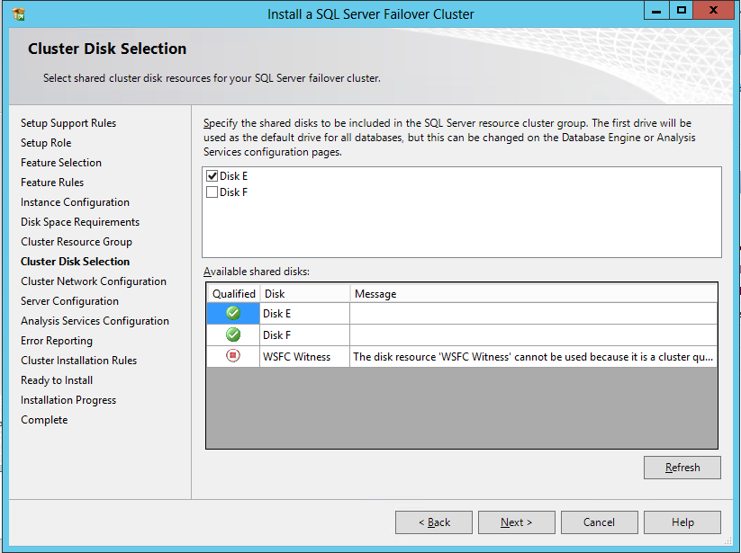

**Figure 25.** Multiple disks available for use

Figure 26 shows where only one disk is available and other disk resources are in use. This reinforces the concept that disk resources are dedicated to a single clustered instance.

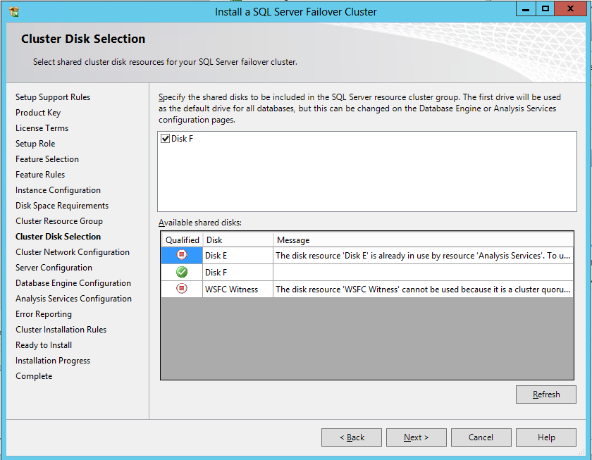

**Figure 26.** One disk in use, one disk available

1. On Cluster Network Configuration, click the checkmark next to the network which has the subnet of the IP address you will associate with the clustered instance. Enter the IP address in the address space. Click **Next**. An example is shown in Figure 27.

**NOTE:** Like the disk names, the networks of a WSFC should be renamed to more descriptive names. A name like ‘Public Network’ will not appear unless you configure it. By default, network are enumerations, like Cluster Network 1, Cluster Network 2, and so on.

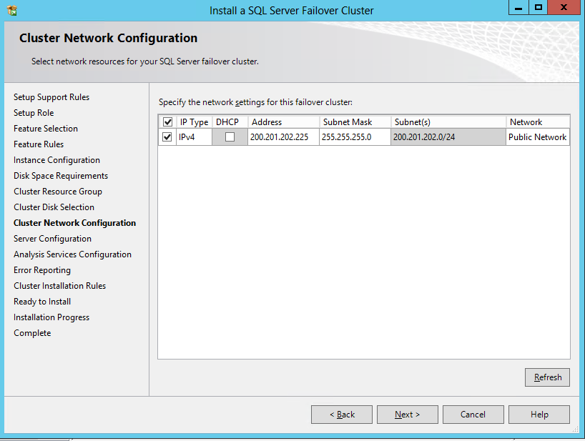

**Figure 27.** Entering the IP address

1. On the Server Configuration dialog, enter or select a domain account to be the service account(s).

Figure 28 demonstrates what you will see if configuring only SSAS, while Figure 29 shows what you would see if configuring both SSAS and the database engine at the same time. If you need to change the collation, go to Step 15, otherwise click **Next** and go to Step 16.

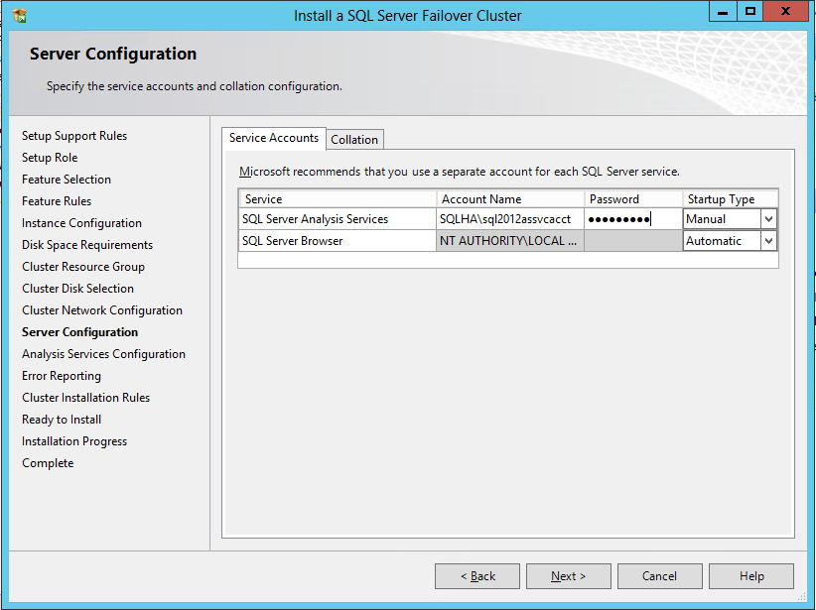

**Figure 28.** Service Accounts tab for only SSAS

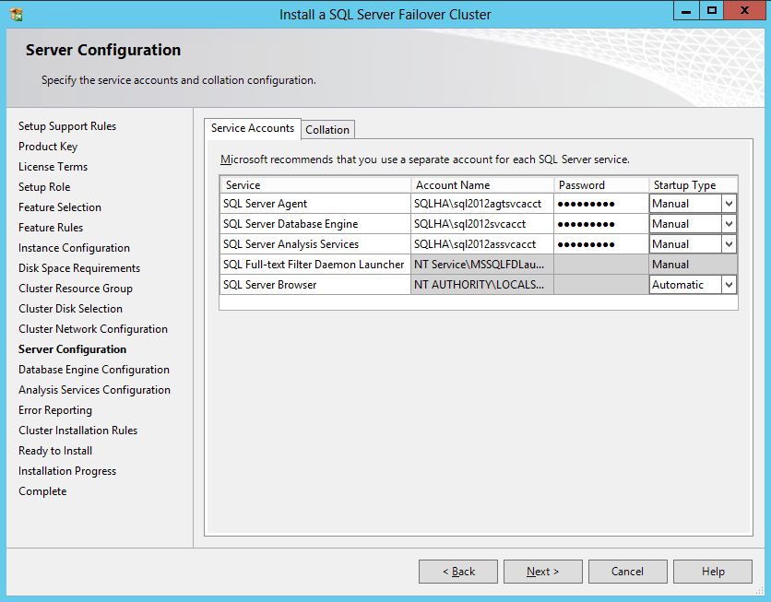

**Figure 29.** Service Accounts tab for SSAS and FCI combined

1. If you need to alter the collation for the instance, select the Collation tab. Figure 30 shows what it would look like if you were just configuring SSAS, and Figure 31 shows both SSAS and the database engine. Click **Configure** to change the collation, and when done, click **Next** to continue.

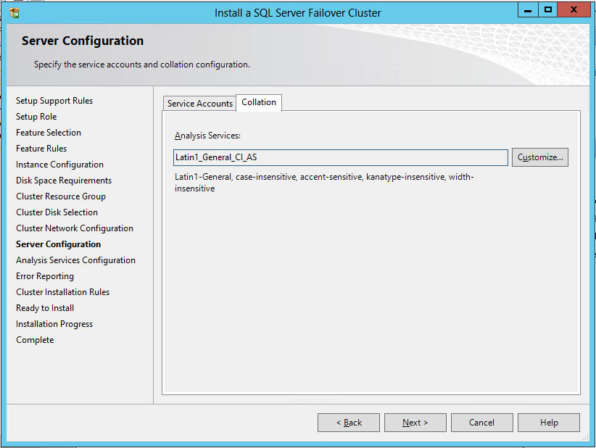

**Figure 30.** Collation for just an SSAS install

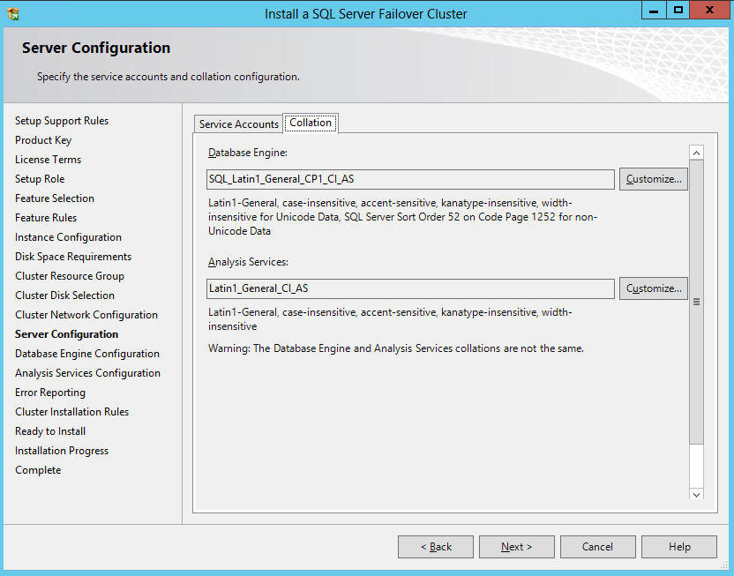

**Figure 31.** Collation for SSAS and FCI

1. If you are installing a combined SSAS and database engine instance, you will see a dialog similar to the one in Figure 32. If you are only installing SSAS, skip to Step 18.

The Server Configuration tab is where you will configure the basic security settings for the database engine instance. Select an authentication mode and add an administrator. If you do not need to change the path for the SQL Server databases, skip to Step 18.

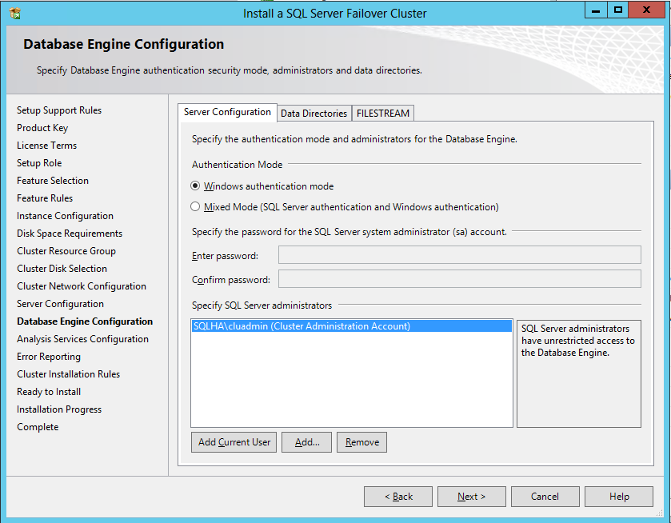

**Figure 32.** Security configuration for an FCI

1. If you want to customize where the SQL Server databases, log files, and backups are stored for the FCI portion, click on the Data Directories tab as shown in Figure 33 and alter the respective values accordingly. Click **Next**.

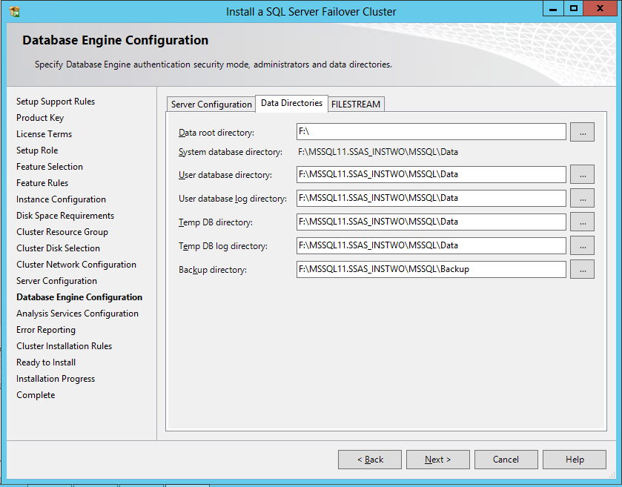

**Figure 33.** Data Directories tab

1. On the Analysis Services Configuration dialog, the first tab is Server Configuration. Select the type of mode you want to run SSAS and add one or more administrator accounts.

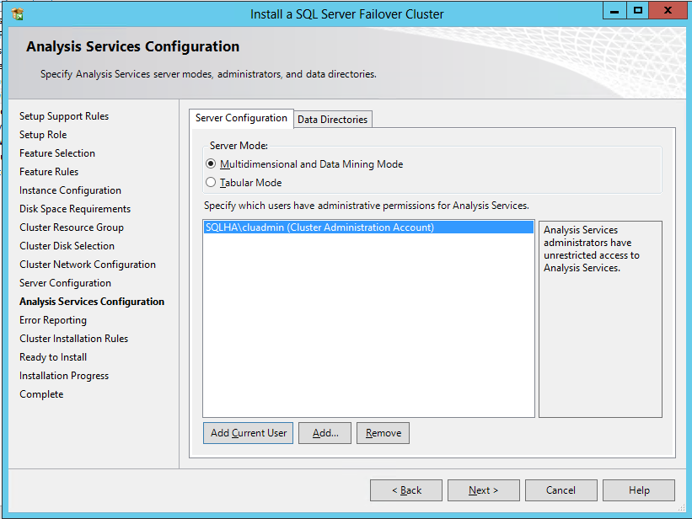

**Figure 34.** Choosing the type of SSAS deployment

1. To customize where the SSAS data will be stored, use the Data Directories tab. You might do this if you are adding multiple disks and/or you are combining SSAS with the database engine. Click **Next**.

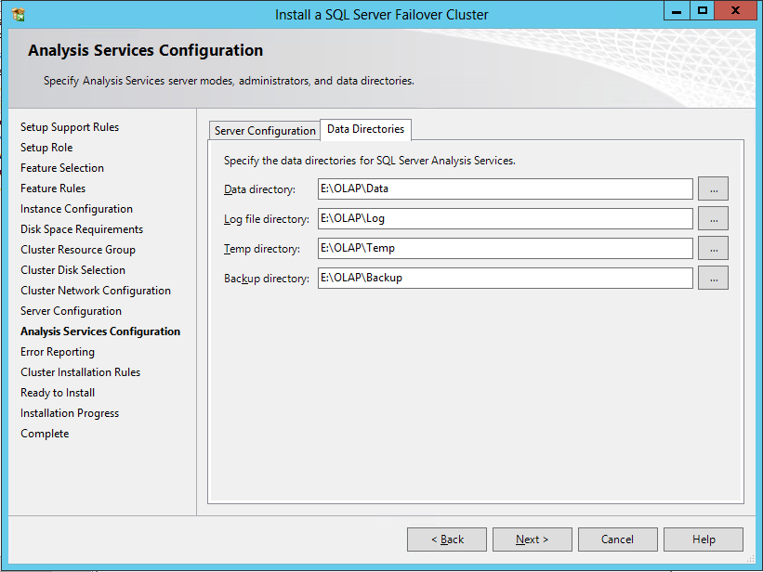

**Figure 35.** Changing where SSAS files are placed

1. On the Error Reporting dialog, the default is to opt out. Click the check box to opt-in, and click **Next**.

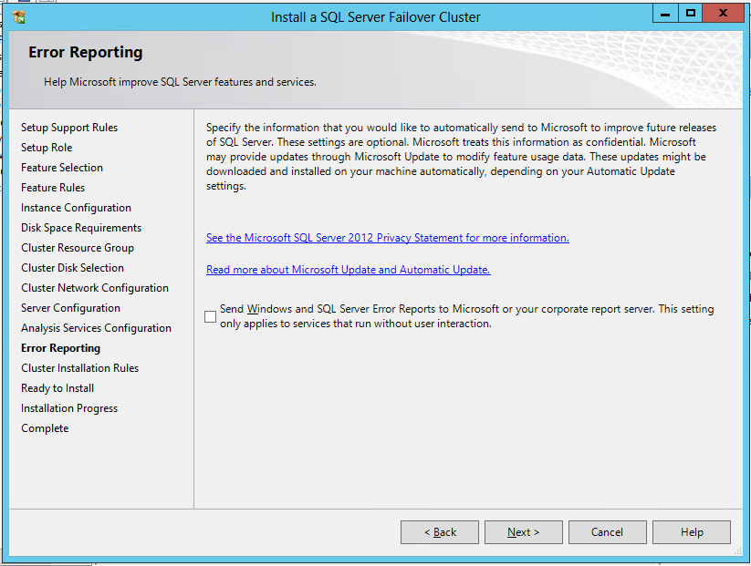

**Figure 36.** Error Reporting page

1. On the Cluster Installation Rules shown in Figure 37, assuming you encounter no problems, click **Next**.

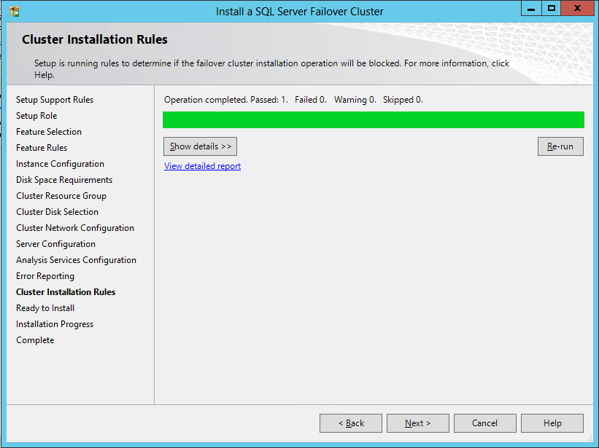

**Figure 37.** Cluster Installation Rules dialog

1. You will see a dialog similar to the one in Figure 38 at the end of the configuration process. It will summarize the choices made. Review, and if necessary, go back and correct. When ready, click **Install**.

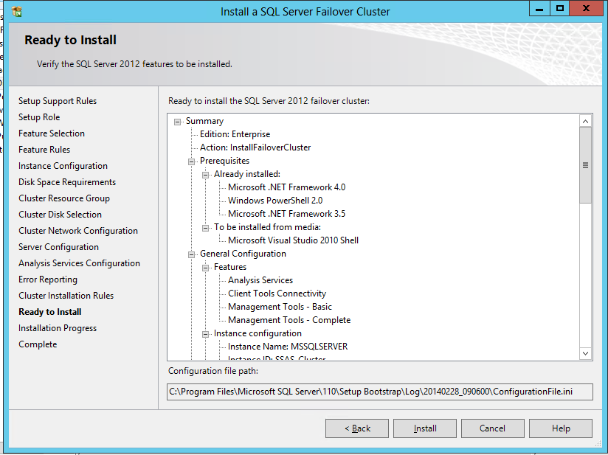

**Figure 38.** Ready to Install dialog

The instance will now be configured on that node and into the WSFC. During its installation, progress will be shown in a dialog similar to the one in Figure 39.

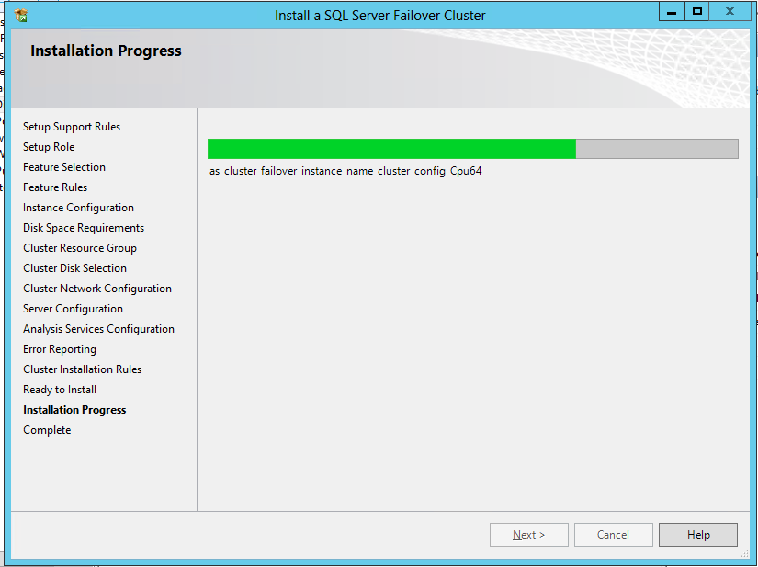

**Figure 39.** Installation progress

1. Once installation is complete and successful, you should see a dialog similar to the one in Figure 40.

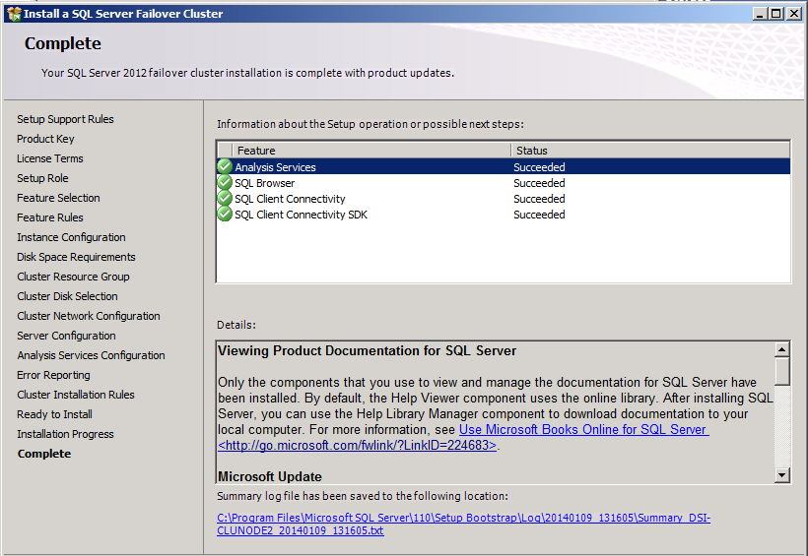

**Figure 40.**  Successful SSAS install

## Add Nodes to the Clustered SSAS Instance

Once the instance has been configured, each node that may host it needs to be added to the configuration.

1. Follow Steps 1 – 6 of the First Instance Install on one of the nodes that will be added to the instance that was just installed. The only difference is that for Step 1, choose the option **Add node to a SQL Server failover cluster**.
2. On the Cluster Node Configuration dialog shown in Figure 41, select a clustered instance to join from the dropdown. Any instance that this node can join will be displayed in the table at the bottom. Click **Next**.

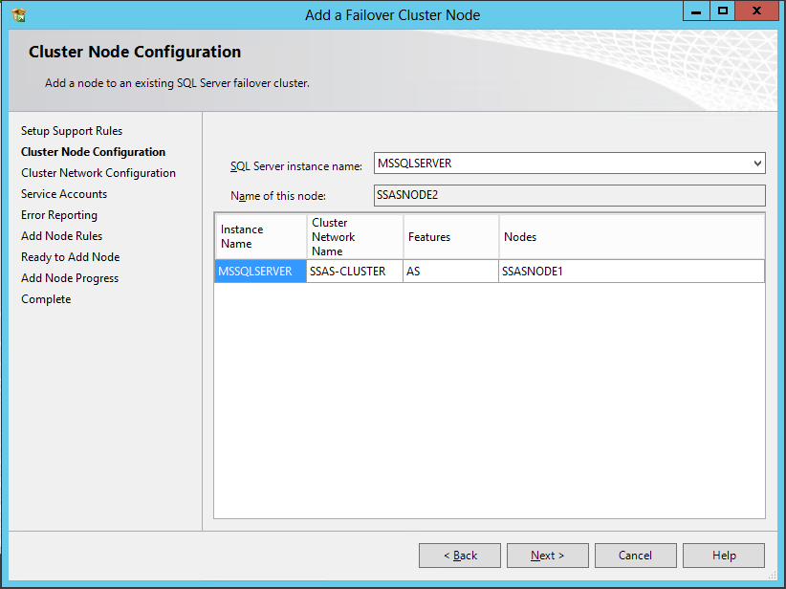

**Figure 41.** Cluster Node Configuration dialog

1. On the Client Network Configuration dialog, if this is not a geographically dispersed implementation, you will see an IP address that is checked but greyed out. There is nothing to do. An example is shown in Figure 42. If this was a geographically dispersed configuration, you would be prompted to configure an IP in the additional subnet similar to the dialog in Figure 27. Click **Next**.

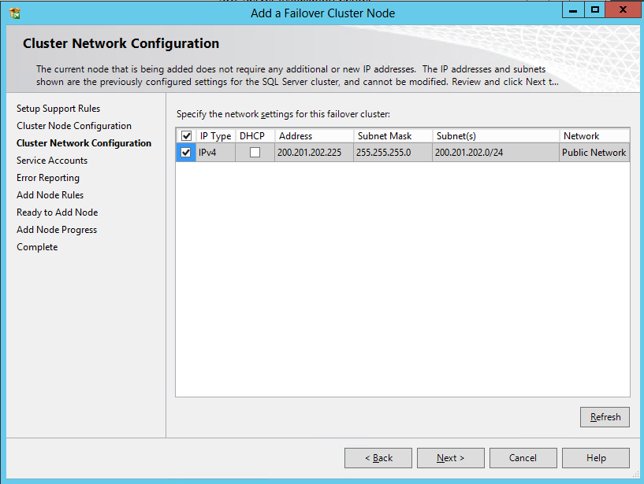

**Figure 42.** Cluster Network Configuration dialog

1. On the Service Accounts dialog, enter the passwords for the different service accounts. Figure 43 shows what this dialog looks like if it is just Analysis Services being installed. Click **Next** to continue.

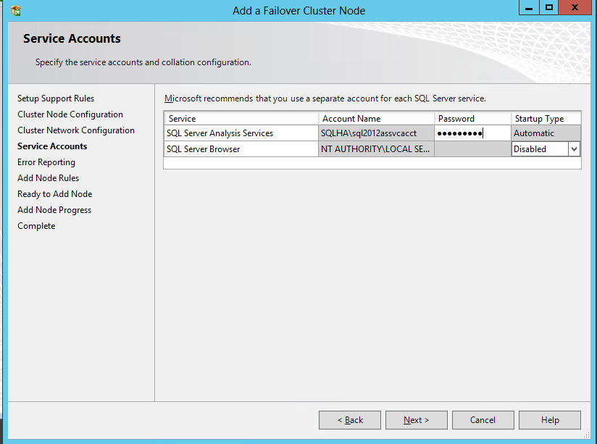

**Figure 43.** Service Accounts dialog

1. On the Error Reporting dialog as seen earlier in Figure 36, opt in or out, and click **Next**.
2. On the Add Node Rules dialog shown in Figure 44, if there are no problems, click **Next**.

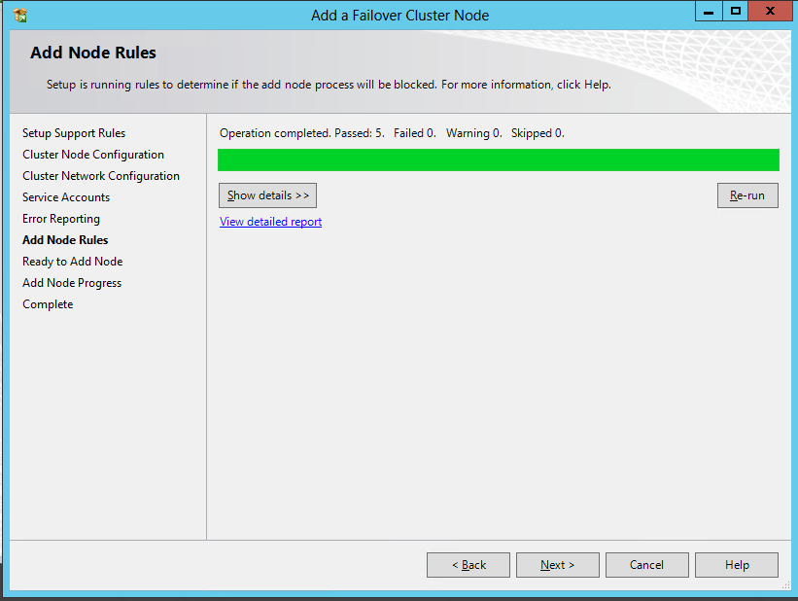

**Figure 44.** Add Node Rules dialog

1. On the Ready to Add Node dialog similar to the one in Figure 45, click **Install**.

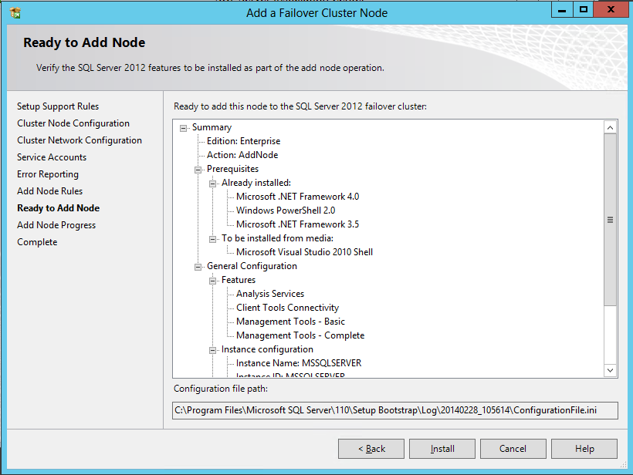

**Figure 45.** Ready to Add Node

The node will now be added to the configuration and a successful result will be similar to the one for the first node install.

## Add More Instances to the WSFC

You can have multiple clustered instances of SQL Server or SSAS in one WSFC. Adding more instances is basically as simple as following the steps contained in “First Instance Install” and then “Add Nodes to the Clustered SSAS Instance”.

# Verifying the Installation

After installing the clustered instance, you should test to make sure it is functioning properly and it has everything it should.

**NOTE:** It is also recommended at this point to take backups of any system databases in their pristine state prior to adding any user databases.

## Visual Verification

To see what was created, open FCM. In Windows Server 2008 R2, expand Services and applications. You should see the resource group name you created. For Windows Server 2012 and 2012 R2, select Role, and then the Resources tab as shown in Figure 41.

Windows Server 2008 R2, 2012, and 2012 R2 should show the same resources depending on the configuration. Figure 46 shows an installation of SSAS with the database engine.

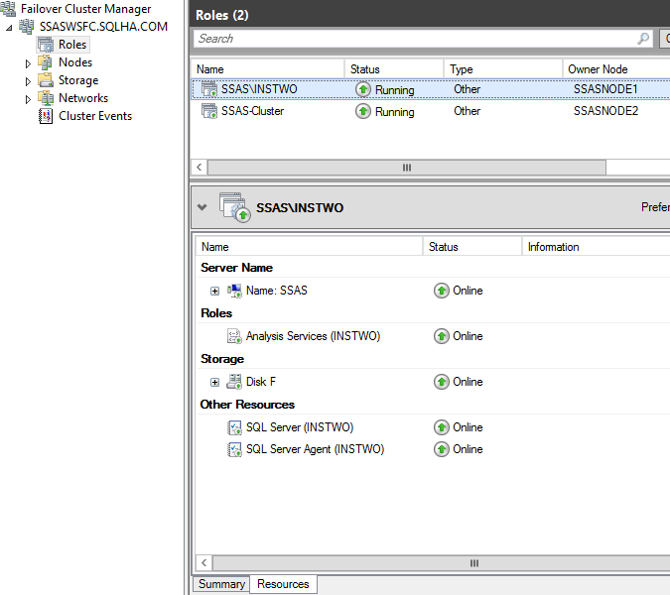

**Figure 46.** SSAS and database engine in the same clustered instance

Figure 47 shows just a clustered instance of SSAS.

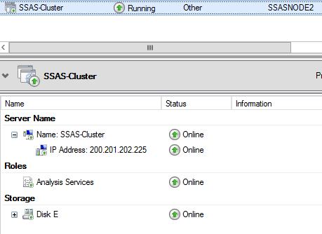

**Figure 47.** Clustered SSAS

The same information can be garnered from PowerShell. First, execute a *Get-ClusterGroup* command. This will display a list of all of the resource groups. The SSAS instance should have a State of Online. To see the resources, enter the command *Get-ClusterGroup “GroupName” | Get-Cluster Resource* where *GroupName* is the name of the resource group you configured. An example is shown in Figure 48.

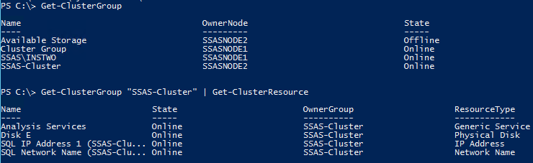

**Figure 48.** Groups and resource status via PowerShell

## Testing Failover

First and foremost, you must test failover between the nodes that have been configured to ensure that the instance properly starts on all nodes.

To do this in FCM, the steps are slightly different between the versions of Windows. As the resources are stopping on one node and starting on another, you will see them rotate through various states. An example is shown in Figure 49. If the failover process is successful, all resources should come online with no problems on the node now hosting the instance.

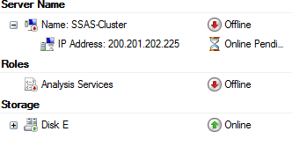

**Figure 49.** SSAS-Cluster instance during the failover process

**On Windows Sever 2008 R2**

1. In FCM, expand Services and applications.
2. Right-click on the instance that you want to move to another node, select **Move this service or application to another node**, and the select the node to move it to. An example is shown in Figure 50.

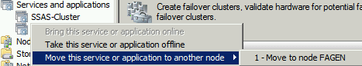

**Figure 50.** Menu option to move the instance to another node

1. Repeat until all possible moves are tested.

**On Windows Server 2012 and 2012 R2**

1. In FCM, select Role.
2. In the center pane, right-click the instance that you want to move to another node, and select **Move, then Select Node**. An example is shown in Figure 51.

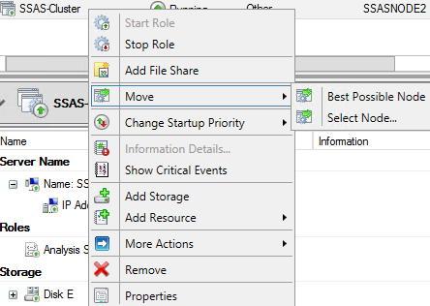

**Figure 51.** Option to move the resources to another node

1. On the Move Clustered Role dialog, select the node to move the role to and click **OK**.

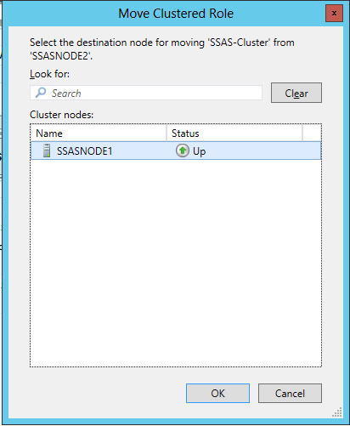

**Figure 52.** Move Clustered Role dialog

1. Repeat until all possible moves are tested.

**Using PowerShell**

If you want to do this via PowerShell, open up a window (make sure you opened it with administrative privileges) and execute the following command *Move-ClusterGroup “GroupName” –Node DestinationNode*. The value for *GroupName* is the same as the one entered in Step 12 of the section First Instance Install. An example is shown in Figure 53.

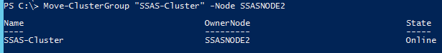

**Figure 53**. Using PowerShell to move resource groups

## Testing Connectivity

Next, test the connectivity to the clustered instance. The next section “Connecting to a SQL Server Clustered Analysis Services Instance” demonstrates how to connect. You should not only connect from within the WSFC if you installed the tools, but from another computer that will access the instance to ensure that it can be connected to from outside the cluster.

Remember to open TCP 2383 in the firewall before connecting from a remote computer. See [Configure Windows Firewall for Analysis Services Access](http://technet.microsoft.com/en-us/library/ms174937.aspx) (http://technet.microsoft.com/en-us/library/ms174937.aspx) for details.

# Connect to a Clustered SSAS Instance

Remember that SSAS will use port 2383. All applications or clients will connect to an SSAS failover cluster using the unique network name of the clustered instance. This is the name configured as part of Step 10 of “First Instance Install”. Never try to connect using any of the node names or the name of the WSFC. Do not append a named instance name or the port.

If you do not remember the network name used for the clustered instance of SSAS, use either FCM or PowerShell as shown earlier in Figures 41 through 43.

## Client Connections and Failover

As mentioned earlier, when a failover of the instance occurs, SSAS stops on its current node and restarts on another. This is similar to cycling a standalone server, which means all connections will be dropped in the process of moving the instance to another node. How this is handled depends on the client application using SSAS:

* On demand reporting applications such as Excel or Power View will display an error and prompt to reconnect or retry.
* Scheduled report execution, such as an SQL Server Reporting Services (SSRS) report, will fail with no automatic restart. You will need to manually execute the report again or wait for the next scheduled report execution.
* SSRS content management tools, such as Report Manager or SharePoint, display errors on report administration pages when data retrieval fails.

## Connection Examples

This section will demonstrate how to connect to a clustered installation of SSAS using various methods.

### Using SQL Server Management Studio

Enter the name of the clustered SSAS instance in the Connect to Server dialog when SQL Server Management Studio (SSMS) opens as shown in Figure 54. When SSMS opens, you should see the clustered instance in Object Explorer. At this stage since the instance is new, no databases have been deployed so the Databases folder is empty.

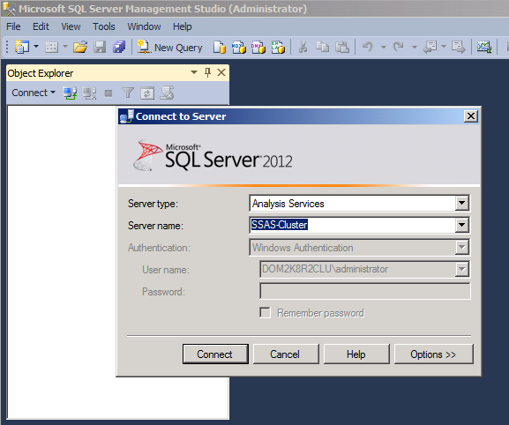

**Figure 54.** Connection information in Management Studio

Figure 55 shows what things look like in SSMS once connected. This particular example shows the case where both an FCI and SSAS were configured at the same time. The FCI is a named instance. As demonstrated, you would use the full name to connect to the FCI (SSAS\INSTWO) while only using the network name to connect to the Analysis Services (SSAS).

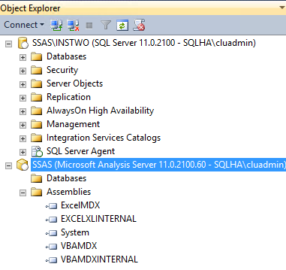

**Figure 55.** Connecting to both SSAS and the FCI in the same clustered instance

### Using SQL Server Data Tools

In Analysis Services projects that you deploy to the clustered instance, specify the name of the instance on the Project Properties page as shown in Figure 56. You can then deploy the project as you would using a standalone SSAS instance.

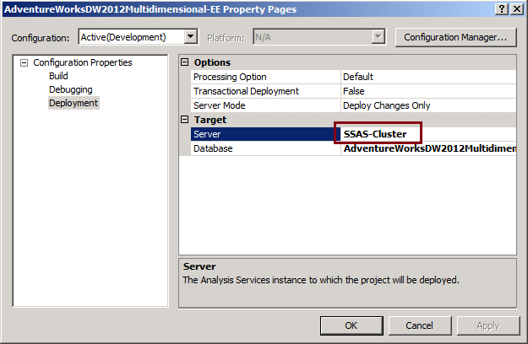

**Figure 56.** Connection for project deployments in SQL Server Data Tools

### Using Excel

Enter the clustered SSAS instance name in the Data Connection Wizard as shown below.

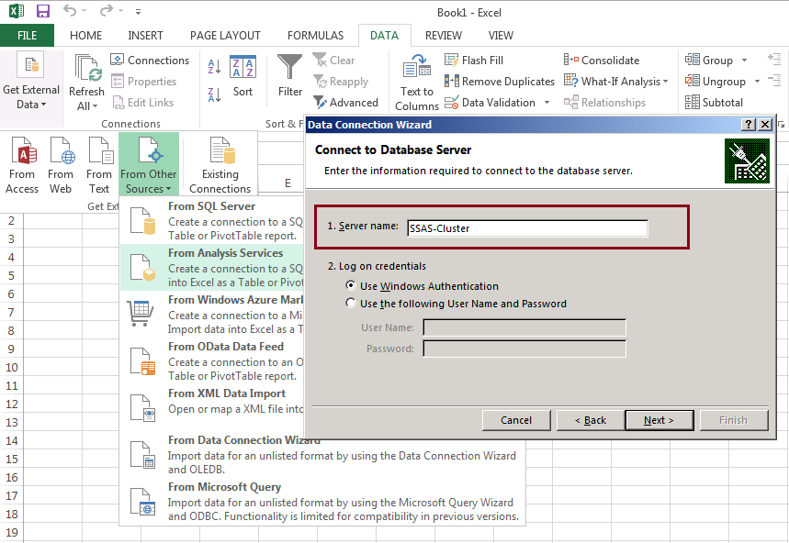

**Figure 57.** Connection from Excel 2013

On the next page of the Wizard, you should see a list of available databases and cubes. If the connection fails, for example with "Unable to obtain list of tables from the data source", verify that the server has databases on it, and that you have permission to read the database.

### Using HTTP

If you’ve configured SSAS for HTTP access, the cluster instance is specified in the msmdpump.ini file, in lieu of the standalone server name. See [Configure Analysis Services for HTTP Access](http://technet.microsoft.com/en-us/library/gg492140.aspx) (http://technet.microsoft.com/en-us/library/gg492140.aspx) for details.

# Administer a Clustered SSAS Instance

For most tasks, treat the clustered SSAS instance as you would a standalone server. However, there are a few tasks that are different or unique to a clustered installation. This section lists the most common or important ones.

## Adjust Memory Settings

As part of ensuing that performance is maintained, one of the most common tasks you will need to deal with is memory configuration. Part of this was addressed in the earlier topic around the failover condition. However, should you find it necessary to run both SSAS and an FCI in the same deployment, remember to modify server configuration properties, namely memory and processor thresholds, to reduce the effects of resource contention.

At start up, both SSAS and the database engine allocate memory for respective caches. Depending on which service starts up first, there may be insufficient memory for the second service. By modifying the server properties for maximum memory, you can ensure that memory is available for server startup and operations, should all resources end up on one node at the same time.

Memory settings for SSAS include **LowMemoryLimit**, **TotalMemoryLimit**, and **HardMemoryLimit**. For tabular instances, also set the **VertipaqMemoryLimit**.

The default values for these properties work best when SSAS is the primary or only server application on the computer. Given other server workloads, parcel the available memory based on expected server activity. If you have multiple instances of SSAS, treat each one as a separate server with independent demands on system memory. See <http://www.sqlservergeeks.com/blogs/AmitBansal/sql-server-bi/17/memory-management-in-sql-server-analysis-services> or <http://msdn.microsoft.com/en-us/library/ms174514.aspx> for details.

Similarly, for the database engine, lower the maximum server memory property to use an appropriate portion. See <http://technet.microsoft.com/en-us/library/ms178067.aspx> for details on how to set the property.

## Changing Node Configuration

If you need to reconfigure a node that is part of a WSFC, you should use Windows and WSFC-related utilities, such as FCM or PowerShell. Some activities, such as changing domains, will require a full uninstall and reconfigure of the clustered configuration.

## Servicing Clustered Instances of SSAS

Applying SQL Server updates (including CUs and service packs) to a clustered instance is a completely different process than for standalone servers. Make sure you read the instructions carefully. See <http://support.microsoft.com/kb/958734> for details.

## Stopping and Starting Clustered Instances

To start and stop clustered instances (FCIs or SSAS), use SQL Server Configuration Manager, SSMS, or one of the WSFC-related utilities (FCM or PowerShell). Never use the Windows Services console application (services.msc) to stop or start the clustered instance of SSAS (or an FCI for that matter).

## Changing Service Accounts

To change the service account or service account password of an SSAS instance in a cluster, you must use SQL Server Configuration Manager. Never use the Windows Services console application (services.msc) to change the service account.

## Renaming a Clustered Instance and Changing the IP Address

You can rename the network name portion of the clustered name which is done via PowerShell or in FCM. You cannot rename the named instance part of an install; that requires a full uninstall and reinstall with the correct named instance name. See http://msdn.microsoft.com/en-us/library/ms178083.aspx

Similarly, you can change any IP address associated with the clustered instance using the WSFC tools as well.

## Adding and Removing Nodes

If you want to add or remove a node, there are two approaches depending on what you are trying to achieve.

* Leave the node in the WSFC but remove SSAS from it: follow the instructions at <http://msdn.microsoft.com/en-us/library/ms191545.aspx>.
* Evict a node completely from the WSFC itself. This is done using FCM or PowerShell. However, doing this will not remove the SQL Server software from that server; the process just removes the node from the WSFC. If you just want to remove SSAS from a node, follow the link in the previous bullet.

# Hands on Learning

To learn the ropes, use VMs in a virtual network and virtual storage devices, all of which are available through Hyper-V and Windows Server. This exercise involves setting up an iSCSI Target Server and create iSCSI devices that map to a VHD subsequently used as a cluster disk, which is useful if you do not have expensive storage devices to experiment with. See <http://blogs.technet.com/b/babulalghule/archive/2013/02/16/how-to-configure-two-node-windows-server-2012-cluster-on-virtual-machines-for-testing.aspx> for details.

# Conclusion

Clustering SSAS like a traditional SQL Server database engine FCI is not only possible, but fully supported. While you do not get the same benefits as an FCI with health detection, failover clusters are a valid way of making SSAS available in a single data center or across distances in a geographically dispersed configuration.

**For more information:**

[Mission Critical SQL Server](http://www.sqlha.com/2013/07/11/allans-mission-critical-sql-server-book-ordering-information-and-faq/) by Allan Hirt. Also visit Allan’s web site at [SQLHA.com](http://www.sqlha.com) for more information and his blog.

<http://www.microsoft.com/sqlserver/>: SQL Server Web site

<http://technet.microsoft.com/en-us/sqlserver/>: SQL Server TechCenter

<http://msdn.microsoft.com/en-us/sqlserver/>: SQL Server DevCenter

[Scale-Out Querying for Analysis Services with Read-Only Databases](http://download.microsoft.com/download/A/5/7/A575AD7C-4172-42D0-8D58-0698D6802F81/SSASReadOnlyDBs.docx)

[Windows Failover Clustering with SQL Server](http://technet.microsoft.com/en-us/library/hh270278.aspx)

[SQL Server Failover Cluster Installation](http://technet.microsoft.com/en-us/library/hh231721.aspx)

[Create a New SQL Server Failover Cluster (Setup)](http://technet.microsoft.com/en-us/library/ms179530.aspx)

[Windows Server 2012 What's New in Failover Clustering](http://technet.microsoft.com/en-us/library/hh831414.aspx)

[Configuring iSCSI Storage for High Availability](http://technet.microsoft.com/en-us/library/gg232621(v=ws.10).aspx)

[SQL 2012 Tabular Performance Guide](http://msdn.microsoft.com/en-us/library/dn393915.aspx)

Did this paper help you? Please give us your feedback. Tell us on a scale of 1 (poor) to 5 (excellent), how would you rate this paper and why have you given it this rating? For example:

* Are you rating it high due to having good examples, excellent screen shots, clear writing, or another reason?
* Are you rating it low due to poor examples, fuzzy screen shots, or unclear writing?

This feedback will help us improve the quality of white papers we release.

[Send feedback](mailto:sqlfback@microsoft.com?subject=White%20Paper%20Feedback:%20Analysis%20Services%20Failover%20Clustering).