A V PAREKH TECHNICAL INSTITUTE

*TAGORE ROAD, RAJKOT*

CERTIFICATE

This is to certify that the Project report, submitted along with the project entitled **LiViD (Live Streaming)** has been carried out by **Jay Nakum 186020307051, Bhavik Bhundiya 186020307011, Kishan Dholakiya 186020307033** under my guidance in partial fulfillment for the Diploma in Computer Engineering 5th Semester of Gujarat Technological University, Ahmadabad during the academic year 2020-21. These students have successfully completed Project-1 activity under my guidance.

Internal Guide Head of Department

Acknowledgement

Presentation inspiration and motivation have always played a key role in the success of any venture.

We express our sincere thanks to P.J. Joshi.

I pay our deep sense of gratitude to P.J. Joshi of Computer Department. A. V. Parekh Technical Institute, Rajkot to encourage us to the highest peak and to provide us the opportunity to prepare the project.

We feel to acknowledge our indebtedness and deep sense of gratitude to our guide Prof. P.J. Joshi whose valuable guidance and kind supervision given to us throughout the course which shaped the present work as it shown.

We are pleased to present this report on the project called “LiViD (Live Streaming)” developed at A. V. Parekh Technical Institute in the Computer Department based on Gujarat Technological University.

Index

|  |  |
| --- | --- |
| **Title** | **Page No.** |
| Abstract | 1 |
| Tools and Technologies | 1 |
| Introduction | 2 |
| Scope | 3 |
| Process Model | 4 |
| Stack Holders | 6 |
| Functional Requirements | 7 |
| Non-functional Requirements | 10 |
| Feasibility Study | 11 |
| Software Requirements Specification | 12 |
| Diagrams | 15-24 |
| Input Output Form | 25 |
| Graphical User Interface | 27 |

Abstract

LiViD (short for *LIVeVIDeo*) is a streaming platform that provides live interaction using camera and screen sharing, which will provide connection to large audience for any live events.

In LiViD, public and private live sessions can be scheduled and will provide end to end encryption and good security in private streams to ensure user data privacy. It contains a chat section where users can communicate with streamer. Users can create community posts sharing information about their upcoming sessions. LiViD has an internal currency called LCoins, which can be earned during live sessions and can be spent to get membership; and send gifts to their friends and fans. Becoming a member will give access to unlimited stream time, special chats and advertisements; for their promotion as a creator. Streamers will be ranked according to their statistics such as maximum watch time, maximum viewers and longest stream; based on which their LCoin revenue will increase.

LiViD will allow users to connect, interact and broadcast around the world at any time. With a smooth, fast and better experience *Let the world know what you’re doin’!*

**Tools and Technologies**

* Flutter
* SQLite

Introduction

## Characteristics of existing system

## In current system, no other app or software provides direct screen share option.

## Characteristics

* + - 1. The existing system is time consuming like setting up the whole stream.
      2. Live streaming became very popular in this decade, but there are no other tools to do it fluently and easily.

## Characteristics of new system

## This app is easy to use, lite and user friendly.

#### Characteristics

* + - 1. This application provides direct screen share without any 3rd party software.
      2. User can go live anytime without any professional tools.
      3. No any skills required to go live.
      4. Powerful and user friendly interface.
      5. Users can watch live from anywhere anytime.
      6. Any inappropriate content can be reported.

Scope

There has been significant growth in the live streaming of content in the past years. According to eMarketer no. of online viewers are increased significantly after 2017! Amazing, right?

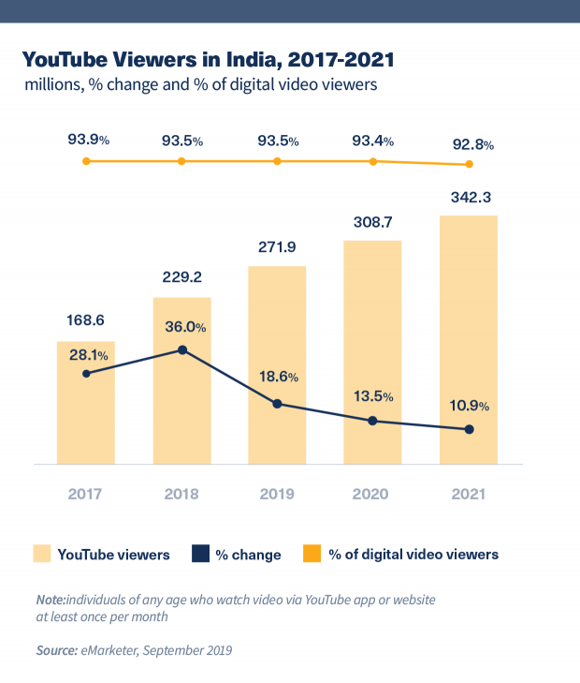

Online streamers and gamers will have a good time now and in the future as well. According to hootsuite, only 33% of videos are in English while others are in their regional languages which makes it easy to local users to stream in mother tongue.

Process model

# Iterative Waterfall

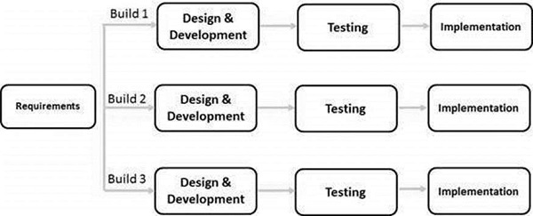

Incremental Model is a process of software development where requirements divided into multiple standalone modules of the software development cycle. In this model, each module goes through the requirements, design, implementation and testing phases. Every subsequent release of the module adds function to the previous release. The process continues until the complete system achieved.

***Reason to Use:***

* When the requirements are superior.
* A project has a lengthy development schedule.
* When Software team are not very well skilled or trained.
* When the customer demands a quick release of the product.
* You can develop prioritized requirements first.

***Phases:***

* **Requirement Analysis:** In the first phase of the incremental model, the product analysis expertise identifies the requirements. And the system functional requirements are understood by the requirement analysis team. To develop the software under the incremental model, this phase performs a crucial role.
* **Design and Develop:** In this phase of the Incremental model of SDLC, the design of the system functionality and the development method are finished with success. When software develops new practicality, the incremental model uses style and development phase.
* **Testing:** In the incremental model, the testing phase checks the performance of each existing function as well as additional functionality. In the testing phase, the various methods are used to test the behavior of each task.
* **Implementation:** Implementation phase enables the coding phase of the development system. It involves the final coding that design in the designing and development phase and tests the functionality in the testing phase. After completion of this phase, the number of the product working is enhanced and upgraded up to the final system product.

***Advantages:***

* Errors are easy to be recognized.
* Easier to test and debug
* More flexible.
* Simple to manage risk because it handled during its iteration.
* The Client gets important functionality early.

***Disadvantages:***

* Need for good planning
* Total Cost is high.
* Well defined module interfaces are needed.

Stakeholders

***User***

* Register
* Login
* View Stream
* Become member
* Comment
* Go live (45min)
* Search
* Report
* Statistics will be counted
* Earn LCoin

***Member***

* Login
* View Stream
* Become member
* Chats
* Go live (unlimited time)
* Search
* Statistics will be counted
* Earn LCoin
* Enable advertisements
* Report

***Admin***

* Review grievance and reports
* Block users/members (if suspicious)

Functional Requirements

Registration:

* Get Name, Email address, Password, Profile photo
* Give an unique tag
* Send/Re-Send OTP

Login:

* Sign in through Email I’D/Tag and Password
* Forgot Password [Through OTP]

Explore:

* Display users’ profiles Rank Wise (based on Lscore) Refreshes every day at 12:00am;
* Search
  + Recent search
  + Tag-Wise Recommendation
  + Searched Profiles

Home:

* Display followed profiles
* Floating button for Go Live
* Settings menu
  + Contact us and Grievance
  + About us
  + Feedback
  + Updates on Reported content

Profile:

* Display your profile details:
  + Profile photo
  + User name
  + LCoins
  + LScore
  + Tag
* Edit Profile
  + Change Password
  + Change Profile Details
* Statistics
  + Followers
  + Average number of distinct viewers per stream
  + Stream Time
  + Total no. of streams (longer than 30 minutes) [maximum 3 streams Daily]
  + LScore [(Followers/10000)+(avg-viewers/10000)+(Stream time/6000)+(number of streams/10)]
* Advertisement
  + For my Profile->Take advertisement
    - Take/Reject [max 2 advertisements per session]
    - Receive max 30sec video clip
  + For searched Profile->Give advertisement
    - Send 30Sec video-clip
    - If accepted then deduct LCoins from account and credit into account
    - Reject/cancel Advertisement , if cancelled then refund Lcoins
  + If accepted then automatically show advertisement clip as viewer joins

Membership and Lcoins:

* Purchase Lcoins ($1 per Lcoin)
* Purchase membership –According to plan
* 99LCoin/month
* 249LCoin/3months
* 499LCoin/6months
* 899LCoin/year

Go Live:

* Set stream details:
* Title
* Thumbnail
* Description
* Tags
* Set whether Private or Public stream
* If Private, then generate a link to join the stream.
* Set sharing options
* Screen
* Front camera
* Rear camera
* Voice
* System voice
* Schedule Live stream
* Get time and date.
* Add in community posts.
* Add community post about stream date and time either scheduled or non-scheduled

During Live Session (Streamer):

* Show chats
* Edit stream details
* Change sharing option
* Comment on own stream.
* Stop Live(Store the stream details)

During Live Session (Viewer):

* Show advertisement
* Leave the session
* Donate/Gift LCoins (Min. 20 LCoin)
* Chat
* Special chat (Min. 5 LCoin)

Redeem LCoins (Per Month):

* Convert Lcoins to money (1Lcoin= $0.5)
* AddLCoin to user’s profile
* Received gifts & donations
* Special chats
* From ranking revenue [LScore / 1000]

Non-functional Requirements

Scalability

Scalability is a non-functional property of a system that describes the ability to appropriately handle increasing and decreasing workloads.

Portability

Portability is the ease with which a software system can be transferred from its current hardware or software environment to another environment. Portability requirements address the user concern for how easy it is to transport the system.

Usability

Usability measures characteristics such as consistency and aesthetics in the user interface. Consistency is the constant use of mechanisms employed in the user interface while aesthetics refers to the artistic, visual quality of the user interface.

Maintainability

Maintainability is how easy it is for a system to be supported, changed, enhanced, and restructured over time. This impact makes maintainability an important non-functional requirement to consider when developing software.

Reliability

Reliability is the extent to which the software system consistently performs the specified functions without failure.

System Requirements

Memory: *4GB* recommended *2GB* minimum

Processor: *2.2GHz octa-core Qualcomm Snapdragon 710* recommended *2GHz octa-core MediaTek Helio G85* processor minimum

Operating System: *Android Oreo (8.0)*

Camera and Microphone Required (as per user requirements)

Feasibility Study

Cost Feasible:

* Convert LCoins to Money
* This module is not Cost Feasible because there are not enough funds to provide the users money for the coins they have earned

Time Feasible:

* Private streams
* Advertisements
* These modules are removed because they are not time feasible and they don’t have any major impact on our application

Technical Feasible:

* None
* Every technical requirement is possible and feasible

Software Requirements Specification [SRS] Document

F1. Registration

**Input:** Name, Email, Password, Profile photo

**Output:** “Confirm registration by OTP”

**Process:** Check constraints of mandatory fields and others and store data in database,

and generate OTP.

F2. Confirm Registration

**Input:** OTP, Email

**Output:** Registration status

**Process:** check whether it is correct or not. Generate a tag, Send to Email.

F3. Login

**Input:** Email Id/Tag, Password.

**Output:** Login Status

**Process:** Check constraints of mandatory fields and others. And match Id and Password.

F4. Change Password/Forgot Password

4.1

**Input:** User Details

**Output:** Link will be received in mail

**Process:** Generate a link to change password and send via email

4.2

**Input:** New Password, Confirm Password

**Output:** “Password changed successfully”

**Process:** Update password in data-base

F5. Explore

**Output:** Display streamers rank wise

**Process:** Calculate Rank according to LScore

5.1 Search

**Input:** Name/Id

**Output:** Display streamers

**Process:** Retrieve from Database

F6. Buy membership

**Input:** Membership Plans

**Output:** “Membership purchased”

**Process:** Deduct Lcoins from account/profile.

F7. Go live

7.1 Details for stream to display

**Input:** Title of stream*, Thumbnail*, Description, Schedule Session

**Output:** Preview

7.2 Advanced Options

**Input:** Enable/Disable special chats.

**Output:** “Settings saved”

**Process:** Start the live session according to saved settings

F8 View Stream

**Input:** Stream id

**Output:** Play Stream

**Process:** Retrieve stream data from server

F9 Chat

9.1 Regular Chat

**Input:** Chat Message

**Output:** Comment On the stream

**Process:** Show message in chat section

9.2 Special Chat

**Input:**  Chat Message, Lcoins (minimum 1)

**Output:** Highlighted Comment in the Stream

**Process:** Show message in chat section with Highlighted and notify streamer

F10 Statistics

**Input:** Stream data from profile

**Output:** Show stats graphs and Charts

**Process:** Calculate required Data

F11 Redeem LCoins

**Output:** LCoins Credited

**Process:** AddLCoin to user’s profile

Received gifts & donations

Special chats

From ranking revenue [LScore / 1000]

F12 Convert LCoins to Money and purchase LCoins

**Output:** Simulation of Transaction

F13 Contact Us/ Grievance and Report

13.1 User

**Input:** Ask a Question

**Output:** Reply from Admin/ Invalid Question

**Process:** Add Question Box

13.2 Admin

**Input:** Get Reply Message

**Output:** Reply to User

**Process:** Add Answer to Question Box

Diagrams

## Use Case:

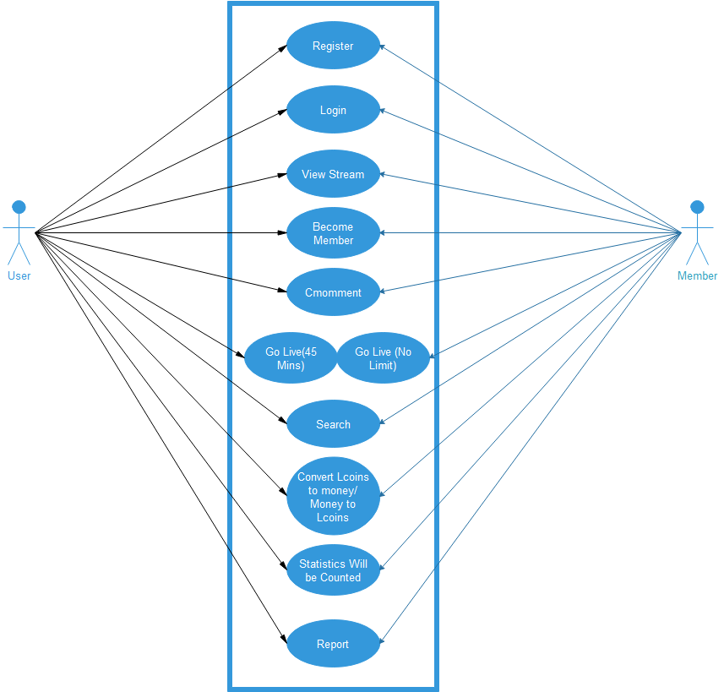

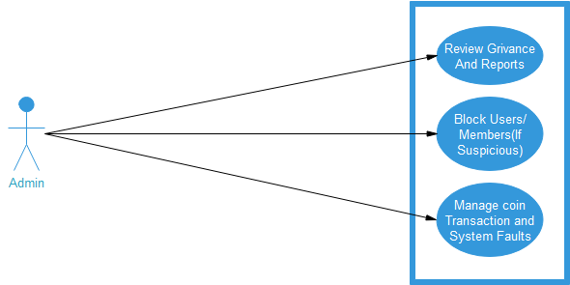

## Entity Relationship Diagram:

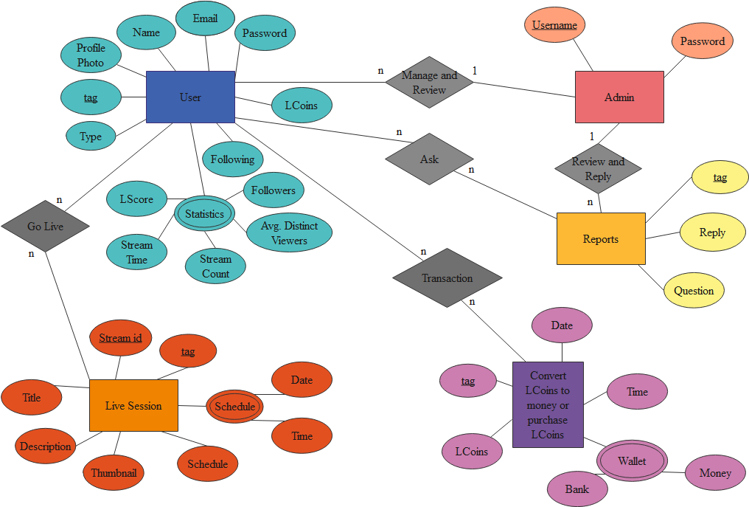

## Activity Diagram:

|  |  |  |  |  |
| --- | --- | --- | --- | --- |
| Data Dictionary: User | | | | |
| Field Name | Size | Datatype | Description | Example |
| Tag | 9 | Hex | Unique id for all user | 1490 |
| Name | 20 | Varchar | Display Name of The User | Pars Joshi |
| Email | 40 | Varchar | Linked Email Address | [Contact.livid@gmail.com](mailto:Contact.livid@gmail.com) |
| Password | 15 | Varchar | Authentication | 123pass |
| Profile Photo | 200kb | Image | Display Image of the profile |  |
| Type | 1 | Boolean | User Type (User/Member) | Member |
| Lcoins | 10 | Int | In-app Currency | 420 |
| Following | 5 | Int | No. of Users Following | 5 |
| Followers | 10 | Int | No. of Users Followers | 20 |
| Avg.Distinct View | 10 | Double | Average no. of viewers connecting to Stream | 420.05 |
| Stream Count | 10 | Int | Number of streams conducted by User | 302 |
| Stream Time |  | Time | Total time spent on stream | 6hrs |
| Lscore | 10 | Double | Total Score achieved by user | 469 |
| Admin | | | | |
| Name | 20 | Varchar | Display Name of Admin | Jay Nakum |
| Email | 40 | Varchar | Linked Email Address | [erjaynakum@gmail.com](mailto:erjaynakum@gmail.com) |
| Password | 15 | Varchar | Authentication | 696pass |
| Live Session | | | | |
| Stream Id | 20 | Varchar | Unique Id of a stream | jaucbasu9hq121312 |
| Tag | 9 | Hex | Unique Id of a user | 1969 |
| Title | 30 | Varchar | Title of Stream | Fall Guys Live | Jay Nakum |
| Description | 1000 | Long Text | Description about Stream or Streamer | Fall Guys India Live |
| Thumbnail | 1mb | Image | Display Image of Stream |  |
| Date | 2 | Date | Date of Stream | 13-sept |
| Time | 2 | Time | Time of Stream | 6pm |
| Transaction | | | | |
| Date | 8 | Date | Date of Transaction | 14-9-2002 |
| Time | 6 | Time | Time of Transaction | 09:30:00 |
| Money | 10 | Int | Converted/convertible money | 100 |
| Lcoins | 10 | Int | Lcoins Converted | 10 |
| Tag | 9 | Hex | Unique tag of Lcoin Owner | 1409 |
| Transaction Id | 10 | Varchar | Unique Tag for Transaction | t140900001 |
| Reports | | | | |
| Tag | 9 | Hex | Unique Tag of Users | 1409 |
| Question | 255 | Varchar | Questions of user asked | "Inappropriate Username" |
| Reply | 255 | Varchar | Reply From Admin Side | "We'll take care of that" |

## Data Flow Diagram:

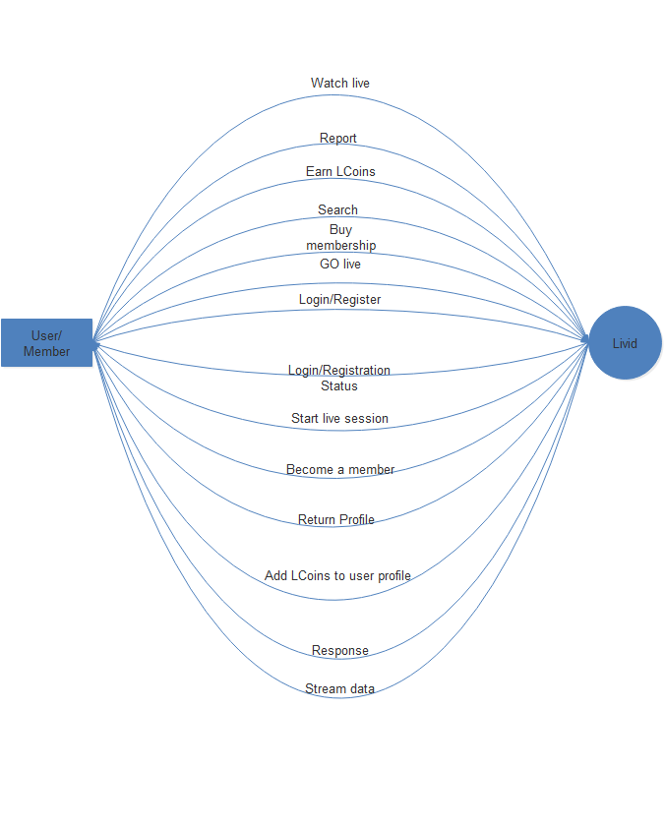

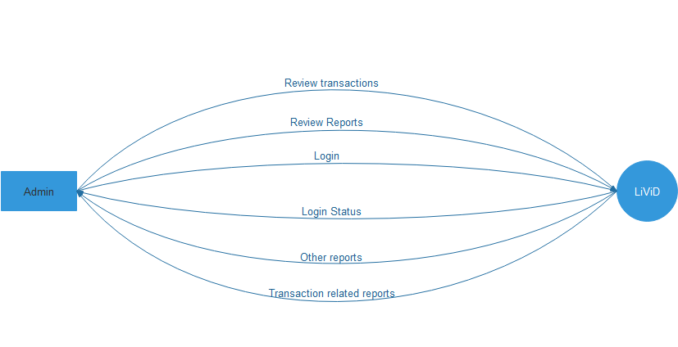

### Level 1

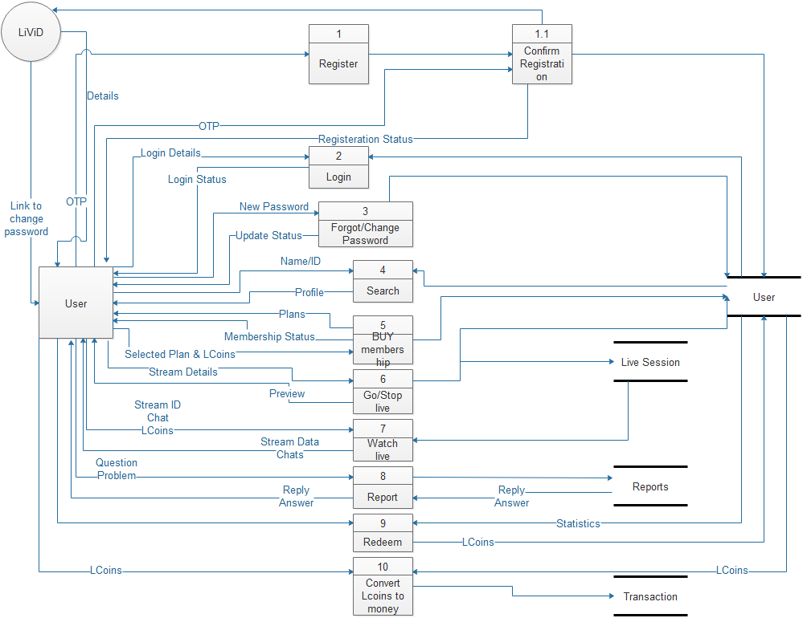

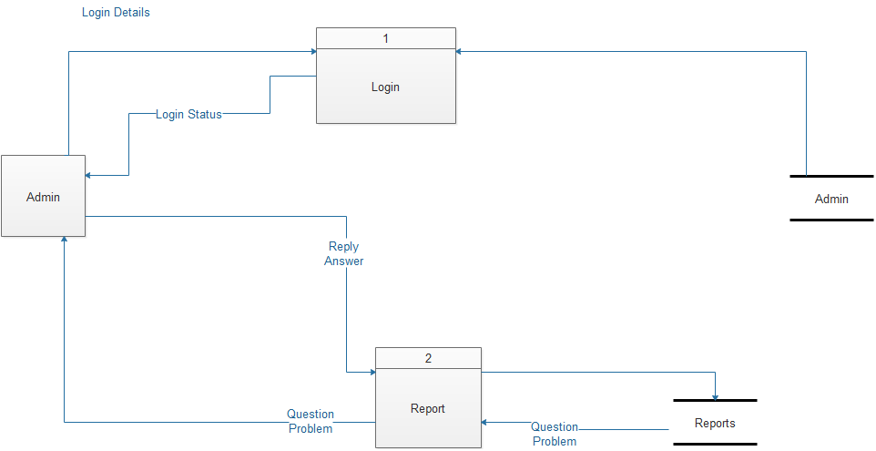

### Level 2

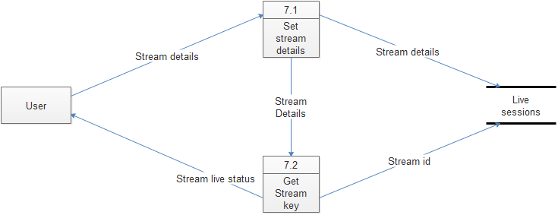

### Sequence Diagram:

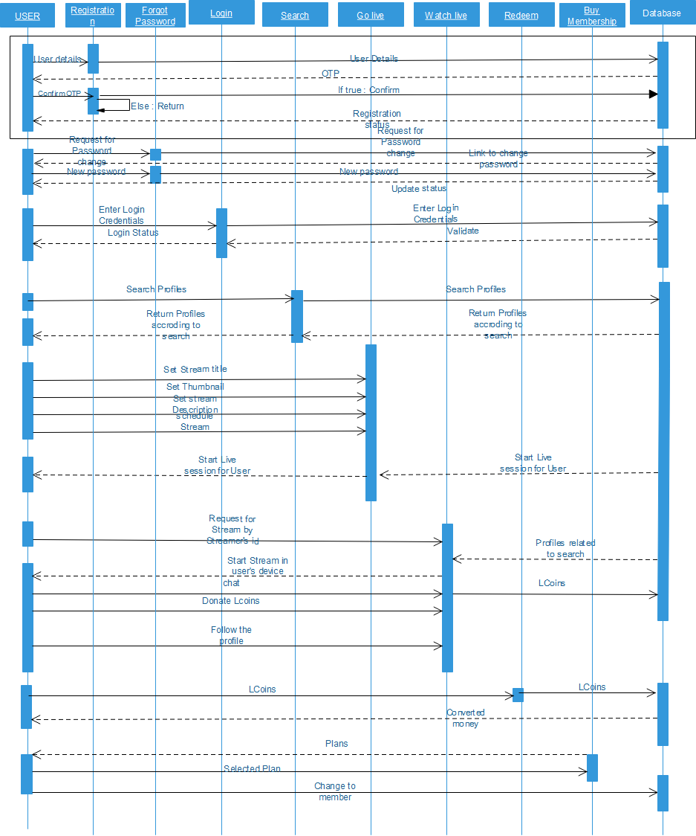

Input Output Form

**Input:**

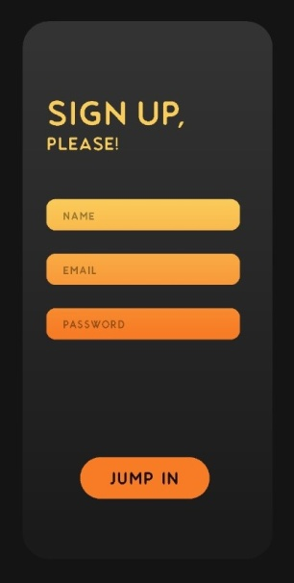

**Output:**

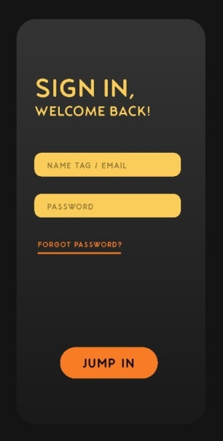

**Input:**



**Output:**

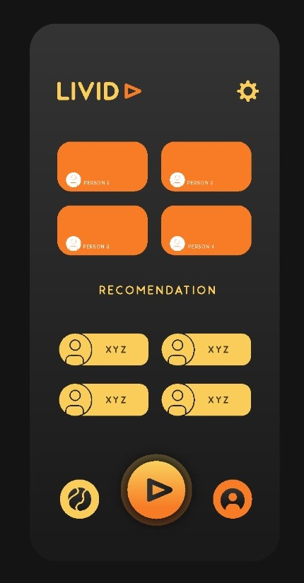

Graphical User Interface

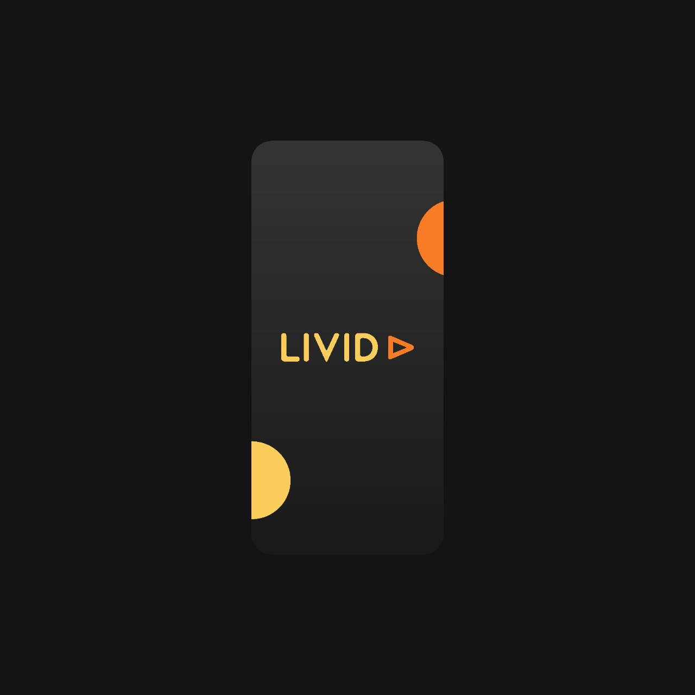

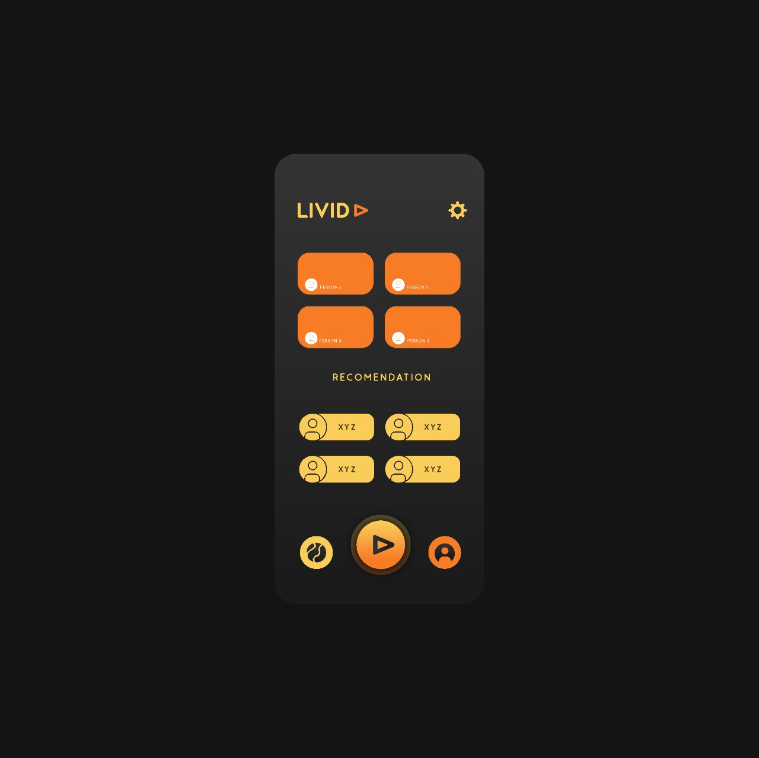

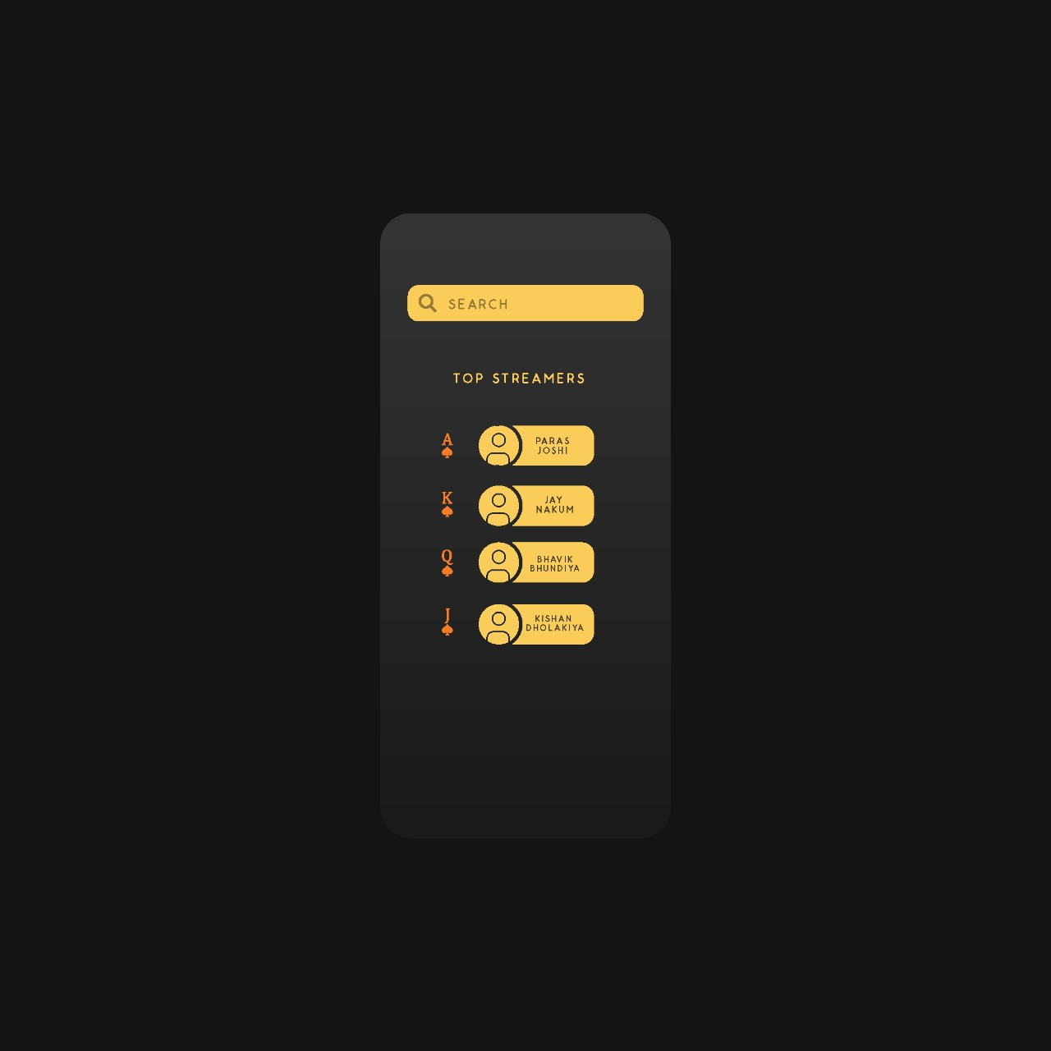

References

• <https://www.twitch.tv/>

• <https://obsproject.com/>

• <https://meet.google.com/>

• <https://www.javatpoint.com/>

• <https://www.geeksforgeeks.org/>

• <https://www.visual-paradigm.com/guide/data-flow-diagram/what-is-dataflow-diagram/>

• <https://www.lucidchart.com/blog/data-flow-diagram-tutorial>

• <https://medium.com/@warren2lynch/data-flow-diagram-comprehensiveguide-with-examples-d9858387f25e>

• [https://miro.medium.com/max/829/0*W691GG6rn94caqFZ.gif](https://miro.medium.com/max/829/0*W691GG6rn94caqFZ.gif)

• <https://pin.it/2P3MkH9>

• <https://pin.it/7CsN0a8%20References>

• <https://pin.it/1E8mBb5>

• <https://pin.it/1UIKXTz>

• <https://pin.it/4z3KorM>

• <https://www.sketch.com/>

• <https://www.behance.net/gallery/88403131/Social-App-for-Live-streamingVideo>

• <https://blog.hootsuite.com/youtube-statsmarketers/#:~:text=1.,1.8%20billion%20in%20May%202018>

• <https://www.tutorialspoint.com/sdlc/images/sdlc_iterative_model.jpg>

• <https://www.javatpoint.com/software-engineering-incremental-model>

• <https://www.qualcomm.com/snapdragon/processors/comparison>

• <https://gadgets.ndtv.com/mobiles/micromax-phones>