**3. Design The Form**

**activity_main.xml**

<?xml version="1.0" encoding="utf-8"?>  
<androidx.constraintlayout.widget.ConstraintLayout xmlns:android="http://schemas.android.com/apk/res/android"  
 xmlns:app="http://schemas.android.com/apk/res-auto"  
 xmlns:tools="http://schemas.android.com/tools"  
 android:layout_width="match_parent"  
 android:layout_height="match_parent"  
 android:scrollbarSize="4dp"  
 android:background="@drawable/bg"  
 tools:context=".MainActivity">  
  
 <TextView  
 android:id="@+id/textView3"  
 android:layout_width="wrap_content"  
 android:layout_height="wrap_content"  
 android:fontFamily="@font/caviar_dreams_bold"  
 android:text="Registration Form"  
 android:textColor="@color/FrontHand"  
 android:textSize="40sp"  
 app:layout_constraintBottom_toBottomOf="parent"  
 app:layout_constraintHorizontal_bias="0.551"  
 app:layout_constraintLeft_toLeftOf="parent"  
 app:layout_constraintRight_toRightOf="parent"  
 app:layout_constraintTop_toTopOf="parent"  
 app:layout_constraintVertical_bias="0.086" />  
  
 <TextView  
 android:id="@+id/textView"  
 android:layout_width="wrap_content"  
 android:layout_height="wrap_content"  
 android:text="First Name:"  
 android:textColor="#FFFFFF"  
 android:textSize="24sp"  
 android:fontFamily="@font/caviar_dreams_bold"  
 android:textStyle="bold"  
 app:layout_constraintBottom_toBottomOf="parent"  
 app:layout_constraintEnd_toEndOf="parent"  
 app:layout_constraintHorizontal_bias="0.066"  
 app:layout_constraintStart_toStartOf="parent"  
 app:layout_constraintTop_toTopOf="parent"  
 app:layout_constraintVertical_bias="0.228" />  
  
 <TextView  
 android:id="@+id/textView2"  
 android:layout_width="wrap_content"  
 android:layout_height="wrap_content"  
 android:text="Email:"  
 android:textColor="#FFFFFF"  
 android:textSize="24sp"  
 android:textStyle="bold"  
 android:fontFamily="@font/caviar_dreams_bold"  
 app:layout_constraintBottom_toBottomOf="parent"  
 app:layout_constraintEnd_toEndOf="parent"  
 app:layout_constraintHorizontal_bias="0.116"  
 app:layout_constraintStart_toStartOf="parent"  
 app:layout_constraintTop_toTopOf="parent"  
 app:layout_constraintVertical_bias="0.334" />  
  
 <TextView  
 android:id="@+id/textView4"  
 android:layout_width="wrap_content"  
 android:layout_height="wrap_content"  
 android:text="Address:"  
 android:textColor="#FFFFFF"  
 android:textSize="24sp"  
 android:textStyle="bold"  
 android:fontFamily="@font/caviar_dreams_bold"  
 app:layout_constraintBottom_toBottomOf="parent"  
 app:layout_constraintEnd_toEndOf="parent"  
 app:layout_constraintHorizontal_bias="0.085"  
 app:layout_constraintStart_toStartOf="parent"  
 app:layout_constraintTop_toTopOf="parent"  
 app:layout_constraintVertical_bias="0.426" />  
  
 <TextView  
 android:id="@+id/textView5"  
 android:layout_width="wrap_content"  
 android:layout_height="wrap_content"  
 android:text="Mobile No."  
 android:textColor="#FFFFFF"  
 android:textSize="24sp"  
 android:fontFamily="@font/caviar_dreams_bold"  
 android:textStyle="bold"  
 app:layout_constraintBottom_toBottomOf="parent"  
 app:layout_constraintEnd_toEndOf="parent"  
 app:layout_constraintHorizontal_bias="0.064"  
 app:layout_constraintStart_toStartOf="parent"  
 app:layout_constraintTop_toTopOf="parent"  
 app:layout_constraintVertical_bias="0.52" />  
  
 <TextView  
 android:id="@+id/textView6"  
 android:layout_width="wrap_content"  
 android:layout_height="wrap_content"  
 android:text="Gender"  
 android:textColor="#FFFFFF"  
 android:fontFamily="@font/caviar_dreams_bold"  
 android:textSize="24sp"  
 android:textStyle="bold"  
 app:layout_constraintBottom_toBottomOf="parent"  
 app:layout_constraintEnd_toEndOf="parent"  
 app:layout_constraintHorizontal_bias="0.114"  
 app:layout_constraintStart_toStartOf="parent"  
 app:layout_constraintTop_toTopOf="parent"  
 app:layout_constraintVertical_bias="0.622" />  
  
 <RadioButton  
 android:id="@+id/radioButton"  
 android:layout_width="wrap_content"  
 android:layout_height="wrap_content"  
 android:text="Male"  
 android:textColor="#FFFFFF"  
 android:textSize="20sp"  
 android:textStyle="bold"  
 android:fontFamily="@font/caviar_dreams_bold"  
 app:layout_constraintBottom_toBottomOf="parent"  
 app:layout_constraintEnd_toStartOf="@+id/radioButton2"  
 app:layout_constraintHorizontal_bias="0.666"  
 app:layout_constraintStart_toEndOf="@+id/textView6"  
 app:layout_constraintTop_toTopOf="parent"  
 app:layout_constraintVertical_bias="0.626" />  
  
 <RadioButton  
 android:id="@+id/radioButton2"  
 android:layout_width="wrap_content"  
 android:layout_height="wrap_content"  
 android:text="Female"  
 android:textColor="#FFFFFF"  
 android:fontFamily="@font/caviar_dreams_bold"  
 android:textSize="20sp"  
 android:textStyle="bold"  
 app:layout_constraintBottom_toBottomOf="parent"  
 app:layout_constraintEnd_toEndOf="parent"  
 app:layout_constraintHorizontal_bias="0.837"  
 app:layout_constraintStart_toStartOf="parent"  
 app:layout_constraintTop_toTopOf="parent"  
 app:layout_constraintVertical_bias="0.626" />  
  
 <Button  
 android:id="@+id/button"  
 android:layout_width="112dp"  
 android:layout_height="63dp"  
 android:background="@drawable/custombutton"  
 android:text="Submit"  
 android:textColor="#FFFFFF"  
 android:fontFamily="@font/caviar_dreams_bold"  
 app:layout_constraintBottom_toBottomOf="parent"  
 app:layout_constraintEnd_toEndOf="parent"  
 app:layout_constraintStart_toStartOf="parent"  
 app:layout_constraintTop_toTopOf="parent"  
 app:layout_constraintVertical_bias="0.89" />  
  
 <EditText  
 android:id="@+id/namTextTextEmailAddress"  
 android:layout_width="wrap_content"  
 android:layout_height="wrap_content"  
 android:ems="10"  
 android:inputType="textEmailAddress"  
 app:layout_constraintBottom_toBottomOf="parent"  
 app:layout_constraintEnd_toEndOf="parent"  
 app:layout_constraintHorizontal_bias="0.825"  
 app:layout_constraintStart_toStartOf="parent"  
 app:layout_constraintTop_toTopOf="parent"  
 app:layout_constraintVertical_bias="0.231" />  
  
 <EditText  
 android:id="@+id/editTextTextEmailAddress"  
 android:layout_width="wrap_content"  
 android:layout_height="wrap_content"  
 android:ems="10"  
 android:inputType="textEmailAddress"  
 app:layout_constraintBottom_toBottomOf="parent"  
 app:layout_constraintEnd_toEndOf="parent"  
 app:layout_constraintHorizontal_bias="0.825"  
 app:layout_constraintStart_toStartOf="parent"  
 app:layout_constraintTop_toTopOf="parent"  
 app:layout_constraintVertical_bias="0.32999998" />  
  
 <EditText  
 android:id="@+id/editTextTextPersonName3"  
 android:layout_width="wrap_content"  
 android:layout_height="wrap_content"  
 android:ems="10"  
 android:inputType="textPersonName"  
 app:layout_constraintBottom_toBottomOf="parent"  
 app:layout_constraintEnd_toEndOf="parent"  
 app:layout_constraintHorizontal_bias="0.825"  
 app:layout_constraintStart_toStartOf="parent"  
 app:layout_constraintTop_toTopOf="parent"  
 app:layout_constraintVertical_bias="0.43" />  
  
 <EditText  
 android:id="@+id/editTextNumber"  
 android:layout_width="wrap_content"  
 android:layout_height="wrap_content"  
 android:ems="10"  
 android:inputType="number"  
 app:layout_constraintBottom_toBottomOf="parent"  
 app:layout_constraintEnd_toEndOf="parent"  
 app:layout_constraintHorizontal_bias="0.8"  
 app:layout_constraintStart_toStartOf="parent"  
 app:layout_constraintTop_toTopOf="parent"  
 app:layout_constraintVertical_bias="0.529" />  
  
 <Spinner  
 android:id="@+id/spinner1"  
 android:layout_width="175dp"  
 android:layout_height="wrap_content"  
 android:background="#FFFFFF"  
 android:dropDownSelector="@color/FrontHand"  
 android:fontFamily="@font/caviar_dreams_bold"  
 android:foreground="@drawable/background"  
 android:padding="10px"  
 android:scrollbarSize="250dp"  
 android:scrollbarThumbHorizontal="@drawable/bg"  
 android:theme="@style/Theme.Forms"  
 app:layout_constraintBottom_toBottomOf="parent"  
 app:layout_constraintEnd_toEndOf="parent"  
 app:layout_constraintHorizontal_bias="0.498"  
 app:layout_constraintStart_toStartOf="parent"  
 app:layout_constraintTop_toTopOf="parent"  
 app:layout_constraintVertical_bias="0.758" />  
  
</androidx.constraintlayout.widget.ConstraintLayout>

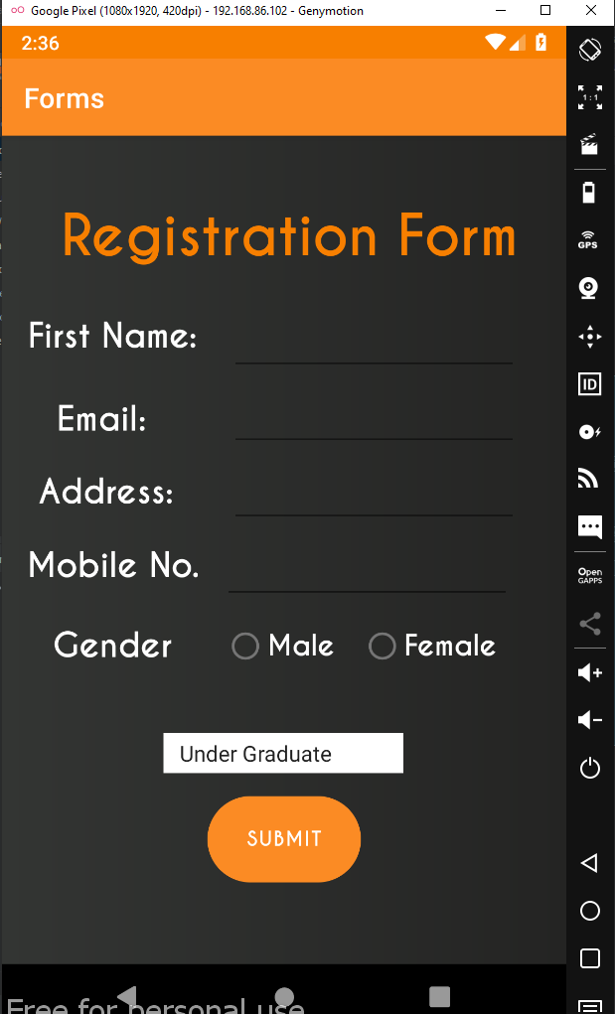**Output:**