Workshop 5
Image Processing Workshop Presentation Export
Generated: 2026-03-05 16:57:19
Included sections: Assignment 1 - Task 2

Table of Contents
Table of contents will appear here after updating fields.
Open this file in Word and update fields to render TOC page numbers.

Assignment 1 - Task 2

Segmentation
Method: Otsu, Block: 23, C: 9.9

Figure 1: A1 Task2 Segmentation - Original gray

Figure 2: A1 Task2 Segmentation - Binary mask

Figure 3: A1 Task2 Segmentation - Labeled regions

Object Detection
Mask Source: Adaptive Gaussian, Min Area: 50.0, Morph Open: 3, Morph Close: 3
Figure 4: A1 Task2 Detection - Original gray
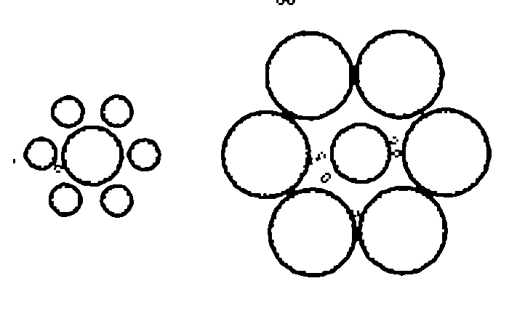
Figure 5: A1 Task2 Detection - Binary mask
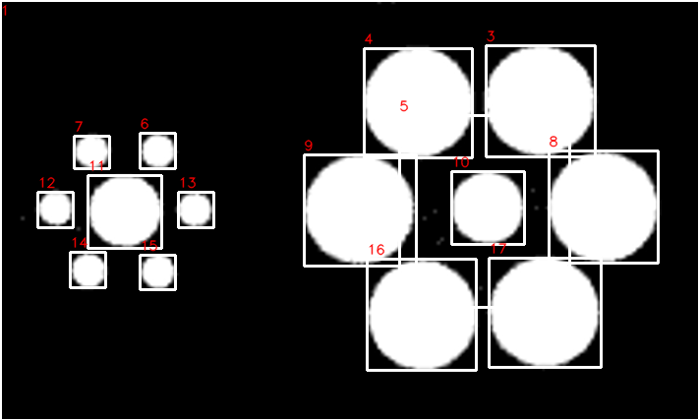
Figure 6: A1 Task2 Detection - Annotated
A1 Task2 Detection table
Label | Area | Perimeter | BBox | Centroid
1 | 199740 | 2306.97 | (0, 0, 711, 427) | (314.2, 214.0)
3 | 9750 | 395.08 | (494, 46, 111, 113) | (548.7, 101.8)
4 | 9715 | 383.66 | (370, 49, 110, 111) | (424.9, 103.8)
5 | 10068 | 760.04 | (406, 117, 173, 195) | (485.5, 210.1)
6 | 931 | 123.84 | (142, 135, 36, 36) | (160.5, 153.2)
7 | 922 | 117.01 | (75, 138, 36, 33) | (92.8, 153.7)
8 | 9705 | 394.01 | (558, 153, 111, 114) | (613.0, 210.0)
9 | 9661 | 407.32 | (309, 157, 114, 113) | (365.1, 212.6)
10 | 4218 | 261.10 | (459, 174, 74, 74) | (495.6, 210.6)
11 | 4213 | 259.44 | (89, 178, 75, 74) | (126.6, 214.0)
12 | 955 | 123.25 | (38, 195, 36, 36) | (56.1, 211.3)
13 | 943 | 123.01 | (181, 195, 36, 36) | (197.8, 212.8)
14 | 949 | 124.77 | (71, 256, 36, 36) | (89.6, 274.5)
15 | 934 | 122.43 | (142, 259, 36, 35) | (160.4, 275.8)
16 | 9648 | 391.42 | (373, 263, 111, 113) | (429.1, 320.0)
17 | 9716 | 395.76 | (497, 262, 114, 111) | (553.3, 317.0)

