ID Action Gesture Example



0 Left Click Peace Sign

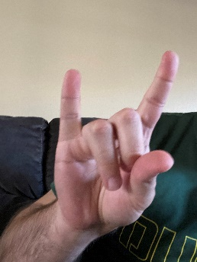

1 Right Click Rock and Roll Sign

2 Scroll Down Thumb Down

3 Scroll Left Thumb Left

4 Scroll Right Thumb Right

5 Scroll Up Thumb Up

6 Zoom In Reverse Pinch

7 Zoom Out Pinch