To run this program (as specified in the readme)

make

./lab

Enter dimensions as two separate integers.

Output (19x8 maze)

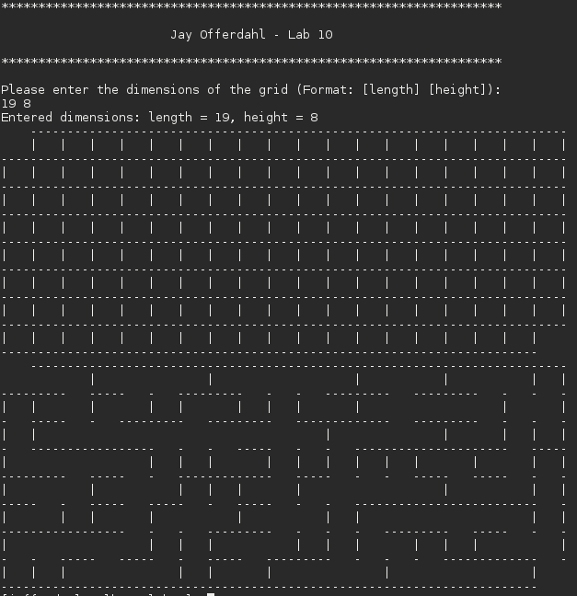

Output (20x20 maze)

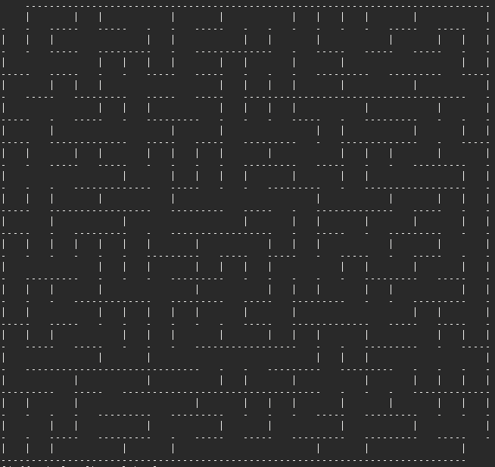

Solution (19x8)

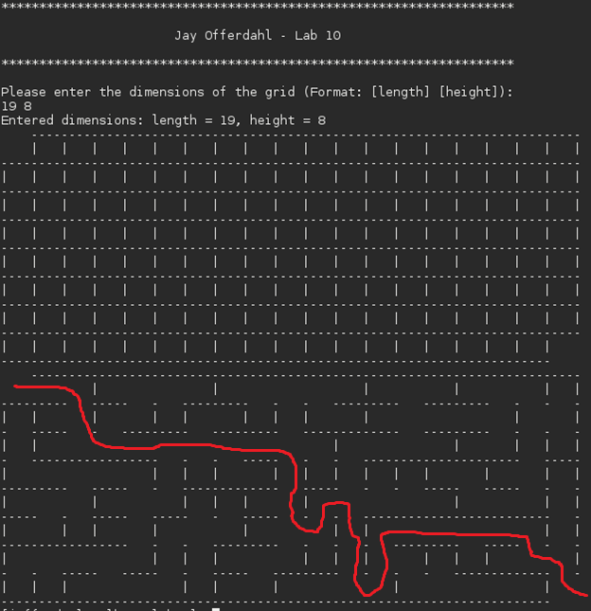

Solution (20x20)

