EECS 560 Homework 4 Name _________________________

Due: April 5, 2016

Write on only one side of the page, do problems in order, and staple this page to your answers.
Do not write on this sheet.

1. Use the list below to build the indicated data structures. Use buildheap for part a and show the heap (in array format) after each loop iteration. Show the structure after each insertion for parts b – d.
List: 5, 8, 10, 9, 16, 12, 2, 6, 7, 15, 25, 30, 1, 13, 4

a. binary minheap
b. 3-heap
c. leftist heap
d. binomial queue

2. For each of the structures built in question 2 perform one delete min operation and show the resulting structure after the heap order property is restored.

3. Merge leftist heaps T₁ and T₂. Show all work. After merging the two heaps, perform one deletemin operation and show the resulting leftist heap.
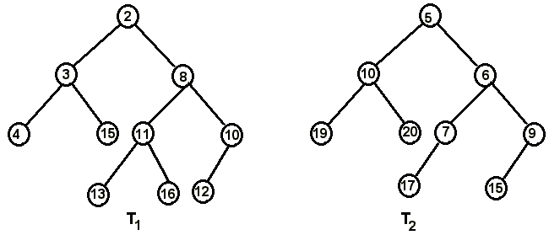

4. Merge the binomial queues below. Then perform one deletemin operation and restore the binomial queue properties.
