EECS 560 Homework 5 Name _________________________

Due: April 19

Write on only one side of the page, do problems in order, and staple this page to your answers.
Do not write on this sheet.

1. Perform the following sequence of union operations, in the given order. Initially, each of the 14 elements is in its own set. Use the convention that unless otherwise indicated, the second argument becomes the parent of the first.
union(4, 1), union(6, 14), union(13, 2), union(7, 5), union(9, 11), union(12, 8), union(6, 8)
union(1, 8) by size---show the structure at this point, union((7, 2)
union(13, 11)—show the structure
union(3, 14), union(5, 12) by height and show the final structure.

2. Use Dijkstra's algorithm to find the shortest paths from A to all other vertices in the graph below. Show the table after each vertex is processed.
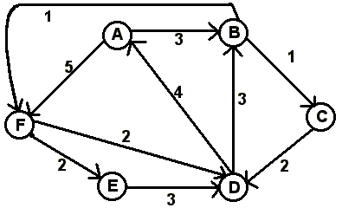

3. Using the graph below, answer the questions that follow it. When performing a DFS or BFS, if you have a choice of which vertex to visit next, choose the one that is alphabetically first.
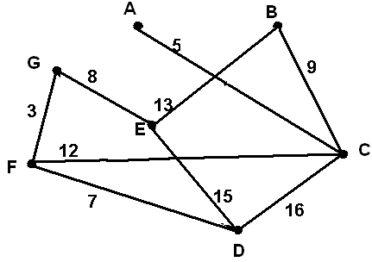
a. Draw the graph of the DFS tree starting from vertex E.
b. Draw the BFS tree starting from vertex A
c. Use both Prim’s and Kruskal’s algorithms to find a minimum cost spanning tree for the graph. List the order in which the edges are chosen for each algorithm.

