Spring 16 Test 2 Review topics

Here are some general questions to get you thinking about the material to be covered on Test 2. The review sheet is not intended to be all inclusive so be sure to go over all material covered in class and in the lab.

You will be expected to know how to perform various tree operations such as the following:
Insertion, deletemin and build for binary heaps, d-heaps, minmax and maxmin heaps
Insertion and deletion in skip lists
Insertion, deletemin and merge for leftist heaps, skew heaps, binomial queues,

Other topics:
Hashing
Properties of structures e.g. for binomial queues the relationship between the number of nodes, number of trees given total number of nodes, height of a binomial tree, and the number of nodes at a particular level in a binomial tree; for leftist heaps best and worst case height as a function of the number of nodes; location of the largest key in a minheap, etc.
union-find algorithm and path compression
Graphs including Dijkstra’s algorithm, spanning tree algorithms, shortest paths, depth and breadth-first searches, topological sort
material covered in labs and in the project.

Here are some short answer questions for you to look at. (You know, the kind you really like to answer ☺.) You should know the data structures and their properties well enough to be able to answer these and similar questions.

1. How many nodes are there in a binomial tree of height 5?

2. How many children does the root of a binomial tree of height 5 have?

3. The root of a leftist heap has a null path length of 6. What is the minimum height of the leftist heap? In that case, how many nodes does the leftist heap contain?

4. A deap has 100 keys. In what positions might the 2nd smallest value be found?

5. In the union-find algorithm for a set containing n elements, what is the worst case complexity of a find operation?

6. What is the complexity of deletemin for a binomial queue?

7. What is the worst case complexity of each of the following? Assume all structures are min structures i.e. min leftist heap, binomial queue in which each binomial tree is a min heap

a. deleting the smallest element of a leftist heap
b. building a leftist heap
c. finding the smallest element in a binomial queue

8. Using the buildheap algorithm, build a heap from the following list: 10, 12, 1, 14, 6, 5, 8, 15, 3, 9, 7, 4, 11, 13, 2. Show the partially constructed heap after each iteration of the loop in the algorithm.

9. Show the heap that results from one deletemin operation on heap in your answer to question 8.

10. Give the ranges of indices where the third smallest key in a min heap of size 80 may be found.

11. Suppose you have a three-heap, H. That is, parent nodes have three rather than two children. Given an index k what are the array indices of its children and its parent?

12. Show the result of the following sequence of union instructions: union(1, 2), union(3, 4), union(6, 2), union(8, 9), union(1, 8), union(11, 12), union(3, 12), union(7, 10), union(5, 10), union(13, 10), union(14, 5), union(1, 7), union(2, 10), union(4, 15) where

a. union by height is used
b. union by size (weight) is used

13. Perform a find with path compression on the deepest node in each of the final trees in your answer to problem 12.

14. Merge the binomial queues below. Then perform one deletemin operation and restore the binomial queue properties.
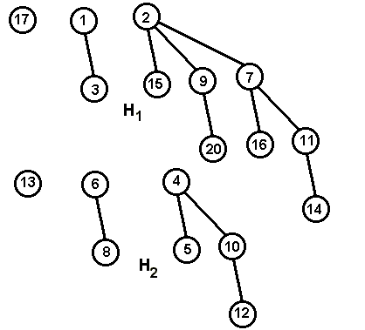

15. Shown below is a partially filled hash table. (The X’s indicate that a position is filled. The next number to be inserted hashes to 9.

 | X |  | X |  |  |  |  |  | X | X
0 1 2 3 4 5 6 7 8 9 10 11

Where will it be placed if linear probing is used to resolve collisions?
Where will it be placed if quadratic probing is used to resolve collisions?

16. You have an open hash table which holds 100 records and has a load factor of 2.5. How large is the table?

17. You should be able to set up recurrence relations for variations of the mergesort, quicksort, and select algorithms. For example,

a. worst case quicksort in which the median of 5 is used to find the pivot.

b. mergesort on a list of length n when all elements in the list are the same

c. three-way mergesort on list of size n i.e. three lists each of size n/3 are merged into one.

18. Given below is a path matrix obtained when Dijkstra’s algorithm was used to find the shortest paths from vertex 1 to the other vertices in a graph. What is the shortest path between vertices 1 and 4?
1 | 6 | 1 | 2 | 7 | 3 | 4

19. Use the graph below to answer questions that follow

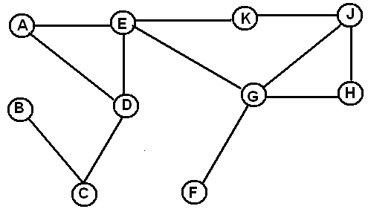

a. Draw the depth first spanning tree obtained by starting at vertex E. If you have a choice of which vertex to visit next, choose the one that comes first in alphabetical order.

b. Write the vertices in the order in which they would be visited by a breadth first search starting at D. Use alphabetical order in deciding which vertex to place on the queue next.

20. Find minimum spanning trees for the graph below using both Prim’s and Kruskal’s algorithms. For each algorithm list the edges in the order chosen. If you have a choice of which edge to use next, pick the one that comes first alphabetically.

