Spring 16 Test 2 Answers to review questions

1. How many nodes are there in a binomial tree of height 5? 2⁵

2. How many children does the root of a binomial tree of height 5 have? 5

3. The root of a leftist heap has a null path length of 6. What is the minimum height of the leftist heap? 6 In that case, how many nodes does the leftist heap contain? 2⁷ - 1

4. A deap has 100 keys. In what positions might the 2nd smallest value be found? 4 or 5

5. In the union-find algorithm for a set containing n elements, what is the worst case complexity of a find operation?

O(n) if the union is arbitrary i.e. not union by height or union by size (weight)

6. What is the complexity of deletemin on a binomial queue? O(lg n)

7. What is the worst case complexity of each of the following? Assume all structures are min structures i.e. min leftist heap, binomial queue in which each binomial tree is a min heap.

a. deleting the minimum element of a leftist heap O(lg N)
b. building a leftist heap O(N)
c. finding the smallest element in a binomial queue O(lg N)

8. Using the buildheap algorithm, build a heap from the following list: 10, 12, 1, 14, 6, 5, 8, 15, 3, 9, 7, 4, 11, 13, 2. Show the partially constructed heap after each iteration of the loop in the algorithm.

orig. heap:
10 | 12 | 1 | 14 | 6 | 5 | 8 | 15 | 3 | 9 | 7 | 4 | 11 | 13 | 2

Start in position 15/2✗ = 7
10 | 12 | 1 | 14 | 6 | 5 | 2 | 15 | 3 | 9 | 7 | 4 | 11 | 13 | 8

10 | 12 | 1 | 14 | 6 | 4 | 2 | 15 | 3 | 9 | 7 | 5 | 11 | 13 | 8

10 | 12 | 1 | 14 | 6 | 4 | 2 | 15 | 3 | 9 | 7 | 5 | 11 | 13 | 8
no change in the one above.

10 | 12 | 1 | 3 | 6 | 4 | 2 | 15 | 14 | 9 | 7 | 5 | 11 | 13 | 8

10 | 12 | 1 | 3 | 6 | 4 | 2 | 15 | 14 | 9 | 7 | 5 | 11 | 13 | 8

10 | 3 | 1 | 12 | 6 | 4 | 2 | 15 | 14 | 9 | 7 | 5 | 11 | 13 | 8

1 | 3 | 2 | 12 | 6 | 4 | 8 | 15 | 14 | 9 | 7 | 5 | 11 | 13 | 10

9. Show the heap that results from one deletemin operation on the heap in your answer to question 8.

2 | 3 | 4 | 12 | 6 | 5 | 8 | 15 | 14 | 9 | 7 | 10 | 11 | 13

10. Give the ranges of indices where the third smallest key in a min heap of size 80 might be found.
2-7

11. Suppose you have a three-heap, H. That is, parent nodes have three rather than two children. Given an index k what are the array indices of its children?

3k - 1, 3k, and 3k + 1

12. Show the result of the following sequence of union instructions: union(1, 2), union(3, 4), union(6, 2), union(8, 9), union(1, 8), union(11, 12), union(3, 12), union(7, 10), union(5, 10), union(13, 10), union(14, 5), union(1, 7), union(2, 10), union(4, 15) where

a. union by height is used
b. union by size (weight) is used

The answers are not unique. Here’s one possibility.
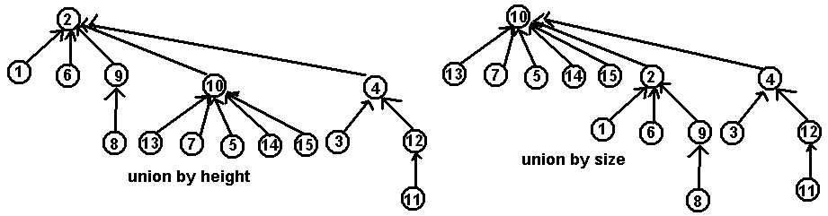

13. Perform a find with path compression on the deepest node in each of the final trees in your answer to problem 12.

14. Merge the binomial queues below. Then perform one deletemin operation and restore the binomial queue properties.
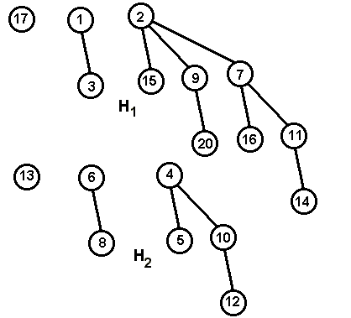

After the merge:
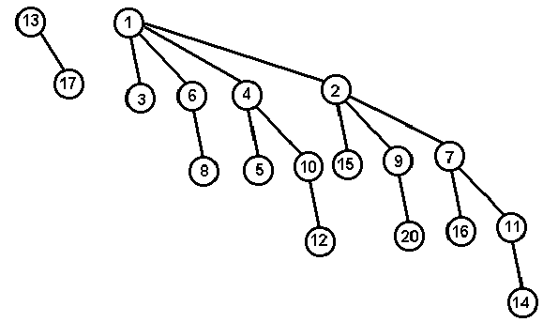
After the deletemin operation
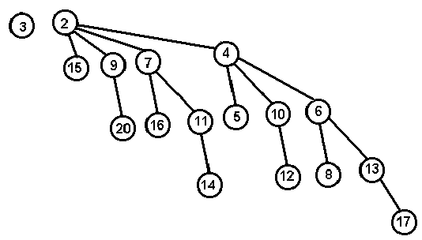

15. Shown below is a partially filled hash table. (The X’s indicate that a position is filled. The next number to be inserted hashes to 9.

 | X |  | X |  |  |  |  |  | X | X
0 1 2 3 4 5 6 7 8 9 10 11

Where will it be placed if linear probing is used to resolve collisions? 11
Where will it be placed if quadratic probing is used to resolve collisions? 6

16. You have an open hash table which holds 100 records and has a load factor of 2.5. How large is the table? The table size is 40

17. You should be able to set up recurrence relations for variations of the mergesort and quicksort algorithms. For example,

a. worst case quicksort in which the median of 5 is used to find the pivot.

The worst case situation is when one list has only two items so the recurrence is
T(n) = T(2) + T(n-3) + cn

b. mergesort on a list of length n when all elements in the list are the same.

This means that two sublists each of length n/2 will be merged. Since every element in the left hand list will be compared to the first element in the right hand list, the number of comparisons required for the merge is n/2. Thus, the recurrence is:
T(n) = 2T(n/2) + n/2.

c. three-way mergesort on list of size n i.e. three lists are merged into one.

T(n) = 3T(n/3) + 2n-3

(2n – 3 comparisons are needed in the worst case to merge three lists—it takes two comparisons to find the smallest of three elements. In the worst case two comparisons must be made to determine the next item for a total of n – 2 items. Thus, in the worst case it takes 2(n-2) + 1 comparisons. (The +1 is needed for the comparison when only two items remain.)

18. Given below is a path matrix obtained when Dijkstra’s algorithm was used to find the shortest paths from vertex 1 to the other vertices in a graph. What is the shortest path between vertices 1 and 4? 13624

1 | 6 | 1 | 2 | 7 | 3 | 4

19. Use the graph below to answer parts a - c

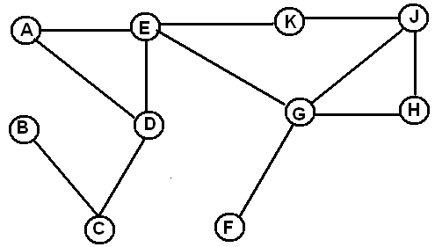

a. Draw the depth first spanning tree obtained by starting at vertex E. If you have a choice of which vertex to visit next, choose the lowest one in alphabetical order.
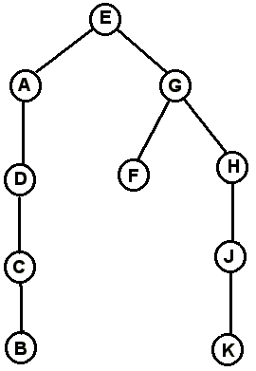

b. Write the vertices in the order in which they would be visited by a breadth first search starting at D. Use alphabetical order in deciding which vertex to place on the queue next.

D | A | C | E | B | G | K | F | H | J

20. Find minimum spanning trees for the graph below using both Prim’s and Kruskal’s algorithms. For each algorithm list the edges in the order chosen. If you have a choice of which edge to use next, pick the one that comes first alphabetically.

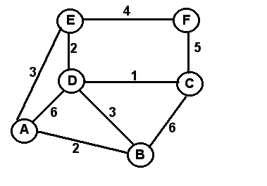
Prim | Kruskal
(C, D) | (C, D)
(D, E) | (A, B)
(A, E) | (D, E)
(A, B) | (A, E)
(E, F) | (E, F)
Cost is 12

