**Resume**

**Panchal Jay Dinesh** 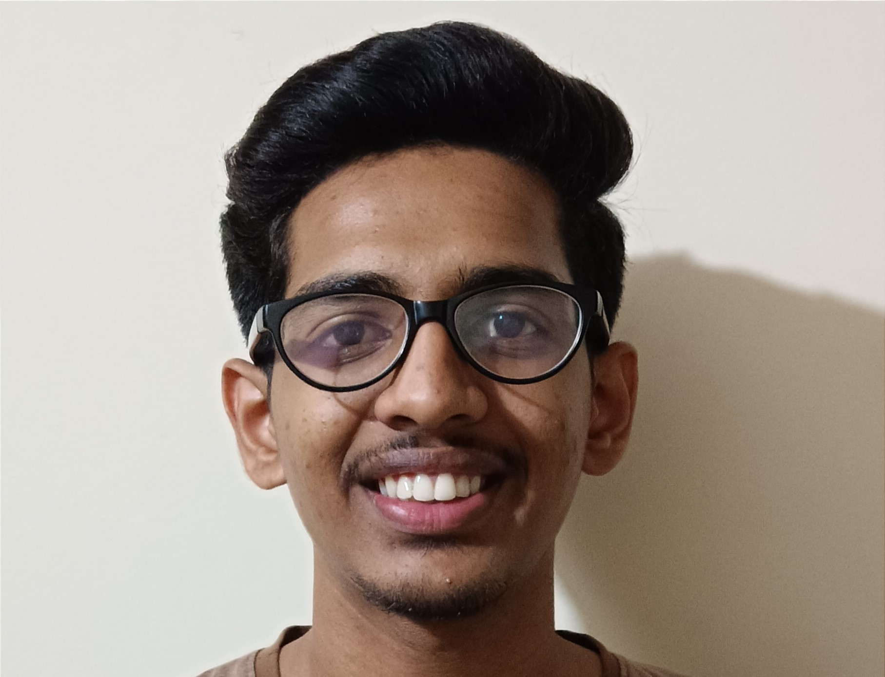

**Contact no:7757881113**

**Email** [**:jp6589819@gamil.com**](mailto::jp6589819@gamil.com)

------------------------------------------------------------------------------------------------------------------------------------------ Academic Qualification:

• 12th pass from Holy Family Convent High School

• 10th pass from The Ambassador High School

Professional Skills:

• Basic knowledge of computer.

• Typing ,Editing ,Email writing.

• Knowledge of HTML ,CSS ,and Javascript.

Work Experience:

• Fresher

Personal Details:

Father name : Dinesh Panchal

Gender : Male

Date of Birth : 7th June 2004

Language Speaking : English, Hindi & Gujarati

Hobbie : Football