 | Sanjivani Rural Education Society's  SANJIVANI COLLEGE OF ENGINEERING  (An Autonomous Institution)  Kopargaon – 423 603, Maharashtra. | ACAD-F-15 K
Academic Year:  2026-27 | CIA ACTIVITY REPORT | Revision : 00
Department : | Computer Engineering | Date of Preparation  16.10.2026
Course Code & Name: | PCCO201 : Discrete Mathematics | Year/Sem: S.Y B. Tech/ 3rd
Activity Title: Social Media Friendship Network
Submitted by:
Group Id- _______07_______
Roll No | PRN No | Name of the Student | Signature
95 | 0125UCSM1095 | Jay Kale
96 | 0125UCSM1096 | Kartik Tadge
97 | 0125UCSF1097 | Samruddhi Ugale
98 | 0125UCSM1097 | Onkar Godage
Dr. S. N Gunjal
Course Incharge

Abstract
Abstract—
A social network can be described mathematically by a relation. If U is the set of users of a platform, the friendship or follow structure is a subset R ⊆ U × U, in which (a, b) ∈ R means that user a is connected to user b. This report studies such a relation from the standpoint of discrete mathematics. The reflexive, symmetric and transitive properties are defined, tested and interpreted for social media: a friendship relation is symmetric and irreflexive but is never transitive, because a non-empty symmetric and irreflexive relation cannot be transitive (Theorem 1). A weaker, practical property called friend-transitivity (“a friend of my friend is my friend”) is introduced, and it is proved that it holds exactly when every connected group of users is complete (Theorem 2). The reflexive, symmetric, transitive and equivalence closures are computed with Warshall’s algorithm, and the classes of the equivalence closure are shown to be the clusters of the network (Theorem 3).
The theory is then turned into a C++ program that stores the relation as an adjacency matrix, tests all properties and prints a witness whenever a property fails, computes the four closures, and finds clusters, mutual connections, isolated users and friend suggestions. It was applied to two datasets of ten users: an undirected friendship network (16 ordered pairs, four clusters, one isolated user) and a directed follow network (11 ordered pairs, three clusters, six mutually reachable groups). The property tests, the closure routine and Theorem 2 were verified on all 66 064 relations over two, three and four users with no mismatch (the numbers of equivalence relations, 2, 5 and 15, agree with the Bell numbers), eight further test cases were run, and the routines were benchmarked for up to 400 users. The measurements confirm O(n) growth for the reflexive test, O(n²) for the symmetric test and the cluster search, and O(n³) for the transitivity test and Warshall’s closure. The networks are visualised as graphs and matrices, and applications to friend suggestion, community detection and the spread of information are discussed.
Index Terms—Discrete mathematics, relations, social network, friendship graph, symmetric, reflexive, transitive, closure, Warshall algorithm, C++.

Index
Abstract 2
Chapter 1 Introduction 4
1.1 Background 4
1.2 Problem Statement 4
1.3 Objectives 4
1.4 Scope and Limitations 5
1.5 Methodology 5
1.6 Organization of the Report 5
Chapter 2 Literature Survey 6
2.1 Sets, Cartesian Products and Relations 6
2.2 Properties of Relations 6
2.3 Equivalence Relations and Partitions 7
2.4 Matrix and Digraph Representation 7
2.5 Closures of Relations 8
2.6 Graph Concepts for Social Networks 9
2.7 Friendship as a Relation 9
2.8 Social Network Analysis Concepts 10
2.9 Historical Development 10
2.10 Applications 11
Chapter 3 System Design 13
3.1 Overall Design 13
3.2 Mathematical Model and Theorems 13
3.3 Algorithm 1: Property Testing 14
3.4 Algorithm 2: Closures (Warshall) 14
3.5 Algorithm 3: Clusters, Isolated Users and Suggestions 15
3.6 Complexity Comparison 16
3.7 Data Representation and Limits 16
3.8 Test Plan 16
Chapter 4 Implementation Details 18
4.1 Development Environment 18
4.2 Main Program 18
4.3 Explanation of the Code 22
4.4 Benchmark Program 23
4.5 Implementation Notes 23
Chapter 5 Result Screenshots and Analysis 25
5.1 Program Output 25
5.2 Network Visualisation 29
5.3 Performance Comparison 31
5.4 Analysis of Results 32
5.5 Problem Solutions 33
5.6 A Cautionary Example 34
Chapter 6 Conclusion 35
6.1 Conclusion 35
6.2 Future Scope 35
References 36
Annexure 1: GitHub Upload Screenshot 37
Annexure 2: Certificate of Online Course 38

Chapter 1 Introduction

1.1 Background
Discrete mathematics studies structures that are countable and separate: sets, relations, graphs, logical statements and sequences. Among these, relations are the tool for describing how objects are connected. A relation from a set A to a set B is any subset of the Cartesian product A × B, and a relation on a set U is a subset of U × U [1], [2]. Everyday examples include “is a divisor of” on the integers, “is a prerequisite of” on a set of courses, and “is a friend of” on a set of people.
Social media platforms make the last example concrete. A platform has a set U of users, and every friendship, follow or connection is a pair of users. The whole network is therefore a relation R ⊆ U × U in which (a, b) ∈ R means that a is connected to b. The mathematical properties of R then answer practical questions. Is a friendship mutual? That is symmetry. Does a user count as their own friend? That is reflexivity. Is a friend of a friend also a friend? That is transitivity. The graph of the relation shows which users form clusters, which pairs are mutually connected and which users are isolated [5], [6].
Because the relation can be stored as a matrix and analysed with simple loops, it is a natural meeting point of discrete mathematics and programming. This project builds that bridge for a small social network: the relation, its properties and closures are defined mathematically, proved where necessary, implemented in C++ and finally drawn as a graph.

1.2 Problem Statement
The problem addressed in this project is stated as follows: to demonstrate how relations can represent friendships in a social network, by defining a relation R ⊆ U × U on the set U of users, to analyse whether the friendship relation is symmetric, reflexive or transitive, and to visualise the network as a graph in order to identify clusters, mutual connections and isolated users. The relation is implemented and analysed in C++.

1.3 Objectives
- To study sets, Cartesian products and relations, and their representation by matrices and directed graphs.
- To define and test the reflexive, symmetric and transitive properties for a friendship relation and to explain what each property means in a social network.
- To compute the reflexive, symmetric, transitive and equivalence closures of a relation and to interpret them.
- To identify clusters, mutual connections, isolated users and possible friend suggestions from the graph of the network.
- To implement the analysis in C++, verify it exhaustively and by test cases, and measure its running time.
- To connect the concepts to applications such as friend recommendation and community detection.

1.4 Scope and Limitations
The report treats relations on a finite set of users. Two datasets of ten users are analysed in detail: a symmetric friendship relation and a directed follow relation. The program stores the relation as an n × n adjacency matrix of int values, so memory grows as n² and the cubic algorithms (the transitivity test, Warshall’s closure and composition) are practical only for networks of a few hundred users, as the benchmark of Chapter 5 shows. Real platforms with millions of users need sparse data structures and are outside the scope. The report does not model weights, time stamps or the strength of a friendship. Timing results depend on the machine, compiler and optimisation level and are meant to show trends rather than absolute values. The pictures of the graphs were drawn with Python (matplotlib and networkx) from the same data that the C++ program contains.

1.5 Methodology
The work followed four stages. First, the relevant theory of relations, closures and graphs was collected from standard textbooks [1]–[7]. Second, the model was formalised: the friendship relation, its properties, and three theorems with proofs. Third, the algorithms were designed, their correctness argued and their complexity derived. Fourth, the algorithms were coded in C++, compiled with the GNU compiler, run on two datasets, verified exhaustively for every relation on two, three and four users, tested on eight special cases and benchmarked for up to 400 users. Every group member contributed to one or more of these stages, and the results were consolidated in this report and in the accompanying presentation.

1.6 Organization of the Report
Chapter 2 presents the literature survey, covering relations, their properties and closures, the graph concepts used in social network analysis, the history of the subject and its applications. Chapter 3 describes the system design: the model, three theorems with proofs, the algorithms, their complexity, the data representation and the test plan. Chapter 4 documents the C++ implementation. Chapter 5 presents result screenshots, the visualisation of the networks, performance analysis and solved problems. Chapter 6 concludes the report and suggests future work. References and annexures follow.

Chapter 2 Literature Survey

2.1 Sets, Cartesian Products and Relations
A set is a collection of distinct objects. For a set U of users, the Cartesian product U × U is the set of all ordered pairs (a, b) with a, b ∈ U; if |U| = n it has n² elements. A (binary) relation on U is any subset R ⊆ U × U. We write a R b or (a, b) ∈ R to say that a is related to b [1], [2]. Because each of the n² pairs may independently be in or out of R, there are exactly 2^{n²} relations on an n-element set: 16 for n = 2, 512 for n = 3, 65 536 for n = 4 and about 1.27 × 10³⁰ for the ten users of this project.
As an example let U = {Aarav, Bhavna, Chetan} and R = {(Aarav, Bhavna), (Bhavna, Aarav), (Aarav, Chetan), (Chetan, Aarav)}. The relation has four ordered pairs and describes two friendships, each of which is stored in both directions.
Since relations are sets, union, intersection and complement apply to them. Two further operations are special. The inverse R⁻¹ = {(b, a) : (a, b) ∈ R} reverses every pair, and the composition R∘R = {(a, c) : there is a b with a R b and b R c} chains two steps. For a friendship relation, R∘R contains the pairs joined by a path of length two, that is, pairs of users with a common friend. This is the starting point for friend suggestion (Section 2.10.1).

2.2 Properties of Relations
Let R be a relation on a set U. The following properties are the ones that matter for a social network [1], [3]:
- Reflexive. Every element is related to itself: ∀a ∈ U, (a, a) ∈ R. The opposite property, irreflexive, requires (a, a) ∉ R for every a.
- Symmetric. Whenever a R b, also b R a: ∀a, b, (a, b) ∈ R → (b, a) ∈ R.
- Antisymmetric. Two different elements are never related in both directions: [ (a, b) ∈ R ∧ (b, a) ∈ R ] → a = b.
- Transitive. [ (a, b) ∈ R ∧ (b, c) ∈ R ] → (a, c) ∈ R.

In social media terms, a user normally does not list themselves as a friend, so a friendship relation is irreflexive and fails to be reflexive. Mutual friendship, in which a request must be accepted by the other side, is symmetric; a follow relation, in which one user can follow another without being followed back, is not. Transitivity is the statement “a friend of my friend is my friend”. Symmetric and antisymmetric are not opposites: the empty relation is both, and a relation can be neither. To show that a property fails, a single counter-example (a witness) is enough, and the program of Chapter 4 prints such a witness. Fig. 1 summarises the procedure that is followed for every network.
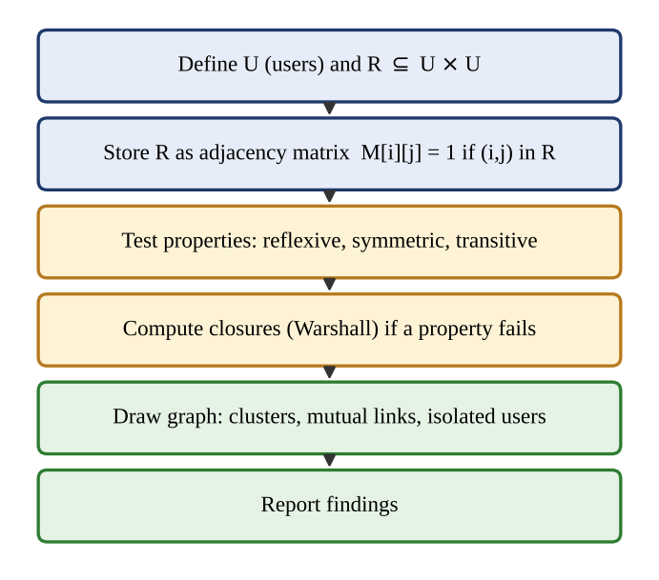
Fig. 1. Procedure for analysing a relation: define, store, test, close, draw and report.

2.3 Equivalence Relations and Partitions
A relation that is reflexive, symmetric and transitive is called an equivalence relation. Its main property is that it splits the set into disjoint equivalence classes: the class of a is [a] = {x : a R x}, two classes are either equal or disjoint, and together the classes cover U [1], [3]. Conversely, every partition of U defines an equivalence relation (“lie in the same block”). Equivalence relations on an n-element set therefore correspond one-to-one with its partitions, and their number is the Bell number B(n): B(2) = 2, B(3) = 5, B(4) = 15 and B(5) = 52.
In a social network the relation “belongs to the same cluster as” is an equivalence relation, whereas “is a friend of” normally is not. Section 2.5 shows how closures turn the second into the first, and Chapter 3 proves that the classes obtained are exactly the connected clusters of the network. The values B(2), B(3) and B(4) also appear as results of the exhaustive test of Section 5.4.

2.4 Matrix and Digraph Representation
A relation on U = {u₁, …, u_{n}} is stored as an n × n Boolean matrix M with M[i][j] = 1 exactly when (u_{i}, u_{j}) ∈ R. The properties then have simple matrix tests: R is reflexive when the diagonal consists of ones, irreflexive when it consists of zeros, symmetric when M equals its transpose, and transitive when the Boolean product M∘M has no 1 where M has a 0. The Boolean product is
(M∘M)[i][j] = ⋁_{k} ( M[i][k] ∧ M[k][j] ) (1)
The same relation can be drawn as a directed graph (digraph) whose vertices are the users and which has an arrow from a to b whenever (a, b) ∈ R. For a symmetric relation the two opposite arrows of every pair are merged into one undirected edge, and if the relation is also irreflexive the result is a simple undirected graph without loops, the usual picture of a friendship network [5], [7]. Fig. 2 shows the matrices of the two datasets used in this report: the left matrix is symmetric about its diagonal and has an all-zero diagonal, the right matrix is not symmetric.
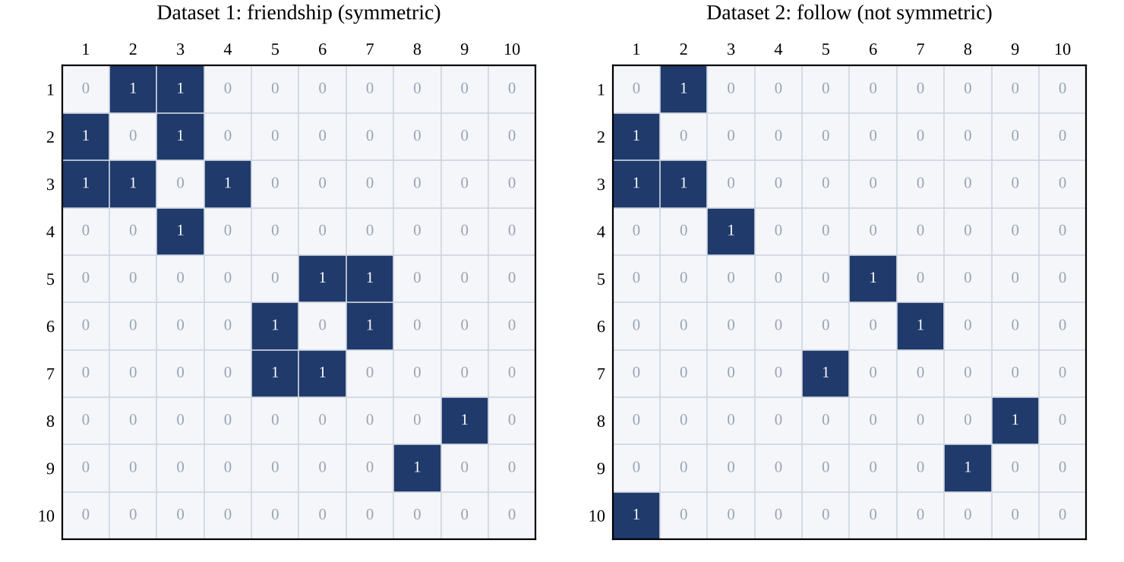
Fig. 2. Adjacency matrices of the friendship relation (left, symmetric) and the follow relation (right, not symmetric) for ten users.

2.5 Closures of Relations
If a relation lacks a property, one can ask for the smallest relation that contains it and has the property. This relation is the closure of R with respect to that property [1]. Three closures are basic. The reflexive closure is r(R) = R ∪ Δ, where Δ = {(a, a) : a ∈ U}; it adds at most n pairs. The symmetric closure is s(R) = R ∪ R⁻¹; in a follow network it adds the missing “follow-back” pairs. The transitive closure t(R) contains (a, b) whenever there is a path of one or more arrows from a to b:
t(R) = R ∪ R² ∪ R³ ∪ … ∪ R^{n} (2)
The transitive closure is computed efficiently by Warshall’s algorithm [8]. It examines the users one by one as possible “intermediate” users and, for k = 1, …, n, updates every entry by
M[i][j] ← M[i][j] ∨ ( M[i][k] ∧ M[k][j] ) (3)
After step k, entry (i, j) is 1 exactly when there is a path from u_{i} to u_{j} whose intermediate users all lie among u₁, …, u_{k}. Finally, the equivalence closure combines the three:
e(R) = t( s( r(R) ) ) (4)
Fig. 3 shows the effect of the transitive closure on one cluster of the friendship network used in this report: the dashed edges are friendships that are implied by “friend of a friend” but are not present in the data.
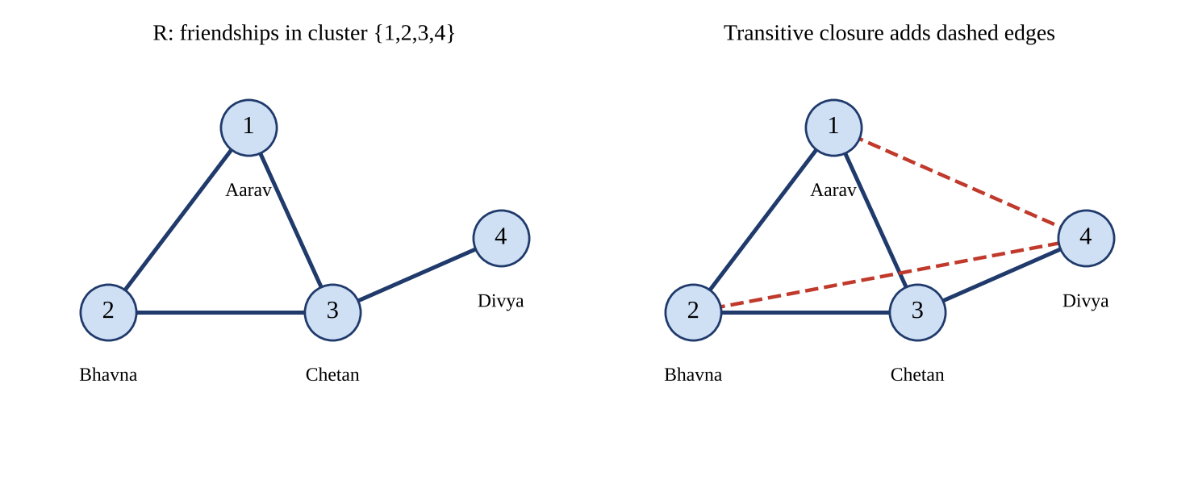
Fig. 3. Transitive closure of the cluster {Aarav, Bhavna, Chetan, Divya} (self-pairs not drawn): the dashed edges Aarav–Divya and Bhavna–Divya are added.

2.6 Graph Concepts for Social Networks
Social network analysis uses the vocabulary of graph theory [5]–[7]. A vertex is a user and an edge (or arrow) is a connection. The degree of a user in an undirected graph is the number of friends; in a directed graph the out-degree counts the users followed and the in-degree counts the followers. A path is a sequence of users in which consecutive users are connected. A connected component, called a cluster in this report, is a maximal set of users any two of whom are joined by a path when the direction of arrows is ignored. A user without any connection to another user is isolated. Table I links the properties of Section 2.2 to the picture of the graph.
TABLE I
RELATION PROPERTIES AND THEIR MEANING IN THE FRIENDSHIP GRAPH
Property | Matrix test | Picture in the graph | Meaning in a social network
Reflexive | Diagonal all 1 | Every user has a loop | Everybody is their own friend
Irreflexive | Diagonal all 0 | No loops | Nobody is their own friend
Symmetric | M equals its transpose | Every arrow has a reverse arrow | All connections are mutual
Antisymmetric | No two-way pair off the diagonal | No pair of opposite arrows | Nobody follows back
Transitive | M∘M has no 1 where M has 0 | Every two-step path has a shortcut | A friend of a friend is a friend

2.7 Friendship as a Relation
Two models are in common use. In the friendship model (undirected), a connection exists only after both users agree; the relation is symmetric and irreflexive. In the follow model (directed), a user may follow another without any reply; the relation is irreflexive but in general neither symmetric nor antisymmetric. Many platforms combine both by treating a pair of mutual follows as a friendship.
For a friendship relation the question “is it transitive?” has a definite and perhaps surprising answer. If Aarav is a friend of Bhavna, then by symmetry Bhavna is a friend of Aarav, and strict transitivity would require Aarav to be a friend of Aarav, which the irreflexive relation forbids. Hence a friendship relation with at least one friendship is never transitive in the strict sense (Theorem 1 in Section 3.2). What people really mean by “a friend of my friend is my friend” is the weaker statement that two different users with a common friend are themselves friends. This report calls this property friend-transitivity and proves in Theorem 2 that it holds exactly when every cluster is a group in which everybody is friends with everybody else.
Real networks are only partly friend-transitive. Granovetter observed that if two people are strongly tied to a third, they are likely to be at least weakly tied to each other [9], and the fraction of such closed triangles is measured by the clustering coefficient [7], [11]. The relation-based view of this report is the idealised, all-or-nothing counterpart of that measurement.

2.8 Social Network Analysis Concepts
- Mutual connection. A pair of users (a, b) with both (a, b) and (b, a) in R. In an undirected friendship network every connection is mutual; in a follow network mutual pairs are the “friends”.
- Cluster. A connected component of the graph. The clusters are the equivalence classes of e(R) (Theorem 3).
- Isolated user. A user with no connection to any other user, i.e. both in-degree and out-degree are zero (loops are ignored).
- Density. The ratio of the number of friendships to the largest possible number, n(n − 1)/2 for an undirected network. A value near 0 means a sparse network.
- Mutually reachable group. In a directed network, a set of users each of whom can reach the others by following arrows. It is stricter than a cluster, which ignores direction.
- Friend suggestion. A pair (a, c) that belongs to R∘R but not to R, with a ≠ c: the two users share a friend but are not yet connected.

2.9 Historical Development
The mathematics of relations and graphs is older than social media by centuries. Leonhard Euler’s solution of the Königsberg bridge problem in 1736 is regarded as the first result of graph theory, and the word “graph” in its modern sense was introduced by J. J. Sylvester in 1878. In the nineteenth century Augustus De Morgan and C. S. Peirce developed the logic of relations, which Alfred Tarski later systematised as the calculus of relations. Closures and the algorithmic treatment of relations became important with computers: Stephen Warshall published his algorithm for the transitive closure of a Boolean matrix in 1962 [8], and it is closely related to Floyd’s shortest-path algorithm [4].
The study of social structure with graphs began with Jacob Moreno, who drew “sociograms” of friendships among schoolchildren in 1934 [12]. Stanley Milgram’s small-world experiment in 1967 suggested that two people are linked by a short chain of acquaintances [10]. Mark Granovetter’s “The Strength of Weak Ties” appeared in 1973 [9], and Watts and Strogatz explained the combination of short paths and high clustering in 1998 [11]. With the growth of online social networks, relations and graphs became the standard data model for friendship, following and recommendation [6], [7].

2.10 Applications

2.10.1 Friend Suggestion
The composition R∘R lists pairs of users with a common friend. Removing the pairs that are already connected leaves the suggestions “people you may know”. For the friendship network of this report the two suggestions are Aarav–Divya and Bhavna–Divya, both through Chetan. Ranking by the number of common friends refines the list.

2.10.2 Community Detection
The clusters of a network are its connected components, found by a depth-first search. They are the first step of community detection; finer methods that split a large component into tightly knit groups, such as modularity maximisation, build on this decomposition [7].

2.10.3 Information and Disease Spread
The transitive closure tells who can eventually be reached by a message, a rumour or an infection that travels along connections. A cluster bounds the spread, and an isolated user is unaffected. The same model is used in the analysis of epidemics on contact networks [7].

2.10.4 Privacy and Access Control
Visibility settings such as “friends only” and “friends of friends” are set operations on relations: the audience of a post is the set {b : (a, b) ∈ R} in the first case and the set {b : (a, b) ∈ R ∪ R∘R} in the second.

2.10.5 Databases and the Web
A follow network is stored as a table of pairs, and “who can reach whom” is a transitive-closure query, which relational databases answer with recursive queries. The same closure computation underlies reachability analysis of the web graph.

2.10.6 Program Verification and Teaching
Property tests with a printed witness make the abstract definitions concrete, which is why relations on a small set of friends are a favourite classroom example [1], [2]. Exhaustive testing on all relations over a few elements, as done in Section 5.4, also gives a strong check of the code.

Chapter 3 System Design

3.1 Overall Design
The software component of the project is a small C++ console program. It asks for a dataset, builds the relation R as an adjacency matrix and then runs three groups of operations: tests of the properties, computation of the closures, and the network analysis that finds clusters, degrees, mutual connections, isolated users and friend suggestions. Everything is printed as a console report. The design is deliberately simple so that attention stays on the mathematics: each operation is one function with the matrix as argument, and the main function only orchestrates input, calls and printing. Fig. 4 shows the structure.
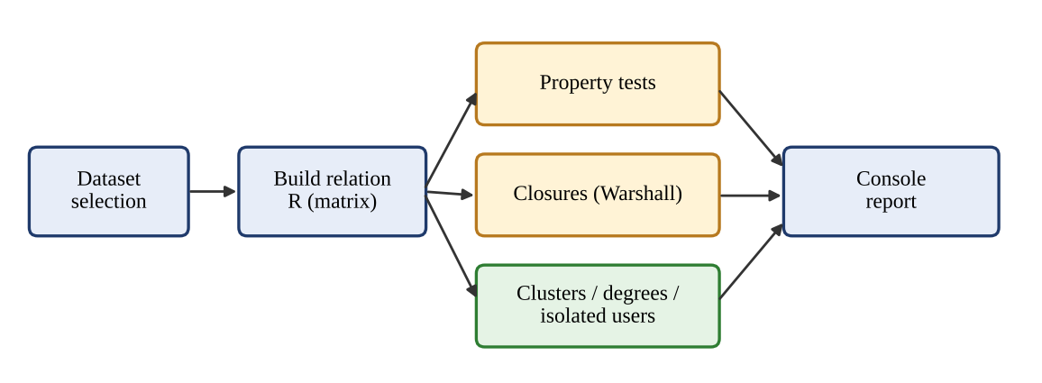
Fig. 4. Block diagram of the friendship-network analysis program.

3.2 Mathematical Model and Theorems
Let U = {u₁, …, u₁₀} be the set of users and R ⊆ U × U the connection relation. For the friendship model R is symmetric and irreflexive. A relation is called friend-transitive if a R b, b R c and a ≠ c together imply a R c. Three theorems describe the behaviour of such relations.
Theorem 1. A non-empty relation that is symmetric and irreflexive is not transitive.
Proof. Let (a, b) ∈ R. By symmetry (b, a) ∈ R. If R were transitive, (a, b) and (b, a) would give (a, a) ∈ R, contradicting irreflexivity. ∎
Theorem 2. Let R be a symmetric and irreflexive relation. Then R is friend-transitive if and only if every connected component of its graph is complete, that is, any two users in the same cluster are friends.
Proof. (⇐) Suppose every component is complete and a R b, b R c with a ≠ c. Then a, b, c are in one component, so a R c. (⇒) Suppose R is friend-transitive and let x and y be two different users of one component. Take a shortest path x = p₀, p₁, …, p_{m} = y. If m ≥ 2, the users p₀ and p₂ are different (a shortest path repeats no vertex) and p₀ R p₁, p₁ R p₂, so friend-transitivity gives p₀ R p₂, a shorter path, which is impossible. Hence m = 1, that is, x R y. ∎
As a corollary, the friend-transitive friendship relations on n users correspond to the partitions of the user set into groups (each group becomes a complete cluster), so their number is the Bell number B(n). The exhaustive test of Chapter 5 confirms 2, 5 and 15 such relations for n = 2, 3, 4.
Theorem 3. For any relation R on U, the equivalence closure e(R) = t(s(r(R))) is an equivalence relation, and its equivalence classes are exactly the clusters (connected components) of R.
Proof. The relation s(r(R)) is reflexive and symmetric. Taking the transitive closure keeps every pair that was already present, so reflexivity survives, and it keeps symmetry, because reversing a path from a to b gives a path from b to a. Hence e(R) is reflexive, symmetric and transitive. Finally, (a, b) ∈ e(R) if and only if a = b or there is a path from a to b in the graph with all arrows treated as undirected edges, which means that a and b lie in the same connected component. ∎
If the clusters have sizes s₁, …, s_{c}, Theorem 3 gives the size of the equivalence closure directly:
| e(R) | = s₁² + s₂² + … + s_{c}² (5)
For the friendship dataset the clusters have sizes 4, 3, 2 and 1, so |e(R)| = 16 + 9 + 4 + 1 = 30, which is the value printed by the program in Section 5.1.

3.3 Algorithm 1: Property Testing
Each property is tested by one pass over the matrix, stopping at the first witness. The reflexive test inspects the n diagonal entries and takes O(n) time. The symmetric and antisymmetric tests inspect pairs (i, j) and take O(n²). The transitivity test examines every pair of arrows (i, j), (j, k) and takes O(n³). The program counts all violating triples, but reports as its example the first violation with i ≠ k, because a violation with i = k merely repeats the failure of reflexivity.
Algorithm TEST-PROPERTIES(M, n)
1. reflexive <- (M[i][i] = 1 for all i) // O(n)
2. symmetric <- (M[i][j] = 1 implies M[j][i] = 1) // O(n^2)
3. antisym <- (no i < j with M[i][j] = M[j][i] = 1) // O(n^2)
4. for all i, j, k: if M[i][j] = 1 and M[j][k] = 1 and
M[i][k] = 0 then count a violation // O(n^3)
5. transitive <- (violations = 0)
6. equivalence <- reflexive and symmetric and transitive

3.4 Algorithm 2: Closures (Warshall)
The reflexive and symmetric closures need one pass over the matrix. The transitive closure uses Warshall’s algorithm of Equation (3). Its correctness is proved by induction on k, in the same way as the theorems above: let T_{k} be the matrix after iteration k. Basis: T₀ = M records the paths without intermediate users, that is, the arrows. Step: assume T_{k−1}[i][j] = 1 exactly when there is a path from i to j with intermediate users among 1, …, k−1. A path whose intermediate users lie among 1, …, k either avoids user k (and is already recorded) or passes through k once and splits into a path from i to k and a path from k to j, both with intermediates among 1, …, k−1. The update of Equation (3) therefore records exactly the paths of the next level. After iteration n all paths are recorded. The three nested loops give O(n³) time and O(n²) space for the matrix copy.
Algorithm WARSHALL(M, n)
1. T <- copy of M
2. for k <- 1 to n do
3. for i <- 1 to n do
4. for j <- 1 to n do
5. if T[i][k] = 1 and T[k][j] = 1 then T[i][j] <- 1
6. return T

EQUIVALENCE-CLOSURE(M) = WARSHALL( symmetric( reflexive(M) ) )

3.5 Algorithm 3: Clusters, Isolated Users and Suggestions
Clusters are found on the symmetric closure of R by depth-first search. Starting from an unlabelled user, the search labels every user it can reach with the same cluster number, and the number is increased for the next unlabelled user. By Theorem 3 the labelled sets are exactly the equivalence classes of e(R). With an adjacency matrix the search costs O(n²). The degrees and the number of mutual connections are counted in one further pass, a user whose in-degree and out-degree are both zero is isolated, and the suggestions are the entries of R∘R that are not in R. Mutually reachable groups are obtained from the transitive closure: users i and j are in one group when T[i][j] = T[j][i] = 1.
Algorithm CLUSTERS(M, n)
1. S <- symmetric closure of M ; comp[1..n] <- -1 ; count <- 0
2. for i <- 1 to n do
3. if comp[i] = -1 then DFS(i, count) ; count <- count + 1
4. return comp, count

DFS(u, id): comp[u] <- id
for each v with S[u][v] = 1 and comp[v] = -1 do DFS(v, id)

3.6 Complexity Comparison
TABLE II
TIME AND SPACE OF THE MAIN OPERATIONS FOR N USERS
Operation | Time | Extra space | Main advantage | Main limitation
Reflexive test | O(n) | O(1) | Fastest; reads the diagonal only | Says nothing about other pairs
Symmetric / antisymmetric test | O(n²) | O(1) | Simple; stops at first witness | Quadratic matrix scan
Transitivity test | O(n³) | O(1) | Gives a witness triple and a count | Cubic; slow for large n
Clusters (DFS) | O(n²) | O(n) | Finds all clusters and isolated users | O(n + m) only with adjacency lists
Warshall closure; R∘R | O(n³) | O(n²) | Exact closure in three loops | Cubic time, matrix memory

3.7 Data Representation and Limits
The relation is stored as vector<vector<int> > of size n × n, here 10 × 10 with the user names in a constant array. An adjacency matrix needs n² entries: 100 for this project, 160 000 for the 400-user benchmark (160 kB with one byte per entry), and about 9 × 10¹⁸ for a platform with three billion users. Large networks must therefore use adjacency lists, which need memory proportional to the number of connections, and cannot use cubic algorithms such as Warshall’s. The count of possible relations, 2^{n²}, also limits exhaustive testing: it is 66 064 relations in total for n = 2, 3, 4, but already 33 554 432 for n = 5 and about 1.27 × 10³⁰ for ten users, which is why the ten-user datasets are checked with theorems and selected cases rather than by enumeration.

3.8 Test Plan
The test plan combines special relations whose answers are known from theory, the two datasets of the project and an exhaustive test. The expected results of Table III follow from the definitions and Theorems 1–3. In addition, all relations on n = 2, 3 and 4 users (66 064 in all) were generated and every one was checked by the program’s routines against independent definitions.
TABLE III
TEST CASES AND EXPECTED RESULTS
Test | Relation R on 10 users | |R| | Reflexive | Symmetric | Transitive | Clusters | Isolated
T1 | Empty relation | 0 | No | Yes | Yes | 10 | 10
T2 | One friendship (Aarav–Bhavna) | 2 | No | Yes | No | 9 | 8
T3 | Identity: everyone related only to self | 10 | Yes | Yes | Yes | 10 | 10
T4 | Everyone friends with everyone else | 90 | No | Yes | No | 1 | 0
T5 | Dataset 1 (friendship network) | 16 | No | Yes | No | 4 | 1
T6 | Dataset 2 (follow network) | 11 | No | No | No | 3 | 0
T7 | Chain of 10 users u₁–u₂–…–u₁₀ | 18 | No | Yes | No | 1 | 0
T8 | Complete relation U × U | 100 | Yes | Yes | Yes | 1 | 0

Chapter 4 Implementation Details

4.1 Development Environment
TABLE IV
DEVELOPMENT AND TEST ENVIRONMENT
Item | Details
Programming language | C++ (ISO C++ standard [14]; default dialect of the compiler)
Compiler | GNU g++ 13.3.0
Operating system | Ubuntu 24.04 Linux (x86-64)
Optimisation level | -O0 (no optimisation) so that loops are not removed
Data structure | vector<vector<int>> adjacency matrix (10 × 10); vector<vector<char>> in the benchmark
Libraries | iostream, vector, string, iomanip, chrono (benchmark only)
Figures | Python 3 with matplotlib and networkx (graphs, matrices, charts)
Version control | Git / GitHub (see Annexure 1)

4.2 Main Program
Listing 1 gives the complete program. It contains the property tests, the three closures, the composition and the depth-first search of Chapter 3, and a main function that selects the dataset, builds the relation and prints the four sections of the report.
Listing 1. friendnet.cpp — properties, closures and clusters of a friendship relation
#include <iostream>
#include <vector>
#include <string>
#include <iomanip>
using namespace std;

const int N = 10;
const string U[N] = {"Aarav", "Bhavna", "Chetan", "Divya", "Esha",
"Farhan", "Gauri", "Harsh", "Ishaan", "Jiya"};
typedef vector<vector<int> > Matrix;

Matrix emptyRel() { return Matrix(N, vector<int>(N, 0)); }

Matrix build(const vector<pair<int, int> >& p, bool mutual) {
Matrix M = emptyRel();
for (size_t i = 0; i < p.size(); i++) {
M[p[i].first - 1][p[i].second - 1] = 1;
if (mutual) M[p[i].second - 1][p[i].first - 1] = 1;
}
return M;
}

int countPairs(const Matrix& M) {
int c = 0;
for (int i = 0; i < N; i++) for (int j = 0; j < N; j++) c += M[i][j];
return c;
}

// ---------- property tests ----------
bool isReflexive(const Matrix& M, int& w) {
for (int i = 0; i < N; i++) if (!M[i][i]) { w = i; return false; }
return true;
}
bool isIrreflexive(const Matrix& M, int& w) {
for (int i = 0; i < N; i++) if (M[i][i]) { w = i; return false; }
return true;
}
bool isSymmetric(const Matrix& M, int& a, int& b) {
for (int i = 0; i < N; i++) for (int j = 0; j < N; j++)
if (M[i][j] && !M[j][i]) { a = i; b = j; return false; }
return true;
}
bool isAntisymmetric(const Matrix& M, int& a, int& b) {
for (int i = 0; i < N; i++) for (int j = i + 1; j < N; j++)
if (M[i][j] && M[j][i]) { a = i; b = j; return false; }
return true;
}
// counts violations of transitivity; stores the first one with distinct ends
bool isTransitive(const Matrix& M, int& a, int& b, int& c, int& total) {
total = 0; a = b = c = -1;
for (int i = 0; i < N; i++) for (int j = 0; j < N; j++) {
if (!M[i][j]) continue;
for (int k = 0; k < N; k++)
if (M[j][k] && !M[i][k]) {
total++;
if (a < 0 && i != k) { a = i; b = j; c = k; }
}
}
return total == 0;
}

// ---------- closures ----------
Matrix reflexiveClosure(Matrix M) { for (int i = 0; i < N; i++) M[i][i] = 1; return M; }
Matrix symmetricClosure(Matrix M) {
for (int i = 0; i < N; i++) for (int j = 0; j < N; j++) if (M[i][j]) M[j][i] = 1;
return M;
}
Matrix transitiveClosure(Matrix M) { // Warshall's algorithm
for (int k = 0; k < N; k++)
for (int i = 0; i < N; i++)
for (int j = 0; j < N; j++)
if (M[i][k] && M[k][j]) M[i][j] = 1;
return M;
}
Matrix compose(const Matrix& A, const Matrix& B) {
Matrix C = emptyRel();
for (int i = 0; i < N; i++) for (int k = 0; k < N; k++) if (A[i][k])
for (int j = 0; j < N; j++) if (B[k][j]) C[i][j] = 1;
return C;
}

// ---------- graph analysis ----------
void dfs(const Matrix& S, int u, vector<int>& comp, int id) {
comp[u] = id;
for (int v = 0; v < N; v++) if (S[u][v] && comp[v] < 0) dfs(S, v, comp, id);
}
vector<int> components(const Matrix& M, int& count) {
Matrix S = symmetricClosure(M);
vector<int> comp(N, -1);
count = 0;
for (int i = 0; i < N; i++) if (comp[i] < 0) dfs(S, i, comp, count++);
return comp;
}

void printMatrix(const Matrix& M) {
cout << " ";
for (int j = 0; j < N; j++) cout << setw(3) << j + 1;
cout << endl;
for (int i = 0; i < N; i++) {
cout << setw(2) << i + 1 << " | ";
for (int j = 0; j < N; j++) cout << setw(3) << M[i][j];
cout << endl;
}
}
void printGroups(const vector<int>& comp, int count) {
for (int g = 0; g < count; g++) {
cout << " {";
bool first = true;
for (int i = 0; i < N; i++) if (comp[i] == g) {
cout << (first ? "" : ", ") << U[i]; first = false;
}
cout << "}" << endl;
}
}
string yn(bool b) { return b ? "Yes" : "No"; }
void sizeLine(const string& name, const Matrix& M, int base) {
cout << left << setw(30) << name << right << "= " << countPairs(M)
<< " (+" << countPairs(M) - base << ")" << endl;
}

int main() {
int ds;
cout << "Enter dataset (1 = Friendship, 2 = Follow): ";
cin >> ds;

vector<pair<int, int> > p;
bool mutual = (ds == 1);
if (ds == 1) {
int e[8][2] = {{1,2},{1,3},{2,3},{3,4},{5,6},{6,7},{5,7},{8,9}};
for (int i = 0; i < 8; i++) p.push_back(make_pair(e[i][0], e[i][1]));
} else {
int e[11][2] = {{1,2},{2,1},{3,1},{3,2},{4,3},{5,6},{6,7},{7,5},{8,9},{9,8},{10,1}};
for (int i = 0; i < 11; i++) p.push_back(make_pair(e[i][0], e[i][1]));
}
Matrix R = build(p, mutual);

cout << "\n== 1. Relation R on U ==" << endl;
for (int i = 0; i < N; i++) cout << setw(3) << i + 1 << " = " << U[i] << endl;
cout << "|U| = " << N << ", |R| = " << countPairs(R) << " ordered pairs" << endl;
printMatrix(R);

cout << "\n== 2. Properties of R ==" << endl;
int a = -1, b = -1, c = -1, tot = 0;
bool refl = isReflexive(R, a);
cout << "Reflexive : " << yn(refl);
if (!refl) cout << " (" << U[a] << ", " << U[a] << ") not in R";
cout << endl;
bool irr = isIrreflexive(R, a);
cout << "Irreflexive : " << yn(irr) << endl;
bool sym = isSymmetric(R, a, b);
cout << "Symmetric : " << yn(sym);
if (!sym) cout << " (" << U[a] << ", " << U[b] << ") in R but ("
<< U[b] << ", " << U[a] << ") not";
cout << endl;
bool asym = isAntisymmetric(R, a, b);
cout << "Antisymmetric : " << yn(asym);
if (!asym) cout << " " << U[a] << " <-> " << U[b] << " both in R";
cout << endl;
bool tr = isTransitive(R, a, b, c, tot);
cout << "Transitive : " << yn(tr);
if (!tr) {
cout << " (" << U[a] << "," << U[b] << "),(" << U[b] << "," << U[c]
<< ") in R but (" << U[a] << "," << U[c] << ") not";
cout << "\n " << tot << " violating triples in all";
}
cout << endl;
bool eq = refl && sym && tr;
cout << "Equivalence : " << yn(eq) << endl;

cout << "\n== 3. Closures ==" << endl;
Matrix Rr = reflexiveClosure(R), Rs = symmetricClosure(R), Rt = transitiveClosure(R);
Matrix Re = transitiveClosure(symmetricClosure(reflexiveClosure(R)));
cout << "|R| = " << countPairs(R) << endl;
int base = countPairs(R);
sizeLine("|reflexive closure|", Rr, base);
sizeLine("|symmetric closure|", Rs, base);
sizeLine("|transitive closure|", Rt, base);
sizeLine("|equivalence closure|", Re, base);
int w1, w2, w3, t2;
bool okEq = isReflexive(Re, w1) && isSymmetric(Re, w1, w2)
&& isTransitive(Re, w1, w2, w3, t2);
cout << "Equivalence closure is reflexive, symmetric, transitive: "
<< yn(okEq) << endl;

cout << "\n== 4. Network analysis ==" << endl;
int k;
vector<int> comp = components(R, k);
cout << "Clusters (connected groups): " << k << endl;
printGroups(comp, k);
cout << "Degrees:" << endl;
cout << " User Out In Mutual" << endl;
int mutualPairs = 0;
vector<int> iso;
for (int i = 0; i < N; i++) {
int out = 0, in = 0, mu = 0;
for (int j = 0; j < N; j++) if (j != i) {
out += R[i][j]; in += R[j][i];
if (R[i][j] && R[j][i]) mu++;
}
mutualPairs += mu;
if (out == 0 && in == 0) iso.push_back(i);
cout << " " << left << setw(9) << U[i] << right << setw(3) << out
<< setw(4) << in << setw(7) << mu << endl;
}
cout << "Mutual connections (unordered pairs): " << mutualPairs / 2 << endl;
cout << "Isolated users: ";
if (iso.empty()) cout << "none";
for (size_t i = 0; i < iso.size(); i++) cout << (i ? ", " : "") << U[iso[i]];
cout << endl;

// strongly connected groups: a ~ b when each can reach the other
vector<int> sc(N, -1);
int scn = 0;
for (int i = 0; i < N; i++) if (sc[i] < 0) {
sc[i] = scn;
for (int j = i + 1; j < N; j++) if (sc[j] < 0 && Rt[i][j] && Rt[j][i]) sc[j] = scn;
scn++;
}
cout << "Mutually reachable groups: " << scn << endl;
printGroups(sc, scn);

Matrix R2 = compose(R, R);
cout << "Suggestions (R o R, not in R, distinct users):" << endl;
int sug = 0;
for (int i = 0; i < N; i++) for (int j = 0; j < N; j++)
if (i != j && R2[i][j] && !R[i][j] && (!mutual || i < j)) {
cout << " " << U[i] << (mutual ? " - " : " -> ") << U[j] << endl; sug++;
}
if (!sug) cout << " none" << endl;
return 0;
}

4.3 Explanation of the Code
- Data. U[] holds the ten user names and Matrix is a 10 × 10 table of integers. build() turns a list of user-number pairs into the matrix; with mutual = true every pair is stored in both directions, which models a friendship.
- isReflexive, isIrreflexive, isSymmetric, isAntisymmetric. Direct translations of the definitions of Section 2.2. Each returns false at the first counter-example and passes it back through its reference arguments, so that the program can print a witness.
- isTransitive. Three nested loops over (i, j, k). It counts all triples with i R j, j R k and not i R k and remembers the first one with i ≠ k.
- reflexiveClosure, symmetricClosure, transitiveClosure. Implement r(R), s(R) and Warshall’s algorithm of Equation (3). The equivalence closure in main is their composition, Equation (4).
- compose. Computes R∘R, used for friend suggestions.
- dfs, components. Label the clusters on the symmetric closure of R, as in Algorithm CLUSTERS.
- main. Reads the dataset number, builds R and prints (1) the relation and its matrix, (2) the properties with witnesses, (3) the sizes of the closures, and (4) clusters, degrees, mutual connections, isolated users, mutually reachable groups and suggestions. The last line of section 3 re-tests that the equivalence closure really is reflexive, symmetric and transitive, which is an automatic self-check of Theorem 3.

4.4 Benchmark Program
To compare running times, a second program generates a random relation with a density of about 10 % (fixed seed 42) for n = 25, 50, 100, 200 and 400, and reports the mean time per call of five routines in milliseconds, using the high-resolution clock of the C++ chrono library. Each routine returns a checksum that is accumulated into a variable, so that its result is really used. The reflexive test is repeated 2000 times because it is extremely fast; the other routines are repeated 20 times for n ≤ 100 and 3 times for larger n. Listing 2 shows the timing routine and two of the measured functions.
Listing 2. bench.cpp — timing of the routines (excerpt)
template<class F> double timeIt(F f, int reps, long long &out) {
long long s = 0;
auto a = chrono::high_resolution_clock::now();
for (int r = 0; r < reps; r++) s += f();
auto b = chrono::high_resolution_clock::now();
out = s;
return chrono::duration<double, milli>(b - a).count() / reps;
}

// transitivity test: counts violating triples
double t3 = timeIt([&]() { long long c = 0;
for (int i = 0; i < n; i++) for (int j = 0; j < n; j++)
if (R[i][j]) for (int k = 0; k < n; k++)
if (R[j][k] && !R[i][k]) c++;
return c; }, reps, o);

// Warshall closure on a copy of R
double t4 = timeIt([&]() { M T = R;
for (int k = 0; k < n; k++) for (int i = 0; i < n; i++)
if (T[i][k]) for (int j = 0; j < n; j++)
if (T[k][j]) T[i][j] = 1;
long long c = 0; for (int i = 0; i < n; i++) c += T[i][i];
return c; }, reps, o);

4.5 Implementation Notes
- The program is compiled with g++ -O0 -o friendnet friendnet.cpp and run as ./friendnet; the dataset number 1 (friendship) or 2 (follow) is typed when asked. Optimisation was disabled for the benchmark because an optimising compiler may remove or restructure the loops being measured.
- Two datasets are built into the program for reproducibility. A production version would read the pairs from a file or database, validate user numbers and reject duplicate or out-of-range pairs.
- Isolated users are determined from in-degree and out-degree excluding loops, so that a user whose only pair is (a, a) is still isolated (test T3).
- An exhaustive test over all 66 064 relations on two, three and four users compared the property tests, Warshall’s closure and Theorem 2 with independent definitions, and reported zero mismatches. The eight cases of Table III were also run individually.
- The source code was uploaded to a GitHub repository by the group (screenshot in Annexure 1), and each member contributed to coding, testing or documentation.

Chapter 5 Result Screenshots and Analysis

5.1 Program Output
The set of users is U = {1 Aarav, 2 Bhavna, 3 Chetan, 4 Divya, 5 Esha, 6 Farhan, 7 Gauri, 8 Harsh, 9 Ishaan, 10 Jiya}. Table V defines the two datasets that were analysed.
TABLE V
DATASETS USED IN THE EXPERIMENTS
Dataset | Pairs in the relation R | |R|
1: Friendship (mutual) | Aarav–Bhavna, Aarav–Chetan, Bhavna–Chetan, Chetan–Divya, Esha–Farhan, Esha–Gauri, Farhan–Gauri, Harsh–Ishaan; each friendship is stored in both directions. Jiya has no friends. | 16
2: Follow (directed) | Aarav ⇄ Bhavna, Chetan → Aarav, Chetan → Bhavna, Divya → Chetan, Esha → Farhan, Farhan → Gauri, Gauri → Esha, Harsh ⇄ Ishaan, Jiya → Aarav | 11

Figures 5 to 11 show the console output of the program. In Figs. 5 to 8 the friendship network (dataset 1) is analysed, and Figs. 9 to 11 show the follow network (dataset 2).
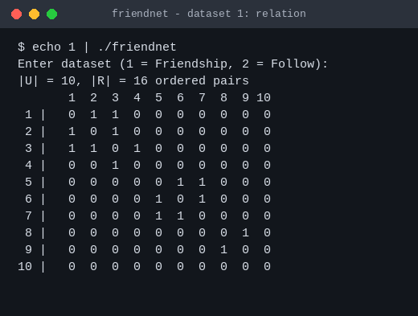
Fig. 5. Dataset 1: the relation R and its adjacency matrix.
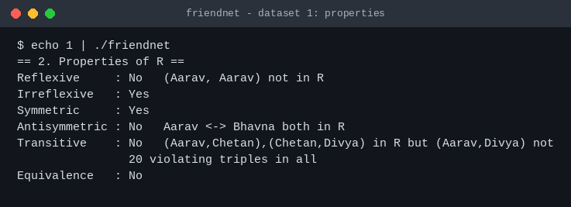
Fig. 6. Dataset 1: properties of R with witnesses.
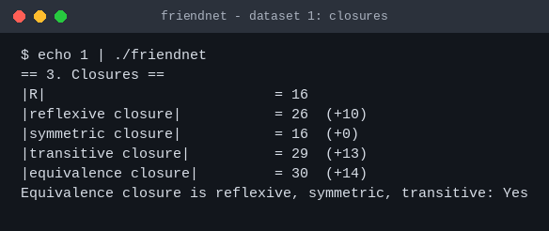
Fig. 7. Dataset 1: sizes of the closures.
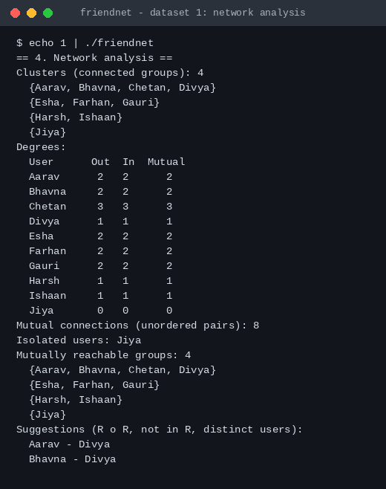
Fig. 8. Dataset 1: clusters, degrees, isolated user and suggestions.
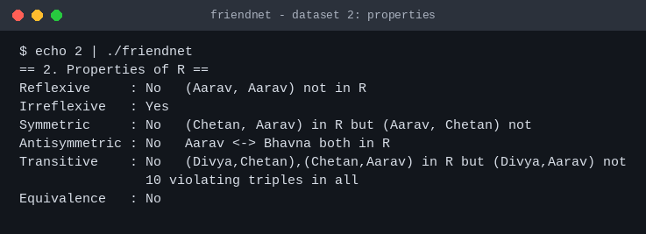
Fig. 9. Dataset 2: properties of R with witnesses.
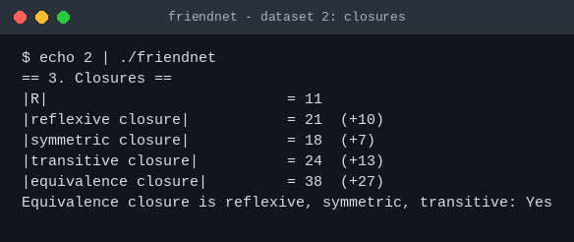
Fig. 10. Dataset 2: sizes of the closures.
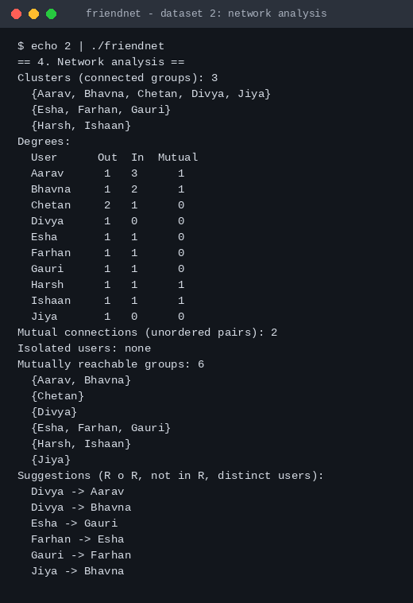
Fig. 11. Dataset 2: clusters, degrees, mutually reachable groups and suggestions.
Table VI compares the two networks. The friendship relation is symmetric and irreflexive but not transitive, exactly as Theorem 1 predicts, and its equivalence closure has 30 pairs, as Equation (5) predicts. The follow relation fails symmetry, and its closures are correspondingly larger.
TABLE VI
SUMMARY OF THE RESULTS FOR THE TWO DATASETS
Quantity | Dataset 1 (friendship) | Dataset 2 (follow)
Pairs in R | 16 | 11
Reflexive / Irreflexive | No / Yes | No / Yes
Symmetric | Yes | No
Antisymmetric | No | No
Transitive (violating triples) | No (20) | No (10)
Equivalence relation | No | No
Reflexive closure (added pairs) | 26 (+10) | 21 (+10)
Symmetric closure (added pairs) | 16 (+0) | 18 (+7)
Transitive closure (added pairs) | 29 (+13) | 24 (+13)
Equivalence closure (added pairs) | 30 (+14) | 38 (+27)
Clusters | 4 (sizes 4, 3, 2, 1) | 3 (sizes 5, 3, 2)
Mutual connections (pairs) | 8 | 2
Isolated users | 1 (Jiya) | 0
Mutually reachable groups | 4 | 6
Friend suggestions from R∘R | 2 | 6

5.2 Network Visualisation
Figs. 12 and 13 draw the two networks as graphs, with one colour for each cluster. In the friendship network (Fig. 12) the four clusters are the group of four users around Chetan, the triangle Esha–Farhan–Gauri, the pair Harsh–Ishaan and the isolated user Jiya. Chetan, with three friends, has the highest degree, and Divya is connected to the rest of the network only through him. The triangle, the pair and the single user are complete clusters and are therefore friend-transitive; the cluster around Chetan is not, because Divya is a friend of Chetan only. In the follow network (Fig. 13) the arrows show that Jiya and Divya follow users of the largest cluster without being followed, whereas the cycle Esha → Farhan → Gauri → Esha and the pair Harsh ⇄ Ishaan are tightly connected groups.
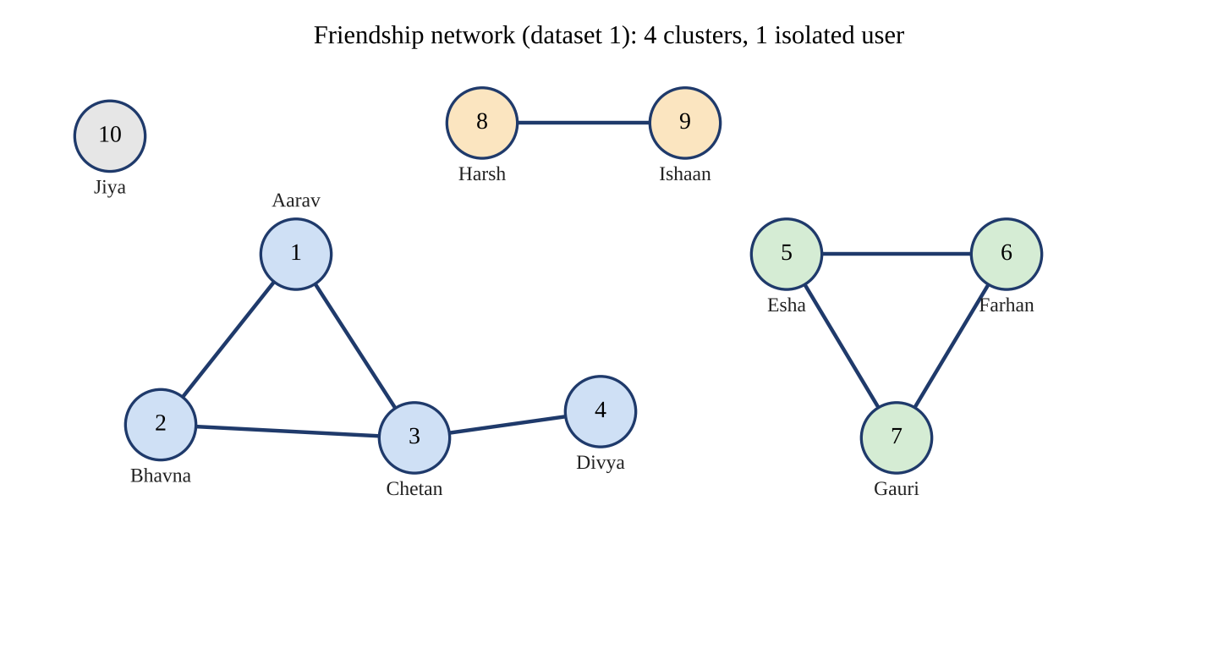
Fig. 12. Friendship network (dataset 1) drawn as an undirected graph; colours mark the clusters.
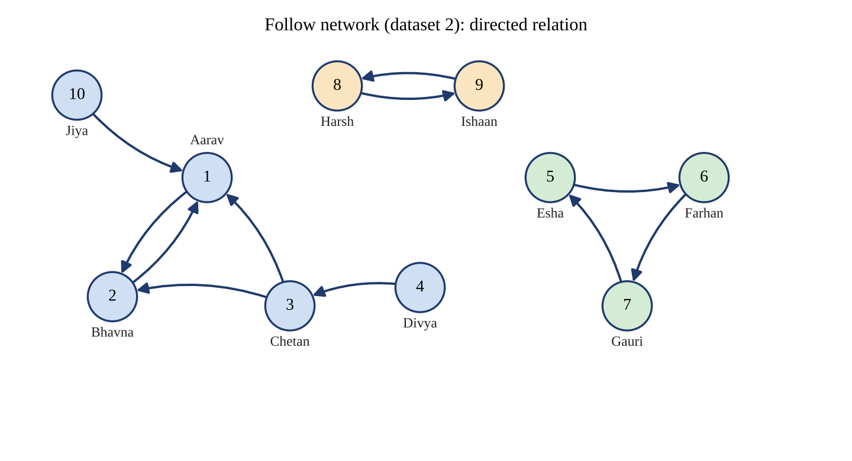
Fig. 13. Follow network (dataset 2) drawn as a directed graph; colours mark the clusters.
Fig. 14 shows the degrees. In the friendship network the degrees are 2, 2, 3, 1, 2, 2, 2, 1, 1, 0 with an average of 1.6 friends per user, and the density is 8/45 ≈ 0.18. In the follow network Aarav has the most followers (three) and Divya and Jiya have none.
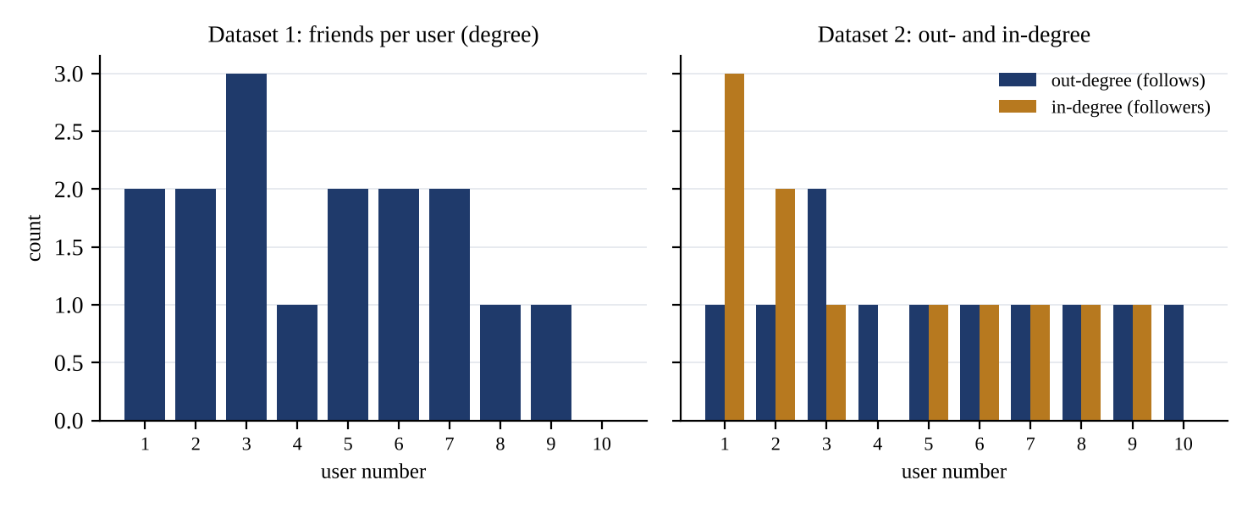
Fig. 14. Degree of each user: friends per user in dataset 1 (left), follows and followers per user in dataset 2 (right).

5.3 Performance Comparison
Table VII and Fig. 15 show the mean time per call of the five routines for random relations of growing size. The reflexive test is far below the others. The symmetric test and the cluster search grow by a factor of about four when n is doubled (for example 0.092 ms for n = 100, 0.385 ms for n = 200 and 1.75 ms for n = 400), which is the quadratic growth O(n²). The transitivity test and Warshall’s closure grow by a factor of about eight when n is doubled (the transitivity test from 4.4 ms to 35.6 ms and the closure from 54 ms to 500 ms between n = 200 and 400), which is the cubic growth O(n³), visible in Fig. 15 as lines of slope three. The closure is about 6 to 14 times slower than the test because it also writes to a copy of the matrix.
TABLE VII
MEAN TIME PER CALL (MILLISECONDS) ON THE TEST MACHINE
n | Reflexive | Symmetric | Clusters (DFS) | Transitive test | Warshall closure | Warshall / test
25 | 0.00012 | 0.00633 | 0.00608 | 0.00941 | 0.061 | 6.5
50 | 0.00018 | 0.023 | 0.022 | 0.078 | 0.541 | 6.9
100 | 0.00035 | 0.092 | 0.089 | 0.593 | 7.65 | 12.9
200 | 0.00059 | 0.385 | 0.386 | 4.41 | 54.00 | 12.2
400 | 0.00191 | 1.75 | 1.55 | 35.62 | 500.4 | 14.0

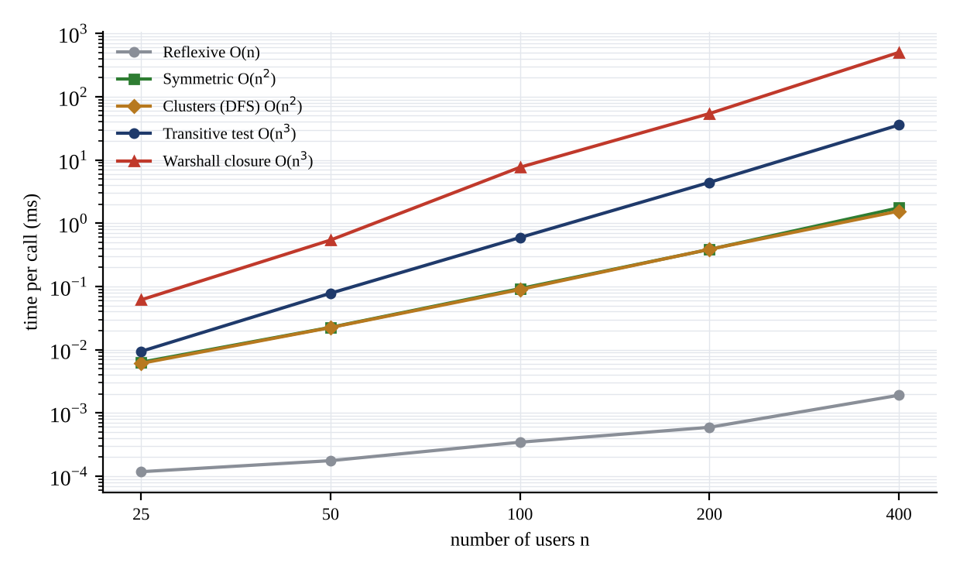
Fig. 15. Running time of the routines versus the number of users (logarithmic axes).
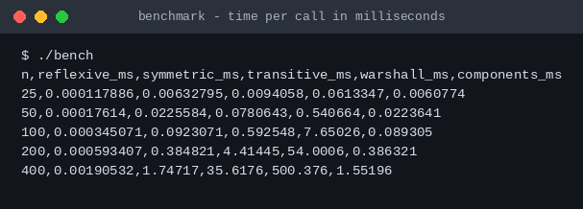
Fig. 16. Output of the benchmark program (time in milliseconds per call).

5.4 Analysis of Results
- Correctness. The property tests, Warshall’s closure and Theorem 2 agreed with independent definitions for all 66 064 relations on two, three and four users (Table VIII), and the eight test cases of Table III gave the expected answers. The equivalence closure of both datasets was confirmed to be reflexive, symmetric and transitive by the program itself.
- Social meaning. The friendship relation is symmetric and irreflexive, and hence never transitive (Theorem 1); it is friend-transitive only inside complete clusters (Theorem 2). Dataset 1 is not friend-transitive, since Aarav–Chetan and Chetan–Divya are friendships while Aarav–Divya is not.
- Structure. Dataset 1 has four clusters (sizes 4, 3, 2, 1), eight mutual connections and one isolated user. Dataset 2 has three clusters, only two mutual pairs and six mutually reachable groups, because most arrows are one-way.
- Efficiency. The quadratic routines are cheap, but the cubic routines already need 36 ms and 0.5 s for 400 users. They are suitable for classroom-size networks, while real networks need adjacency lists and linear-time searches.
- Reliability of counts. The numbers of reflexive (2^{n²−n}) and symmetric (2^{n(n+1)/2}) relations found by enumeration equal the formulas, and the numbers of equivalence relations (2, 5, 15) equal the Bell numbers.

TABLE VIII
EXHAUSTIVE VERIFICATION OVER ALL RELATIONS ON N USERS
n | Relations | Reflexive | Symmetric | Transitive | Equivalence | Friend-transitive friendships | Mismatches
2 | 16 | 4 | 8 | 13 | 2 | 2 | 0
3 | 512 | 64 | 64 | 171 | 5 | 5 | 0
4 | 65 536 | 4 096 | 1 024 | 3 994 | 15 | 15 | 0

5.5 Problem Solutions
The following problems illustrate the concepts of the report.
Problem 1. How many different friendship relations (symmetric and irreflexive) are possible on 10 users? Solution: Every subset of the C(10, 2) = 45 possible pairs defines one, so there are 2⁴⁵ = 35 184 372 088 832 ≈ 3.5 × 10¹³. Dataset 1 uses 8 of the 45 pairs.
Problem 2. How many reflexive and how many symmetric relations exist on 10 users? Solution: A reflexive relation has all 10 diagonal pairs and any subset of the other 90, giving 2⁹⁰ ≈ 1.24 × 10²⁷. A symmetric relation is fixed by its 10 diagonal entries and the 45 pairs above the diagonal, giving 2⁵⁵ ≈ 3.6 × 10¹⁶.
Problem 3. Show that dataset 1 is not transitive. Solution: (Aarav, Chetan) and (Chetan, Divya) are in R but (Aarav, Divya) is not. In all there are 20 violating triples: 16 of the form (a, b, a), one for each ordered pair, which would need (a, a) ∈ R, and 4 with different end points, namely Aarav–Chetan–Divya and Bhavna–Chetan–Divya in both directions.
Problem 4. Find the size of the symmetric closure of dataset 2. Solution: The pairs Aarav ⇄ Bhavna and Harsh ⇄ Ishaan are already mutual (4 pairs). The other 7 pairs lack their reverse, so 7 pairs are added: |s(R)| = 11 + 7 = 18.
Problem 5. Find the size of the equivalence closure of each dataset. Solution: By Equation (5) the size is the sum of the squares of the cluster sizes. Dataset 1: 4² + 3² + 2² + 1² = 30. Dataset 2: 5² + 3² + 2² = 38.
Problem 6. How many friend suggestions arise in a chain of 10 users, where user i is a friend of user i + 1? Solution: The suggestions are the pairs at distance two, (i, i + 2) for i = 1, …, 8, so there are 8 (confirmed by the program, test T7).
Problem 7. How many friendships must be added to dataset 1 to make it friend-transitive? Solution: By Theorem 2 every cluster must be complete. The cluster {Aarav, Bhavna, Chetan, Divya} needs C(4, 2) = 6 friendships and has 4, so 2 must be added (Aarav–Divya and Bhavna–Divya, the two suggestions); the other clusters are already complete.
Problem 8. In dataset 2, can Aarav reach Divya by following users? Solution: No. Divya follows Chetan and Chetan follows Aarav, so Divya reaches Aarav, but nobody follows Divya, so Aarav cannot reach Divya. They are in the same cluster but not in the same mutually reachable group.

5.6 A Cautionary Example
Closures must be used with care. The transitive closure of dataset 1 adds 13 ordered pairs. Nine of them are self-pairs such as (Aarav, Aarav), which hold in every transitive closure of a symmetric relation, but the other four state that Aarav and Divya, and Bhavna and Divya, are friends. These friendships are not in the data. Replacing the relation by its closure would therefore invent connections; the correct use of the closure is to compute who can be reached, and of R∘R to suggest friendships, not to assert them.
A second pitfall is to treat a cluster as a single community in a directed network. In dataset 2 the five users Aarav, Bhavna, Chetan, Divya and Jiya form one cluster, but only Aarav and Bhavna can reach one another; Chetan, Divya and Jiya each form a mutually reachable group of one. The 3 clusters and the 6 mutually reachable groups of Table VI measure different things, and which one is appropriate depends on whether direction matters for the question asked.

Chapter 6 Conclusion

6.1 Conclusion
This project showed how a relation R ⊆ U × U represents friendships in a social network and how the properties and closures of the relation answer questions about the network. It was proved that a friendship relation, being symmetric and irreflexive, can never be transitive in the strict sense (Theorem 1); that the practical property “a friend of a friend is a friend” holds exactly when every cluster is a complete group (Theorem 2); and that the equivalence closure of any relation has the connected clusters as its classes (Theorem 3).
The analysis was implemented in C++. For a friendship network of ten users the program found four clusters, eight mutual friendships and one isolated user, together with two friend suggestions, and for a follow network it found three clusters, two mutual pairs and six mutually reachable groups. The program’s property tests, closure routine and Theorem 2 agreed with independent definitions for all 66 064 relations on up to four users, and the benchmark confirmed quadratic growth for the symmetric test and the cluster search and cubic growth for the transitivity test and Warshall’s closure.
The project shows in a concrete way that the abstract definitions of discrete mathematics, the graph drawn from them and the program that computes them are three views of the same fact about a social network.

6.2 Future Scope
- Replacing the adjacency matrix by adjacency lists, with breadth-first search and union–find, to analyse networks with thousands or millions of users in linear time.
- Reading the relation from a file or database, and adding weights and time stamps to model the strength and age of a friendship.
- Computing the clustering coefficient, centrality measures and community-detection methods based on modularity, and comparing them with the clusters found here.
- Extending the exhaustive verification to n = 5 (33 554 432 relations) and to partial orders and other relation types.
- Adding a graphical interface that draws the network and the effect of each closure interactively.

References
[1] K. H. Rosen, Discrete Mathematics and Its Applications, 8th ed. New York, NY, USA: McGraw-Hill Education, 2019.
[2] S. S. Epp, Discrete Mathematics with Applications, 5th ed. Boston, MA, USA: Cengage Learning, 2019.
[3] R. Johnsonbaugh, Discrete Mathematics, 8th ed. Boston, MA, USA: Pearson, 2018.
[4] T. H. Cormen, C. E. Leiserson, R. L. Rivest, and C. Stein, Introduction to Algorithms, 4th ed. Cambridge, MA, USA: MIT Press, 2022.
[5] D. B. West, Introduction to Graph Theory, 2nd ed. Upper Saddle River, NJ, USA: Prentice Hall, 2001.
[6] S. Wasserman and K. Faust, Social Network Analysis: Methods and Applications. Cambridge, U.K.: Cambridge University Press, 1994.
[7] M. E. J. Newman, Networks: An Introduction. Oxford, U.K.: Oxford University Press, 2010.
[8] S. Warshall, “A theorem on Boolean matrices,” Journal of the ACM, vol. 9, no. 1, pp. 11–12, 1962.
[9] M. S. Granovetter, “The strength of weak ties,” American Journal of Sociology, vol. 78, no. 6, pp. 1360–1380, 1973.
[10] S. Milgram, “The small-world problem,” Psychology Today, vol. 1, no. 1, pp. 60–67, 1967.
[11] D. J. Watts and S. H. Strogatz, “Collective dynamics of ‘small-world’ networks,” Nature, vol. 393, pp. 440–442, 1998.
[12] J. L. Moreno, Who Shall Survive? A New Approach to the Problem of Human Interrelations. Washington, DC, USA: Nervous and Mental Disease Publishing Co., 1934.
[13] B. Stroustrup, The C++ Programming Language, 4th ed. Upper Saddle River, NJ, USA: Addison-Wesley, 2013.
[14] Programming Languages—C++, ISO/IEC Standard 14882:2020, International Organization for Standardization, Geneva, Switzerland, 2020.

Annexure 1
GitHub Upload Screenshot
. 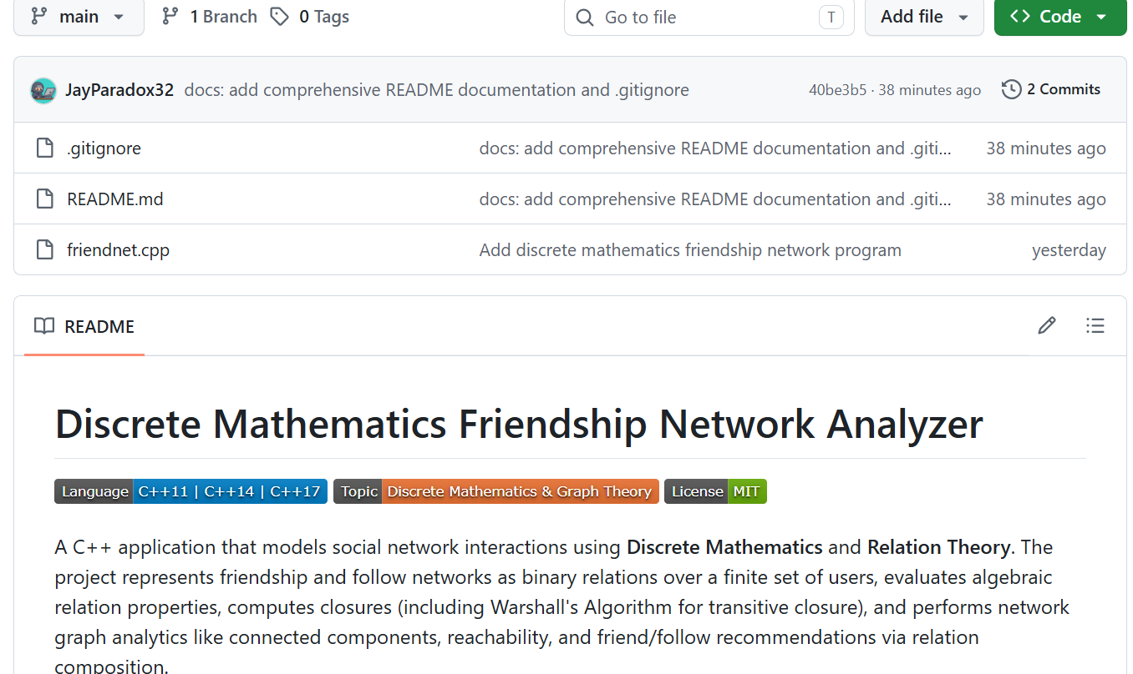

Annexure 2
Certificate of Online Course Related to Discrete Mathematics




Certificate of an online course related to the Discrete Mathematics course.

