SnakeGuard
Explainable Snake vs. Look-alike Detection for an Ankle-worn Early-warning System

Review 2
Objectives · Dataset Selection & Understanding · Methodology
Team: Jay Vishal Parikh (24BAI0143) · Fida M S (24BAI0180)
[Department], [Institution]
October 2026

Contents
1. Introduction and Problem Context 3
2. Clear Objectives 4
2.1 Aim 4
2.2 Specific objectives 4
2.3 Research questions 5
2.4 Scope 5
2.5 Division of work 5
3. Dataset Selection and Understanding 6
3.1 Requirements 6
3.2 Why a composite dataset 6
3.3 Classes 6
3.4 Sources and composition 6
3.5 Annotation format 8
3.6 Splits and statistics 8
3.7 Data quality audit 10
3.8 Dataset for venom classification (Member B) 11
3.9 Licensing and ethics 11
4. Methodology 12
4.1 Overview 12
4.2 Detection model 12
4.3 What is being explained: the target score 13
4.4 Explanation methods 13
4.5 Multi-scale fusion 14
4.6 Evaluation protocol for explanations 14
4.7 Experimental protocol 15
4.8 Hard-case analysis and explanation-based check 16
4.9 Runtime pipeline 16
4.10 Implementation 17
4.11 Work plan 17
5. Anticipated Review Questions 18
5.1 Objectives and motivation 18
5.2 Dataset 18
5.3 Model and methodology 19
6. References 22

Right-click the table and choose “Update Field” if page numbers are missing.

1. Introduction and Problem Context
Snakebite is a major occupational hazard in agriculture. The WHO estimates about five million bites per year, 1.8–2.7 million envenomings and up to 138,000 deaths, mostly in rural farming communities. Farmers work at ground level, in tall crops and dense grass, often in low light at dawn and dusk: exactly the conditions in which a snake's camouflage works best and the human eye is least reliable.
SnakeGuard is a proposed ankle-worn, camera-based early-warning system. It watches the ground immediately ahead of the wearer's next step, separates real snakes from common look-alike objects (ropes, roots, hoses, sticks), judges how dangerous a detection is, and turns that judgement into a glanceless audio alert: a beep that quickens as danger rises.
Two gaps in the existing literature motivate this work. First, of the eight prior systems reviewed in our literature survey, seven train on snake-only data without an explicit class of visually similar negatives, so they cannot be expected to reject a garden hose or a tree root. Second, none validates why its detector fires. For a device that decides whether to alarm a person in a field, a bare confidence score is not enough grounds for trust: it cannot reveal a spurious correlation, confirm genuine reasoning, or explain a failure before deployment.
This document sets out, for Review 2, the project's objectives, the selection and understanding of the dataset, and the complete methodology: the detection model, the explainability (XAI) layer that validates it, the evaluation protocol that compares XAI methods objectively, and the runtime pipeline built around them. A final chapter lists questions the review panel is likely to ask, with prepared answers.

2. Clear Objectives

2.1 Aim
Project aim
To build a trustworthy, explainable snake-detection pipeline for a wearable early-warning device: one that distinguishes real snakes from look-alike objects, explains every detection, and quantitatively validates which explanation method can be trusted before the device is deployed.

2.2 Specific objectives
Each objective has a concrete deliverable and a measurable success criterion, so progress can be checked objectively.
# | Objective | Deliverable | Success criterion
O1 | Assemble and characterise a detection dataset with an explicit look-alike class (ropes, roots, pipes, hoses, belts) next to real snakes | Two-class YOLO dataset, documented sources, statistics, quality audit | Both classes well represented in every split; composition, biases and leakage documented
O2 | Train and evaluate a lightweight, edge-deployable detector | YOLO11n weights; baseline evaluation with an error taxonomy | Standard COCO-style metrics (mAP@0.5, mAP@0.5:0.95, per-class P/R) reported on a held-out test split
O3 | Implement multiple independent explanation methods for the detector | Activation-based (Eigen-CAM), gradient-based multi-scale (Grad-CAM, Grad-CAM++, LayerCAM) and perturbation-based (Occlusion, D-RISE) explainers behind one interface | Every method explains one chosen detection and returns a map aligned with the original image
O4 | Compare the methods objectively, not by eye | Benchmark: faithfulness (deletion / insertion vs. a random baseline), localisation, agreement, sanity, stability, runtime | Statistically supported ranking (confidence intervals, paired tests) on the test split
O5 | Diagnose the hardest cases: real snakes vs. visually similar look-alikes | Matched-pair analysis of snake / look-alike detections | Human-checkable reasons for correct detections and for confusions
O6 | Test whether explanations can act as a validation signal | Explanation-based check that flags suspicious detections | Measured against confidence alone (AUROC, false alarms at fixed recall)
O7 | Build the runtime pipeline around the detector | Conflict resolution, small-object filter, 3-of-5 temporal confirmation, proximity estimate, 0–100 threat score, beep rate, venom-classifier interface | Each stage unit-tested; end-to-end run on real images
O8 | Venom-status classification of confirmed snakes (Member B) | Classifier + its own XAI evaluated with the shared protocol | Venomous recall prioritised; plugs into the pipeline interface
Table 2.1 – Project objectives, deliverables and success criteria.

2.3 Research questions
- RQ1 – Faithfulness: which XAI method most faithfully explains a one-stage YOLO detector, judged by deletion/insertion against a random-order baseline?
- RQ2 – Localisation: do the explanations land on the snake itself (ground-truth box or polygon), or on background cues?
- RQ3 – Hard cases: in matched snake / look-alike pairs, what drives correct detections and confusions (body shape, head silhouette, or a locally snake-like texture)?
- RQ4 – Design choices: does multi-scale fusion beat a single coarse layer, as the proposal claims? Do activation-based and gradient-based methods agree, and is agreement trustworthy?
- RQ5 – Deployment: what is the best trade-off between faithfulness, localisation, stability and runtime for the device?

2.4 Scope
In scope | Out of scope (this phase)
Frozen YOLO11n detector trained on the two-class dataset | Retraining or architecture search for the detector
Post-hoc explanation of individual detections | Hardware build of the ankle device, battery and enclosure
Quantitative comparison of XAI methods | Field trials with farmers
Runtime logic: confirmation, proximity, threat score, alert | Depth sensing; distance is estimated from box size only
Venom classifier interface (classifier by Member B) | Medical advice; the system is a warning aid, not a diagnosis
Table 2.2 – Scope of the current phase.

2.5 Division of work
Member A (Jay Vishal Parikh) – Detection, XAI and evaluation | Member B (Fida M S) – Venom classification and application
Environment, detector wrapper, baseline evaluation | Species-labelled snake dataset; species → venomous mapping
Detector explainers (Eigen-CAM, Grad-CAM/++, LayerCAM, Occlusion, D-RISE) | Venom classifier training and evaluation
Shared evaluation harness used by both members | Classifier explainers via the shared interface
Benchmark, matched-pair analysis, explanation-based check | Benchmark of classifier XAI with the shared harness
Runtime pipeline (confirmation, proximity, threat, alert) | Demonstration application
Table 2.3 – Work split. Both members share one code base and one evaluation protocol.

3. Dataset Selection and Understanding

3.1 Requirements
The dataset must reflect what the device will actually see and what it must not confuse. We derived five requirements from the problem statement and the literature gap:
- R1 – Explicit hard negatives. A dedicated class of snake-like objects (ropes, roots, hoses, pipes, belts, branches) rather than an unstructured background, because these are the objects that cause false alarms in the field.
- R2 – Natural snake imagery. Many species, postures (coiled, stretched, partly hidden), backgrounds (soil, grass, leaf litter, roads) and lighting, including night shots.
- R3 – Localisation labels. Bounding boxes for detection; where available, polygons that trace the object outline, which allow stricter checks of where explanations point.
- R4 – Size. Enough images for a modern detector (tens of thousands), with held-out validation and test splits.
- R5 – Open licences. Publicly available sources with permissive licences (mostly CC BY 4.0).

3.2 Why a composite dataset
No single public dataset meets R1–R4. Public snake datasets are almost all positive-only, and the one prior system with negatives (a patent disclosure using ropes, sticks and leaves) has not released its data. We therefore assembled a composite dataset from several public Roboflow Universe and Kaggle sources: snake datasets for the positive class and separate datasets for each look-alike category. The sources were merged, relabelled into two classes and split into train / validation / test. This directly addresses the dataset gap identified in the literature review: the look-alikes are a first-class part of training, not an afterthought.

3.3 Classes
Class id | Name | Definition | Examples
0 | snake | Any real snake, any species, any posture, fully or partly visible | Wild snakes in grass, leaf litter, on roads and walls, held in hands, at night
1 | snake_like_object | A non-snake object that is elongated, thin, curved or coiled and could be mistaken for a snake | Belts, ropes and nooses, fallen trees and roots, mangrove roots, garden and fire hoses, pipes
Table 3.1 – Class definitions.

3.4 Sources and composition
During merging the images were renamed (snake_XXXXXX, snake_like_XXXXXX), so per-image source names were not kept. We reconstructed the composition from the data itself: each source export appears as a contiguous block of image numbers with one fixed resolution, and visual inspection of each block identifies its content (Figure 3.1, Figure 3.2).
Class | ≈ Images | Content | Resolution | Source type
look-alike | 2,900 | Belts (product photos, worn belts) | mixed | Roboflow belt datasets
look-alike | 820 | Fallen and uprooted trees, roots, branches | 416×416 | Roboflow fallen-tree dataset
look-alike | 1,150 | Fire-hose cabinets, hose reels | 512×512 | Roboflow fire-hose dataset
look-alike | 1,170 | Pipes, plumbing | 416×416 | Roboflow pipe dataset
look-alike | 1,220 | Mangrove roots in water (video frames) | 640×360 | Roboflow mangrove-roots dataset
look-alike | 600 | Underwater pipelines; ropes and nooses | mixed | Roboflow underwater-pipes and rope/hanging datasets
snake | 13,700 | Wild snakes, many species, natural scenes | ≤ 500 px long side | iNaturalist-derived snake images (Kaggle)
snake | 1,512 | Snakes incl. ball pythons | 1080×1080 | One Roboflow snake dataset
Table 3.2 – Composition reconstructed from the images. Exact source links are listed in the project file report/dataset_sources.md.
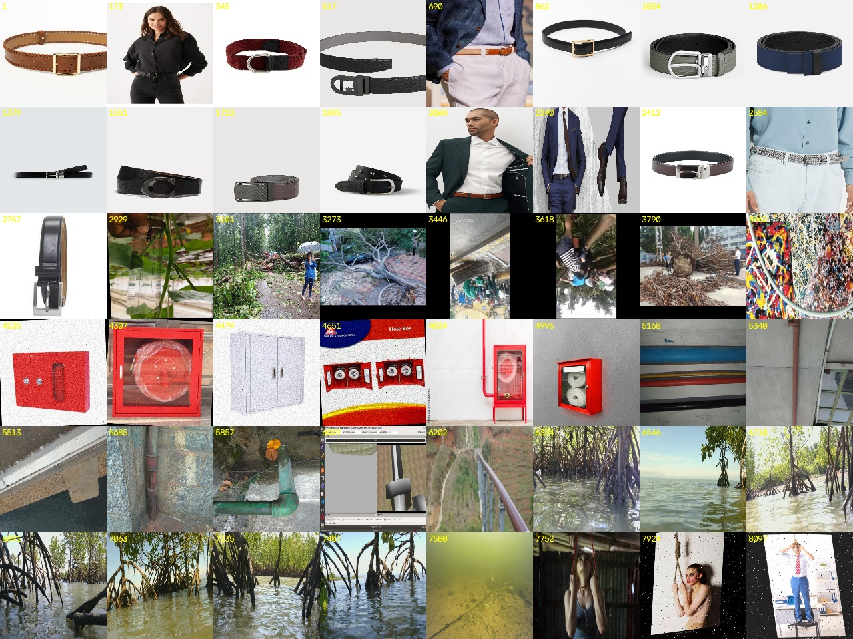
Figure 3.1 – Look-alike class: 48 images sampled evenly across the ID range. Blocks are visible: belts → fallen trees → hose cabinets → pipes → mangrove roots → ropes/nooses.
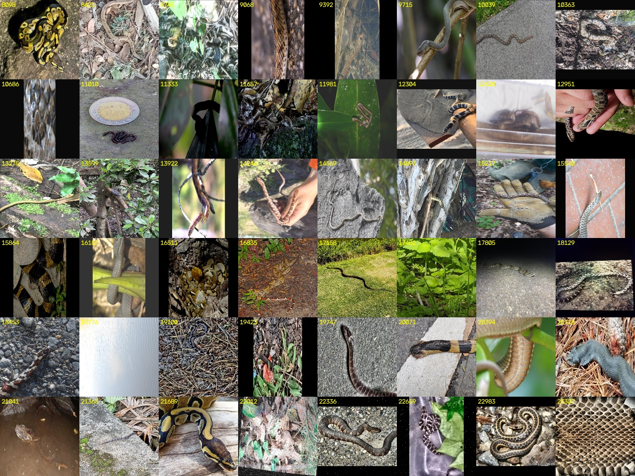
Figure 3.2 – Snake class: 48 images sampled evenly across the ID range. Many species, backgrounds and lighting conditions.

3.5 Annotation format
Labels follow the YOLO text format, one file per image and one line per object, with coordinates normalised to [0, 1]. Two kinds of lines occur:
- Bounding box (5 values): class, x-centre, y-centre, width, height. Used by about 77 % of training labels.
- Polygon (class + x1 y1 x2 y2 …): the object outline. About 23 % of training labels. For detection training the box enclosing the polygon is used; for the XAI evaluation the polygon gives a precise object mask (Section 4.6).
Images with an empty label file are background images (no object). They teach the detector that not every frame contains something to report.

3.6 Splits and statistics
Split | Images | Snake objects | Look-alike objects | Box labels | Polygon labels | Background images
Train | 20,294 | 12,086 | 9,394 | 16,630 | 4,850 | 1,813
Validation | 2,172 | 1,138 | 1,370 | 2,057 | 451 | 7
Test | 841 | 569 | 380 | 707 | 242 | 0
Total | 23,307 | 13,793 | 11,144 | 19,394 | 5,543 | 1,820
Table 3.3 – Split statistics (24,937 annotated objects in total).
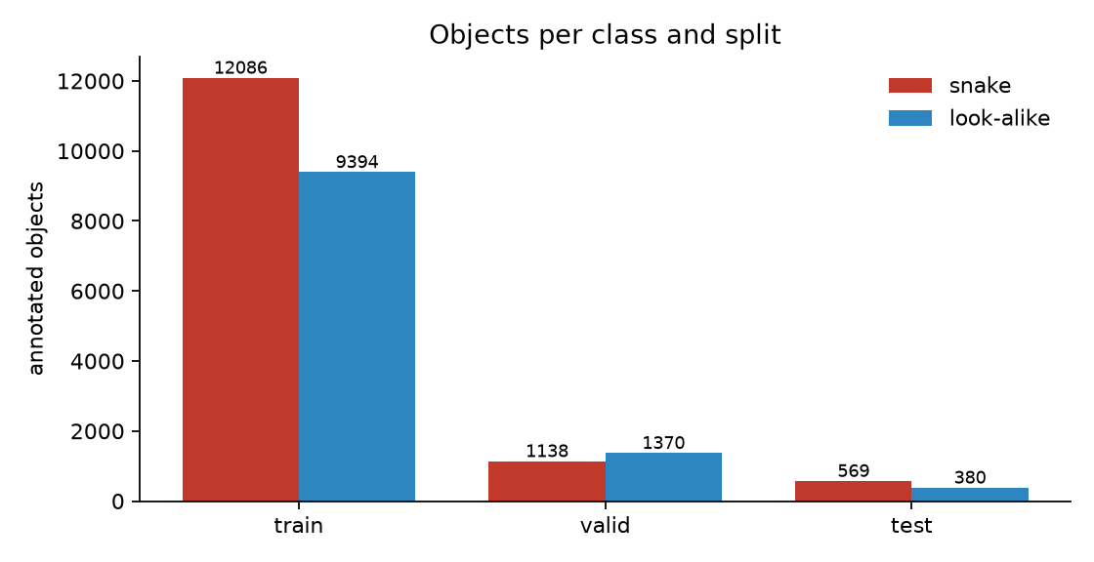
Figure 3.3 – Objects per class and split. Both classes are well represented in every split (snake : look-alike ≈ 55 : 45 overall).

Objects per image
Most images contain exactly one object (train: 16,778 of 20,294). Multi-object images (2–5+ objects) are mostly look-alikes such as root clusters and pipe runs. Training also includes 1,813 background images.

Object size
Snakes are typically large in frame: the median snake box covers 33 % of the image, a quarter cover more than half of it, and only 0.5 % are smaller than 1 % of the image. Look-alikes are smaller and more varied: median 18 %, with 6.3 % smaller than 1 % of the image. For an ankle-mounted camera this matters: a snake close to the foot fills much of the frame, while distant objects are small. Small objects are therefore the hardest case, and a small-object filter is part of the pipeline (Section 4.9).
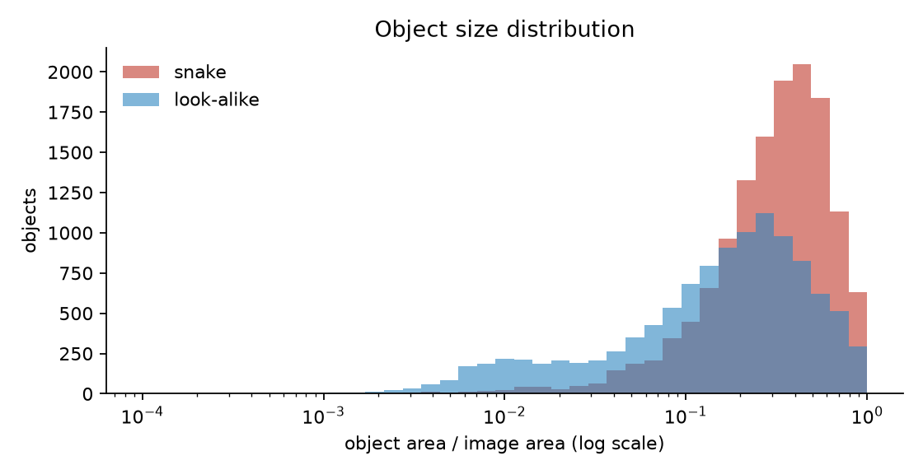
Figure 3.4 – Object area as a share of image area (log scale).
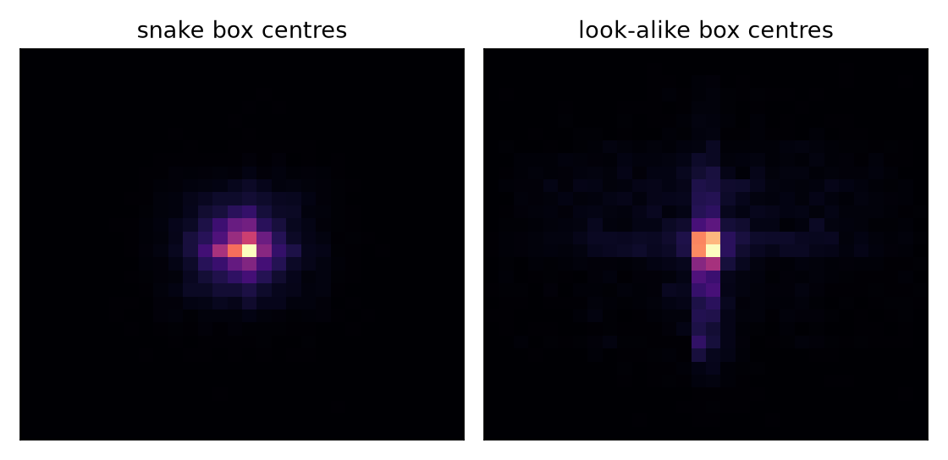
Figure 3.5 – Where objects lie in the image: box centres concentrate near the middle (photographer bias), more strongly for snakes.

Image resolution
The images have 994 distinct resolutions. The most common are 500×375 and 375×500 (snake photos), 416×416, 640×360 and 512×512 (look-alike exports) and 1080×1080 (one snake export). All images are letterboxed to 640 px on the long side before entering the network, so the model never sees the raw resolution.
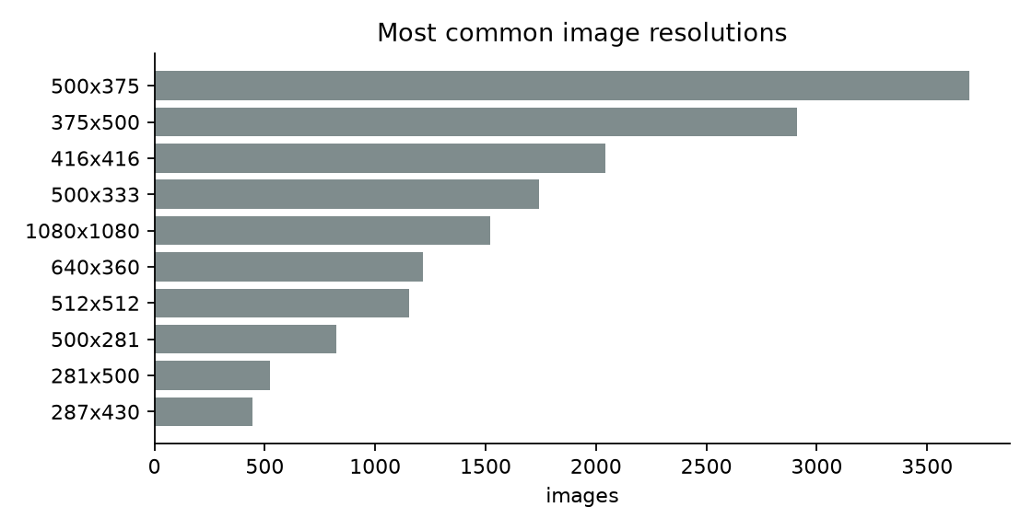
Figure 3.6 – The ten most common image resolutions.

3.7 Data quality audit
Because the dataset is a merge of independent sources, we audited it for problems that could inflate scores or create shortcuts.

Source / class shortcut
Each class comes from different sources, so image resolution alone identifies the class for 99.4 % of images. The network does not see resolution directly (all inputs are resized), but source-specific style (white product backgrounds for belts, video frames for mangroves, Roboflow augmentations) could still act as a shortcut. This is a known risk of composite datasets. It is one of the reasons the project needs XAI: if the detector relied on background style instead of the object, the explanations would point away from the object. The localisation metrics in Section 4.6 test exactly this.

Near-duplicates across splits
We hashed every image (64-bit difference hash) and confirmed candidate pairs by pixel correlation of 32×32 greyscale versions (> 0.95). The pixel check is essential: the hash alone matches different belts photographed the same way. Result: 646 verified near-duplicate pairs across splits (614 train–validation, 25 test–train, 7 test–validation). Only 20 test images (2.4 %) have a near-twin in another split. These are mostly augmented copies of the same photograph.
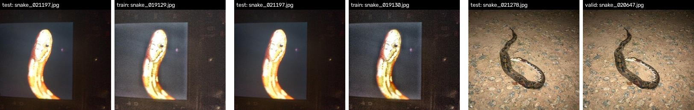
Figure 3.7 – Verified near-duplicates: the same photograph in test and in train/validation, differing only by augmentation.
Consequences for the methodology: the validation split is used only for tuning, never for reported numbers, and the test set is checked with and without the 20 affected images.

Other characteristics
- Baked-in augmentation: black borders, rotations and noise in many images come from Roboflow export augmentation.
- Annotation granularity: some look-alikes (root clusters, pipe runs) are annotated object-by-object in one source and as a group in another.
- Domain gap: belts on white backgrounds and fire-hose cabinets are indoor/product images, unlike a farm field. They are useful shape negatives but not field-realistic.
- No species labels: the detection dataset cannot be used for venom classification. Member B uses a separate species-labelled dataset.
- Camera viewpoint: most images are taken from standing height, not from an ankle-mounted camera.

3.8 Dataset for venom classification (Member B)
Venom status needs species-level labels, which the detection dataset does not have. Member B's stage uses a species-labelled snake dataset (candidates: SnakeCLEF, which is built from iNaturalist and HerpMapper observations, and Kaggle snake-species collections). Species are mapped to venomous / non-venomous using herpetological references, with a regional focus on medically important species (in India the "Big Four": spectacled cobra, common krait, Russell's viper, saw-scaled viper). Splits are made per observation to avoid leakage.

3.9 Licensing and ethics
- Sources are public; most Roboflow Universe datasets are CC BY 4.0. Licences are recorded per source before publication.
- Some look-alike images show people (belts being worn; staged rope/noose images). They are used only as negative examples for object detection, not for recognising people.
- The device gives a warning, not a medical diagnosis. Unknown venom status is treated as venomous.

4. Methodology

4.1 Overview
SnakeGuard follows the five-stage pipeline of the proposal (Sense → Detect → Classify → Locate → Alert) with an explainability and validation layer attached to the safety-critical Detect stage (Figure 4.1). The research work follows the workflow in Figure 4.2: characterise the dataset, evaluate the detector, explain it with several independent methods, tune the evaluation on the validation split, run the final benchmark on the test split, analyse it, and build the runtime pipeline.
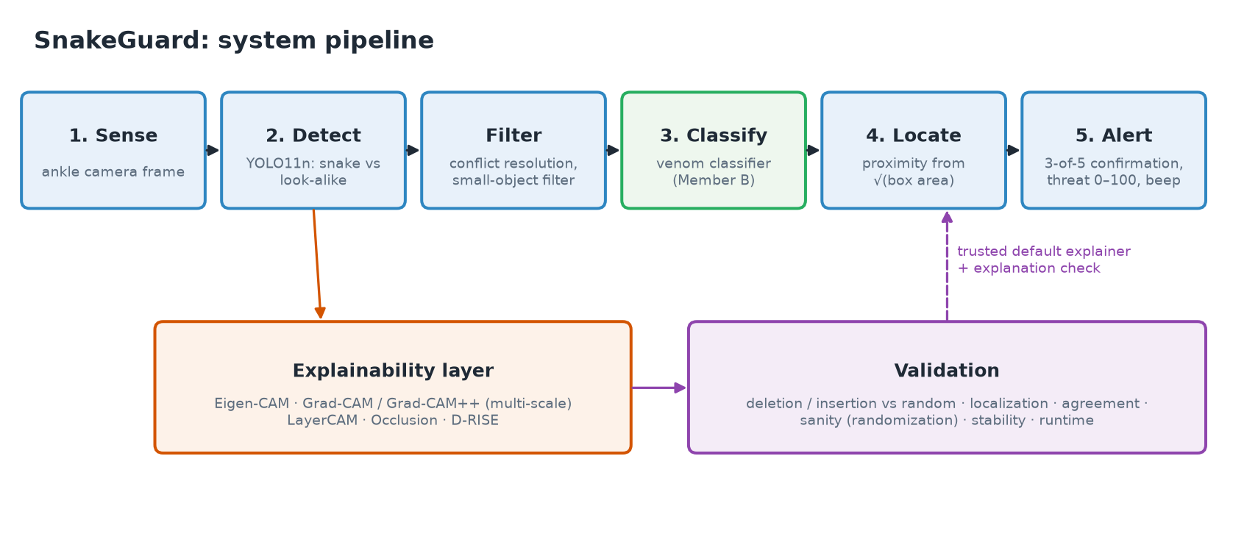
Figure 4.1 – System pipeline with the explainability and validation layer.
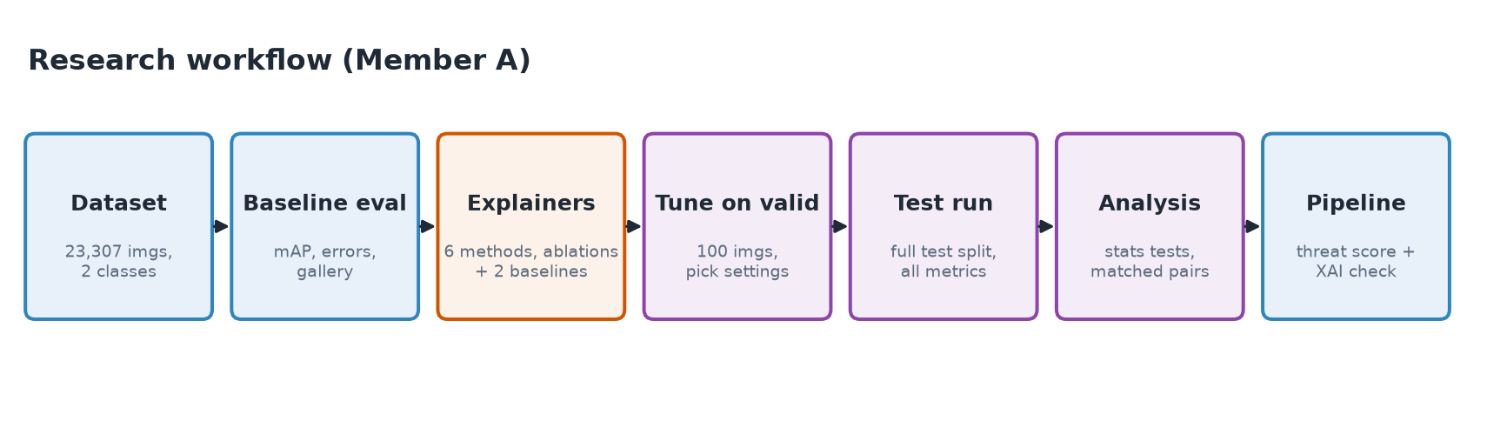
Figure 4.2 – Research workflow.

4.2 Detection model
We use YOLO11n (Ultralytics), a one-stage anchor-free detector with 2.58 M parameters and 6.4 GFLOPs. A nano model was chosen because the target is an embedded wearable: YOLO-family nano models dominate the edge snake-detection literature (YOLOv5, YOLOv8n, YOLOv8-nano), and a small model leaves compute headroom for the XAI layer.
Component | Details
Backbone (layers 0–10) | Convolutional feature extractor with C3k2 blocks, SPPF and a C2PSA attention block
Neck (layers 11–22) | Feature pyramid that fuses features into three scales: P3 (stride 8, small objects), P4 (stride 16), P5 (stride 32, large objects)
Head (layer 23) | Decoupled detection head: for every location of P3/P4/P5, box regression + sigmoid scores for the two classes
Training | Ultralytics default training pipeline; 30 epochs, input 640 px, batch 16, on Google Colab
Inference | Aspect-preserving resize of the long side to 640 px, padding to a multiple of 32; per-class NMS (IoU 0.7); operating threshold conf ≥ 0.25
Status in this phase | Frozen: the XAI work explains this exact model and does not retrain it
Table 4.1 – Detector configuration.

Baseline evaluation protocol
- COCO-style mAP@0.5 and mAP@0.5:0.95, per-class precision and recall, on validation and test.
- Error taxonomy at the operating threshold: each detection is matched to ground truth (IoU ≥ 0.5, class-agnostic) and labelled TP, class confusion (right place, wrong class), background FP or FN (missed object).
- A failure gallery of the most confident mistakes, and comparison with the mAP figures reported in the literature review.

4.3 What is being explained: the target score
A detector outputs many boxes per image, so "the model's confidence" must be defined per detection. For a detection with box b and class c we use the D-RISE similarity score:
s(x) = maxᵢ IoU( bᵢ(x), b ) · pᵢ( c | x )
The maximum runs over all raw (pre-NMS) predictions i of the image x. On the unperturbed image, s equals the detection's own confidence. When the image is perturbed, s follows the object even if a neighbouring prediction takes over, so it stays meaningful. The same score is used everywhere: for the gradients of the CAM methods, for the perturbations of Occlusion and D-RISE, and for the deletion/insertion metric. This way every method is judged on the quantity it claims to explain.
A contrastive variant, s = IoU · (p(c) − p(other class)), explains why the model chose snake rather than look-alike.

4.4 Explanation methods
The proposal calls for several independent methods that cross-check one another: an activation-based method, a class-targeted gradient-based method fused across scales, and a model-agnostic perturbation method, with a quantitative test to settle disagreements. We implement these and add methods that strengthen the comparison.
Method | Family | Principle | Role in this project
Eigen-CAM | Activation, gradient-free | Projects the feature maps onto their first principal component: what the network responds to most, regardless of class | Proposal: fast first-pass check
Grad-CAM | Gradient | Weights each feature channel by its average gradient of s | Baseline for Grad-CAM++
Grad-CAM++ | Gradient, class-targeted | Like Grad-CAM, but with higher-order weights that handle several object parts | Proposal: “why was this labelled snake”
LayerCAM | Gradient, per-location | Weights every location by its own positive gradient instead of one weight per channel; designed for fusing shallow and deep layers | Added: multi-scale fusion done per location
Occlusion | Perturbation, model-agnostic | Slides a grey patch over the image and records how much s drops | Proposal: independent “ground-truth” cross-check
D-RISE | Perturbation, model-agnostic | Thousands of random masks; each mask is weighted by s of the masked image | Added: detector-specific black-box method
Random map | Baseline | Smooth random blobs | Proposal's random-order reference
Box prior | Baseline | Gaussian centred on the detected box | Tests whether a method does more than highlight the box
Table 4.2 – Explanation methods.

Method details
Eigen-CAM. For activations A ∈ R^(C×H×W) at a layer, reshape to (HW × C), take the first right singular vector v₁ and project: map = ReLU(A·v₁). The sign of an SVD component is arbitrary, so it is oriented to correlate positively with activation energy.
Grad-CAM / Grad-CAM++. With gradients g = ∂s/∂A, Grad-CAM uses channel weights wₖ = mean(gₖ) and map = ReLU(Σₖ wₖ Aₖ). Grad-CAM++ replaces the mean with weights wₖ = Σ αₖ(i,j)·ReLU(gₖ(i,j)), where αₖ = gₖ² / (2gₖ² + Σ Aₖ · gₖ³).
LayerCAM. map = ReLU(Σₖ ReLU(gₖ(i,j)) · Aₖ(i,j)). Each location keeps its own gradient weight, so a channel that fires on the image border but does not influence the detection gets no weight there.
Occlusion. Grey (114/255) patches of 48 and 96 px at 50 % stride; saliency at a pixel = mean drop of s over all patches covering it, averaged over the two patch sizes. Model-agnostic and faithful by construction, but needs hundreds of forward passes.
D-RISE. 2,000 random binary masks on a 16×16 grid (keep probability 0.5), upsampled with random shifts. Saliency = Σ s(masked image) · mask, minus the mean weight to remove the uniform bias of plain RISE.

Why not SHAP or LIME
As stated in the proposal, SHAP and LIME were set aside for the detector: both assume single-label classification and are a poor fit for detection, where one frame contains several boxes, classes and scores. They remain appropriate for Member B's single-label venom classifier.

4.5 Multi-scale fusion
YOLO detects small objects on P3 and large ones on P5. Hooking only the coarsest layer (P5, a 20×20 grid at 640 px) loses the fine spatial detail that separates a thin, elongated snake from its surroundings. Following the proposal, the gradient-based methods are computed on all three neck outputs (layers 16, 19, 22). Each map is upsampled to the input size and normalised, and the three are fused (mean; max and sum are also tested). Single-scale P3, P4 and P5 variants are kept as ablations to test the multi-scale claim (RQ4).

4.6 Evaluation protocol for explanations
The proposal's central principle is that an explanation is judged by a quantitative test, not by how plausible the heatmap looks. Every explanation of every target detection is scored on six axes:

1. Faithfulness: deletion and insertion
Pixels are ranked by the explanation. Deletion removes them in that order (replaced with grey) in 50 steps and records s after each step. Insertion starts from a heavily blurred image and reveals the pixels in the same order. The area under each curve, normalised by the original score:
AUC(del) = ∫₀¹ s(xₜ)/s(x) dt (lower is better) AUC(ins) = ∫₀¹ s(xₜ)/s(x) dt (higher is better)
A faithful explanation collapses the score quickly on deletion and recovers it quickly on insertion. Each method is also compared with the random-order baseline on the same detection: we report the share of detections where the method beats random, and the mean gain over it.

2. Localisation
- Pointing game: is the map's maximum within 15 px of the ground-truth object?
- Energy-based pointing game: what share of the total saliency falls inside the ground truth?
- Saliency IoU: overlap between the most salient pixels and the ground truth.
- Each is computed against the ground-truth box and, where a polygon label exists, against the much stricter polygon mask.

3. Agreement
Spearman rank correlation and top-20 % IoU between the maps of different methods. The proposal treats agreement between the activation-based and gradient-based methods as stronger evidence; this metric tests whether that is justified.

4. Sanity check
Model-parameter randomisation (Adebayo et al., 2018): the weights are randomised in cascade (head → neck → whole network) and the explanation is recomputed. If the map barely changes when the layers that make the decision are destroyed, the method is not explaining the decision.

5. Stability
Similarity of the map before and after adding small Gaussian noise (σ = 0.02) to the input. A trustworthy explanation should not change drastically for an imperceptible change.

6. Cost
Wall-clock milliseconds per explanation on the target GPU, which decides what can run on or near the device.

Statistics
Means are reported with 95 % bootstrap confidence intervals. Methods are compared on the same detections with paired Wilcoxon signed-rank tests.

4.7 Experimental protocol
Item | Setting
Targets explained | Detections at conf ≥ 0.25, matched to ground truth at IoU ≥ 0.5: true positives, class confusions and background false positives (at most 2 per image)
Tuning | 100 validation images: choose fusion rule, Eigen-CAM variant and method set
Final evaluation | Full test split (841 images); expensive D-RISE on a fixed 200-image subset; sanity and stability on a fixed 150-image subset
Leakage control | Test results checked with and without the 20 test images that have near-duplicates in other splits
Reproducibility | Fixed seed (42); every run saves its configuration; resumable scripts; 55 automated tests (letterbox mapping, label parsing, metrics, matching, pipeline logic, agreement with Ultralytics predictions)
Hardware / software | NVIDIA RTX 4060 Laptop GPU (8 GB); PyTorch 2.14, Ultralytics 8.4, Python 3.12
Table 4.3 – Experimental protocol.

4.8 Hard-case analysis and explanation-based check

Matched snake / look-alike pairs
As required by the proposal, the explainability layer is tested on the hardest cases. Every look-alike detection (and every confusion or false positive) is paired with the real-snake detection that the detector itself finds most similar: the cosine similarity of RoI-aligned P5 features. Both are shown side by side under all methods. Comparing explanations of inputs the model considers near-identical shows whether a snake is recognised by its coiled body or head shape, and whether a look-alike fools the model through a locally snake-like texture.

Explanation-based verification
To test whether explanations add information beyond the confidence score, we compute per detection: the share of saliency inside the box, whether the map's peak lies inside the box, and the agreement between methods. A logistic regression trained on validation predicts "this detection is wrong" on test, compared with confidence alone (AUROC; share of wrong detections still passing at 90 % and 95 % recall of correct ones).

4.9 Runtime pipeline
The pipeline implements the proposal's stages around the detector. Each step is configurable and unit-tested.
Step | Method | Rationale
Conflict resolution | If a snake box and a look-alike box overlap (IoU ≥ 0.5), keep the snake unless the look-alike is ≥ 0.15 more confident | Safety bias: a missed snake is worse than a false alarm
Small-object filter | Drop boxes smaller than 0.1 % of the frame | Distant or noisy detections are not an immediate threat
Venom status | Crop → Member B's classifier → P(venomous); unknown is treated as venomous | Graded danger instead of treating all snakes alike
Proximity | proximity = clip( (√area − √0.005) / (√0.25 − √0.005), 0, 1 ) | An object's linear size scales with 1/distance, so √(box area) tracks closeness without depth hardware
Temporal confirmation | A snake must appear in at least 3 of the last 5 frames | Suppresses one-off false positives from a single ambiguous frame
Threat score | T = 100 · conf · (0.6 · proximity + 0.4 · P(venomous)) | One continuous 0–100 signal combining certainty, distance and venom
Alert | Beep interval falls linearly from 1,500 ms (T = 0) to 150 ms (T = 100); distinct alert if venomous | Glanceless, hands-free warning
Explanation check | On demand, the most threatening detection is explained and the share of saliency inside its box is reported | Flags detections driven by context rather than the object
Table 4.4 – Runtime pipeline steps.

4.10 Implementation
- Language and libraries: Python 3.12, PyTorch, Ultralytics; all XAI methods implemented from scratch for full control over YOLO's multi-scale hooks. They were checked against the reference library pytorch-grad-cam.
- Shared interface: every explainer returns a map in [0, 1] aligned with the original image, so detector and classifier methods are evaluated with the same harness.
- Preprocessing detail: the wrapper reproduces Ultralytics' letterbox exactly (verified by tests) and maps every box and map back to original image coordinates. Square padding was avoided because large grey borders attracted coarse CAMs.
- Robustness: long experiments save results per image and resume after interruptions.

4.11 Work plan
Phase | Activities | Owner
1. Setup and baseline | Environment, detector wrapper, baseline evaluation, dataset audit | A
2. Explainers | Implement and verify all detector explanation methods | A
3. Evaluation harness | Faithfulness, localisation, agreement, sanity, stability, cost | A (shared)
4. Benchmark and analysis | Tune on validation, evaluate on test, matched pairs, verification | A
5. Venom stage | Dataset, classifier, classifier XAI with the shared harness | B
6. Integration | Runtime pipeline, venom-classifier plug-in, demonstration app | A + B
7. Reporting | Report, slides, demonstration | A + B
Table 4.5 – Work plan.

5. Anticipated Review Questions
Prepared answers to questions the panel is likely to ask about the objectives, the dataset and the methodology.

5.1 Objectives and motivation
Q. What is new compared with existing snake-detection systems?
A. Three things. (1) An explicit look-alike class: seven of the eight reviewed systems train on snake-only data. (2) An explainability layer that is quantitatively validated: none of the reviewed systems examines what its detector attends to. (3) A wearable pipeline with temporal confirmation and a graded 0–100 threat score instead of a single confidence threshold.
Q. Why is explainability needed if the detector is already accurate?
A. Accuracy on a test set does not show why the model is right. A composite dataset invites shortcuts, such as recognising the source's background style instead of the object. Explanations reveal whether the detector looks at the snake. For a safety device, trust requires checking the reasoning, not only the score.
Q. Why several explanation methods instead of one?
A. Every XAI method has blind spots. Activation methods ignore the decision, gradient methods can be noisy or saturate, and perturbation methods are slow and coarse. The proposal combines independent families so they cross-check each other, and uses a quantitative test to settle disagreements.
Q. How will you know the objectives are met?
A. Each objective has a measurable criterion (Table 2.1): reported detection metrics on a held-out test set, a statistically supported ranking of XAI methods, a measured comparison of the explanation-based check against confidence, and unit-tested pipeline stages.
Q. Why is distance estimated from box size rather than a depth sensor?
A. To keep the wearable cheap and light. For an object of roughly known size, its image size scales with 1/distance, so √(box area) is a usable proximity proxy. It is approximate and the threat score is designed with that in mind.

5.2 Dataset
Q. Why did you not use a single existing dataset?
A. No public dataset has both natural snake images and an explicit class of snake-like objects at this scale. Building a composite from public sources was the only way to meet the requirement of explicit hard negatives.
Q. Where exactly did the data come from?
A. Public Roboflow Universe datasets (belts, fallen trees, fire hoses, pipes, mangrove roots, underwater pipes, ropes/nooses, one snake set) and iNaturalist-derived snake images from Kaggle. The images were renamed during merging, so we reconstructed the composition from resolution blocks and visual inspection (Table 3.2). The exact source links are documented in the project.
Q. Why include belts and fire-hose cabinets? They are not found in fields.
A. They are shape negatives: long, thin, curved or coiled objects that teach the model that elongation and curvature alone do not make a snake. They are not field-realistic, and we acknowledge this domain gap; roots, ropes, hoses and pipes are the field-relevant negatives.
Q. Is the dataset balanced?
A. Reasonably. Objects are 55 % snake and 45 % look-alike overall, and both classes are well represented in every split (Table 3.3). Within the look-alike class the sub-categories differ in size; belts are the largest group.
Q. Could the model cheat by recognising the source rather than the object?
A. That is a real risk: image resolution alone identifies the class for 99.4 % of images. The network never sees the raw resolution because all inputs are resized, but source style could still leak. That is exactly why we measure localisation: if explanations pointed at backgrounds or borders rather than the object, it would expose such a shortcut.
Q. Is there data leakage between train and test?
A. We checked with perceptual hashing confirmed by pixel correlation. Only 20 of 841 test images (2.4 %) have a near-duplicate in train or validation, and the protocol reports test results with and without them. Validation has more overlap with train (614 pairs), so validation is used only for tuning, never for reported numbers.
Q. Why are some labels polygons and others boxes?
A. Different sources were annotated differently. The detector uses the enclosing box of a polygon. For XAI, polygons are an advantage: they give a precise object mask, so we can test whether explanations follow the actual snake body rather than just its box.
Q. What are the background images for?
A. The 1,813 training images with no objects teach the detector that most scenes contain nothing to report, which reduces false alarms.
Q. The images are not from an ankle-mounted camera. Is that a problem?
A. Yes, it is a limitation. Most images are taken from standing height. The ankle viewpoint (close range, low angle, motion blur) should be addressed with targeted data collection or augmentation in a later phase.
Q. How do you handle venom labels?
A. The detection dataset has no species labels. Member B uses a separate species-labelled dataset (e.g. SnakeCLEF) and maps species to venomous / non-venomous using herpetological references, with priority on medically important species such as India's Big Four.

5.3 Model and methodology
Q. Why YOLO11n?
A. It is the smallest current YOLO model (2.58 M parameters, 6.4 GFLOPs), suits embedded hardware, and continues the YOLO line that dominates the snake-detection literature. A small model also leaves compute budget for explanations.
Q. How do you explain one detection when YOLO outputs hundreds of boxes?
A. We define a per-detection target score: the maximum over all raw predictions of IoU with the explained box times the probability of its class (the D-RISE similarity). It equals the detection's confidence on the original image and follows the object under perturbation. All methods and metrics use this same score.
Q. What is the difference between Eigen-CAM, Grad-CAM++ and LayerCAM?
A. Eigen-CAM uses only activations (principal component), so it is class-agnostic. Grad-CAM++ weights each channel by gradients of the score, so it is class-targeted. LayerCAM also uses gradients but weights every location separately, which keeps explanations local and works well when fusing shallow and deep layers.
Q. Why fuse multiple scales?
A. YOLO detects small objects on high-resolution feature maps (P3) and large objects on coarse ones (P5). A single coarse layer (20×20) cannot resolve a thin snake. Fusing P3–P5 keeps fine detail, and the single-scale variants are tested as ablations.
Q. Why include Occlusion and D-RISE if they are slow?
A. They are model-agnostic: they make no assumption about layers or gradients and directly measure how the score responds to hiding image regions. That makes them the independent reference the proposal asks for. Their cost is measured too, to decide what can run on the device.
Q. Why not SHAP or LIME?
A. They are built for single-label classification. A detection frame has several boxes, classes and scores, so their assumptions do not fit. The proposal set them aside for the detector; they remain suitable for the venom classifier.
Q. What does deletion/insertion actually measure?
A. Faithfulness: whether the pixels an explanation calls important really drive the model's score. Removing the top-ranked pixels first should collapse the score quickly (low deletion AUC), and revealing them first should recover it quickly (high insertion AUC).
Q. Why compare with a random baseline and a box prior?
A. Random tells whether a method beats chance. The box prior (a blob on the detected box) tells whether a method does anything more than highlight the box. Without these references a number like 0.6 has no meaning.
Q. What is the sanity check?
A. Model-parameter randomisation: we randomise the network's weights from the head downward and recompute the explanation. A method that produces almost the same map for a destroyed model is not explaining the model's decision.
Q. How do you avoid tuning on the test set?
A. All settings (fusion rule, method variants) are chosen on 100 validation images. The test split is used once for the final numbers.
Q. How are results checked statistically?
A. 95 % bootstrap confidence intervals for every mean and paired Wilcoxon tests between methods on the same detections.
Q. How do the explanations feed back into the device?
A. The best-validated method becomes the device's explainer. For the most threatening detection it reports how much of the explanation lies inside the box; a detection explained mostly by its surroundings can be flagged as suspicious.
Q. Why 3 of 5 frames for confirmation?
A. It suppresses single-frame false alarms while confirming a real snake within a fraction of a second at normal frame rates. The window and threshold are configurable.
Q. Why is unknown venom status treated as venomous?
A. Safety: the cost of under-warning about a venomous snake is far higher than the cost of an unnecessary warning.
Q. How is the work reproducible?
A. Fixed seeds, saved configurations per run, scripts for every number, pinned library versions and 55 automated tests, including a test that our wrapper reproduces Ultralytics' own predictions.

6. References
- Shivaraj et al., “Real-Time Snake Detection and Alert System,” IJERT 13(5), 2024.
- Prasad et al., “VenoScan: AI-Powered Classification of Venomous and Non-Venomous Snakes,” ISACC, 2025.
- Dube & Bhuru, “Snake Identification System Using Convolutional Neural Networks,” ZCICT, 2022.
- Limje, Reddy & Sivakumar B, “An IoT-Enabled Continuous Snake Detection System with GPS-Based Alerting,” ICCSP, 2026.
- Bharath et al., “Serpent-ID: A Deep Learning-Based Mobile Application for Rapid Snake Identification,” ICSFT, 2026.
- IN 202521121126, IN 202541120085, CN 121459270 (patent disclosures reviewed in the proposal).
- Muhammad & Yeasin, “Eigen-CAM: Class Activation Map using Principal Components,” IJCNN, 2020.
- Selvaraju et al., “Grad-CAM: Visual Explanations from Deep Networks via Gradient-based Localization,” ICCV, 2017.
- Chattopadhay et al., “Grad-CAM++: Generalized Gradient-Based Visual Explanations,” WACV, 2018.
- Jiang et al., “LayerCAM: Exploring Hierarchical Class Activation Maps for Localization,” IEEE TIP, 2021.
- Zeiler & Fergus, “Visualizing and Understanding Convolutional Networks,” ECCV, 2014.
- Petsiuk et al., “RISE: Randomized Input Sampling for Explanation of Black-box Models,” BMVC, 2018.
- Petsiuk et al., “Black-box Explanation of Object Detectors via Saliency Maps (D-RISE),” CVPR, 2021.
- Adebayo et al., “Sanity Checks for Saliency Maps,” NeurIPS, 2018.
- Zhang et al., “Top-down Neural Attention by Excitation Backprop” (pointing game), IJCV, 2018.
- Wang et al., “Score-CAM: Score-Weighted Visual Explanations” (energy-based pointing game), CVPR-W, 2020.
- Ultralytics YOLO11 documentation, https://docs.ultralytics.com.
- WHO, “Snakebite envenoming” fact sheet.

