SnakeGuard – Review 2
Presentation script
What to say on each of the 15 slides, written to be spoken. Total speaking time is about 15 minutes, leaving time for questions. Each slide shows a thumbnail, a suggested speaker, a time budget, the script, and a transition line into the next slide. Tips cover likely follow-up questions.
Speaker split: suggested: Jay (Member A) presents the opening, objectives and methodology; Fida (Member B) presents the dataset, scope and close. Change it freely.
Delivery: don't read the slide aloud; the script adds what the slide doesn't say. Point at the chart or diagram you are describing, pause briefly when moving from objectives to dataset to methodology, and keep the formula slide slow.
# | Slide | Section | Speaker | Time
1 | SnakeGuard | Opening | Jay | 30 s
2 | Why SnakeGuard | Opening | Jay | 1 min
3 | Aim: detect, explain, validate | Objectives | Jay | 1 min
4 | Specific objectives | Objectives | Jay | 1.25 min
5 | Selection: requirements and why a composite dataset | Dataset | Fida | 1.25 min
6 | Classes and composition | Dataset | Fida | 1 min
7 | What the classes look like | Dataset | Fida | 45 s
8 | Splits and annotation format | Dataset | Fida | 1 min
9 | System pipeline | Methodology | Jay | 1 min
10 | Detection model: YOLO11n | Methodology | Jay | 1 min
11 | Explanation methods and what they explain | Methodology | Jay | 1.5 min
12 | Evaluation protocol: six axes | Methodology | Jay | 1.25 min
13 | Runtime pipeline | Methodology | Jay | 1.25 min
14 | Scope and division of work | Plan | Fida | 1 min
15 | Thank you | Close | Fida | 30 s
 | Total |  |  | ≈ 15 min

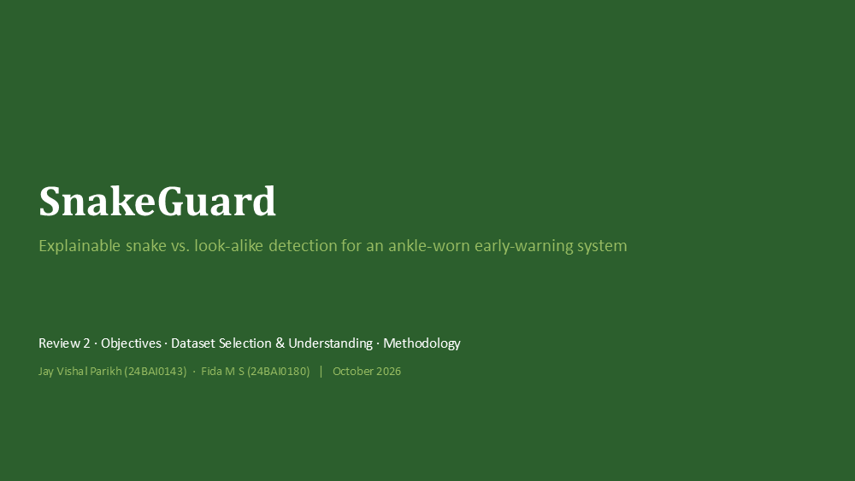  Slide 1 · Opening  ≈ 30 s · Speaker: Jay | SnakeGuard  Good morning. We are presenting SnakeGuard: explainable snake versus look-alike detection for an ankle-worn early-warning system.  We will cover three things: our objectives, how we selected and understood the dataset, and the complete methodology.  → Let me start with why this problem matters.

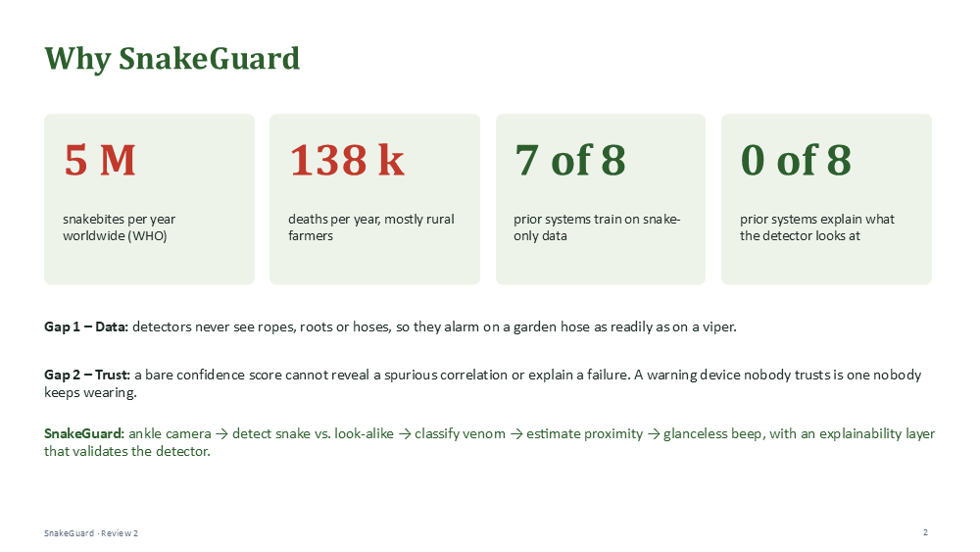  Slide 2 · Opening  ≈ 1 min · Speaker: Jay | Why SnakeGuard  The WHO estimates about five million snakebites every year and up to 138,000 deaths, mostly among rural farmers working at ground level, in tall crops and in low light.  When we reviewed eight existing systems, we found two gaps. Seven of the eight train only on snake images, so they have never seen a rope, a root or a hose, and they alarm on a garden hose as readily as on a viper.  And none of them explains what the detector is looking at. A bare confidence score cannot reveal a spurious correlation, and a warning device nobody trusts is one nobody keeps wearing.  SnakeGuard closes both gaps: an ankle camera detects snakes against explicit look-alikes, classifies venom, estimates proximity and gives a glanceless beep, with an explainability layer that validates the detector.  → So what exactly are we trying to achieve?  Tip: If asked about the numbers: they come from the WHO snakebite fact sheet cited in our proposal.

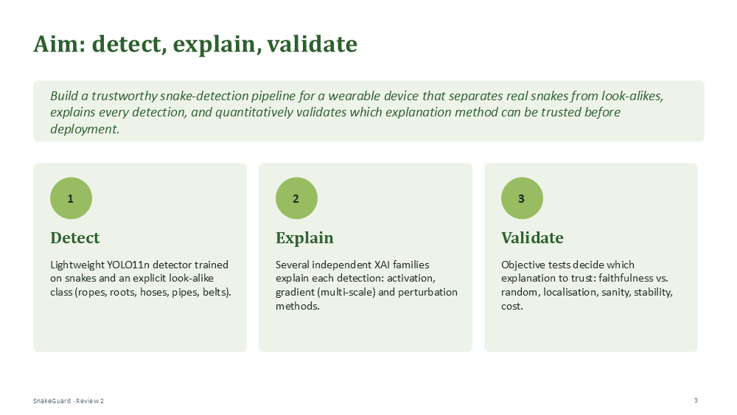  Slide 3 · Objectives  ≈ 1 min · Speaker: Jay | Aim: detect, explain, validate  Our aim: build a trustworthy snake-detection pipeline for a wearable device that separates real snakes from look-alikes, explains every detection, and quantitatively validates which explanation method can be trusted before deployment.  Three pillars. Detect: a lightweight YOLO11n detector trained on snakes and an explicit look-alike class. Explain: several independent explainability methods for each detection. Validate: objective tests that decide which explanation to trust.  The key word is validate. We do not trust a heatmap because it looks plausible; we test it.  → These pillars break down into eight specific objectives.

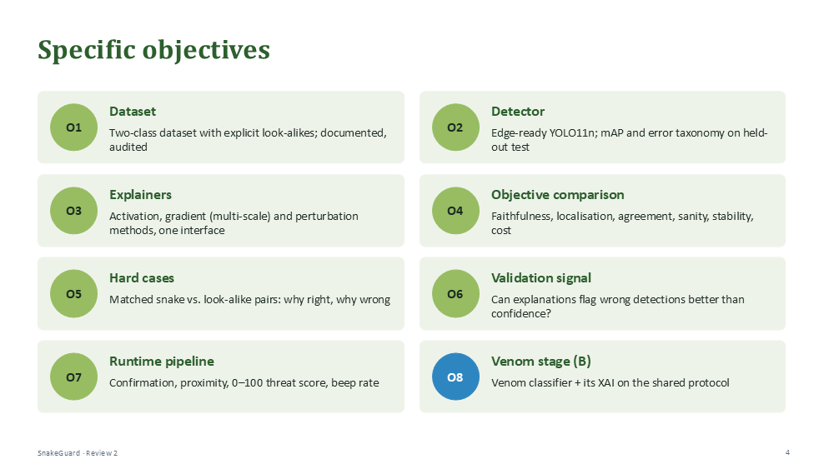  Slide 4 · Objectives  ≈ 1.25 min · Speaker: Jay | Specific objectives  O1 is the dataset: two classes with explicit look-alikes, documented and audited. O2 is an edge-ready detector, evaluated with mAP and an error analysis on a held-out test set.  O3 and O4 are the core: implement explainers from three families, activation, gradient and perturbation, and compare them objectively on faithfulness, localisation, agreement, sanity, stability and cost.  O5 studies the hardest cases, matched pairs of real snakes and look-alikes. O6 asks whether explanations can flag wrong detections better than the confidence score alone.  O7 is the runtime pipeline, and O8, in blue, is the venom classifier from Member B, which plugs into the same protocol. Each objective has a measurable success criterion in our document.  → That is what we want to achieve. Now the data we use to do it.  Tip: If asked for research questions: faithfulness, localisation, hard cases, multi-scale design, and the deployment trade-off. They are listed in Section 2.3 of the document.

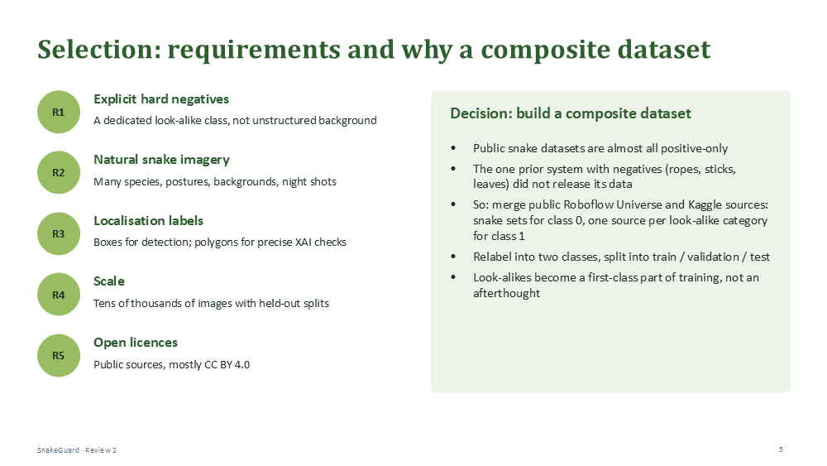  Slide 5 · Dataset  ≈ 1.25 min · Speaker: Fida | Selection: requirements and why a composite dataset  We started from five requirements: explicit hard negatives, meaning a dedicated look-alike class; natural snake images across species, postures and lighting; localisation labels, boxes and where possible polygons; scale, tens of thousands of images; and open licences.  No single public dataset meets these. Public snake datasets are almost all snake-only, and the one prior system that used ropes and sticks did not release its data.  So we built a composite dataset: public snake datasets for class zero, one source per look-alike category for class one, relabelled into two classes and split into train, validation and test. This directly addresses the dataset gap from our literature review.  → Here is what the dataset is made of.

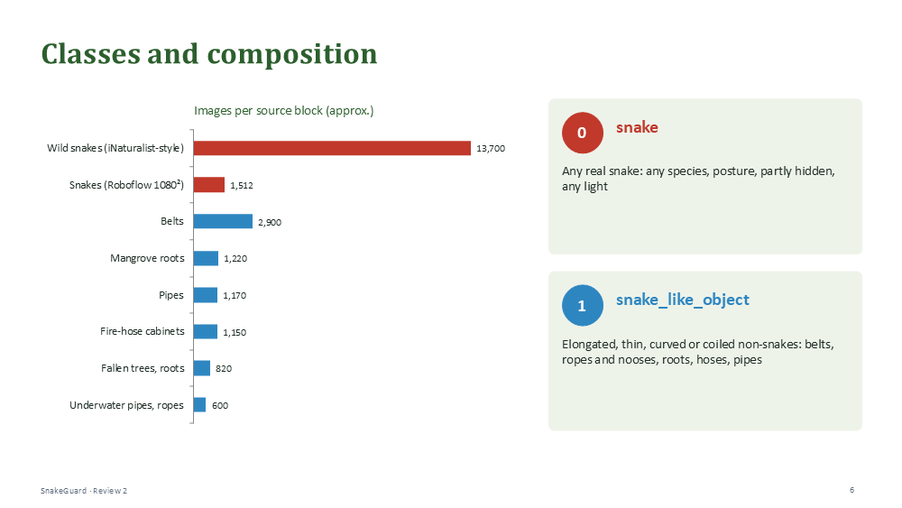  Slide 6 · Dataset  ≈ 1 min · Speaker: Fida | Classes and composition  Two classes. Class zero, snake: any real snake, any species or posture, even partly hidden. Class one, snake-like object: anything elongated, thin, curved or coiled that could be mistaken for one.  The chart shows the sources. Red is snakes: about 13,700 wild-snake photos and one Roboflow set of 1,512. Blue is look-alikes: belts, mangrove roots, pipes, fire-hose cabinets, fallen trees, underwater pipes and ropes.  The images were renamed when the sources were merged, so we reconstructed this composition from the data itself. Each source appears as a block of image numbers with one fixed resolution. The exact source links are in our project documentation.  → Here is what those images look like.  Tip: If asked why belts: they are shape negatives, teaching the model that long and curved alone does not mean snake.

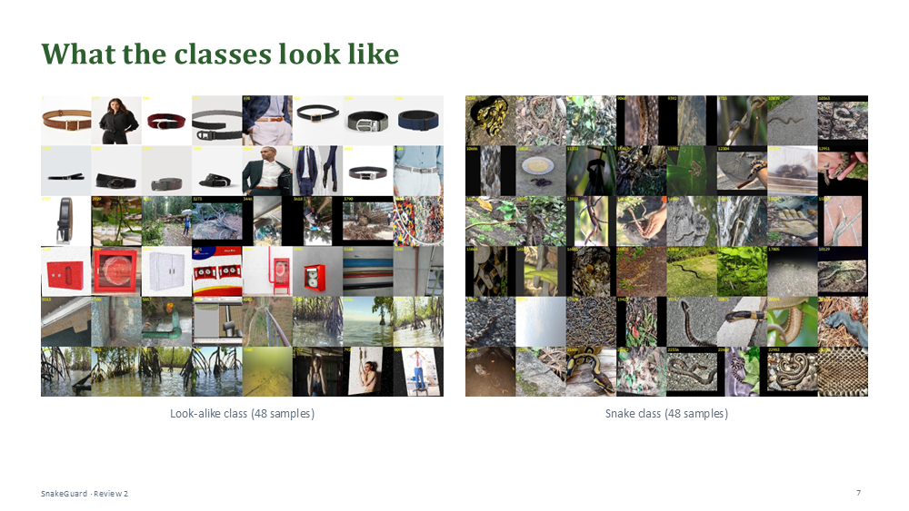  Slide 7 · Dataset  ≈ 45 s · Speaker: Fida | What the classes look like  On the left are 48 look-alikes sampled across the dataset; you can see the source blocks: belts, fallen trees, fire-hose cabinets, pipes, mangrove roots and ropes.  On the right are 48 snakes: many species, on soil, leaves, roads and walls, by day and at night.  → And the numbers behind the splits.

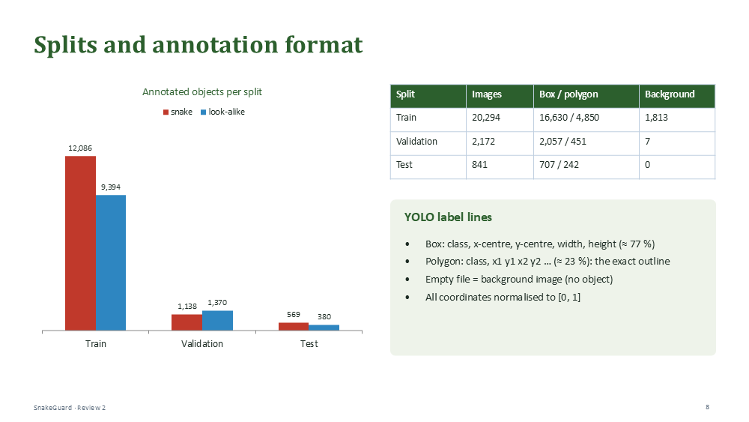  Slide 8 · Dataset  ≈ 1 min · Speaker: Fida | Splits and annotation format  In total there are 23,307 images with 24,937 annotated objects: 20,294 for training, 2,172 for validation and 841 for testing. Both classes appear in every split, at roughly 55 to 45.  Labels are in YOLO format: about 77 percent bounding boxes and 23 percent polygons tracing the exact outline. We use the polygons later as precise masks, to check whether explanations follow the actual snake body.  1,813 training images have no objects at all; they teach the detector that most scenes contain nothing to report.  → With the data in place, the methodology.  Tip: If asked about data quality: only 20 test images (2.4 %) have a near-duplicate in another split, and validation is used only for tuning. Details are in Section 3.7 of the document.

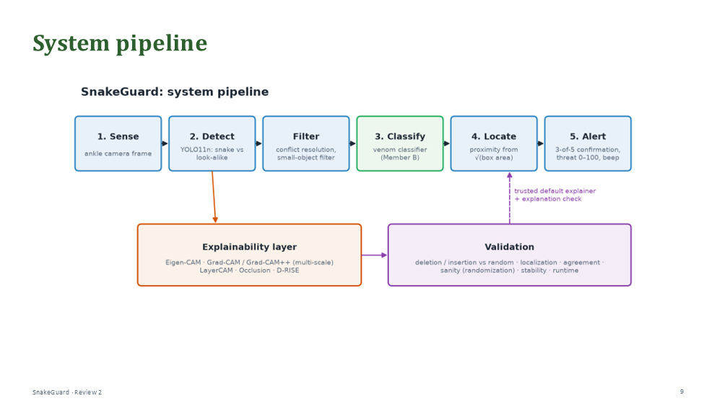  Slide 9 · Methodology  ≈ 1 min · Speaker: Jay | System pipeline  This is the whole system. Across the top are the stages from our proposal: Sense with the ankle camera, Detect with YOLO11n, Filter, Classify venom, Locate and Alert.  Below is the explainability layer, attached to the Detect stage because every later decision depends on it. The validation box tests the explanations, and the method that passes becomes the device's default explainer: that is the dashed arrow back into the pipeline.  → First, the detector itself.

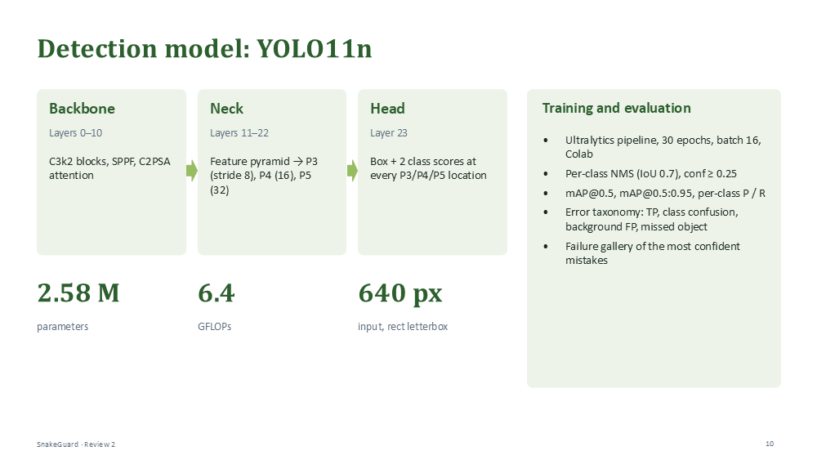  Slide 10 · Methodology  ≈ 1 min · Speaker: Jay | Detection model: YOLO11n  We use YOLO11n, the nano model, because the target is an embedded wearable: 2.58 million parameters and 6.4 GFLOPs.  The backbone extracts features, the neck builds a pyramid at three scales, P3 for small objects, P4 for medium and P5 for large, and the head predicts a box and two class scores at every location.  It is trained with the Ultralytics pipeline for 30 epochs at 640 pixels, and evaluated with mAP, per-class precision and recall, and an error taxonomy: correct detections, class confusions, background false positives and missed objects.  → Now, how we explain a detection.

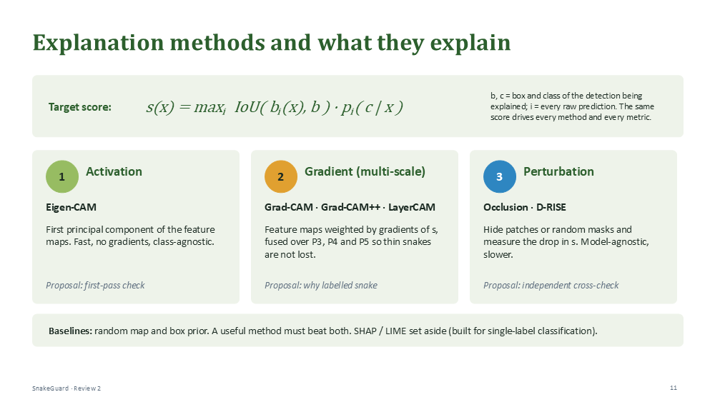  Slide 11 · Methodology  ≈ 1.5 min · Speaker: Jay | Explanation methods and what they explain  YOLO outputs hundreds of boxes, so we first define what we explain. For a detection with box b and class c, the target score is the best overlap-times-probability among all raw predictions. On the original image it equals the detection's confidence, and when we hide parts of the image it keeps following the same object. Every method explains this same score.  We use three independent families that cross-check each other. Activation: Eigen-CAM, fast and gradient-free but not class-specific. Gradient: Grad-CAM, Grad-CAM++ and LayerCAM, fused over the three scales P3 to P5 so a thin snake is not lost in the coarse grid. Perturbation: occlusion and D-RISE, which hide parts of the image and measure the drop. They are model-agnostic, which makes them the independent cross-check.  Two baselines, a random map and a box prior, tell us whether a method beats chance or just highlights the box. SHAP and LIME are set aside, as in our proposal, because they assume single-label classification.  → How do we decide which explanation to trust?  Tip: If asked why multi-scale: P5 is only a 20 × 20 grid, while P3 (80 × 80) keeps the fine detail. Single-scale versions are kept as ablations to test the claim.

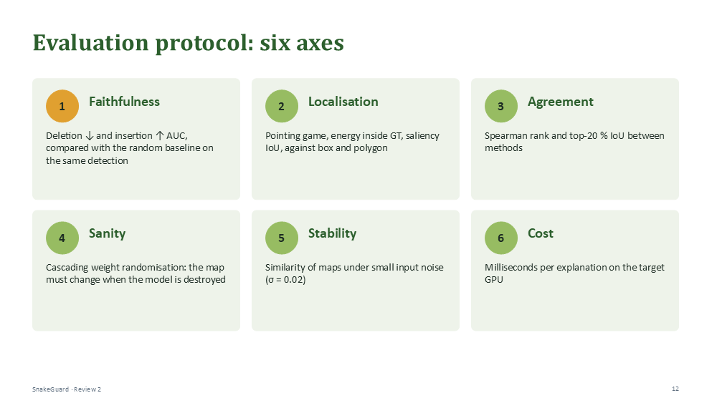  Slide 12 · Methodology  ≈ 1.25 min · Speaker: Jay | Evaluation protocol: six axes  Every explanation is scored on six axes. The main one is faithfulness: we remove pixels in the order the explanation ranks them, and a faithful map makes the score collapse quickly; revealing them in the same order should restore it quickly. We compare against a random ordering on the same detection.  Localisation checks that the explanation falls on the object, against both the box and the exact polygon. Agreement compares methods. Sanity: if we randomise the network's weights, the explanation must change. Then stability under small noise, and cost in milliseconds.  Settings are tuned on validation only, the test split is used once, and results come with confidence intervals and paired statistical tests.  → Finally, the runtime pipeline that turns detections into alerts.  Tip: If asked for the formula: deletion and insertion are areas under the score curve, normalised by the original score. Lower is better for deletion, higher for insertion.

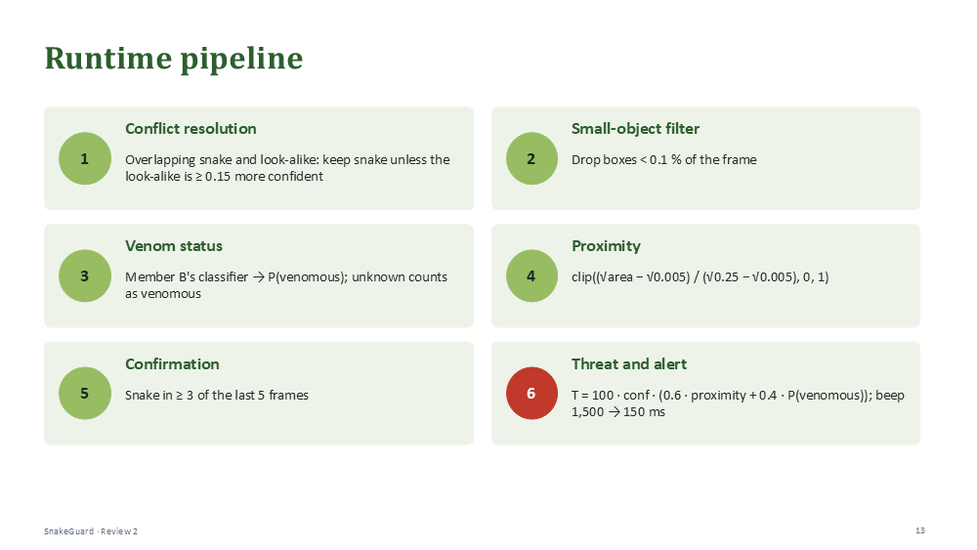  Slide 13 · Methodology  ≈ 1.25 min · Speaker: Jay | Runtime pipeline  Around the detector there are six steps. Conflict resolution with a safety bias: if snake and look-alike boxes overlap, we keep the snake unless the look-alike is clearly more confident. A small-object filter removes distant noise. Venom status comes from Member B's classifier, and unknown counts as venomous.  Proximity comes from the square root of the box area, because an object looks bigger as it gets closer. Confirmation requires a snake in at least three of the last five frames, which removes one-off false alarms.  Finally, a threat score from 0 to 100 combines confidence, proximity and venom, and sets the beep interval from 1.5 seconds down to 150 milliseconds.  → To close, the scope of this phase and how we divide the work.  Tip: If asked why unknown venom counts as venomous: under-warning is far more costly than an unnecessary warning.

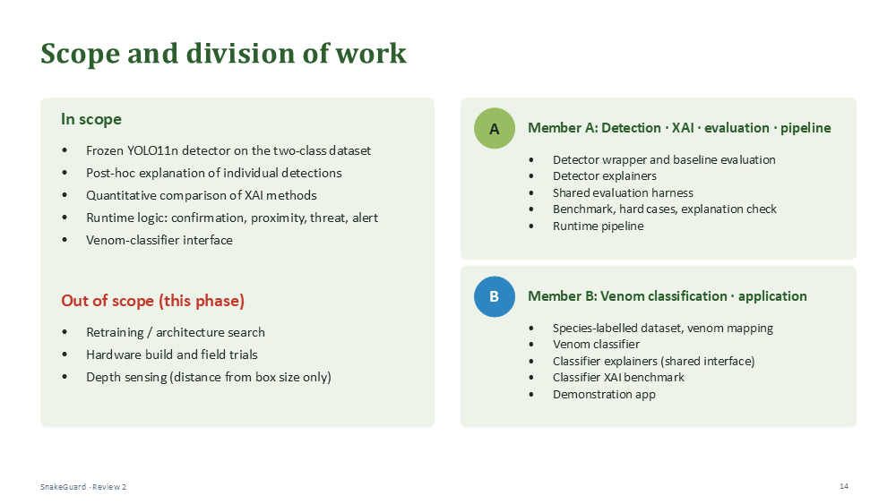  Slide 14 · Plan  ≈ 1 min · Speaker: Fida | Scope and division of work  In scope for this phase: the detector is frozen so our work explains one fixed model; we explain individual detections, compare the methods quantitatively, and build the runtime logic. Out of scope: retraining, the hardware build, field trials and depth sensing.  Member A owns detection, the explainability methods, the shared evaluation harness and the pipeline. Member B owns the venom dataset, the classifier, its explanations and the demonstration app. Both use the same evaluation protocol, so results are directly comparable.

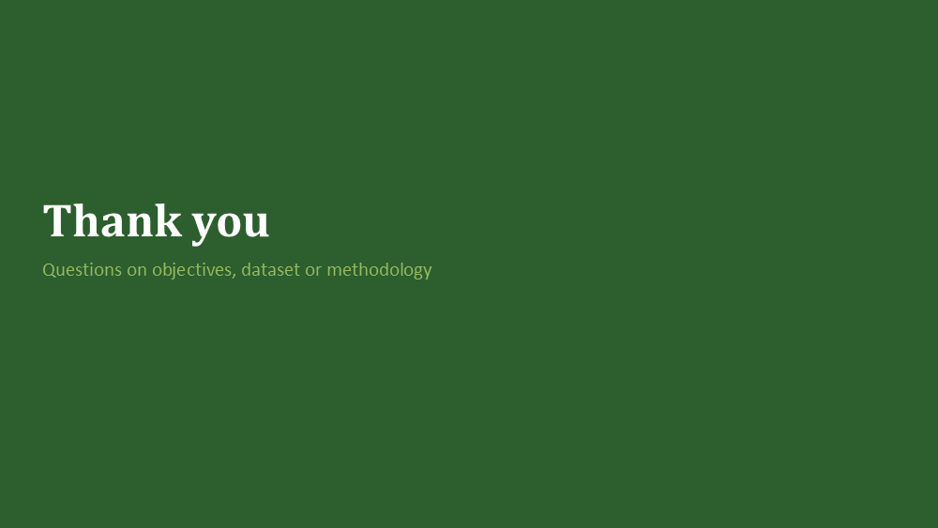  Slide 15 · Close  ≈ 30 s · Speaker: Fida | Thank you  To summarise: we want a snake detector whose reasoning is tested before anyone relies on it. That takes a dataset with explicit look-alikes, and a methodology that judges explanations by evidence, not by appearance.  Thank you. We are happy to take questions.  Tip: Prepared answers to 30 likely questions are in Chapter 5 of the Review-2 document.

