Algonquin College Logo

# SCHOOL OF ADVANCED TECHNOLOGY

### ICT - Applications & Programming

### Computer Engineering Technology – Computing Science



A11

Game Interface

Team:

[Neeraj Kumar Bansal] - Id: [041000185] / [Jay Patel] - Id: [041028206 ]

Game Proposal - NumPuz

***This template is suggested (not mandatory) to answer A11 Specification.***

|  |  |
| --- | --- |
| **Part**  **1** | **GUI Definition** |

**EXPLANATION**

*The purpose of this assignment is to define the elements of the GUI application to be used in your game implementation.*

* ***Example****:*

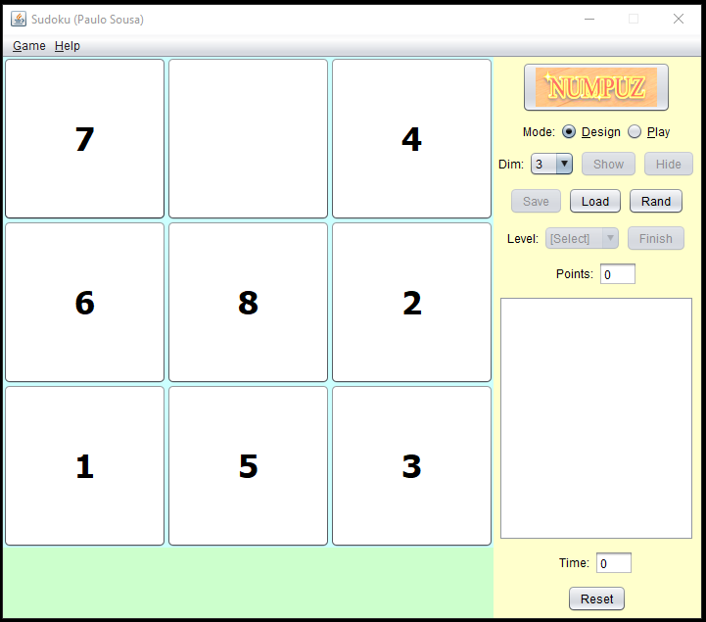

* ***Note****: The professor interface is also a proposal. It means that your own implementation can be different. What does matter is that the game functionality will be respected.*
  1. **Defining the Components**

**List of components**

*Include the list of components that you will use (they can be from Swing or JavaFX).*

1. ***JRadioButton****: Creates an unselected button which allow to choose one option from multiple options.*
2. ***JButton****: Creates a labelled button that has platform independent implementation.*
3. ***JTable****: Helps to print data in tabular form*
4. ***JScrollBar****: Used to add horizontal or vertical scrollbar.*
5. ***JToggleButton****: Creates a toggle button, two-states ON or OFF.*
6. ***JLabel****: Label class used to place text in a container.*
7. ***JProgressBar****: This is used to show progress of the task.*
8. ***Digital Watch****: Using calendar class and time, show digital clock.*
9. ***JComponent****: Base class for all swing components like JPanel, JScrollBar, etc.*

**Functionalities and Behaviors** [1]

*What are the behaviors and functionalities that you will provide? How these elements are related with functionalities.*

***Example****:*

1. *The game has an option for choosing the dimensions for it and that is going to be implemented using JRadioButton and JScrollBar.*
2. *There is a moves option too which counts every movement of empty block and increments the count by 1, this functionality requires JButton and position of empty block on puzzle.*
3. *Sound functionality requires JToggleButton which allows user to turn the music or sound ON and OFF.*
4. *Timer counts the current game time and at the backend, it is going to use Digital Watch function which is using Calendar class and Time.*
5. *Tips function is giving description to user and using JText and JLabel on the coding side.*
6. *All the components are being group together using a uniform Panel.*
7. *The Progress Bar function will let the player know of the progression of the current game and requires logic where the result matches with the saved result in the code and increasing percentage based on similarity between 2 versions.*
8. *New Game or reset button is a JButton function which resets the current game and randomizes the numbers again.*
9. *All the numbers are in format using JPanel, JLabel and JTable and in random format using rand function.*
10. *When the player arranges the numbers in ascending format starting from left to right, a winning pop up is going to give congratulations and an option to start new game.*

**Details**

*Drawn your interface (ex: in an image from Paint / Powerpoint slide, or any sketch tool), describing:*

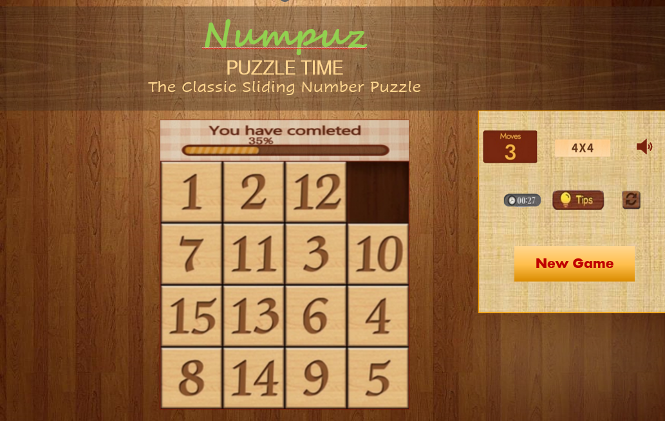

* 1. **User Manual**

**Basic cycle**

*Create a brief description about how your game can be used.*

Numpuz is a puzzle game which can be played in 7 different dimensions (from 3x3 to 9x9). The player need to arrange randomly placed numbers in ascending order starting from the top-left corner in the least possible time and number of moves. The game difficulty gradually increases with the rise in the size of dimension.

Progress bar on top help player to let him know if the move was correct or incorrect and sound button uses toggle ON or OFF and “New Game” button reset the game for chosen dimension.

**FINAL SUGGESTIONS**

*Here some ideas to think about your language....*

* *Try to create a game whose execution can be very intuitive (easy to be played).*
* *Remember that this game will be in fact implemented only in the next assignment.*

**References**

|  |  |
| --- | --- |
| [1] | P. Pedamkar, "Swing Compnents in Java," 2020. [Online]. Available: <https://www.educba.com/swing-components-in-java/>.  <https://www.javatpoint.com/java-swing> |

Algonquin College

Fall, 2022