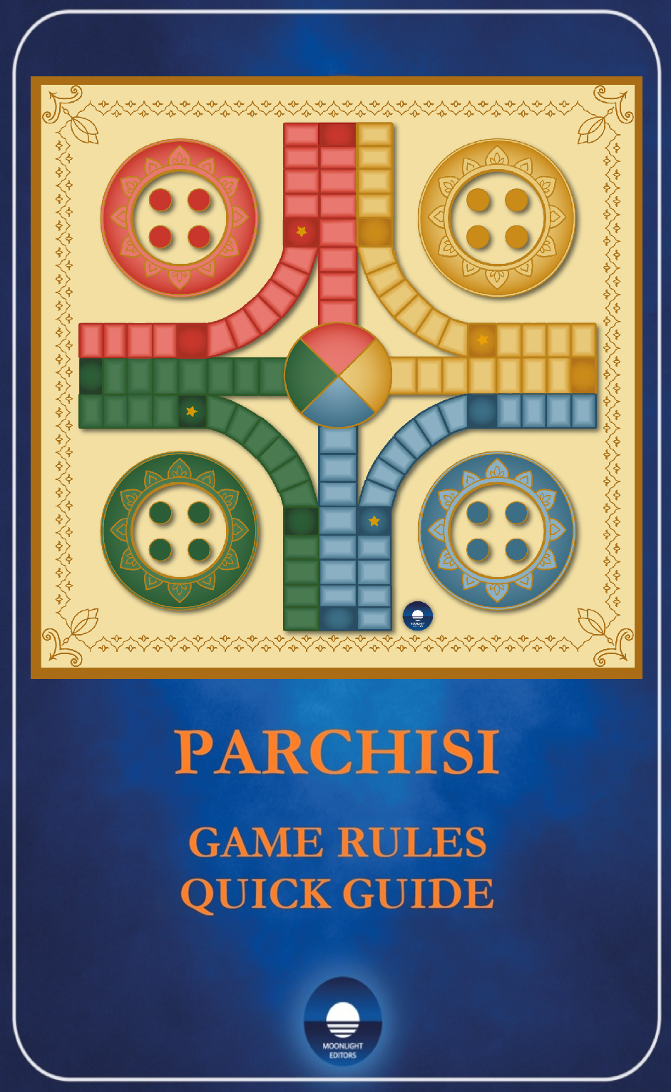

UNIFIED PARCHISI RULES

CONTACT............................................ .................................................2
PC 1. INTRODUCTION.................... ...............................................3
PC 1.1. BOARDS........................................ .............................................3
PC 1.2. PAWNS.......................................... ..............................................3
PC 1.3. DICE............................................. ................................................3
PC 1.4. OBJECTIVE OF THE GAME.... ...........................................3
PC 2. PAWNS MOVEMENT................ .............................................3
PC 2.1. DEPARTURE............................. ................................................4
PC 2.2. PROTECTED AREAS............ ...............................................6
PC 2.3. DOUBLES................................. ...............................................6
PC 2.4. BARRIERS................................. ...............................................7
PC 3. REMOVE PAWNS.................. ...............................................8
PC 4. FINISH ARRIVAL................... ...............................................8
PC 5. REWARDS.................................. ..............................................9
PC 6. ORDER OF PRIORITY.......... ...............................................9
PC 6.1. REMOVE BARRIERS... 9
PC 6.2. COLLECT REWARDS.. 9
PC 6.3. MOVE A PAWN OUT OF THE SHELTER ...................9
STRATEGICS TIPS.......................................... ...................................9

CONTACT
If you have any questions or concerns about a specific move or situation, please send your images, inquiries, or suggestions to our customer service team. We welcome your feedback and suggestions. customers@parkillergame.com
You can also view the rules and special situations on our website.https://parkillergame.com

PC 1. INTRODUCTION
This ancient game originated in India and has been interpreted and adapted in different ways in various countries. The rules are often changed to suit local customs. We standardized the rules using two dice to make the game more dynamic and exciting.

PC 1.1. BOARDS
The classic game board included in the box is designed for four players and features 68 movement spaces and eight spaces on the finish path. While our modern design stays true to the classic layout, you can still use the old board if you prefer.

PC 1.2. PAWNS
Each player is assigned a color and may use the four corresponding pawns.

PC 1.3. DICE
Two white dice with black dots will be used to move the pawns across the board.
The first player to roll will be the one who rolls the highest number. In the event of a tie, the roll will be repeated. Then, the player to their right will take their turn, and so on. Each player’s pawn color can also be determined by drawing lots to decide their starting position on the game board..

PC 1.4. OBJECTIVE OF THE GAME
Be the first to get all four pawns to the center circle.

PC 2. PAWN MOVEMENT
Pawns move counterclockwise, that is, from right to left.
― Both white dice are rolled at the same time, and pawns can be moved individually using the value of one die, the value of the other die, or the sum of both.
― Once a pawn has been moved and placed on a square, the move cannot be undone or changed.
― If the move is impossible, the roll is lost.
― There can never be more than two pawns per square.
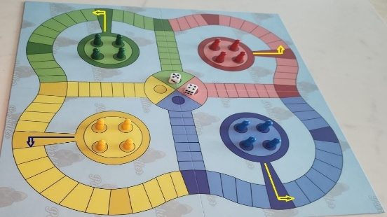

PC 2.1. DEPARTURE
― A pawn is placed on the starting square when a 5 is rolled on one die or when the sum of both dice is 5 (e.g., 1+4 or 2+3). A pawn must move to the starting square unless it is already occupied by two of the player's own pawns. In that case, any other pawn may be moved.
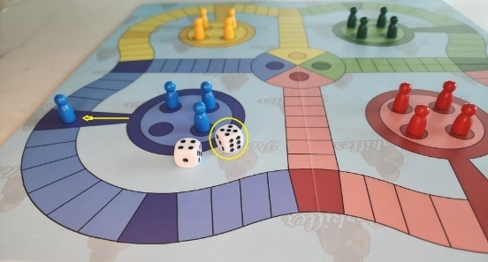
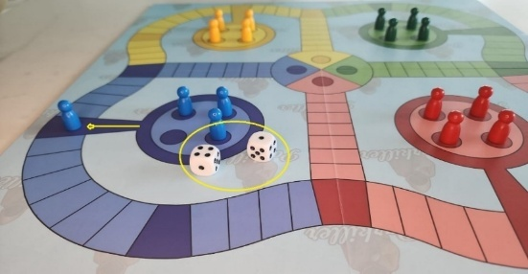
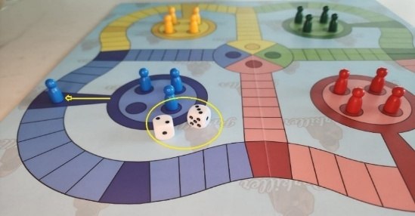
― If the starting square is occupied by a pawn belonging to another player and a pawn belonging to the shelter's owner, and the number 5 is rolled (5, 1+4, or 2+3), the opposing pawn is removed.
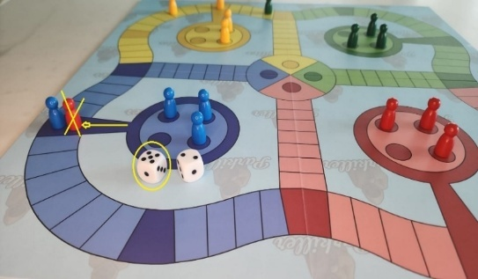
― If another player's pawn is on the starting square and you roll doubles of five, that pawn is removed. (You must have two pawns left to move)
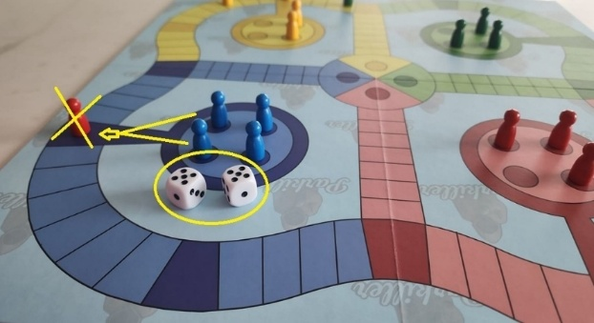
― If there are two pawns of different colors on the starting square and a five is rolled, the one that arrived last is eliminated.
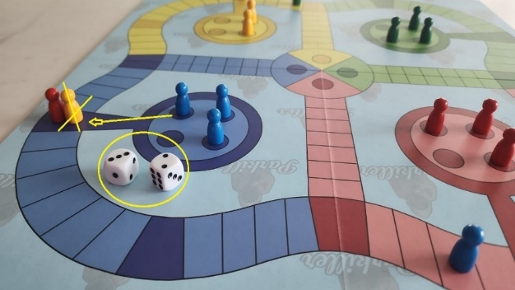
― If there are two pawns of different colors on the starting square and a double five is rolled, both are removed. *(You must have two pawns left to move)
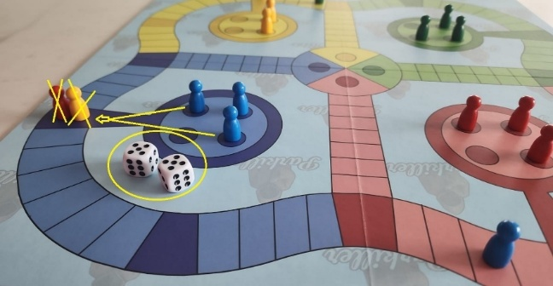
― Pawns must be moved according to the numbers on both dice. If only one pawn can be moved, the higher number is always used.
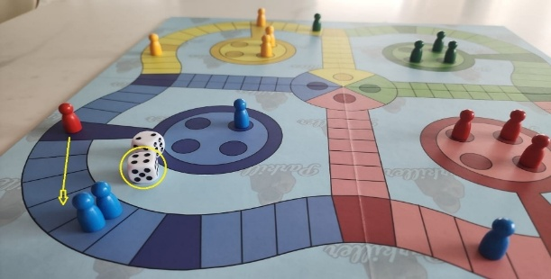

― If that doesn't work, use the lowest number on the other die.
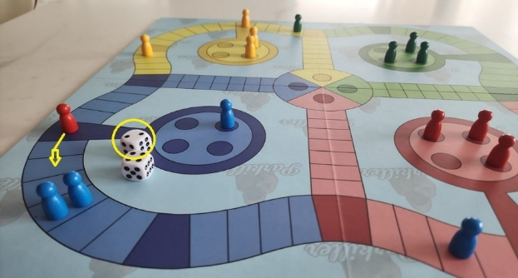

PC 2.2. PROTECTED AREAS
― Pawns are protected from attacks by other players' pawns if they are in any of the safe zones, marked in a darker color, except on another player's starting square if one of that player's pawns moves out according to the conditions described above.
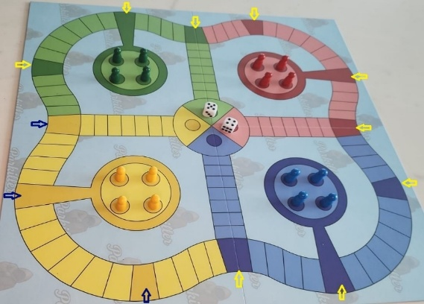

PC 2.3. DOUBLES
― If a player rolls doubles, they may roll the dice again. On the third roll of doubles, the last piece moved is eliminated, except in the home zone, where it may roll again.

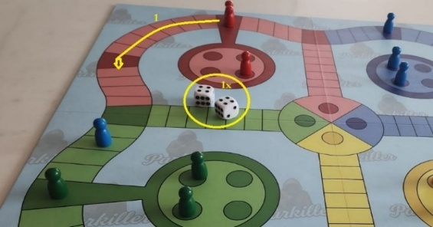
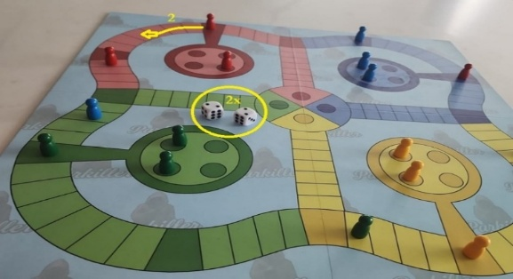
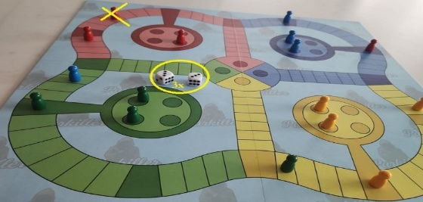

PC 2.4. BARRIERS
― A player can form a barrier by placing two pawns of the same color side by side on the same square, or two pawns of different colors in a protected area, so that both are safe from other players' pawns.
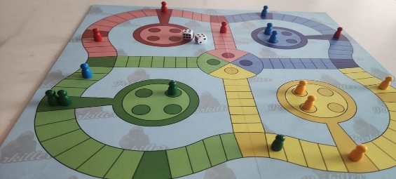
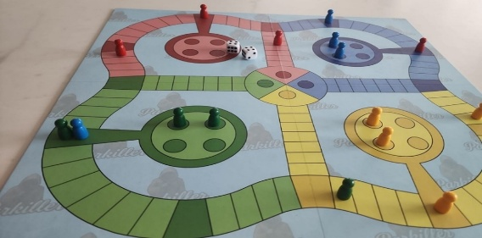
― No pawn, not even those of the same color, can jump over the barriers.
― Scoring a double forces the player to open a barrier, including those in the finish zone, if the numbers allow it.
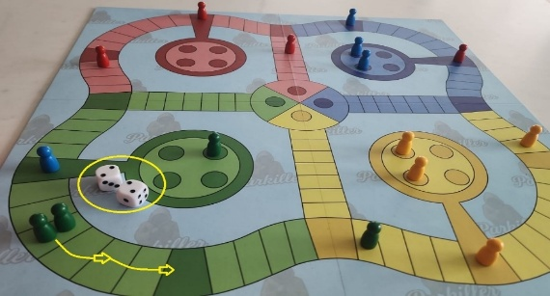
― If a barrier is formed using the number on one die, there is no requirement to break it with the number on the other die, even if it was formed with a double. The second number rolled can be used to move another piece.
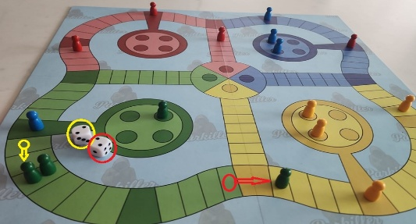
― You cannot move both pawns from a barrier—each by the number rolled on a double—and create a new barrier at a distance. You can move one of the pawns from the barrier by the sum of the two dice, or move one of them by the value of one die and a third pawn by the value of the other.
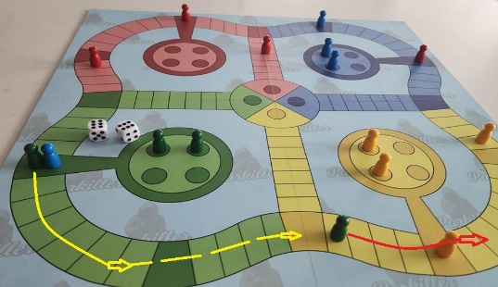
― This does not apply in the final stretch. A double can allow two pawns to reach the finish line.
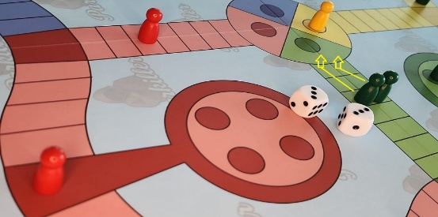

PC 3. REMOVE PAWNS
― If the roll of a die or the sum of both dice lands on a space occupied by another player's pawn, that pawn is eliminated and must return to its starting point. You receive a reward of 20 spaces. If there is a barrier and you cannot claim the reward, you lose it.
― If the number rolled on one of the dice matches the square occupied by another player's pawn, you can only move forward if you capture that pawn. You cannot “jump” without capturing.
― If you want to avoid this, you can move another pawn with the same number first, and then the pawn in question.
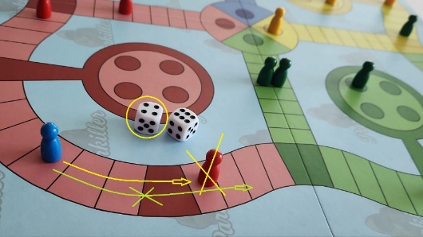

PC 4. FINISH ARRIVAL
― When a pawn completes a lap around the board and reaches a dark square of its own color, it turns onto the path leading to the finish line in the center of the board.
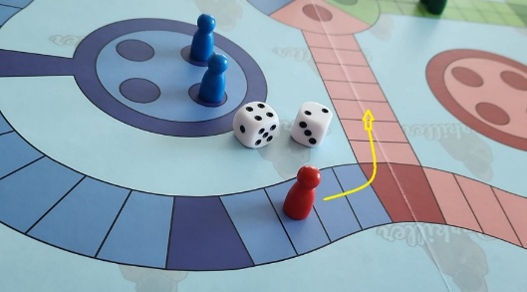
― To reach the finish, you must move the exact number of remaining squares.
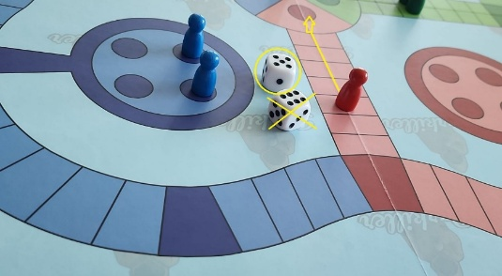
― For every pawn that reaches the finish line, you receive a reward of 10 squares.

PC 5. REWARDS
― Rewards must be used on pawns currently in play. You cannot remove a pawn from the shelter after receiving a reward and then claim it.
― Rewards must be claimed immediately after they are obtained, or they will be forfeited. Other moves may then be made.
― If, while counting a reward, you land on another player's space, that player is eliminated and the reward is added to your total.

PC 6. ORDER OF PRIORITY
No player is allowed to give instructions to another player regarding where to place their pawns, or how to remove or block their opponents' pawns.
In ORDER OF PRIORITY, the obligations are: (unless movement is impossible).
PC 6.1. REMOVE THE BARRIERS if the same number appears on both dice (double).
PC 6.2. COLLECT REWARDS by moving a pawn across the squares earned. First for eliminating another player's pawn (20x) and then for a pawn reaching the finish line (10x). Any rewards that cannot be collected are forfeited.
PC 6.3. MOVE A PAWN OUT OF THE SHELTER. You may then move forward the number of spaces corresponding to the roll of the remaining die, if there is one.

STRATEGICS TIPS
― The goal is not to eliminate your opponent's pieces. Doing so sends them back to their starting point, which can be useful, as can creating barriers that prevent them from advancing or force them to risk being eliminated. The ultimate goal is to reach the finish line with all four of your pawns before the other players.
― You should try to avoid risks and proceed through the protected areas.
― Before capturing an opponent’s pawn, it’s best to calculate where your own pawns would end up with the rewards. It might be a good idea to advance those pawns, but it could also put the pawns that have advanced further at risk. It’s better to risk the pawns closest to the home board so that the others have a better chance of reaching the finish line.



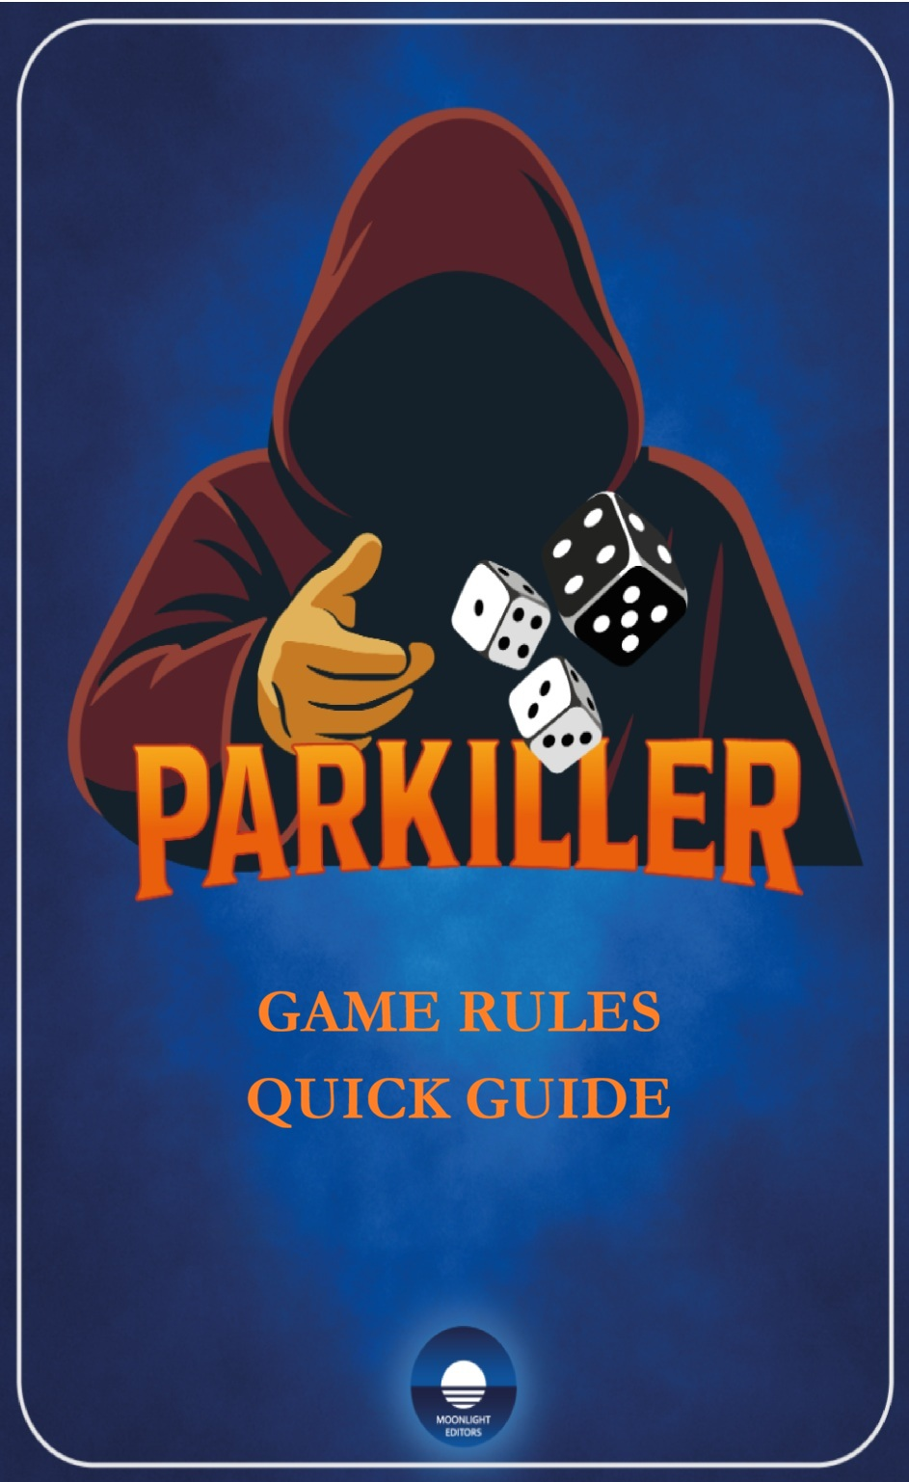

PARKILLER™®
THE PARCHISI OF THE 21ST CENTURY
STRATEGY, LUCK, AND INTELLIGENCE
TRY YOUR HAND AT PARKILLER A MERCILESS PAWN USE THE BLACK DICE

You can play the classic four-player game, but you also have access to other revolutionary boards and unprecedented options that let you play a head-to-head duel, a three-player game, or spend a weekend afternoon with five or six friends.
Parkiller doesn’t redefine the rules: it’s simple, but more fun and exciting.
There are also two alternative game modes available: the pairs mode or the single-player mode with two colors.

INSTRUCTIONS

PK 1. THE PARKILLER'S PAWN 13
PK 2. THE BLACK DICE............ 13
PK 3. PARKILLER'S MOVEMENTS 14
PK 4. PARKILLER AND BARRIERS 14
PK 5. REMOVE PAWNS............. 16
PK 6. REMOVAL OF THE PARKILLER 16
PK 7. REWARDS AT PARKILLER 17
PK 8. ORDER OF PRIORITY....... 18
V. VARIANTIONS OF THE GAME 18
V1. DOUBLES MATCH.............. 18
V2. A PLAYER WITH TWO COLORS 18
STRATEGICS TIPS.......................... 18
GAME FOR A LIFE'S JOURNEY: PARKILLER 20

PARKILLER®™ GAME RULES

PK 1. THE PARKILLER'S PAWN
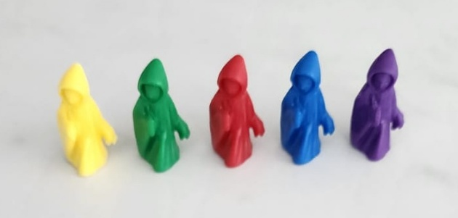

PK 2. THE BLACK DICE
The black die with white dots is rolled only once per turn, even if a double is rolled with the white dice. It is resolved first, with the Parkiller moving first.
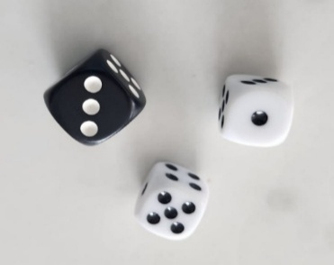

PK 3. PARKILLER'S MOVEMENTS
The pawn moves clockwise in front of the players' pawns: from left to right.
―The Parkillers start at the finish square in the center of the board.
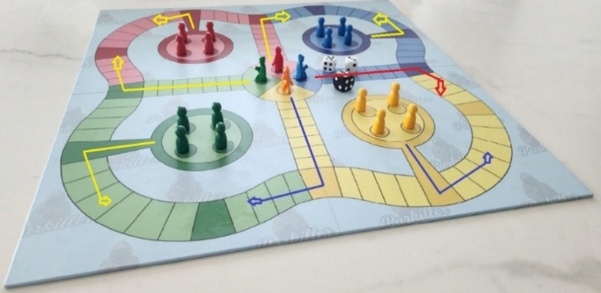

PK 4. PARKILLER AND BARRIERS
― The Parkiller can jump over barriers by counting the space they occupy.
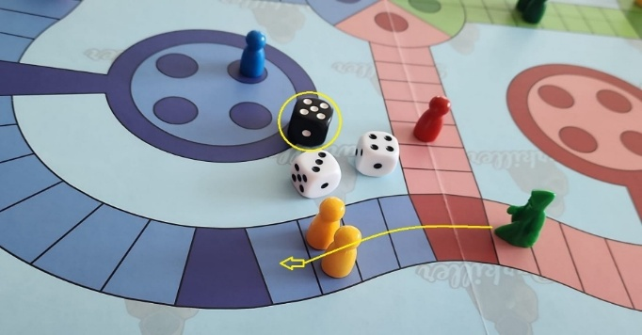
― A Parkiller can form a barrier with a pawn of the same color or with a pawn of a different color on a protected square.
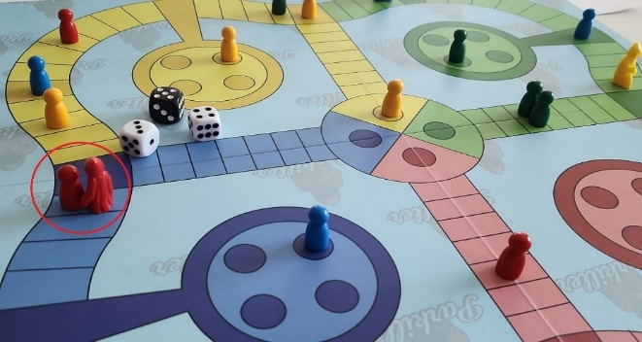
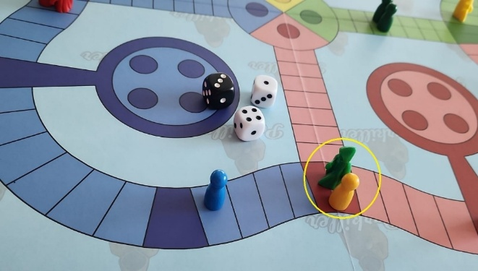

― If a Parkiller lands on a barrier formed by pawns of a different color, it eliminates the one that arrived last.
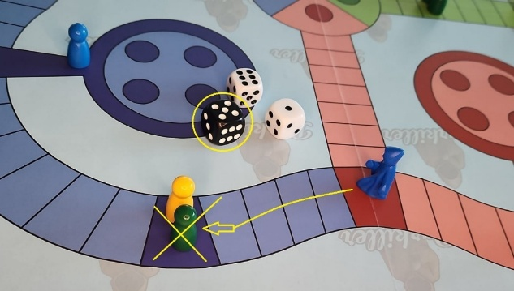
― If one of the pawns is the same color as Parkiller, the other player's pawn is removed.
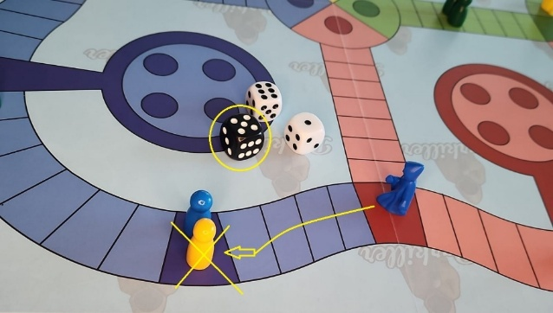
― If a Parkiller lands on a barrier formed by two of the same player's pawns, one of the pawns is eliminated.
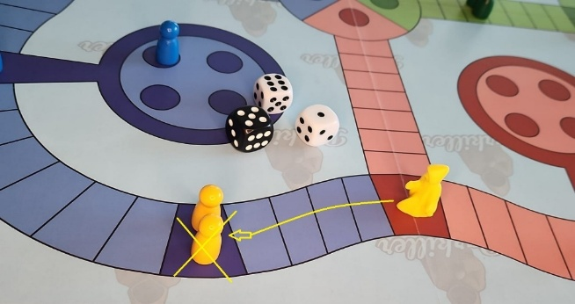
― If another Parkiller lands on a barrier formed by a Parkiller and a pawn of the same color, the pawn is eliminated and the two Parkillers form a new barrier. A pawn protects its Parkiller.
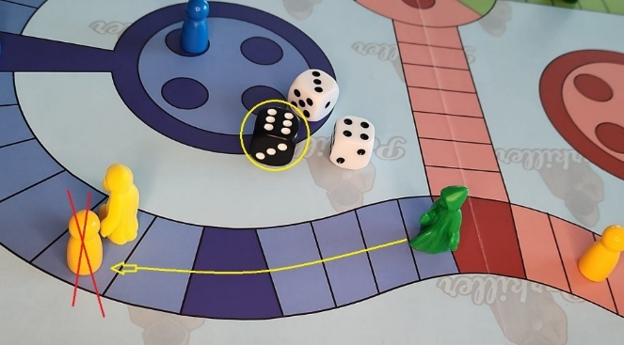

PK 5. REMOVE PAWNS
There is no reward for pawns eliminated by the Parkiller.
― The Parkiller removes any pawn of a different color that matches the number on its die, except in protected zones, where it would form a barrier with that pawn.
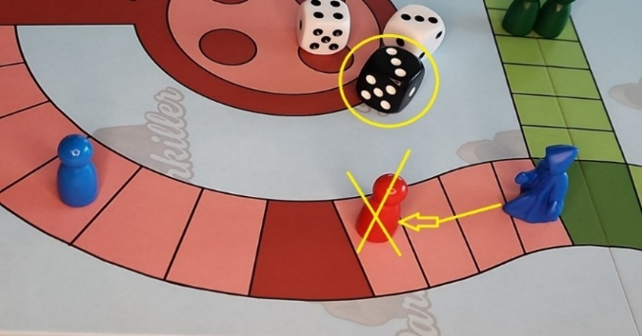
― Pawns are eliminated if the number obtained by adding the two dice matches the square occupied by the Parkiller and they have no legal moves with other pawns. The elimination of a pawn results in the loss of any remaining rewards, if any.
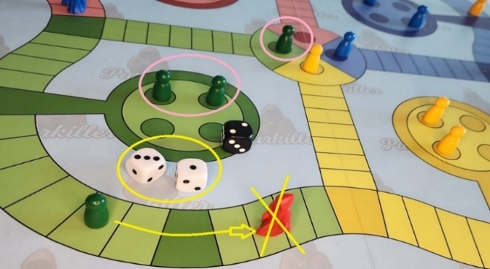
― You can avoid the Parkiller if one of the dice shows a number different from the one on your location.
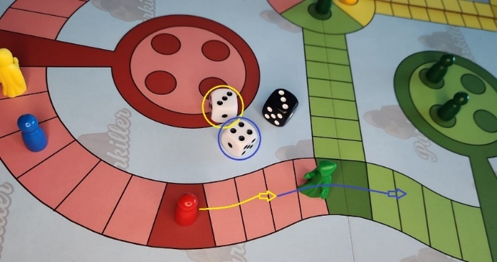

PK 6. REMOVAL OF THE PARKILLER
― Eliminated Parkillers leave the game, and the player can only use the white dice to move their pawns. The reward for eliminating a Parkiller is 10 x 2 spaces.
― If a Parkiller lands on an unprotected space occupied by another Parkiller, it eliminates that Parkiller and can collect the 10 x 2 reward.

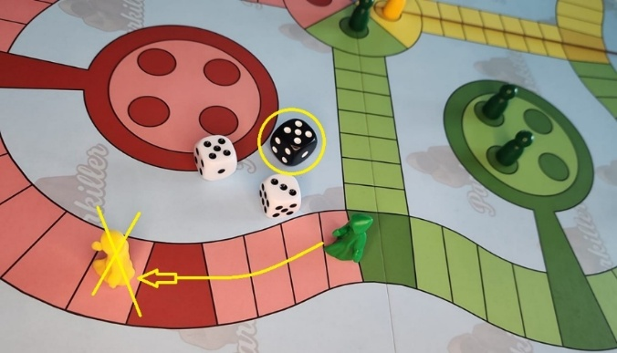
― If a pawn moving straight ahead rolls a double of the number separating it from the Parkiller, it eliminates the Parkiller, unless the Parkiller is in a protected zone.
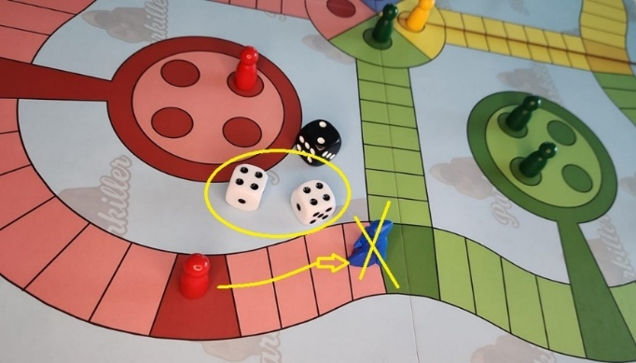
Se mueve con la cifra de un dado el peón que elimina al Parkiller, se cobra la recompensa, se cuenta la cifra del dado restante y se vuelven a lanzar los dados.

PK 7. REWARDS AT PARKILLER
― Eliminating another player's pawn or Parkiller is rewarded with a move of 10 x 2 squares for each piece eliminated, and this reward can be claimed using the same pawn or different pawns. Eliminating a Parkiller does not count as a double.
― Crossing the finish line earns you 10 spaces per pawn.
― In the event of a double elimination, the reward may be claimed by both pawns on a barrier, provided that the rule against forming a new barrier at a distance is observed.
― Each 10-space jump resulting from a reward has a chance of landing on a space occupied by a pawn of a different color, which would be eliminated and whose reward would be added to the existing one.

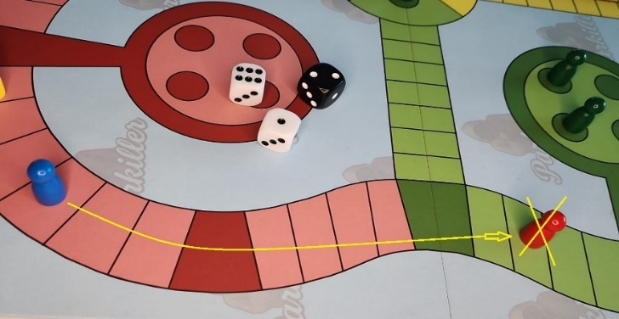

― You also risk being eliminated if you land on a space occupied by another player's Parkiller.

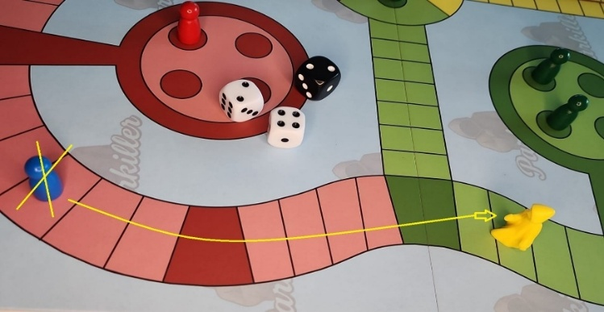

PK 8. ORDER OF PRIORITY
THE REMOVAL OF A PARKER BY A PAWN TAKES PRECEDENCE OVER ANY OTHER RULE AND IS RESOLVED FIRST.
It is not mandatory to capture the Parkiller, but there is no rule preventing you from doing so. You may inadvertently miss the opportunity to do so by moving a pawn other than the one that could capture it.

V. VARIANTIONS OF THE GAME

V1. DOUBLES MATCH
― Four people play, forming two pairs, with each player standing next to the side of the game board opposite their opponents.
― Each player moves the pawns and Parkillers of their own color. However, if they cannot make a move (because they have completed the course with their 4 pawns), they must move one of their partner’s pawns.
― Pawns of different colors can capture each other, even if they belong to the same team.
― The Parkillers eliminate any pawn that isn't their own color, including those belonging to their partner.
― The winning team is the one that completes the course with all 8 pawns of both colors.

V2. A PLAYER WITH TWO COLORS
― Two players take part, each controlling two colors located at opposite ends of the game board.
― On their turn, players may only move the pawns of the color corresponding to the roll until all of them have reached the finish line; at that point, they may move the pawns of the other color on their turn.
― Pawns of different colors can capture each other, even if they belong to the same player.
― The Parkillers remove any pawn that isn't their own color, even if it belongs to the same player.
― The winner is the player who completes the course with all 8 pawns of both colors.

STRATEGICS TIPS
― Before capturing an opponent's pawn, it's best to calculate where your own pawns would land with the rewards to avoid landing on a Parkiller.
― Remember that the Parkiller can ruin your entire strategy. Look behind you to check on your opponents, but don't forget to watch out for Parkillers coming head-on, including your own.

Sometimes there aren't enough people to organize a game, or, conversely, there are more people who want to play a weekend game. We've designed balanced game boards with the number of squares adapted for two, three, four, five, or six players.

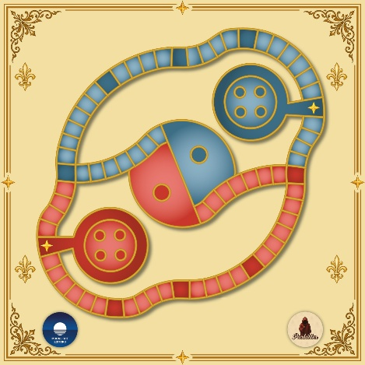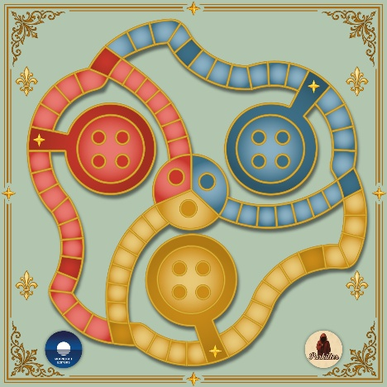
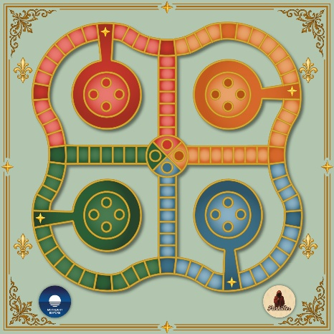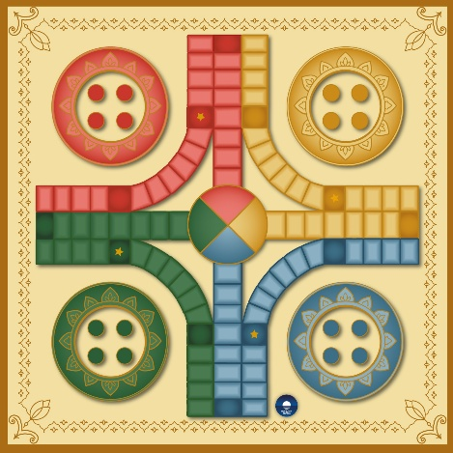
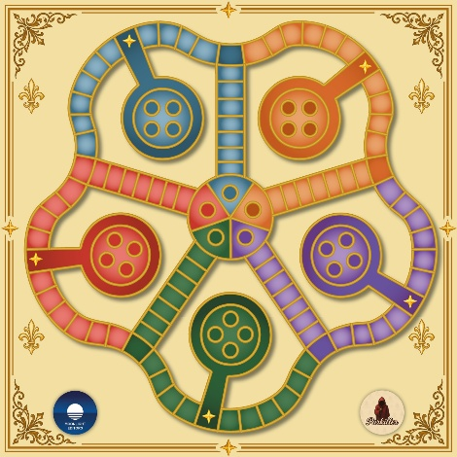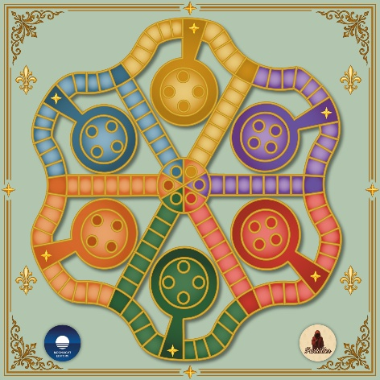

GAME FOR A LIFE'S JOURNEY: PARKILLER

This game is like life. You can't play it alone!
You'll learn to win, knowing that someone else will lose. Having class means consoling the loser and appreciating their effort. That's pure «upper class».
You will learn how to lose gracefully, viewing defeat as a normal part of life from which you can learn and improve next time. You will accept that there are those who are better than you or who were luckier in their decisions. Knowing how to lose is essential to truly appreciating the value of a victory.
Envy will get you nowhere. Don't belittle the winner; applaud and value the merit of their victory. If they can do it, so can you. That's called «respect».
When you win, you'll understand that you succeeded because you made good decisions at the right time, but luck helped too. Other people will influence your success through their attitudes and decisions. They will help you, either willingly or unwittingly. Some, with their negative attitudes, will motivate you to prove what you are capable of.
You will lose because you didn't make the right decisions at the right time, or because luck wasn't on your side. Others will influence your defeat because they performed better or were luckier. Resentment will get you nowhere!
You will learn that you can unintentionally hurt others just by participating in the game. Every decision you make will have repercussions on other people, whether you know it or not.
Likewise, other people's decisions will affect your life, and you won't be able to do anything about it because it's not up to you.
You will encounter the «Parkillers», characters who, for reasons unknown to you, want to eliminate you. They may want your place if you are doing well, or they may want to bring you down further if you are already having a difficult life. You can see them coming! Don't be surprised, even if circumstances lead you to them.
The mediocre, envious, and mean-spirited are the most dangerous. They have no friends, only accomplices of circumstance, and they can kill each other. You can recognize them by their cloaks of slander and lies.
Not everything that happens to you is the result of your decisions, work, or efforts.
You must learn to choose the best path and consider the consequences before acting. The better you know yourself and those around you, the better your circle will be!
If you listen carefully, you will be able to say intelligent things. Don't speak until you know what you're going to say. Stay curious, and cultivate your imagination: the world will be at your fingertips!
And be happy! It's the only legitimate goal in life. If you can make others happy, even better! Choose a friend and enjoy the game! It's great!
When people ask you what you want to be when you grow up, don't settle for just one answer. You can be many things in life.
Robert Zara



