**Abstract:**

Diabetic Retinopathy (DR) is a chronic disease in the eye due to blood leakages which causes vision impairment and can be identified on the retinal surface. This disease is commonly observed among diabetic patients, and ignorance to it can result in permanent visual damage and eventual blindness. DR falls in two categories: Proliferative Diabetic Retinopathy (PDR) and Non-Proliferative Diabetic Retinopathy (NPDR). Non-Proliferative DR is the most common form of DR whereas Proliferative DR is the severe stage of DR which causes the blood vessels to close off. DR can be detected in its early stages by the Red lesions i.e. microaneurysms and haemorrhages. In this paper we implement a method of detecting Red lesions for detection of NPDR form. The proposed methodology uses fundus images as its input and employs modified approach to extraction of retinal blood vessels and median filtering. To train the model, multiclass Support Vector Machine classifier is implemented using the extracted features. The model grades the severeness of the input image on a scale of 0 to 4. The method is tested on 1928 fundus images from ‘KAGGLE APTOS’ database. The proposed algorithm gives performance as sensitivity 75.16%, specificity 92.76%, F1 Score of 82.51% and accuracy 94.20%.

**Introduction:**

The advancement in computer technologies and specifically in Artificial Intelligence and Machine Learning has become one of the most important factors in development of medical field and its resources. Diabetic Retinopathy is complication which causes damages to the blood vessels of the light sensitive tissue of the back of the eye also known as retina. DR has fatal consequences if it is not dealt with for a long period of time, one of them is permanent blindness. One of the early symptoms of DR is Red lesions viz. microaneurysms and haemorrhages. The paper proposes an algorithm to detect Red Lesions for prediction of Diabetic Retinopathy. The automated system for detection of Diabetic Retinopathy uses colour fundus images obtained by fundus camera as its input.

The microaneurysms are tiny red dots that appear in the eye and due to vascular leakage are surrounded by yellow rings. Microaneurysms causes swelling of tiny retinal blood vessels and release fluid into the retina. They do not have any effect on the visual abilities of a person and have no other symptoms. The blot haemorrhages occur as micro-aneurysms ruptured in the deep retina layers like the inner nuclear and outer plexiform layers. When the blood vessels carrying blood to the retina closes, there is not enough blood flowing to the retina through them, leading to PDR.The feature extraction process results in the extraction of a set of 5 features which are subsequently used in the Multiclass Support Vector Machine classifier training of the training dataset. The dataset is mixed with true and false lesion objects.

‘KAGGLE APTOS’ database of coloured fundus images contains 3601 training images and 1928 testing images for the developed model. The performance analysis of the model is done through the parameters achieved i.e. sensitivity, specificity, precision, recall, F1 score and accuracy of the results. The paper has ‘X’ sections divided as: Section 1: Proposed System explaining the methodology of the proposed model, Section 2: Experimental Analysis of the model, Section 3: Conclusions reached from the experimental analysis, Section 4: Related Work

**Description of The Eye:**

**Proposed System:**

In this paper, the proposed method detects presence of red lesions using the images from fundus camera as its input. Figure ‘x’ shows the UML diagram for the proposed methodology.

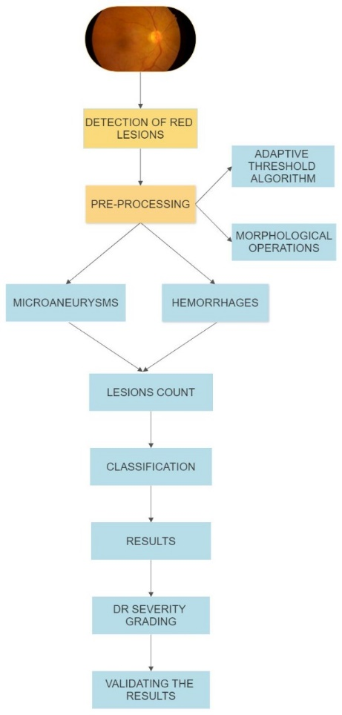

**PRE-PROCESSING**:

Pre-Processing is needed in order to remove any noise, get a better contrast and so that a more consistent dataset with only relevant features is obtained.

In Pre-processing the first step involved is to convert the images from a 2D matrix to a 3D matrix in order to get 3 planes (red, blue and green) so as to make it easier to perform morphological operations on the image. After the conversion to 3D matrix, a median filter is applied to remove additional noise or dilutions from the image.

After the application of filter on the images, the green plane is extracted to clear the dark spots of red lesions, high of red lesions and low value of other lesions. In order to spot the lesions, based on its properties of colour it having low pixel in the green plane, resulting in dark spots in the green channel providing with the best contrast for the images.

The bright lesions detection algorithm steps:

1. Adaptive threshold.
2. Filtering operations through Morphological operations.

The method starts firstly by applying the adaptive threshold algorithm to the improved image with sensitivity level of 0.85, this image then to morphological operations which tries to filter any noise and perform area-based rejection to the output image.

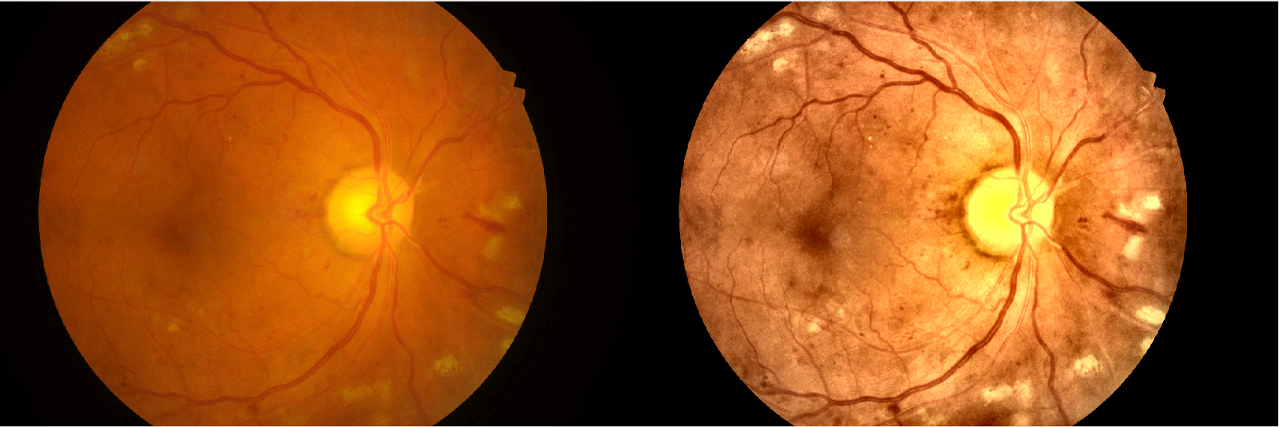

Figure 2: Enhanced figure of fundus image after applying filtering methods

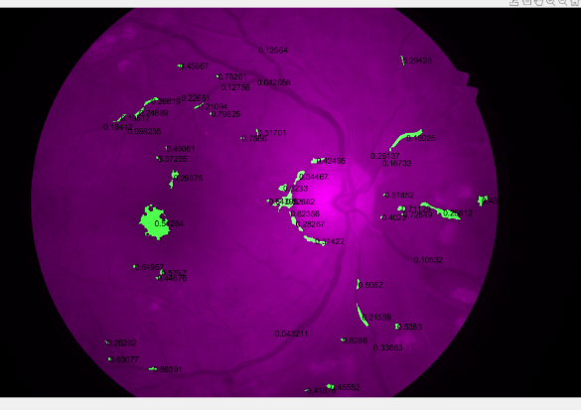

Figure 3: Spotting lesions using region props

**EXTRACTION OF RETINAL BLOOD VESSELS**

Retinal vasculature is like roots of a tree. Doctors can diagnose some diseases like hypertension, glaucoma and diabetic retinopathy etc. from retinal vessels.Retinal blood vessels appear red in colour fundus image, however, in green channel image, blood vessels look darker than other parts of image. Blood vessels are widest at origin viz. optic disc. The removal of blood vessels eases further operations while detecting lesions. Blood vessels are widest near the point of lesions and become narrow as we move away from that point. The grey level profile in the image is estimated using Gaussian function. But, due to the random nature of the blood vessels it’s difficult to perform morphological operations for the extraction and therefore Matched filtering is used to estimate the character of the feature.

*f(x,y) = e^((-x^2)/2(σ^2)) for |y| < L/2*

The gaussian kernel of the matched filtering is dependent on the value of variance parameter, sigma (µ). Results have shown that the value of this parameter for human retinal blood vessels ranges from 1.5 to 3. The classical approach uses just one value of µ whereas in our approach, we use two values for µ: 1.5 and 2. This is done in order to extract wider vessels as larger value extract wider vessels. Due to the random orientation of the blood vessels as mentioned before, the kernel rotates from 0º to 180º through an angle of 15º. The pre-processed image now has 12 kernels for the matched filtering. Each pixel of the image has 12 responses from the kernel, and the output image of matched filtering is made by taking the maximum of the 12 responses for every pixel. Likewise, we use the values 1.5 and 2 to obtain two output images. To separate the enhanced blood vessels, a threshold must be set. To search the threshold required, we use automatic thresholding technique. When grey level intensity 'x' has neighbourhood intensity ‘y', we determine the threshold value. The pairs obtained are stored within the sort of co-occurrence matrix. The co-occurrence matrix is split into four

quadrants by threshold ‘th’. The total entropy is the cumulative summation of entropies of quadrant ‘A’ to ‘D’.

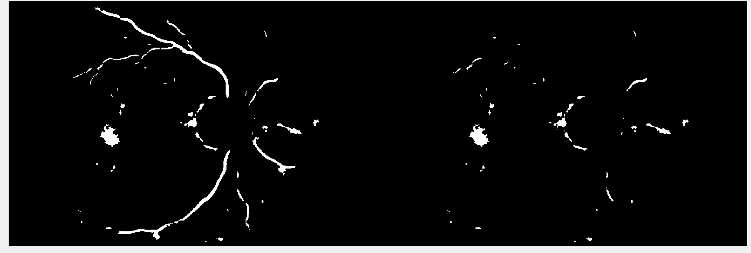Figure : Removing noise and other disturbances and getting the final lesions

**CANDIDATE LESION DETECTION**

Candidate lesion detection has a multitude of approaches which perform morphological operations using techniques like h-maxima transformation, thresholding, region growing etc. We employ the morphological operation of opening and then closing on the length filtered images and local entropy threshold of 0.15. The preprocessing operations result in a loss of a few lesions near the vessel segment, which are recovered by the sequential morphological operations of abrasion and dilation, performed on the image. The recovered lesions are added to the images and are now detected. The resulting image is cleaned to obviate salt and pepper noise.

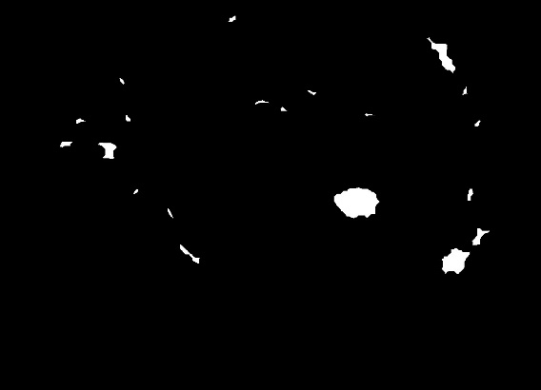 

Figure 6: Lesion detection Figure 7: Major lesion count = 2

The method as are often seen is nearly almost like the brilliant region’s detection, except the sensitivity level for the adaptive threshold is below 0.15 and therefore the morphological operations are roughly an equivalent in bright regions. However, when extracting red regions, the veins was also extracted; this is often the most motivation to feature the anomaly rejection algorithm which tries to filter the veins by having a few ratio thresholds, and an expand threshold which measures how the tested object fills its corresponding bounding box.

To distinguish the lesions and non-lesions the proposed methodology applies multiclass Support Vector Classifier. SVM segregates the different classes using a hyper-plane in the feature space in the given image. This segregation window is maximized in order to best separate the categories using the multiclass SVM. The SVM classifier uses the extracted features to classify the images into categories of 0 for non-lesion and 1 for true lesion. The true lesions are counted and obtained in the output image. The objects in the output images are mapped to the original input image .

**RESULTS:**

|  |  |  |  |  |  |  |  |
| --- | --- | --- | --- | --- | --- | --- | --- |
| DATASET | NO OF IMAGES | ACCURACY | SENSITIVITY | SPECIFICITY | RECALL | F1 | PRECISION |
| IDRiD | 516  Train – 413  Test -103 | 93.3% | 78.5% | - | 73.2% | 74.6% | 78.1% |
| KAGGLE APTOS | 5529  Train – 3601  Test –1928 | 94.20% | 75.16% | 92.76% | 91.4% | 82.51% | 75.6% |
| DIAREDDB1 | 89 images  84-mild  5-normal | 92.6% | 98.9% | - | 99.8% | 90.3% | 97.7% |