ANEMIA RISK PREDICTION
USING MACHINE LEARNING
A KDD-Based Predictive Analytics Project Using NFHS-5 District Factsheet Data

PROJECT REPORT
Submitted in partial fulfilment of the requirements for the course
Predictive Analytics / Data Mining

Submitted by: ______________________________
Roll Number: ______________________________
Department / Institution: ______________________________
Academic Year: ______________________________

Abstract
This project presents an end-to-end predictive analytics workflow for classifying district-level anemia risk using indicators from the National Family Health Survey-5 (NFHS-5) India Districts Factsheet dataset. The project follows the Knowledge Discovery in Databases (KDD) process, including domain understanding, data selection, cleaning, preprocessing, transformation, data reduction, feature selection, data mining, evaluation, validation, and knowledge presentation. The dataset used in the reported run contains 707 district records. The notebook reports 106 numeric features before selection and retains 20 features for model training. An 80:20 stratified split produces 565 training records and 142 testing records. Low, Medium, and High risk categories are constructed from the selected anemia-prevalence column using the 33rd and 66th percentiles. Random Forest, XGBoost, and a Stacking Ensemble are used as candidate classifiers. The resulting district-level output is intended to support exploration and prioritisation, not to diagnose an individual or replace clinical assessment.

Project Problem Statement
To develop a machine learning model that predicts anemia risk based on demographic, nutritional, and health-related factors.

Report Organisation
Chapter 1 introduces the problem and objectives. Chapter 2 reviews the public-health and KDD background. Chapter 3 explains the workflow and modelling process. Chapter 4 presents the available run outputs and discusses their interpretation. Chapter 5 concludes the work, and Chapter 6 lists the references.

1. Introduction

1.1 Background
Anemia is a public-health concern associated with reduced haemoglobin levels and can have multiple causes, including nutritional deficiencies, infections, chronic conditions, and other health factors. Reliable population-level information helps public-health teams understand the distribution of the problem and plan further screening, awareness, and service delivery. India's National Family Health Survey-5 (NFHS-5), conducted during 2019–2021, provides district-level indicators covering health, nutrition, family welfare, and related demographic conditions [1, 2].

1.2 Problem Definition
The project uses district-level NFHS-5 indicators to classify districts into Low, Medium, or High anemia-risk categories. It treats the selected anemia-prevalence measure as the target used to derive these categories and uses other numeric demographic, nutritional, and health-related indicators as predictors. Because the data are district aggregates, the model's output describes a district-level pattern rather than the risk of a specific person.

1.3 Objectives
- Understand and clean the NFHS-5 district factsheet dataset.
- Explore data quality, distributions, and relationships between indicators.
- Transform anemia prevalence into three relative risk categories.
- Select informative numeric features and train classification models.
- Evaluate model predictions with suitable classification metrics.
- Present district-level predictions with clear interpretation and limitations.

1.4 Scope and Limitations
The scope is limited to the available NFHS-5 district factsheet and the columns included in the notebook. The risk thresholds are quantile-based and therefore relative to the dataset; they are not official clinical cut-offs. A high classification score, if observed, should be interpreted cautiously because the labels are derived from an anemia-prevalence column and district indicators may be correlated. Independent validation and leakage checks are necessary before any operational use.

2. Literature Review

2.1 NFHS-5 as a Public-Health Data Source
NFHS-5 is a large national survey that reports indicators relating to population, reproductive and child health, nutrition, anemia, and other health and family-welfare topics. The Ministry of Health and Family Welfare and the International Institute for Population Sciences publish survey reports and factsheets for use by researchers, administrators, and programme planners [1, 2]. The district factsheet dataset is appropriate for an exploratory project because it combines multiple indicators at a common geographic level.

2.2 Knowledge Discovery in Databases
Knowledge Discovery in Databases (KDD) is a multi-stage process for converting raw data into useful knowledge. Fayyad, Piatetsky-Shapiro, and Smyth describe KDD as a process that includes data selection, preprocessing, transformation, data mining, and interpretation/evaluation [3]. In this project, the KDD approach structures the work from understanding the domain to presenting model outputs.

2.3 Machine Learning for Risk Classification
Random Forest combines predictions from multiple decision trees and can model nonlinear relationships. XGBoost builds boosted trees sequentially to improve predictive performance. A Stacking Ensemble combines the outputs of base estimators through a final estimator, which in this project is Logistic Regression. These methods are suitable candidates for tabular classification, but the best-performing model must be selected from measured validation results rather than assumed in advance.

2.4 Research Gap and Project Motivation
This student project focuses on demonstrating an end-to-end KDD workflow using district-level indicators, rather than claiming a clinical diagnostic system. It integrates data quality checks, feature selection, comparative classification, evaluation, and a district lookup interface in one reproducible notebook. The project is educational and exploratory; it does not establish causal relationships between predictors and anemia.

3. Workflow / Predictive Modelling Process

3.1 Dataset Description
The input is the NFHS-5 India Districts Factsheet dataset supplied for this project. In the run summary provided, the cleaned data contains 707 district records. The notebook reports 106 numeric features before feature selection and uses the top 20 selected features in the final modelling stage.
Item | Value in reported run | Description
Dataset | NFHS-5 India Districts Factsheet | District-level demographic, health and nutrition indicators
District records | 707 | Records available after the reported cleaning process
Numeric features before selection | 106 | Candidate numeric predictor columns
Selected features | 20 | Features retained for model training
Training set | 565 (80%) | Records used to fit the model
Testing set | 142 (20%) | Held-out records used for evaluation
Target classes | Low / Medium / High | Derived from the target prevalence distribution
Table 3.1: Dataset and Modelling Summary
Table 3.1 summarises the dataset dimensions and the split used in the reported run. The 565 training records and 142 testing records sum to 707 district records.

3.2 KDD Workflow
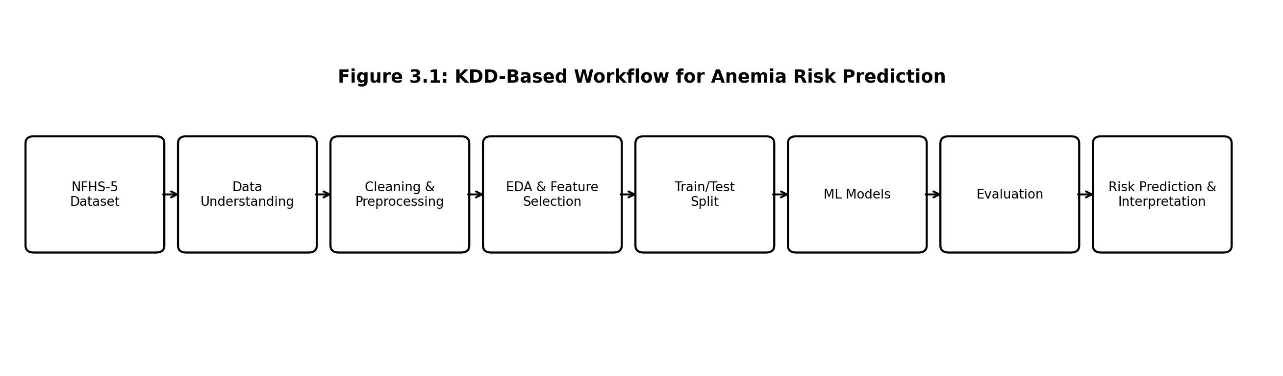
Figure 3.1: KDD-Based Workflow for Anemia Risk Prediction
Figure 3.1 shows the project pipeline from NFHS-5 data selection through cleaning, exploration, feature selection, modelling, evaluation, and interpretation. The stages are iterative: data-quality findings or weak evaluation results may require revisiting earlier steps.

3.3 Domain Understanding and Data Selection
The objective is to classify district-level anemia risk using available demographic, nutritional, and health indicators. The supplied NFHS-5 factsheet is loaded into a pandas DataFrame, after which its shape, column names, and sample rows are inspected to understand the structure of the data.

3.4 Data Integration and Cleaning
Only one factsheet file is used in the reported workflow, so no external data sources are merged. Column names are standardised by trimming whitespace and replacing punctuation or spaces. Duplicate rows are checked and removed. Asterisks and the value -99 are treated as missing-value markers where applicable. Numeric columns are converted to numeric types, infinite values are replaced with missing values, and missing numeric values are imputed using the column median. The selected target column should be checked manually to ensure it genuinely represents anemia prevalence.

3.5 Exploratory Data Analysis (EDA)
EDA is used to inspect dataset dimensions, missing values, numeric summaries, target distribution, and feature relationships. Histograms, box plots, class counts, and correlation plots can reveal skewness, outliers, imbalance, and redundant predictors. EDA helps guide preprocessing and interpretation; it does not by itself demonstrate predictive performance.

3.6 Target Creation and Data Transformation
The continuous anemia-prevalence column is converted into three classes using the 33rd and 66th percentiles. Values below the first threshold are labelled Low (0), values between the thresholds are labelled Medium (1), and values at or above the second threshold are labelled High (2). These are relative categories derived from the dataset distribution, not medically approved thresholds.

3.7 Data Reduction and Feature Selection
Non-predictive identifiers such as district and state names, the continuous target column, and the derived class label are excluded from the predictors. Numeric columns with no variation are removed. A Random Forest feature-importance ranking is fitted on the training partition, and the 20 highest-ranked features are retained. Performing feature selection on training data only reduces the risk of information leakage from the test partition.

3.8 Train/Test Split and Preprocessing
The data is split into 80% training and 20% testing partitions using stratification, preserving the relative distribution of the three risk classes. The reported split contains 565 training records and 142 testing records. Median imputation is fitted on the training data and then applied to the test data using the same fitted imputer.

3.9 Model Development
Three classifiers are considered. Random Forest uses an ensemble of decision trees. XGBoost uses gradient boosted trees and supports sample weights to help account for class frequencies. The Stacking Ensemble combines Random Forest and XGBoost through a Logistic Regression final estimator. Model settings and random seeds are recorded in the notebook to support reproducibility.
Model | Role in project | What is assessed
Random Forest | Bagged decision-tree ensemble | Accuracy, precision, recall, F1-score, confusion matrix
XGBoost | Gradient-boosted tree classifier | Accuracy, precision, recall, F1-score, confusion matrix
Stacking Ensemble | Combines base-model outputs using Logistic Regression | Held-out performance and cross-validation
Table 3.2: Machine Learning Models Used
Table 3.2 describes the three candidate classifiers and the metrics used to compare them. The final model should be chosen from actual evaluation results, not from algorithm complexity alone.

3.10 Evaluation and Validation
Accuracy measures the proportion of correct predictions. Precision measures the reliability of predicted classes, recall measures how many actual members of a class are recovered, and the F1-score balances precision and recall. A confusion matrix displays correct and incorrect class assignments. Stratified cross-validation on the training partition estimates performance across multiple folds. Since the labels are constructed from a measured prevalence column, a leakage review is particularly important: the target column must not appear among the predictors, and correlated proxy indicators can make the task easier than a true future prediction problem.

3.11 District-Level Prediction
The notebook accepts a district name, matches it to the dataset, extracts the selected features, applies the fitted imputer, and predicts a Low, Medium, or High class. The displayed anemia percentage is read from the NFHS-5 target column in the same district record; it is not a separately predicted continuous percentage. The risk class and percentage therefore have different meanings and should be labelled accordingly in the output.

4. Results and Discussion

4.1 Dataset Split and Class Distribution
The run summary reports 707 district records, 106 numeric features before selection, and 20 selected features. The training set contains 565 records and the test set contains 142 records. The class counts are reasonably balanced across Low, Medium, and High categories in both partitions, as shown in Table 4.1.
Risk class | Training records | Testing records | Interpretation
Low (0) | 185 | 47 | Lower relative prevalence group
Medium (1) | 187 | 47 | Middle relative prevalence group
High (2) | 193 | 48 | Higher relative prevalence group
Total | 565 | 142 | All reported district records
Table 4.1: Risk-Class Distribution in Training and Testing Sets
Table 4.1 indicates that the stratified split preserved similar class proportions across training and testing partitions. This helps make class-wise evaluation more meaningful than a split that omits or under-represents a category.

4.2 District Prediction Example
The attached notebook output for Almora displays an NFHS-5 anemia prevalence of 57.70% and a predicted risk category of Low. The percentage is the observed dataset value, whereas Low is the classifier's predicted relative category. This pairing may appear counter-intuitive because the class thresholds are computed from the complete dataset distribution; the result should be interpreted using the exact target column and thresholds printed by the notebook.
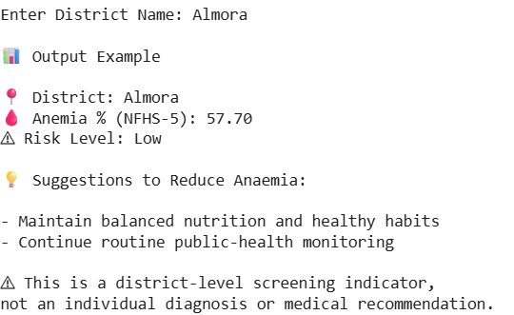
Figure 4.1: Sample District Prediction Output for Almora
Figure 4.1 records the notebook's displayed district-level result and general suggestions. The output is illustrative and should not be interpreted as an individual diagnosis or a treatment plan.

4.3 Dataset Split Summary Output
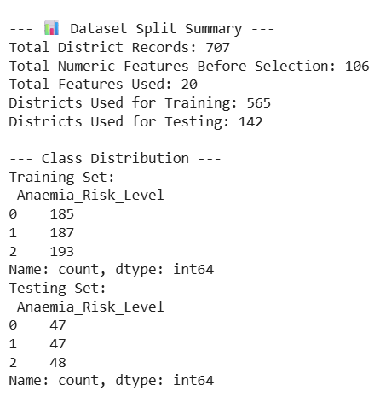
Figure 4.2: Dataset Split and Class Distribution Output
Figure 4.2 shows the reported counts for records, selected features, and train/test partitions. These counts provide a basic consistency check that the number of training and testing records sums to the total reported dataset size.

4.4 Interpretation of Results
The project demonstrates the complete structure of a tabular classification task: preparing data, constructing a target, selecting features, training multiple models, evaluating predictions, and presenting a district lookup result. The supplied screenshots confirm the dataset and split counts and one district prediction. They do not show the model accuracy, precision, recall, F1-score, or cross-validation score; those values should be copied from the final notebook output before submission rather than inferred from the screenshots. If a high accuracy is reported, verify that the target column and any direct or near-direct proxies are excluded from the predictors.

4.5 Practical Significance and Limitations
District-level risk summaries can help identify places for further investigation and public-health planning. However, this dataset is observational and aggregated. It cannot identify individual-level causes, and the model may be affected by missing values, measurement uncertainty, correlated indicators, and differences between districts. The quantile-based categories are dataset-relative, so they should not be presented as official clinical classifications. Additional validation against independently collected data is required before real-world deployment.

5. Conclusion
The project developed an end-to-end machine learning workflow for district-level anemia risk classification using NFHS-5 India Districts Factsheet data. The workflow follows the KDD stages from domain understanding and data selection through cleaning, transformation, data reduction, feature selection, modelling, evaluation, validation, and presentation. In the reported run, 707 district records were processed, 20 features were selected from 106 numeric candidates, and an 80:20 split produced 565 training records and 142 testing records. Random Forest, XGBoost, and a Stacking Ensemble were included as candidate models.
The district lookup function demonstrates how model output can be made understandable through a named risk category and general public-health suggestions. The Almora example reports 57.70% anemia prevalence from the dataset and a Low predicted category. These two outputs must be distinguished: the first is an observed prevalence value, while the second is a classification result based on relative quantile thresholds. The system is a learning prototype for population-level analysis, not a clinical diagnostic tool.
Future work should include confirming the exact anemia target column, documenting the final evaluation metrics, checking for target leakage, comparing against simpler baselines, testing on independent data, and improving the user interface. A validated version could support exploratory public-health dashboards while keeping clinical decisions with qualified healthcare professionals.

6. References
[1] International Institute for Population Sciences (IIPS) and ICF. (2021). National Family Health Survey (NFHS-5), 2019–21: India. Mumbai: IIPS. https://www.dhsprogram.com/pubs/pdf/FR375/FR375.pdf
[2] Ministry of Health and Family Welfare, Government of India. (2021, November 24). Union Health Ministry releases NFHS-5 Phase II Findings. Press Information Bureau. https://www.pib.gov.in/PressReleasePage.aspx?PRID=1774533
[3] Fayyad, U., Piatetsky-Shapiro, G., & Smyth, P. (1996). From Data Mining to Knowledge Discovery in Databases. AI Magazine, 17(3), 37–54.
[4] International Institute for Population Sciences. (n.d.). National Family Health Survey (NFHS-5) – official survey information. https://www.nfhsiips.in/nfhsuser/nfhs5.php
[5] International Institute for Population Sciences. (n.d.). National Family Health Survey project. https://iipsindia.ac.in/content/nfhs-project
[6] Breiman, L. (2001). Random Forests. Machine Learning, 45, 5–32. https://doi.org/10.1023/A:1010933404324
[7] Chen, T., & Guestrin, C. (2016). XGBoost: A Scalable Tree Boosting System. Proceedings of the 22nd ACM SIGKDD International Conference on Knowledge Discovery and Data Mining, 785–794. https://doi.org/10.1145/2939672.2939785
[8] Wolpert, D. H. (1992). Stacked generalization. Neural Networks, 5(2), 241–259. https://doi.org/10.1016/S0893-6080(05)80023-1
[9] Pedregosa, F., et al. (2011). Scikit-learn: Machine Learning in Python. Journal of Machine Learning Research, 12, 2825–2830. https://www.jmlr.org/papers/v12/pedregosa11a.html
[10] McKinney, W. (2010). Data Structures for Statistical Computing in Python. Proceedings of the 9th Python in Science Conference, 56–61. https://doi.org/10.25080/Majora-92bf1922-00a

