Bank Transaction Analytics
and Fraud Detection
Big Data Analytics — Project Report and Technical Explanation
Python · Apache Spark (Spark SQL, MLlib) · MongoDB · Machine Learning
Submitted by: ______________________________
Roll number: ______________________________
Course / Instructor: ______________________
Repository: https://github.com/JayQuery-007/bank_transaction_analysis
October 2026
Contents
1. Summary 4
2. Introduction 5
2.1 Problem statement 5
2.2 Objectives 5
2.3 Why this is a big data problem 5
3. Dataset 6
3.1 Source 6
3.2 Columns 6
3.3 Data quality check results 6
4. Technology stack 8
5. System architecture 9
6. Pipeline implementation 10
6.1 Shared Spark setup (spark_jobs/common.py) 10
6.2 Step 1 — Ingest (spark_jobs/ingest.py) 10
6.3 Step 2 — Analytics with Spark SQL (spark_jobs/analytics.py) 11
6.4 Step 3 — Fraud detection model (spark_jobs/train_model.py) 11
6.5 MongoDB serving layer 13
6.6 Backend API (backend/app) 13
6.7 Dashboard (frontend/) 13
7. How a transaction is classified as fraud or legitimate 15
7.1 Where the fraud labels come from 15
7.2 What the model looks at 15
7.3 How the Random Forest makes a decision 15
7.4 Worked examples from the running application 16
7.5 How to explain it to your professor 16
8. Application of Big Data in this project 17
8.1 The five Vs of Big Data 17
8.2 Big data techniques used 17
8.3 Why not just Excel or pandas? 17
8.4 Real-world uses of this kind of system 18
9. Results and findings 19
9.1 Which transaction types are affected? 19
9.2 When does fraud happen? 20
9.3 What do fraudulent transactions look like? 20
9.4 Model results 21
10. Running the project 24
10.1 Requirements 24
10.2 Start the dashboard 24
10.3 Rebuild everything from the raw data 24
10.4 Verified run 24
10.5 Dashboard screenshots 25
11. Technical challenges and how they were solved 28
11.1 Spark cannot write files on Windows without winutils.exe 28
11.2 PySpark Python workers crash with Python 3.13 on Windows 28
11.3 Long file names in the saved model 28
11.4 Making the repository runnable without the 494 MB dataset 28
12. Limitations and future work 29
12.1 Limitations 29
12.2 Future work 29
13. Viva preparation: likely questions 30
14. Project structure 32
References 32

1. Summary
This project builds a batch big data pipeline for a dataset of 6,362,620 mobile-money transactions (494 MB). Apache Spark loads the raw CSV into a Parquet data lake, Spark SQL is used to analyse where, when and how fraud happens, and Spark MLlib trains a model that detects fraudulent transactions. The results are stored in MongoDB and shown on a web dashboard served by a FastAPI backend.
Main results:
- Fraud occurs only in TRANSFER and CASH_OUT transactions (0.77% and 0.18% of those types). The other three types contain no fraud.
- The provider's existing rule (isFlaggedFraud) caught only 16 of 8,197 frauds (0.2%).
- Fraud volume is almost constant through the day, so when legitimate activity drops at night the fraud rate rises to 22.3% at 5:00.
- 97.7% of frauds empty the sender's account, compared with 42.7% of legitimate transfers and cash-outs.
- The Random Forest model caught 2,401 of 2,407 frauds in the unseen test set with 17 false alarms (precision 0.993, recall 0.998).

2. Introduction

2.1 Problem statement
Banks and payment providers process millions of transactions every day. Only a tiny fraction are fraudulent, but each one is a direct financial loss and a trust problem for the customer. Rule-based checks (for example "flag transfers above a fixed amount") are simple to run but miss most fraud. The data is too large to inspect by hand, so it needs distributed processing for both analysis and detection.

2.2 Objectives
- Load a large raw transaction log into an efficient, query-friendly storage format.
- Check data quality and prepare the data (cleaning, derived features).
- Describe the data: which transaction types, times, amounts and accounts are involved in fraud.
- Train and evaluate a fraud detection model and compare it with the existing rule.
- Store the results in a database and present them through an API and a dashboard.

2.3 Why this is a big data problem
- Volume: 6,362,620 rows and 494 MB for one month of a single provider. A real bank produces this volume every few days, so the solution has to scale beyond a single machine's memory.
- Scalability: All processing is written with Spark DataFrames and Spark SQL. The same code runs on a laptop (local mode) or on a cluster with the data in HDFS or cloud storage, without changes.
- Variety of workloads: The same data is used for batch ETL, SQL analytics and distributed machine learning, which is what the Spark ecosystem is designed for.

3. Dataset

3.1 Source
PaySim — Synthetic Financial Datasets For Fraud Detection (Kaggle, dataset id ealaxi/paysim1).
Real bank transactions cannot be published because of customer privacy and banking regulations. PaySim was generated by an agent-based simulator that was calibrated on one month of real transaction logs from a mobile money service operating in an African country. It reproduces the statistical behaviour of the real data, including fraud, without exposing any real customers. It is the standard public benchmark for transaction fraud detection and is widely used in research and teaching.
Important for presentation: PaySim is simulated from real logs. It is real in the sense that it is a published, widely used Kaggle dataset, not something generated for this project, but it is not raw bank data. Section 12 explains how this affects the results.

3.2 Columns
Column | Type | Description
step | integer | Hour of the simulation, 1 to 744 (31 days)
type | string | CASH_IN, CASH_OUT, DEBIT, PAYMENT or TRANSFER
amount | double | Transaction amount in local currency
nameOrig | string | Sender (customer) account ID
oldbalanceOrg | double | Sender's balance before the transaction
newbalanceOrig | double | Sender's balance after the transaction
nameDest | string | Receiver account ID (IDs starting with M are merchants)
oldbalanceDest | double | Receiver's balance before the transaction
newbalanceDest | double | Receiver's balance after the transaction
isFraud | integer | 1 if the transaction is fraudulent (the label)
isFlaggedFraud | integer | 1 if flagged by the provider's existing rule (attempts to transfer more than 200,000 at once)

3.3 Data quality check results
These checks are run by the ingest job on the full raw file:
Check | Result
Total rows | 6,362,620
Rows with null values | 0
Duplicate rows | 0
Negative amounts | 0
Zero amounts (removed) | 16 (all CASH_OUT, all labelled fraud)
Distinct sender accounts | 6,353,307
Distinct receiver accounts | 2,722,362
Rows written to the data lake | 6,362,604

The data is clean. The 16 zero-amount rows are not valid transactions, so they are removed, leaving 8,197 fraud cases. Almost every sender appears only once (6,353,307 distinct senders in 6,362,620 rows), which limits per-customer behavioural analysis.

4. Technology stack
The course allows several technology combinations. This project uses Python + Spark + MongoDB + Machine Learning, with Parquet as the storage format and FastAPI for the dashboard.
Technology | Role in the project | Why it was chosen
Python 3 | Language for all jobs, the API and the notebook | Main language of the course; PySpark gives full access to Spark
Apache Spark 3.5 (PySpark) | Ingest, cleaning, feature engineering | Distributed, lazy DataFrame engine that scales from a laptop to a cluster
Spark SQL | All descriptive analytics (7 queries) | Standard SQL over large data, optimised by Spark's Catalyst optimiser
Spark MLlib | Logistic Regression and Random Forest training and evaluation | Trains on the full 2.77M-row training data in parallel, with no sampling needed
Apache Parquet | Data lake storage format | Columnar and compressed, stores the schema, supports partition pruning
MongoDB 8 | Serving database for analysis results | JSON documents match what the API and dashboard need; flexible schema per result set
FastAPI + Uvicorn | REST API and web server for the dashboard | Lightweight, fast and auto-documents its endpoints
HTML, CSS, Chart.js | Dashboard | Simple static front end with no build step; Chart.js is bundled so it works offline
Jupyter, matplotlib | Exploratory data analysis notebook | Interactive exploration and plots
kagglehub | Dataset download | Official Kaggle client
Git / GitHub | Version control and submission | Code, results and trained model are versioned together

5. System architecture
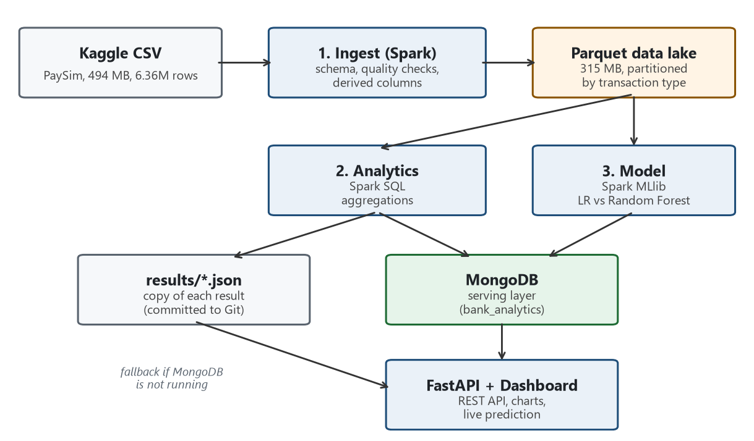
Figure 1. Data flow through the pipeline
The architecture follows the usual split between a batch layer and a serving layer:
- Batch layer (Spark + Parquet): the full 6,362,604 rows live in the Parquet data lake. All heavy processing (cleaning, aggregations, model training) runs here.
- Serving layer (MongoDB): only the results the dashboard needs are stored: aggregates, model metrics and flagged transactions. These are a few thousand documents, not millions, so queries are instant.
- Presentation layer (FastAPI + dashboard): reads from MongoDB and renders charts and tables. It also loads the trained Spark model to score single transactions on request.
Every result set is written both to MongoDB and to a JSON file in results/. The JSON copies are committed to Git, so anyone who clones the repository can open the dashboard immediately, without downloading the data or installing MongoDB. When MongoDB is running, the API reads from it.

6. Pipeline implementation
The pipeline has four steps. python run_pipeline.py runs them in order. Each step is a separate Python module that can also be run on its own.
Step | Script | Input → Output | Runtime*
0. Download | data/download_data.py | Kaggle → data/raw/paysim.csv | ~20 s
1. Ingest | spark_jobs/ingest.py | CSV → Parquet lake | ~20–40 s
2. Analytics | spark_jobs/analytics.py | Parquet → 7 result sets in MongoDB | ~25–40 s
3. Model | spark_jobs/train_model.py | Parquet → model, metrics, flagged transactions | ~2.5 min

*Measured on a 16 GB Windows laptop with Spark in local mode using all CPU cores.

6.1 Shared Spark setup (spark_jobs/common.py)
All jobs get their Spark session from get_spark(), which:
- runs Spark in local mode on all cores (local[*]) with 4 GB of driver memory,
- enables Apache Arrow for fast transfer of results from Spark to pandas,
- finds Java automatically (JAVA_HOME, the PATH, or a JDK bundled in the project folder),
- on Windows only, plugs in a small custom file system class (explained in Section 11).
The same file has publish(name, records), which writes a result set to MongoDB (one collection per result) and to results/<name>.json.

6.2 Step 1 — Ingest (spark_jobs/ingest.py)

Explicit schema
The CSV is read with a hand-written StructType schema instead of inferSchema. Schema inference would need an extra full pass over all 6.36M rows just to guess the types, and it can guess wrong. With an explicit schema, Spark reads the file once with the correct types.

Cleaning and renaming
Columns are renamed to consistent snake_case (for example oldbalanceOrg → old_balance_orig, which also fixes the inconsistent 'Org'/'Orig' naming in the source). Zero-amount rows are removed.

Derived columns
Column | Formula | Purpose
day | (step − 1) / 24 + 1 | Day of the month (1–31)
hour_of_day | step mod 24 | Time-of-day analysis and model feature
dest_is_merchant | name_dest starts with 'M' | Merchants have no balance information
error_balance_orig | new_balance_orig + amount − old_balance_orig | How far the sender's recorded balance is from what the amount implies
error_balance_dest | old_balance_dest + amount − new_balance_dest | Same check for the receiver
orig_emptied | old_balance_orig > 0 and new_balance_orig = 0 | Did the transaction empty the sender's account?

Parquet data lake, partitioned by type
The cleaned data is written to data/lake/transactions/ in Parquet format, partitioned by transaction type, so each type gets its own folder (type=TRANSFER/, type=CASH_OUT/ and so on).
- Smaller: 494 MB of CSV becomes 315 MB of Parquet, even after adding six derived columns, thanks to columnar storage and Snappy compression.
- Faster: queries read only the columns they use, and the schema is stored with the data, so there is no parsing step.
- Partition pruning: the model only needs TRANSFER and CASH_OUT. Because of the partitioning, Spark reads only those two folders (2.77M rows) and skips the other 3.6M rows entirely. The notebook shows this in Spark's physical plan as a PartitionFilters entry.

6.3 Step 2 — Analytics with Spark SQL (spark_jobs/analytics.py)
The Parquet lake is registered as a temporary SQL view called tx and cached in memory. Seven SQL queries are then run, and each result is published to its own MongoDB collection:
Result set (collection) | Question it answers
overview | Totals: transactions, value, fraud count and value, fraud rate, accounts, days
type_summary | Which transaction types carry fraud, and at what rate?
hourly | How do volume and fraud rate change by hour of day?
daily | Volume and fraud per day across the 31 days
amount_bands | How are fraud and legitimate amounts distributed (order-of-magnitude bands)?
balance_patterns | How do account balances behave in fraud vs legitimate transactions?
repeat_fraud_destinations | Which receiver accounts got more than one fraudulent transaction (possible mule accounts)?

Example: the hourly query.
SELECT hour_of_day,
COUNT(*) AS transactions,
SUM(is_fraud) AS fraud_transactions,
ROUND(100 * AVG(is_fraud), 3) AS fraud_rate_pct
FROM tx
GROUP BY hour_of_day
ORDER BY hour_of_day

6.4 Step 3 — Fraud detection model (spark_jobs/train_model.py)

Training data
The analytics showed that fraud only occurs in TRANSFER and CASH_OUT, so the model is trained on those 2,770,393 transactions only. The data is split at random into 70% training (1,938,956 rows) and 30% test (831,437 rows, 2,407 frauds), with a fixed seed so the results are reproducible. The test set is never used for training. It plays the role of new, unseen transactions.

Features
Feature | Meaning
is_transfer | 1 for TRANSFER, 0 for CASH_OUT
amount | Transaction amount
old_balance_orig, new_balance_orig | Sender's balance before and after
old_balance_dest, new_balance_dest | Receiver's balance before and after
error_balance_orig, error_balance_dest | Balance inconsistencies (Section 6.2)
hour_of_day | Hour 0–23

Class imbalance
Fraud is only 0.30% of the training data, roughly 1 fraud for every 337 legitimate transactions. A model can reach 99.7% accuracy by never predicting fraud, which is useless. Two measures address this:
- Logistic Regression is trained with class weights: each fraud row counts 337 times, so both classes carry equal total weight.
- Models are judged on precision, recall, F1 and AUC-PR, not accuracy.

Models compared
- Logistic Regression: a linear model. Features are standardised with StandardScaler first. It is fast and easy to interpret, but it can only learn linear boundaries.
- Random Forest: an ensemble of 60 decision trees (maximum depth 12). Each tree learns rules such as "the sender's balance became 0 and the amount equals the old balance", and the trees vote. It can capture non-linear patterns and interactions between features.
- Existing rule (baseline): the dataset's own isFlaggedFraud column, evaluated on the same test set. It represents the system already in place.
Each model is built as a Spark ML Pipeline: VectorAssembler (combines the feature columns into one vector), then an optional StandardScaler, then the classifier.

Evaluation metrics
Metric | Definition | Meaning here
Precision | TP / (TP + FP) | Of the transactions flagged, how many are really fraud (few false alarms)
Recall | TP / (TP + FN) | Of all frauds, how many were caught
F1 | 2·P·R / (P + R) | Single score balancing precision and recall
AUC-ROC | Area under the ROC curve | Ranking quality across all thresholds
AUC-PR | Area under the precision-recall curve | Like AUC-ROC but focused on the rare class, so better suited to imbalanced data
Confusion matrix | TP, FP, FN, TN counts | Exact numbers of correct and wrong decisions

TP = true positive (fraud correctly flagged), FP = false positive (legitimate transaction flagged), FN = false negative (fraud missed), TN = true negative.

Outputs
- metrics for all three models (model_metrics), training details (model_info)
- Random Forest feature importance (feature_importance)
- precision and recall at alert thresholds from 0.1 to 0.9 (threshold_curve)
- every test transaction that was flagged or was a missed fraud, 2,424 rows with probability and outcome (flagged_transactions)
- the trained Random Forest pipeline, saved in Spark ML format to models/fraud_rf/ (347 KB)

6.5 MongoDB serving layer
Database bank_analytics holds one collection per result set, 13 in total. Each run of the pipeline replaces a collection's contents, so the database always matches the latest run.
Collection | Documents | Written by
data_quality | 1 | ingest
overview | 1 | analytics
type_summary | 5 | analytics
hourly | 24 | analytics
daily | 31 | analytics
amount_bands | 7 | analytics
balance_patterns | 2 | analytics
repeat_fraud_destinations | 43 | analytics
model_metrics | 3 | train_model
model_info | 1 | train_model
feature_importance | 9 | train_model
threshold_curve | 9 | train_model
flagged_transactions | 2,424 | train_model

6.6 Backend API (backend/app)
Endpoint | Description
GET /api/source | Shows whether data is coming from MongoDB or results/*.json
GET /api/results/{name} | Returns any result set, for example /api/results/hourly
GET /api/flagged | Paged flagged transactions, optionally filtered by outcome (true positive, false positive, missed fraud)
POST /api/predict | Scores one transaction with the saved Random Forest and returns the fraud probability
GET / | Serves the dashboard

store.py decides where to read from (MongoDB if reachable, otherwise the JSON files). predict.py starts a Spark session on the first prediction request (about 5–7 seconds), loads the model once and reuses it, so later predictions take about 0.1 seconds. Input is validated by Pydantic: type must be TRANSFER or CASH_OUT, amounts must be positive, hour must be 0–23.

6.7 Dashboard (frontend/)
A single static page arranged as a report. Each section answers one question:
- Dataset overview: totals and data quality
- Which transaction types are affected?
- When does fraud happen? (hourly volume and fraud rate)
- What do fraudulent transactions look like? (amounts, balances, mule accounts)
- Fraud detection model: comparison table, confusion matrix, feature importance, threshold curve
- Flagged transactions: filterable, paged table
- Check a transaction: a form that scores a transaction with the model
The text findings on the page are generated from the data, not hard-coded, so they stay correct if the pipeline is rerun.

7. How a transaction is classified as fraud or legitimate

7.1 Where the fraud labels come from
Every transaction in the dataset already carries a label, isFraud = 1 (fraud) or 0 (legitimate). The simulator knows which of its simulated customers are fraudsters, so it records the ground truth. In a real bank, labels come from confirmed cases: chargebacks, customer complaints and investigations by the fraud team.
This project does not define fraud with hand-written rules. The model learns what fraud looks like from the 8,197 labelled fraud examples. This is called supervised learning: learn from past, labelled examples, then apply what was learned to new transactions.

7.2 What the model looks at
For every transaction the model sees nine numbers:
- the type (TRANSFER or CASH_OUT) and the amount,
- the sender's balance before and after the transaction,
- the receiver's balance before and after the transaction,
- two consistency checks: do the balances change by exactly the amount? (error_balance_orig, error_balance_dest),
- the hour of the day.
It does not see names or account numbers. It judges the behaviour of the transaction, not who made it.

7.3 How the Random Forest makes a decision
A decision tree is a flowchart of yes/no questions. During training, Spark picks each question (a feature and a threshold) as the one that best separates fraud from legitimate transactions in the training data. Below is a real path from the first tree of the trained model, written in plain words:
Was the sender's balance before the transaction at most 327,397? yes
Did it happen at night (hour 7 or earlier)? yes
Is the receiver's balance afterwards at most 55,262? yes
Did the sender's balance drop by exactly the amount? yes
Did the receiver's balance rise by exactly the amount? yes
Is the sender's balance afterwards (almost) 0?
yes -> FRAUD
no -> LEGITIMATE

This one path describes the classic account-takeover pattern: at night, the whole balance is moved out and the sender's account is left empty.
A Random Forest is a group of 60 such trees (14,182 decision points in total). Each tree is trained on a random sample of the rows and features, so each learns slightly different rules. To classify a new transaction:
- Spark computes the nine features for the transaction.
- The transaction is passed through all 60 trees. Each tree follows its questions down to a leaf, which gives a fraud probability.
- The forest averages the 60 answers into one fraud probability between 0 and 1.
- If the probability is 0.5 or higher, the transaction is classified as fraud; otherwise it is legitimate.
Using many trees instead of one makes the decision more stable. A single tree can be fooled by one unusual value, but the majority of 60 trees rarely is.

7.4 Worked examples from the running application
Transaction | Key signals | Fraud probability | Decision
CASH_OUT of 2,658,595.89 at 2:00. Sender: 2,658,595.89 → 0. Receiver: 286,931 → 2,945,527 | Night time; entire balance taken; sender left at exactly 0 | 1.000 | Fraud
CASH_OUT of 18,500 at 14:00. Sender: 42,000 → 23,500. Receiver: 125,000 → 143,500 | Daytime; part of the balance; balances add up | 0.000 | Legitimate

The first example is a real fraud from the test set, which the model had never seen during training.

7.5 How to explain it to your professor
"The dataset contains 8,197 transactions confirmed as fraud. Using Spark MLlib, I trained a Random Forest of 60 decision trees on 1,938,956 labelled transactions. Each tree learned yes/no rules about the amount, the balances before and after, and the time of day. To classify a new transaction, all 60 trees vote, and the share of fraud votes is the fraud probability. Above 0.5, the transaction is flagged as fraud. The model learned that fraud usually empties the sender's whole balance, often at night, and leaves inconsistent balances. On 831,437 transactions it had never seen, it caught 2,401 of 2,407 frauds with 17 false alarms, while the bank's existing rule caught 4."

8. Application of Big Data in this project

8.1 The five Vs of Big Data
V | In this project | In a real bank
Volume | 6,362,620 transactions (494 MB) for one month of one provider. A year would be about 76 million rows. | Millions of transactions per day across cards, transfers and mobile payments; years of history kept for analysis and regulation.
Velocity | About 8,552 transactions per simulated hour, processed in batch. | Each payment must be scored in milliseconds before it is approved, which needs streaming (Kafka + Spark Structured Streaming).
Variety | Structured transaction records, plus results stored as flexible JSON documents in MongoDB. | Transactions combined with device data, locations, login logs and customer profiles, often semi-structured.
Veracity | Data-quality checks on every column; 16 invalid rows removed; balance inconsistencies measured and used as features. | Missing, delayed and inconsistent records from many systems must be detected and handled.
Value | The model caught 2,401 of 2,407 test frauds, worth 3.51 bn of 3.52 bn (99.95% of fraud value). The existing rule caught 4. | Prevented losses, fewer false alarms for investigators, protected customers and regulatory compliance.

8.2 Big data techniques used
Technique | Where it is used | Benefit
Distributed processing | All jobs run on Spark, which splits data into partitions processed in parallel on all CPU cores | Same code scales from a laptop to a cluster of machines
Lazy evaluation and query optimisation | Spark builds the whole plan (read → filter → aggregate) and optimises it before running | Avoids unnecessary work and intermediate copies
Data lake in a columnar format | Raw CSV converted to Parquet | 494 MB → 315 MB; only needed columns are read
Partitioning and partition pruning | Lake partitioned by transaction type | Model reads 2.77M rows and skips 3.6M without opening them
Schema on write | Explicit schema in the ingest job | No extra full pass over the data to guess types
In-memory caching | Transactions view cached for the 7 analytics queries | Data is read from disk once, not seven times
Distributed machine learning | Spark MLlib trains on all 1.94M training rows; trees are built in parallel | No need to sample the data down to fit in memory
Batch layer and serving layer | Parquet lake for processing, MongoDB for serving results | Heavy work runs offline; the dashboard reads a few thousand small documents instantly
NoSQL database | MongoDB stores each result set as JSON documents | Flexible schema; results map directly to the API responses

8.3 Why not just Excel or pandas?
- Excel can hold at most 1,048,576 rows per sheet. This dataset has 6,362,620, six times the limit.
- pandas loads all data into one machine's memory. It can manage one month here, but not years of data from a real bank, and it cannot spread the work across machines. Spark processes data in partitions, spills to disk when memory is full, and scales out by adding machines.
- Spark SQL and MLlib give SQL analytics and machine learning in the same engine over the same data, with no export or copy between tools.

8.4 Real-world uses of this kind of system
- Real-time fraud scoring: card and mobile payments checked before approval.
- Anti-money-laundering: finding mule accounts and suspicious chains of transfers, like the 43 repeat receivers found here.
- Transaction monitoring dashboards: for fraud and risk teams.
- Customer risk scoring and regulatory reporting: over the full transaction history.

9. Results and findings

9.1 Which transaction types are affected?
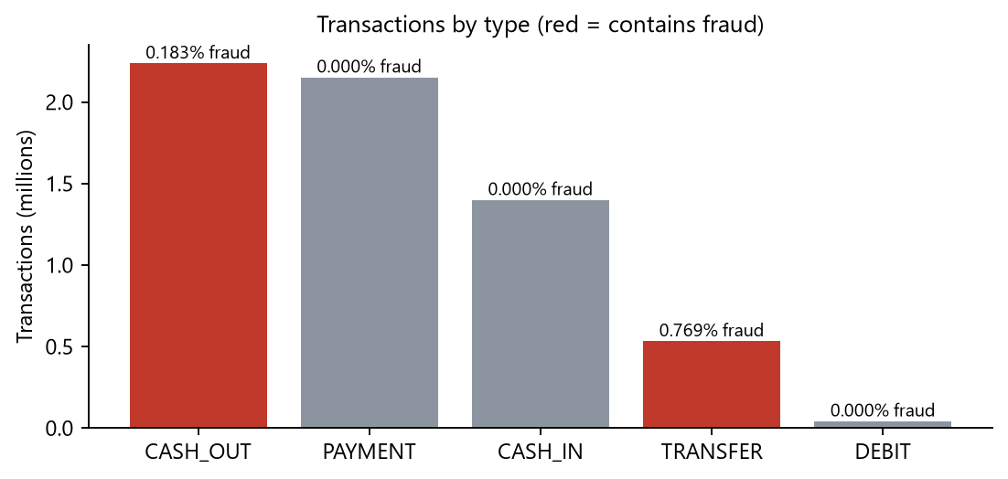
Figure 2. Transactions by type; red bars contain fraud
Type | Transactions | Avg amount | Fraud | Fraud rate
CASH_OUT | 2,237,484 | 176,275 | 4,100 | 0.183%
PAYMENT | 2,151,495 | 13,058 | 0 | 0.000%
CASH_IN | 1,399,284 | 168,920 | 0 | 0.000%
TRANSFER | 532,909 | 910,647 | 4,097 | 0.769%
DEBIT | 41,432 | 5,484 | 0 | 0.000%

Fraud exists only in TRANSFER and CASH_OUT. This matches how fraud works in the simulation: a fraudster takes over an account, transfers the balance to an account they control, and then cashes it out. The near-equal fraud counts in the two types (4,100 and 4,097) support this two-step pattern. The existing rule flagged only 16 transactions in the whole dataset. All of them were fraud, but that is 0.2% of all fraud.

9.2 When does fraud happen?
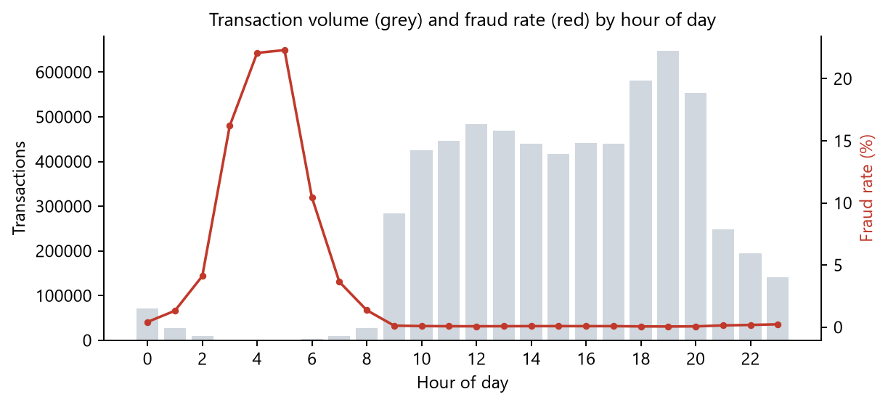
Figure 3. Hourly volume and fraud rate
The number of frauds per hour slot is almost constant (274–371). Legitimate activity follows a daily cycle and nearly stops between 2:00 and 7:00, so in those hours fraud makes up a large share of all transactions, peaking at 22.3% at 5:00. During business hours the fraud rate is below 0.1%. In practice, a transaction at 4 a.m. deserves more scrutiny, so hour_of_day is included as a model feature.

9.3 What do fraudulent transactions look like?
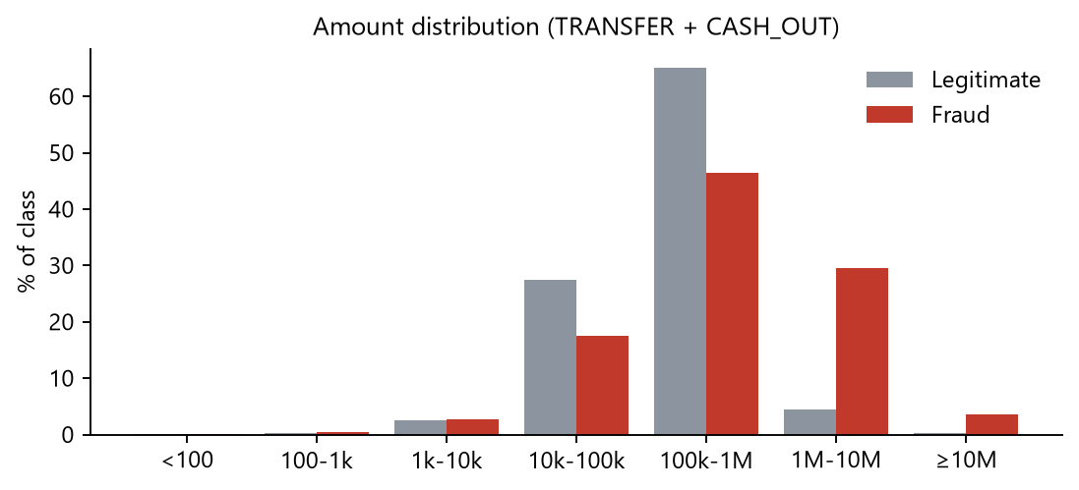
Figure 4. Amount distribution, TRANSFER and CASH_OUT only
Measure (TRANSFER + CASH_OUT) | Legitimate | Fraud
Transactions | 2,762,196 | 8,197
Average amount | 314,116 | 1,470,833
Median amount | 171,021 | 442,290
Sender account emptied | 42.72% | 97.74%
Receiver balance stays 0 before and after | 0.06% | 49.65%
Amount exactly 10,000,000 | 2,920 | 287

- Fraudulent amounts are larger: the median is 442,290 vs 171,021. No fraud exceeds 10 million, and 287 frauds are exactly 10,000,000.
- 97.7% of frauds empty the sender's account. The fraudster takes everything.
- In 49.6% of frauds the receiver's recorded balance stays at 0 even though money arrived, compared with 0.06% of legitimate transactions. This inconsistency is a strong fraud signal.

Possible mule accounts
Most frauds send money to a different account each time, but 43 receiver accounts received more than one fraudulent transaction (86 frauds in total). In a real bank these accounts would be referred for investigation as possible money-mule accounts. The top three by value:
Receiver account | Frauds | Total amount | First hour | Last hour
C668046170 | 2 | 10,160,088.68 | 269 | 686
C1669818195 | 2 | 8,848,239.99 | 446 | 571
C1981613973 | 2 | 7,265,501.67 | 72 | 88

9.4 Model results
Results on the 831,437-row test set (2,407 frauds):
Model | Precision | Recall | F1 | AUC-PR | Caught | False alarms
Existing rule | 1.000 | 0.002 | 0.003 | – | 4 / 2,407 | 0
Logistic Regression | 0.043 | 0.909 | 0.083 | 0.549 | 2,189 / 2,407 | 48,466
Random Forest | 0.993 | 0.998 | 0.995 | 0.998 | 2,401 / 2,407 | 17

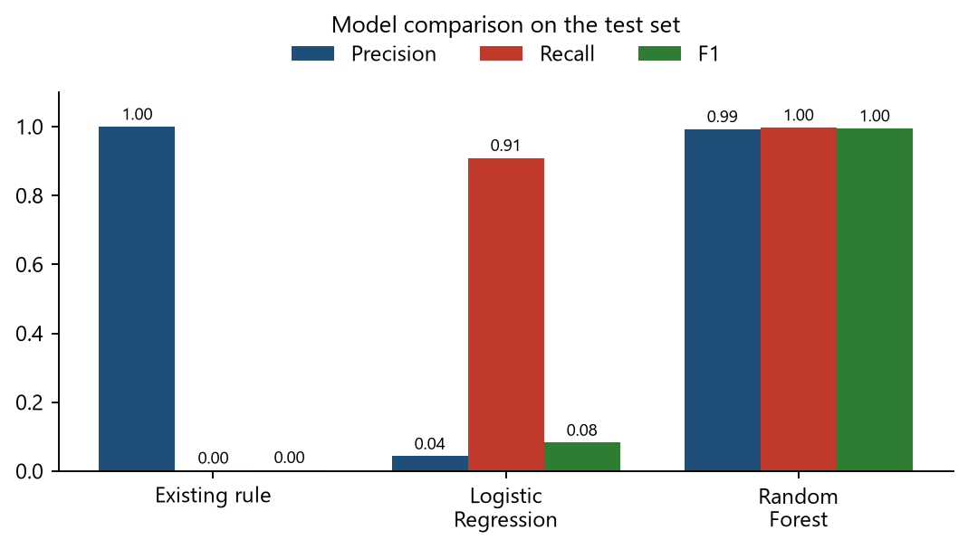
Figure 5. Precision, recall and F1 of the three approaches
- Existing rule: never wrong when it fires (precision 1.0), but it caught only 4 of 2,407 frauds.
- Logistic Regression: catches 90.9% of frauds but raises 48,466 false alarms, about 22 for every real fraud. With class weights it errs heavily on the side of flagging, and a linear boundary cannot separate the classes well.
- Random Forest (selected): catches 2,401 of 2,407 frauds (recall 0.9975) with only 17 false alarms (precision 0.9930). AUC-PR is 0.9978. Training took 94 seconds on 1,938,956 rows.

Confusion matrix — Random Forest
 | Predicted legitimate | Predicted fraud
Actual legitimate | 829,013 (TN) | 17 (FP)
Actual fraud | 6 (FN) | 2,401 (TP)

Feature importance
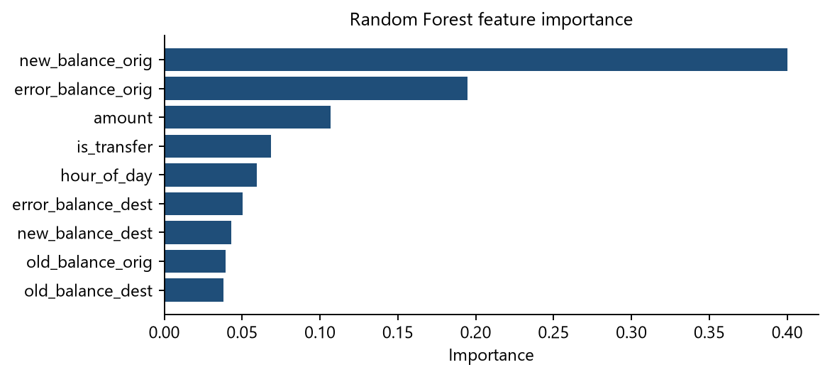
Figure 6. Which features the Random Forest relies on
The most important features are new_balance_orig (0.4001), error_balance_orig (0.1946) and amount (0.1066). In other words, the model mainly checks whether the sender's account was emptied and whether the balances add up, which matches the patterns found in the analytics.

What the model gets wrong
- All 6 missed frauds have a sender balance recorded as 0 both before and after the transaction. Without balance information the model has nothing to go on, which is the same signal it relies on most.
- The 17 false positives are legitimate transactions that look like fraud: typically the whole balance is moved out and the receiver's balance doesn't add up.

Choice of alert threshold
A transaction is flagged when its predicted fraud probability is at least 0.5. The threshold curve shows that precision and recall both stay above 0.99 for any threshold between 0.2 and 0.7. Recall only drops at 0.8 and above (0.9609 at 0.9), so the result does not depend on a carefully tuned cut-off.

10. Running the project

10.1 Requirements
- Python 3.10 or newer
- Java 17 (only needed to rerun the Spark pipeline or use the live prediction form)
- Optional: MongoDB on localhost:27017 (otherwise the dashboard uses results/*.json)
- Optional: a Kaggle API token in ~/.kaggle/ for the automatic download (otherwise download the CSV manually from Kaggle and save it as data/raw/paysim.csv)

10.2 Start the dashboard
git clone https://github.com/JayQuery-007/bank_transaction_analysis.git
cd bank_transaction_analysis
python -m venv venv
venv\Scripts\activate (macOS/Linux: source venv/bin/activate)
pip install -r requirements.txt
python run.py

Then open http://localhost:8000 in a browser. On Windows, .\start.ps1 starts the local MongoDB first (if present in the mongodb folder) and then the dashboard.

10.3 Rebuild everything from the raw data
python run_pipeline.py

This downloads the dataset, then runs ingest, analytics and model training (about 4 minutes in total), refreshing MongoDB, results/ and models/.

10.4 Verified run
The project was run end to end for this report:
Check | Result
Fresh clone + new virtual environment + pip install -r requirements.txt | Installed without errors
Full pipeline from raw CSV (python run_pipeline.py) | Completed: ingest 42 s, analytics 41 s, model 165 s. Reproduced the same metrics.
Dashboard (python run.py) with MongoDB running | All 7 sections load; data source shows MongoDB
Dashboard without MongoDB (fresh clone) | Loads from results/*.json
Live prediction: real fraud from test set (CASH_OUT of 2,658,595.89 at 2:00, sender emptied) | Fraud probability 1.000 → Likely fraud
Live prediction: normal cash-out (18,500 of a 42,000 balance at 14:00) | Fraud probability 0.000 → Looks legitimate

10.5 Dashboard screenshots
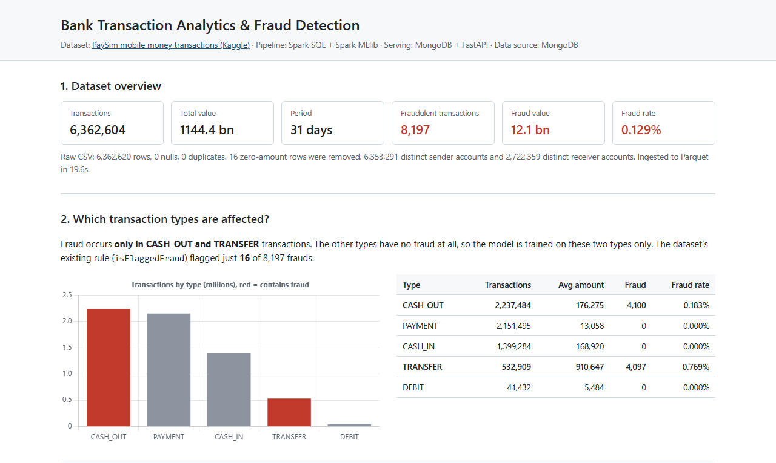
Figure 7. Header, dataset overview and transaction types
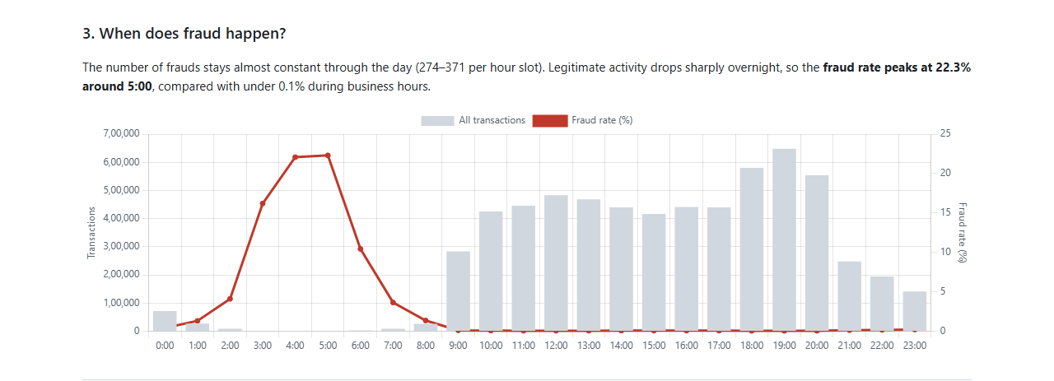
Figure 8. Time-of-day analysis
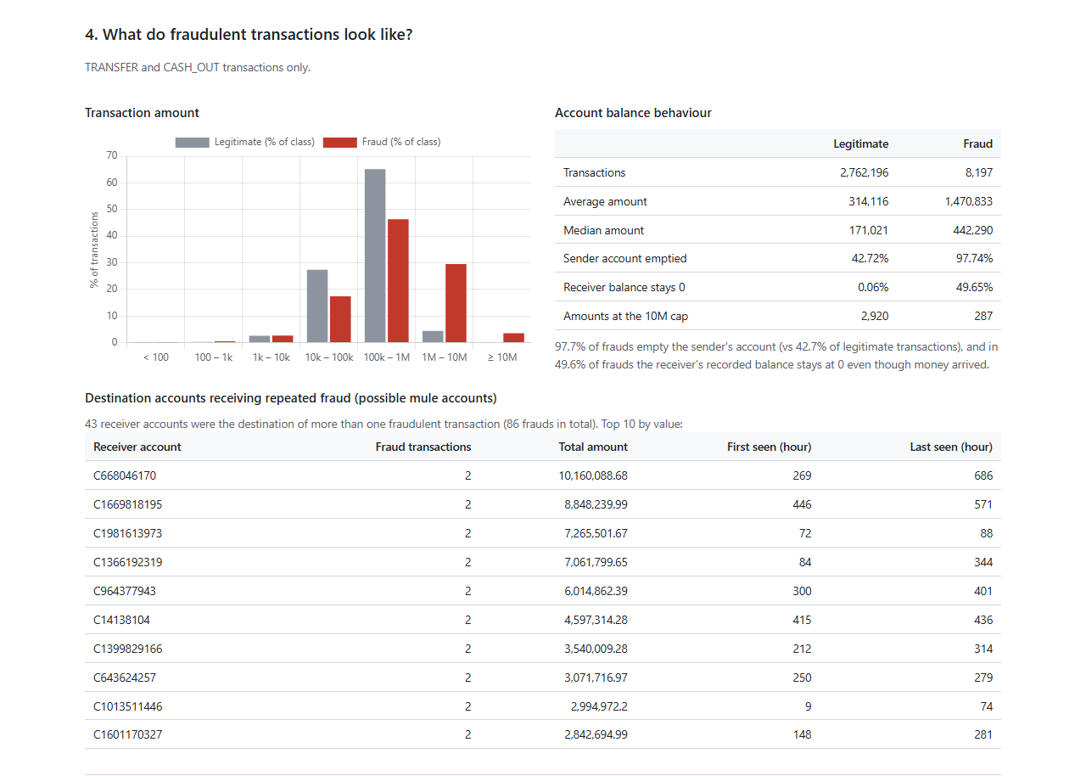
Figure 9. Amounts, balance behaviour and possible mule accounts
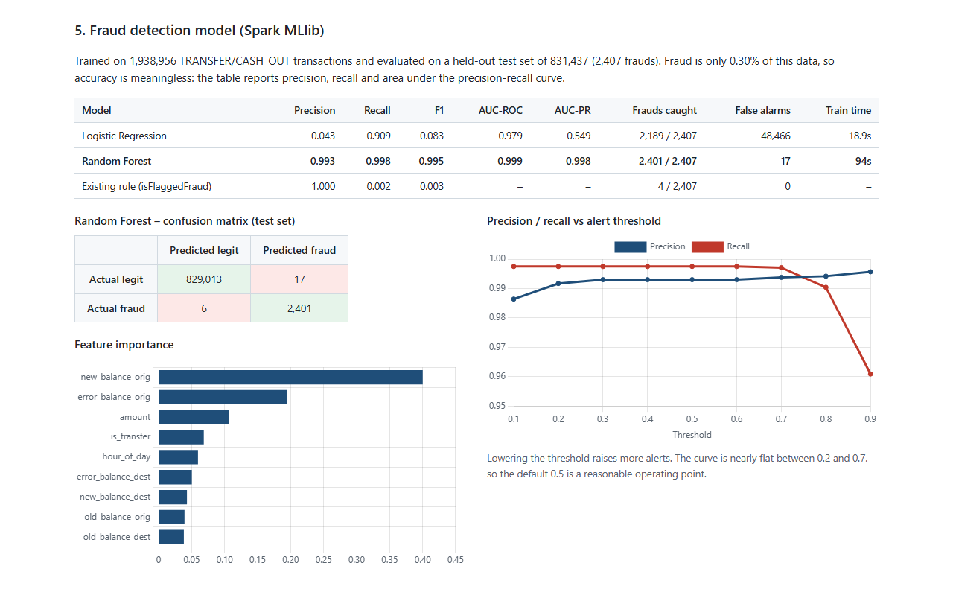
Figure 10. Model comparison, confusion matrix, feature importance and threshold curve
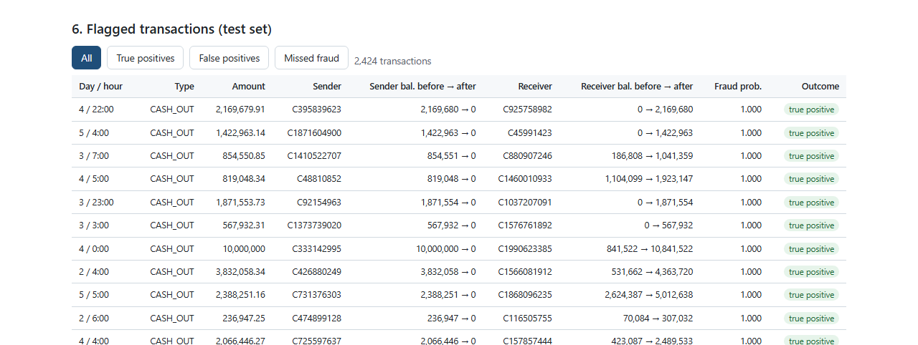
Figure 11. Flagged transactions from the test set
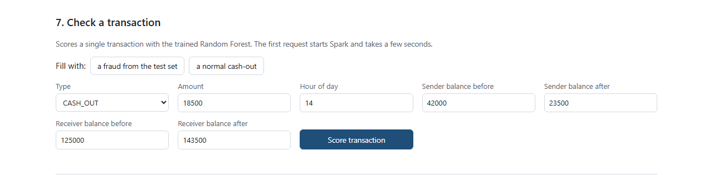
Figure 12. Form for scoring a single transaction

11. Technical challenges and how they were solved

11.1 Spark cannot write files on Windows without winutils.exe
When Spark writes Parquet or saves a model on Windows, the Hadoop library underneath tries to set Unix-style file permissions and check file access by calling native helper programs (winutils.exe, hadoop.dll). Apache does not ship these for Windows, so writes fail with HADOOP_HOME and hadoop.home.dir are unset. The common workaround is to download these binaries from unofficial GitHub repositories.
Solution: instead of running unofficial executables, the project includes a small Hadoop FileSystem subclass (spark_jobs/winfs/src/bda/, about 60 lines of Java). It overrides three methods (setPermission, getFileStatus, listStatus) to use plain Java file operations. File permissions are meaningless on a single-user laptop. The class is compiled into winfs.jar (2 KB), and common.py enables it only when running on Windows. On Linux or macOS, and on a real cluster, Spark's normal file system is used.

11.2 PySpark Python workers crash with Python 3.13 on Windows
Some PySpark operations start separate Python worker processes, for example Python UDFs, RDD operations and PipelineModel.load(). On Windows with Python 3.12 or newer these workers crash with a socket error. Upgrading to Spark 4.0 did not fix it.
Solution: all jobs use only DataFrame, Spark SQL and MLlib operations, which run inside the JVM, plus Arrow to move results to pandas. This is also the recommended way to write efficient Spark code, because Python UDFs are slow. The API loads the saved model through the JVM directly (spark._jvm...PipelineModel.load).

11.3 Long file names in the saved model
Spark names saved files like part-00000-<36-character id>-c000.snappy.parquet. Cloned into a deep folder on Windows, these paths went over the 260-character limit and git clone failed.
Solution: after saving, the model's part files are renamed to short names (part-00000.parquet). Spark reads every part file in a folder regardless of its name.

11.4 Making the repository runnable without the 494 MB dataset
The raw CSV and the Parquet lake are too large for GitHub. The small outputs are committed instead: the results JSON files (under 1 MB) and the trained model (347 KB). The dashboard therefore works right after cloning, and the full pipeline can still be rerun to regenerate everything from the original data.

12. Limitations and future work

12.1 Limitations
- Simulated data: PaySim records balances for fraudulent transactions in a distinctive way (accounts emptied, receiver balances not updated). The model relies heavily on these balance features, which is why its scores are near-perfect. On real bank data the same approach would score lower and would need more behavioural features.
- No customer history: almost every sender appears only once, so features such as "spending compared with this customer's usual behaviour" or transaction velocity cannot be computed.
- Batch only: transactions are analysed after the fact, not as they happen.
- Local mode: Spark ran on one machine. The code is cluster-ready, but it was not run on a cluster.

12.2 Future work
- Real-time scoring: stream incoming transactions through Apache Kafka and score them with Spark Structured Streaming using the saved model, writing alerts to MongoDB.
- Cluster deployment: run the same jobs on a Spark cluster with the data in HDFS or cloud object storage.
- More models: try Gradient-Boosted Trees and an unsupervised anomaly detector, which would catch new fraud patterns without labels.
- Graph analysis: model sender → receiver links as a graph (for example in Neo4j) to find rings of mule accounts.

13. Viva preparation: likely questions
Q1. How does your system decide whether a transaction is fraud?
It learned from 8,197 transactions labelled as fraud (supervised learning). A Random Forest of 60 decision trees looks at the amount, the sender's and receiver's balances before and after, whether those balances add up, the transaction type and the hour. Each tree answers with a probability, the forest averages them, and if the result is 0.5 or more the transaction is flagged. In practice it flags transactions that empty the sender's whole balance, especially at night, and leave the balances inconsistent.
Q2. Where exactly is Big Data used in your project?
In every stage. 6.36M rows are ingested in parallel by Spark into a partitioned Parquet data lake. Analytics run as distributed Spark SQL with caching and partition pruning. The model is trained with Spark MLlib on all 1.94M training rows without sampling. MongoDB serves the results as a separate serving layer. The same code would run unchanged on a cluster with years of data.
Q3. Why did you use PaySim instead of real bank data?
Real transaction data with fraud labels is never published, because of customer privacy and banking regulations. PaySim was generated by a simulator calibrated on real logs from a mobile money provider, so it keeps the real statistical patterns without exposing customers. It is the standard public dataset for this problem.
Q4. Pandas can load 6 million rows. Why use Spark?
One month of one provider is already 494 MB. A real bank generates this every few days, which quickly exceeds one machine's memory. Spark processes data in parallel partitions and the same code scales to a cluster unchanged. It also gives SQL, a Parquet data lake and distributed ML in one engine.
Q5. Why convert CSV to Parquet?
Parquet is columnar and compressed: 494 MB of CSV became 315 MB, even with six extra columns. It stores the schema, reads only the columns a query needs, and supports partition pruning.
Q6. Why partition by transaction type?
Both the analysis and the model filter by type. Fraud only occurs in TRANSFER and CASH_OUT, so the model reads only those two partitions (2.77M rows) and Spark skips the other 3.6M rows without opening them.
Q7. Why MongoDB, and why not store all 6.36M rows in it?
MongoDB is the serving layer. It stores the results the dashboard needs as JSON documents, which match what the API returns. The full data stays in the Parquet lake, where Spark processes it efficiently. Copying millions of rows into the serving database would add cost without benefit.
Q8. Why didn't you use accuracy?
Fraud is 0.3% of the training data. A model that never predicts fraud would be 99.7% accurate and completely useless. Precision, recall, F1 and AUC-PR measure performance on the rare fraud class.
Q9. How did you handle class imbalance?
Logistic Regression uses class weights: each fraud row counts about 337 times, so both classes have equal total weight. Evaluation uses metrics that focus on the minority class. Random Forest handled the imbalance well without weights.
Q10. Why does Logistic Regression perform so badly?
It draws one linear boundary. The fraud signal depends on combinations, such as 'balance became 0 and the amount equals the old balance', which are non-linear. With class weights it also errs heavily towards flagging, giving about 22 false alarms per real fraud.
Q11. Isn't 0.995 F1 a sign of overfitting?
The score is measured on a 30% test set the model never saw, so it is not memorisation. The real reason is the dataset: the simulator records fraudulent balances in a distinctive way that the balance-error features capture. This is a limitation of the data, and real-world performance would be lower.
Q12. What are the error_balance features?
They compare recorded balances with what the amount implies: new sender balance + amount − old sender balance, and old receiver balance + amount − new receiver balance. For a correct transaction both are 0. Large or unusual values point to inconsistent bookkeeping, which is common in the fraud cases.
Q13. What does the threshold curve tell you?
It shows precision and recall if fraud is flagged at different probability cut-offs. Both stay above 0.99 from 0.2 to 0.7, so the model is not sensitive to the exact threshold. A bank could lower it to catch more fraud at the cost of more alerts.
Q14. How would you make this work in real time?
Publish incoming transactions to a Kafka topic, read them with Spark Structured Streaming, apply the saved Random Forest pipeline to each micro-batch, and write flagged transactions to MongoDB for the dashboard or an alerting system.
Q15. What was the hardest technical problem?
Running Spark on Windows. Writes need Hadoop's winutils.exe, which Apache doesn't provide, and PySpark's Python workers crash with Python 3.13. I wrote a small Hadoop FileSystem class in Java to replace the native calls, and kept all processing in DataFrame, SQL and MLlib operations so no Python workers are needed.

14. Project structure
Path | Purpose
config.py | File paths, Kaggle dataset ID, MongoDB connection settings
run_pipeline.py | Runs the four pipeline steps in order
run.py | Starts the dashboard server on http://localhost:8000
start.ps1 | Windows: starts local MongoDB, then the dashboard
requirements.txt | Python dependencies
data/download_data.py | Downloads PaySim from Kaggle into data/raw/
spark_jobs/common.py | Spark session setup and publish() to MongoDB + results/
spark_jobs/ingest.py | Step 1: CSV → cleaned, enriched Parquet lake
spark_jobs/analytics.py | Step 2: Spark SQL analysis queries
spark_jobs/train_model.py | Step 3: MLlib training, evaluation, model saving
spark_jobs/winfs/ | Windows file system class for Hadoop (Java source + jar)
notebooks/eda.ipynb | Exploratory data analysis with plots
backend/app/main.py | FastAPI routes
backend/app/store.py | Reads results from MongoDB or results/*.json
backend/app/predict.py | Loads the Spark model and scores single transactions
frontend/ | Dashboard: index.html, style.css, app.js, bundled Chart.js
models/fraud_rf/ | Trained Random Forest pipeline (Spark ML format)
results/ | JSON copies of all result sets (also loaded into MongoDB)
data/raw/, data/lake/ | Raw CSV and Parquet lake (created by the pipeline, not in Git)

References
1. E. A. Lopez-Rojas, A. Elmir and S. Axelsson, "PaySim: A financial mobile money simulator for fraud detection," 28th European Modeling and Simulation Symposium (EMSS), 2016.
2. PaySim dataset on Kaggle: https://www.kaggle.com/datasets/ealaxi/paysim1
3. Apache Spark documentation (Spark SQL, MLlib): https://spark.apache.org/docs/3.5.3/
4. MongoDB documentation: https://www.mongodb.com/docs/
5. FastAPI documentation: https://fastapi.tiangolo.com/

