1. Find all students from the CS department with marks greater than 80.
Ans -
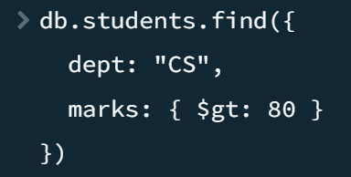

2. Find students whose marks are between 60 and 85 (inclusive) using $gte and $lte.
Ans –
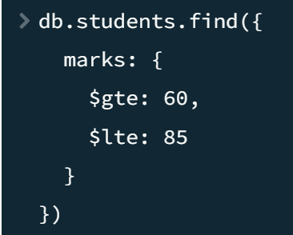

3. Find all students who are either from IT or ECE department using $in operator.
Ans –
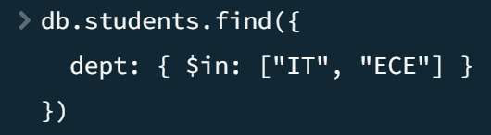

4. Find students NOT in the CS department using $nin and project only name and dept.
Ans –
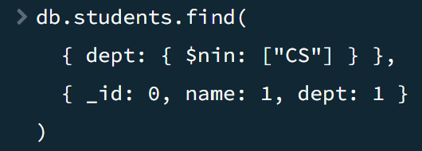

5. Find students where the address.city is 'Chennai' using dot notation.
Ans –
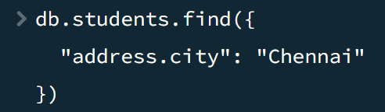

6. Find total revenue per category using $group and $sum on a computed field (price × sold).
Ans –
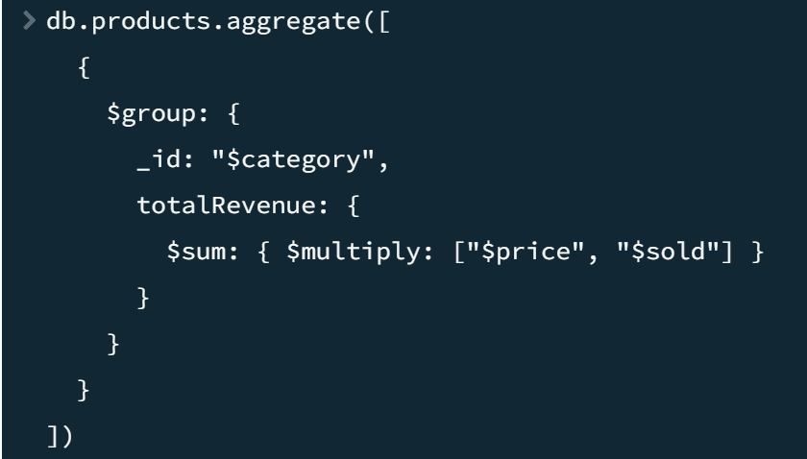

7. Use aggregation to find total number of students and average marks per department.
Ans –
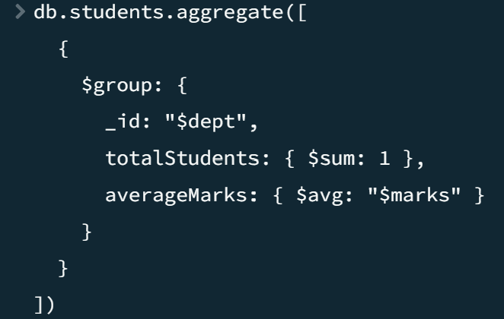

8. Remove the 'scholarship' field from all students using $unset.
Ans –
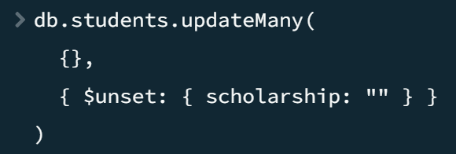

9. Add a new field 'scholarship' with value false to all CS students using $set.
Ans –
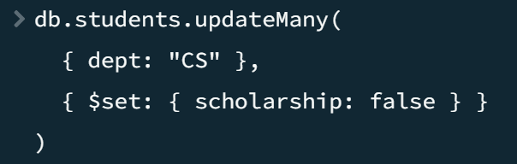

10. Increment marks of student with _id:6 by 10 using $inc.
Ans –
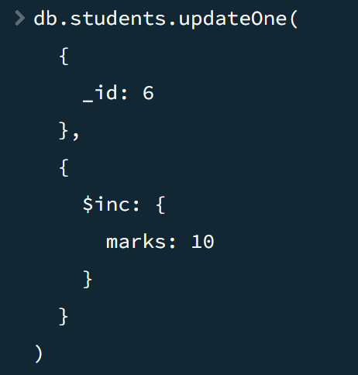
11. Find the 3rd and 4th highest scoring students using sort, skip, and limit (pagination).
Ans –
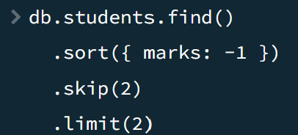

12. Find employees whose salary is greater than 50000 and experience greater than 5.
Ans –
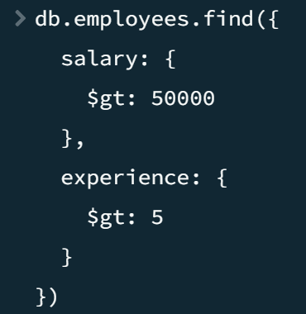

13. Find employees whose skills array size is greater than 2.
Ans –
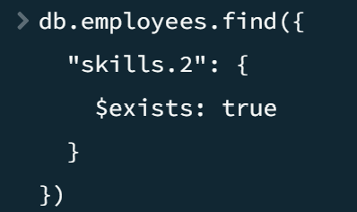

14. Find departments whose average salary is greater than 50000.
Ans –
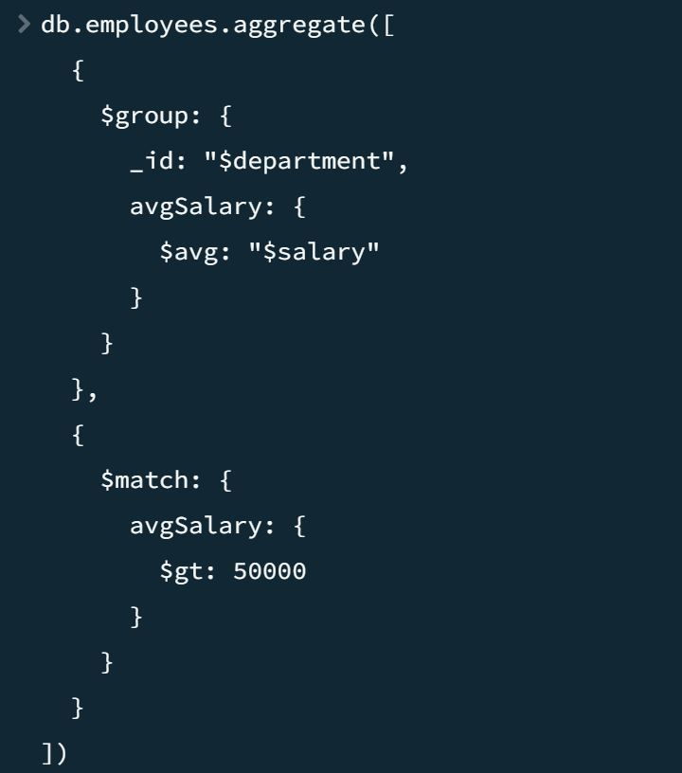

15. Find minimum salary in each department.
Ans –
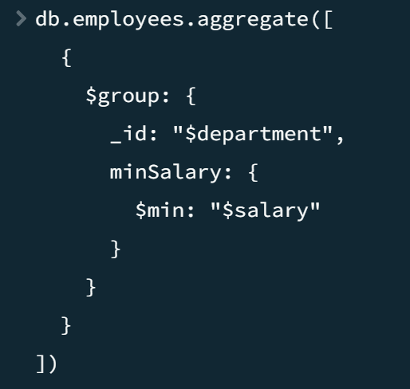

16. Rename field city to location.
Ans –
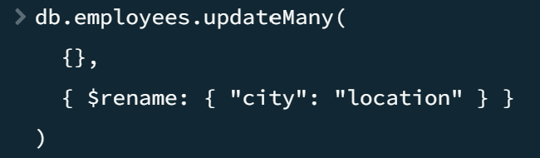

17. Find products where stock is of type Number using $type operator.
Ans –
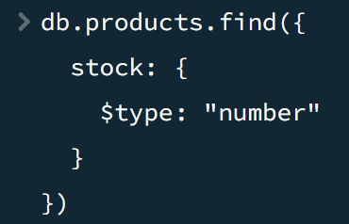
18. Set the active status to true for all inactive students using updateMany and $set.
Ans –
