***Name:*** *Jay A. Sorathiya*

*Link to Git-hub repository:* [*https://github.com/JaySRT/PythonFlaskDockerPycharm/tree/Flask_oscar_dataset_Docker_mysql*](https://github.com/JaySRT/PythonFlaskDockerPycharm/tree/Flask_oscar_dataset_Docker_mysql)

***Part 3 of Web App***

*q. The project showing that you can view* ***YOUR*** *data tables in pycharm*:

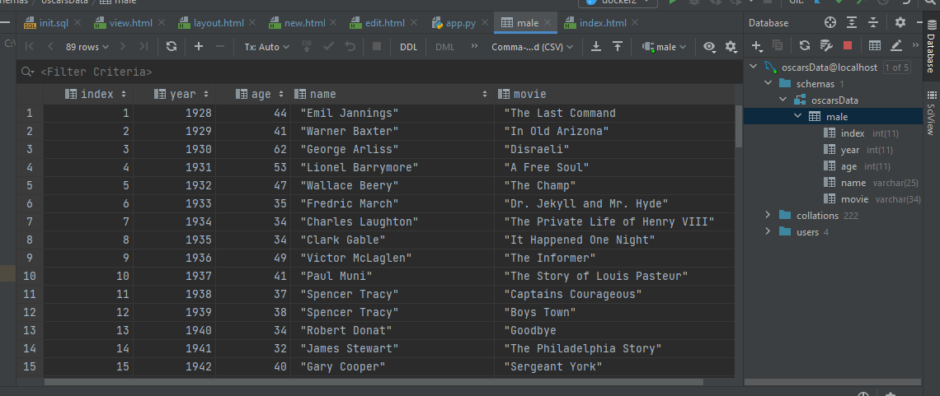

1. ***YOUR*** *project running correctly in the browser displaying your homepage with your data*

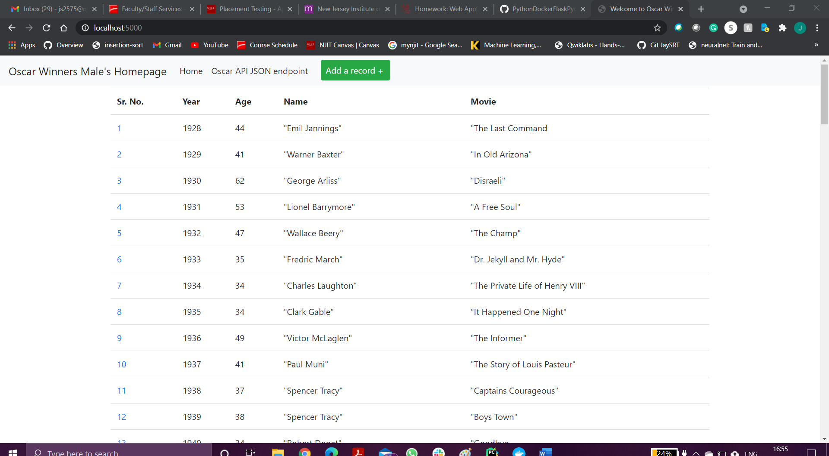

1. ***YOUR*** *project running correctly in the browser displaying your data record as a view of one record*

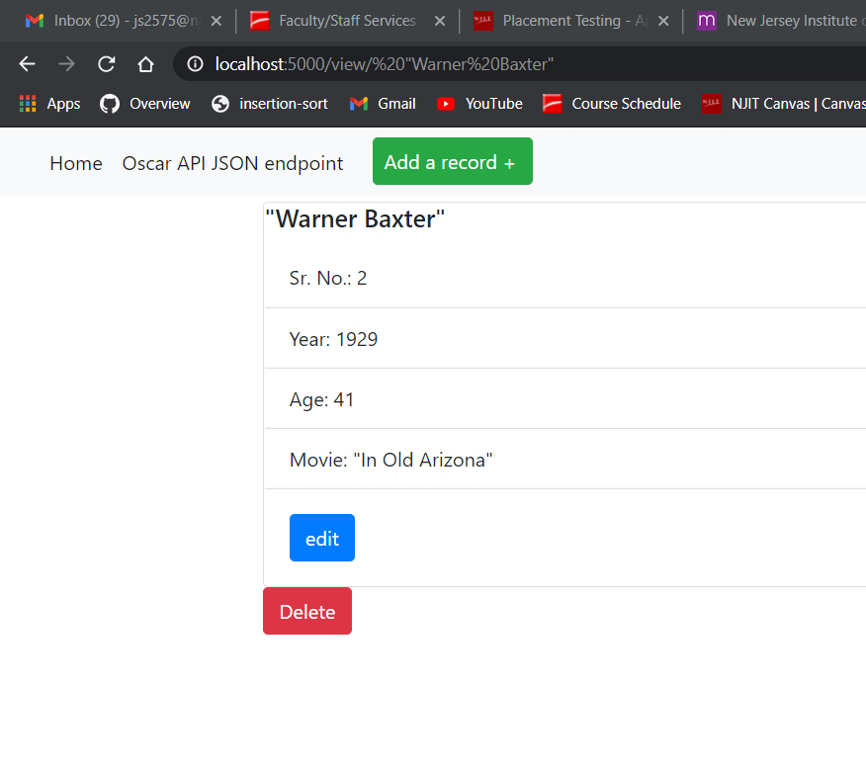

1. ***YOUR*** *project running correctly in the browser displaying a new record added to your home page*

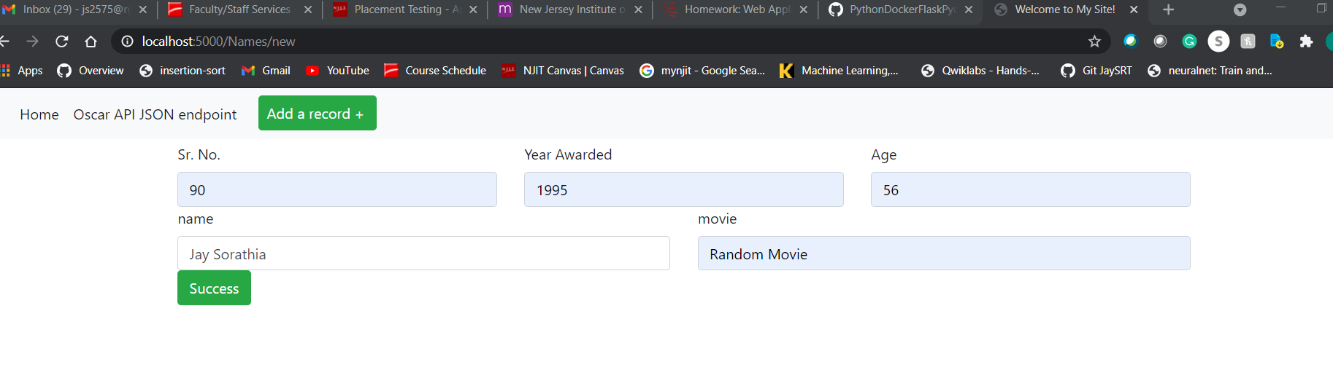

*e.* ***YOUR*** *project running correctly in the browser displaying an updated record added to your home*

*page*

*Record no. 90 has been added.*

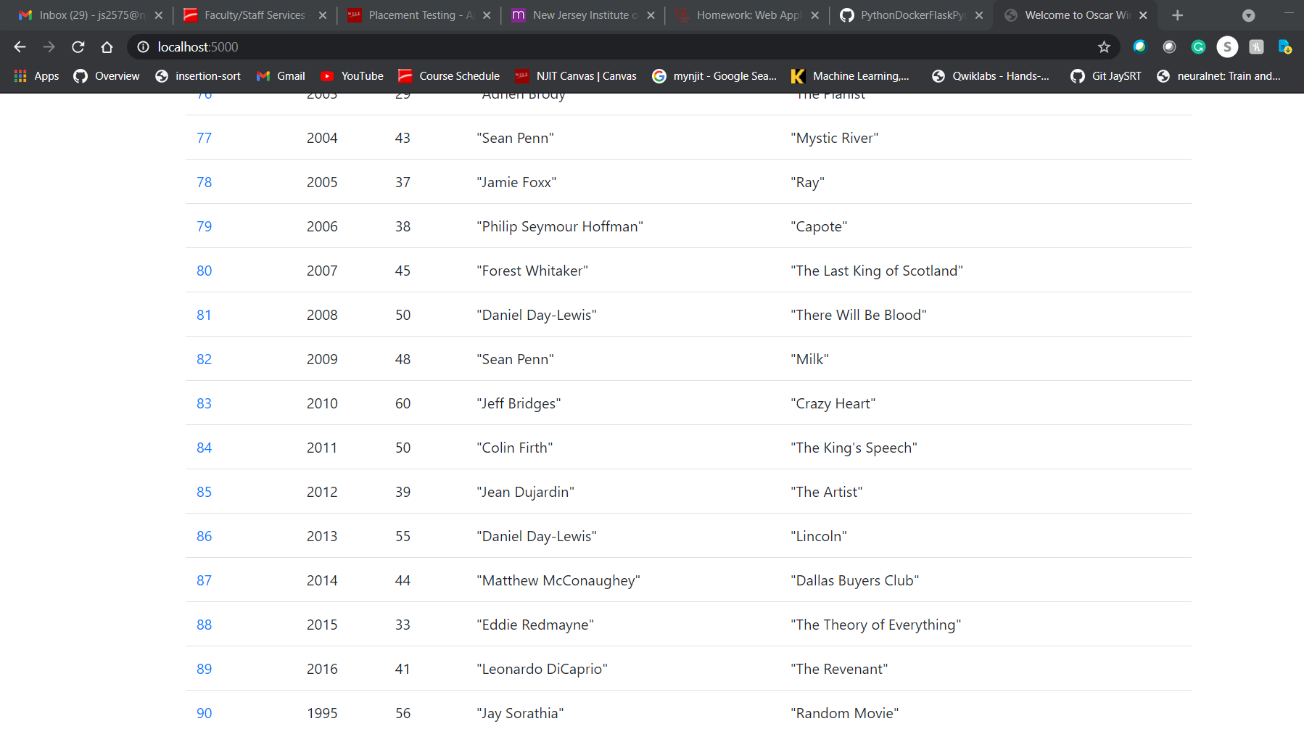

*f.* ***YOUR*** *project running correctly in the browser displaying a deleted record added to your home*

*page*

*Record no 3 is deleted in the below screenshot.*

