**Requirement from the slide**

Develop **a simulation engine** for testing **traffic management**

**policies**

Should simulate individual **vehicles** (cars, coaches, buses etc.)

operating in different **parts** of a **road network** (e.g. roundabouts,

multi-lane junctions).

Consider where vehicles enter road network and where they

leave it.

Consider **individual behaviors** (e.g. reckless, cautious, normal).

Consider timing of journeys (based on purpose and patterns of

use).

Consider support for **emergency services** (e.g. priorities

ambulances at traffic lights).

Allow different traffic management policies to be plugged in and

compared.

**simulation engine**

Decide on a **time granularity** for the simulation (e.g. 10 seconds).

Each tick of the simulation clock will require all parts of the

simulation to update.

The simulation engine will record **vehicle positions**, new entries

and exits and any other data and then update the state before

moving to the next tick.

GUI for visualization of initial maps and/or the moving

simulation or command-line?

User configurable maps?

How does the scale of the map affect your choices?

How to report sensible numbers of the success/failure of

different policies? e.g. average speed, congestion rate etc.

**Business Concept Model：**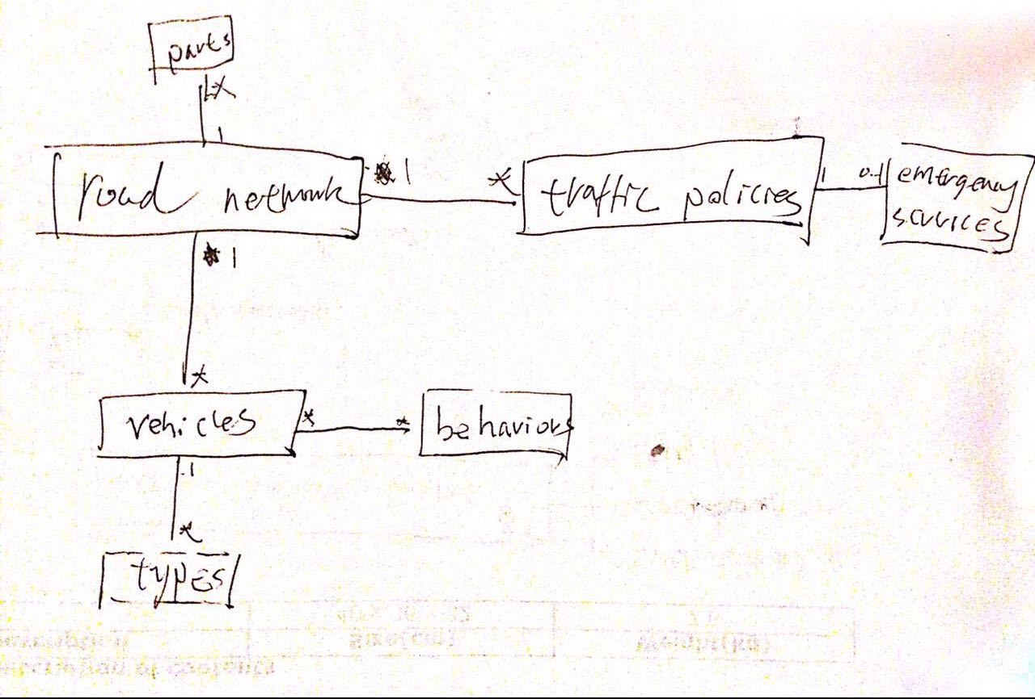

**use cases：**  
1、set the road network

2、set operating factors for vehicles

3、plug traffic management policies

4、policies analysis

**System Interfaces：**

ISetRoadnetwork

ISetOperatingfactor

IPlugPolicy

IAnalysis

IRoadnetworkMgt

IVehicleMgt

IPolicyMgt

**Initial System Architecture：**