

**Project Report On**

**E-Medicine system**

****

**Developed By:**

Savani Jay Dilipbhai (CE120) (20CEUOS103)

**Subject:**

WEB SERVICE DEVELOPMENT

**Guaided By:**

Prof. Ankit P. Vaishnav



**B. Tech. CE Semester – VI**

**Faculty of Technology**

**Department of Computer Engineering**

**Dharmsinh Desai University**



**Faculty of Technology**

**Department of Computer Engineering**

**Dharmsinh Desai University**

**CERTIFICATE**

This is to certify that the project entitled

“**E-Medicine System**” in the subject of “**Web Service Development**” is a bonafied report of the work carried out by

**SAVANI JAY D. (CE120) (20CEUOS103)**

of Department of **Computer Engineering** semester **VI**

during the academic year 2022-2023.

Prof. Ankit P. Vaishnav Dr. C. K. Bhensdadia,

Associate Professor, Head,

Dept. of Computer Engg., Dept. of Computer Engg.,

Faculty of Technology, Faculty of Technology,

Dharmsinh Desai University, Nadiad Dharmsinh Desai University, Nadiad

**CONTENTS**

1. ABSTRACT 4
2. INTRODUCTION 5-8

2.1 Introduction to platform 6

2.2 Introduction to technology 6

1. SOFTWARE REQUIREMENTS SPECIFICATIONS 9-10
2. DATABASE DESIGN 11-12

4.1 Usecase diagram 11

4.2 E-R diagram 12

1. TESTING 13
2. SCREEN SHOTS 14-20
3. IMPLEMENTATION DETAILS 21
4. CONCLUSION 23
5. LIMITATIONS AND FUTURE EXTENSION 24

10) BIBLIOGRAPHY 24

**ABSTRACT**

The eMedicine system is a digital platform that functions similarly to an eCommerce platform in the healthcare industry. The system provides a user-friendly interface that offers a wide range of medical products, including medication, medical equipment, and healthcare supplies. The platform utilizes advanced technologies to provide a seamless and secure purchasing experience for both healthcare professionals and patients. The eMedicine system allows users to browse and purchase medical products from the comfort of their homes, and it provides secure payment options for transactions. Additionally, the system ensures timely delivery of medical products to the customers. This abstract provides an overview of the eMedicine system that functions like an eCommerce platform in the healthcare industry, and its benefits for both healthcare professionals and patients.

**INTRODUCTION**

The project "EMedicine System" is a comprehensive digital platform dedicated to the general requirements of pharmacies and medicine stores. The main objective of the project is to create an online medicine ordering processing system that allows customers to search for and purchase medicines conveniently. The platform will provide information on available medicines, their prices, quantities, and other details.

The ordering process begins with the customer searching for the medicine by name or category. The system will provide a list of pharmacies and medicine stores that have the medicine in stock. Once the customer selects the preferred pharmacy, they can view the medicine details, including its price and availability.

In the next step, the customer can choose the desired quantity of medicine and add it to their virtual shopping cart. Based on the selected parameters, the system will calculate the total cost of the medicine and provide a secure payment gateway for the customer to make the payment.

The administrator of the platform will have access to a comprehensive dashboard that displays information on all orders, stock levels, and sales data. The system also provides the ability to manage inventory and update medicine prices, quantities, and other details.

In conclusion, the " EMedicine System" aims to make the process of purchasing medicines convenient and hassle-free for customers and streamlines the operations of pharmacies and medicine stores.

**2.1 INTRODUCTION TO PLATEFORM**

**Visual Studio Code and Visual Studio :**

Visual Studio Code is a lightweight but powerful source code editor which runs on your desktop and is available for Windows, macOS and Linux. It comes with built-in support for JavaScript, TypeScript and Node.js and has a rich ecosystem of extensions for other languages and runtimes.

**2.2 INTRODUCTION TO TECHNOLOGY**

## ReactJS

[ReactJS](https://itechnolabs.ca/hire-reactjs-developer" \t "_blank) is a JS library that lets you make user interfaces for mobile and single-page applications (SPAs). It enables you to write JavaScript code and build user interface (UI) components. The JS library does everything with virtual DOM.

With the React library, you can make views that are rendered in HTML. Ideas in React are told what to do. This means that developers don’t have to worry about managing the effects of changes to the data or the view’s state, which is the object that controls how components act.

Instead of using templates to automate the creation of HTML or DOM (Document Object Model) elements used over and over, React uses a full-featured programming language (JavaScript) to build HTML or DOM elements used over and over or that are created based on certain conditions.

**Why use React?**

* Virtual DOM – A virtual DOM object is a representation of a DOM object. Virtual DOM is actually a copy of the original DOM. Any modification in the web application causes the entire UI to re-render the virtual DOM. Then the difference between the original DOM and this virtual DOM is compared and the changes are made accordingly to the original DOM.
* JSX – Stands for JavaScript XML. It is an HTML/XML JavaScript Extension which is used in React. Makes it easier and simpler to write React components.
* Components – ReactJS supports Components. Components are the building blocks of UI wherein each component has a logic and contributes to the overall UI. These components also promote code reusability and make the overall web application easier to understand.
* High Performance – Features like Virtual DOM, JSX and Components makes it much faster than the rest of the frameworks out there.
* Developing Android/Ios Apps – With React Native you can easily code Android-based or IOS-Based apps with just the knowledge of JavaScript and ReactJS.
* You can start your react application by first installing “create-react-app” using npm or yarn.

## Asp.Net Core Web API

ASP.NET Core Web API is a framework developed by Microsoft for building web APIs on top of the .NET Core platform. It is a lightweight and cross-platform framework that allows developers to create RESTful APIs using a simple and flexible architecture.

ASP.NET Core Web API provides a wide range of features that make it easier for developers to build APIs. These features include built-in support for dependency injection, middleware, routing, and serialization. It also provides support for authentication and authorization, which is essential for building secure APIs.

**Why use Asp.Net Core Web API ?**

* Cross-platform support : ASP.NET Core Web API is cross-platform, which means it can be run on Windows, Linux, and macOS. This makes it easier for developers to create APIs that can run on multiple platforms, which can help to reduce costs and increase the reach of the API.
* Easy to use: ASP.NET Core Web API provides a simple and flexible architecture that makes it easy for developers to build APIs. It includes built-in support for common API features, such as routing, serialization, and dependency injection, which can help to reduce development time and improve code quality.
* Security: ASP.NET Core Web API provides built-in support for authentication and authorization, which is essential for building secure APIs. It supports a range of authentication methods, including OAuth2, OpenID Connect, and JWT tokens, which can help to protect sensitive data and prevent unauthorized access to the API.
* Customization: ASP.NET Core Web API is highly customizable, which means developers can choose to use the default settings provided by the framework or customize the behavior of the API to meet their specific requirements. This makes it easy to build APIs that are tailored to the needs of individual applications.

**3. SOFTWARE REQUIREMENT SPECIFICATIONS**

**1) Login System:**

**R.1.1 Sign Up:**

Description: New user can sign up in website using basic details like Email and Password.

Input: Email , Password.

Output: Confirmation of sign up.

**R.1.2 Sign in:**

Description: Once user sign up by email id then for next time

sign in can be done by correct mail id and password.

Input: Email,Password.

Output: User redirected to home page.

**2) Manage user:**

**R.2.1 Add user:**

Description: add new user with all of its information.

Users: Admin

Input: New user

Output: Conformation of user added.

**R.2.2 Update user:**

Description: Admin can change user’s information if required.

Input: Updated user.

Output: Conformation of user updation.

**R.2.3 Delete user:**

Description: Admin can delete any user if required.

Output: Conformation of user deletion.

**R.2.4 Display user:**

Description: Display uploaded user so admin can see list of all user.

Output: Display users.

**3) Manage medicine:**

**R.2.1 Add medicine:**

Description: add new medicine with all of its information.

Users: Admin

Input: New medicine

Output: Conformation of medicine added.

**R.2.2 Update medicine:**

Description: Admin can change medicine’s information if required.

Input: Updated medicine.

Output: Conformation of medicine updation.

**R.2.3 Delete medicine:**

Description: Admin can delete any medicine if required.

Output: Conformation of medicine deletion.

**R.2.4 Display medicine:**

Description: Display uploaded medicine so customer can buy it.

Output: Display medicines.

**4) Logout**

Description: user can logout any time.

Output: Confirmation of logout.

**4 DATABASE DESIGN**

**4.1 Usecase Diagram:**

1. **Admin:**

The Administrator is the user of the system. He is the responsible person to manage the Medicines details,User Account Details, orders details.

🚺

**Admin**

1. **User:**

He/She is responsible for the registration of the User Account, The user can Change password, view No seats Available and booking the tickets.

🚺

**User**

**4.2 E-R Diagram:**

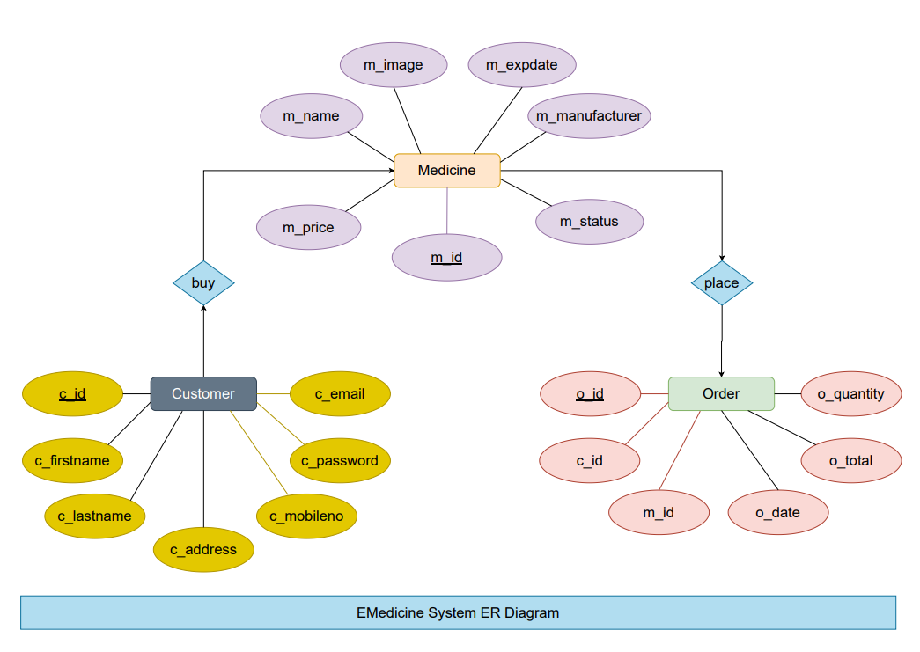

**5. TESTING**

**Software Testing Strategies**

Testing is a set of activities that can be planned in advanced and conducted systematically. A strategy for software testing must accommodation low-level tests that are necessary to verify that a small source code segment has been correctly implemented as well as high-level tests that validate major system functions against customer requirements

There are three types of testing strategies

1. Unit test
2. Integration test

3. Performance test

**Unit Testing:**

Unit testing focuses verification efforts on the smallest unit of software design module. The unit test is always white box oriented. The tests that occur as part of unit testing are testing the module interface, examining the local data structures, testing the boundary conditions, execution all the independent paths and testing error-handling paths.

**Integration Testing:**

Integration testing is a systematic technique or construction the program structure while at the same time conducting tests to uncover errors associated with interfacing. Scope of testing summarizes the specific functional, performance, and internal design characteristics that are to be tested. It employs top-down testing and bottom-up testing methods for this case.

**Performance Testing:**

Timing for both read and update transactions should be gathered to determine whether system functions are being performed in an acceptable timeframe.

**6. SCREEN-SHOTS**

**Login page:**

**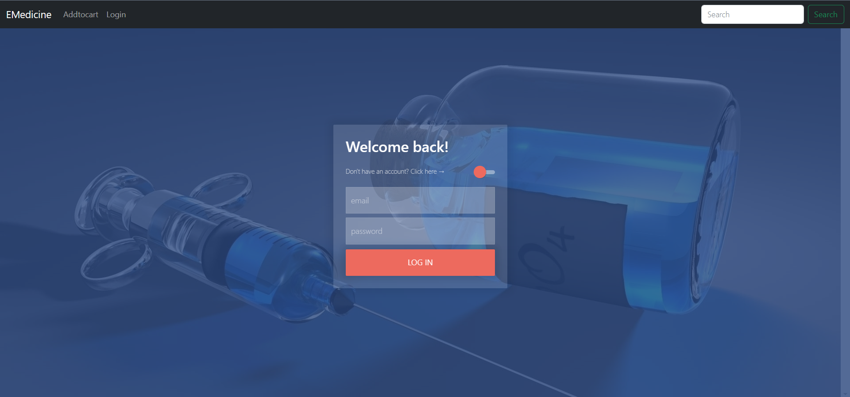**

**Register page:**

**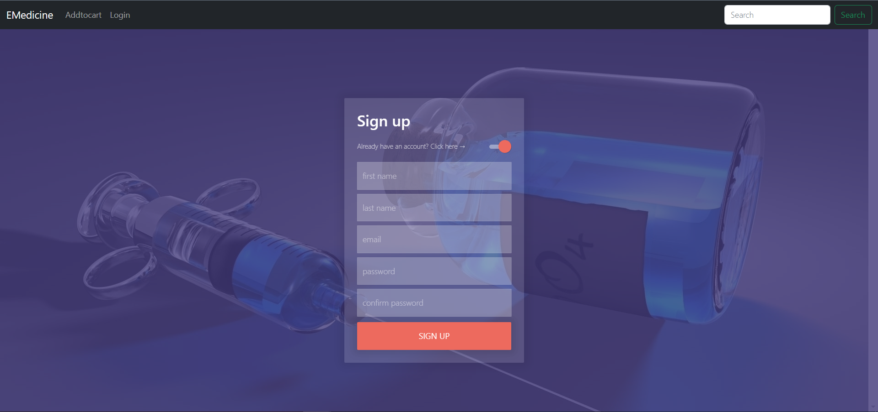**

**Home page:**

**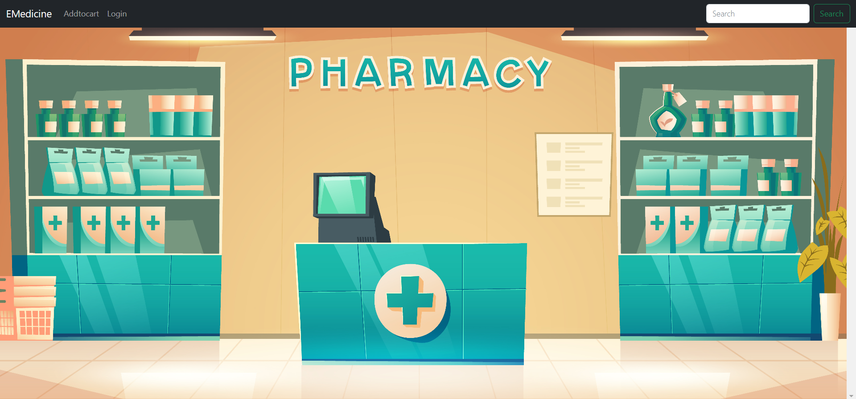**

**Add To Cart page :**

**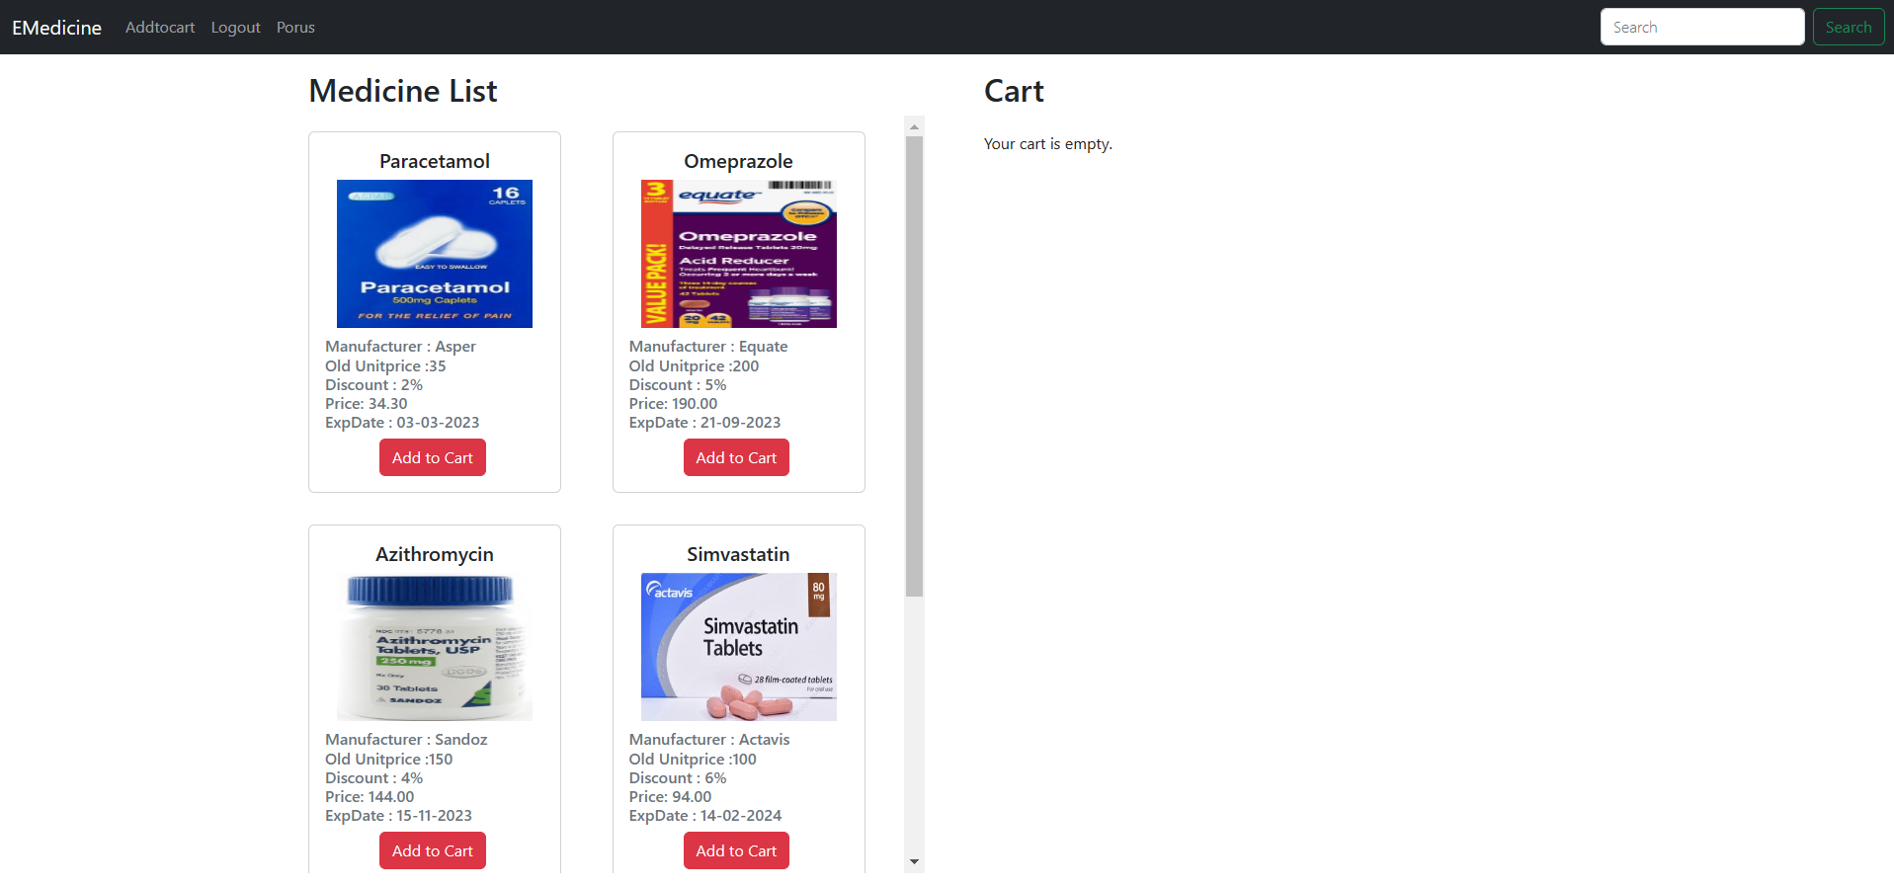**

**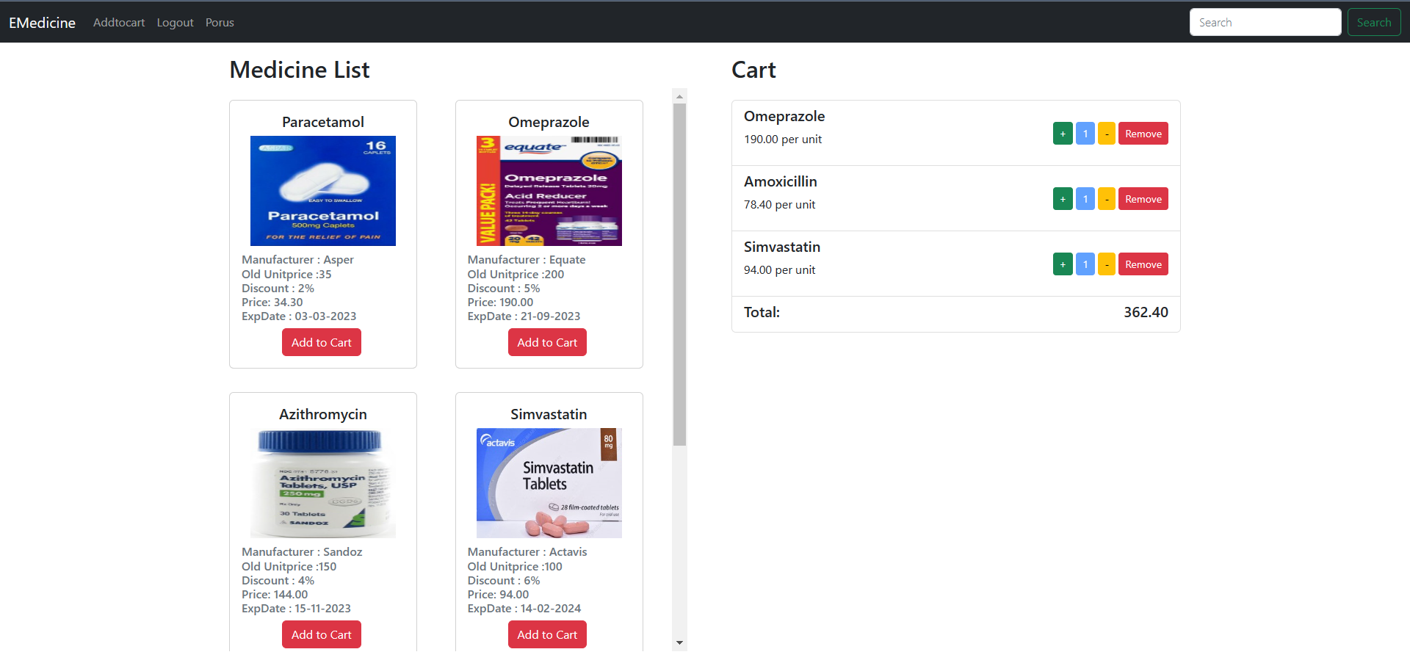**

**Admin Pages:**

**Users page:**

**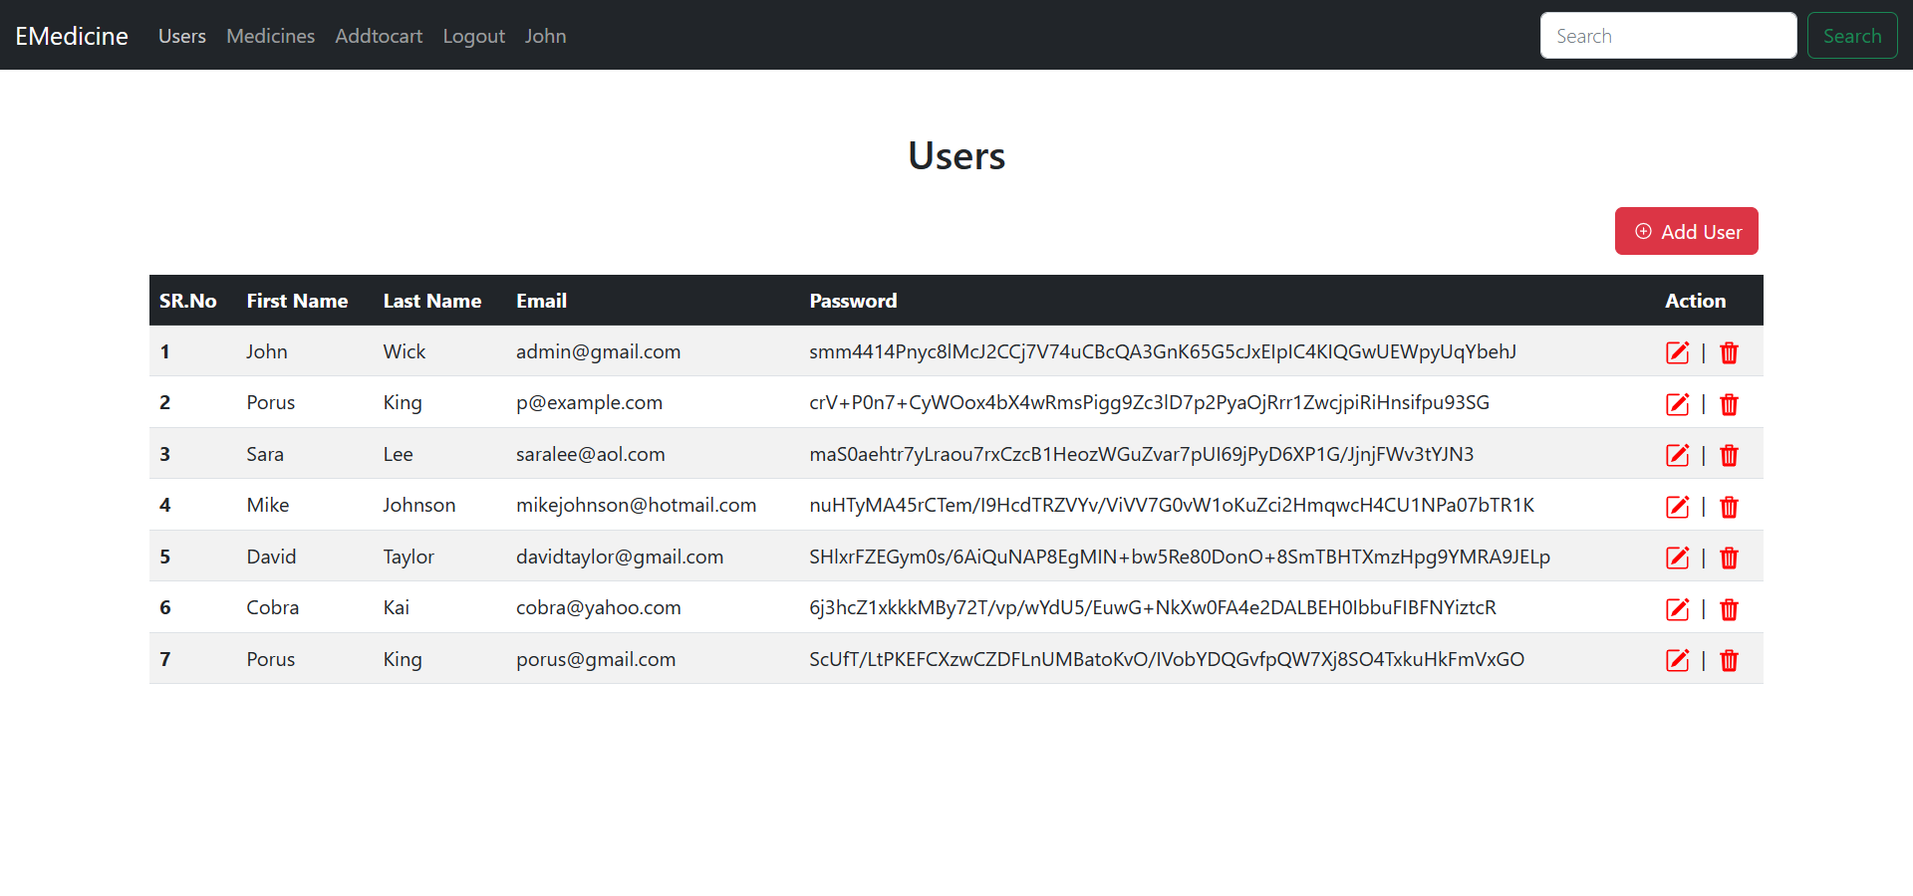**

**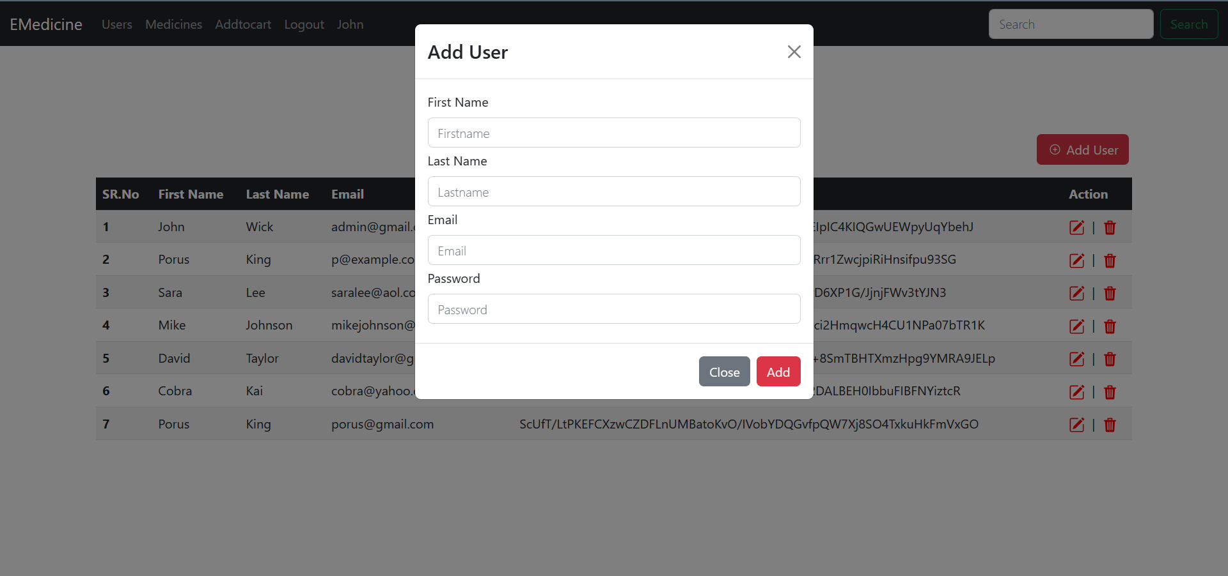**

**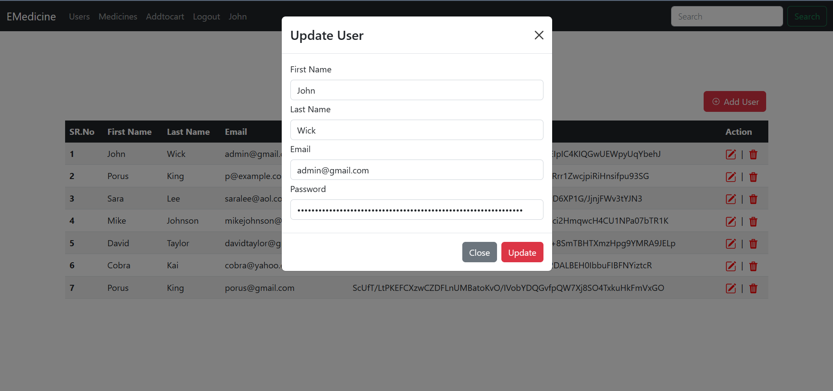**

**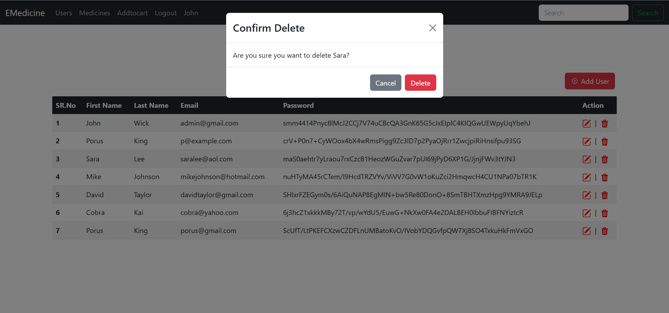**

**Medicine Page:**

**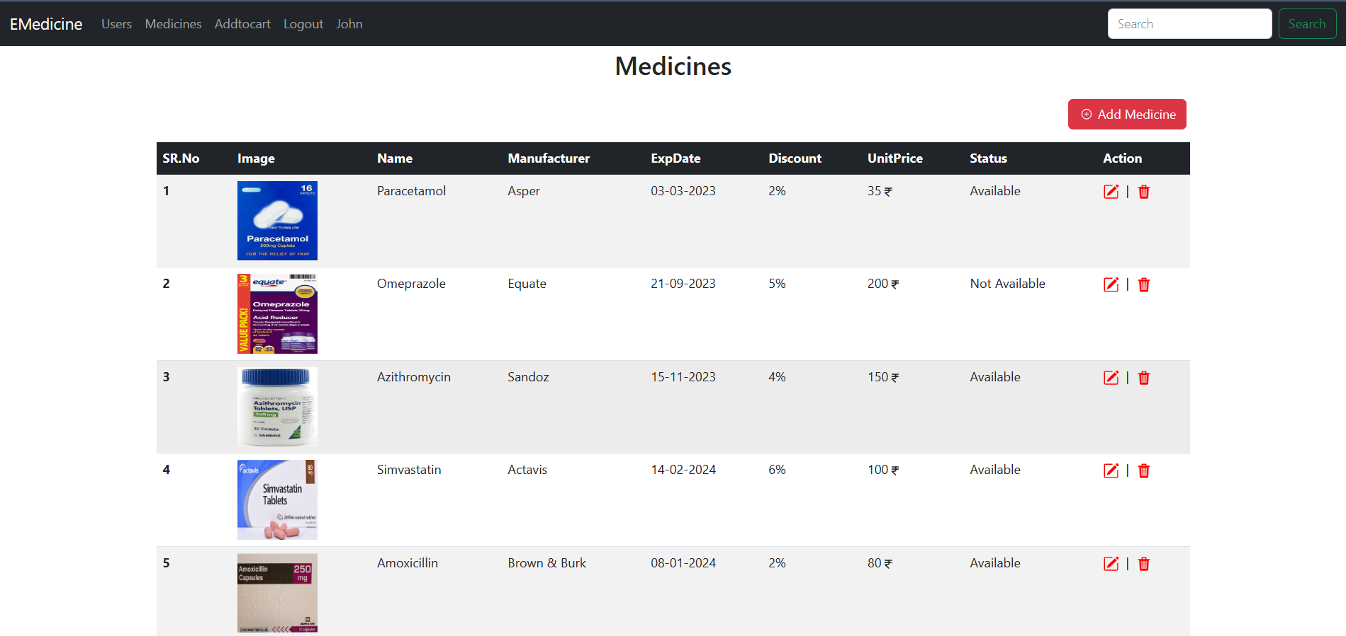**

.

Add medicine:

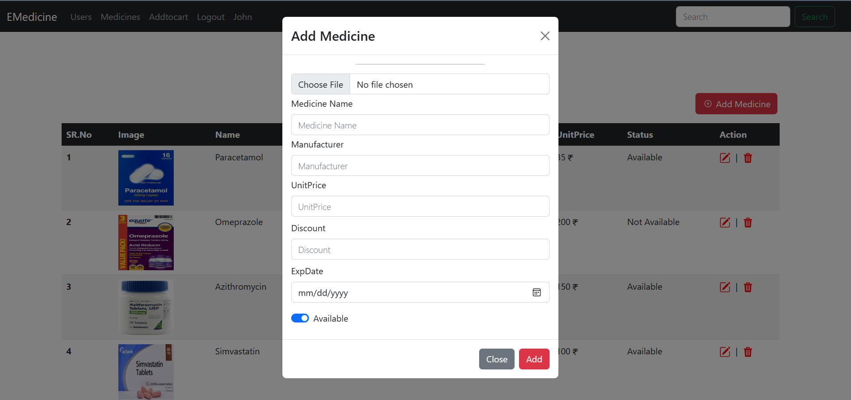

Edit medicine: 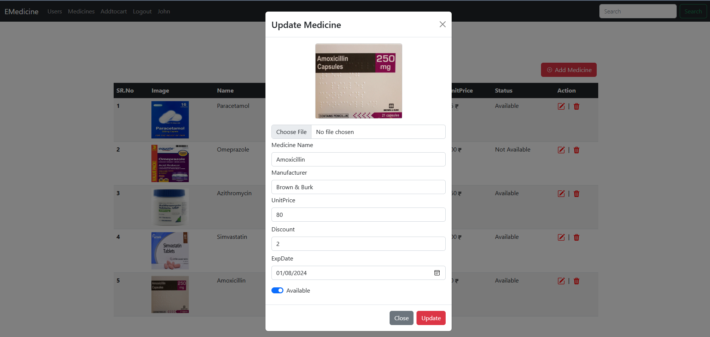

Delete medicine:

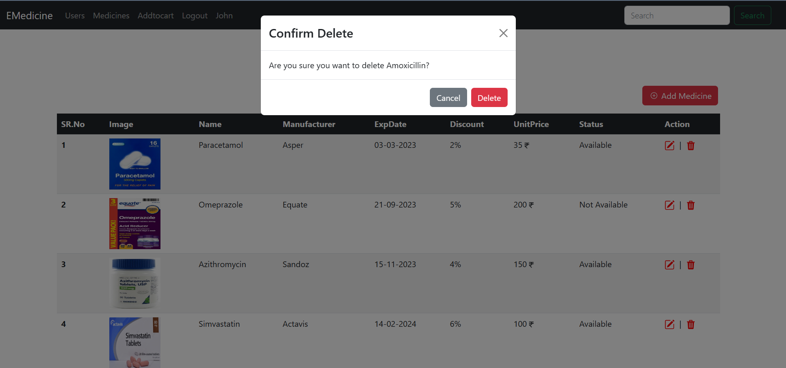

**7. Implementation Details**

**Models**

1. **User.cs**

namespace EMedicine.Models

{

    public class Users

    {

        public int Id { get; set; }

        public string FirstName { get; set; }

        public string LastName { get; set; }

        public string Password { get; set; }

        public string Email { get; set; }

        public string Type { get; set; }

    }

}

1. **Medicine.cs**

using System.ComponentModel.DataAnnotations.Schema;

namespace EMedicine.Models

{

    public class Medicines

    {

        public int Id { get; set; }

        public string Name { get; set; }

        public string Manufacturer { get; set; }

        public decimal UnitPrice { get; set; }

        public decimal Discount { get; set; }

        public string ImageUrl { get; set; }

        public DateTime ExpDate { get; set; }

        public Boolean Status { get; set; }

        [NotMapped]

        public IFormFile? ImageFile { get; set; }

        [NotMapped]

        public string ImageSrc { get; set; }

    }

}

1. **EMedicineContext.cs**

using Microsoft.EntityFrameworkCore;

namespace EMedicine.Models

{

    public class EMedicineContext : DbContext

    {

        public EMedicineContext(DbContextOptions<EMedicineContext>options) : base (options)

        {

        }

        public DbSet<Users> Users { get; set; } = null!;

        public DbSet<Loginuser> Loginuser { get; set; } = null!;

        public DbSet<Medicines> Medicines { get; set; } = null!;

    }

}

**8. CONCLUSION**

• User Registration containing all the necessary validations on fields.

• Login

• User Authentication

• Order Medicines

• Select Medicine

• Admin Add, update, Delete user

• Admin Add , Update , Delete the Medicine

The entire project has been developed and deployed as per the requirements stated by the user, it is found to be bug free as per the testing standards that is implemented. Any specification-untraced errors will be concentrated in the coming versions, which are planned to be developed in near future. The system at present does not take care off the money payment methods, as the consolidated constructs need SSL standards and are critically to be initiated in the first face, the application of the credit card transactions is applied as a developmental phase in the coming days. The system needs more elaborative technicality for its inception and evolution.

**9. LIMITATIONS AND FUTURE EXTANSION**

**Limitations:**

* These website doesn’t contain feature for payment.
* These website doesn’t show medicine that is most seller.

**Future extansion:**

* By using any payment gate way feature for payment can be added into system so that it looks more realistic.
* There should be one selection on home page for most popular medicine.

**10.** **BIBLIOGRAPHY**

1) React : <https://legacy.reactjs.org/docs/getting-started.html>

2) Asp .Net Core Web API : <https://learn.microsoft.com/en-us/aspnet/core/tutorials/first-web-api?view=aspnetcore-7.0&tabs=visual-studio>

3) Bootstrap : <https://getbootstrap.com/docs/5.3/getting-started/introduction/>