Jonathan Schall, Greg Kosakowski

Professor Eyad Hailat

CIS 427 – 002, Group 13

November 19, 2022

**Programming Assignment 2: Online Cryptocurrency Trading**

**Introduction:**

For this programming assignment, we will be using Python. Python allows us to create a server-client program scheme without requiring a Makefile to compile. This makes our programs highly compatible.

**Prerequisites:**

1. The user must have the python3 installed on their Unix-based system. These programs do NOT require a Makefile as python is an interpreted language.

**Running Instructions:**

1. After the client and server programs are uploaded, the user can start them.
2. Start the server using the command “python PythonServer.py”. This will start a server on the computer with the local IP address of the computer.
3. Next, start the client using the command “python PythonClient.py {IPv4 address}”. In the address, you must specify the address of the server. For example, you can use the local IPv4 address of the server e.g. “python PythonClient.py 141.215.69.202”.
4. If done correctly, you should be able to enter things into the client with the server echoing received.

**Group Member Roles:**

When it came to each of our roles, we split them evenly. We initially used Jonathan's project 1 implementation.

Jonathan: multithreading clients, LOGIN and LOGOUT, fixed SHUTDOWN for multithreading, partial string LOOKUP

Greg: DEPOSIT, WHO, new BUY, new SELL, new LIST, initial LOOKUP, updated database for WHO

**Crypto Commands:**

1. “BUY”: Allows the user to buy a cryptocurrency given that the user exists, and they have money.
   1. Example: “BUY DOGECOIN 1 2”

Buys DOGECOIN, 1 share at 2 dollars per share for logged-in user.

Output: “200 OK

BOUGHT: New balance 1.0 DOGECOIN USD balance $98.00”

1. “SELL”: Allows the user to sell a cryptocurrency given that the user exists, and they have the necessary amount to sell in their account.
   1. Example: ”SELL DOGECOIN 1 1”

Sells DOGECOIN, 1 share for 1 dollar per share for logged-in user.

Output: “200 OK

SOLD: New balance: 0.0 DOGECOIN USD balance $99.00”

1. “LIST”: Allows the user to list all cryptocurrencies in the Cryptos table.
   1. For root user:

Example: “LIST”

Lists all cryptocurrencies in the table.

Output: “200 OK

The list of records in the Crypto database for ALL users:

1 DOGECOIN 1.0 mary

2 BITCOIN 2.5 john”

* 1. For non-root users (e.g mary):

Example: “LIST”

Lists all cryptocurrencies in the table.

Output: “200 OK

The list of records in the Crypto database for mary:

1 DOGECOIN 1.0 mary”

1. “BALANCE”: Allows the user to see the USD balance for the currently logged-in user.
   1. Example: “BALANCE”

Shows the balance for the current user. (e.g. mary)

Output: “200 OK

Balance for user Mary Beth: $99.00”

1. “SHUTDOWN”: Allows the logged-in user to close the server.
   1. Example: “SHUTDOWN”

Closes the server down (closes the correct sockets and terminates server program.

Output: “200 OK

Shutting down server…”

1. “QUIT”: Allows any user (logged in or not) to close their client.
   1. Example: “QUIT”

Closes the client down (closes the correct socket and terminates client program.

Output: “200 OK

Quitting client…”

1. “LOGIN”: Allows any client to log in given they use valid credentials.
2. Example: “LOGIN root root01”

Logs the user in with username = root, password = root01.

Output: “200 OK” (User now logged in).

1. “LOGOUT”: Allows any logged-in user to log out.
2. Example: “LOGOUT”

Logs out the user and allows them to log in to another account.

Output: “200 OK” (User now logged out).

1. “WHO”: Allows only the root user to view all active users and their IP addresses.
2. Example: “WHO”

Lists all active users with their usernames and IP addresses.

Output: “200 OK

The list of the active users:

john 141.215.195.255

root 127.0.0.1”

1. “LOOKUP”: Allows any logged-in user to search for crypto records in their account.
2. Example: “LOOKUP DOGECOIN”

Looks up DOGECOIN in the logged-in user’s account

Output: “200 OK

Found 1 matching records

DOGECOIN 1.0”

1. “DEPOSIT”: Allows any logged-in user to add funds to their account balance.
2. Example: “DEPOSIT 100”

Deposits 100 dollars into their account balance.

Output: “200 OK

Deposit successful. New balance: $200.00”

**Users in Database:**

The database is initialized with the following usernames and passwords:

| **UserID** | **Password** |
| --- | --- |
| root | root01 |
| mary | mary01 |
| john | john01 |
| moe | moe01 |

**Testing:**

| **Test #** | **Description of test** | **Logged In before command?** | **Input Value** | **Expected Output** | **Actual Output** | **Pass/Fail** |
| --- | --- | --- | --- | --- | --- | --- |
| 1 | Incorrect login | No | LOGIN bob bob | 403 Wrong UserID or Password | 403 Wrong UserID or Password | PASS |
| 2 | Successful login | No | LOGIN mary mary01 | 200 OK | 200 OK | PASS |
| 3 | Check user’s balance when not logged in | No | BALANCE | 400 invalid command | ​​400 invalid command | PASS |
| 4 | Check user’s balance | Yes | BALANCE | 200 OK  Balance for user mary beth: $100.00 | 200 OK  Balance for user mary beth: $100.0 | PASS |
| 5 | Buy a crypto when not logged in | No | BUY BTC 4 2 | 400 invalid command | 400 invalid command | PASS |
| 6 | Buy a crypto | Yes | BUY BTC 4 2 | 200 OK  BOUGHT: New balance: 4.00 BTC USD balance: $92.00 | 200 OK  BOUGHT: New balance: 4.00 BTC USD balance: $92.00 | PASS |
| 7 | Buy another crypto | Yes | BUY DOGE 1.5 3 | 200 OK  BOUGHT: New balance: 1.50 DOGE USD Balance: $87.50 | 200 OK  BOUGHT: New balance: 1.50 DOGE USD Balance: $87.50 | PASS |
| 8 | Sell some of a crypto when not logged in | No | SELL BTC 3 1 | 400 invalid command | 400 invalid command | PASS |
| 9 | Try selling too much crypto | Yes | SELL BTC 5 1 | Not enough crypto | Not enough crypto | PASS |
| 10 | Sell some of a crypto | Yes | SELL BTC 3 1 | 200 OK  SOLD: New balance: 1.00 BTC USD Balance: $90.50 | 200 OK  SOLD: New balance: 1.00 BTC USD Balance: $90.50 | PASS |
| 11 | List cryptos  (Logged in as mary) | Yes | LIST | The list of records in the Crypto database for mary:  1 BTC 1.0  2 DOGE 1.5 | The list of records in the Crypto database for mary:  1 BTC 1.0  2 DOGE 1.5 | PASS |
| 12 | Admin login | No | LOGIN root root01 | 200 OK | 200 OK | PASS |
| 13 | View current users (Logged in as root) | Yes | WHO | 200 OK  The list of the active users:  root 10.0.0.63  mary 10.0.0.63 | 200 OK  The list of the active users:  root 10.0.0.63  mary 10.0.0.63 | PASS |
| 14 | View current users  (Logged in as anybody besides root) | Yes | WHO | Need root user permissions | Need root user permissions | PASS |
| 15 | View current users (Not logged in) | No | WHO | 400 invalid command | 400 invalid command | PASS |
| 16 | Search for crypto (Logged in as root) | Yes | LOOKUP DOG | 200 OK  Found 1 matching records  DOGE 1.5 | 200 OK  Found 1 matching records  DOGE 1.5 | PASS |
| 17 | login another client | No | LOGIN john john01 | 200 OK | 200 OK | PASS |
| 18 | Buy on new client (Logged in as John) | Yes | BUY WLV 6 4 | 200 OK  BOUGHT: New balance: 6.00 WLV USD Balance: $76.00 | 200 OK  BOUGHT: New balance: 6.00 WLV USD Balance: $76.00 | PASS |
| 19 | Admin list all cryptos (Logged in as root) | Yes | LIST | 200 OK  The list of records in the Crypto database for ALL users:  1 BTC 1.0 mary  2 DOGE 1.5 mary  3 WLV 6.0 john | 200 OK  The list of records in the Crypto database for ALL users:  1 BTC 1.0 mary  2 DOGE 1.5 mary  3 WLV 6.0 john | PASS |
| 20 | logout | Yes | LOGOUT | 200 OK | 200 OK | PASS |
| 21 | logout when not logged in | No | LOGOUT | 400 invalid command | 400 invalid command | PASS |
| 22 | Client quits | No | QUIT | Quitting client | Quitting client | PASS |
| 23 | add funds to client | Yes | DEPOSIT 50 | 200 OK  Deposit successful. New balance: $140.50 | 200 OK  Deposit successful. New balance: $140.50 | PASS |
| 24 | add funds to client when not logged in | No | DEPOSIT 100 | 400 invalid command | 400 invalid command | PASS |
| 25 | Client quits | No | QUIT | Closing client | Closing client | PASS |
| 26 | Admin shutdown server  (Logged in as root) | Yes | SHUTDOWN | Shutting down server | Shutting down server | PASS |
| 27 | Shutdown server (Logged in as anybody else) | Yes | SHUTDOWN | 400 invalid command | 400 invalid command | PASS |

**Screenshots:**

Test case 1:



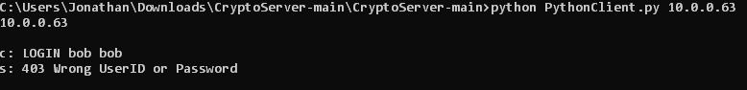

Test case 2:





Test case 3:



Test case 4:



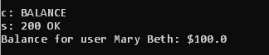

Test case 5:



Test case 6:



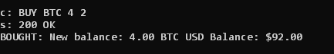

Test case 7:



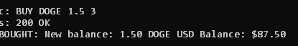

Test case 8:

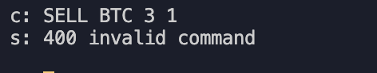

Test case 9:





Test case 10:





Test case 11:



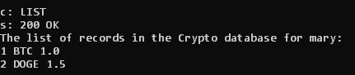

Test case 12:



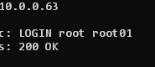

Test case 13:



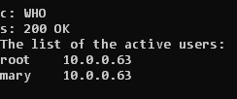

Test Case 14:



Test Case 15:

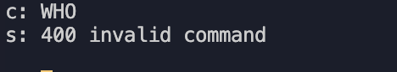

Test case 16:



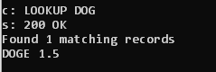

Test case 17:



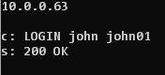

Test case 18:



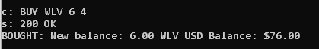

Test case 19:



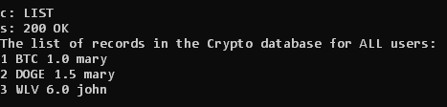

Test case 20:





Test Case 21:

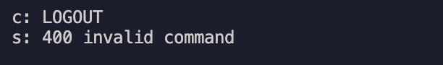

Test case 22:



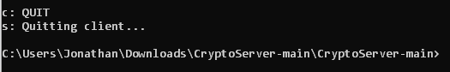

Test case 23:



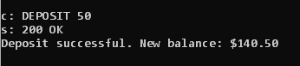

Test case 24:

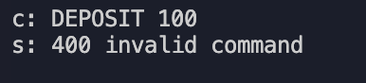

Test case 25:



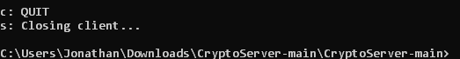

Test case 26:

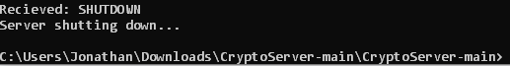

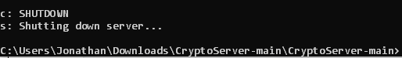

Test Case 27:

