**README doc – Module 4 Databases Assignment – Jay Smith**

**Github URL** - [TBC](https://github.com/JaySmith-Dev/MovieBookingsRUs)

**Render URL** - [TBC](https://moviebookingsrus.onrender.com)

This web app was deployed on render by creating a web service, entering a name “moviebookingsrus”, and choosing a locale (Frankfurt). All other settings were default.

TBC

**Concept**

The concept of my project was to try and create a version of Santa’s Naughty (or nice) list. The web app was to use Flask to route the web pages, passing values i.e. the childrens details and wishlist items between pages, being able to get and post information, i.e. pull data, and update wishlist items, or childrens details etc. I also decided to utilise bootstrap for the layout to try it out, and a small amount of css and javascript.

**Challenges**

I enjoyed this project. It was pretty difficult to get to grips with the database element of it, and while I work with data, and am comfortable with joining etc., working with the web side of it is much tricker to wrap my head round.

We had worked through various elements of creating models and basic web sites through the module, and this has formed the basis for this project. I decided to simplify this in order to get a working design, and think I have delivered on that. I would like to take this now, and improve based on my learnings through creating this app.

I used bootstrap for designing the majority of the page to keep it consistent across the various templates being used, and will look to improve my knowledge of this over the rest of the course, but I feel it really helps allow time for concentrate on the other elements rather than design.

In order of work, it started with the models, knowing what I wanted to create and save, then building the initial pages using flask to route etc, tidying up the design, and then finally adding some javascript Christmas lights, which I found code for on GitHub, and implemented this in my design as is.

Once those were completed, getting it up on render, and updating relevant values in the code were straight forward enough.

**Conceptual / ERD Diagrams**

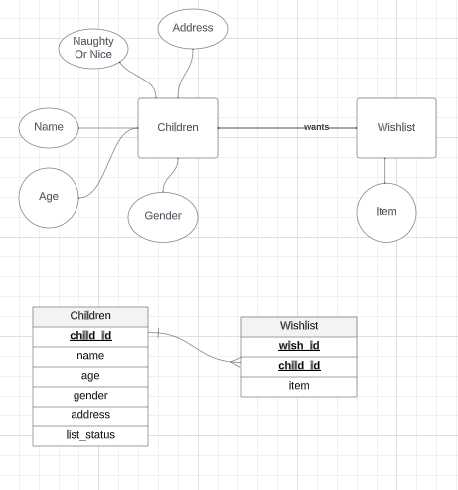

**References**

* <https://getbootstrap.com/docs/5.3/components/navbar/#how-it-works>
* Coding examples from coursework, all live on github - <https://github.com/UCD-PA-Full-Stack-March-2023/4-Databases>
* <https://github.com/thechinedu/christmas-lights/blob/master/index.html>