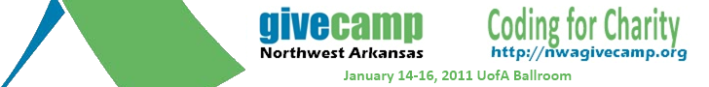
Does your non-profit need a new website? Is it time to escape those Excel spreadsheets and get a real donor database? Trying to figure out how to build your social media presence? Then the Northwest Arkansas GiveCamp is for you.
Fayetteville, Ark. – The Northwest Arkansas .NET User Group in Partnership with the University of Arkansas announces the first annual Northwest Arkansas GiveCamp to provide technology solutions for Local Non-Profits.
The Northwest Arkansas GiveCamp is a weekend-long event that brings together local technology professionals committed to providing your organization with solutions, strategies, and tools that can help you continue your good work.
Local experts such as designers, web developers, database administrators and solutions architects assemble to help work on your technology project. To be considered as one of the 10 non-profits for this year’s event please visit our website located at http://nwagivecamp.com and submit your project proposal. Once we receive your proposal an analyst will contact you to gather more detailed information to be used for our final selection process. Once the selections have been made you will be notified of the selection status.

Who: NWA .Net User Group in partnership with University of Arkansas
What: 1st Annual Northwest Arkansas GiveCamp
Where: University of Arkansas, Student Union Ballroom
When: Friday thru Sunday, January 14 – 16, 2011
Contact:
Jay Smith Event Chairman 479-422-0122
Matt Garcia Marketing and PR 479-435-0331

About the Northwest Arkansas .NET User Group
The Northwest Arkansas .NET User Group is a non-profit 501(c)(3) organization that is dedicated to the promotion, education and adoption of Microsoft .NET Technologies. They strive to provide an environment for professionals to network in Northwest Arkansas to foster the free exchange of ideas and information.

For more online information and video, visit:
www.nwagivecamp.org
www.givecamp.org
www.vimeo.com/8474638

If you have further questions please feel free to contact us,

Jay Smith
Northwest Arkansas GiveCamp Chairman

