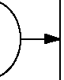

Start

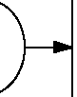

Start

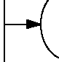

Stop



Stop

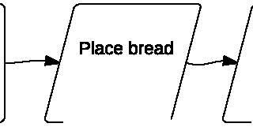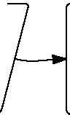

Get 2 slices of

bread from bag.

in toaster

Toaster

toasts bread, remove bread

Eat bread

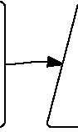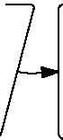

Remove nail from

box.

Retrieve hammer

Hammer nail

in wall.

Hang picture.

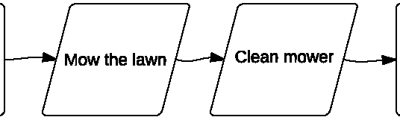

Retrieve lawn

mower

Park mower

Sequential Code



Start



Stop

Start

Start

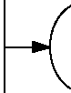

Stop

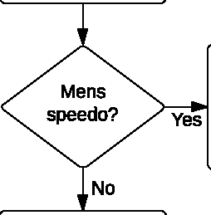

Decide to go for a swim.

Swim!

Stay home

P=?

Home

Stop

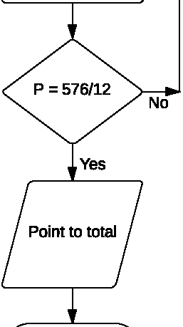

p x (14-2) = 576

P X 12 = 576

End

Conditional Code

Start Start

A board 1" thick

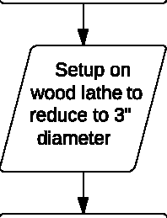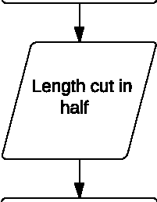

Stock 6X6X8 Maple Wood

Blanks for baseball bats

Machine checked

at 3" diameter

Stop Stop

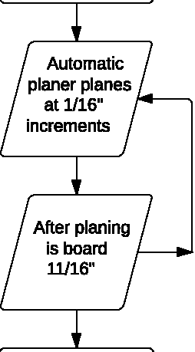

Board must be

planed to 11/16ths thickness

Board is 11/16

Repetitive Code Reusable Code