- I am the sole team member, and I take full responsibility for each aspect of the app.
- My app will be a mobile app that helps students stay focused while studying. Many students find it hard to avoid distractions and keep their attention during long study sessions. This app addresses that by offering structured focus sessions and customizable background soundscapes to create a better study environment. It is mainly designed for college students who want an easy way to manage their study time and boost productivity. Key features include Pomodoro-style focus sessions, soundscapes that match your mood or task, tools to track focus and distractions, and the option to save session presets called blueprints. The app also has a simple rule-based “AI Focus DJ” that suggests sound combinations based on your past sessions. All data is stored locally to meet project requirements. Session history, blueprints, and productivity data are saved with SQLite, so you can create, view, update, and delete records. Simple settings like theme and default session length are stored with SharedPreferences. This setup lets the app work fully offline while still giving you a personalized experience.
- https://github.com/JayTK13/MADProj1
- Submitted with this document.
- Screen Flow
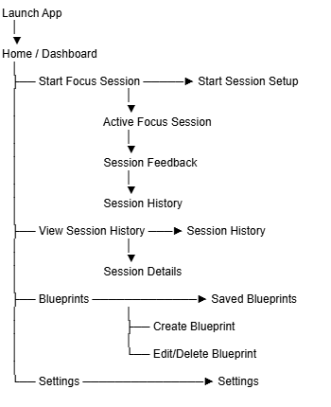

Navigation Buttons
Home | History | Blueprints | Settings

Edge Cases
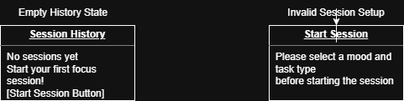

Wireframe Navigation Flow
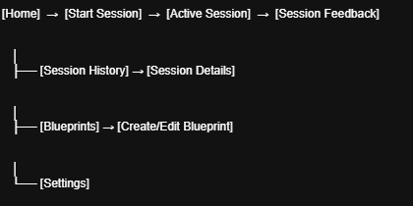

Iteration Plan
Once I achieve my first rough build of the app, I will test it out by using the screens like a user would in the actual app. I’ll be looking for how easy it is to use, how clear the navigation is, and whether it’s accessible. This includes checking if buttons and gestures feel natural, if users can easily find the info they need, and if the screens work well in both portrait and landscape modes. I’ll also run my edge cases of empty session history or if there's invalid input during the setup. After gathering all that data, I may adjust the wireframe by modifying layouts, smoothing out the navigation, adding labels or helpful hints, and refining button placements to make sure everything runs smoothly for users. I will rerun the process until I have a user-friendly app that I believe someone with no connection to the project could understand.

