**IOT-BASED SMART LIQUID VENDO MACHINE**

__________________________________________________

A Thesis

Presented to the Faculty of the

College of Engineering

University of Cebu Lapu - Lapu and Mandaue

Mandaue City, Philippines

_________________________________________________

In Partial Fulfillment

of the Requirements for the

Degree Bachelor of Science in Computer Engineering

By

**Claudee Mae R. Enghug**

**Jay Michael M. Tanza**

**Michell Anthony A. Grandea**

**April Lloyd L. Senamin**

December 2022

# APPROVAL SHEET

This thesis entitled **“IOT-BASED SMART LIQUID VENDO MACHINE,”** prepared and submitted by **PROPONENTS (Enghug, C., Tanza, J., Grandea, M., Senamin, A.)**, in partial fulfillment of the requirements for the degree of **BACHELOR OF SCIENCE IN COMPUTER ENGINEERING (BSCpE)** has been reviewed by the Panel of Examiners and is recommended for acceptance and approval.

**ENGR. JEAN CAREEN M. ENGKONG**

Adviser

**ENGR. JONAH AUBREY T. DELANI** **ENGR. MARVIN V. BUBULI**

Member 1 Member 2

**ENGR. DIEGO V. ABAD JR.**

Chairman

**ACCEPTED AND APPROVED** in partial fulfillment of the requirements for the degree of **BACHELOR OF SCIENCE IN COMPUTER ENGINEERING (BSCpE)**.

**ENGR. ROLAND B. FERNANDEZ**

Dean, College of Engineering

**ACKNOWLEDGEMENT**

The researchers would like to express sincere gratitude to those who have influenced them spiritually, helped, and assisted them in planning, selecting, and completing this research work. **Engr. Jean Careen Engkong**, technical adviser, for her confidence in the researchers' ability to complete this study and his fatherly concern and sensible advice.

Sincere appreciation is also extended to **Engr. Jean Careen Engkong**, the research adviser, provided research guidance and mentoring to the researchers and encouragement to continue this research study.

**Engr. Roland B. Fernandez**, Dean of the College of Engineering, for enabling us to conduct the study.

To the study's respondents, for giving the researchers the time they needed to perform their research survey and sampling.

The researchers are extremely grateful to the parents and families for all the contributions to our education, unending love, care, and motivation to complete this report.

Finally, to the **Almighty God** for providing the supreme source of power, good health, and encouragement that helped the researchers to complete this research paper despite all the trials and sacrifices.

To all of them, THANK YOU AND GOD BLESS.

APRIL LLOYD L. SENAMIN, MICHELLE ANTHONY A. GRANDEA, JAY MICHEAL TANZA, CLAUDEE MAE ENGHUG

**THE RESEARCHERS**

Table of Contents

IOT-BASED SMART LIQUID VENDO MACHINE I

APPROVAL SHEET I

ACKNOWLEDGEMENT II

CHAPTER 1 1

THE PROBLEM AND ITS SCOPE 1

Rationale 1

Theoretical Background 3

Statement of the Problem 8

Review of Related Literature 9

Significance of the Study 15

RESEARCH METHODOLOGY 17

Research Design 17

Research Respondents 17

Research Environment 18

Research Instrument 19

Data Gathering Procedures 19

Data Gathering Instruments 20

Research Procedure 20

Definition of Terms 21

CHAPTER II 23

PRESENTATION, ANALYSIS, AND INTERPRETATION OF DATA 23

DATA PRESENTATION 23

Conceptual Framework 27

Block Diagram 28

Design Layouts 29

Prototype Design 29

GUI App Design 30

System Schematic Diagram 32

Hardware Specifications 33

DC-DC Buck Converter StepDown Module 34

Hardware Components 36

Software Specifications 39

Software Description 39

References 41

APPENDICES 43

Appendix A 43

Appendix B 44

Appendix C 46

Appendix D 48

**LIST OF FIGURES**

Figure 1.1 IoT theoretical framework and conceptual model 3

Figure 1.2 IOT Base Smart Liquid Vendo Machine Theoriticial 6

Figure 1.3 Research Setting 18

Figure 2.1. Diagram of Conceptual Framework 27

Figure 2.2 IOT Base Smart Liquid Vendo Machine Block Diagram 28

Figure 2.3 IOT Base Smart Liquid Vendo Machine Prototype Design 29

Figure 2.4 IOT Base Smart Liquid Vendo Machine Schematic Diagram 32

**LIST OF TABLES**

Table 1.1 Evaluating and Developing Theories in the Systems and Discipline 4

Table 2.1 Business Enterprises Level 23

Table 2.2 Payment Method 24

Table 2.3 Vendo Machined Owned 24

Table 2.4 Goods Accommodated 25

Table 2.5 Attacks 25

Table 2.6 Prefer adding IoT in their Vendo Machines 26

Table 2.7 Hardware Specification 35

Table 2.8 Software Specifications 39

# 

# CHAPTER 1

# THE PROBLEM AND ITS SCOPE

# Rationale

The Internet of Things (IoT) is gaining popularity in modern society. To make an intelligent machine concept a reality, much work is required. The local network is accessible to all IoT devices. A computer or smartphone might be used to monitor and manage everything. It is made feasible by numerous experts in various IT domains.

Automated vending machines are an excellent example of intelligent devices; in the current world, a system must be in place for selling anything. Its application domains are very diverse in the public sector. The primary idea behind vending machines is to quickly give customers items like food and drinks needed and to let them pay without assistance from anybody present. Furthermore, it provides 24-hour support, ensuring the product is accessible late at night.

Customers can also purchase things securely, enabling them to get personal items like sanitary napkins and others. Thanks to vending machines at offices, public restrooms, and other areas, one may save more time and effort while purchasing what they need from a store. The digital platform of a vending machine enables the tracking of product quantity, product consumption rate, and transactions.

This system design project explains how to use the Internet of Things (IoT) concept to upgrade a franchisor's conventional drinks vending machine to an intelligent drink vending machine (SDVM) with remote monitoring and control capabilities for 24 hours. The goal is to increase the effectiveness of the franchise and innovation of the system. The IoT opens possibilities for closer integrating the natural world with computer-based systems, leading to increased productivity, financial gains, and fewer human interventions.

In this project, the researchers will utilize Arduino to create a liquid vending machine that can serve water using currency coins in any public setting. This vending machine uses a single Coin Acceptor Module. To dispense, TRIAC and Optocoupler circuitry are employed.

The device also includes a cancel feature, allowing users to cancel the request and receive their money back. The user will receive a bill detailing the total number of delivered items and their total cost. This device is suitable for usage in various settings, including schools, hospitals, hotels, restaurants, and food markets. Time and money are saved as a result.

# Theoretical Background

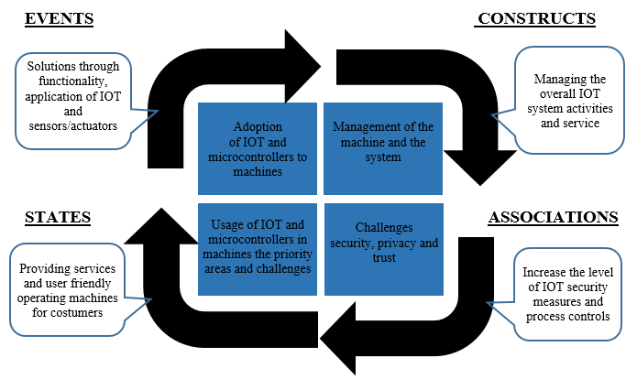The study is anchored by the theory of Weber [1]. The approach represents someone's perception of how a subset of real-world phenomena should be described the events, constructs, associations, and states. In addition, it emphasizes the main traits of the real world in a clear and systematic natural method to produce a unified picture of reality. However, the challenges of privacy, security, and this theory contribute to IoT knowledge, including priority areas in business that guide practitioners and most. And most importantly is a reminder that the challenges of privacy and security must be addressed to gain user trust and successful usage of IoT.

## ***Figure* 1.1** IoT theoretical framework and conceptual model

This figure was to establish IoT theory and provide a clear and concise explanation and prediction of the main components of the IoT to guide practitioners on IoT adoption and implementation and scholars on future IoT research. Fig. 2 also depicts the theoretical framework and conceptual model. Type IV of Gregor's [2] taxonomy theories for explanation and prediction and Weber's proposed framework structure were used to develop Fig. 1.

EVENTS

An event that a thing undergoes is represented by a change from one of its states to another of its states (at least one of its attributes changes values). For instance, in a user's Ongoing use of an information system, her perception might change from one state to another state the users and interaction between things.

STATES

A vector of attributes in particular represents a state of a thing (its, attributes in general along with their associated values). States can also be conceived as a complex attribute in particular. For instance, a particular user of an information system has two attributes in particular that relate to the information system.

CONSTRUCTS

A construct in a theory represents an attribute in general of some class of things in its domain). He further emphasizes that the classes of things to which attributes in general pertain should be defined precisely to ensure that the meanings of each class and the things in each class are clear.

ASSOCIATIONS

Associations that theory development is approached from a process perspective indicate that the researcher might theorize about the event or stages that would constitute adopting a technology. This approach was followed which led to the identification of the associations.

## **Table 1.1** *Evaluating and Developing Theories in the Systems and Discipline*

The Arduino UNO as a microcontroller for coin counting will help the researcher to have Accuracy in counting coins, according to Kavale [4]. There needs to be more than the mechanisms of the machines that are now on the market since they occasionally make mistakes while detecting the value of the coin and which result in inaccurate calculations. In the proposed work, a coin-operated device that can precisely and automatically distinguish between coins is built. Using an ARDUINO-UNO as the primary controller, a prototype for an automatic coin-counting and the sorting machine is created. Designing the display screen to show the total number of each coin and the overall value was part of this effort. The coin acceptor has been employed because it serves as a coin selector to establish the coin's denomination in the sorting system, which uses a DC motor to store and distribute cash to the appropriate slot.

The concept of a payment system determines the type of coin and bills, according to Alexandria [5]. Fluorescent ink on one-dollar notes glows when exposed to ultraviolet light. Some vending machines monitor a bill's radiance with UV scanners to ensure it's an actual bill. Magnetic ink is also used to produce real money notes. Vending machines frequently use a magnetic reader to identify a bill's magnetic signature, verify its validity, and ascertain its value. On the other hand, coin Identification Coins are primarily recognized and validated based on their physical characteristics. Most vending machines compare the physical traits of coins, such as their diameter, thickness, and the number of ridges on the edge, even though some devices may have sophisticated technology that enables them to assess the chemical composition of coins.

The concept of making the drinks cold by Katsuyuki [6]; in typical machines, cold air that has been through an evaporator kept at a specific temperature is internally circulated. The cooling system is shut off when the interior temperature drops too low. To maintain a consistent internal temperature, the unit repeatedly cycles on and off. The circulating cold air is concentrated in the lowest area of the storage, where the next-to-be-sold items are held, to reduce the cooling load and limit power usage. Aside from this concept, the researcher could use an Ice dispenser as an alternative for the cold air flow cooling concept.

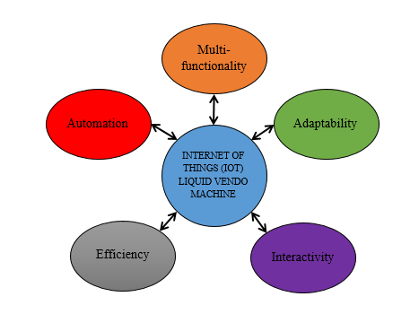

## **Figure 1.2** *IOT Base Smart Liquid Vendo Machine Theoretical*

The figure above shows the five major components of the Internet of Things for liquid vendo-machine multi-functionality, Adaptability, Interactivity, Efficiency, and lastly, Automation. The multi-functionality refers to the ability of the vendo machine to perform multi-functions. Adaptability refers to the machine that performs/adjusts during a particular event. Interactivity refers to the Graphic User Interface, which can easily allow users to monitor, edit, and configure the system. Efficiency refers to reducing electric consumption cost, minimizing errors, being user-friendly, etc. Automation-related system components where we automation to automate a certain process and reduce operating expenditures.

# Statement of the Problem

This project and design aim to develop the regular Vendo Machine into IOT Base Smart Liquid Vendo Machine and solve the problems stated below.

Specifically, this study will address the following:

1. Determine the materials to be used in terms of:

1.1 Components

1.2 Computer hardware

1.3 Compatibility

2. Determine the Security to be used in terms of:

2.1 Software Attacks

2.2 Physical Attacks

2.3 Network Attacks

3. Determine the Monitoring

3.1 Provide detailed reports

3.2 Maintenance

3.3 Payment System

4. Evaluate the performance of the system in terms of:

4.1 Accuracy

4.2 Flexibility

4.3 Functionality

# Review of Related Literature

Various research has been done about vending machines to advance or renovate the vending machine system. A real-time vending machine and a cost-affordable communications solution based on open innovation technology are designed [7]. Wi-Fi and GPRS are introduced inside the vending machine to store the stock level information in a database that can help make informed decisions or refill the machine with new stocks. Likewise, the Mealy Model of the "Finite State Machine strategy" is utilized to structure and implement an automated beverage vending machine [8]. They presented a field programmable gate array (FPGA) based vending machine which consumes less time and utilizes less power when contrasted microcontroller based with a vending machine. In addition, vending machine payment has changed a lot. In the early stage, the payment system uses cash or coins. This system faces a problem if there is limited space to store the money and give changes. A new design of an automatic vending machine is proposed using short message payment [9]. It may confront an issue if they fail to receive a message.

The vending machine is an IoT-enabled automated machine that dispenses items like drinks, snacks, food, etc. The vending machine can assist shopkeepers with reducing their expenses by paying a lower rental charge with 24 hours of working time each day, thereby maximizing their profit margin. A customer can buy products easily with the help of digital payment systems through the vending machine. Vending machines are extensively and frequently used in many technologically advanced nations like the USA, the UK, China, Japan, and more [10].

The customer can organize items using a PDA without working with the confectionery machine in an intelligent vending machine. Counting the finesse of a device increases the unpredictability accordingly. As the cost of sensors continues to decrease, it is important to equip an entire office with sensors on every rack, room, or winding. In addition, programming forms and configurations require regular updates. These considerations arouse the interest of retailers who want to modernize existing confectionery machines for the world today [11].

The emerging era of canned food machines offers tremendous opportunities for business change thanks to progress (IoT) and cloud technology; thus, Vendo Machine providers and managers can increasingly expect successful approaches to customer loyalty, increase transactions and save money through remote management confidential maintenance. By reviewing the information, you can improve the right machines and inventory in each area, as well as essential knowledge about progress, estimation, location, climate, season, and other factors [12].

Youkouchi, based on his works, stated that a Vendo machine should have the components that can be seen in front of the Vendo machine; the details are the following: Take out the box - wherein the selected choice drops upon a successful transaction between customers and the Vendo machine, 2nd Coin Slot - the coin slot is where the customer drop their coin for the payment, 3rd the Change Outlet - from it name suggest it is the section where the changes drop, it falls coins and cash depend on the evolution of the client, 4th is the selection button - the primary function of the election button is the customer click to choose its desired goods from the menu or display of the vendo machine. In addition, Yoichi also emphasizes that the design of the vendo machine is user-friendly, in the environment of Yououchi wherein most of the people are senior, to be specific, in Japan, wherein the senior population is steadily increasing. To cope with this the author should have an accessible design [13].

According to Ankit, the Internet of Things (IoT) gained colossal attention because it helps the consumer to better their lifestyles and professionally stay up with the cyber-physical world's technological developments The IoT edge devices are diverse in terms of the technology they utilize and the storage file types they support. Before transferring data, these devices must authenticate each other using highly secure mutual authentication. Mutual authentication is a critical component of peer-to-peer communication. These resource-constrained devices can show each other using certain session keys. A machine can be approved and access shared resources after successful authentication. The requirement to validate a device requesting data transmission to avoid data privacy breaches that might jeopardize confidentiality and integrity. Blockchain and artificial intelligence (AI) are both widely employed as technologies. Blockchain is a decentralized technique for storing certified data. Session keys can be assigned to network devices. Blockchain is also used to load balance edge devices that are under stress due to low battery levels. AI, on the other hand, improves learning and adaptability to IoT assaults. The use of modern technology in IoT key management results in increased security. In this essay, we evaluate emerging technologies from the standpoint of IoT security and analyze conventional core security measures. This paper provides researchers with a complete quality analysis of authentication and session keys, integrating IoT with blockchain, and AI-based authentication in cybersecurity [14].

The following are the Attacks on IoT described in the works of Ankit:

Physical Attacks - Physical assaults are related to hardware equipment in the network compromising the system's physical functionality. The physical attacks are the following: Micro-probing, Reverse Engineering, Sensor Capture, Physical Communication Channel tapping, Physical Damaging, Stolen Smart cards, and Biometric fingerprint recreation.

Software Attacks -Refers to the system access and running unprivileged code on the system to perform a variety of suspicious activities that disrupt normal operations, under software attacks we have the following: viruses, worms, trojans, spyware, adware, Key-logger, Logic Bomb, Malware, Root Exploit, and Phishing.

Network Attacks - Refers to the sensor nodes connected over the network to share data and transfer network information. The attackers use several complex tactics to acquire access to a single system or a network inside an organization. Many potential threats must be addressed in an IoT ecosystem for developing defensive tactics, under networks attacks are the following: running attacks, Traffic sniffing, flooding attack, Eavesdropping, packet cloning, sinkhole attacks, blackhole attacks, selective forwarding, IP spoofing and masquerading [15].

Large-scale IoT deployments created situations that cloud computing could not handle efficiently and effectively. For instance, applications that require low latency while processing the data on the edge of the network. In real life, a massive amount of data is being collected by IoT from many different sensors in various environments such as factory production lines, vehicles, machines, elevators, etc. for individual purposes such as smart home systems, hobby-related sensors, etc.

There are downsides to using a cloud network for data analysis and streaming, such as high communication and bandwidth expenses. Securing the data is another crucial concern, especially if the user data are sensitive. The information is vital for audits, asset control to increase efficiency, disaster prevention, etc.

As a fog-assisted IoT application for vending machines, a vending machine may notify the vendor of missing products so that they can be delivered on time. An automatic status check report may be created and sent to the vendor for maintenance. Intelligent vending machines mitigate security problems, but much more can be achieved from a "smart" machine [15].

According to the manual, the maintenance composes of various components the following are described in the manual [16]:

Basic Operating Principles – mainly focused on how the Vendo-Machine operates and also describes the proper procedure for using the Vendo-Machine.

1st Start-Up Operations – refers to how to start up the Vendo-Machine properly, close/turn off the Vendo-Machine, and lastly, reset and recover.

2nd Programming of the Machine – refers to the maintenance of the software side of the machine, wherein fix discovered bugs or update/upgrade the existing program for further enhancement.

3rd Installation of the Payment Systems – Checking if there is a problem in payment, like on the physical side, wherein users might use foreign objects to inject into the coin and bill slot. They are checking the payment system to see if its works well.

4th Cleaning and Loading Operations – Cleaning and loading operations are where the maintenance cleans the container, tuber, removes dust, and disinfects parts, especially where drinks have been contacted to avoid bacteria and dust; on the other hand, the loading operations are checking wherein it has available stock, its load means restocking the depleted goods/product for continuous operation.

5th Ordinary and Prevention Maintenance – Refers to essential maintenance like testing the machine multiple times if it's working fine, physical/component checking, repainting, and others.

According to Chiles [17], using a systematic system to process bills in coins, in this literature the researcher was able to make a system that can keep track of the statements and cash; it could determine the amount or number of coins and bills inputted by the user, also execute simple process like deducting and summing the total, with this, the researcher could incorporate the design or concept of the currency bill and coin processing system to IoT Vendo-machine for payment system. A small currency bill processing device, a coin scale, a keyboard, and a processor are all merged into a housing unit in an integrated system for processing currency bills, coins, and other media. The bill processing device has an input receptacle and a transport mechanism and is used to count currency notes of various denominations. To calculate a coin total for at least one group of coins, the con scale is modified. The keyboard is configured to manually request information on at least one of the currency notes and coins from an operator. The processor is designed to determine an aggregate total that equals the sum of a received currency bill total, a received coin total, and another immediate total. It is communicatively connected to the currency bill processing device, the coin scale, and the keyboard.

# Significance of the Study

The project's primary goal is to create a vending machine that allows for online monitoring via web applications. This solution eliminates the need for users to be concerned about integrating point of sale and vending machines based on the Internet of Things (IoT) for self-service scale micro-enterprises. Applications that record while simultaneously transmitting data from multiple sensors. Data from sensors is sent to the server via the IoT module, and the server saves the data in a server database. New data will be visualized regularly using a server application as a service. For 24 hours, a real-time sales recapitulation system via an IoT vending machine. The Internet of Things (IoT) module will embed the 24-hour machine after it has been developed and implemented. All operational forms of the system are suitable in the form of stock, recapitulation of vending machine sales, and the latest vending machine conditions will be sent to the server so that users can monitor them at any time. The system can record items in addition to the profit-taking report. Because they are linked to the server API (Application Package Interface), owner outlets can remotely control vending machines via mobile phones.

The researchers believe that this study will not only yield data that will be helpful to them, more so to the following groups of people:

**Computer Engineering students:** Aspiring future researchers with related studies can gain and benefit from some concepts from the study through our gathered information, sources, and realizations regarding the methods and learning about the machine's control with the internet of things. This can be used as their reference for their future study.

**Future Researchers:** This study may reference other future researchers who want to learn about the Smart Liquid Vendo Machine. This will help future researchers' by innovating the Smart Liquid Vendo Machine.

**Community:** The study benefits the community as it would give them the idea and emphasize the easy way to use the Smart Liquid Vendo Machine for the customers to purchase items with their desired amount and fair price.

**Entrepreneurs/Businessmen:**  This study will help the businessman in their Vendo-machine in terms of profit and convenience; it is convenient in that owners can monitor their vendo-machine status with just their laptop or cellphone.

# Scope and Limitations

# RESEARCH METHODOLOGY

To incorporate the feedback from Vendo-Machine Small and Medium Enterprise owners, the researcher uses prototyping. Prototyping allows the researcher to modify the prototype by the survey feedback and evaluation. In addition to its flexibility, prototyping also enable the researcher to make the most of the required timeframe. The researcher uses a survey form in analyzing the market trend for the IoT Base Smart Liquid Vendo Machine, with the use of a market survey, the researcher will able to gather necessary data that will help the researcher to determine the product customer requirements, characteristics, specifications, features, market price, and marketability, with the aid of those data will greatly contribute in product marketing and further feature enhancement.

## **Research Design**

Learning methods, specifically, visualization and auditory, need an in-depth analysis of the information given to identify their relationship. The study will validate what would need to improve in the usual Vendo Machines into Smart Vendo Machines.

Thus, to attain the purpose of this study, the researcher uses a Qualitative research design. In particular, the research design embodies qualitative due to the information gathered in form of statements, phrases, and sentences. The report was analyzed on the gathering of data.

## **Research Respondents**

The target respondent of the IoT Smart Liquid Vendo Machine is the Small, Medium, and Large Enterprise Level business people or stores who have already been using vendo machines such as Piso wifi, water, drinks vendo, coffee vendo machines, pads or tissue vendo, etc. The researcher will ask the respondents on their Enterprise Level how many Vendo Machines that has respondents or people in business currently owned. Small Enterprise has only 1 to 2 vendo machines, Medium Enterprise has 3 to 4 vendo machines, and Large Enterprise has 5 or more Vendo machines that respondents own.

## **Research Environment**

Most IoT-based machines in Mandaue are Piso wifi; other vendos are not IOT based; this can be seen in vendo coffee, vendo water, and vendo drinks. Those are common vendo-machine that can be found in the corners of Mandaue; this indicates that there is enough market/target for the survey in the area.

This study will be conducted outside the University of Cebu Lapu-Lapu and Mandaue as it provides the necessary tools, equipment, electronic components, and the Vendo Machine needed to construct the prototype.

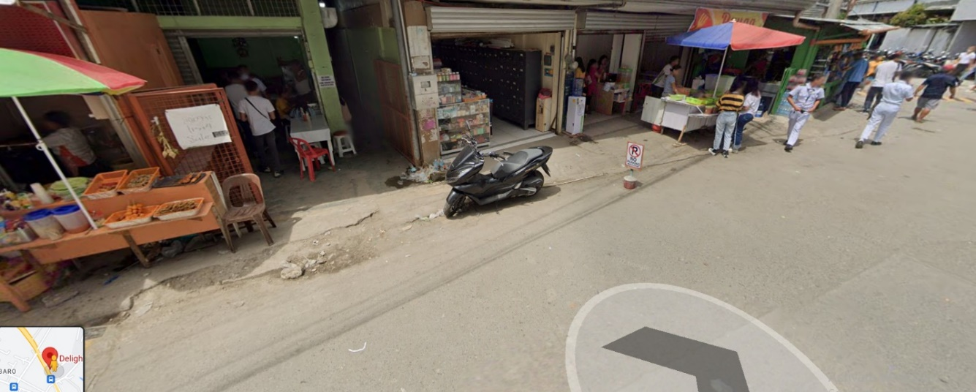

### **Figure 1.3** *Research Setting*

## **Research Instrumen**t

In this study, the researcher's survey was used to determine the things needed to improve regarding the Vendo Machines. The survey will assess the respondent's learning style satisfaction, which will play an essential role in the analysis of the gathered data. The survey will further ask the respondents how familiar and satisfied they are with IoT Based Liquid Vendo machines. The participants will be given a chance to expound and elaborate on their answers as much as they could do.

## **Data Gathering Procedures**

This study will be conducted through a survey questionnaire distributed physically to the Vendo Machine owners in their stores. The respondents will be oriented on the purpose of the study, and all information that will be gathered will be kept confidential. In the survey, questions that will be presented include the categories of materials to be used, security, monitoring, performance of the system of the Vendo Machine, and the owner's satisfaction with using it. To achieve these results, researchers need to fulfill the data needed with a series of steps;

First, the researchers will ask the College of Engineering to conduct the study.

Second, the researchers will create a survey questionnaire. In gathering data, it is a requirement to complete a survey questionnaire that the researchers will use to collect data.

Third, researchers must carefully distribute the survey questionnaire to the Vendo Machine owners.

Lastly, after the respondents answer the survey questionnaire, the researchers will be gathered, check, analyze, and interpret them correctly by the researchers.

## **Data Gathering Instruments**

The researchers will use a survey questionnaire in conducting the study. A structured type of questionnaire will be used in which the respondents will choose the answer they want as indicated in the choices. The study will utilize the questionnaire as the main instrument of data collection. The respondent's data and responses were kept confidential based on the Data Privacy Act of 2012 and used only for the study.

## **Research Procedure**

The participants were given a survey form to gather data concerning their satisfaction with the IoT Base Smart Liquid Vendo Machine. Then, there will be the following questions in the survey form, which the respondents will answer. The survey form can be answered through their response on what they think of the IoT Base Smart Liquid Vendo Machine. The form will be distributed the respondents must observe. The data collected on the survey will be later on concluded after the researcher analyzes the data.

# Definition of Terms

The following terms are described in this research to better understand this study.

**Application -** is a computer program designed to carry out tasks other than one relating to the computer’s operation, typically used by end-users: Word processors, media players, and accounting software.

**Automation** - a wide range of technologies that reduce human intervention in processes, namely by predetermining decision criteria, subprocess relationships, and related actions, as well as embodying those predeterminations in machines.

**Circuit -** is composed of electronic components, such as resistors, transistors, capacitors, inductors, and diodes, connected by conductive wires or traces through which electric current can flow.

**Internet of Things** - describes physical objects with sensors, processing ability, software, and other technologies that connect and exchange data with other devices and systems over the Internet or other communications networks.

**Micro-probing** - is a failure analysis technique used to achieve electrical contact with or access to a point in the active circuitry of the die.

**Software** - a set of computer programs and associated documentation and data. This is in contrast to hardware, from which the system is built and which performs the work.

**Vendo Machine** - It is controlled by a microcontroller and distributed to the given inputs. Vendo machines are computerized, offer payment capabilities, allow customers to place orders before visiting the vending machine, and can be located by the consumer.

# CHAPTER II

# PRESENTATION, ANALYSIS, AND INTERPRETATION OF DATA

This chapter concerns the technical understanding of the prototype's development and design, including interpreting the obtained data. The gathered data information is presented in a tabular form to show the collected data.

This study aims to develop the regular Vendo Machine into IOT Base Smart Liquid Vendo Machine.

# DATA PRESENTATION

## **Table 2.1** *Business Enterprises Level*

A total of 13 people in business were collected from the face-to-face interview. 11 participants are at the Small business level. And only two are at the Medium business level.

## **Table 2.2** *Payment Method*

Among the participants, the use of Coins was mainly the payment method. And only one business uses Bills.

## **Table 2.3** *Vendo Machined Owned*

Among the respondents shown in table 2.3, most participants only owned 1 to 2 Vendo machines. And only 2 participants own 3 to 4 Vendo machines.

## **Table 2.4** *Goods Accommodated*

Among the 13 respondents, 8 of the participants owned a Piso-wifi vendo machine. 4 of them own a coffee vendo machine, and the remaining 2 participants own a water vendo machine.

## **Table 2.5** *Attacks*

Among the respondents, most of them experienced a Physical Attack. 2 of the respondents experienced a Software Attack, and one of the respondents experienced Network Attack. The Software and Network Attacks do not apply to our vendo machine since we don't give internet services.

## **Table 2.6** *Prefer adding IoT in their Vendo Machines*

Table 2.5 shows that 85% of the respondents prefer adding IoT to their Vendo machines for better monitoring and passive income. Only 15% don't want to have IoT.

# Conceptual Framework

The project will go through six phases. The 1st phase is where the researcher determines the materials used, specifically the components, computer hardware, and compatibility. The 2nd phase is where the researchers choose the different attacks: Software Attacks, Physical Attacks, and Network Attacks. The 3rd phase is where the researcher determines the monitoring procedures. 4th Phase is where it evaluates the functionality of the system.

## **Figure 2.1**. *Diagram of Conceptual Framework*

Figure 2.1 shows the flow of the study through a diagram, wherein it consists of different phases, each phase is essential in developing the prototype system.

# Block Diagram

The block diagram of the study consists of the following sensors and actuators interconnected to the microcontroller and IoT module to achieve an IoT vendo machine and the entire system works based on the application of electronic and electrical systems.

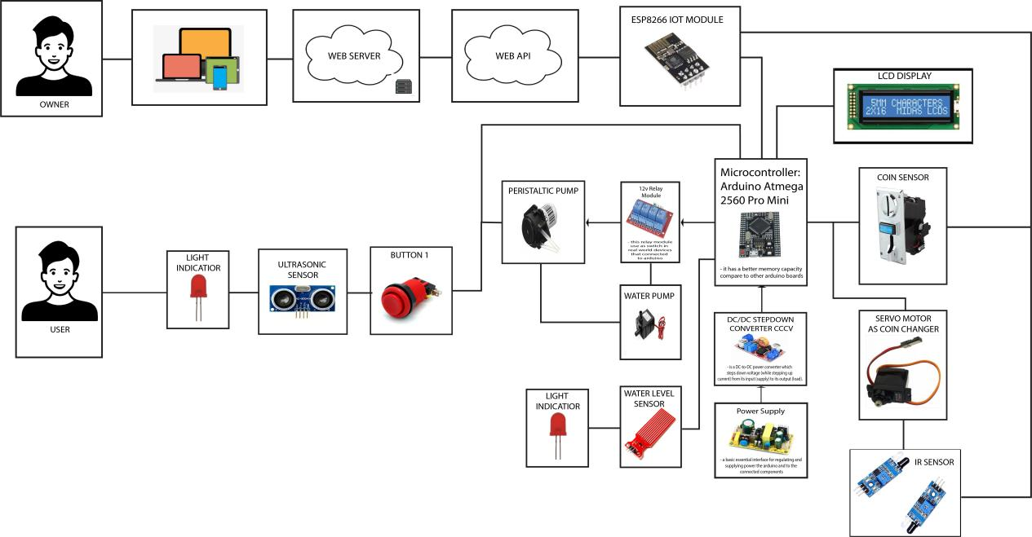

## **Figure 2.2** *IOT Base Smart Liquid Vendo Machine Block Diagram*

Figure 2.2 illustrates how the prototype's optimized connection is accomplished by differentiating the system's flow using arrows, shapes, and images. A coin sensor on the left side of the diagram is used to operate the coins, servo motors are used to change the coins, and an IR sensor is used to detect distance motion. The system’s microcontroller converts the input value to 5V and 12V using a buck converter before cutting power from the AC/DC power supply. Push buttons are utilized for dispensing, an ultrasonic sensor is used to determine whether a cup is present, and an LED light is used as a price indicator on the diagram's reverse side.

## **Design Layouts**

## **Prototype Design**

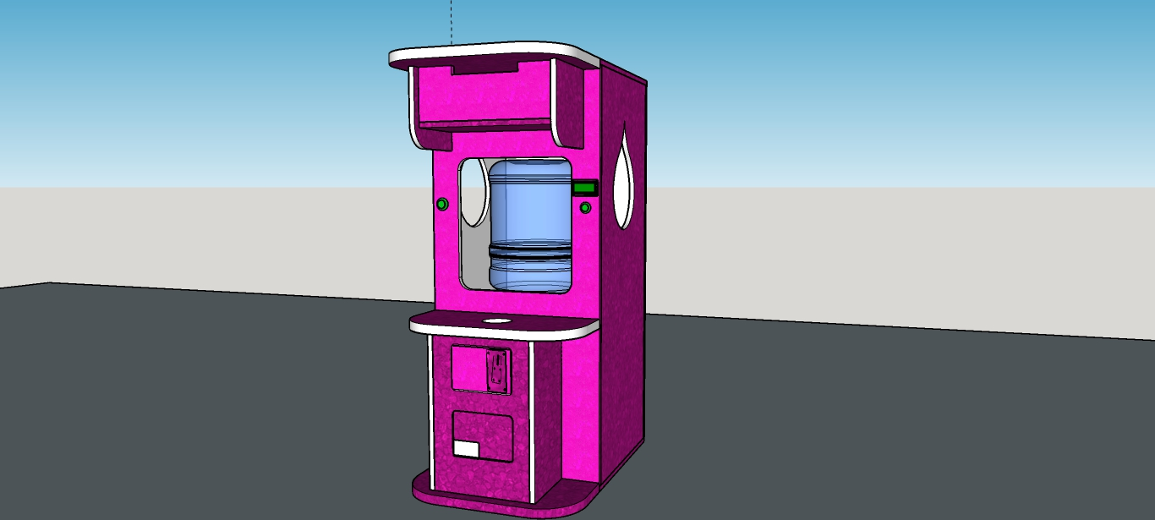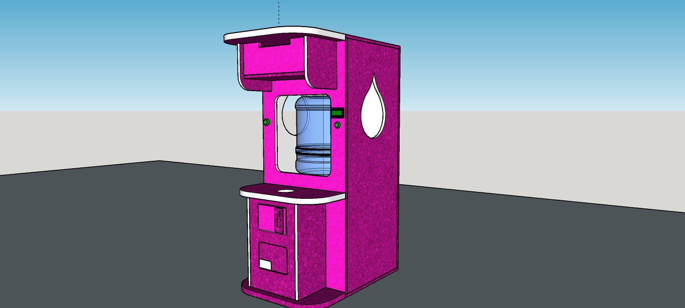

Coin Changer

LCD

Coin Slot

Water Dispense Button

Coin Changer Button

### **Figure 2.3** *IOT Base Smart Liquid Vendo Machine Prototype Design*

As illustrated in figure 2.3, the researcher produced a 3D model of the vendo machine prototype to explore how it would seem. It just accommodated water. You can see the coin slot on the lower portion, which is controlled by a coin sensor. It only uses coins for payment. And after it is entered by cash, if the user inserts full money like P5.00 or P10.00, it includes an LCD that shows the message the amount of the user's change. The coin changer is used to dispense the change of the user. Additionally, it has an alarm that will alert the owner if someone physically attacks the vending machine and will flash the word "ALARM" on the LCD. In the upper part, it is where the gallon of water is placed.

# GUI App Design

# 

User Settings

Tracking of Sales

Machine Inventory

Alert Notification

## **Figure 2.4** GUI App

Figure 1.4 is the real-time monitoring with the user-friendly application for the Vendo Machine. The app will be utilized by the owner. Once the app is opened it will use a username & password for security to log in. And once the owner is already in, it will get through the Menu Dashboard which is composed of the User Settings, Tracking of Sales, Machine Inventory, Alerts Notifications. In the User Settings, it will show the Owner's Information which includes the name, address, and contact details, also the details of its vendo machines like how many are the vendo machines owned and their location. Tracking of Sales is the way to determine if the vendo machines are yielding a financial gain by using the ESP8266 Wi-Fi module to interconnect to the internet and it is where to monitor the sales daily. Machine Inventory is the inventory tracking from the Vendo Machines such as Water level monitoring and Coin Stack. Alerts Notifications allow sending data to the internet; the purpose of this tab is to build a connection to hardware parts as the machine is being tampered can be monitored through the application.

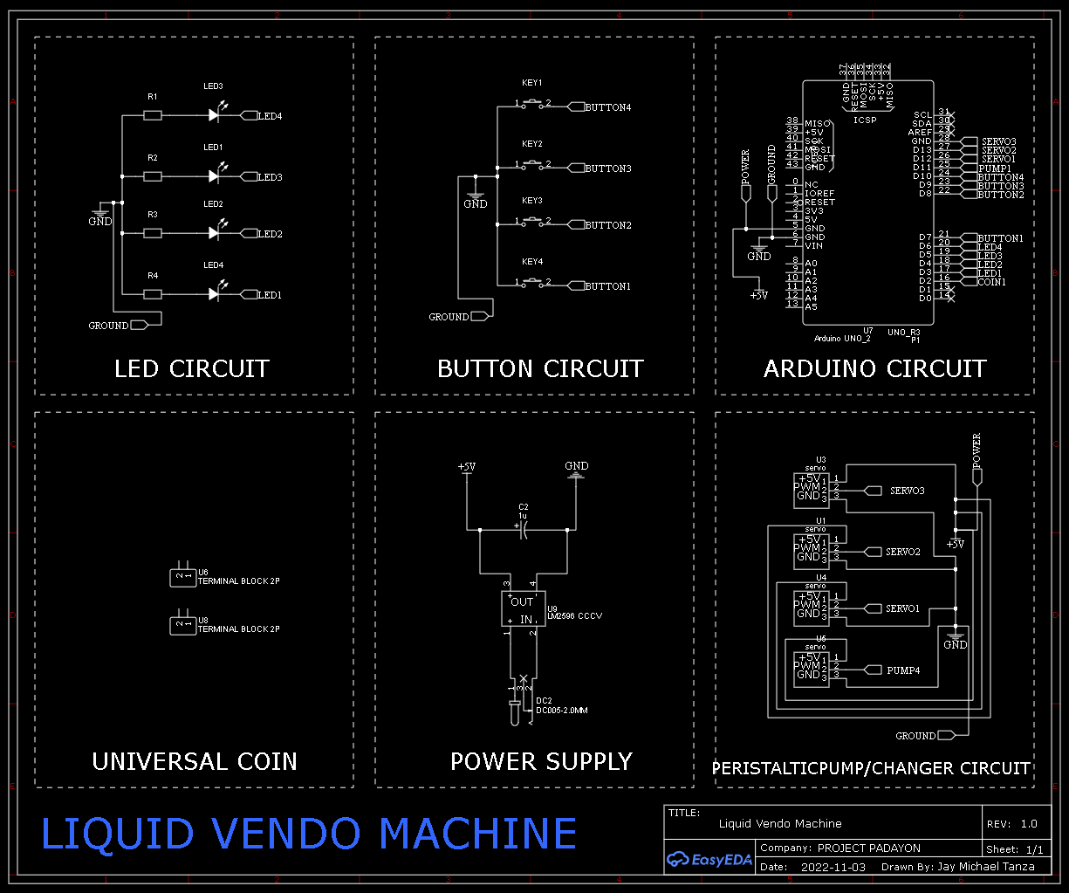

# Figure 2.5. *IoT Base Smart Liquid Vendo Machine Schematic Diagram*

# System Schematic Diagram

As shown in figure 2.5, the schematic diagram explains that six different circuits make up the hardware part of the system this helps us understand the wiring and operation of the hardware system. As more tasks are completed and managed, this project will become relatively simple. The following circuits are connected to the Arduino microcontroller: The LED circuit is attached to Digital pins 2 to 6 on the Arduino, the Button circuit is attached to Digital pins 7 to 10, the Universal Coin Pin is connected to Digital pins 2, and the output circuit, which uses AC/DC power, is connected to Ground and Input Power on the Arduino.

# Hardware Specifications

The hardware specification requires the researchers to identify and direct the following values and information from each component. The hardware specifications are listed in Table 2.1.

|  |  |
| --- | --- |
| **Hardware Devices** | **Specification** |
| Arduino Mega 2560 | |  |  | | --- | --- | | Operating Voltage | 5V | | Input Voltage (recommended) | 7-12V | | Input Voltage (limit) | 6-20V | | Digital I/O Pins | 54 (of which 15 provide PWM output) | | Analog Input Pins | 16 | | DC Current per I/O Pin | 20 mA | | DC Current for 3.3V Pin | 50 mA | | Flash Memory | 256 KB, of which the bootloader uses 8 KB | | SRAM | 8 KB | | EEPROM | 4 KB | | Clock Speed | 16 MHz | | LED_BUILTIN | 13 | | Length | 101.52 mm | | Width | 53.3 mm | | Weight | 37 g | |
| ESP8266 | Wireless standard: IEEE 802.11b/g/n  6 x Digital I/O, 3 x PWM Channels, 1 x ADC Channel  Full I/O control through WiFi network  GPIO with 15mA current drive capability  Supports Smart Link intelligent networking  Built-in 32-bit MCU  built-in TCP/IP protocol stack, and support multiple TCP Client connection  UART/GPIO data communication interface |
| **DC-DC Buck Converter StepDown Module** | Conversion efficiency: 92%(highest)  Switching frequency: 150KHz  Output ripple: 30mA9maximum  Load Regulation: ± 0.5%  Voltage Regulation: ± 0.5%  Dynamic Response speed: 5% 200uS  Input voltage: 4.75-35V  Output voltage: 1.25-26V(Adjustable)  Output current: Rated current is 2A, maximum 3A (Additional heat sink is required)  Conversion Efficiency: Up to 92% (output voltage higher, the higher the efficiency)  Switching Frequency: 150K Hz  Rectifier: Non-Synchronous Rectification  Module Properties: Non-isolated step-down module (buck)  Short Circuit Protection: Current limiting, since the recovery  Operating Temperature: Industrial grade (-40 to +85 ) (output power 10W or less) |
| 12v Relay Module | Power supply: 12V  Coil voltage: 12V  Max switching voltage: 250VAC / 30VDC  Max switching current: 10A  Logic: 5V |
| Coin Detector and Counter | Applicable coin diameter: 12mm to 29mm  Applicable coin thickness: 1mm to 3mm  Working voltage: DC, 12 V + 20%  Operating temperature: -20 ~ + 70°  Color: Silver  Size: 64*143*123mm |
| Peristaltic Pump | Product name: micro peristaltic pump  Material: metal / Plastic  Applicable voltage: 12V  Type: Right Angle black, Flat black (Optional)  Working conditions: temperature 0 to 40℃, relative humidity, < 80%  Medium flow direction: depends on the positive and negative connection of the power supply, and the terminal can choose any positive and negative  Flow range: 0.1-100 ml/min  Speed range: 0.1-100 RPM  Drive size (Dia. x H): 27.6 * 37.9mm / 1.1 * 1.5in  Pump head size (Dia. x H): 31.7 * 20.1mm / 1.2 * 0.8in  Auxiliary pump pipe (ID x OD): 2.5x 4.7mm  Weight: 88 g / 3.1 oz(approx.) |
| IR Sensors | Main Chip: LM393  Operating Voltage: 3.3 ~ 5VDC  Distance Measuring Range: 2 ~30CM  Dimensions: 48*14*8mm  Weight: 15grams |
| Ultra-Sonic  Sensors | Main technical parameters:  Voltage: DC 5V  Static current: less than 2mA  Electrical level output: 5V high  Electrical level output: at the end of 0V  Induction angle: not more than 15 degrees  Detection distance: 2cm-450cm  High precision: 2mm |
| LED | Forward Current: 20mA  Max Forward Voltage: 2.6V  Color: Red, Green, Yellow, Blue, and White |
| Buttons | Mode of Operation: Tactile feedback  Power Rating: MAX 50mA 5V DC  Insulation Resistance: 100Mohm at 100v  Operating Force: 2.55±0.69 N  Contact Resistance: MAX 100mOhm  Using Temperature Range: -20 to +70 ℃  Storage Temperature Range: -20 to +70 ℃ |
| 12V  Servo  Motor | Weight: 55g  Dimension: 40.7×19.7×42.9mm  Stall torque: 9.4kg/cm (4.8v); 11kg/cm (6.0v)  Operating speed: 0.19sec/60degree (4.8v); 0.15sec/60degree (6.0v)  Operating voltage: 4.8 – 6V  Gear Type: Metal gear/Plastic Gear  Temperature range: 0- 55deg  Dead band width: 1us  Wire length: 32cm  Aluminum 6061-T6. |

### **Table 2.7** *Hardware Specification*

### **Hardware Components**

The IoT vendo machine proposed in this paper is made by the following list of components:

A. Microcontroller

B. Esp8266 Iot Module

C. DC to DC Buck Converter

D. 12v Power Adapter

E. 12v Relay Module

F. Coin Detector and Counter

G. Peristaltic Pump

H. IR Sensors

I. Ultra-Sonics Sensors

J. LED

K. Buttons

L. 12v Servo Motor

Microcontroller:

A microcontroller (sometimes abbreviated μC, uC, or MCU) is a small computer on a single integrated circuit containing a processor core, memory, and programmable input/output peripherals. Program memory in the form of Ferroelectric RAM, NOR flash, or OTP ROM is also often included on the chip, as well as a typically small amount of RAM. Microcontrollers are designed for embedded applications, in contrast to the microprocessors used in personal computers or other general-purpose applications. Estimated Cost: ₱ 829.00

Esp8266 IoT Module:

An ESP8266 Wi-Fi module is a SOC microprocessor mainly utilized to create end-point Internet of Things (IoT) applications. It is known as a standalone wireless transceiver and is very inexpensive. It is uses to make it possible for various embedded system applications to connect to the internet. Estimated Cost: ₱ 160.00

DC to DC Buck Converter:

Buck converters are standard DC-DC converters that effectively transform high and low voltages. Efficiency in power conversion increases battery life, lowers the heat, and enables the construction of more compact devices. There are a ton of innovative applications for the buck converter. Estimated Cost: ₱ 44.75

LED:

A light-emitting diode (LED) is a semiconductor device that emits light when current flows through it. Estimated Cost: ₱ 5.00

12v Power Adapter:

A power supply for electronic devices. Also called an "AC adapter" or "charger," power adapters plug into a wall outlet and convert AC to a single DC voltage. Estimated Cost: ₱ 119.00

12v Relay Module:

12V Relay Module is a 12V 1-channel relay interface board with a screw terminal; it can be controlled directly by a wide range of microcontrollers such as Arduino, AVR, PIC, ARM, and so on. Estimated Cost: ₱ 159.00

Coin Detector and Counter:

A currency detector or currency validate is a device that determines whether bills or coins are genuine or counterfeit. These devices are used in many automated machines found in retail kiosks, self-checkout machines, gaming machines, transportation parking machines, automatic fare collection machines, and vending machines. Estimated Cost: ₱ 500.00

Peristaltic Pump:

It uses positive displacement and is known as a hose or tube pump. Rollers that spin squeeze a flexible tube against the pump housing to feed fluid through the tubing. The tubing expands as the roller passes over it, creating a vacuum that lets more fluid in.

Estimated Cost: ₱ 349.00

IR Sensors:

It is an electronic device that measures and detects infrared radiation in its surrounding environment. Estimated Cost: ₱ 30.00

Ulta Sonic Sensors:

An electronic device that measures the distance of a target object by emitting ultrasonic sound waves, converts the reflected sound into an electrical signal. Estimated Cost: ₱ 50.00

Buttons:

A push-button, often known as a pushbutton or just a button, is a straightforward switch mechanism used to operate a machine or process. Usually constructed of metal or plastic, buttons are made of strong materials. Estimated Cost: ₱ 37.00

12v Servo Motor:

These are electronic devices and rotary or linear actuators that rotate and push parts of a machine with precision.

## **Software Specifications**

|  |  |
| --- | --- |
| Software Applications | Specifications |
| Arduino IDE | **Hardware Requirements:**  For the Arduino IDE to install and run, the system is required to have 256 MB RAM on top of the requirements for the operating system, CPU with Pentium 4 or above.  **Network Requirements:**  the Arduino IDE requires a network connection to check and download updates for both the IDE and libraries.  **Operating System:**  the Arduino IDE is built on Processing modules and Java, both of which are cross-platform. There are no official sources about the minimum version requirements for the Arduino IDE. |
| easy | **Operating System**: Windows 7/8/8.1/10  **Memory (RAM)**: 1 GB of RAM is required.  **Hard Disk Space:** 150 MB of free space required.  **Processor:** Intel Pentium 4 or later. |
| Sketchup | 2.8+ GHz Intel processor  8GB+ RAM  At least 1GB of available hard-disk space  At least 512MB video memory Discrete  Radeon R9 M37X 2048 MB  2.8+ GHz Intel processor |
| Fritzing | PC/laptop/tablet running Windows  (Windows XP64 / Vista64 / Windows 7 64 / Windows 8 64 / Windows 10 64) |

### **Table 2.8** *Software Specifications*

### **Software Description**

### **Arduino** **Integrated Development Environment -** contains a text editor for writing code, a message area, a text console, a toolbar with buttons for common functions, and a series of menus. It connects to theArduino hardware to upload programs and communicate with them.

**EasyEDA** allows the creation and editing of schematic diagrams, SPICE simulation of mixed analog and digital circuits, and the creation and editing of printed circuit board layouts and, optionally, the manufacture of printed circuit boards.

**Sketchup** is a 3D modeling program that can be used **to** create 3D objects in a 2D environment. Whether you plan to model for 3D printing or other purposes



**Fritzing** is an open-source initiative to develop amateur or hobby CAD software for the design of electronic hardware, intended to allow designers and artists to build more permanent circuits from prototypes.

# Test and Refinements

This section provides the tabulations of tests and refinements during the installation of the

device. The researchers were also able to successfully install LEDs, IR Sensors, Resistors, Buzzer, Wire Jumpers, Applications, Software, Database and Python Libraries such as OpenCV on the device.

|  |  |
| --- | --- |
| **TEST CASE** | **DESCRIPTION** |
| **UNIT TESTING** | |
| Check machine power stability | Check the machine if it can turn On and stay on if it is plugged over DC power. |
| Check solid wires are properly soldered and attached to Arduino pins | Check if the solid wires are soldered and correctly attached to Arduino pins. |
| Check machine IR sensors automatic reading functionality | Check if the IR Sensors automatically read and send data to the app. |
| Check if the buttons are placed and soldered properly and function correctly. | Check if the push buttons are placed and soldered and functioned completely. |
| Check Arduino if it runs properly and the  connected devices is connected and working  properly. | Check if the Arduino if it turns ON and stay functional together with the connected devices properly. |
| Check the display in LCD of coin inserted and its change | Check if the display is coincided with the inserted coins and its change. |
| Check the change dispenses in coin changer | Check if the coin changer dispenses the right amount. |
| Check machine Bluetooth connection response | Check if the machine is easily connected to Bluetooth through Bluetooth Module. |
| Check machine Wi-Fi connection response | Check if the machine is easily connected to Wi-Fi/Data Connection through Wi-Fi Module. |
| Check machine dispenses the right amount of water | Check if the machine dispenses the right amount of water |
| **SYSTEM SOFTWARE TEST** | |
| Check application initial start-up functionality | Check if the initial start-up of the application successfully executes, ask for profit value, and successfully saved it to app. |
| Check application dashboard display functionality | Check if the application's dashboard accurately displays the current water level and successfully changes when getting different data from the machine. |
| Check application bar graph display functionality | Check if the line graph display of the application records the past and current data that was received by the application and properly displays it in the graph. |
| Check application sales display functionality | Check if the display of the application records the past and current data that was received by the application and properly displays the amount. |
| Check application notification functionality | Check if the application will notify the user of every 5% increase in wastewater level when the wastewater level reaches 75% |
| Check application alert functionality | Check if the application will send an alert if the wastewater level reaches 100%. |
| **INTEGRATION TEST** | |
| Verify User has inserted cash | System displays how much money user has inserted on coins’ slot.  The number is accumulated as the coin is inserted. |
| Verify change has to be given when user inserts more cash than product cost. | The system will display the amount entered on screen. The product will get dispensed first. The change will also be dispensed. |
| Verify product when it is out of stock | The system will display a message informing the user that the product is out of stock. The system will not have accepted any payment at this point. |
| Verify refund/return money feature returns correct money | The system will return the money through coin changer if the user wants to cancel. |
| Verify not enough change is available when user inserts enough money. | The system will display the amount entered in cash on the display. When the user has selected their product and there is not enough change, the system will; Return a message informing the user there is not enough change. Not dispense the product. |
| Verify shaking machine does not dispense any product as of the moment. | Message will be displayed in the LCD and will notify the owner through the app. |
| Verify Sales Data | The data the vending machine returns will corroborate with the sales made. |
| Enter an ineligible coin | The coin inserted is not real one. |
| Machine does change | The machine dispense change for the user. |
| How quickly it drops the water | The time span for the water to drop. |
| Keep inserting coins continuously for 1 hr. | The accuracy of the machine and its data sent to app. |
| Different coins are inserted.  Note: 1, 5, and 10-peso coin only (old & new) | The machine accepts 1, 5- and 10-peso coins. |
| Verify if the water level is monitored by the app. | The sensors read accurately and sends to app. |
| Check for the indicator lights when the machine is switched on-off | The LEDs will be the indicator it the machine is on or off. |
| Verify that system should display an error when it runs out of water. | The LCD must display an error message if there’s no water to dispense. |

## **Table 2.9.** *Test Case*

|  |  |  |  |
| --- | --- | --- | --- |
| **UNIT TESTING** | | | |
| **TEST DESCRIPTION** | **OUTPUT** | **REMARKS** | |
| Check machine power stability |  | Trial 1 | Passed |
| Trial 2 | Passed |
| Trial 3 | Passed |
| Trial 4 | Passed |
| Trial 5 | Passed |
| Trial 6 | Passed |
| Trial 7 | Passed |
| Trial 8 | Passed |
| Trial 9 | Passed |
| Trial 10 | Passed |
| Check solid wires are properly soldered and attached to Arduino pins |  | Trial 1 | Passed |
| Trial 2 | Passed |
| Trial 3 | Passed |
| Trial 4 | Passed |
| Trial 5 | Passed |
| Trial 6 | Passed |
| Trial 7 | Passed |
| Trial 8 | Passed |
| Trial 9 | Passed |
| Trial 10 | Passed |
| Check machine IR sensors automatic reading functionality |  | Trial 1 | Passed |
| Trial 2 | Passed |
| Trial 3 | Failed |
| Trial 4 | Passed |
| Trial 5 | Passed |
| Trial 6 | Failed |
| Trial 7 | Passed |
| Trial 8 | Passed |
| Trial 9 | Passed |
| Trial 10 | Passed |
| Check if the buttons are placed and soldered properly and function correctly. |  | Trial 1 | Passed |
| Trial 2 | Passed |
| Trial 3 | Passed |
| Trial 4 | Passed |
| Trial 5 | Passed |
| Trial 6 | Passed |
| Trial 7 | Passed |
| Trial 8 | Passed |
| Trial 9 | Passed |
| Trial 10 | Passed |
| Check Arduino if it runs properly and the  connected devices is connected and working  properly. |  | Trial 1 | Passed |
| Trial 2 | Passed |
| Trial 3 | Passed |
| Trial 4 | Passed |
| Trial 5 | Passed |
| Trial 6 | Passed |
| Trial 7 | Passed |
| Trial 8 | Passed |
| Trial 9 | Passed |
| Trial 10 | Passed |
| Check the display in LCD of coin inserted and its change |  | Trial 1 | Passed |
| Trial 2 | Passed |
| Trial 3 | Passed |
| Trial 4 | Passed |
| Trial 5 | Passed |
| Trial 6 | Passed |
| Trial 7 | Passed |
| Trial 8 | Passed |
| Trial 9 | Passed |
| Trial 10 | Passed |
| Check the change dispenses in coin changer |  | Trial 1 | Passed |
| Trial 2 | Passed |
| Trial 3 | Passed |
| Trial 4 | Passed |
| Trial 5 | Passed |
| Trial 6 | Passed |
| Trial 7 | Failed |
| Trial 8 | Passed |
| Trial 9 | Passed |
| Trial 10 | Passed |
| Check machine Bluetooth connection response |  | Trial 1 | Passed |
| Trial 2 | Passed |
| Trial 3 | Passed |
| Trial 4 | Passed |
| Trial 5 | Passed |
| Trial 6 | Passed |
| Trial 7 | Passed |
| Trial 8 | Failed |
| Trial 9 | Passed |
| Trial 10 | Passed |
| Check machine Wi-Fi connection response |  | Trial 1 | Passed |
| Trial 2 | Passed |
| Trial 3 | Passed |
| Trial 4 | Passed |
| Trial 5 | Passed |
| Trial 6 | Passed |
| Trial 7 | Passed |
| Trial 8 | Failed |
| Trial 9 | Passed |
| Trial 10 | Passed |
| Check machine dispenses the right amount of water |  | Trial 1 | Passed |
| Trial 2 | Passed |
| Trial 3 | Passed |
| Trial 4 | Passed |
| Trial 5 | Passed |
| Trial 6 | Passed |
| Trial 7 | Passed |
| Trial 8 | Passed |
| Trial 9 | Passed |
| Trial 10 | Passed |

## **Table 2.10** *Unit Testing*

Table 2.10 shows the Unit test for the components of the IoT-Based Smart Liquid Vendo Machine. This test is to ensure that the components worked and connected properly while the program runs. After several trials and refinements, the device’s components work without any issues. There were some encountered errors or issues when the researchers conducted these tests such as overheating, jumper wires connected disconnected due to cabling issues, fragile handling of the device. The researchers were able to assess the functionality of the selected components on the devices but may still need to improve or upgraded to enhance the performance.

|  |  |  |  |
| --- | --- | --- | --- |
| **SYSTEM SOFTWARE** | | | |
| **TEST DESCRIPTION** | **OUTPUT** | **REMARKS** | |
| Check application initial start-up functionality |  | Trial 1 | Passed |
| Trial 2 | Passed |
| Trial 3 | Passed |
| Trial 4 | Passed |
| Trial 5 | Passed |
| Trial 6 | Passed |
| Trial 7 | Passed |
| Trial 8 | Passed |
| Trial 9 | Passed |
| Trial 10 | Passed |
| Check application dashboard display functionality |  | Trial 1 | Passed |
| Trial 2 | Passed |
| Trial 3 | Passed |
| Trial 4 | Passed |
| Trial 5 | Passed |
| Trial 6 | Passed |
| Trial 7 | Passed |
| Trial 8 | Passed |
| Trial 9 | Passed |
| Trial 10 | Passed |
| Check application bar graph display functionality |  | Trial 1 |  |
| Trial 2 |  |
| Trial 3 |  |
| Trial 4 |  |
| Trial 5 |  |
| Trial 6 |  |
| Trial 7 |  |
| Trial 8 |  |
| Trial 9 |  |
| Trial 10 |  |
| Check application sales display functionality |  | Trial 1 | Passed |
| Trial 2 | Passed |
| Trial 3 | Passed |
| Trial 4 | Passed |
| Trial 5 | Passed |
| Trial 6 | Passed |
| Trial 7 | Passed |
| Trial 8 | Passed |
| Trial 9 | Passed |
| Trial 10 | Passed |
| Check application notification functionality |  | Trial 1 | Passed |
| Trial 2 | Passed |
| Trial 3 | Passed |
| Trial 4 | Passed |
| Trial 5 | Passed |
| Trial 6 | Failed |
| Trial 7 | Passed |
| Trial 8 | Failed |
| Trial 9 | Passed |
| Trial 10 | Passed |
| Check application alert functionality |  | Trial 1 | Passed |
| Trial 2 | Passed |
| Trial 3 | Passed |
| Trial 4 | Passed |
| Trial 5 | Passed |
| Trial 6 | Failed |
| Trial 7 | Passed |
| Trial 8 | Failed |
| Trial 9 | Passed |
| Trial 10 | Passed |

## **Table 2.11** *Software test*

Table 2.11 shows the software test for the machine. It is used to determine the performance of the Mega Arduino and its operating system the researchers used to run the application and

components. Expected outcomes of each testing were met after some trials in performing these

tests. In the researcher’s various testing’s, the software runs smoothly. But overall, the Arduino function properly but had some minor

performance issues such as lagging and delay of the displaying in the LCD. The researchers were able to assess the different performance of the selected specification of the Mega Arduino.

|  |  |  |  |
| --- | --- | --- | --- |
| **IoT-Based Smart Liquid Vendo Machine** | | | |
| **TEST DESCRIPTION** | **OUTPUT** | **REMARKS** | |
| Verify User has inserted cash |  | Trial 1 | Passed |
| Trial 2 | Passed |
| Trial 3 | Passed |
| Trial 4 | Passed |
| Trial 5 | Passed |
| Trial 6 | Passed |
| Trial 7 | Passed |
| Trial 8 | Passed |
| Trial 9 | Passed |
| Trial 10 | Passed |
| Verify change has to be given when user inserts more coin than product cost. |  | Trial 1 | Passed |
| Trial 2 | Passed |
| Trial 3 | Passed |
| Trial 4 | Passed |
| Trial 5 | Passed |
| Trial 6 | Failed |
| Trial 7 | Passed |
| Trial 8 | Failed |
| Trial 9 | Passed |
| Trial 10 | Passed |
| Verify water is out of stock |  | Trial 1 | Passed |
| Trial 2 | Passed |
| Trial 3 | Passed |
| Trial 4 | Passed |
| Trial 5 | Passed |
| Trial 6 | Failed |
| Trial 7 | Passed |
| Trial 8 | Failed |
| Trial 9 | Passed |
| Trial 10 | Passed |
| Verify refund/return money feature returns correct money |  | Trial 1 | Passed |
| Trial 2 | Passed |
| Trial 3 | Passed |
| Trial 4 | Passed |
| Trial 5 | Passed |
| Trial 6 | Passed |
| Trial 7 | Passed |
| Trial 8 | Passed |
| Trial 9 | Passed |
| Trial 10 | Passed |
| Verify not enough change is available when user inserts enough coins. |  | Trial 1 | Passed |
| Trial 2 | Passed |
| Trial 3 | Passed |
| Trial 4 | Passed |
| Trial 5 | Passed |
| Trial 6 | Failed |
| Trial 7 | Passed |
| Trial 8 | Failed |
| Trial 9 | Passed |
| Trial 10 | Passed |
| Verify shaking machine does not dispense any product. |  | Trial 1 | Passed |
| Trial 2 | Passed |
| Trial 3 | Passed |
| Trial 4 | Passed |
| Trial 5 | Passed |
| Trial 6 | Failed |
| Trial 7 | Passed |
| Trial 8 | Failed |
| Trial 9 | Passed |
| Trial 10 | Passed |
| Verify Sales Data  Note: To test, purchase the product.  Make a note of exactly the quantities of products available in the machine, all products purchased, their cost and total sales value. |  | Trial 1 | Passed |
| Trial 2 | Passed |
| Trial 3 | Passed |
| Trial 4 | Passed |
| Trial 5 | Passed |
| Trial 6 | Passed |
| Trial 7 | Passed |
| Trial 8 | Passed |
| Trial 9 | Passed |
| Trial 10 | Passed |
| Enter an ineligible coin |  | Trial 1 |  |
| Trial 2 |  |
| Trial 3 |  |
| Trial 4 |  |
| Trial 5 |  |
| Trial 6 |  |
| Trial 7 |  |
| Trial 8 |  |
| Trial 9 |  |
| Trial 10 |  |
| Machine does change |  | Trial 1 | Passed |
| Trial 2 | Passed |
| Trial 3 | Passed |
| Trial 4 | Passed |
| Trial 5 | Passed |
| Trial 6 | Passed |
| Trial 7 | Passed |
| Trial 8 | Passed |
| Trial 9 | Passed |
| Trial 10 | Passed |
| How quickly it drops the water |  | Trial 1 | Passed |
| Trial 2 | Passed |
| Trial 3 | Passed |
| Trial 4 | Passed |
| Trial 5 | Passed |
| Trial 6 | Passed |
| Trial 7 | Passed |
| Trial 8 | Passed |
| Trial 9 | Passed |
| Trial 10 | Passed |
| Keep inserting coins continuously for 10 times. |  | Trial 1 | Passed |
| Trial 2 | Passed |
| Trial 3 | Passed |
| Trial 4 | Passed |
| Trial 5 | Passed |
| Trial 6 | Passed |
| Trial 7 | Passed |
| Trial 8 | Passed |
| Trial 9 | Passed |
| Trial 10 | Passed |
| Different coins are inserted.  Note: 1, 5, and 10-peso coin only (old & new) |  | Trial 1 | Passed |
| Trial 2 | Passed |
| Trial 3 | Passed |
| Trial 4 | Passed |
| Trial 5 | Passed |
| Trial 6 | Passed |
| Trial 7 | Passed |
| Trial 8 | Passed |
| Trial 9 | Passed |
| Trial 10 | Passed |
| Verify if the water level is monitored by the app. |  | Trial 1 |  |
| Trial 2 |  |
| Trial 3 |  |
| Trial 4 |  |
| Trial 5 |  |
| Trial 6 |  |
| Trial 7 |  |
| Trial 8 |  |
| Trial 9 |  |
| Trial 10 |  |
| Check for the indicator light when the machine is switched on-off |  | Trial 1 | Passed |
| Trial 2 | Passed |
| Trial 3 | Passed |
| Trial 4 | Passed |
| Trial 5 | Passed |
| Trial 6 | Passed |
| Trial 7 | Passed |
| Trial 8 | Passed |
| Trial 9 | Passed |
| Trial 10 | Passed |
| Verify that system should display an error when it runs out of water. |  | Trial 1 | Passed |
| Trial 2 | Passed |
| Trial 3 | Passed |
| Trial 4 | Passed |
| Trial 5 | Passed |
| Trial 6 | Passed |
| Trial 7 | Failed |
| Trial 8 | Passed |
| Trial 9 | Passed |
| Trial 10 | Passed |

## **Table. 2.12** *Integration Test*

# Findings

After a series of testing and refinements done by the researchers to the project, the

following results were acquired:

1. The coin changer button needs to be long press so that the coin changer can dispense all of the changes.
2. The sensors need to be cleaned and maintained because some of them are very sensitive and can easily cause a grounded connection, resulting in errors.
3. The speed in dispensing the coins is not fast because the coin changer is using servo to dispense coins, the servo has to rotate from 0 degrees to 90 degrees as servo it slowly rotates to the said position resulting to slow coin dispense.
4. There is a noticeable delay in dispensing and display. The delay is required because the Arduino Uno cannot perform multiple tasks at once. The delay is used so that all the tasks have to be executed in a procedural process, which helps ensure that no task is left behind.
5. There is noticeable noise during coin changer dispensing; the servo on the coin changer is rotating, resulting in that noise that can be heard during coin changer dispensing.
6. The water dispensing last only 3 seconds, during that time the pump will put pressure on the tube resulting to the water to be dispense at the tube.
7. If there is no remining coin changer stock the remining change will be converted to water to dispense.

# Chapter 3

# Summary, Conclusion and Recommendation

This chapter presents the summary and conclusion derived in the product of the study which is to probe on IoT-Based Smart Liquid Vendo Machine in the University of Cebu Lapu-Lapu and Mandaue Campus. It also provides recommendations that can be pursued by the students, teachers and admins.

# Summary

The main objective of this study is to develop an IoT-based vendo machine that will send data to the GUI App for the monitoring that includes the tracking of sales, inventory (water level, changer stack), and alarm notification from the machine. Since the machine has alarm sensor, it will notify the owner if there is someone tampering the machine. This research will address the materials to be used for hardware and software components. Determining which software’s programming language, operating system and application to be used. Then, develop a system that will be an Iot-based vendo machine and then triggers an alarm to notify the owner as well as the user who violates. After creating the system, the researchers will evaluate the performance of the system. This project implements concepts of Internet of things and Artificial Intelligence with Automation.

The study's participants will be students and teachers of the Department of College of Engineering at the University of Cebu Lapu - Lapu and Mandaue. The research instrument for this study is an experimental study that is based on the research problem. The study will take place at the University of Cebu Lapu-Lapu and Mandaue Campus on A.C Cortes St., Mandaue City, Cebu

Philippines. Data will be collected through forms.

# Conclusion

After a series of test conducted and further refinements, the researchers were able to devise the IoT-based vendo machine through techniques using a specific Operating System which is the Arduino Mega 2560 Operating System. The researchers project would then be placed inside the premises of University of Cebu Lapu-Lapu and Mandaue for using the IoT-Based Smart Liquid Vendo Machine. Moreover, the study presented a useful tool in using the concept of IoT and Artificial Intelligence with Automation to make innovative machines from the ordinary vending machine. Internet on Things is becoming more and more visible over the past years due to the innovations of technology. The researcher’s IoT-based vendo machine project includes using C and C++ programming language for the Arduino, Java for the Application, Javascript for the Website. And LCD I2C, ESP 8266 Wifi, and Firebase for online database Libraries needed. Then integrated with components needed like LED, LCD, Arcade Push Buttons, Coin Changer mechanisms, Universal Coin Slot, IR sensors, and Alarm Sensor, Buck Converter where all are connected in the Arduino hardware, after integrating the components and applications needed the proposed project runs successfully. The IoT-based smart liquid vendo machine will operate as the usual water vendo machine but it has LCD to display the coin inserted by the user, buttons for dispensing the water and the change if ever the user has remaining amount displayed in the LCD. And if somebody is tampering the machine, it would automatically trigger the alarm sensor and sends data to the app used by the owner. And if there’s no water, and coin stack remaining, the machine will also send data to app that there’s no water and coin stack be dispensed. All the profit income will be saved in the database and it will be checked by the connection of Wi-Fi otherwise saved locally and be checked through Bluetooth connection.

The implemented fully automated IoT-Based Smart Liquid Vendo Machine (with coin changer and alarm system) could be used to any individual that want to start a business like having vendo machines that makes it an advantage through mobile application. There is this feature that makes the work faster and easier to manage and monitor the machine.

Lastly, the proposed project can locate the machine through GPS within the GUI App, not only for the location itself but it can determine if that location have more users suit for having vendo machine. The researchers also concluded that the better the microcontroller, the better the functionality of the proposed project.

# Recommendations

Based on the results of this study, the researchers recommended the following to future researchers:

* The future researcher may use bill acceptor so that the system can utilize bills.
* Increase the coin stocks using longer stacking tube.
* The future researcher can utilize a smart automatic stacking system if there is no coin stack remaining, the coins inserted to the slot will be automatically stocked to the coin changer, if the stack is full the coins will be automatically dropped to profit box.
* Aside from servo, the future researcher can implement another method in coin changer so that they can increase the coin changer speed in dispensing the change.
* Aside from cold water, the future researcher can add additional option like hot water.
* The future researcher can use another model LCD that is much bigger and more visible.
* The future researcher may use the entire concept and upgrade it to not only water but other goods, like juice, coffee, drinks, snacks and others.
* The future researcher may use vibrator sensor instead of clap sensor for the alarm system.

# References

|  |  |
| --- | --- |
| [1] | R. Weber, Evaluating and developing theories in the information systems, vol. 13(1), Journal of the Association for Information Systems, 2012, pp. 1-30. |
| [2] | S. Gregor, The nature of theory in information systems, vol. 30(3), 2006, p. 611–642. |
| [3] | J. Potting, and E. Harst, Facility arrangements and the environmental performance of, vol. 20(8), The International Journal of Life Cycle Assessment, 2015, pp. 1143-1154. |
| [4] | A. Kavale, S. Shukla and P. Bramhe, Coin counting and sorting machine, In 2019 9th International Conference on Emerging Trends in Engineering and Technology-Signal and, November 2019, pp. 1-4. |
| [5] | F. Sherman and M. Alexandria, How to Do Vending Machines Read Money?, March 2020. |
| [6] | K. OSAWA, Vending Machine That Can Sell -5°C Beverages, Fuji Electric Innovating Energy Technology, 2019, pp. 1-10. |
| [7] | Y. Park and Y. Soon, A Comparison study of stock-out policies in vending machine systems., In 2011 2nd International Conference on Engineering and Industries (ICEI), 2011, pp. 1-4. |
| [8] | W. Alam, D. Sarma, R. Chakma, and M. Hossain, Internet of things based smart vending machine using the digital payment system., vol. 9, Indonesian Journal of Electrical Engineering and Informatics (IJEEI), 2021, pp. 719-731. |
| [9] | T. Poon, C. Choy, K. Cheng, and S. Lao, A real-time replenishment system for vending machine industry, 2010 8th IEEE International conference on industrial informatics, July 2010, pp. 209-213. |
| [10] | V. Khrishna, A. Sadulla, J. Phrathiba and A. Monisha, Design and implementation of automatic beverages vending machine and its performance evaluation using Xilinx ISE and Cadence, Fourth International Conference on Computing, Communications and Networking Technologies (ICCCNT), July 2013, pp. 1-6. |
| [11] | A. Solano, R. Dormido, N. Duro and J. Sanchez, A self-provisioning mechanism in OpenStack for IoT devices. Sensors, vol. 8, 2016. |
| [12] | D. Macarthy, Vending Machine IoT Makeovers: Retrofit Kit Modernizes Operations and Extends Equipment Life, 2016. |
| [13] | T. Yokouchi, Today and tomorrow of vending machine and its services in Japan, 2010 7th International Conference on Service Systems and Service Management, June 2010, pp. 1-5. |
| [14] | A. Attkan and V. Ranga, Cyber-physical security for IoT networks: a comprehensive review on traditional, blockchain and artificial intelligence-based key-security, Complex & Intelligent Systems, 2022, pp. 1-33. |
| [15] | D. Airehrour, J. Gutierrez and S. Ray, A lightweight trust design for IoT routing, In 2016 IEEE 14th Intl Conf on Dependable, Autonomic and Secure Computing, 14th Intl Conf on Pervasive Intelligence and Computing, August 21016, pp. 552-557. |
| [17] | M. Chiles, Currency bill and coin processing system, Montgomery, TX, US, 2003. |

# APPENDICES

## **Appendix A**

Transmittal Letter

Nov 25, 2022

Engr. Roland Fernandez

Dean, Engineering Department

University of Cebu Lapu-Lapu and Mandaue

Dear Roland Fernandez,

Greetings!

The undersigned is a fourth-year student of the College of Engineering program of University of Cebu Lapu-Lapu and Mandaue, taking Bachelor of Science in Computer Engineering. In Partial Fulfillment of the Requirements for the CPE 413 (Practice and Design) with the research entitled “IOT Base Smart Liquid Vendo Machine”. The researchers have to collect the required amount of data outside of the school.

Rest assured that the obtained information will be used solely for the purpose of conducting this study in adherence to the Data Privacy Act of 2012.

Hoping for your consideration.

Respectfully yours,

April Lloyd Senamin

Group Representative

Noted by:

Engr. Jean Careen Engkong

Research Adviser

Approved by:

Roland Fernandez

Dean, College of Engineering

## **Appendix B**

Research Instrument

Part 1: Data Privacy Act

• The researchers have clearly explained to me the DATA PRIVACY ACT, as well as the risks and benefits of my participation, and I have understood it.

o I agree to answer and be part of the study.

o I disagree with to answer.

Part 2: Respondent’s Profile

Name (Optional):

Years of owning the Vendo Machine:

Barangay:

Part 3: Business Enterprises Level

o Small Business

o Medium Business

o Large Business

Part 4:

Specification:

What is/are the methods used to pay in your vendo-machine?

o Coins o Paper bills o Paper bills and coin o Cashless

What is the number of vendo-machine owned?

o 1 to 2 o 3 to 4 o 5 to 6 o more than 7

Goods accommodated by your vendo-machine?

o Water o Coffee o Drinks o others:___________

How often do you perform maintenance on the vendo-machine?

o once a week o Twice a month o Once a month o others:___________

Have you ever tried any attacks on your vendo-machine?

Yes o No

If yes, what kind of attack is it?

Software attack o Physical Attack o Network Attack

What happened?

Explain:

Is there any time delay in having the goods after inserting the payment in the vendo-machine?

Yes o No

If yes, for how long?

10 seconds and below o 10 to 15 seconds o 15 seconds and above

Are you in favor of adding IoT on your Vendo machine, like a cancel feature or income monitoring?

Yes o No

And why?

## **Appendix C**

**University of Cebu - Lapu-Lapu and Mandaue Campus**

**University Research Office (URO)**

A.C. Cortes Avenue, Looc, Mandaue City, Cebu 6014 Philippines

Telephone Number: 345-6666 local 6256

E-mail Address: uclmresearchoffice@gmail.com

Official FB Page: @uclmresearchoffice

**STANDARD FORM 10**

**ADVISER’S ACCEPTANCE**

September 17, 2022

Engr. Jean Careen M. Engkong

Engineering Faculty

University of Cebu Lapu-Lapu and Mandaue

Dear Engr. Engkong,

Greetings!

In partial fulfillment of the requirements for the subject CPE 413 (CPE Practice and Design 1),

the students who are officially enrolled this First Semester of School Year 2022-2023 are required to accomplish research on topics related to the pressing and relevant issues in the field of Bachelor of Science in Computer Engineering.

Given the preceding, this is to request your service and expertise to serve as the adviser of the following students listed hereunder. Details are as follows:

|  |  |
| --- | --- |
| Approved Thesis Title: | IoT Base Smart Liquid Vendo Machine |
| Members of the Group: | 1. Claudee Mae R. Enghug  2. Jay Michael Tanza  3. Michelle Anthony A. Grandea  4. April Lloyd L. Senamin |

The Academic Council of the College of Engineering of this University firmly believes in your knowledge and skills in research and that these will be instrumental to the success of the research endeavors of our students. For confirmation of your feedback, please fill out the form at the back portion of this letter.

Thank you for the time you have accorded to this correspondence, and your affirmation of this humble request is greatly appreciated.

Yours in serving the academic community,

Engr. Roland B. Fernandez

Research Instructor

Endorsed by: Recommending Approval:

Engr. Jonah Aubrey T. Delani Engr. Roland B. Fernandez

Program Research Coordinator Dean, College of Engineering

|  |  |  |  |
| --- | --- | --- | --- |
| **RESEARCH ADVISER CONFIRMATION SLIP** | | | |
| **Approved Research Title:**  IoT-Based Smart Liquid Vendo Machine | | **Members of the Group:**  1. Claudee Mae R. Enghug  2. Jay Michael Tanza  3. Michelle Anthony A. Grandea  4. April Lloyd L. Senamin | |
| **Confirmation:**  **Please check the box that corresponds to your answer.** | | **Reasons/Remarks:** | |
| **Accept** | **Don’t Accept** |
| Engr. Jean Careen M. Engkong  Signature over the printed name of the Adviser  (please indicate the date) | | Conforme: | Signatures |
| 1 Claudee Mae R. Enghug |  |
| 2 Jay Michael M. Tanza |  |
| 3 Michelle Anthony A. Grandea |  |
| 4 April Lloyd L. Senamin |  |
| 5 |  |
| Noted by:  Engr. Roland B. Fernandez  Research Instructor | | Endorsed by:  Engr. Jonah Aubrey T. Delani  Program Research Coordinator | |
| Recommending Approval:  Engr. Roland B. Fernandez  Dean, College of Engineering | | | |

## **Appendix D**

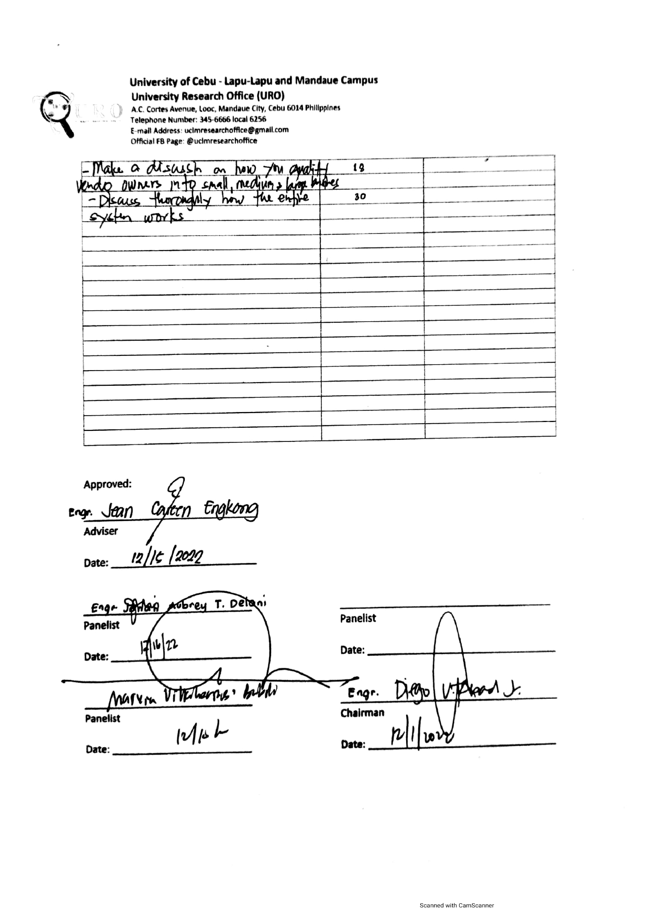

## **Appendix E**

**Bill of Materials**

|  |  |  |  |
| --- | --- | --- | --- |
| **Quantity** | **Item Description** | **Cost/Unit** | **Subtotal** |
| 30 pcs | Staple Wire (1/2) | Php 0.50 | Php 15.00 |
| 15 pcs | MS 4 Screw | Php 0.75 | Php 11.25 |
| 15m | Hock Up Wire (Solid) | Php 5.00 | Php 75.00 |
| 4 pcs | IR Sensor | Php 120.00 | Php 480.00 |
| 4 pcs | Push Button Switch | Php 20.00 | Php 80.00 |
| 1 pc | Servo Motor NG 995 | Php 525.00  (-26.25) | Php 498.75 |
| 20 pcs | WS 3 Screw | Php 0.25 | Php 5.00 |
| 2 pcs | PLU#10085 B.Board HSO2 (7cm) | Php 30.00 | Php 60.00 |
| 5 pcs | 8903 Glue Stick | Php 7.00 | Php 35.00 |
| 4 pcs | 3D Print | Php 500.00 | Php 2,000.00 |
| 1 unit | Dispenser with box (secondhand) | Php 5,000.00 | Php 5,000.00 |
| 1 pc | Tower Pro Digital Robot Servo Motor (180 rotation) | Php 170.00 | Php 170.00 |
| 1 pc | ESP8266 ESP-01s WiFi Module | Php 110.00 | Php 110.00 |
| 1 pc | 12v 2A Power Adapter | Php 119.00 | Php 119.00 |
| 1 pc | Calibrated ALLAN Universal Coin Slot | Php 500.00 | Php 500.00 |
| 1 pc | 30 pins and 38 pins ESP32 WiFi IoT | Php 160.00 | Php 160.00 |
| 1 pc | NodeMCU V3 ESP8266 | Php 160.00 | Php 160.00 |
| 1 box | Polyolefin Heat Shrink Tube | Php 199.00 | Php 199.00 |
| 1 pc | Mega 2560 R3 Motherboard Arduino | Php 849.00 | Php 849.00 |
| 1 pc | Power Jack Socket | Php 92.00 | Php 92.00 |
| 1 pc | ALLAN Water Pump | Php 169.00 | Php 169.00 |
| 1m | Tubing for pumps PVC | Php 44.00 | Php 44.00 |
|  |  |  |  |

## **Appendix F**

Activity Timetable

During the 8 months, the researchers were able to formulate, execute, and finalize the

findings of the various activities carried out over the period.

|  |  |  |  |  |  |  |  |  |  |  |  |  |  |  |  |  |
| --- | --- | --- | --- | --- | --- | --- | --- | --- | --- | --- | --- | --- | --- | --- | --- | --- |
| Activities | September | | | | October | | | | November | | | | December | | | |
| No. of  Weeks | | | | No. of Weeks | | | | No. of  Weeks | | | | No. of  Weeks | | | |
| 1 | 2 | 3 | 4 | 1 | 2 | 3 | 4 | 1 | 2 | 3 | 4 | 1 | 2 | 3 | 4 |
| 1. Proposal |  |  |  |  |  |  |  |  |  |  |  |  |  |  |  |  |
| Proposed Title |  |  |  |  |  |  |  |  |  |  |  |  |  |  |  |  |
| Statement of the Problem |  |  |  |  |  |  |  |  |  |  |  |  |  |  |  |  |
| Rationale |  |  |  |  |  |  |  |  |  |  |  |  |  |  |  |  |
| Theoretical Background |  |  |  |  |  |  |  |  |  |  |  |  |  |  |  |  |
| Review of Related Literature |  |  |  |  |  |  |  |  |  |  |  |  |  |  |  |  |
| Significance of the Study |  |  |  |  |  |  |  |  |  |  |  |  |  |  |  |  |
| Research Methodology |  |  |  |  |  |  |  |  |  |  |  |  |  |  |  |  |
| Research Instrument |  |  |  |  |  |  |  |  |  |  |  |  |  |  |  |  |
| Data Gathering |  |  |  |  |  |  |  |  |  |  |  |  |  |  |  |  |
| Conceptual Framework |  |  |  |  |  |  |  |  |  |  |  |  |  |  |  |  |
| Block Diagram |  |  |  |  |  |  |  |  |  |  |  |  |  |  |  |  |
| Prototype and GUI App Design |  |  |  |  |  |  |  |  |  |  |  |  |  |  |  |  |
| Proposed Bill of Materials |  |  |  |  |  |  |  |  |  |  |  |  |  |  |  |  |
| Definition of Terms |  |  |  |  |  |  |  |  |  |  |  |  |  |  |  |  |
| Preparation for Oral Presentation |  |  |  |  |  |  |  |  |  |  |  |  |  |  |  |  |
| Presentation of Thesis Proposal |  |  |  |  |  |  |  |  |  |  |  |  |  |  |  |  |

### **Chart 2.1** *Gantt chart of the Thesis Proposal from September 2022 to December 2022*

Chart 2.1 shows the various activities that took place from September 2022 to December 2022. These are initial activities for thesis proposal. On the 3rd and 4th week of September, the researchers were able to decide on the title for the thesis proposal. The 1st, 2nd week of the October, the researchers were able to formulate the Statement of the Problem. The Rationale, Theoretical Background, and Significance of the Study were constructed on the 2nd week of the October. The Review of Related Literature was done on the 2nd to 3rd week of October. The Research Methodology and Research Instrument were also done on the 3rd week of October. On the last week of October, the researchers conducted the Data Gathering and Conceptual Framework. Also, during the 4th week to 1st week of November, the researchers made the Block Diagram.

On the first week and second week of November, the researchers made the Prototype and GUI App and also formulated the Proposed Bill of Materials. The Definition of terms was done on the same week where the Proposed Bill of Material was formulated.

Before the first semester ended, the Oral Presentation of the Thesis Proposal was conducted during the first week of December.

|  |  |  |  |  |  |  |  |  |  |  |  |  |  |  |  |  |  |  |  |  |  |  |  |
| --- | --- | --- | --- | --- | --- | --- | --- | --- | --- | --- | --- | --- | --- | --- | --- | --- | --- | --- | --- | --- | --- | --- | --- |
| Activities | January | | | | February | | | | | March | | | | April | | | | | May | | | | |
| No. of  Weeks | | | | No. of Weeks | | | | | No. of  Weeks | | | | No. of  Weeks | | | | | No. of  Weeks | | | | |
| 1 | 2 | 3 | 4 | | 1 | 2 | 3 | 4 | 1 | 2 | 3 | 4 | | 1 | 2 | 3 | 4 | | 1 | 2 | 3 | 4 |
| 1. Implementation |  |  |  |  | |  |  |  |  |  |  |  |  | |  |  |  |  | |  |  |  |  |
| Canvassed of Materials |  |  |  |  | |  |  |  |  |  |  |  |  | |  |  |  |  | |  |  |  |  |
| Purchased the Materials Needed |  |  |  |  | |  |  |  |  |  |  |  |  | |  |  |  |  | |  |  |  |  |
| Planning where to Assemble the Machine |  |  |  |  | |  |  |  |  |  |  |  |  | |  |  |  |  | |  |  |  |  |
| Preparing the Materials Needed |  |  |  |  | |  |  |  |  |  |  |  |  | |  |  |  |  | |  |  |  |  |
| Testing the Materials |  |  |  |  | |  |  |  |  |  |  |  |  | |  |  |  |  | |  |  |  |  |
| Prototype Making of Coin Changer |  |  |  |  | |  |  |  |  |  |  |  |  | |  |  |  |  | |  |  |  |  |
| Programming Microcontroller |  |  |  |  | |  |  |  |  |  |  |  |  | |  |  |  |  | |  |  |  |  |
| Constructing of the Machine |  |  |  |  | |  |  |  |  |  |  |  |  | |  |  |  |  | |  |  |  |  |
| Purchasing Additional Materials |  |  |  |  | |  |  |  |  |  |  |  |  | |  |  |  |  | |  |  |  |  |
| Programming |  |  |  |  | |  |  |  |  |  |  |  |  | |  |  |  |  | |  |  |  |  |
| Testing the System |  |  |  |  | |  |  |  |  |  |  |  |  | |  |  |  |  | |  |  |  |  |
| Data Collection |  |  |  |  | |  |  |  |  |  |  |  |  | |  |  |  |  | |  |  |  |  |
| Preparation for Oral |  |  |  |  | |  |  |  |  |  |  |  |  | |  |  |  |  | |  |  |  |  |
| Oral Defense |  |  |  |  | |  |  |  |  |  |  |  |  | |  |  |  |  | |  |  |  |  |

### **Chart 2.2** *Gantt chart of the Thesis Implementation from January 2023 to May 2023*

Chart 4.2 demonstrate the activities done from January 2023 to May 2023, which is the

thesis implementation. The researchers canvassed the materials during the 2nd to 4th week of

January. From the 3rd week of January up to the 2nd week of February researchers starting to purchase the materials needed for the project. Planning where to assemble the machine was done

4th to 2nd week of February. Testing material was done during the 2nd to 4th week of February. Researchers started to made a prototype of the coin changer on the 4th week of February. Then on the 2nd week of February up to 4th week of February, researchers started to program the microcontroller. Constructing the machine was constructed during the 1st week of March up to last week of April. During the 4th week of the March to 2nd week of April researchers decided to purchase some of the materials needed for the Machine. During the 1st week of March up to last week of April, the researchers started to program the System flow, and it was tested during the 2nd week up to the last week of April.

` Data Collection was done during the last week of April up to 1st week of

May. And Preparation of the projects was conducted during the 1st week of May. Oral defense was scheduled on the first week of May.

## **Appendix G**

**User’s Manual**

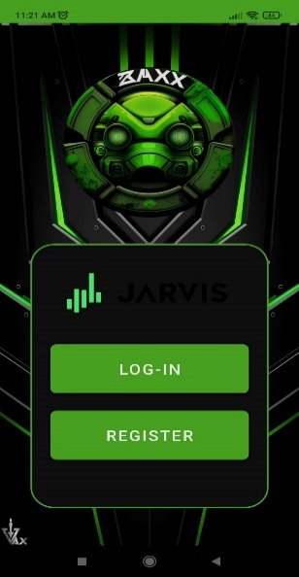

On Startup Screen:

1. Login Button – Submit Button
2. Register Button – Create Admin Account

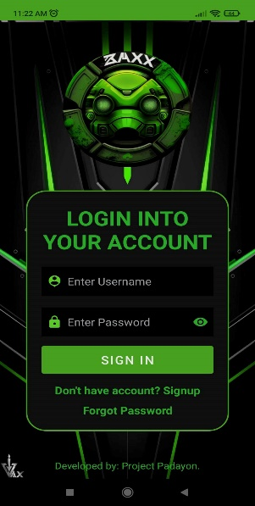

On Login Screen:

1. Username – Registered Admin User
2. Password – Registered Admin Password
3. Login – Sign in Button
4. Sign up – Register New Account
5. Forgot Password – Reset Password

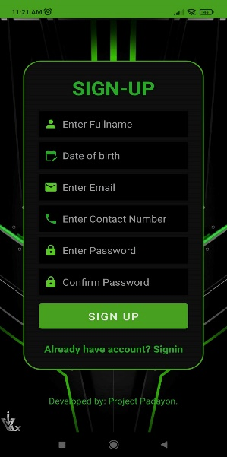

On Sign Up Screen:

1. Personal Information – Fill in necessary information
2. Sign Up – Submit Button
3. Sign In – Back to Login screen

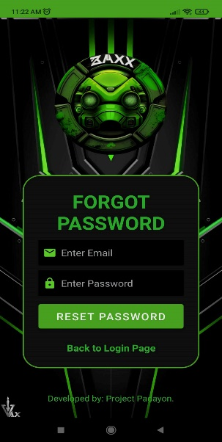

On Forgot Password Screen:

1. Username – Registered Admin User
2. Password – Unregistered Admin Password
3. Reset Password – New Password
4. Back to Login Page – Exit

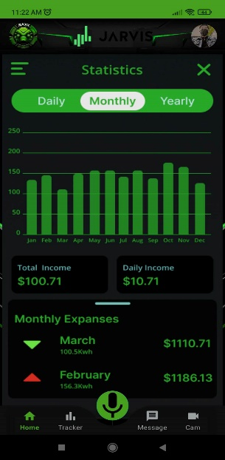

` On Sales Statistics Screen:

