Electronics Students and Staff AssociationSession: 2023-24
Activity Report

1.Title: Secret of Canva
Date: Sunday 8th October, 2023
Time: 9am to 12pm
Venue: DSP Lab
Total Students: 28 Students
Resource Person: Prasad Deshmukh, Niharika Dagaonkar, Shreya Dharmale
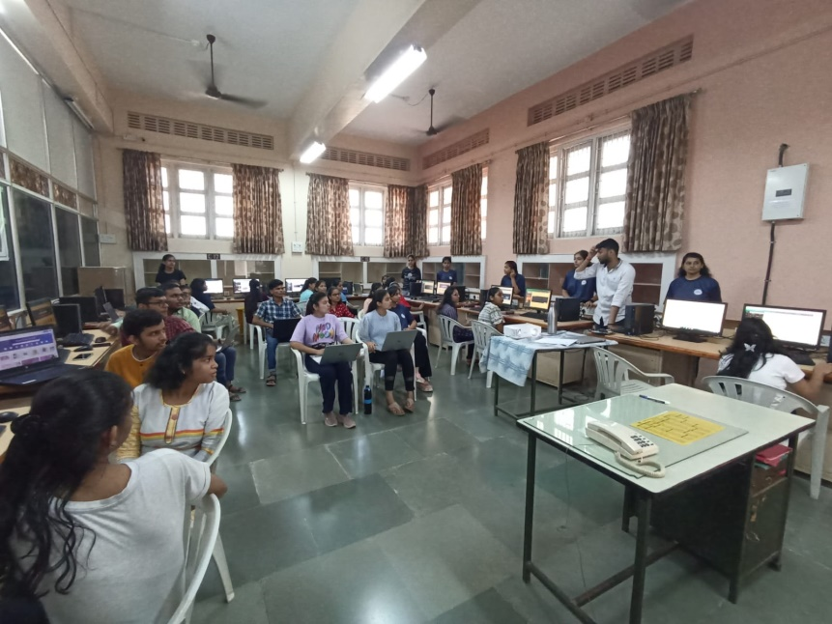

2.Title: Arduino Mastery
Date: 13th & 14th March,2024
Time: 4pm to 8pm
Venue: Old Auditorium
Total Students: 95 Students
Resource Person: Prof. Mangesh Bharati and Team
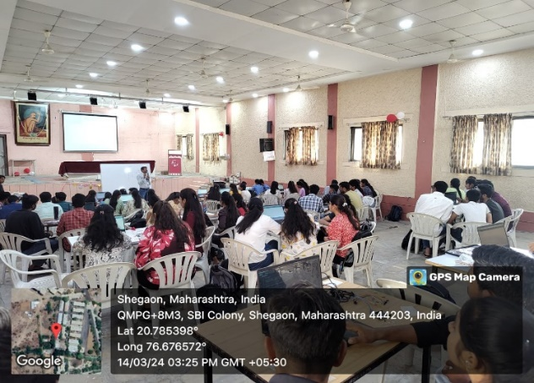

3.Title: Electrofiesta
Date: 15th & 16th March, 2024
Time: 4pm to 6pm,1pm to 3pm.
Venue: EXTC Department, Class C2.
Total Students: 20 Students
Resource Person: Mansi Agrawal, Prasad Deshmukh , Niharika Dagaonkar.
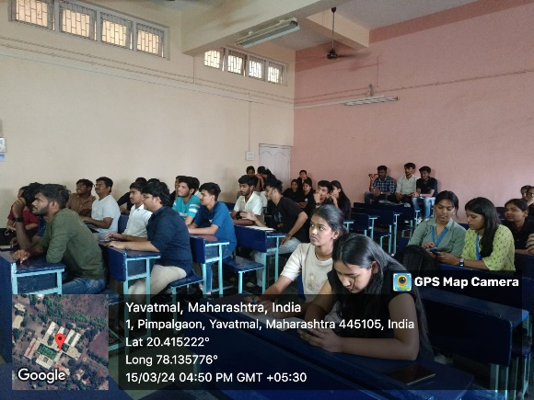
4.Title: First Year Orientation
Date: 25 August 2023
Time: 11 am to 5 pm
Venue: EXTC Seminar Hall
Total Students: 80 Students
Resource Person: Dr. M. N. Tibdewal, Mrs. K. S. Vyas, Mr. S. P. Badar, Mr. S. G. Nemane
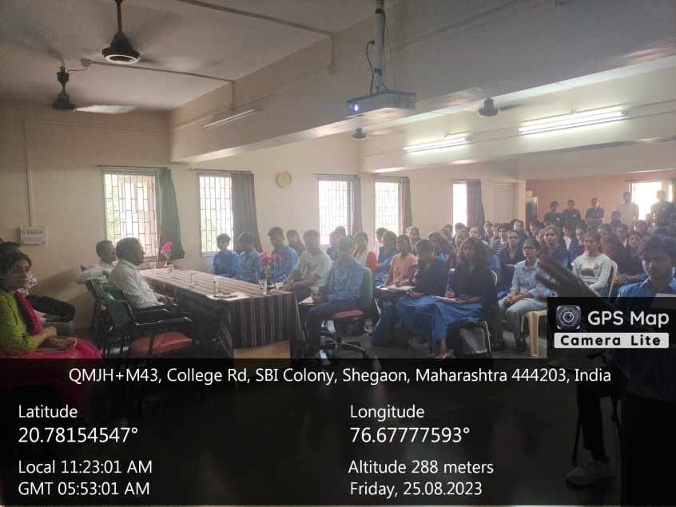

5. Title: Aerobics Training
Date: 23 January 2024
Time: 4-8 pm
Venue: Chinchili
Total Students: 54 Students
Resource Person: Bhumika Deshmukh

