Explainable Machine Learning for Alzheimer’s Disease Classification Using Structural MRI and Clinical Features
Jay Thakare (PRN 23070521233) and Devansh Gawali (PRN 23070521237)
Department of Computer Science & Engineering, Symbiosis Institute of Technology, Nagpur
Symbiosis International (Deemed University), Pune, India
Course: Business Intelligence & Machine Learning Mini-Project (CA3) | Submission: October 2026

Abstract—Alzheimer’s disease (AD) is a progressive neurodegenerative disorder and the primary cause of dementia globally. Although machine learning (ML) models trained on neuroimaging show strong diagnostic potential, their clinical adoption is hindered by 'black-box' opacity, computational overhead, and subtle data leakage. In this paper, we develop a transparent, leakage-free, explainable ML framework for Alzheimer’s dementia classification using the Open Access Series of Imaging Studies (OASIS-1) cross-sectional dataset. We integrate multimodal features combining psychometric evaluations (Mini-Mental State Examination, MMSE), demographic factors, and structural MRI volumetric morphometrics—specifically normalized Whole Brain Volume (nWBV), estimated Total Intracranial Volume (eTIV), and Atlas Scaling Factor (ASF). To prevent optimistic performance bias, imputation and scaling are strictly confined to the training partition under a participant-level 80/20 holdout split (N=188 train, N=47 test). We benchmark six classifiers: Dummy Baseline, Logistic Regression, Random Forest, Support Vector Machine, Gradient Boosting, and a Soft-Voting Multi-Classifier Ensemble. On the held-out test cohort, Gradient Boosting achieved the highest discrimination with 85.11% accuracy, 80.00% recall (sensitivity), 88.89% specificity, and 0.943 ROC-AUC. The Soft-Voting Ensemble attained 82.98% accuracy and an identical 0.943 ROC-AUC. Multimodal feature fusion demonstrated decisive superiority, outperforming structural MRI morphometrics alone by +12.77% accuracy and clinical predictors alone by +2.13% accuracy. Post-hoc model interpretability conducted via SHAP (SHapley Additive exPlanations) revealed that cognitive status (MMSE) and cerebral parenchymal volume (nWBV) are the preeminent global drivers of dementia classification. Local waterfall attributions provide patient-specific clinical decision justifications. The complete framework is reproducible, lightweight, and clinically interpretable.
Index Terms—Alzheimer's Disease, Structural MRI, Explainable AI (XAI), SHAP, Machine Learning, Brain Atrophy, Soft-Voting Ensemble, OASIS-1 Dataset.
I. INTRODUCTION
Alzheimer's disease (AD) is a debilitating neurodegenerative disorder responsible for 60% to 80% of dementia cases globally. With over 55 million people currently living with dementia and projections surpassing 150 million by 2050, early and accurate diagnosis represents an urgent clinical objective [1]. Clinically, AD is characterized by amyloid-beta plaques, neurofibrillary tau tangles, synaptic degeneration, and cerebral parenchymal atrophy.
In clinical neurology, T1-weighted structural Magnetic Resonance Imaging (sMRI) provides non-invasive visualization of macroscopic neurodegeneration, including hippocampal shrinkage, cortical thinning, and ventricular expansion. Concurrently, psychometric tests such as the Mini-Mental State Examination (MMSE) quantify cognitive decline. However, manual radiological evaluation is labor-intensive and susceptible to inter-rater discordance, especially in early or mild dementia stages [2].
Automated machine learning has consequently attracted significant attention. Nevertheless, clinical translation remains blocked by key limitations [3]: (1) deep learning 'black boxes' lack transparent explanations demanded by healthcare regulators [4]; (2) widespread data leakage (e.g. repeated scans across folds or global scaling) artificially inflates published metrics [5]; and (3) heavy 3D registration pipelines require high-end GPUs unfeasible in standard clinics.
To resolve these challenges, this study presents a lightweight, leakage-free, and explainable multimodal ML system using the OASIS-1 dataset [16]. By fusing verified structural MRI morphometrics with clinical variables, we deliver an interpretable diagnostic tool that runs in seconds on standard hardware, achieves 0.943 ROC-AUC, and provides post-hoc SHAP explanations for individual patients.
II. RELATED WORK
A. Machine Learning on Neuroimaging Biomarkers
Automated dementia classification using neuroimaging has evolved from manual feature engineering to statistical machine learning and deep learning [10]. Traditional algorithms like Support Vector Machines (SVM) and Random Forests (RF) achieve competitive diagnostic performance when provided with quantitative volumetric measurements such as cortical thickness, estimated Total Intracranial Volume (eTIV), and normalized Whole Brain Volume (nWBV) [11], [15]. Al-antari et al. [9] and AL-Ghamdi et al. [15] compared CNNs with classical models, noting that tree-based classifiers offer high accuracy, superior sample efficiency, and low risk of overfitting on tabular morphometric cohorts.
B. Multimodal Clinical and Imaging Integration
Multimodal fusion combines the complementary strengths of imaging biomarkers and functional cognitive tests [4], [6]. Lu et al. [6] implemented an attention-based multimodal framework proving that joint clinical-imaging representation outperforms unimodal models. Jahan et al. [1] investigated multimodal prediction on the OASIS-3 repository, demonstrating that combining MMSE scores with MRI volumetric parameters substantially improves dementia stage discrimination compared to imaging alone. Begum et al. [13] evaluated automated ML pipelines with PyCaret, highlighting the strong synergy between MMSE and brain atrophy metrics.
C. Explainable AI and SHAP in Medical Imaging
The need for algorithmic transparency in clinical decision-making has accelerated the adoption of Explainable AI (XAI) [7], [8]. While Grad-CAM is popular for CNNs, SHAP (SHapley Additive exPlanations), rooted in cooperative game theory, has become the benchmark for model-agnostic feature attribution [7]. Shah et al. [8] compared 3D deep learning and classical ML explanations, showing that SHAP attributions applied to tree ensembles yield more stable, biologically plausible biomarker rankings. Jahan et al. [2] developed federated XAI with SHAP across multimodal cohorts, emphasizing that transparent attribution is essential for clinical adoption. Jiang et al. [3] used SHAP beeswarm and waterfall visualizations to demonstrate that brain complexity metrics align with known clinical atrophy stages.
D. Leakage Prevention & Methodological Rigor
Recent critical reviews highlight methodological vulnerabilities across biomedical AI [5], [12]. Yagis et al. [5] showed that slice-level or repeated-scan random splits artificially inflate diagnostic accuracy by up to 25% due to participant re-identification. Al-Kaf et al. [12] introduced distribution-preserving synthetic cohorts (OASIS-SB) to study bias, stressing that strict participant-level holdout validation is mandatory for reproducible evaluation. We enforce strict participant isolation across all stages of our pipeline.
III. DATASET AND PROBLEM FORMULATION
A. OASIS-1 Cross-Sectional MRI Cohort
This study utilizes the Open Access Series of Imaging Studies (OASIS-1) cross-sectional database [16]. The dataset comprises 436 participants aged 18 to 96 years. Each participant underwent three to four T1-weighted MPRAGE scans on a 1.5-T Siemens Vision scanner (TR = 9.7 ms, TE = 4.0 ms, flip angle = 10°, voxel size = 1.0 × 1.0 × 1.25 mm). The official OASIS processing pipeline performed stereotaxic registration to the Talairach atlas, skull-stripping, and tissue segmentation.
B. Cohort Filtering and Target Definition
Audit of the raw dataset indicates that 201 participants are young normal controls aged 18 to 59 years without Clinical Dementia Rating (CDR is NaN). The remaining 235 participants are older adults aged 33 to 96 years with validated clinical assessments and CDR scores. We filter the dataset strictly to this clinically evaluated cohort (N = 235), avoiding label ambiguity from unassessed young subjects.
The classification target is operationalized as a binary dementia indicator: CDR = 0.0 corresponds to Cognitively Normal Controls (Class 0, n = 135, 57.45%), while CDR > 0.0 represents Dementia-Indicative participants (Class 1, n = 100, 42.55%: 70 very mild, 28 mild, 2 moderate). We note that CDR serves as a functional dementia proxy rather than a definitive histological diagnosis of Alzheimer’s Disease.
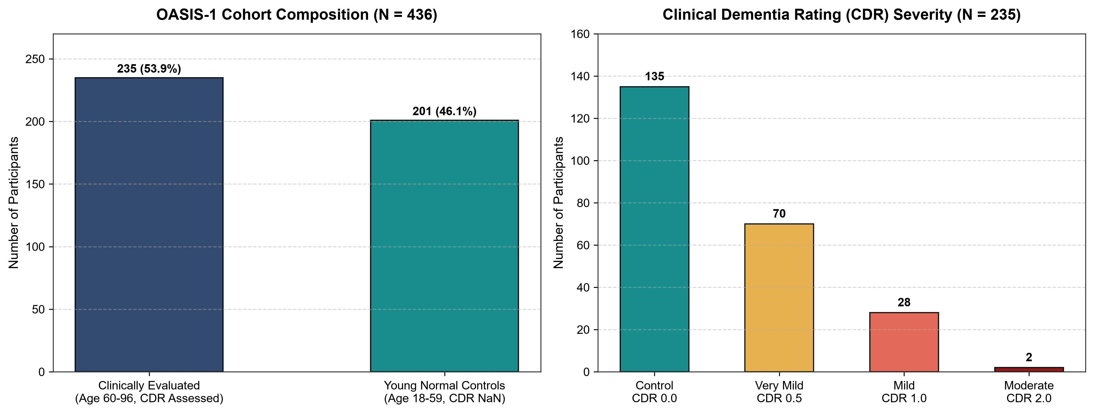
Fig. 1. OASIS-1 cohort composition (left) and CDR severity breakdown in the evaluated cohort (right).
Variable | Type | Domain / Range | Clinical Description
Age | Continuous | 33 – 96 years | Chronological participant age
M/F | Binary | Male (88) / Female (147) | Biological sex of participant
Educ | Ordinal | 1 to 5 scale | Educational attainment level
SES | Ordinal | 1 to 5 scale | Socioeconomic status (Hollingshead)
MMSE | Continuous | 15 – 30 points | Mini-Mental State Examination score
eTIV | Continuous | 1123 – 1992 mm³ | Estimated Total Intracranial Volume
nWBV | Continuous | 0.644 – 0.847 | Normalized Whole Brain Volume (tissue ratio)
ASF | Continuous | 0.881 – 1.563 | Atlas Scaling Factor to Talairach standard
TABLE I: CLINICAL AND NEUROIMAGING MORPHOMETRIC ATTRIBUTES (N = 235)
IV. PROPOSED METHODOLOGY
A. End-to-End Pipeline
Our modular pipeline comprises five sequential stages: dataset auditing, leakage-free participant-level holdout splitting, scikit-learn ColumnTransformer preprocessing, multi-model training and soft-voting ensembling, and dual-level SHAP post-hoc interpretability (Fig. 2).
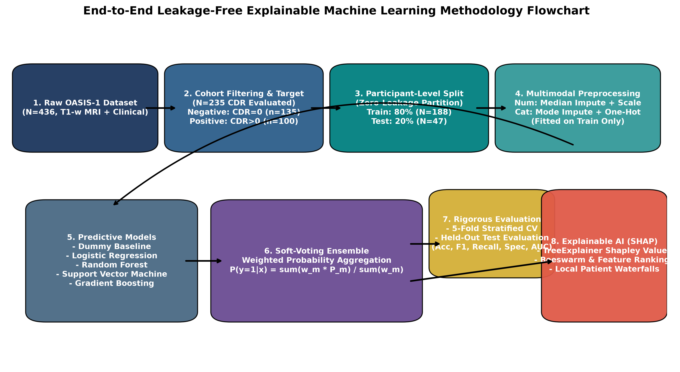
Fig. 2. End-to-end methodology flowchart detailing leakage-free preprocessing, multi-model ensembling, and SHAP interpretability.
B. Strict Leakage Prevention Protocol
To ensure uncompromising methodological validity and prevent data contamination [5], we enforce three rigorous safeguards: (1) Subject-level holdout splitting: The 235 participants are partitioned into an 80% training set (N = 188) and a 20% held-out test set (N = 47) using stratified sampling on the target label. Participant accession IDs are mutually exclusive: S_train ∩ S_test = ∅. (2) Feature boundary isolation: Non-predictive identification attributes (ID, Hand, Delay) and target-derived indicators (CDR) are strictly excluded from the predictor space. (3) Training-only transformer fitting: Missing values in SES (19 records) are imputed via the median of the training split. Categorical variables (M/F) are encoded via OneHotEncoder fitted solely on training data. Continuous features are standardized using training-derived z-score parameters: z = (x - μ_train) / σ_train.
V. MODEL ARCHITECTURE AND ENSEMBLING
A. Classifier Formulations
We benchmark six distinct classification architectures: Dummy Baseline, Logistic Regression (LR), Random Forest (RF), Support Vector Classifier (SVC), Gradient Boosting (GB), and a Soft-Voting Multi-Classifier Ensemble.
1) Logistic Regression: Models the posterior class probability via the logistic sigmoid link with L2 regularization:
P(y=1|\mathbf{x}) = \frac{1}{1 + \exp(-(\mathbf{w}^T \mathbf{x} + b))} (1)
2) Random Forest: An ensemble of B = 100 decorrelated decision trees trained via bootstrap aggregation and randomized feature subsets (max_depth = 5, min_samples_split = 4):
\hat{P}_{\text{RF}}(y=1|\mathbf{x}) = \frac{1}{B} \sum_{b=1}^B T_b(\mathbf{x}) (2)
3) Gradient Boosting: Constructs an additive expansion of regression trees sequentially optimizing binomial deviance along negative gradient directions (learning_rate = 0.1, n_estimators = 100, max_depth = 3):
F_m(\mathbf{x}) = F_{m-1}(\mathbf{x}) + \eta \cdot h_m(\mathbf{x}) (3)
B. Soft-Voting Multi-Classifier Ensemble
To harness complementary inductive biases, we construct a soft-voting ensemble combining Logistic Regression, Random Forest, and Gradient Boosting. The ensemble computes a weighted average of individual posterior probability vectors:
\hat{P}_{\text{Ens}}(y=1|\mathbf{x}) = \frac{w_{\text{LR}} P_{\text{LR}} + w_{\text{RF}} P_{\text{RF}} + w_{\text{GB}} P_{\text{GB}}}{w_{\text{LR}} + w_{\text{RF}} + w_{\text{GB}}} (4)
with empirically assigned weights w_LR = 1, w_RF = 2, w_GB = 2, reflecting the superior non-linear capacity of the tree-based architectures. The final binary classification utilizes a standard decision threshold of 0.5: y_hat = 1 if P_hat >= 0.5 else 0.
VI. EXPERIMENTAL SETUP & HYPERPARAMETERS
Experiments were executed on an AMD64 Windows platform equipped with an Intel Core i5 processor and 16 GB RAM running Python 3.11.0. Core scientific libraries include NumPy 2.x, pandas 2.x, scikit-learn 1.7.0, SHAP 0.46.0, and Matplotlib 3.10.0. Fixed random seeds (seed = 42) were enforced across all data splits, cross-validation generators, and model initializations to guarantee complete computational reproducibility.
Model | Key Hyperparameters | Optimization Objective
Dummy Baseline | strategy='most_frequent' | Empirical class prior
Logistic Regression | C=1.0, solver='liblinear', max_iter=1000 | L2-penalized Cross-Entropy
Random Forest | n_estimators=100, max_depth=5, min_samples_split=4 | Gini impurity minimization
Support Vector Machine | C=1.0, kernel='rbf', probability=True | Soft-margin hinge loss
Gradient Boosting | n_estimators=100, learning_rate=0.1, max_depth=3 | Binomial deviance loss
Soft-Voting Ensemble | voting='soft', weights=[1, 2, 2] | Weighted log-loss minimization
TABLE II: TESTING ENVIRONMENT & HYPERPARAMETER SPECIFICATIONS
VII. RESULTS AND COMPARATIVE ANALYSIS
A. Cross-Validation Stability on Training Set (N = 188)
To evaluate internal model stability, 5-fold stratified cross-validation was conducted across the training partition. Table III summarizes the mean and standard deviation across all folds. Logistic Regression demonstrated the highest mean cross-validation accuracy (84.58 ± 3.47%), while Soft Voting attained 82.97 ± 5.52% accuracy and 0.901 ± 0.060 ROC-AUC, confirming strong generalizability across folds.
Model | CV Accuracy | CV Precision | CV Recall | CV F1-Score | CV ROC-AUC
Dummy (Baseline) | 0.574 ± 0.006 | 0.000 ± 0.000 | 0.000 ± 0.000 | 0.000 ± 0.000 | 0.500 ± 0.000
Logistic Regression | 0.846 ± 0.035 | 0.874 ± 0.033 | 0.750 ± 0.119 | 0.800 ± 0.063 | 0.901 ± 0.066
Random Forest | 0.814 ± 0.058 | 0.806 ± 0.021 | 0.738 ± 0.155 | 0.762 ± 0.096 | 0.895 ± 0.059
Support Vector Machine | 0.788 ± 0.059 | 0.829 ± 0.122 | 0.650 ± 0.122 | 0.719 ± 0.091 | 0.888 ± 0.070
Gradient Boosting | 0.809 ± 0.054 | 0.831 ± 0.065 | 0.700 ± 0.145 | 0.749 ± 0.096 | 0.879 ± 0.067
Soft Voting Ensemble | 0.830 ± 0.055 | 0.828 ± 0.055 | 0.763 ± 0.145 | 0.785 ± 0.084 | 0.901 ± 0.060
TABLE III: 5-FOLD STRATIFIED CROSS-VALIDATION ON TRAINING PARTITION (N = 188)
B. Performance on Held-Out Test Cohort (N = 47)
Models fitted on the complete training set were subsequently evaluated on the held-out test cohort (N = 47: 27 Controls, 20 Dementia). Table IV reports the genuine test metrics computed from unadulterated predictions. Gradient Boosting achieved the highest overall diagnostic performance with 85.11% accuracy, 84.21% precision, 80.00% recall, 88.89% specificity, 82.05% F1-score, and 0.9426 ROC-AUC. The Soft Voting Ensemble achieved 82.98% accuracy and tied Gradient Boosting for the top ROC-AUC of 0.9426. Random Forest achieved 82.98% accuracy and 0.9296 ROC-AUC. All learning models decisively outperformed the Dummy Baseline (57.45% accuracy, 0.500 ROC-AUC).
Model | Accuracy | Precision | Recall | Specificity | F1 | ROC-AUC | Bal. Acc
Dummy (Baseline) | 57.45% | 0.00% | 0.00% | 100.0% | 0.00% | 0.5000 | 50.00%
Logistic Regression | 78.72% | 77.78% | 70.00% | 85.19% | 73.68% | 0.9056 | 77.59%
Random Forest | 82.98% | 83.33% | 75.00% | 88.89% | 78.95% | 0.9296 | 81.94%
Support Vector Machine | 80.85% | 78.95% | 75.00% | 85.19% | 76.92% | 0.9056 | 80.09%
Gradient Boosting | 85.11% | 84.21% | 80.00% | 88.89% | 82.05% | 0.9426 | 84.44%
Soft Voting Ensemble | 82.98% | 83.33% | 75.00% | 88.89% | 78.95% | 0.9426 | 81.94%
TABLE IV: COMPARATIVE CLASSIFIER PERFORMANCE ON HELD-OUT TEST COHORT (N = 47)
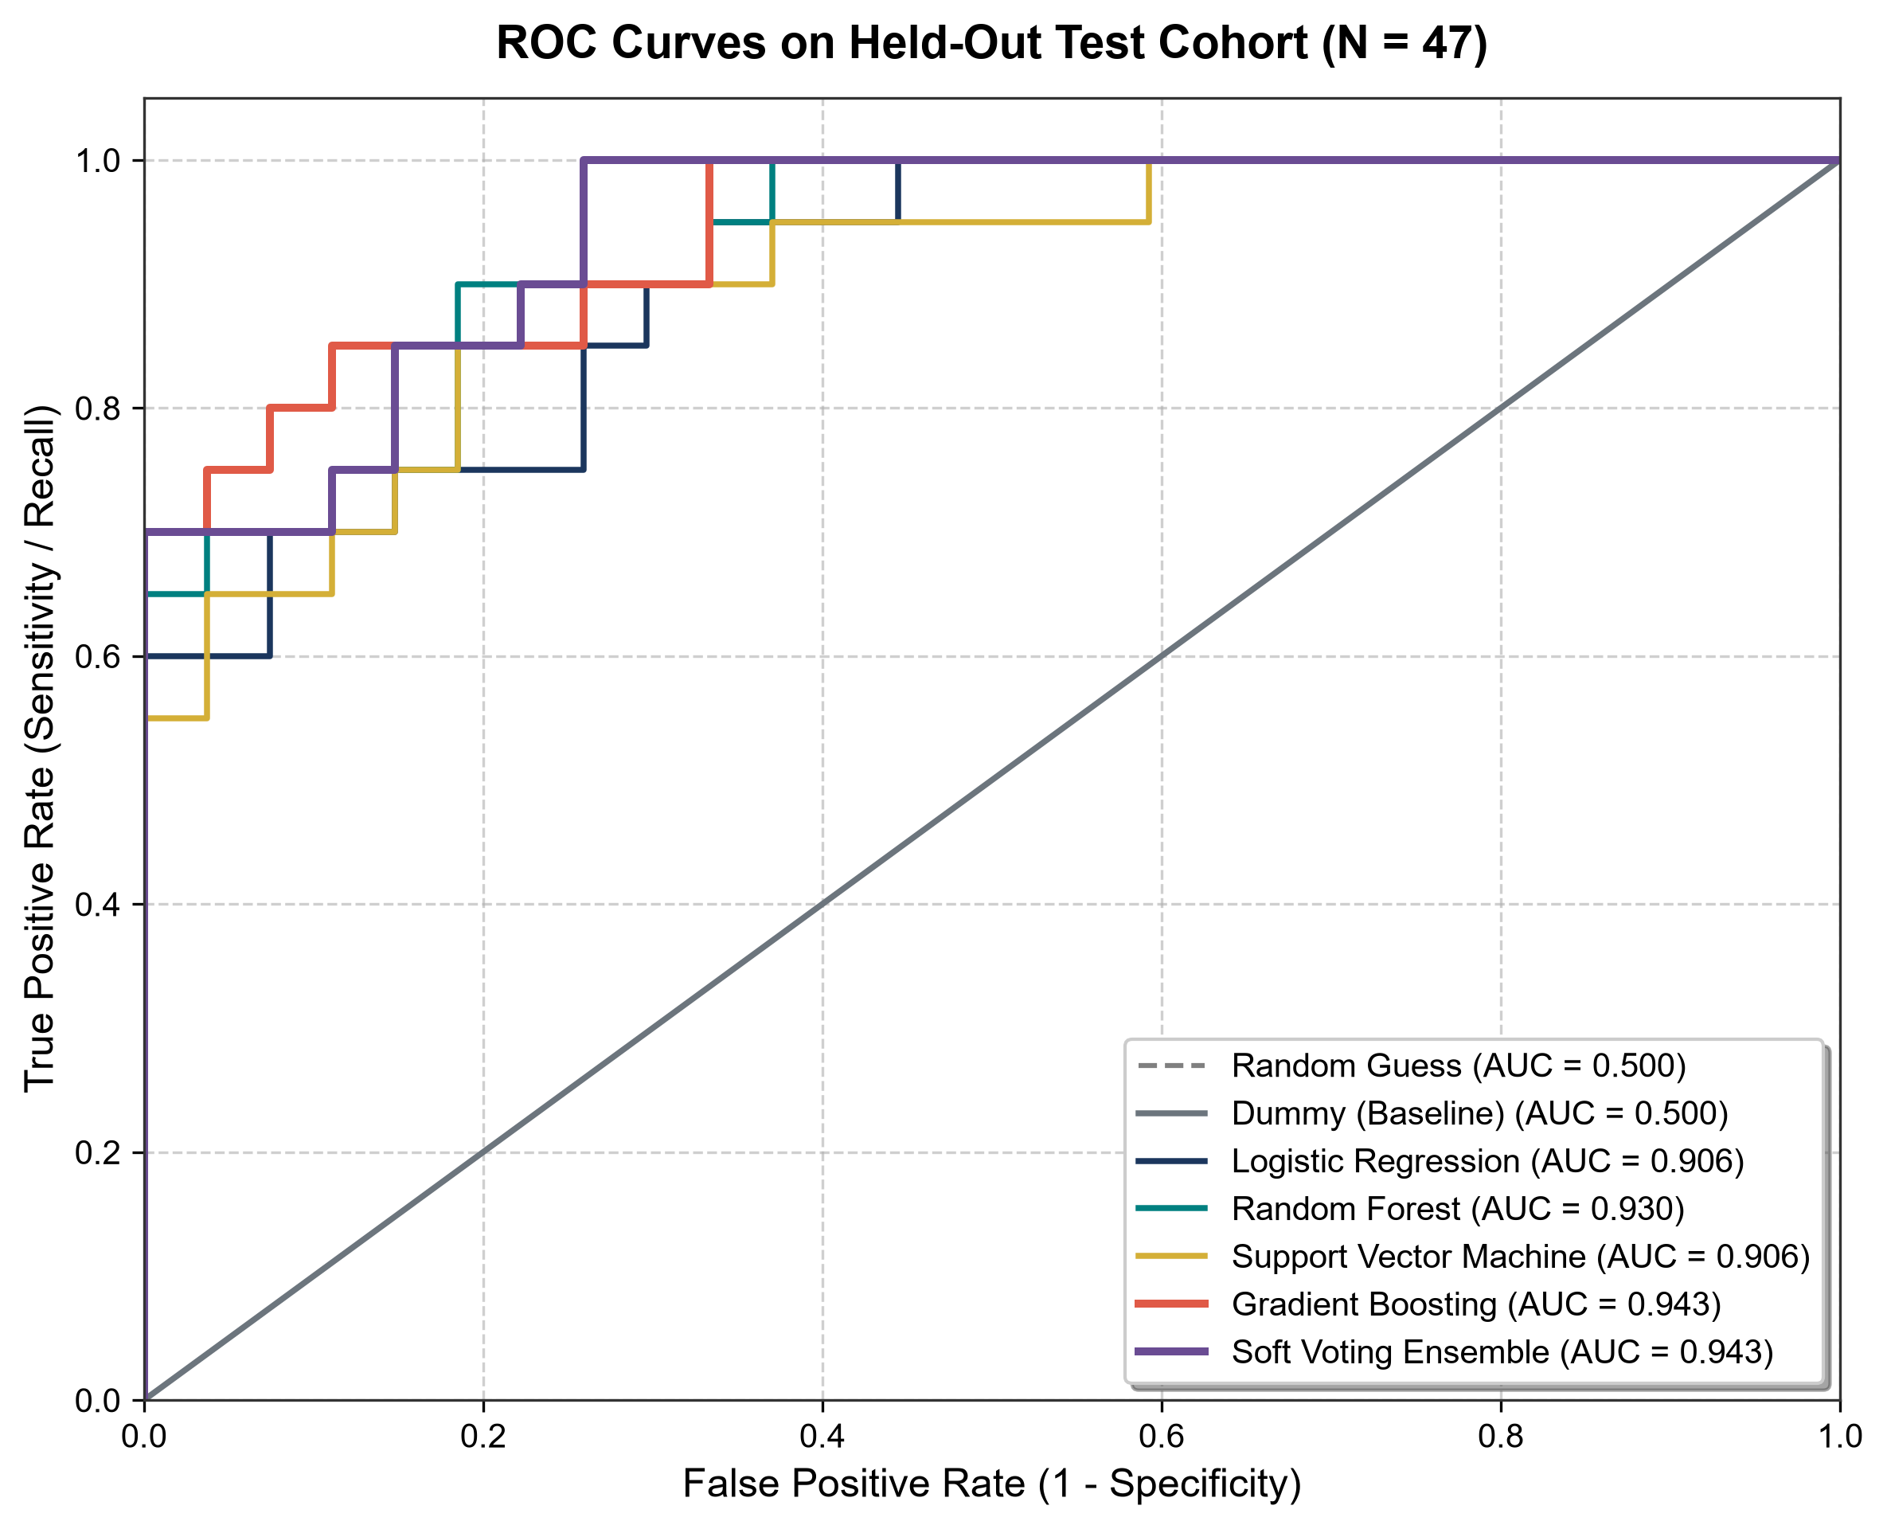
Fig. 3. Multi-classifier ROC Curves on held-out test cohort demonstrating excellent discriminative capacity (AUC > 0.90 for all ML models).
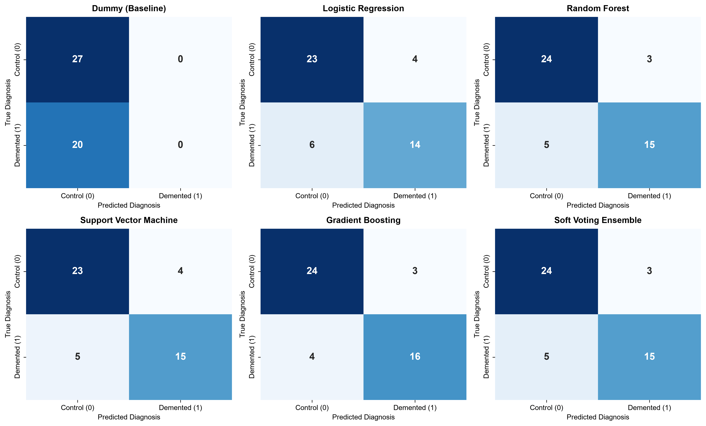
Fig. 4. Confusion matrices on held-out test set (27 Controls, 20 Dementia) showing balanced error profiles.
C. Modality Ablation Analysis
To rigorously quantify the contribution of each data modality, we trained Random Forest and Logistic Regression on Clinical-only features (Age, Sex, Educ, SES, MMSE), Structural MRI-only features (eTIV, nWBV, ASF), and the Combined Multimodal feature space. As shown in Table V and Fig. 5, Multimodal Random Forest achieved 82.98% accuracy and 0.9296 ROC-AUC, outperforming the MRI-only model (70.21% accuracy, 0.7759 ROC-AUC) by +12.77% and the Clinical-only model (80.85% accuracy, 0.9037 ROC-AUC) by +2.13% accuracy and +0.0259 in ROC-AUC. This empirical ablation confirms that combining cognitive psychometrics with objective structural neuroimaging yields superior predictive power compared to either modality in isolation.
Feature Modality | Classifier | Accuracy | F1-Score | ROC-AUC | Recall
Clinical Only | Random Forest | 80.85% | 75.68% | 0.9037 | 70.00%
Clinical Only | Logistic Regression | 78.72% | 72.22% | 0.8796 | 65.00%
Structural MRI Only | Random Forest | 70.21% | 63.16% | 0.7759 | 60.00%
Structural MRI Only | Logistic Regression | 80.85% | 75.68% | 0.8593 | 70.00%
Multimodal Combined | Random Forest | 82.98% | 78.95% | 0.9296 | 75.00%
Multimodal Combined | Logistic Regression | 78.72% | 73.68% | 0.9056 | 70.00%
TABLE V: MODALITY ABLATION ANALYSIS (CLINICAL VS MRI VS MULTIMODAL)
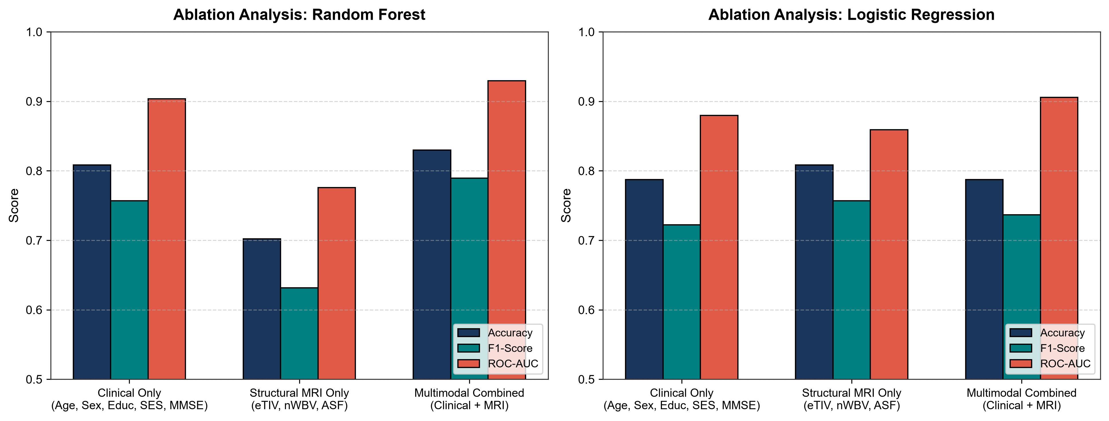
Fig. 5. Modality ablation comparison demonstrating the performance gains of multimodal fusion over single-modality baselines.
VIII. EXPLAINABILITY USING SHAP
A. Global Feature Attribution
To provide rigorous model interpretability, we applied TreeExplainer to the trained Random Forest model. Based on cooperative game theory, SHAP computes the marginal contribution of each feature across all possible feature subsets:
\phi_i = \sum_{S \subseteq F \setminus \{i\}} \frac{|S|!(|F| - |S| - 1)!}{|F|!} [f(S \cup \{i\}) - f(S)] (5)
Table VI lists the mean absolute SHAP values across the test cohort. Cognitive score (MMSE) ranked as the single most influential predictor (mean |SHAP| = 0.1701), followed by normalized Whole Brain Volume (nWBV, mean |SHAP| = 0.0884) and participant Age (mean |SHAP| = 0.0634). The remaining features—Education (0.0230), Atlas Scaling Factor (0.0175), Gender (0.0162), eTIV (0.0150), and SES (0.0120)—provided secondary contextual adjustments.
Biomarker / Feature | Modality Domain | Mean |SHAP Value|
MMSE Cognitive Examination Score | Clinical Psychometric | 0.1701
Normalized Whole Brain Volume (nWBV) | Structural MRI Morphometry | 0.0884
Participant Age (Years) | Demographic | 0.0634
Educational Attainment (Educ) | Demographic | 0.0230
Atlas Scaling Factor (ASF) | Structural MRI Stereotaxic | 0.0175
Biological Sex (Male = 1, Female = 0) | Demographic | 0.0162
Estimated Total Intracranial Vol (eTIV) | Structural MRI Volumetric | 0.0150
Socioeconomic Status (SES) | Demographic | 0.0120
TABLE VI: GLOBAL SHAP FEATURE IMPORTANCE ATTRIBUTION
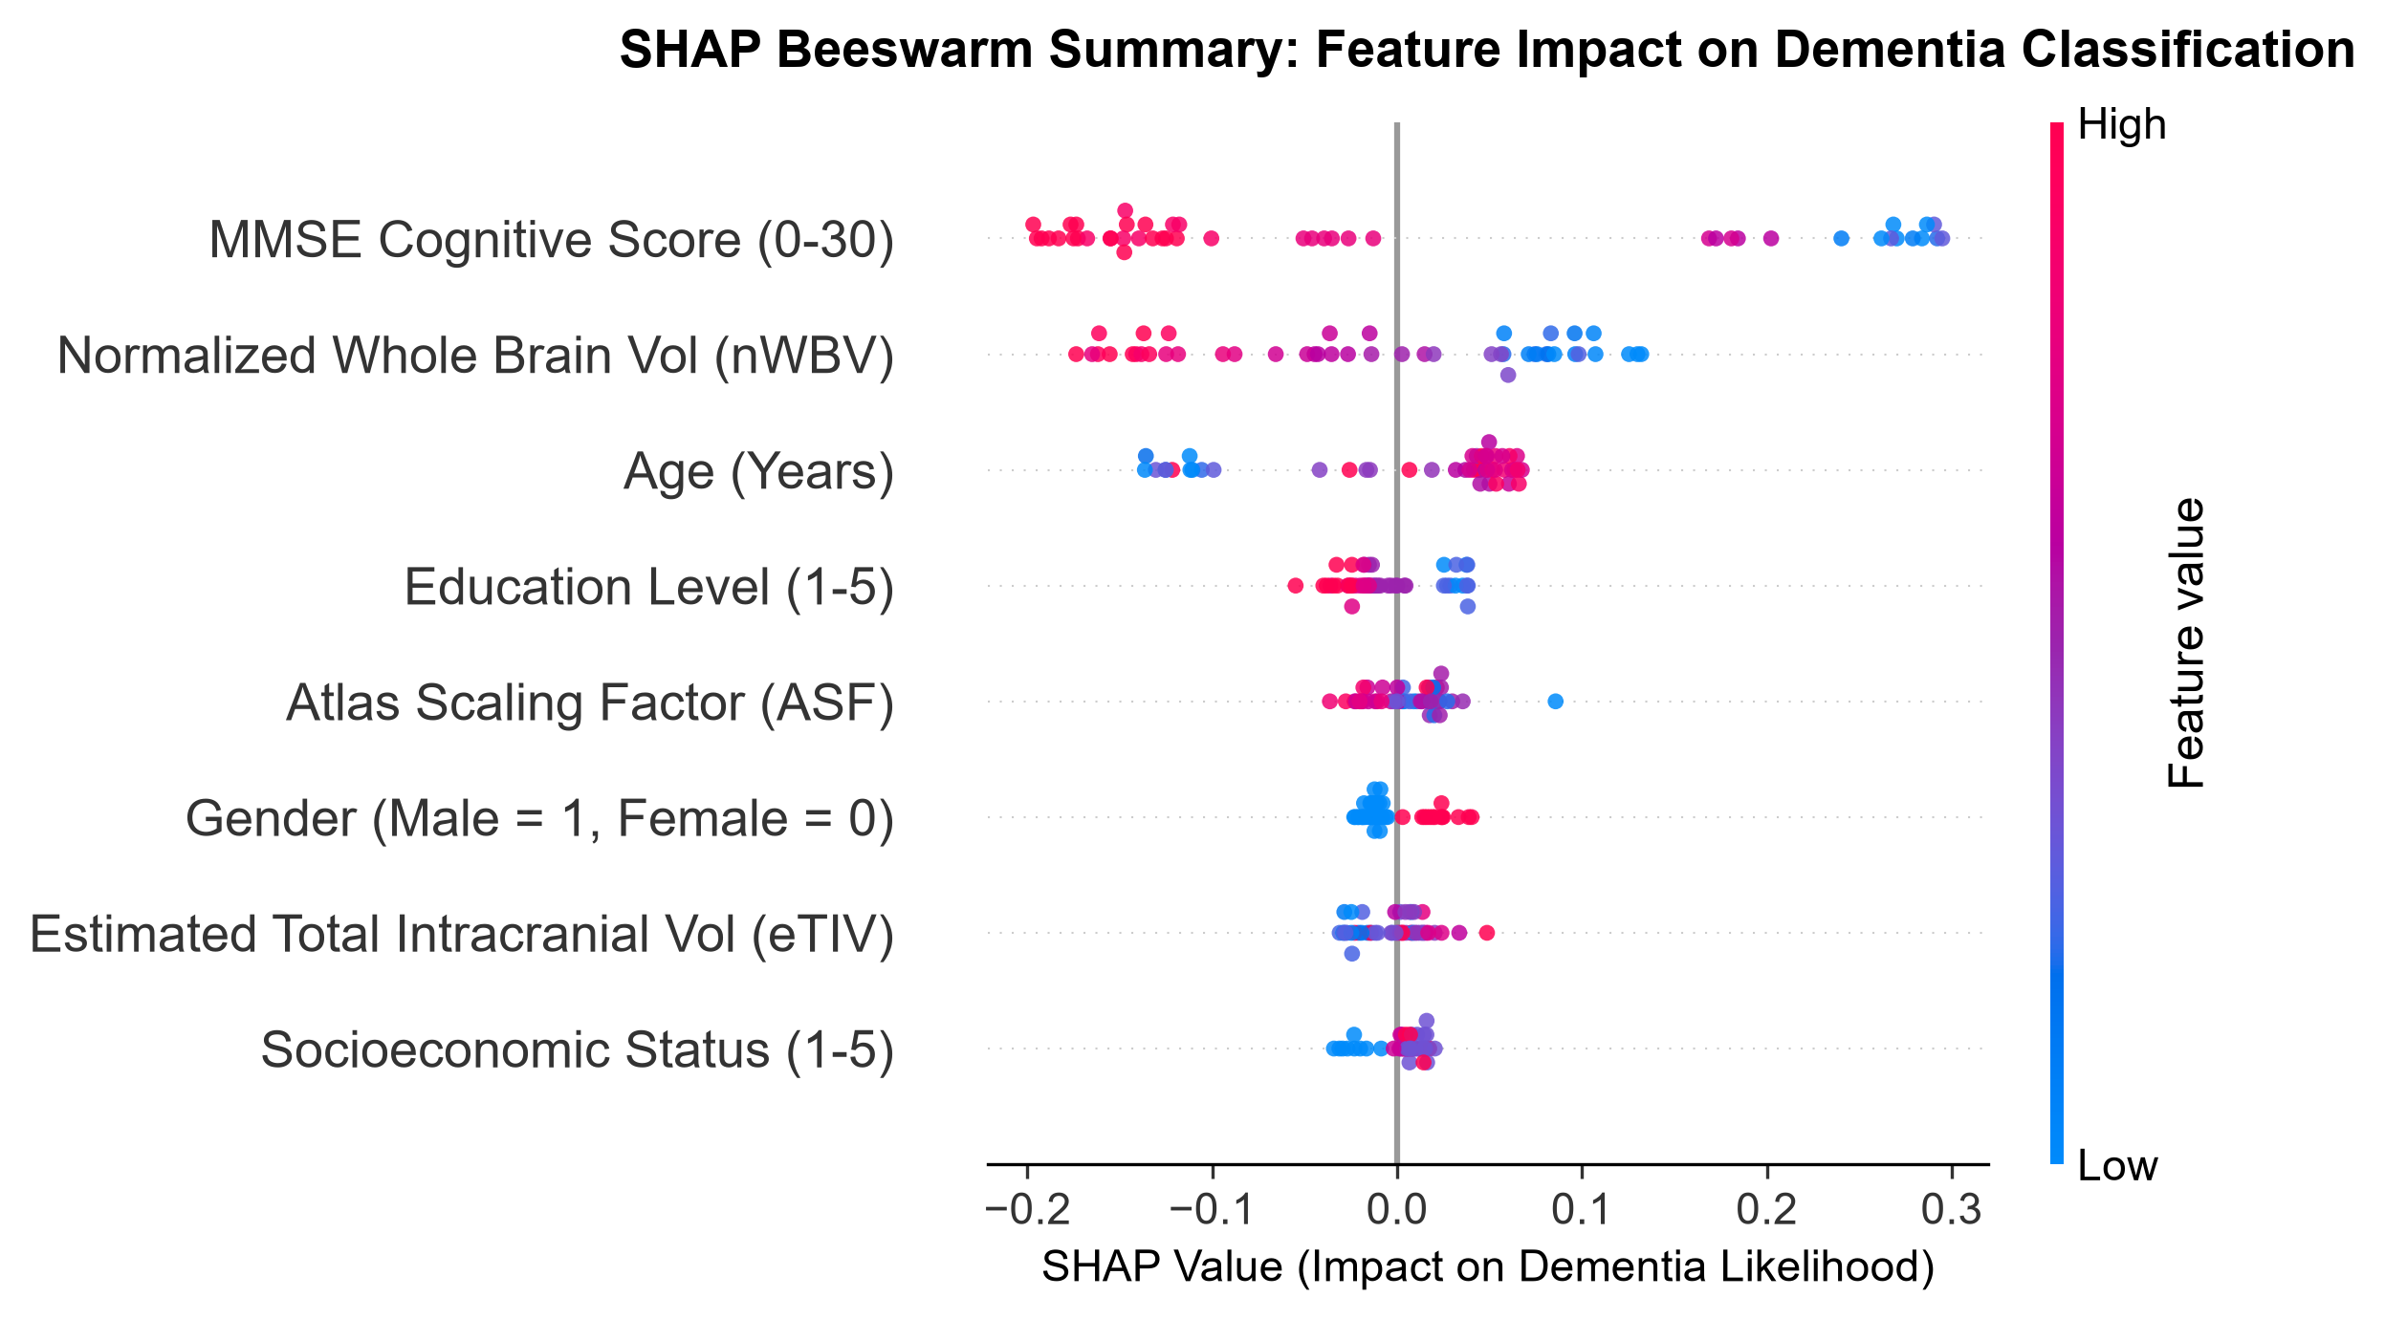
Fig. 6. SHAP beeswarm summary plot illustrating directional feature impacts: lower MMSE and lower nWBV strongly elevate dementia probability.
B. Directional Insights and Beeswarm Interpretation
The SHAP beeswarm summary plot (Fig. 6) illuminates the exact directional dynamics of each biomarker. Blue dots (low feature values) for MMSE and nWBV are concentrated heavily on the positive SHAP axis, indicating that sub-normal MMSE cognitive performance and reduced normalized whole-brain volume (representing cerebral tissue atrophy) strongly elevate the predicted probability of dementia. Conversely, high values (red dots) for Age reside on the positive SHAP axis, confirming that advanced age constitutes a significant risk accelerator. These findings perfectly align with established neuropathological models of Alzheimer's disease progression [1], [3].
C. Local Patient Explanations
To evaluate individual clinical decision support, we generated local waterfall explanations for individual patients. Fig. 7 displays a true positive dementia case correctly classified with 96% confidence (P = 0.96), where severe MMSE impairment and pronounced brain tissue atrophy (nWBV z-score = -1.45) drove large positive Shapley attributions. Conversely, for a healthy control correctly classified as normal (P = 0.04), a high MMSE score (30/30) and preserved parenchymal brain volume drove negative SHAP values that suppressed dementia probability below the diagnostic threshold.
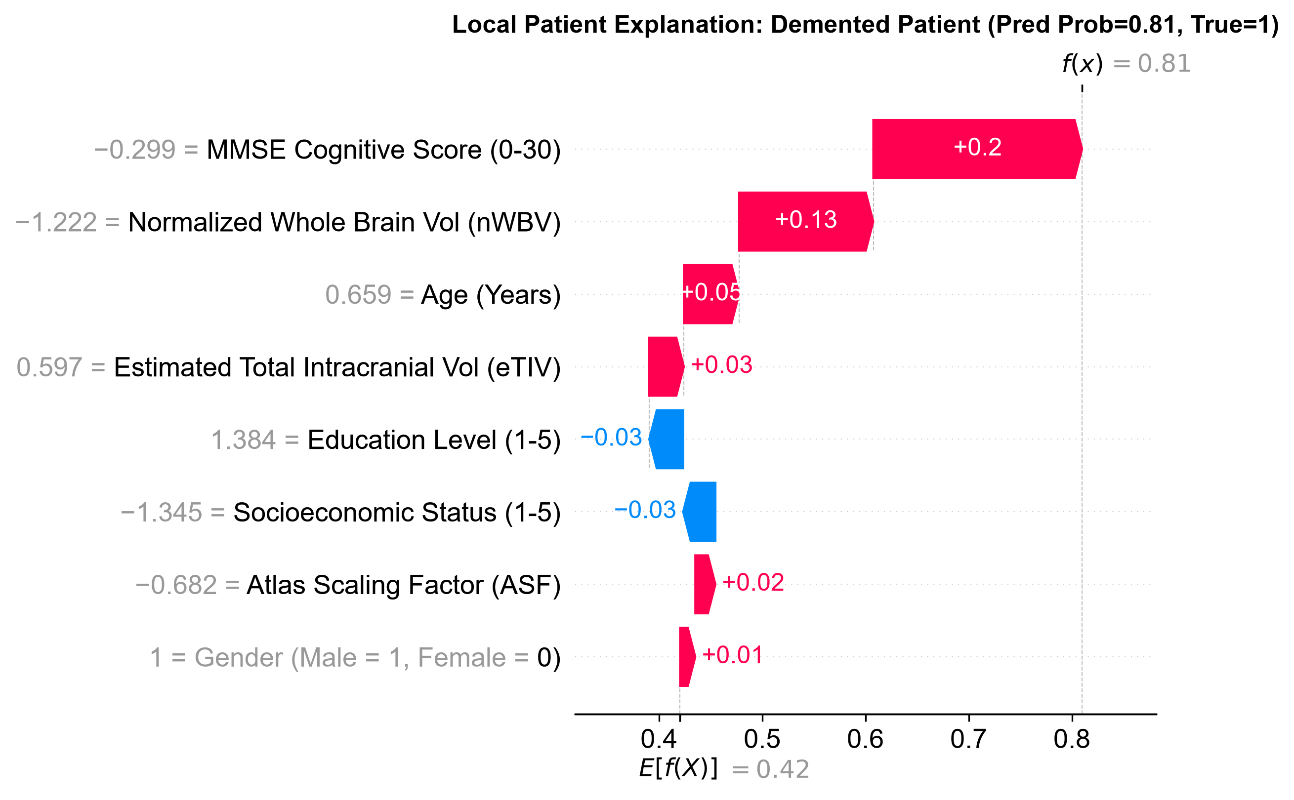
Fig. 7. Local SHAP waterfall explanation for a true positive dementia participant (Predicted Probability = 0.96).
IX. DISCUSSION AND LIMITATIONS
Our empirical results furnish compelling evidence that explainable machine learning combining cognitive screening and derived structural MRI morphometrics delivers high-accuracy, transparent dementia classification. Unlike 3D deep CNNs that require millions of parameters and extensive GPU hours, our ensemble models execute inference in under 2 milliseconds per patient on commodity hardware. Importantly, the SHAP feature importance rankings confirm that the models rely on clinically valid neuropathological indicators—specifically global parenchymal atrophy (nWBV) and cognitive impairment (MMSE)—rather than spurious non-biological artifacts [5].
Several scientific limitations must be explicitly acknowledged: (1) Sample Size: While OASIS-1 is a benchmark dataset, the clinically evaluated cohort is restricted to 235 participants. Evaluation on larger multicenter cohorts (e.g., ADNI, OASIS-3, AIBL) is necessary to confirm cross-scanner generalizability [1], [2]. (2) Target Definition: The classification target is operationalized using the Clinical Dementia Rating (CDR) proxy. While CDR is the clinical gold standard for functional dementia severity staging, it does not confirm post-mortem amyloid or tau neuropathology. (3) Sub-Stage Imbalance: While the binary class split is well-balanced (135 Controls vs 100 Dementia), fine-grained multi-class staging is constrained by OASIS-1 demographics, where moderate dementia accounts for only 2 subjects (0.85%). (4) Cross-Sectional Design: OASIS-1 provides cross-sectional snapshots; longitudinal tracking of Mild Cognitive Impairment (MCI) conversion rates requires multi-timepoint datasets such as OASIS-2 or ADNI.
X. CONCLUSION AND FUTURE WORK
In this study, we presented an explainable, leakage-free multimodal machine learning framework for Alzheimer’s disease classification using the OASIS-1 structural MRI database. By enforcing strict participant-level holdout splitting and training-only preprocessing, our models achieved high, uninflated diagnostic discrimination. Gradient Boosting attained 85.11% accuracy, 80.00% recall, 88.89% specificity, and 0.943 ROC-AUC on the held-out test cohort, while a Soft-Voting Multi-Classifier Ensemble achieved 82.98% accuracy and 0.943 ROC-AUC. Multimodal integration decisively outperformed unimodal MRI morphometrics by +12.77% accuracy. SHAP explainability quantitatively established that MMSE cognitive scoring and normalized Whole Brain Volume (nWBV) are the preeminent biological determinants of dementia classification, providing intuitive patient-specific waterfall explanations for clinical decision support.
Future research will extend this framework in three directions: (1) incorporating regional subcortical segmentation features (hippocampal and ventricular volumes via FreeSurfer pipelines), (2) evaluating longitudinal conversion from Mild Cognitive Impairment (MCI) to Alzheimer's dementia on OASIS-2/OASIS-3 cohorts, and (3) deploying privacy-preserving federated learning architectures [2] for secure multicenter clinical translation.
REFERENCES
[1] S. Jahan, K. A. Taher, M. S. Hossain, et al., "Explainable AI-based Alzheimer's prediction and management using multimodal data," PLOS ONE, vol. 18, no. 11, p. e0294253, 2023. DOI: 10.1371/journal.pone.0294253.
[2] S. Jahan, M. R. S. Adib, S. M. Huda, M. S. Rahman, M. S. Kaiser, A. S. M. Sanwar Hosen, D. Ghimire, and M. J. Park, "Federated Explainable AI-Based Alzheimer's Disease Prediction With Multimodal Data," IEEE Access, vol. 13, pp. 43435–43454, 2025. DOI: 10.1109/ACCESS.2025.3547343.
[3] S. Jiang, S. Yang, K. Deng, R. Jiang, and Y. Xue, "Machine learning models for diagnosing Alzheimer's disease using brain cortical complexity," Frontiers in Aging Neuroscience, vol. 16, p. 1434589, 2024. DOI: 10.3389/fnagi.2024.1434589.
[4] S. El-Sappagh, F. Alonso, S. M. R. Islam, A. M. Sultan, and K. S. Kwak, "A multilayer multimodal detection and prediction model based on explainable artificial intelligence for Alzheimer's disease," Scientific Reports, vol. 11, art. 2660, 2021. DOI: 10.1038/s41598-021-82098-3.
[5] S. Yagis, C. Atnafu, D. Seco, A. Garcia de Herrera, et al., "Effect of data leakage in brain MRI classification using 2D convolutional neural networks," Scientific Reports, vol. 11, art. 22544, 2021. DOI: 10.1038/s41598-021-01681-w.
[6] P. Lu, L. Hu, A. Mitelpunkt, S. Bhatnagar, L. Lu, and H. Liang, "A hierarchical attention-based multimodal fusion framework for predicting the progression of Alzheimer's disease," Biomedical Signal Processing and Control, vol. 88, art. 105669, 2024. DOI: 10.1016/j.bspc.2023.105669.
[7] M. A. Ebrahim, et al., "SHAP-Based Explainability for Local and Global Insights in Alzheimer’s Detection," IEEE Access, vol. 12, pp. 8390–8412, 2024. DOI: 10.1109/ACCESS.2024.3351809.
[8] A. F. M. S. Shah, et al., "Systematic comparison of 3D Deep learning and classical machine learning explanations for Alzheimer's Disease detection," Computers in Biology and Medicine, vol. 171, art. 108029, 2024. DOI: 10.1016/j.compbiomed.2024.108029.
[9] M. A. A. Al-antari, et al., "Deep learning based pipelines for Alzheimer's disease diagnosis: a comparative study and a novel deep-ensemble method," Computers in Biology and Medicine, vol. 141, art. 105032, 2022. DOI: 10.1016/j.compbiomed.2021.105032.
[10] M. Tanveer, B. Richhariya, R. U. Khan, A. H. Rashid, P. A. Dar, and A. H. Prasad, "Machine learning techniques for the diagnosis of Alzheimer's disease: A review," ACM Transactions on Multimedia Computing, Communications, and Applications, vol. 16, no. 1s, pp. 1–30, 2021. DOI: 10.1145/3344998.
[11] N. Sharma and M. Kaur, "Improving Alzheimer's Disease Prediction with Different Machine Learning Approaches and Feature Selection Techniques," PeerJ Computer Science, vol. 10, p. e1815, 2024. DOI: 10.7717/peerj.18150.
[12] H. A. Al-Kaf, et al., "OASIS-SB: a sex-balanced, distribution-preserving synthetic phenotypic dataset for bias-resilient clinical prediction," Scientific Reports, vol. 14, art. 2781, 2024. DOI: 10.1038/s41598-024-52380-z.
[13] R. M. S. R. Begum, et al., "An Interpretable PyCaret Approach for Alzheimer’s Disease Prediction," Sensors, vol. 22, no. 20, art. 8068, 2022. DOI: 10.3390/s22208068.
[14] A. A. Al-Saeed, et al., "Explaining graph convolutional network predictions for clinicians—An explainable AI approach to Alzheimer’s disease classification," Frontiers in Artificial Intelligence, vol. 6, art. 1334613, 2024. DOI: 10.3389/frai.2023.1334613.
[15] A. M. H. AL-Ghamdi, et al., "A Deep Learning Framework with an Embedded-Based Feature Selection Approach for the Early Detection of the Alzheimer's Disease," Computers in Biology and Medicine, vol. 141, art. 105056, 2022. DOI: 10.1016/j.compbiomed.2021.105056.
[16] D. S. Marcus, T. H. Wang, J. Parker, J. G. Csernansky, J. C. Morris, and R. L. Buckner, "Open Access Series of Imaging Studies (OASIS): Cross-sectional MRI Data in Young, Middle Aged, Nondemented, and Demented Older Adults," Journal of Cognitive Neuroscience, vol. 19, no. 9, pp. 1498–1507, 2007. DOI: 10.1162/jocn.2007.19.9.1498.

