FOOP 202, CA1 Due date: Feb 28, 2017 @ 11.59am

Create an application which lists vehicles for sale in 3 categories – Cars, Motorbikes, Vans.

The user should be able to;

* View all vehicles for sale
* Filter by All, Cars, Bikes, Vans
* Sort by Price, Mileage, Make
* View Details on each car
* Edit details on each car
* Load values from file
* Save values to file
* Delete an entry

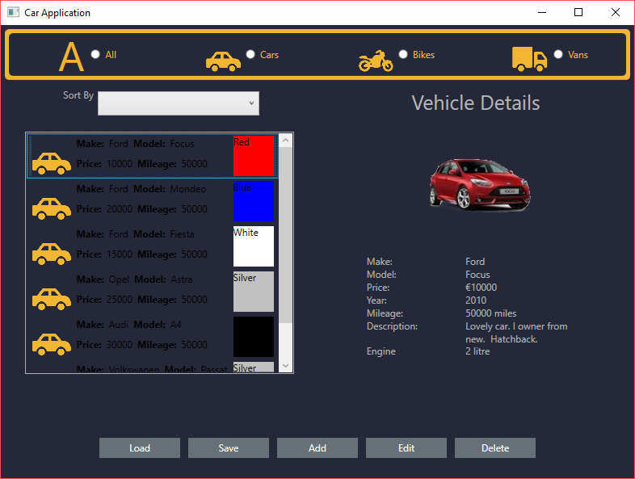

|  |  |  |  |  |  |  |  |  |  |  |  |  |  |  |  |  |  |  |  |  |  |  |  |  |  |  |  |  |  |  |  |  |  |  |  |  |  |  |  |  |  |  |  |  |  |  |  |  |  |  |  |  |  |  |  |  |  |  |  |  |  |  |  |
| --- | --- | --- | --- | --- | --- | --- | --- | --- | --- | --- | --- | --- | --- | --- | --- | --- | --- | --- | --- | --- | --- | --- | --- | --- | --- | --- | --- | --- | --- | --- | --- | --- | --- | --- | --- | --- | --- | --- | --- | --- | --- | --- | --- | --- | --- | --- | --- | --- | --- | --- | --- | --- | --- | --- | --- | --- | --- | --- | --- | --- | --- | --- | --- |
| |  |  | | --- | --- | | **Marking Scheme**  Inheritance | 5 | | Abstract class | 5 | | Abstract method | 5 | | Override | 5 | | Virtual | 5 | | Base ctor call | 5 | | Base method call | 5 | | Type Checking | 10 | | Ctor linking | 5 | | Exception Handling | 5 | | Comments/Readability | 5 | | New Window | 5 | | Add Functionality | 15 | | Edit Functionality | 15 | | Display in Listbox | 5 | | DataTemplates | 10 | | Selection Changed | 5 | | Main Window Layout/XAML | 5 | | Displaying Images | 5 | | Adding Images | 5 | | Editing Images | 5 | | Styles | 5 | | Read from File | 5 | | Write to File | 5 | | Sorting | 10 | | Filtering | 10 | | Working Code | 10 | | Additional Feature | 10 | | Colour Scheme | 10 | |  |  | |  | 200 | |  |

**Class Properties**

|  |  |  |  |
| --- | --- | --- | --- |
| **Vehicle**  Make  Model  Price  Year  Colour  Mileage  Description  Image | **Car**  BodyType – Convertible, Hatchback, Coupe, Estate, MPV, SUV, Saloon, Unlisted | **Bike**  Type – Scooter, Trail Bike, Sports, Commuter, Tourer | **Van**  Wheelbase – Short, Medium, Long, Unlisted  Type – Combi Van, Dropside, Panel Van, Pickup, Tipper, Unlisted |