OpenERP
USPS Certification & Configuration Documentation (US)
V7

Overview:-
This document was created to provide information to administrators regarding the setup and configure OpenERP required to support the use of shipping modules for USPS services.

This document will outline the following steps:
- Installation of necessary modules
- Setup/configuration requirements
- Certification with USPS

Prerequisites:-
The following modules are required:
base
sale
stock
partner_address_validation
sale_weight
shipping_api
sale_negotiated_shipping
shipping_api_usps
email_template
partner_address_zip_search_us
account_analytic_default

Basic System & Accounting setup is required to utilizing these modules including:
- Company
- Chart of Accounts/Accounts
- Account Types
- Sales Journal

Shipping API USPS(OpenERP V7.0):

A module named “shipping_api_usps” is used to track your shipping and validating perticular address through the USPS web service. USPS provides supply chain solution world wide. For this purpose they provides different web service like wise shipping API, Address Validation API and etc.

shipping_api_usps module integrates those services with OpenERP. This module
depends on the “shipping_api” module.

Installing Shipping Api USPS Module:-

In OpenERP web client go to “SETTINGS” >> “Modules” then you will find what modules are available to install. now find module name with “shipping_api_usps”. If found then install it other wise you need to download that module from web the install it on OpenERP.

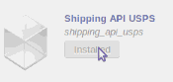

Click on the installed button for installing the Shipping API USPS. Now wait untill
process not finish. At this time all dependent module will directly install by this module.

Now as the module provides address validation so we need to generate Address
Validation Account. There are mainly 3 account types are available.

- UPS Account
- FedEx Account
- USPS Account

Configuration USPS Account:-
The user now can choose in How to get Started to request an access key from
USPS. This key is the User ID, Test URL, and Production URL are available in OpenERP.

To accomplish this the user should click on “Setting”>>”Address Validation
Account”>>”USPS Account”. Thise fields show up and required to be complated.

Below show to the USPS Account View.

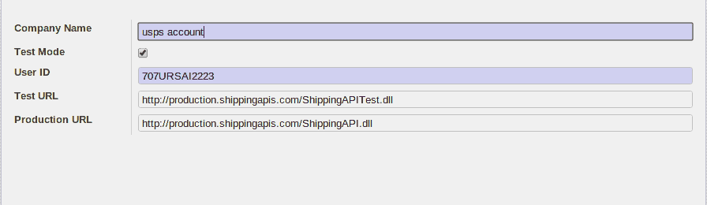

Logistics Company Configuration :-

Now that the user has obtained the correct information from USPS to setup your account within OpenERP a Logistics Account is required to be created. The user must be sure that the account within the chart of accounts used to track the shipping costs to be collected from the customer is created.

To do so you would choose Accounting>Configuration>Accounts>Accounts – and create the account with the correct account type and code.

They user now can enter the Logistics Company information by choosing “Settings”>>”Logistic Company”>>”Logistics Company” and click either Create or USPS should USPS already be created. A form view appears with configuration required.

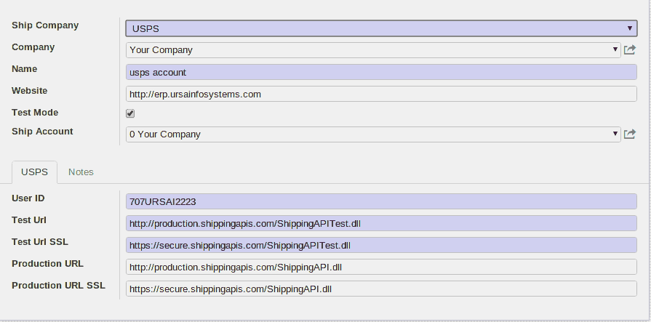

While testing please be sure to click the Test Mode checkbox.

Company Configuration :-

After you have setup a Company in your database, go to the Menu: “Settings” > “Companies” > “Companies” and select your Company. This is the form view of company configuration and allows for many areas of configuration per company. The user will see Tabs within the form view of companies.

By choosing the Configuration tab the user can add/modify/delete the Shipping information configured for that particular company.

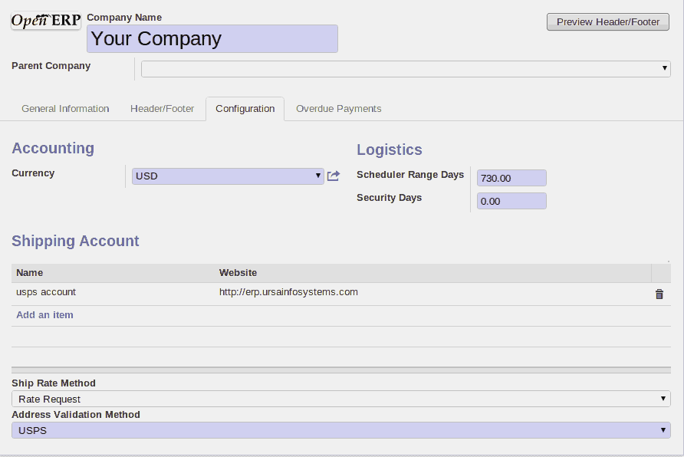
Hare to configura a shipping account,Ship Rate Method and Address Validation Method.

Ship Rate Method
The ship rate method is important when choosing what service the user would like to utilize with the Shipping Company (USPS). There are two options
- Rate Card – Utilizes Sale_Negotiate_Shipping and requires additional configuration. Basically Rate Card are specific rate negotiated for certain modes, lanes, etc.
- Rate Request – Instant call to USPS for a calculated rate

Sale Order:-

Now while generating a new sales order from “Sales” -> “Sales” -> “Sales Orders”. The button named “Validate Address” will validate entered address.

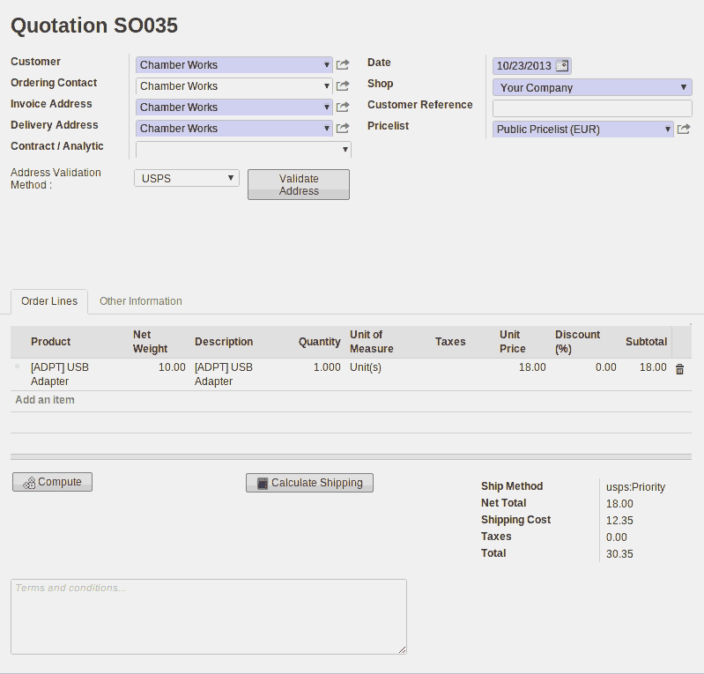

After filling all require field in above form just click on the “Validate Address” button. After clicking it will show relavent address and if not valid address then it will show whatever error or warning.

Here the “compute” button compute unit price and store it value Net Total and Total field.

When you click a “Calculate Shipping” button here below Shipping Rate Wizard will open. Here when you select “Rate Request” The USPS tab open and there you add a Services Type, Package Location, Container and then press “Get Rate” button the wizard will close and shipping rate automaticaly added shipping cost field in the sale order form.

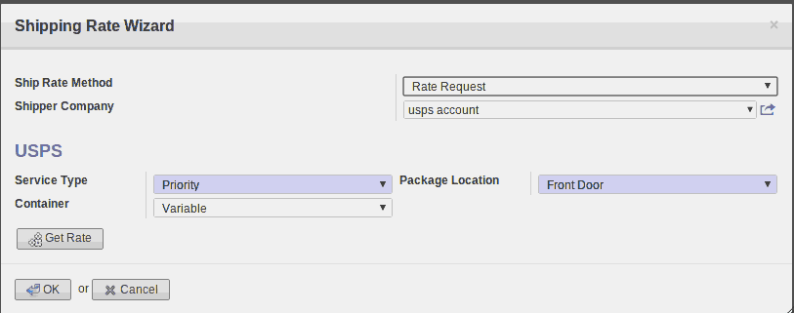

Other Information Tab.

In Other Information form tab there are some fields need to fill up. The form and fields are shown in following image.

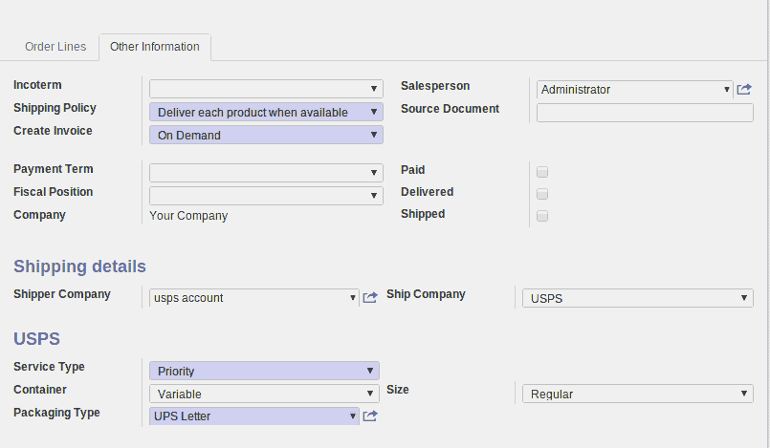
Hare the Service Type, Container, Size fields by default added in sale order.

Descreption:-

Incoterm :- International Commercial terms are a series of predefined commercial terms
used in international transactions.
Shipping Policy :- Pick 'Deliver each product when available' if you allow partial delivery.

Delivery Order:-

Now while generating a new delivery order from “Warehouse” -> “Receive/Deliver By Orders” -> “Delivery Orders”.

The shipping tab will only invisible after draft and cancel state.

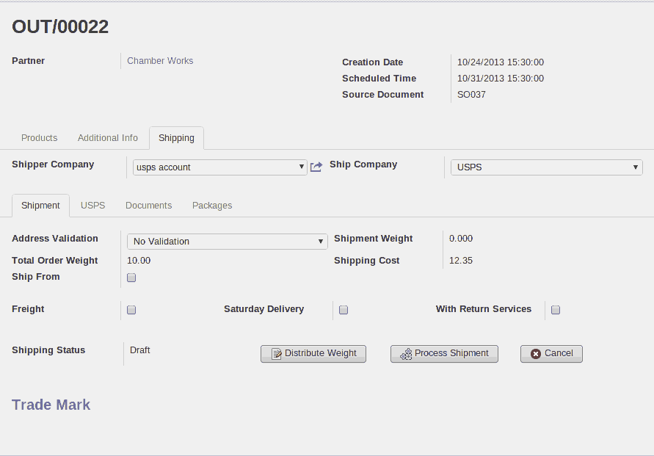

Description of fields

Shipper Company:- Name of the logistics company providing the shipper account.
Freight:- Indicates if the shipment is a freight shipment.
Saturday Delivery:- Indicates is it appropriate to send delivery on Saturday.
With Return Services:- Include return shipping information in the package.
Total Shippement Weight:- Add the total weight of the packages in the packages table.

USPS Tab :-

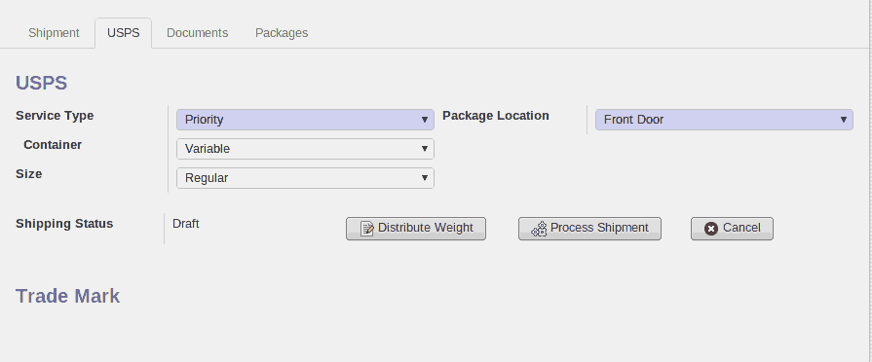

Descreption :-
Service Type :- At the Postal Service™, we have a variety of convenient mailing services for ..... to be delivered as First-Class-type mail by the destination postal administration.

Container :- The new USPS API introduced a bunch of new container types which aren't fully supported by the code yet. We had to switch to the new API ...

Package Location :- Looking for a USPS Post Office location....

Document Tab :-

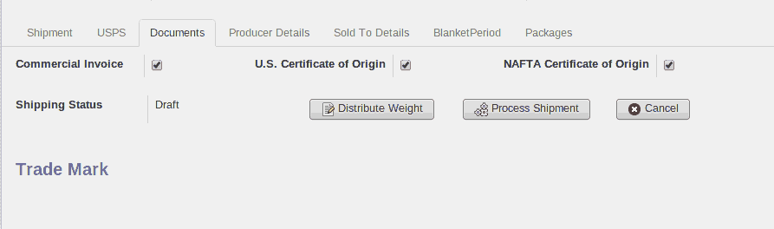
Description :-

NAFTA Certificate of Origin :- This is a boolean field and you active this field the new two tab open the Producer Details and BlanketPeriod.

Producer Details Tab :-

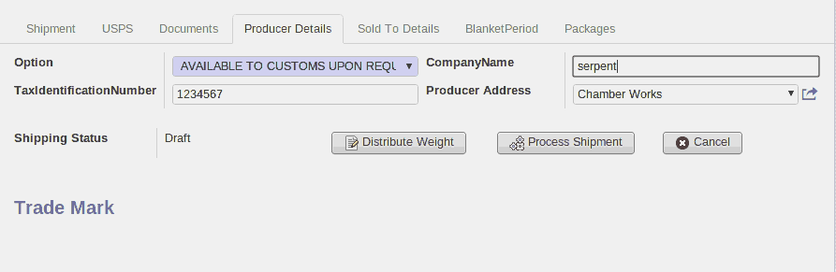

Description :-
Company Name:- Only applicable when producer option is empty or not present.
Option :- Here the option field is required.

Sold To Detail Tab :-

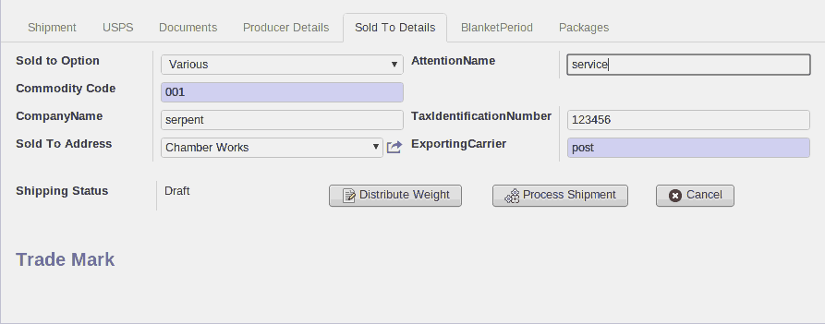
Description:-
Here we have some required field like Sold To Option,Commodity Code and ExportingCarrier.

Blanket Period Tab :-

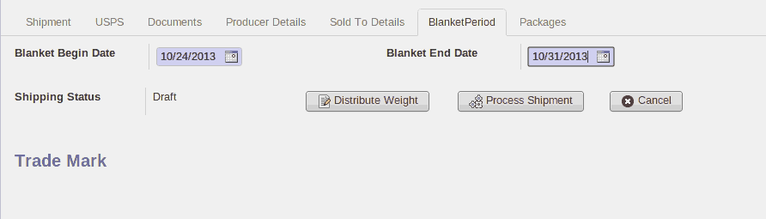
Description:-
:- Here the Begin Date and End Date is required.

Package Tab :-

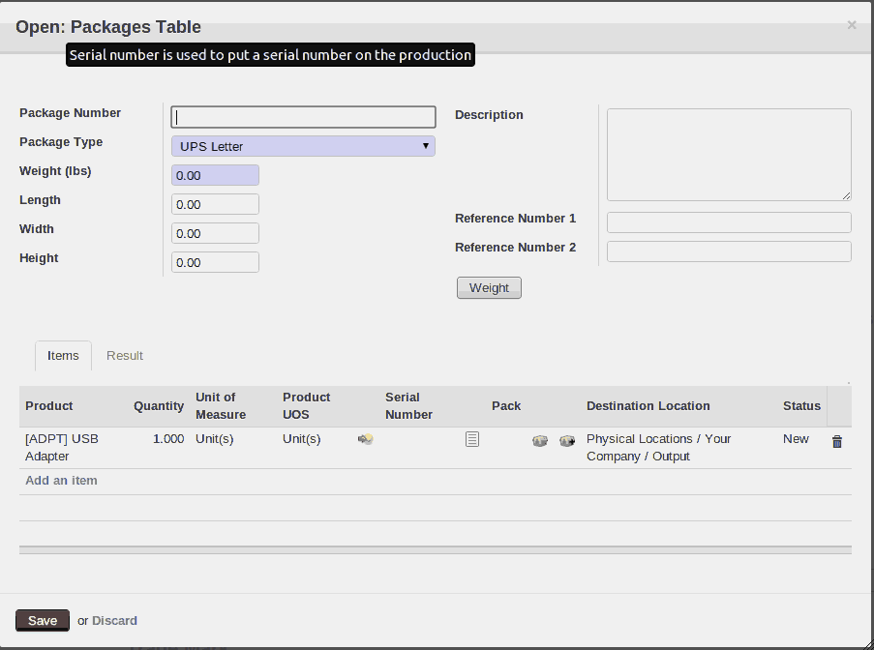
:- Hare item tab one2many field value automatically fill up from move line.

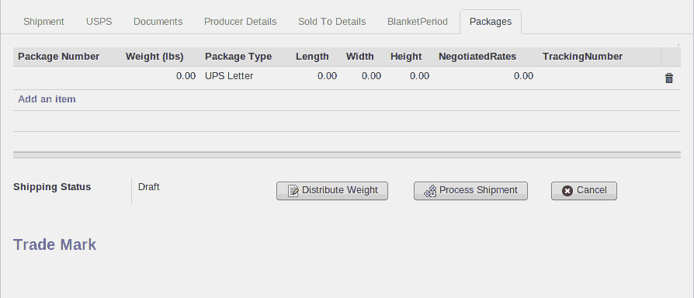
Description:- Inside a packages one2many field package type and weight field are required in which you can add multiple packages.

Process Shipment Button:-process shipment button use in our module to request and responce the USPS.

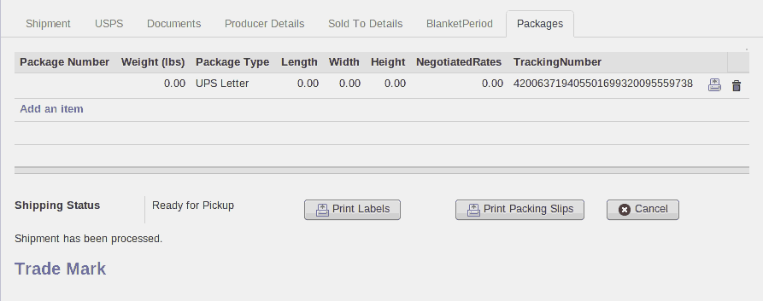
:- When your Shippement process will successfully done here the “TrackingNumber” will
automaticaly added and “Print Labels”,”Print Packing Slips” button will open. And
your Shipment has been processed message store in the Ship_message field.

:- Below the Print Labels report this report sent by usps_api when shipment process will done.

:- Below report gives some information about tracking number,usps labels
and others information.

