CCA and LDA Pick 10 questions, 1 pts per question

LDA classification

True or false: Linear Discriminant Analysis is a classification algorithm.

True

Correct Answer

False

Maximum correlation

Eigendecomposition is used to perform CCA on data stored in two matrices, X and Y. The diagonal eigenvalues matrix comes out to be matrix S. Given this information, what is the absolute value of the maximum canonical correlation between X and Y?

LaTeX: S = \begin{bmatrix}

4 & 0 \\

0 & 2

\end{bmatrix}S = [ 4 0 0 2 ]

Correct Answer

2

4

0

1.41

Wrong dimensions

Given a matrix X consisting of 300 samples across 10 dimensions and a matrix Y consisting of 250 samples across 10 dimensions, how many basis vectors can be extracted for matrix X using CCA?

Correct Answer

CCA cannot be applied to these two matrices

10

250

300

CCA and noise

In which of the following situations would CCA successfully extract a target signal from noise?

Correct Answer

When only the target signal is correlated between the two views

When nothing is correlated between the two views

When only the noise is correlated between the two views

When both the noise and the target signal are correlated between the two views

PCA decorrelation

PCA diagonalizes which of the following covariance matrices? (Select all that apply)

LaTeX: C = E\left( \begin{bmatrix} X \\ Y \end{bmatrix} \begin{bmatrix} X \\ Y \end{bmatrix} ^ \top \right) = \begin{bmatrix} C_{xx} & C_{xy} \\ C_{yx} & C_{yy} \end{bmatrix}C = E ( [ X Y ] [ X Y ] ⊤ ) = [ C x x C x y C y x C y y ]

Correct Answer

LaTeX: CC

Correct Answer

LaTeX: C_{xx}C x x

Correct Answer

LaTeX: C_{yy}C y y

LaTeX: C_{xy}C x y

LaTeX: C_{yx}C y x

Basis dimension

You are given matrix LaTeX: YY of dimension LaTeX: 3\times 15003 × 1500 that represents one view for a CCA problem. In order for CCA to work, what must the dimension of each basis vector be for the other view, LaTeX: XX?

Correct Answer

Not enough information is provided to answer this question

LaTeX: 1500\times 11500 × 1

LaTeX: 3\times 13 × 1

LaTeX: 3\times 15003 × 1500

Variate dimension

You are given matrix LaTeX: YY of dimension LaTeX: 3\times 15003 × 1500 that represents one view for a CCA problem. In order for CCA to work, what must the dimension of each canonical variate be for the other view, LaTeX: XX?

Correct Answer

LaTeX: 1500\times 11500 × 1

LaTeX: 1500\times 31500 × 3

LaTeX: 3\times 15003 × 1500

Not enough information is provided to answer this question

Between-class scatter

You are given 200 data points which are split evenly into two classes. You find that the centroids of the two classes are as follows:

LaTeX: m_1 = \begin{bmatrix}0.4910 \\0.5132 \\0.5027\end{bmatrix}m 1 = [ 0.4910 0.5132 0.5027 ] LaTeX: m_2 = \begin{bmatrix}0.4765 \\0.4794 \\0.5461\end{bmatrix}m 2 = [ 0.4765 0.4794 0.5461 ]

What is the between-class scatter LaTeX: S_BS B for these two classes?

Correct Answer

LaTeX: S_B = \begin{bmatrix}

0.0106 & 0.0246 & -0.0315 \\

0.0246 & 0.0574 & -0.0735 \\

-0.0315 & -0.0735 & 0.0941

\end{bmatrix}S B = [ 0.0106 0.0246 − 0.0315 0.0246 0.0574 − 0.0735 − 0.0315 − 0.0735 0.0941 ]

LaTeX: S_B = \begin{bmatrix}

0.0001 & 0.0002 & -0.0003 \\

0.0002 & 0.0006 & -0.0007 \\

-0.0003 & -0.0007 & 0.0009

\end{bmatrix}S B = [ 0.0001 0.0002 − 0.0003 0.0002 0.0006 − 0.0007 − 0.0003 − 0.0007 0.0009 ]

LaTeX: S_B = \begin{bmatrix}

0.0053 & 0.0123 & -0.0158 \\

0.0123 & 0.0287 & -0.0367 \\

-0.0158 & -0.0367 & 0.0470

\end{bmatrix}S B = [ 0.0053 0.0123 − 0.0158 0.0123 0.0287 − 0.0367 − 0.0158 − 0.0367 0.0470 ]

LaTeX: S_B = \begin{bmatrix}

-0.0053 & -0.0123 & 0.0158 \\

-0.0123 & -0.0287 & 0.0367 \\

0.0158 & 0.0367 & -0.0470

\end{bmatrix}S B = [ − 0.0053 − 0.0123 0.0158 − 0.0123 − 0.0287 0.0367 0.0158 0.0367 − 0.0470 ]

Lagrange multipliers

In the derivation of CCA shown in class, we showed that the Lagrange multipliers were equal to which of the following?

Correct Answer

Canonical correlation

Canonical variate

Basis for view X

Basis for view Y

Covariance space

The following matrix is the cross-covariance of two variables, LaTeX: XX and LaTeX: YY. How many canonical correlations will be found if CCA is applied to LaTeX: XX and LaTeX: YY?

LaTeX: \begin{bmatrix}-0.1883 & -0.2032 \\-0.1613 & -0.1892 \\-0.1290 & -0.1717\end{bmatrix}[ − 0.1883 − 0.2032 − 0.1613 − 0.1892 − 0.1290 − 0.1717 ]

Correct Answer

2

1

3

6

Orthogonality

Which of the following is a true statement about the bases and variates of views LaTeX: XX and LaTeX: YY found by CCA? (Numbers in the subscript indicate bases or variates from different sets.)

Correct Answer

Bases LaTeX: w_{x1}w x 1 and LaTeX: w_{y2}w y 2 are NOT constrained to be orthogonal

Canonical variates LaTeX: x_1x 1 and LaTeX: y_1y 1 are constrained to be orthogonal

Canonical variates LaTeX: x_1x 1 and LaTeX: x_2x 2 are NOT constrained to be orthogonal

Bases LaTeX: w_{x1}w x 1 and LaTeX: w_{y2}w y 2 are constrained to be orthogonal

Satellite

A satellite communicates with two satellite stations simultaneously, as depicted in the following image. Station 1 has three receiver dishes and station 2 has two dishes. CCA is performed on the five signals received by the two stations, where each station corresponds to a view. What is the maximum number of bases CCA can find for station 1?

sat_2_3.png

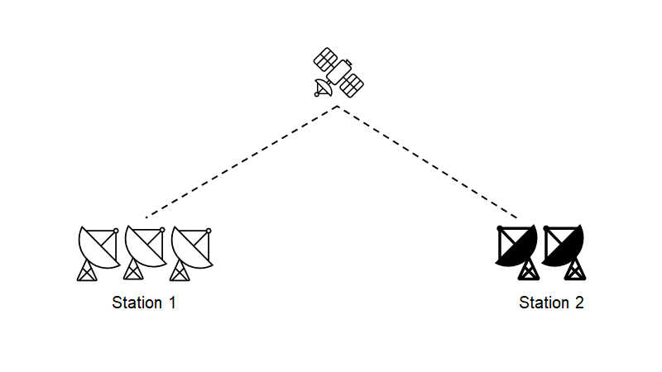

Correct Answer

2

3

1

CCA cannot be performed when the two views have different dimensions

LDA trivia

Which of the following is True about LDA?

Correct Answer

LDA is a specific case of CCA

LDA is a unconstrained optimization problem

LDA does not make any assumption about class distributions

All options are true

CCA vs. PCA

Which of following statements about PCA and CCA are true?

1. PCA is unsupervised

2. CCA is supervised

3. PCA captures the direction of greatest variance

4. CCA finds subspaces onto which two views, X and Y, are projected such that their correlation is maximized

Correct Answer

all of them

1 and 3

2 and 3

1 and 4

CCA and LDA

Which of the following statements is/are true:

1. CCA decorrelates variables from individual views

2. LDA computes a direction maximizing the ratio of between-class variance over within-class variance

3. CCA can be seen as a particular case of LDA

Correct Answer

1 and 2

2 and 3

1 and 3

Only 1

CCA decorrelation

CCA diagonalizes which of the following covariance matrices? (Select all that apply)

LaTeX: C = E\left( \begin{bmatrix} X \\ Y \end{bmatrix} \begin{bmatrix} X \\ Y \end{bmatrix} ^ \top \right) = \begin{bmatrix} C_{xx} & C_{xy} \\ C_{yx} & C_{yy} \end{bmatrix}C = E ( [ X Y ] [ X Y ] ⊤ ) = [ C x x C x y C y x C y y ]

LaTeX: CC

Correct Answer

LaTeX: C_{xx}C x x

Correct Answer

LaTeX: C_{yy}C y y

LaTeX: C_{xy}C x y

LaTeX: C_{yx}C y x

CCA trivia

Which of the following statements is/are true?

1. In CCA the auto-covariance matrices from both views must be invertible

2. CCA can be solved by computing eigenvectors from the cross-covariance matrix between both views

3. CCA finds the subspaces such that the correlation between projected views is minimized

Correct Answer

1 only

2 and 3

1 and 3

All of them