HMM Pick 10 questions, 1 pts per question

Markov Chains

Which of the following statements are true?

A Markov model embodies the Markov assumption on the probabilities of a sequence, that when predicting the future, the past doesn’t matter, only the present.

Second-order Hidden Markov Models follow the Markov assumption.

Markov Chain outputs a sequence of states that the process did go through

Correct Answer

1,3

1,2

3

1, 2 and 3

Forward Algorithm

Which of the following is INCORRECT?

Forward algorithm speeds up the computation by avoiding solving the same sub-problem twice

Trellis is a graphical representation of all possible paths through the HMM to produce a given observation

LaTeX: \alpha\left(s,t\right)α ( s , t ) is the probability of an observation at state LaTeX: ss and time LaTeX: tt

The probability of an observation is the sum of LaTeX: \alpha\left(s,t\right)α ( s , t ) over all states LaTeX: ss, where LaTeX: TT is the last time step

Correct Answer

3

1 and 3

1 and 2

4

Forward & Backward

Which of the following statements are true?

1. A trellis is a graph that shows the set of all possible state sequences through an HMM in a set of time instants.

2. A problem with the Viterbi path is that it does not tell you a posterior confidence for any of its hidden state inferences, which can be a problem if many paths had almost as high probability.

3. The Baum-Welch algorithm or Forward-Backward algorithm is special case of the Expectation Maximization (EM) algorithm, that finds the global optimum parameters of an HMM.

Correct Answer

1 and 2

1 and 3

2 and 3

1, 2 and 3

Weather-Transition

The MLSP teaching assistants work in a lab without windows as they are all allergic to the ultraviolet rays from the sun. Since they are in the lab, they can't observe the weather directly and need to know if the weather is not sunny so they can leave the lab. However, they can observe Professor Bhiksha who visits them every day. What they see is whether he brings an umbrella along, or whether he wears a coat or a cap.

Suppose the weather can either be sunny or rainy. The teaching assistants create a model to guess the weather on any given day. Let LaTeX: W\left(t\right)W ( t ) be the state of day LaTeX: tt and LaTeX: O\left(t\right)O ( t ) be professor Bhiskha's appearance on day LaTeX: tt.

We know that for day 1, LaTeX: \text{P(W(1) = sunny) = 1}P(W(1) = sunny) = 1 and LaTeX: \text{P(W(1) = rainy) = 0}P(W(1) = rainy) = 0. These are the initial probabilities. We also know that LaTeX: P\left(O\left(1\right)=cap\right)=0.6P ( O ( 1 ) = c a p ) = 0.6. The transition probabilities and the emission probabilities are given below.

weather_markov_chain.png

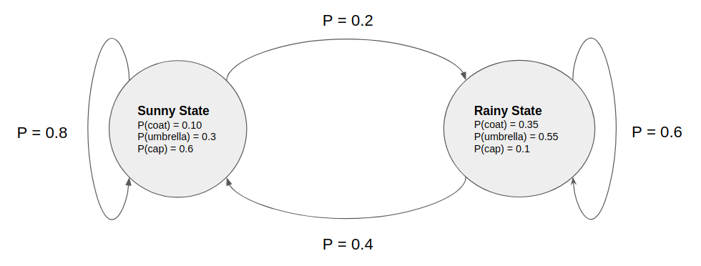

What is LaTeX: P\left(W\left(2\right)=rainy\right)P ( W ( 2 ) = r a i n y )? Round your answer to two decimal places.

Correct Answers

0.2 (with margin: 0)

Weather-State

The MLSP teaching assistants work in a lab without windows as they are all allergic to the ultraviolet rays from the sun. Since they are in the lab, they can't observe the weather directly and need to know if the weather is not sunny so they can leave the lab. However, they can observe Professor Bhiksha who visits them every day. What they see is whether he brings an umbrella along, or whether he wears a coat or a cap.

Suppose the weather can either be sunny or rainy. The teaching assistants create a model to guess the weather on any given day. Let LaTeX: W\left(t\right)W ( t ) be the state of day LaTeX: tt and LaTeX: O\left(t\right)O ( t ) be professor Bhiskha's appearance on day LaTeX: tt.

We know that for day 1, LaTeX: \text{P(W(1) = sunny) = 1}P(W(1) = sunny) = 1 and LaTeX: \text{P(W(1) = rainy) = 0}P(W(1) = rainy) = 0. These are the initial probabilities. We also know that LaTeX: P\left(O\left(1\right)=cap\right)=0.6P ( O ( 1 ) = c a p ) = 0.6. The transition probabilities and the emission probabilities are given below.

weather_markov_chain.png



What is LaTeX: P\left(O\left(2\right)=umbrella\right)P ( O ( 2 ) = u m b r e l l a )? Round your answer to two decimal places.

Correct Answers

0.35 (with margin: 0)

HMM assumptions

Which of the following is CORRECT?

HMMs are exceptionally good in modeling long term dependencies (Hint: what assumptions are made by HMMs?)

Given a lot of training examples, Viterbi segmentation is favorable during training

The markovian assumption made by HMMs is favorable since it reduces the number of parameters that need to be learned

Correct Answer

2 and 3

1 and 3

2

1

Applications of HMM

In which of the following problems would it be appropriate to use an HMM?

Correct Answer

Stock prediction

Correct Answer

Weather forecasting

Correct Answer

Optical Character Recognition

Correct Answer

Automatic Speech Recognition

Correct Answer

Genome Segmentation

Correct Answer

Facial expression identification from videos

Number of states

When learning an HMM for a fixed set of observations, assume we do not know the true number of hidden states (which is often the case), it is not possible to increase the training data likelihood by increasing the number of hidden states.

True

Correct Answer

False

Weather - Observation

The MLSP teaching assistants work in a lab without windows as they are all allergic to the ultraviolet rays from the sun. Since they are in the lab, they can't observe the weather directly and need to know if the weather is not sunny so they can leave the lab. However, they can observe Professor Bhiksha who visits them every day. What they see is whether he brings an umbrella along, or whether he wears a coat or a cap.

Suppose the weather can either be sunny or rainy. The teaching assistants create a model to guess the weather on any given day. Let LaTeX: W\left(t\right)W ( t ) be the state of day LaTeX: tt and LaTeX: O\left(t\right)O ( t ) be professor Bhiskha's appearance on day LaTeX: tt.

We know that for day 1, LaTeX: \text{P(W(1) = sunny) = 1}P(W(1) = sunny) = 1 and LaTeX: \text{P(W(1) = rainy) = 0}P(W(1) = rainy) = 0. These are the initial probabilities. We also know that LaTeX: P\left(O\left(1\right)=cap\right)=0.6P ( O ( 1 ) = c a p ) = 0.6. The transition probabilities and the emission probabilities are given below.

weather_markov_chain.png



What is LaTeX: P\left(W\left(2\right)=rainy\mid O\left(2\right)=coat\right)P ( W ( 2 ) = r a i n y ∣ O ( 2 ) = c o a t )? Round your answer to two decimal places.

Correct Answers

0.47 (with margin: 0)

HMM Assumptions

Which of the following statements are true about Hidden Markov Models (HMM)?

An HMM consists of two components: A state/transition backbone that specifies how many states there are, and how they can follow one another; a set of probability distributions, one for all states, which specify the distribution of all vectors in that state.

The state of the process at any time instant depends only on the state at the previous instant (causality, Markovian).

The actual state of the process is directly observable.

Correct Answer

2

1,2 and 3

1 and 2

3

Most probable sequence

The MLSP teaching assistants like to watch cable TV while working in the lab. The cable TV has the tendency to stop working whenever it is raining or snowing outside. Suppose they can't observe the weather directly since the lab has no windows, but they can observe that the cable TV stopped working.

They modeled the problem using an HMM with the following configurations:

LaTeX: P\left(Rainy\:\longrightarrow\:Snowy\right)\:=\:0.3P ( R a i n y ⟶ S n o w y ) = 0.3

LaTeX: P\left(Rainy\longrightarrow Rainy\right)\:=\:0.7P ( R a i n y ⟶ R a i n y ) = 0.7

LaTeX: P\left(Snowy\:\rightarrow\:Rainy\right)\:=\:0.6P ( S n o w y → R a i n y ) = 0.6

LaTeX: P\left(Snowy\:\rightarrow Snowy\:\right)\:=\:0.4P ( S n o w y → S n o w y ) = 0.4

LaTeX: P\left(TV\:Working\:\mid Snowy\right)=0.8P ( T V W o r k i n g ∣ S n o w y ) = 0.8

LaTeX: P\left(TV\:Not\:Working\mid Snowy\right)=0.2P ( T V N o t W o r k i n g ∣ S n o w y ) = 0.2

LaTeX: P\left(TV\:Working\mid Rainy\right)=0.1P ( T V W o r k i n g ∣ R a i n y ) = 0.1

LaTeX: P\left(TV\:Not\:Working\mid Rainy\right)=0.9P ( T V N o t W o r k i n g ∣ R a i n y ) = 0.9

LaTeX: P\left(Start\:\rightarrow\:Snowy\right)=0.3P ( S t a r t → S n o w y ) = 0.3

LaTeX: P\left(Start\:\rightarrow\:Rainy\right)\:=\:0.7P ( S t a r t → R a i n y ) = 0.7

What would be the most probable weather sequence for the observation sequence LaTeX: \left(TV\:Working,\:TV\:Not\:Working\right)( T V W o r k i n g , T V N o t W o r k i n g )?

Correct Answer

(Snowy, Rainy)

(Rainy, Snowy)

(Rainy, Rainy)

(Snowy, Snowy)

Parameters during training

If any of the start probabilities or transition probabilities are initially set to zero, then those elements will remain zero in all subsequent updates of the EM algorithm.

Correct Answer

True

False