ICA Questions Pick 10 questions, 1 pts per question

PCA Properties

Select properties of PCA from the following:

It can be used for compression.

PCA removes correlations. It does not remove higher order dependencies.

PCA removes correlations. It also removes higher order dependencies.

PCA yields components that have different levels of importance in explaining the data.

All of the components that PCA obtains are equally important in explaining the data.

Correct Answer

1

Correct Answer

2

Correct Answer

4

3

5

General ICA Goals

Which of the following statements are true:

ICA finds independent bases to represent the data.

ICA gives us decorrelated components.

In determining the bases in ICA, we impose a hard constraint of orthogonality.

Correct Answer

1

Correct Answer

2

3

None of the statements are true.

Limitations of ICA

Select the limitations of ICA as we covered it in lecture.

ICA will determine the mixing matrix and the sources up to a scaling factor.

ICA will determine the mixing matrix and the sources up to a plus or minus sign.

ICA will find strictly orthogonal bases.

ICA will determine the sources without any notion of their order or importance.

Correct Answer

1

Correct Answer

2

Correct Answer

4

3

None of the statements are limitations of ICA.

Independence Justification

In the cocktail party problem that we studied in lecture, the independence of sources is a reasonable assertion, as speakers are likely to talk over one another frequently.

Correct Answer

True

False

Orthogonal Transformation of Gaussian

You are given data, LaTeX: XX, sampled from a multivariate normal distribution with two dimensions (i.e., LaTeX: X \sim N(0, I_2)X ∼ N ( 0 , I 2 )). Let LaTeX: AA be a rotation matrix that rotates data on the x-y plane by 13 degrees counter-clockwise. We are interested in the mean and covariance of the resulting distribution, LaTeX: XAX A. Please select the resulting distribution's mean and covariance matrix, LaTeX: \muμ and LaTeX: \SigmaΣ.

Correct Answer

LaTeX: \mu = 0μ = 0 and LaTeX: \Sigma = I_2Σ = I 2

LaTeX: \mu = 0μ = 0 and LaTeX: \Sigma = \begin{bmatrix}

0.97 & -0.22 \\

0.22 & 0.97 \\

\end{bmatrix}.Σ = [ 0.97 − 0.22 0.22 0.97 ] .

LaTeX: \mu = 0μ = 0 and LaTeX: \Sigma = \begin{bmatrix}

-0.97 & 0.22 \\

-0.22 & -0.97 \\

\end{bmatrix}.Σ = [ − 0.97 0.22 − 0.22 − 0.97 ] .

Non-Orthogonal Transformation of Gaussian

You are given data, LaTeX: XX, sampled from a multivariate normal distribution with two dimensions (i.e., LaTeX: X \sim N(0, I_2)X ∼ N ( 0 , I 2 )). Define a matrix LaTeX: AA such that:

LaTeX: A = \begin{bmatrix}

3 & 0 \\

0 & 1 \\

\end{bmatrix}.A = [ 3 0 0 1 ] .

True or false: the resulting distribution LaTeX: XAX A will have the exact same distribution as LaTeX: XX.

True

Correct Answer

False

Central Limit Theorem

You are given a set of independent random variables, LaTeX: \{X_1, X_2, \dots, X_N\}{ X 1 , X 2 , … , X N }. Each random variable is sampled from the same uniform distribution. Consider the absolute value of the kurtosis of one of the random variables (e.g., LaTeX: a = |\textrm{Kurt}(X_2)|a = | Kurt ( X 2 ) |). Also, please consider the absolute value of the kurtosis of the sum of all the random variables, LaTeX: b = |\textrm{Kurt}(\Sigma_i X_i)|b = | Kurt ( Σ i X i ) |. Using the intuition explained in class, select the true statement from the following options:

Correct Answer

a > b

b > a

a = 0

b = N

One-Hot Z

In lecture, we defined the vector LaTeX: zz such that LaTeX: y = z^T sy = z T s. We did this in order to find a way to make LaTeX: yy be equal to one of the independent sources. Consider the case in which we have four independent sources, LaTeX: s = [s_1, s_2, s_3, s_4]^Ts = [ s 1 , s 2 , s 3 , s 4 ] T. If we want LaTeX: yy to equal LaTeX: s_2s 2, select the correct value of LaTeX: zz below:

Correct Answer

LaTeX: z^T = [0, 1, 0, 0]z T = [ 0 , 1 , 0 , 0 ]

LaTeX: z^T = [1, 1, 0, 0]z T = [ 1 , 1 , 0 , 0 ]

LaTeX: z^T = [1, 1, 1, 1]z T = [ 1 , 1 , 1 , 1 ]

LaTeX: z^T = [0, 0, 1, 0]z T = [ 0 , 0 , 1 , 0 ]

Negative Kurtosis

In theory, kurtosis can be negative, therefore, a common technique in optimizing kurtosis is to consider its absolute value.

Correct Answer

True

False

Negative Negentropy

In theory, negentropy can be negative, therefore, a common technique in optimizing negentropy is to consider its absolute value.

True

Correct Answer

False

Resilience of Kurtosis

Kurtosis is robust to small datasets; however, it is computationally expensive. Therefore, it is rarely used as a robust measure of Gaussianity.

True

Correct Answer

False

Higher Entropy

Below are two distributions. Using entropy as defined in lecture, select which distribution has the higher entropy. Please note, Distribution 1 and Distribution 2 are both defined to have the same variance. We will not be sharing the parameters of the distributions, besides the fact that they have equal variances. You are encouraged to use your intuition and make reasonable assumptions about the distributions.

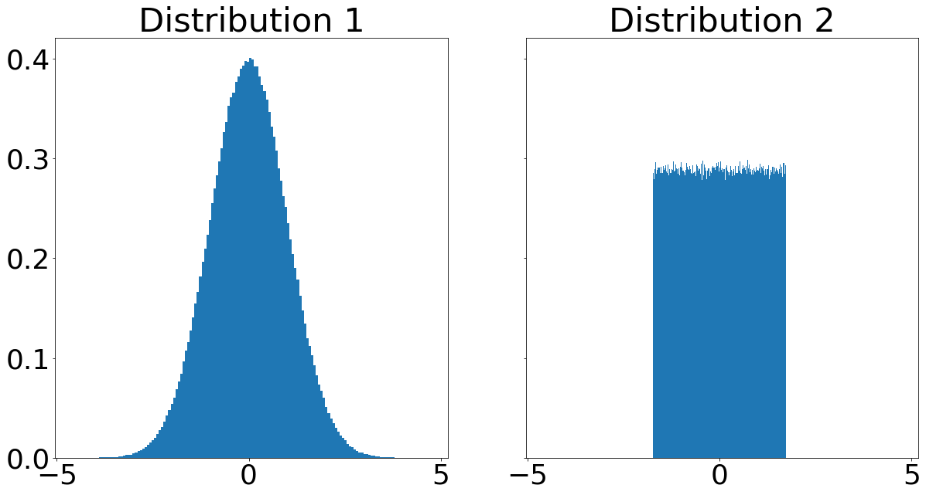

Correct Answer

Distribution 1

Distribution 2

FOBI Goals

Fourth Order Blind Identification (FOBI) seeks to find an unmixing matrix LaTeX: WW such that the sources have which of the following properties? Please allow the vector LaTeX: ss to have as many components as needed for the option to make sense.

Correct Answer

LaTeX: E[s_1s_2s_3s_4] = E[s_1]E[s_2]E[s_3]E[s_4]E [ s 1 s 2 s 3 s 4 ] = E [ s 1 ] E [ s 2 ] E [ s 3 ] E [ s 4 ]

LaTeX: E[s_1s_2] = E[s_1]E[s_2]E [ s 1 s 2 ] = E [ s 1 ] E [ s 2 ]

LaTeX: E[s_1s_2s_3s_4s_5s_6] = E[s_1]E[s_2]E[s_3]E[s_4]E[s_5]E[s_6]E [ s 1 s 2 s 3 s 4 s 5 s 6 ] = E [ s 1 ] E [ s 2 ] E [ s 3 ] E [ s 4 ] E [ s 5 ] E [ s 6 ]

That all moments of the sources are decoupled (i.e., that LaTeX: E[s_1s_2 \ \cdots \ s_N] = E[s_1]E[s_2] \ \cdots \ E[s_N]E [ s 1 s 2 ⋯ s N ] = E [ s 1 ] E [ s 2 ] ⋯ E [ s N ] for any N).

FOBI First Step

Given a data container LaTeX: XX, the first step of FOBI is to use PCA or a similar technique on LaTeX: XX to obtain a whitened version of the data.

Correct Answer

True

False

Weighted Correlation

We created a matrix, LaTeX: D_SD S, and used it to do a number of important things in our FOBI derivation. Please select the true statements about LaTeX: D_SD S.

Correct Answer

LaTeX: D_SD S acted as an indicator of independence for the rows of LaTeX: SS

Correct Answer

We found that LaTeX: D_SD S is just a transformed version of LaTeX: D_XD X

Correct Answer

LaTeX: D_SD S is called the weighted correlation matrix.

We utilized the fact that LaTeX: D_SD S is orthogonal several times.

Higher Kurtosis

Below are two distributions. Using kurtosis as defined in lecture, select which distribution has the higher absolute value of kurtosis. Please note, we are not supplying the parameters of these distributions. You are encouraged to use your intuition and make reasonable assumptions about the distributions.

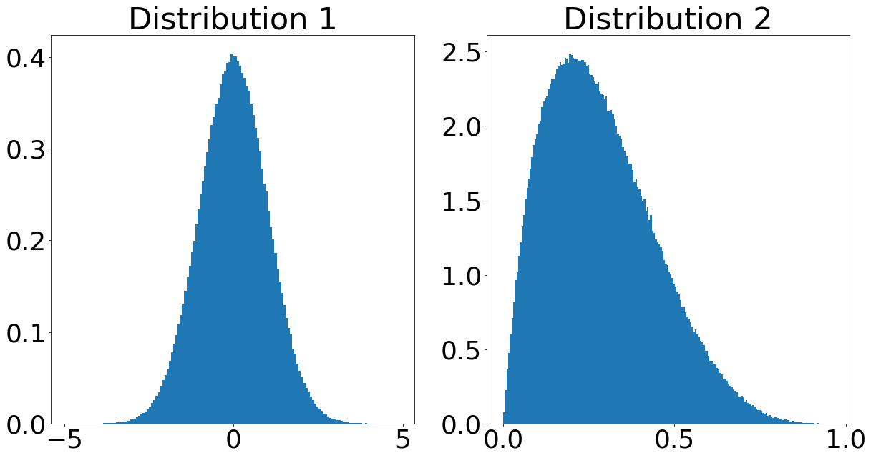

Correct Answer

Distribution 2

Distribution 1

Higher Negentropy

Below are two distributions. Using negentropy as defined in lecture, select which distribution has the higher negentropy. Note, we are not supplying the parameters of these distributions. You are encouraged to use your intuition and make reasonable assumptions about the distributions.



Correct Answer

Distribution 2

Distribution 1

Gaussian Sources and Orthogonal Transformations

Suppose that we have a jointly Gaussian source vector LaTeX: ss. Further suppose that we have somehow estimated a mixing matrix LaTeX: AA. Let LaTeX: BB be an orthogonal matrix. What other matrices are valid mixing matrix for our model LaTeX: x = Asx = A s.

Correct Answer

LaTeX: ABA B

Correct Answer

LaTeX: AB^TA B T

Correct Answer

LaTeX: AB^{-1}A B − 1

Negentropy Calculation

Please calculate the negentropy, as defined in lecture, of the Laplacian distribution, LaTeX: LL. Define the LaTeX: bb-parameter of LaTeX: LL such that the distribution's variance is 1. Please round your calculations to two decimal points.

Hint: consult Wikipedia for a variety of pre-derived statistics of the Laplacian distribution.

N.B.: for all of your calculations, use the logarithm with base 2.

Correct Answers

0.1 (with margin: 0.05)

Sources Weighted Correlation

Suppose you use FOBI to compute the independent sources, LaTeX: SS, comprising observations, LaTeX: XX. If you were to compute the weighted correlation matrix of LaTeX: SS, you would find that it is diagonal.

Correct Answer

True

False