Project Report Template

# 1. INTRODUCTION

* 1. Overview

This Project you to maintain and manage the school related problems which further can be modified based on then requirements. Real time salesforces project, object & Relationship in salesforce ,profile ,users ,permission set, reports and creating the salesforce account. Now creating milestones 1 to 8 the completed.

* 1. Purpose

CRM higher Education Technology Enables Institutions to Manage Relationships with all of their Customers and Connect Insights From those Interaction in a Unified View.(including students ,teachers ,parents).Student Information Systems Manage Student Data ,Including but not limited to Registering Students in Courses Managing Grades ,Transcripts and Student Test Data.

# 2. PROBLEM DEFINITION & DESIGN THINKING

* 1. Empathy Map

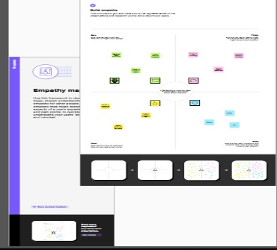

* 1. Ideation & Brainstorming Map

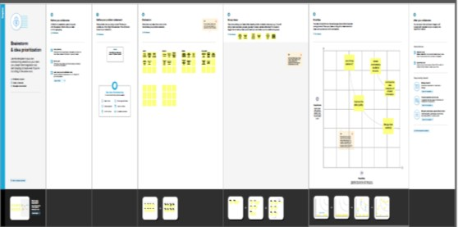

# 3. RESULT

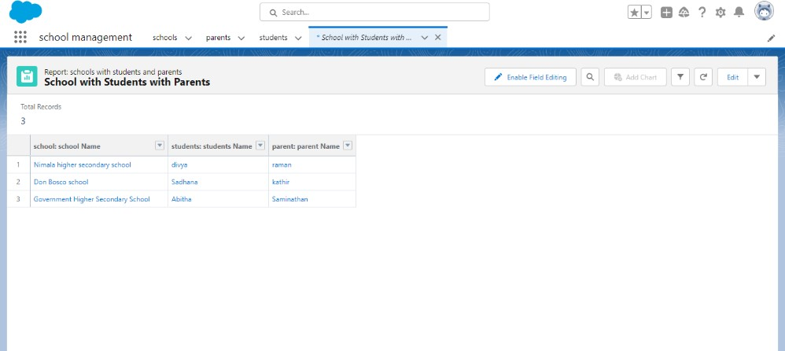

**4. TRAILHEAD PROFILE PUBLIC URL**

**Team lead - https://trailblazer.me/id/jsankar31**

**Team Member 1 - https://trailblazer.me/id/chans293**

**Team Member 2 - https://trailblazer.me/id/ggokila1**

**Team Member 3 - https://trailblazer.me/id/isait8**

**5. ADVANTAGES & DISADVATAGES**

**Advantages:**

* CRM Systems to manage processes, marketing communication and automate admission workflows.
* Its improved communication with students and parents

**Disadvantages:**

* Its requires a process driven sales organization
* It may not suit every business

**6. APPLICATIONS**

CRM software is a powerful tool for businesses looking to improve their customer relationships and drive growth.it offers three main elements: contact management, sales and marketing and customer service and support.

# 7. CONCLUSION

Customer Relationship management enables a company to align its strategy with the needs of the customer in order to best meet those needs and thus ensure long term customer loyalty

# 8. FUTURE SCOPE

CRM system companies solve sales problems, increase the productivity of employees .managing customer contact information to develop in personalized marketing campaigns. Distinguish business processes.